Tuần 7
Tiết 25
Ngày dạy: 22/10/2025

Unit 4: My birthday party
Lesson 2 (1, 2, 3)
I. OBJECTIVES:
By the end of the lesson, Ss will be able to:
- understand and correctly repeat the sentences in two communicative
contexts focusing on what someone wants to eat / drink.
+ correctly say the phrases and use What do you want to eat / drink? – I want ……….to ask and answer questions about what someone wants to eat / drink.
+ enhance the correct use of What do you want to eat / drink? – …….. to ask and answer questions about what someone wants to eat / drink in a freer context.
+ Vocabulary: chips, grapes, jam, juice.
+ Skills: speaking and listening
- Oral Communication: speak about names, ask and answer the questions
+ Co-operation: ready to help friends in pair work/ group work.
+ Sociability: Talk to each other, say good words to others.
- Kindness: Help partners to complete learning tasks.
+ Honesty: tell the truth about feelings and emotions
+ Diligence: complete learning tasks
II. TEACHING AIDS:
- Teacher: Teacher’s guide Pages 59, 60, 61, audio Tracks 40, 41, website hoclieu.vn, posters, laptop, pictures, textbook, lesson plan, TV or projector.
- Students: Pupil’s book Page 30, notebooks, workbooks, school things.
III. PROCEDURES:
Teacher’s activities | Students’ activities
1.Warm- up: (3’)  Sing a song  *Procedure:  - Sing the song When’s your birthday? on page 29.  - Say “Open your book page 30” and look at “Unit 4, Lesson 2 (1,2,3)”.  2. Presentation (16’)  Activity 1. Vocabulary.  *Procedure:  -T elicits the new words  + chips : khoai tây chiên  + grapes : quả nho  +jam :mứt  + juice : nước ép  - T models (3 times).  - T writes the words on the board.  - Checking: Rub out and remember  Activity 2. Look, listen and repeat:  *Procedure:  - Have pupils look at Pictures a and b and identify the characters in the pictures.  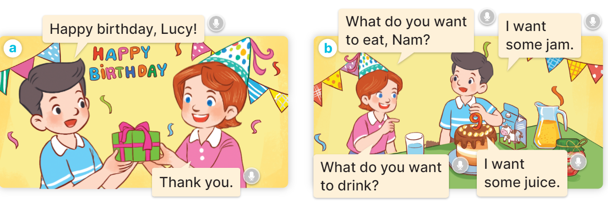  -  Play the audio twice (sentence by sentence). Correct their pronunciation where necessary.  - Have Ss to practice the dialogue  - T invites a few pairs to the front of the class to practice.  - T checks pronunciation for ss.  Activity 3 Listen, point and say.  *Procedure:  * Model sentences:  - T asks Ss look at picture a, b and helps Ss know the structure from the dialogue.  - T introduces new structure for Ss.  - T explains, models and gives meaning.  -Have Ss repeat the model sentences.  A: What do you want to eat/ drink?  B: I want some chips/ milk..  3.Practice: (7’)  *Drill pictures  - Have pupils look at the pictures and elicit the names of the food and drinks.  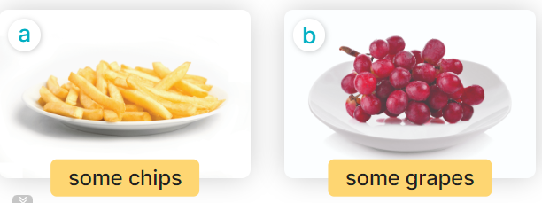  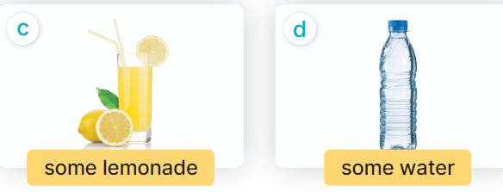  - Run through all the pictures.  - Run through model sentences.  + Run through the questions.  + Run through the answers.  - Have Ss to practise:  + T asks the first – Ss answer (change role).  + Ss – Ss (change role).  - Ask Ss to work in pairs to ask and answer the question What do you want to eat/ drink? I want……  - T controls and corrects.  - Invite a few pairs to point at the pictures and giving the instructions in front of the class.  - Encourage Ss to practise speaking English.  - T gives feedbacks.  4.Production: (7’)  Activity 4. Let’s talk.  *Procedure:  - Have Ss look at the picture and answer the questions:  +Who are they?  + What are they doing?  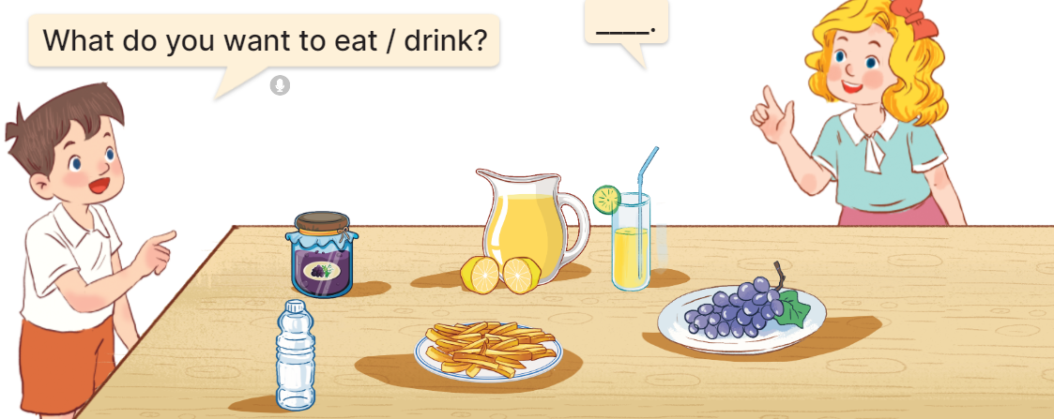  - Have pupils look at the bubbles to understand how the sentence pattern is used. - Have pupils role-play to practise asking the questions and giving their answers in pairs, using the picture cue.  - Invite some pupils to practise asking and answering questions in front of the class.  - Have pupils ask and answer questions about what they want to eat / drink at a birthday party, using the structure learnt.  *Consolidation  *Procedure:  - T asks ss to answer the following questions:  + What have you learnt from the lesson today?  +What are the core values of the lesson? (if the teacher can take from the lesson).  - T review the vocabulary and model sentences.  - T praises some Ss who are hardworking / active/ good…. as well as encourage others to try more.  5. Homework. (2’)  - Learn the vocabulary and model sentences by heart  - Prepare the new lesson: Unit 4, Lesson 2 (4,5,6). | -Ss listen, sing and dance  - Ss open their books  -Ss listen and answer  - - Ss listen and repeat  + Choral repetition (3 times).  + Individual repetition (3 ss)  - Ss take note  - Ss look, remember and write  -Look at the pictures and get to know the characters in the pictures.  + In picture a:  Nam: Happy birthday, Lucy.  Lucy: Thank you.  + In pucture b:  Lucy: What do you want to eat, Nam?  Nam: I want some jam.  Lucy: What do you want to drink?  Nam: I want some juice.  -Ss listen and repeat in chorus (twice)  -Ss work in pairs to practice  -Ss practice the dialogue  -Ss listen  -Ss look at the picture and answer.  -Ss listen  -Ss listen and repeat  -Ss look at the picture and answer  + In picture a: some chips  + In picture b: some grapes  + In picture c: a glass of lemonade  + In picture d: a bottle of water  - Ss look, listen and repeat  -Ss practice in chorus  -Ss work in pairs to practice  -Ss point and ask and answer  -Ss listen.  -Ss take turns pointing at the pictures, asking and answering the question in front of the class.  -Ss look at the picture and listen  Minh and Mary asking and answering questions about food and drink items on a table at a birthday party: jam, lemonade, water, chips, and grapes  -Ss look and pay attention  -Ss work in pairs  -Ss perform in front of the class.  -Ss says about the birthday party.  -Ss answer the questions  - Ss listen  -Ss listen and clap their hands  -Ss listen and take note
IV. ADJUSTMENTS (if necessary):
………………………………………………………………………………………….…..……………………………………………………………………………...………………………………………….…..……………………………………………………………………………….……………………………………………………………………...

Tuần 7
Tiết 26
Ngày dạy: 22/10/2025

Unit 4: My birthday party
Lesson 2 (4, 5, 6)
I. OBJECTIVES:
By the end of the lesson, Ss will be able to:
- listen to and understand two communicative contexts in which pupils ask and answer questions about what they want to eat / drink and tick the correct pictures.
+ complete two gapped dialogues with the help of picture cues.
+ revise the target vocabulary items through playing the game Board race.
+ Vocabulary: Review
+ Skills: speaking, listening, reading and writing.
- Critical Thinking: self-introduce
+ Co-operation: ready to help friends in pair work/ group work.
+ Self-control and independent learning: perform listening tasks.
- Kindness: show kindness in inviting someone to a birthday party and offering them food and drink they want.
+ Honesty: tell the truth about feelings and emotions.
+ Diligence: complete learning tasks.
II. TEACHING AIDS:
- Teacher: Teacher’s guide Pages 62,63; audio Tracks 42; website hoclieu.vn, posters, laptop, pictures, textbook, lesson plan, TV or projector.
- Students: Pupil’s book Page 31, notebooks, workbooks, school things.
III. PROCEDURES:
Teacher’s activities | Students’ activities
1.Warm- up: (5’)  Game: Guessing game  *Procedure:  - T introduces and explains the game.  - How to play:  + T will show some pictures which is hidden.  + Ss look at the pictures in the screen.  + Ss tell what someone is doing.  - T models. (jam)  - Ss play the game.  - T gives feedback.  - Ex:  1. jam 2. grapes 3. chips  4. milk 5. lemonade 6.chicken  - Say “Open your book page 31” and look at “Unit 4, Lesson 2 (4,5,6)”.  2.Practice: (27’)  Activity 1. Listen and tick:  *Procedure:  - Elicit the names of the food and drink items.  - Point at the pictures respectively to explain the context.  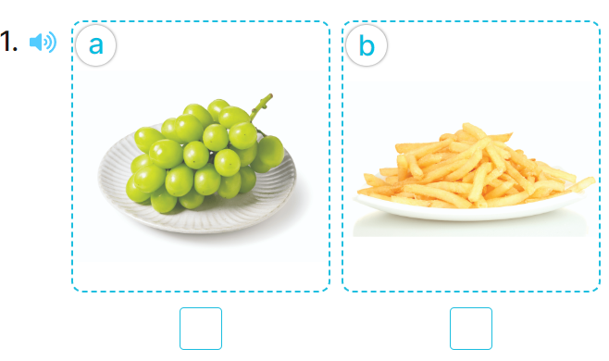  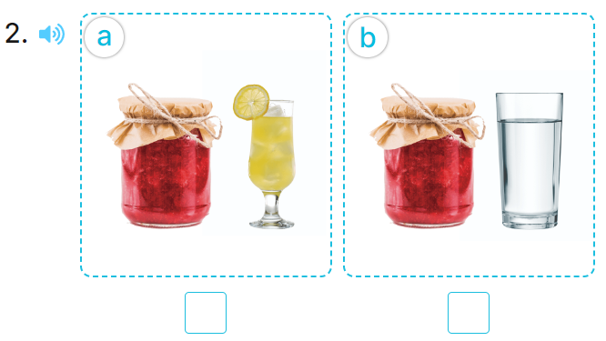  - T ask Ss to guess the answers.  + T writes Ss’guessing on the board.  - Listen to the tape:  + Play the recording  + Play the recording again and get Ss to swap books with their partners.  + Play the recording again to check answers together as a class.  + Write the answers on the board for Ss to correct their answers. Then checks Ss’ guessing.  - Play the recording, sentence by sentence, for the class to listen and repeat in chorus.  Key: 1. a 2.a  Activity 2. Look, complete and read.  *Procedure:  - Have pupils look at the pictures and identify the food and drink items in the pictures.  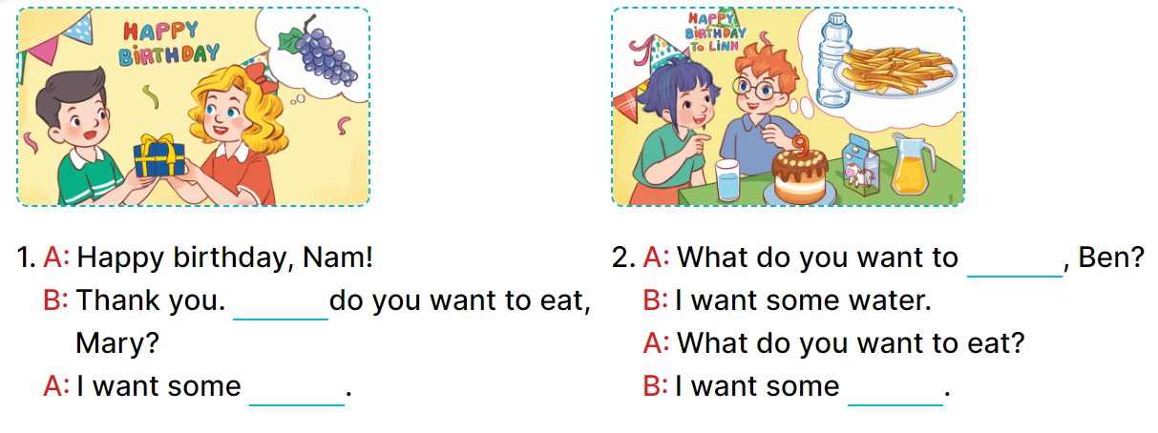  - Have pupils look at the two incomplete dialogues.  - Model Dialogue 1, ask pupils what is missing in the question (What) and the answer (the food).  - Ask pupils to complete the gap (What do you want to eat, Mary? – I want some grapes.).  - Have pupils complete the dialogues individually.  - Ask a few pairs to read them aloud.  - Correct their pronunciation where necessary, praise the readers, and get the class to clap or cheer if their pronunciation is good  Key: 1. What; grapes 2. drink; chips  Activity 3. Let’s play.  *Procedure:  - Tell pupils the goal of the game and how to play it.  - Divide pupils into two teams. They take turns going to the board and each pupil tries to write one word in the columns Drinks and Food as fast as possible.  - The team that writes the most words in the set time wins.  - Point to the words and have pupils read the words out loud.  - Have pupils play the game using other word sets, ex: months, countries, days of the week.  *Consolidation  *Procedure:  - T asks ss to answer the following questions:  + What have you learnt from the lesson today?  +What are the core values of the lesson? (if the teacher can take from the lesson).  - T praises some Ss who are hardworking / active/ good…. as well as encourage others to try more.  3. Homework. (3’)  - Practice about the pictures on page 31.  - Prepare the new lesson: Unit 4, Lesson 3 (1,2,3). | - Ss listen  -Ss play game  - Ss open their books  -Look at the pictures and say:  + Picture 1a: grapes  + Picture 1b: chips  + Picture 2a: jam ad lemonade  + Picture 2b: jam and water  -Ss guess the answers  - Ss listen to the tape and write number  - Ss listen again, write and swap books with their partners.  - Ss check their answers and guessing  -Ss listen and repeat.  -Ss look at the pictures and say  -Ss listen and pay attention  -Ss read and answer  -Ss complete the sentence  -Ss complete the second dialogues  -Ss read aloud  - Ss listen  -Ss listen  -Ss play the game  -Ss play the game  -Ss listen to the teacher.  -Ss answer the questions  -Ss listen and clap their hands  -Ss listen and take note
  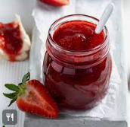 | 
   | 
   | 
IV. ADJUSTMENTS (if necessary):
………………………………………………………………………………………….…..……………………………………………………………………………...………………………………………….…..……………………………………………………………………………….……………………………………………………………………...

Tuần 7
Tiết 27
Ngày dạy: 23/10/2025

Unit 4: My birthday party
Lesson 3 (1, 2, 3)
I. OBJECTIVES:
By the end of the lesson, Ss will be able to:
- correctly repeat the sounds of the letters j and w in isolation, in the words jam and water, and in the sentences I like jam. and I want some water.
+ listen to and demonstrate understanding of simple communicative to identify the target words jam and water while listening.
+ say the chant with the correct pronunciation and rhythm.
+ Vocabulary: Review
+ Skills: speaking, listening, reading and writing.
- Co-operation: ready to help friends in pair work/ group work.
+ Sociability: Talk to each other, say good words to others.
- Kindness: show self-respect to what they want and what others want
+ Honesty: tell the truth about feelings and emotions
II. TEACHING AIDS:
- Teacher: Teacher’s guide Pages 64,65; audio Tracks 43,44,45; website hoclieu.vn, posters, laptop, pictures, textbook, lesson plan, TV or projector.
- Students: Pupil’s book Page 32, notebooks, workbooks, school things.
III. PROCEDURES:
Teacher’s activities | Students’ activities
1.Warm- up: (5’)  Game: Pass the ball  *Procedure:  - T gives Ss a ball.  - T asks Ss to listen to music and transfer a ball around the class.  - When the music stops, Ss who keep a ball have to answer the question using: What do you want to eat/ drink? and I want some…..  - T gives feedback.  - Say “Open your book page 32” and look at “Unit 4, Lesson 3 (1,2,3)”.  2. Presentation (9’)  Activity 1. Listen and repeat:  *Procedure:  - T gives instruction to the letter j and w, in the words jam and water, and in the sentences I like jam. and I want some water.  - Play the recording for the letter j, w.  - Encourage Ss to point at the letter /word/ sentence while listening.  - Play the recording again and encourage Ss to listen and repeat.  - Do this several times until Ss feel confident.  - T calls some Ss to practice.  - T gives feedbacks.  3.Practice: (19’)  Activity 2. Listen and circle.  *Procedure:  - Elicit the sentences and the gap-fill options.  - T ask Ss to guess the answers.  + T writes Ss’guessing on the board.  - Listen to the tape:  + Play the recording  + Play the recording again and get Ss to swap books with their partners.  + Play the recording again to check answers together as a class.  + Write the answers on the board for Ss to correct their answers. Then checks Ss’ guessing.  - Play the recording, sentence by sentence, for the class to listen and repeat in chorus.  - Invite one or two Ss to stand up and read the completed sentences.  Key: 1.b 2.c  Activity 3. Let’s chant  *Procedure:  - Introduce the title and lyrics of the chant.  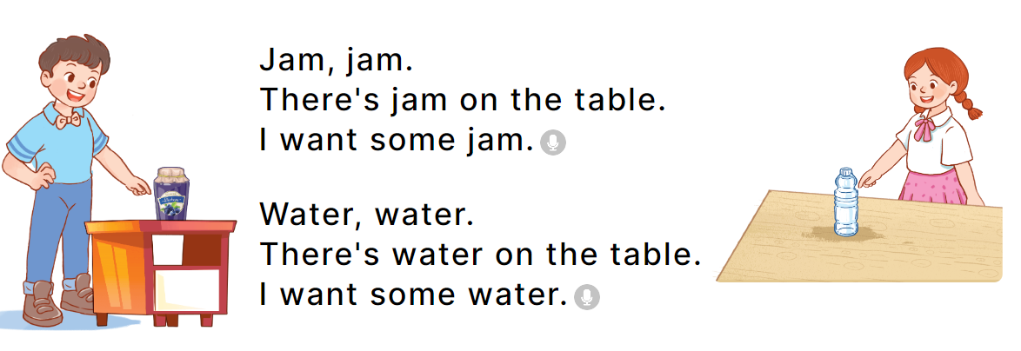  - Play the recording for Ss to listen to the whole chant.  + Have them repeat the title and lyrics line by line.  + Ask Ss to attend to the sounds of the letters j and w and the words jam and water..  - Play the recording all the way through for Ss to listen to pronunciation and melody.  - Play the recording line by line for Ss to listen and repeat  - Play the recording for Ss to chant and clap along.  - Ask Ss to practice chant and clap along in pairs or groups.  - Invite groups to the front of the classroom to perform the chant  -T gives feedback.  *Consolidation  *Procedure:  - T asks ss to answer the following questions:  + What have you learnt from the lesson today?  +What are the core values of the lesson? (if the teacher can take from the lesson).  - T praises some Ss who are hardworking / active/ good…. as well as encourage others to try more.  4. Homework. (2’)  - Practice the chant more.  - Prepare the new lesson: Unit 4, Lesson 3 (4,5,6). | - Ss listen  -Ss play the game  - Ss open their books  - Ss recognize the differences about color of letter  - - Ss listen  - Ss listen and point  - Ss listen again and repeat  -Ss listen again and repeat  -Ss practice  -Ss listen  -Ss listen and say:  + Number 1: I want some…….  + Number 2: There is some….on the table.  -Ss guess the answers  - Ss listen to the tape and circle  - Ss listen again, circle and swap books with their partners.  - Ss check their answers and guessing  -Ss listen and repeat.  -Ss read the sentences  - Ss look and listen.  -Ss listen to the chant  - Ss listen and repeat line by line without clap their hands  -Ss note the sounds, words  -Ss listen to melody of the chant  - Ss listen and chant line by line.  - Ss chant and clap along.  - Ss work in groups (two groups) to chant  -Ss perform in front of the class.  -Ss listen  -Ss answer the questions  -Ss listen and clap their hands  -Ss listen and take note
IV. ADJUSTMENTS (if necessary):
………………………………………………………………………………………….…..……………………………………………………………………………...………………………………………….…..……………………………………………………………………………….……………………………………………………………………...

Tuần 7
Tiết 28
Ngày dạy: 23/10/2025

Unit 4: My birthday party
Lesson 3 (4, 5, 6)
I. OBJECTIVES:
By the end of the lesson, Ss will be able to:
- read and understand a text (Bill’s letter) and circle the correct answers.
+ complete a gapped text using pupils’ personal information.
+ make birthday party invitations at home and present them to the class by using the target language.
+ Vocabulary: Review
+ Skills: speaking, listening, reading and writing.
- Critical Thinking: self-introduce
+ Co-operation: ready to help friends in pair work/ group work.
+ Self-control and independent learning: perform listening tasks.
- Kindness: Show kindness in inviting someone to a birthday party and offering them food and drink they want.
+ Honesty: Show pride in the date of birth of themselves and others’ and respect to their parents for their presence.
II. TEACHING AIDS:
- Teacher: Teacher’s guide Pages 66, 67; website hoclieu.vn, posters, laptop, pictures, textbook, lesson plan, TV or projector.
- Students: Pupil’s book Page 33, notebooks, workbooks, school things.
III. PROCEDURES:
Teacher’s activities | Students’ activities
1.Warm- up: (5’)  Game: “Chant”  *Procedure:  - Ask Ss chant and do the actions in Unit 4, Lesson 3 page 32 in groups.  - Give point for the groups and encourage them.  - Say “Open your book page 33” and look at “Unit 4, Lesson 3 (4, 5, 6)”.  2.Practice: (8’)  Activity 1. Read and circle:  *Procedure:  - Draw pupils’ attention to Bill’s letter and read it together as a class.  - Have pupils pay attention to the gap and the three answer options for each sentence.  - Ask pupils to read the letter again and circle the correct options.  - Tell pupils to swap books with a partner, then check answers together as a class.  - Write the correct answers on the board.  - Tell pupils to return the books to their partners.  - Ask pupils to look at the board and check their answers again.  Key: 1. b 2. a 3. a 4. b  3.Production: (19’)  Activity 2. Let’s write  *Procedure:  - Tell the class the goal of this activity: to read the text and fill in the gaps using their personal information.  - Write the first sentence on the board.  - Read the sentence as a class. When you reach the gap, point at it and encourage pupils to say their own names.  - Give pupils time to write the answers.  - Repeat the same procedure with the other sentences.  - Invite a few pupils to read the sentences they have completed aloud in front of the class.  Ex: My name is Huong. I am from Nghia Lam Village. My birthday is in October. I want some chips, milk and a birthday cake at the party.  Activity 3. Project.  *Procedure:  - Tell pupils the goal of this activity.  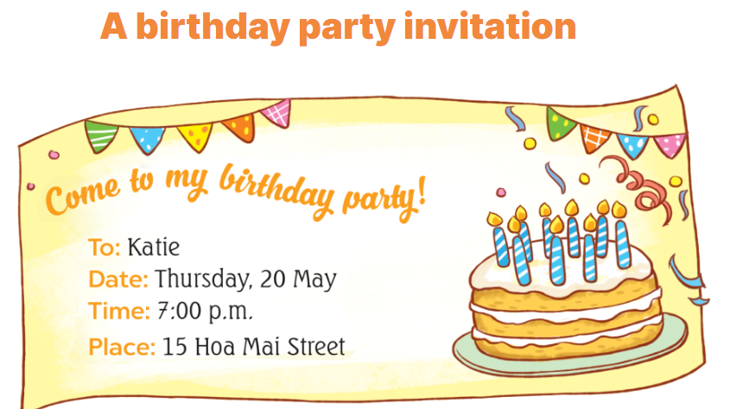  - Explain that they are going to show the birthday party invitations that they have made at home and tell the class about their birthdays.  - Have pupils work in groups of five.  + Each pupil shows his / her invitation and tells the group about his / her birthday  + Ex: My birthday’s in May.  - Invite some pupils to show their work and talk about their birthdays.  - Have pupils stick their invitations on the wall of the classroom as a display.  *Consolidation  *Procedure:  - T asks ss to answer the following questions:  + What have you learnt from the lesson today?  +What are the core values of the lesson? (if the teacher can take from the lesson).  - T praises some Ss who are hardworking / active/ good…. as well as encourage others to try more.  4. Homework. (3’)  - Prepare the new lesson: Unit 5, Lesson 1 (1, 2, 3). | - Ss listen and chant  - Ss open their books  - Ss look at the letter and answer  -Ss read and pay attention  -SS read again and circle  -Ss swap books and check  -Ss write the correct answer  -Ss return the books to their partners  -Ss check their answer again.  -Ss pay attention  -Ss listen and asnwer  -Ss write  -Ss write about themselves  -Ss write about themselves  -Ss read the sentences they have completed.  -Ss listen  -Ss listen to the teacher  -Ss work in groups and talk  -Some Ss perfom in front of the class.  -Ss vote the best invitations  -Ss answer the questions  -Ss listen and clap their hands  -Ss listen and take note
IV. ADJUSTMENTS (if necessary):
………………………………………………………………………………………….…..……………………………………………………………………………...……………

