Week 5 Preparing date: October 6th 2024
Period 17 Teaching date: October 8th 2024

Unit 3: My foreign friends
Lesson 1 (1, 2, 3)
A. OBJECTIVES:
By the end of the lesson, Ss will be able to:
1. Knowledge:

- understand and correctly repeat the sentences in two communicative contexts in which characters ask and answer questions about someone’s nationality.

- correctly say the words for nationalities and use What nationality is he / she? - He’s / She’s _____. to ask and answer questions about someone’s nationality.

- enhance the correct use of What nationality is he / she? - _____. to ask and answer questions about someone’s nationality in a freer context.

- Vocabulary: nationality, Australian, Malaysian, American, Japanese

- Structures: A: What nationality is he / she?
B: He’s/ She’s Australian.
- Skills: speaking and listening
2. Competences:
- Critical thinking and creativity: learn how to ask and answer questions about personal information correctly and fluently.
- Self-control and independent learning: perform speaking tasks.
3. Attitude/ Qualities:
- Show their pride in where they come from and great respect for where someone comes from by asking and answering about nationality
B. TEACHING AIDS:
- Teacher: Teacher’s guide Pages 44, 45, 46, audio Tracks 25, 26, website hoclieu.vn, posters, laptop, pictures, textbook, lesson plan, TV or projector.
- Students: Students’ book Page 22, notebooks, workbooks, school things.
C. PROCEDURES:
Stages/  Time | Teacher’s activities | Students’ activities
1.Warm- up and review: (3’)  2. Presentation (15’)  3.Practice: (7’)  4. Production: (6’)  5. Fun corner and wrap- up (4’)  6. Homework (2’) | Game: Slap the board  *Aims: to revise the vocabulary about different countries that pupils have learnt in English 4.  *Procedure:  - Prepare some flashcards about different countries and stick on the board (America, Australia, Japan, Viet Nam, Malaysia…)  - Divide class into 2 groups: Tom and Jerry.  - How to play:  + Each group chooses five Ss to play.  + Class will read aloud.  + Look at the picture, listen and slap the picture you heard.  + Who faster will get 1 mark.  + Which group with higher mark is the winner.  - Say “Open your book page 22” and look at “Unit 3, Lesson 1 (1,2,3)”.  Activity 1. Vocabulary.  *Aims: Ss will be able to know the vocabulary in the new lesson.  *Procedure:  -T elicits the new words  + American : người Mỹ (explain)  + Australian: người Úc (explain)  + Malaysian : người Ma-lai-xi-a  (explain)  + Japanese : người Nhật (explain )  + nationality: quốc tịch (translation)  - T models (3 times).  - T writes the words on the board.  - Checking: Matching  Activity 2. Look, listen and repeat:  *Aims: Ss will be able to understand and correctly repeat the sentences in two communicative contexts in which characters ask and answer questions about someone’s nationality  *Procedure:  - Have Ss look at Pictures a and b and identify the characters and say what they are talking about.  + Who is he/ she?  + Where is he/ she?  + What are they talking about?  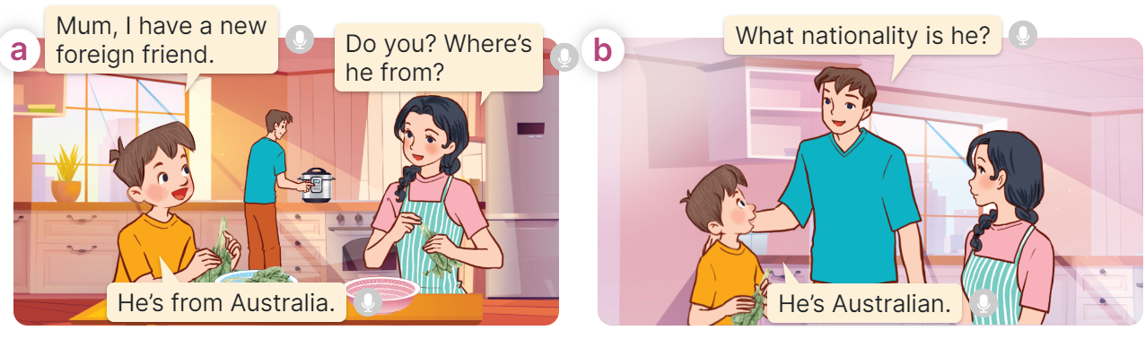  - Play the audio twice (sentence by sentence). Correct their pronunciation where necessary.  - Have Ss to practice the dialogue  - T invites a few pairs to the front of the class to practice.  - T checks pronunciation for ss.  Activity 3 Listen, point and say.  *Aims: Ss will be able to correctly say the words for nationalities and use What nationality is he / she? - He’s / She’s _____. to ask and answer questions about someone’s nationality.  *Procedure:  * Structures:  - T asks Ss look at picture b in activity 1 and helps Ss know the structure from the dialogue.  - T introduces new structures for Ss.  - T explains, models and gives meaning.  - Have Ss repeat the structures  A: What nationality is he / she?  B: He’s/ She’s Australian.  *Drill pictures  - Have Ss look at the pictures and say what they can see in the pictures.  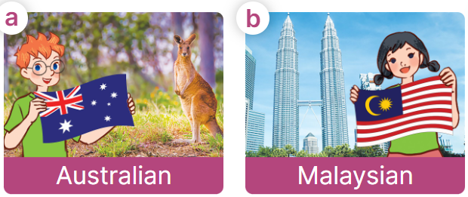  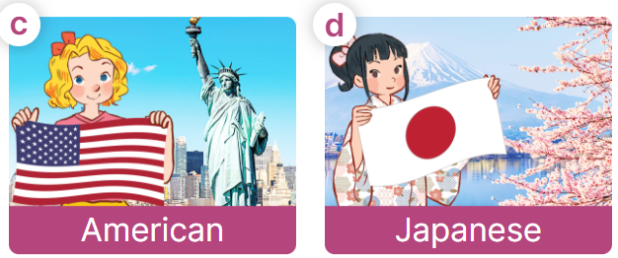  - Have Ss point at pictures, listen and run through all the pictures.  - Have Ss point at the bubbles, listen and run through model sentences.  - Have Ss to practise:  + T asks the first picture, Ss answer  + Ss asks the second picture, T answers  + Group A asks the third picture, group B  answers  + Group B asks the last picture, group A  - Ask Ss to work in pairs to practise asking and answering the What nationality is he / she? – He’s/ She’s ____.  - T controls and corrects.  - Invite a few pairs to point at the pictures and say the questions and answers in front of the class.  Activity 4. Let’s talk.  *Aims: Ss will be able to enhance the correct use of What nationality is he / she? - _____. to ask and answer questions about someone’s nationality in freer contexts.  *Procedure:  - Ask Ss to look at the pictures and elicit the context  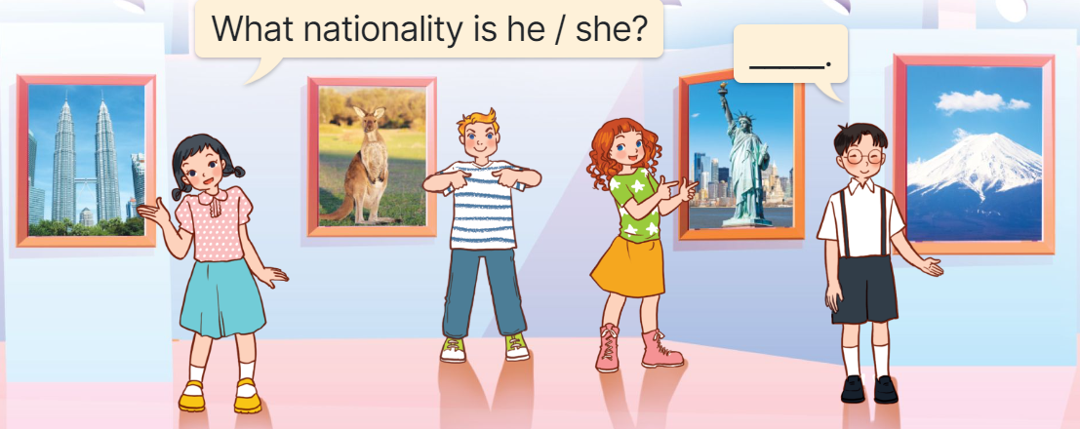  - Point at the ﬁrst picture and elicit the question in the ﬁrst speech bubble What nationality is he / she? and the answer in the second speech bubble He’s/ She’s…. as an example.  - Give Ss time to work in pairs and take turns pointing at each picture to ask and answer using What nationality is he / she? - _____.  - Invite a few pairs to come to the front of the classroom and act out the exchanges.  Game: Sentence Puzzle  - Divide the class into groups of four.  - Give each group a sentence that is broken/cut into pieces.  - Ask them to arrange them to make a complete sentence, then read it aloud.  - The group who makes it first will be the winner.  - Ask Ss to learn vocabulary and structures by heart. | -Ss listen and pay attention  - Ss listen to the teacher  -Ss play the game  .  - Ss continue playing the game  - Ss listen and open their books  -Ss listen and answer  - - Ss listen and repeat  + Choral repetition  (3 times).  + Individual repetition  (3 ss)  - Ss take note  - Ss look and match  -Look at the pictures and say.  + In picture a: Minh and mum in the kitchen, talking Minh’s new friend.  Minh: Mum, I have a new foreign friend.  Mum: Do you? Where’s he from?  Minh: He’s from Australia.  + In picture b: Dad joining the conversation, asking about the nationality of Minh’s new friend.  Dad: What nationality is he?  Minh: He’s Australian.  -Ss listen and repeat in chorus (twice)  -Ss work in pairs to practice  -Ss come to the front of the classroom to practice.  -Ss listen  - Ss look at the picture and answer.  -Ss listen  -Ss listen and repeat  -Ss repeat to the structures  - Ss look, listen and repeat  +Picture a: Ben, Australian flag, a kangaroo and the word Australian underneath.  + Picture b: a girl, Malaysian flag, Petronas Twin tower and the word Malaysian underneath.  + Picture c: Mary, American flag, the Statue of Liberty and the word American underneath  + Picture d: a girl, Japanese flag, Sakura blossoms and the word Japanese underneath  -Ss point at pictures, listen and repeat  -Ss point at the bubbles, listen and repeat  -Ss practice in chorus  -Ss practice in chorus  -Ss work in pairs to practise asking and answering the question  - Pairs of Ss point at the pictures and say in front of the class  -Ss look at the picture and say  + Picture of four characters at the exhibition introducing their countries  - Ss look at the first picture and elicit the missing words in speech bubbles and say the completed sentences.  - Ss role-play to practise asking and answering questions  - Ss practise asking and answering questions in front of the class.  -Ss listen to the teacher  -Ss play the game  Ex:  is  he?  nationality  What  -Ss congratulate the winner  -Ss listen to the teacher  - Ss take note
D. ADJUSTMENTS (if necessary):
………………………………………………………………………………………….…..……………………………………………………………………………...…..…

