Preparing date: February, 21st, 2025
Teaching date: February, 24th, 2025

Unit 13: My house
Lesson 3 (1, 2, 3)
A. OBJECTIVES:
By the end of the lesson, Ss will be able to:
- correctly repeat the sounds of the letters ou and ow in isolation, the words house and brown and the sentences Wow, it’s a big house! and Wow, it’s a brown house! with the correct pronunciation and intonation.
- identify the target words house and brown while listening.
- say the chant with the correct rhythm and pronunciation.
- Vocabulary: Review
- Skills: speaking, listening, reading and writing.
C. PROCEDURES:
Teacher’s activities | Students’ activities
1.Warm- up:  Game: Find and circle the words  *Aims: to create a friendly and active atmosphere in the class to beginning the lesson.  *Procedure:  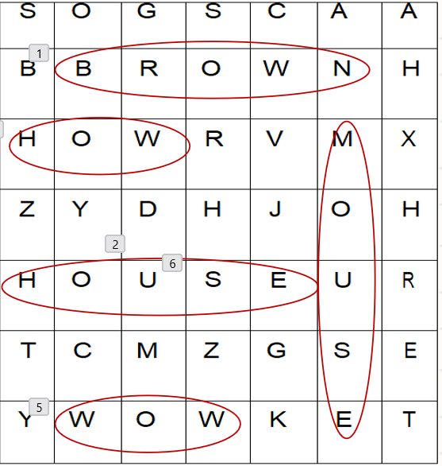  - Divide class into 3 groups  - Ask Ss to find and circle the words that they learnt.  - Which groups find the best correct words is winner.  - Give Ss time to play the game.  Rows: brown, snow, wow  Columns: house, mouse  -T checks who’s winner?  - Say “Open your book page 22” and look at “Unit 13, Lesson 3 (1,2,3)”.  2. Presentation  Activity 1. Listen and repeat:  *Aims: Ss will be able to correctly pronounce the sounds of the letters ou and ow in isolation, in the words house and brown, and in the sentences Wow, it’s a big house! and Wow, it’s a brown house! with correct pronunciation and intonation.  *Procedure:  - T gives instruction to the ou and ow in isolation, in the words house and brown, and in the sentences Wow, it’s a big house! and Wow, it’s a brown house!  - Play the recording for the letter ou, ow.  - Encourage Ss to point at the letter/ word/ sentence while listening.  - Play the recording again and encourage Ss to listen and repeat.  - Do this several times until Ss feel confident.  - T calls some Ss to practice.  - T gives feedbacks.  3.Practice:  Activity 2. Listen and circle.  *Aims: Ss will be able to identify the target words house and brown while listening.  *Procedure:  - Elicit the sentences and explain that they have to listen.  - T ask Ss to guess the answers.  + T writes Ss’guessing on the board.  - Listen to the tape:  + Play the recording  + Play the recording again and get Ss to swap books with their partners.  + Play the recording again to check answers together as a class.  + Write the answers on the board for Ss to correct their answers. Then checks Ss’ guessing.  - Play the recording, sentence by sentence, for the class to listen and repeat in chorus.  - Invite one or two Ss to stand up and read the completed sentences.  Key: 1.b 2.b  Activity 3. Let’s chant  *Aims: Ss will be able to say the chant with the correct rhythm and pronunciation.  *Procedure:  - Introduce the title and lyrics of the chant.  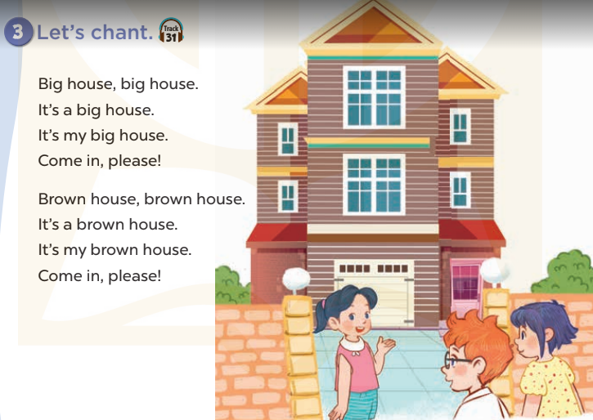  - Play the recording for Ss to listen to the whole chant.  + Have them repeat the title and lyrics line by line.  + Ask Ss to attend to the sounds of the letters ou and ow and the words house and brown.  - Play the recording all the way through for Ss to listen to pronunciation and melody.  - Play the recording line by line for Ss to listen and repeat  - Play the recording for Ss to chant and clap along.  - Ask Ss to practice chant and clap along in pairs or groups.  - Invite groups to the front of the classroom to perform the chant  -T gives feedback.  *Consolidation  *Aims: Ss will be able consolidate and wrap up the content of the lesson.  *Procedure:  - T asks ss to answer the following questions:  + What have you learnt from the lesson today?  +What are the core values of the lesson? (if the teacher can take from the lesson).  - T praises some Ss who are hardworking / active/ good…. as well as encourage others to try more.  4. Homework.  - Practice the chant more.  - Prepare the new lesson: Unit 13, Lesson 3 (4,5,6). | - Ss listen  -Ss play game  - Ss open their books  - Ss recognize the differences about color of letter  - - Ss listen  - Ss listen and point  - Ss listen again and repeat  -Ss listen again and repeat  -Ss practice  -Ss listen  -Ss listen and say:  + Number 1:  a. I like a big house.  b. I like a brown house.  + Number 2:  a. I don’t like a big house  b. I don’t like a brown house  -Ss guess the answers  - Ss listen to the tape and circle  - Ss listen again, circle and swap books with their partners.  - Ss check their answers and guessing  -Ss listen and repeat.  -Ss read the sentences  - Ss look and listen.  -Ss listen to the chant  - Ss listen and repeat line by line without clap their hands  -Ss note the sounds, words  -Ss listen to melody of the chant  - Ss listen and chant line by line.  - Ss chant and clap along.  - Ss work in groups (two groups) to chant  -Ss perform in front of the class.  -Ss listen  -Ss listen.  -Ss answer the questions  -Ss listen and clap their hands  -Ss listen and take note

D. ADJUSTMENTS (if necessary):
………………………………………………………………………………………….…..……………………………………………………………………………...……………

