Week 10  Period 26 | UNIT 4: ETHNIC GROUPS OF VIET NAM  Lesson 2: A CLOSER LOOK 1 | Date of planning: /10/2024  Date of teaching: /10/2024

I. OBJECTIVES
By the end of this lesson, students will be able to gain:
1. Knowledge:
- Vocabulary: The lexical items related to the life of the ethnic people.
- Pronunciation: Correctly pronounce words that contain the sounds /k/ and /g/
2. Core competence:
- Develop communication skills and creativity
- Be collaborative and supportive in pair work and teamwork
- Actively join in class activities
3. Personal qualities
- Respect ethnic groups of Viet Nam and their culture
- Develop self-study skills.
II. MATERIALS
- Grade 8 textbook, A closer look 1
- Computer connected to the Internet
- Projector / TV
- hoclieu.vn
III. PROCEDURES
1. WARM-UP (5 mins)
a. Objectives:
- To create an active atmosphere in the class before the lesson.
- To lead into the new lesson.
b. Content:
- Kim’s game.
c. Expected outcomes:
- Ss review words about ethnic groups in Viet Nam.
d. Organisation
TEACHER AND STUDENTS’ ACTIVITIES | CONTENTS
- Teacher asks Ss to work in 2 groups.  - Teacher shows some pictures related to ethnic groups in 2 minutes.  - Ss look at the pictures and remember (no writing)  - As soon as teacher stops showing the pictures, Ss work in groups and write the words for the pictures they have seen  - The group with more correct answers becomes the winner. | Kim’s game:          Suggested answers:  (a) bamboo house, costume(s), five-colour sticky rice, folk dance, musical instrument(s), post(s), stilt house, terraced field(s)
2. ACTIVITY 1: PRESENTATION (10 mins)
a. Objectives:
1. To introduce visually some nouns/ noun phrases related to the life of ethnic people.
b. Content:
Write a word or phrase from the box under each picture;
c. Expected outcomes: Knowing more new words. Ss know how to pronounce the new words correctly and use them in appropriate situations.
d. Organisation : Teacher’s instructions.
TEACHER AND STUDENTS’ ACTIVITIES | CONTENTS
Task 1: Write a word or phrase from the box under each picture.
* Teach vocabulary:  + Teacher uses different techniques to teach vocab (situation, realia, translation.)  + Teacher introduces the vocabulary by:  - providing the pictures  - eliciting the definition of the words  + Teacher do the checking “What and where?”  ** Teacher asks Ss to look at each picture and say the word or phrase describing it if they know.  - Have Ss to read the words and phrases and do the matching. Ss can start matching the phrases they can easily recognise like terraced fields, Rong house, bamboo flute, wooden statue. The two remaining words on the list (gong and weaving) are different as one is an activity (weaving) and the other is an object (gong)  - Teacher checks the answers as a class.  - Have Ss read the words or phrases aloud. Correct their pronunciation if needed.  - T may ask Ss for the Vietnamese equipvalents of these words or phrases. | - T_Ss  * New words:  1. communal house (n) nhà rông, nhà sinh hoạt cộng đồng.  2. minority group (n) dân tộc thiểu số  3. livestock (n) gia súc  4. raise (v) chăn nuôi  5. gong (n) cái cồng, cái chiêng  *** Answer key:  1. wooden statue  2. Rong house (Nhà Rông )  3. weaving  4. bamboo flute  5. gong  6. terraced fields
3. ACTIVITY 2: PRACTICE ( 15 mins)
a. Objectives:
1. To help Ss understand more clearly the meaning of some words and phrases.
2. To help Ss use the words in specific contexts.
b. Content:
Match the words and phrases with their meanings.; Complete the sentences with the words and phrases from the box.
c. Expected outcomes: Know more new words and phrases. Know how to use the words/ phrases in context.
d. Organisation :
TEACHER AND STUDENTS’ ACTIVITIES | CONTENTS
Task 2: Match the words and phrases with their meanings.
- Ask Ss to read the words and phrases that have been provided in the fist column and meanings in the second column.  - Teacher guides Ss if needed: Two words (gong, gardening) have appeared in the previous tasks and lessons. Two are similar (house- room, group- group)  -Ss can easily find the remaining items.  - Ss work individually, match suitable words/ phrases with their meanings.  - Teacher checks the answers as a class. | - T_Ss  * Key:  1. c 2. a  3. e 4. d  5. b
Task 3: Complete the sentences with the words and phrases from the box.
- Ss should have no difficulty completing the sentences since the words and phrases in the box have been taught in the previous activities.  - Teacher asks Ss to work individually, discuss and choose suitable words/ phrases to fill in the gaps.  - Ss go to the board and write their answers.  - Teacher checks the answers as a class.  - Teacher checks the answers as a class and gives feedback. | - T_ Ss  * Answer key:  1. unique features  2. weave  3. raise  4. communal house  5. minority group  6. livestock
4. ACTIVITY 3: PRODUCTION: ( 10 mins)
PRONUNCIATION /k/ and /g /
a. Objectives:
- To help students identify how to pronounce the sounds /k/ and /g/.
- To help students practise pronouncing these sounds correctly in words and in sentences.
b. Content:
Listen and repeat the words. Pay attention to the sounds /k/ and /g/. Listen and repeat the sentences. Pay attention to the underlined words.
c. Expected outcomes: Students repeats the words correctly. Learn how to pronounce the words correctly. Ss distinguish and pronounce the sound /k/ and /g/ correctly in their speaking.

d. Organisation:
TEACHER AND STUDENTS’ ACTIVITIES | CONTENTS
Task 4: Listen and repeat the words. Pay attention to the sounds /k/ and /g/.
+ Have Ss read the sentences, paying attention to the underlined words /k/ and /g/.  - Play the recording and ask them repeat each sentence  - Teacher asks Ss to listen and pay attention to the sounds /k/ and /g/.  - Ss repeat the words as a class, in groups and individually.  - Call on some Ss to read the sentence individually.  - Play the recording as many times as necessary.  * Teacher gives corrections and feedbacks to students’ pronunciation . | - T_ Ss. Ss- Ss  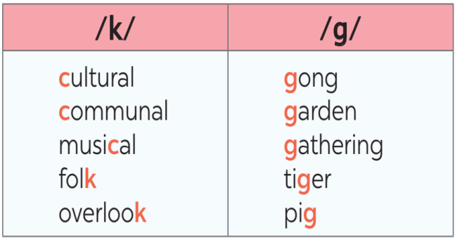
Task 5: Listen and repeat the sentences. Pay attention to the underlined words.
- Have Ss read the sentences, paying attention to the underlined words with the sounds /k/ and /g/.  - Play the recording and ask Ss to repeat each sentence. Correct them if needed.  - Call on some Ss to read the sentences individually.  - Teacher asks some students to read the sentences individually.  ** Teacher’s observation and feedback. | * Answer:  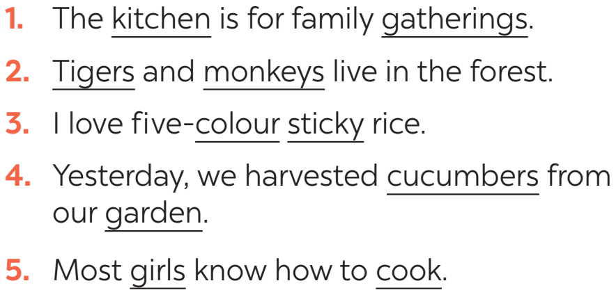
5. CONSOLIDATION ( 5mins )
a. Wrap-up
- Teacher asks Ss to summarise what they have learnt in the lesson.
b. Homework
- Redo the tasks.
- Do more exercises in workbook.
- Prepare project.
- Prepare new lesson: Revision
* Evaluation: ………………………………………………………………………………………
….…………………………………………………………………………………………………………………………………………………………………………………………………………….

