Week: 14 Teaching date 9/12/2024

Period: 41

UNIT 5: NATURAL WONDERS OF VIET NAM

Lesson 7: Looking back and project
I. OBJECTIVES:
By the end of the lesson, students will be able to:
- review language use and skills student have learned in Unit 5;
- apply what they have learnt (vocabulary and grammar) into practice through a project.
II. LANGUAGE ANALYSIS
1. Knowledge:
* Vocabulary: words related to the topic “things in nature” and “travel items”
* Grammar: revise the use of must /mustn't and countable and uncountable nouns
2. Skills: Listening and writing
3. Attitude: To teach SS to work hard and love travelling.
4. Competences: Ss will be developed speaking, writing and co-operating skills when doing project.
III. MATERIALS
* Preparation:
1. Teacher: Text books , pictures, planning , …
- Grade 6 textbook, Unit 5 , Looking back and project
- Smart TV/Pictures.
- sachmem.vn
2. Students: Text books, notebooks, posters, ….
  - IV. PROCEDURES: (45')
* Check- up (5’)
* Aim: To revise the vocabulary related to the topic and lead in the next part of the lesson.
* Content: Game : Brainstorming ( things in nature and travel items)
* Products: Students work group and write the correct answers on the board.
* Organization of implementation:
Teacher’s and Ss’activities |  |  | Content
* Warm up (Team work)  T can have Ss listen to an EL song  - T –Ss.  - Teacher divides the class into 2 big teams A and B.  - Then, teacher asks students to work in groups of 6.  - Write 2 main words on the board.  - One team (team A) finds all the words related to things in nature. Another team (team B) finds all the travel items they know.  - Teacher asks students to make a web map in 2 minutes, try to add as many words as possible.  - The fastest group with the most correct answers is the winner |  |  | * Game : Brainstorming:  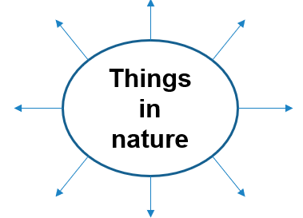  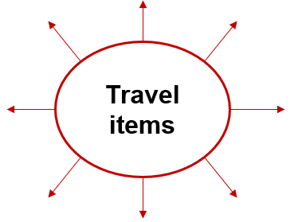  * Suggested answers:  + Things in nature: desert, forest, mountain, lake, river, valley, cave, island, beach,…  + Travel items: lighter, scissors, sleeping bag, compass, plastic, backpack,….
* VOCABULARY
Task 1,2,3 (12’)
* Aim: To help students revise the vocabulary items they have learnt in the unit.
* Content: Write the name for each picture
* Products: Ss say the correct words aloud for each picture.
* Organization of implementation:
Teacher’s and Ss’activities | Content
Task 1:Weak sts  - T –Ss :  - Teacher encourages students to complete the task individually.  - Teacher asks students to swap their books with their partners.  Teacher shows the answer and check  Task 2:  - T –Ss :  - Teacher asks students to work in pairs.  - Teacher monitors the activity lets them do it in 2 minutes.  - Teacher lets each pair answer.  - Teacher checks the answers with the whole class.  Task 3:  - T –Ss :  - Teacher asks students to do this exercise individually.  - Teacher lets students compare their answers in pairs before checking as a class. | Task 1: Write the name for each picture.  * Answer key:  1. waterfall  2. cave  3. desert  4. lake 5. Beach 6. island  Task 2: Match the name of a natural wonder on column A with a word indicating it in column B.  Answer key:  1. d 2. C 3. a  4. e 5. F 6. b  Task 3: Write the words under the pictures.  Answer key:  1. scissors 2. sleeping bag  3. compass 4. backpack 5. plaster
* GRAMMAR (10’)
Task 4+ Task 5
* Aims: To help Ss revise the use of countable and uncountable nouns in sentences.
Tohelp Ss revise the use of must /mustn't in context.
* Content: Find the mistake in each sentence and correct it.
* Products: Students read the sentences carefully and correct the mistakes.
* Organization of implementation:
Teacher’s and Ss’activities |  | Content
- Task 4:  T –Ss ; Ss – Ss  - Teacher asks students to work independently.  - Teacher asks students to read the sentences carefully and correct the mistakes.  - Students complete the task and discuss about the answers.  - Teacher gives feedback as a class discussion.  Task5:  T - Ss, Ss – Ss  - Teacher lets students to work in pairs and complete the activity.  - Teacher asks students to stand up and make a role play.  - Teacher checks the answers with the whole class. |  | Task 4: Find the mistake in each sentence and correct it. (p. 56)  * ANSWER KEY:  1. is / are  2. are / is  3. instrument instruments  4. are / is  5. luggages / luggage  Task 5: Complete the dialogue, using must / mustn’t. (p. 56)  * Answer key:  1. must 2. must  3. mustn’t 4. Must 5. mustn’t
3 . Production(3’):
* Aims: To give Ss further practice on using countable and uncountable nouns and mustn’t
* Content: Rewrite the sentences using the words in brackets.
* Products: Students’ full sentences on the board.
* Organization of implementation:
- T - Ss, Ss – Ss  - T asks students work indepently.  .- SS sewrite the sentences using the words in brackets.  - Ss complete the sentences in the book.  - Teacher invites some students to complete on the board .  - T comments and give marks. |  | * Rewrite the sentences using the words in brackets.  1. There are some chairs and a table in the kitchen.  We have…………………………….  2. Not many people can understand his lecture.  Only………………  ( some / a few people can understand his lecture)  3.It is wrong of us to throw rubbish.  We mustn’t …………………………  4.It is necessary for us to be present at the class discussion on Saturday.  We must ……………………………..  5.The tour guide tells us not to throw rubbish.  The tour guide says that we…………… .
4. Project (5’) *
* Aims: To allow students to apply what they have learnt (vocabulary and grammar) into practice through a project.
* Content: PROJECT: DREAM DESTINATION
* Products: Students’ perfect project.
* Organization of implementation:
Teacher’s and Ss’activities |  | Content
T - Ss, Ss – Ss  - Teacher sets the context:  + Teacher will be a tourist who is looking for a dream destination to go on holiday.  + Students will be the travel agents who have to suggest the tourist by providing their travel brochure (poster).  - Teacher divides the class into groups of 6. Each group will act as a travel agency.  - Teacher asks “the travel agencies” to discuss and choose an interesting place they would like to visit (in Viet Nam or in the world).  - Teacher asks them to look for necessary information for the visit, basically by discussing the suggested questions.  - Students summarise the information and design A0 size posters about the places they would like to promote.  - Teacher asks the class to listen to the reports and ask questions if they would like to.  - Students will critically evaluate all the posters, then give 1 vote for the most attractive poster/ place.  Teacher gives comments and feedback to all groups and awards special prize the group which has the most votes |  | * PROJECT: DREAM DESTINATION  1. In groups, make a poster about a natural wonder you would like to visit. In the poster, draw / print a picture of the place. Then give some information about the place:  - what the natural wonder is  - where it is  - how you can go there  - what it is special about  - what you can do there  …  2. Introduce the attraction to your class  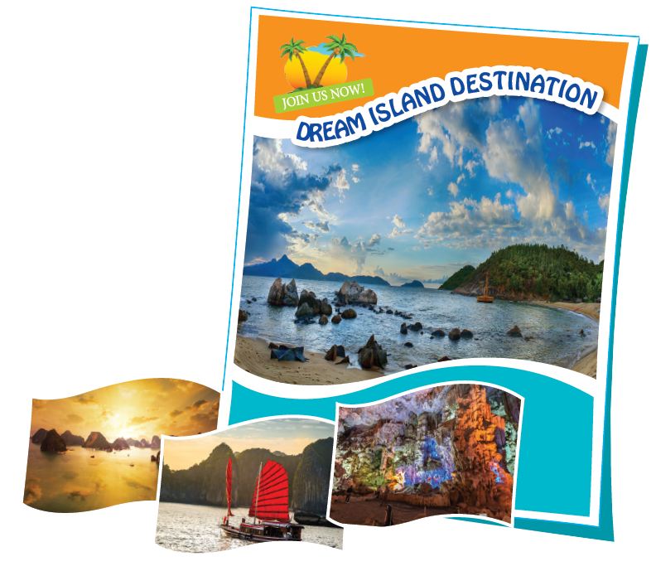
* Consolidation (2’)
* Aim: To consolidate what students have learnt in the lesson.
* Content: summarize the content of the lesson.
* Products: A student says the lesson’s content aloud.
* Organization of implementation:
Teacher’s and Ss’activities |  | Content
- Teacher asks students to talk about what they have learnt in the lesson.(weak sts) |  | - - revise vocabulary and grammar in unit 5  - make Project: “DREAM DESTINATION ”
* Homework (2’)
Aim: To revise the knowledge that students have gained in Unit 5 and To prepare for the next lesson
* Content: Review the lesson and prepare for the next lesson and do exersie in the workbbook
* Products: Students’ textbook and workbook.
* Organization of implementation:
Teacher’s and Ss’ activities |  | Content
- Teacher asks students to revise old lesson and to do exercise in workbook.  - Teacher asks students to complete the project and prepare the new lesson. |  | - Complete the project  - Prepare for the next lesson: Unit 6 ( Getting started)
* Evaluation: ………………………………………………………………………………………………………………………………………………………………………………

