Week: 13 Teaching date : 5/12/2024

Period: 40

UNIT 5: NATURAL WONDERS OF VIET NAM

Lesson 6: Skills 2
I. OBJECTIVES:
By the end of the lesson, students will be able to:
- listening for specific information about a natural wonder;
- writing a paragraph about a natural wonder..
II. LANGUAGE ANALYSIS
1. Knowledge:
* Vocabulary: words related to the topic “things in nature” and “travel items”
* Grammar: Making suggestions, superlatives.
2. Skills: Listening and writing
3. Attitude: To teach SS to work hard and love travelling.
4. Competences: Co-operation, self- study; Students will be developed listening and writing skills.
III. MATERIALS
* Preparation:
1. Teacher: Text books , pictures, planning , …
- Grade 6 textbook, Unit 5, Skills 2
- Smart TV/Pictures.
- sachmem.vn
2. Students: Text books, notebooks, posters, ….
  - IV. PROCEDURES: (45')
1.Warm –up (5’)
* Aim: To help Ss know some famous places
To introduce about the destination in the talk.
* Content: Look at the pictures and name the places in the pictures
* Products: Ss say the correct answers aloud.
* Organization of implementation:
Teacher’s and Ss’activities |  |  | Content
* Warm up  - T - Ss  - Teacher encourages students to complete the task individually.  - Teacher asks students to name the places in the pictures.  - Teacher shows the answer and check.  Lead in:  - T shows a picture on the screen and asks Guess the name of the destination.  Today we are going to listen to a talk about a famous natural wonder of Viet Nam. It’s Phu Quoc Island. |  |  | * Game :  Look at the pictures and name the places in the pictures    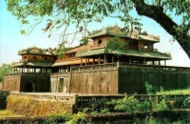  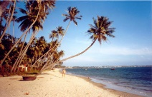  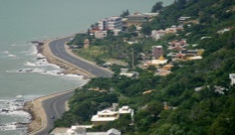  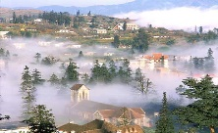    * Answer key:  1. Ha Long Bay 2. Hue 3. Ha Noi  4. Mui Ne 5. Vung tau 6. Sa Pa  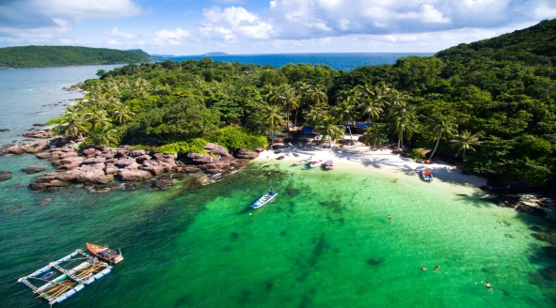  Phu Quoc Island
1. Pre-Listening (5’)
Task 1: (5’)
* Aim: To help students brainstorm about destination in the talk.
* Content: Discuss and answer the question.
* Products: Students’ answers on the posters.
* Organization of implementation:
Teacher’s and Ss’activities | Content
- Teacher asks students to work in groups of four to answer the question:  “What do you know about Phu Quoc Island?”  - Teacher asks students to talk in Vietnamese (sometimes) if they do not have enough vocabulary in English.  - Teacher asks students to share what they have discussed to see what they know about Phu Quoc Island.  - Play the recording one or two times for Ss to check their answers. | Task 1: Work in groups. Discuss and answer the question. (p. 55)  “What do you know about Phu Quoc Island?”  * Suggested answers:  - a beautiful island in Viet Nam.  - the night market,  - The food is delicious  - In Kien Giang province  * Listen to the talk and check your answers.
3. While -listening ( 10’)
Task 2 (5’)
* Aims: To help students develop listening skill for specific information (T / F).
* Content: Listen and tick True or False.
* Products: Listen, understand and say the answer correctly.
* Organization of implementation:
Teacher’s and Ss’activities |  | Content
Task 2: T - Ss, Ss - Ss  - Teacher plays the recording once or twice.  - Teacher asks students to listen and tick the answers.  - Teacher asks students to compare their answers with the prediction made previously.  - Teacher calls on some students to read aloud their answers and correct the false one(s).  - Teacher checks students’ answers as a class. |  | Task 2: Listen and tick True or False.  * True – False prediction:  Answer key:  1. T  2. F (It has beautiful beaches and green forest.)  3. T  4. F (Sailing and fishing are popular water sports.)  5. T
Post-Listening
Task 3: (5’)
* Aims: To help students develop their skill of listening for specific information
* Content: Listen again and fill in the blanks.
* Products: Play game in groups and say the correct answer .
* Organization of implementation:
Teacher’s and Ss’activities |  | Content
- T-Ss, Ss-Ss( work group)  - Ask students to study the phrases with the blanks carefully. Students may work in pairs to discuss the answers from the information they have listened.  - Play the recording again and have students write the answers as they listen.  - T can have SS fill in the blanks by playing game : Lucky number.  - Class is divided into 2 groups.  - Teacher prepares 7 numbers which includes 5 questions about their school, and 2 lucky numbers.  - Each team takes turns and chooses a number and answers the question behind the number. If the team answers the question correctly, they will get 1 point. If the team chooses the lucky number, they get 1 point without answering the question and may choose another number. |  | EX: Listen again and fill in the blanks.  * Game: Lucky number  1. Phu Quoc has beautiful ……….. and green forests.  2. It also has………………, hotels, and bars  3. Phu Quoc has an international……………  4. Tourists can visit fishing villages, national parks, ……………and temples  5. Sailing and fishing are …………water sports  * Audio script:  Phu Quoc is a very beautiful island in Viet Nam. It is in Kien Giang. It has beautiful beaches and green forests. It also has resorts, hotels, and bars. The people here are friendly. Phu Quoc has an international airport, and travelling there is easy. Tourists can visit fishing villages, national parks, pagodas and temples. They also like to eat the seafood here. It is delicious. Sailing and fishing are popular water sports. You can buy interesting things at the markets on the island.
4. Pre -writing (5’)
Task 3:
* Aims: To help students talk about a travel attraction they know and collect information for their later writing.
* Content: Fill each blank in the network with the information about a travel attraction you know.
* Products: Ss fill the information exactly and present in front of the class.
* Organization of implementation:
Teacher’s and Ss’activities |  | Content
– T - Ss, Ss-Ss  -Teacher models the task by summarizing the information of the talk with a student using the questions in the network below:  - Teacher asks students to choose a travel attraction they know and individually brainstorm about that place using the network in Task 3.  - Teacher goes round and help if needed.  Teacher asks students to work in groups of four to introduce about their chosen places using the filled network.  - Teacher asks 1-2 students to stand up and talk about their chosen place then give them comments. |  | Task 3: Fill each blank in the network with the information about a travel attraction you know.  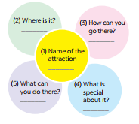  * Suggested answers:  T: What is the name of the attraction?  Ss: It’s Phu Quoc island  T: Where is it?  Ss: It’s in Kien Giang  T: How can you go there?  Ss: You can fly to the island because it has an international airport.  T: What can you do there?  Ss: I can visit the fishing villages, the national parks, beautiful beaches, temples, pagodas, etc. I can enjoy some water sports like Sailing and fishing or buy interesting things at the night market.  T: What is special about it?  Ss: It’s one of the most famous natural wonders of Viet Nam and thousands of tourists visit it every year.
5. While-Writing (5’)
* Aims: To teach students how to write a paragraph about 50 words about a travel attraction they know.
* Content: Write a paragraph about 50 words about a travel attraction you know
* Products: Students’ perfect writing on the posters.
* Organization of implementation:
Teacher’s and Ss’activities |  | Content
- T-Ss, Ss-Ss  - Teacher shows the picture in Task 4 and explains to students that they should begin the paragraph with a topic sentence for  - Teacher asks students to use ideas they have brainstormed to write a paragraph about 50 words about a travel attraction they know.  - Teacher goes round and help if needed. |  | Task 4: Write a paragraph about 50 words about a travel attraction you know. Use the information in Task 3.  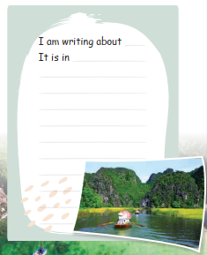  * Example:  I am writing about Ly Son island. It is a beautiful island in Quang Ngai province. And it’s not far from here . You can go there by ship . It is a pristine island with exotic seafood. Ly Son island is famous for its friendliness, long beautiful beaches, and being “the kingdom of garlic.” There you can enjoy great Vietnamese seafood; Especially King crab. You can go diving and swimming. You can join exciting activities. I think, you should have a visit to Ly Son.
6. Post-Writing (5’)
* Aim: To peer check, cross check and final check students’ writing.
* Content: Cross check students’ writing.
* Products: Students’ writing and cross check. (individual work)
* Organization of implementation:
Teacher’s and Ss’activities |  | Content
- T-Ss, Ss-Ss  - Teacher asks students to exchange their textbooks to check their friends’ writing.  - Teacher then gives feedback as a class discussion. |  | Task 5: Sts’ writing and cross check.  * Model writing:  I am writing about Ha Long Bay.  It is in Quang Ninh province. It’s very far from here  - about 500 kilomiters, so you can go there by bus or by train. Ha long Bay has many caves and islands. Tuan Chau is the biggest island in Ha Long Bay. You must take a boat ride around the islands. There you can enjoy great Vietnamese seafood. You can watch traditional dance. You can join exciting activities. Ha Long Bay is Vietnam’s most beautiful natural wonder.
* Consolidation (2’)
* Aim: To consolidate what students have learnt in the lesson.(weak sts)
* Content: summarize the content of the lesson.
* Products: A student says what she/ he has learnt in the lesson.
* Organization of implementation:
Teacher’s and Ss’ activities |  | Content
- Teacher asks students to talk about what they have learnt in the lesson. |  | - listening for specific information about a natural wonder;  - writing a paragraph about a natural wonder..
* Homework (2’)
* Aim: To revise knowledge that students have gained in this lesson.
* Content: Review the lesson and prepare for the next lesson and do ex in the workbbook
* Products: Students’ textbook and workbook
* Organization of implementation:
- Teacher asks students to rewrite their writing in their books.  - Teacher asks students to prepare the new lesson. |  | - Rewrite the writing in the notebook.  - Prepare “ Looking back and project”
* Evaluation: ………………………………………………………………………………………………………………………………………………………………………………

