Date of planning: March 17th , 2025  Date of teaching: April 4th , 2025  WEEK: 29 | Period: 87 UNIT 11 : SCIENCE AND TECHNOLOGY  Lesson 1: GETTING STARTED  Great news for students

I. OBJECTIVES: * By the end of this lesson, Ss will be able to gain the following:
1. Knowledge:
- To introduce an overview about the topic Science and technology.
- To learn how to use the words to talk about Science technology
- To practice listening and reading skills .
+ Vocabulary:The lexical items related to science and technology.
- Sentence stress
- Giving and responding to good news.
+ Grammar: Reported speech (statement)
2. Competence:
- Students will be able to develop communication skills and creativity
- Be co-operative and supportive in pair work and teamwork.
- Actively join in class activities.
3. Qualities:
- Love talking about Science and technology
II. TEACHING AIDS:
- Teacher: Grade 8 text book, projector ; Unit 11, Getting started
- Students : Text books, workbook…
- Computer connected to the Internet
- Hoclieu.vn
III. PROCEDURE:
1. WARM UP & INTRODUCTION ( 3’- 5’)
* Aims:
- To create an active atmosphere in the class before the lesson;
- To lead into the new unit.
* Content: To have some warm-up activities to create a friendly and relaxed atmosphere to inspire Ss to warm up to the subject and new lesson.
* Expected outcomes: Having a chance to speak English and focus on the topic of the lesson.
* Organisation : Teacher’s instructions …
Teacher’s Student’s activities | Content
+ Greeting  GAME: HIDDEN WORD  - T introduces the rule of the game:  + Read the questions or situations  + Find a word to answer each question or fill in each situation.  +  - T leads to the new unit. Write the unit title SHOPPING on the board. Ask Ss to guess what they are going to learn about in this unit. | + Greeting ; T_Ss.  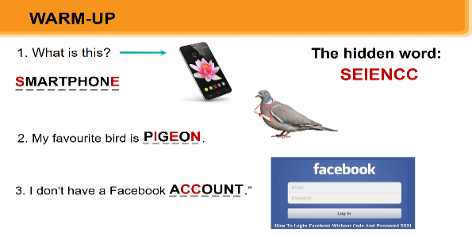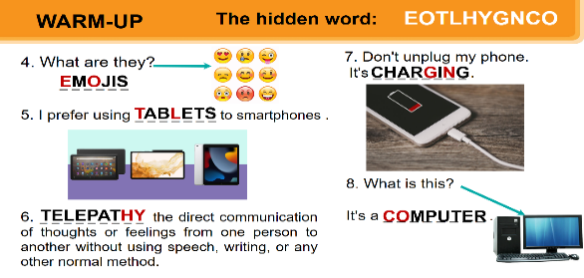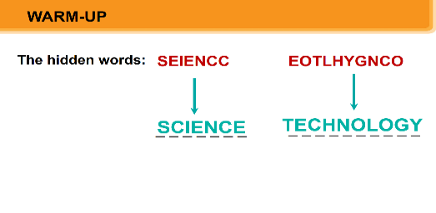  - Open the book and write the tittle of the lesson.
2. PRESENTATION/ NEW LESSON ( 12’- 15’)
* Objectives:
- To set the context for the introductory conversation.
- To introduce the topic of the unit.
* Content: Learn some new words . Read the conversation and find out new words. Focus on topic of the lesson, grammar points…
*Expected outcomes: Know more new words ; Understand the conversation; topic of the lesson
* Organisation : Teacher’s instructions.
Teacher’s Student’s activities | Content
ACTIVITY 1. Listen and read :/ Page 114
* Teach vocabulary:  + Teacher uses different techniques to teach vocab (situation, realia, translation.)  + Teacher introduces the vocabulary by:  - providing the pictures  - eliciting the definition of the words  + Teacher do the “Rub out and remember” checking technique.  - Teacher reveals that these seven words will appear in the reading text and asks students to open their textbooks to discover further.  * Set the context: Have Ss look at the conversation and the picture, and answer some questions, e.g. Who are the girl and the boy?  Where do you think they are? What might they be talking about?  What do you see in the bubble? | - T_Ss  *Vocabulary  1. technology(n) Công nghệ  2. face to face (adj) Trực tiếp, mặt đối mặt  3. epidemics (n) Đại dịch  4. contact lens (n) Kính áp tròng  5. breakout room(n)Phòng học chia nhỏ, chia nhóm  6. invention (n) Phát minh  * Questions:  - Who are the girl and the boy?  - Where do you think they are?  - What might they be talking about?  - What can you see in the bubble?
- Encourage Ss to answer, but do not confirm whether their answers are right.  - Play the recording twice for Ss to listen and read along. Then invite some pairs of Ss to read the conversation aloud.  - Refer to the questions previously asked.  - Confirm the correct answers:  - They are Minh and Ann.  - They are at school.  - They are discussing their online class/robot teacher.  - Have Ss say the words and phrases in the text that they think are related to the topic Science and Technology.  - Quickly write the words and phrases on one part of the board. Comment on Ss'answers. | *Suggested answer:  - They are Minh and Ann.  - They are at school.  - They are discussing their online class / robot teacher.
3. PRACTICE ( 15’)
* Objectives:
- To help Ss understand the conversation.
- To help Ss learn phrases related to the topic Science and Technology.
- To help Ss use the vocabulary in 3 in the right context.
* Content: Listen and read the conversation. Tick T/F. Label pictures. Complete the sentences
* Expected outcomes: Ss understand the content of the conversation and know the vocabulary related to the topic. Do exercises correctly.
* Organisation :
Teacher’s Student’s activities | Content
ACTIVITY 2: Read the conversation again and tick (✓) T (True) or F (False) .

- Ask Ss to work in pairs to read the conversation.  Ask them to underline the keywords and phrases in the statements. Then have pairs work for one or two minutes to check if the statements are true or false.  - Have Ss read out the statements and say if the statements are true or false.  - Make sure they pronounce the words correctly.  - Check the answers as a class | - T_Ss  - Work individually.  Answer key:  1. F 2. T 3. F 4. T 5. T
EXTRA ACTIVITY:
Write this on the board and have Ss copy it.
Minh: _______ yesterday's __________.
Ann: _______ face-to-face _________.
Minh: _______ during bad __________.
Ann: _______ doesn't always _______.
- Play the first four exchanges of the recording again and Ss fill in the blanks by writing the word that comes just before and just after the written word(s).
- Put Ss in pairs and have them compare answers.
- Play the recording again for Ss to check their answers and add one more word before the first one they wrote and one more after the last one they wrote.
ACTIVITY 3: Label each picture with a phrase from the box.
- Ask Ss to say the phrases aloud. Make sure they pronounce the phrases correctly.  - Ask Ss to work in pairs to label the pictures with the appropriate phrases. | - T_ Ss  * Answer key:  1. computer screen 2. 3D contact lenses  3. online class 4. robot teacher  5. breakout rooms  6. Internet connection
ACTIVITY 4: Complete the sentences, using the phrases in 3.
- Ask Ss to work independently to complete each sentence with a phrase from the box in 3.  - Allow Ss to refer to the pictures and phrases in 3 or the conversation if needed.  - Check the answers as a class.  - Ask several Ss to read aloud the full sentences.  - Correct Ss' pronunciation if needed. | - T_ Ss.  - Work individually.  * Answer key:  1. computer screen  2. breakout rooms  3. robot teacher  4. online class  5. 3D contact lenses
4. PRODUCTION/ FURTHER PRACTICE ( 8’)
* Objectives:
- To help Ss learn more about past inventions;
- To create a fun atmosphere in the class.
* Content: Doing the QUIZ. Do you know what things were invented in these years?
* Expected outcomes: Students can answer the questions correctly.

* Organisation :
Teacher’s Student’s activities | Content
ACTIVITY 5: Quiz: Do you know what things were invented in these years? Work in pairs and find out.
Ask Ss to work in pairs to read the information in the Quiz and to make guesses.  Encourage Ss to guess as many things as possible.  Ask some Ss to report the things they have thought of. Confirm the correct answers.  Key:  1. the first computer  2. the telephone  3. penicillin  4. the World Wide Web (WWW)  5. robot ASIMO (Advanced Step in Innovative Mobility) | + T-Ss + Ss  * Key  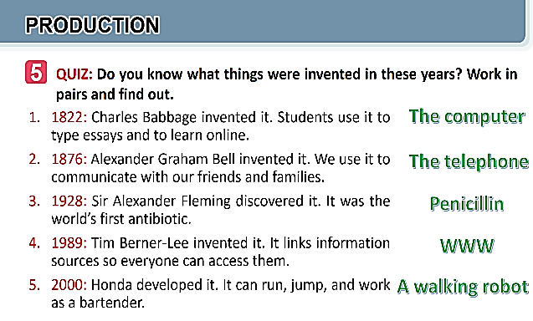
5. WRAP-UP & HOME WORK (2’)
a. Wrap-up
- Ask Ss to use lexical items related to science and technology
- If there is an overhead projector in the classroom, show the dialogue, highlight the key words related to the topic.
* HOME WORK:
- Name technologies and inventions they have learnt about in the lesson.
- Learn the new words and phrases by heart.
- Do Exercise ………..page ……Unit 11/Workbook
** Prepare for the Project of the unit:

==============================================

Date of planning: April 1st , 2025  Date of teaching: April 7th , 2025  WEEK: 30 | Period: 88 UNIT 11 : SCIENCE AND TECHNOLOGY  Lesson 2 : A CLOSER LOOK 1
I. OBJECTIVES: * By the end of this lesson, Ss will be able to gain the following:
1. Knowledge:
- Identify some nouns related to the topic of science and technology and some new technologies.
- Identify some new verb phrases that used to talk about inventions, discoveries, creations and development
- Identify sentence stress.
+ Vocabulary:The lexical items related to science and technology.
- Sentence stress; Giving and responding to good news.
+ Grammar: Reported speech (statement)
2. Competence:
- Students will be able to develop communication skills and creativity
- Be co-operative and supportive in pair work and teamwork.
- Actively join in class activities.
3. Qualities:
- Love talking about Science and technology
II. TEACHING AIDS:
- Teacher: Grade 8 text book, projector ; Unit 11: A closer look 1.
- Students : Text books, workbook…
- Computer connected to the Internet
- Hoclieu.vn
III. PROCEDURE:
1. WARM UP & INTRODUCTION ( 3’- 5’)
* Objectives:
- To create an active atmosphere in the class before the lesson;
- To lead into the new lesson.
* Content: To have some warm-up activities to create a friendly and relaxed atmosphere to inspire Ss to warm up to the subject and new lesson.
*Expected outcomes: Having a chance to speak English. Students get some vocabulary from the lesson and be ready for the lesson.
* Organisation : Teacher’s instructions …
Teacher’s Student’s activities | Content
+ Greeting  Game: Labelling the pictures  - Give Ss a few minutes to play a game. Have Ss play in two groups.  - Give Ss pictures of things and strips of paper with phrases including computer screen, breakout rooms, robot teacher, online class, 3D contact lenses, connection.  - Ask teams to stick the phrases to the right pictures.  - The team with the most correct answers wins.  - Ask Ss to open their books to page 116. | + Greeting  - T_Ss.  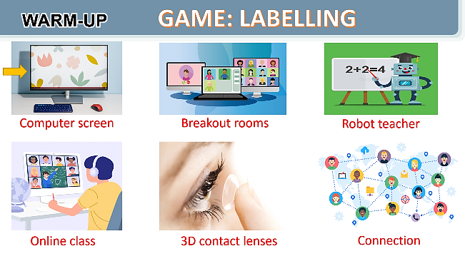  - Open the book and write the tittle of the lesson.
2. PRESENTATION/ NEW LESSON ( 12’- 15’)
* Objectives:
- To introduce new words and phrases that are related to new technologies.
* Content: Write the words and phrases under the correct pictures.
* Expected outcomes: Knowing more new words. Students know how to use some collocations related to the environment and environmental protection.
* Organisation : Teacher’s instructions.
Teacher’s Student’s activities | Content
ACTIVITY 1: Write the words and phrases under each picture.

+ Teacher uses different techniques to teach vocab (situation, realia, translation.)  + Teacher introduces the vocabulary by:  - providing the pictures  - eliciting the definition of the words  + Teacher do the “Rub out and remember” checking technique.  - Teacher checks the students' understanding by the Rub out and Remember technique.  - To introduce new words and phrases that are related to new technologies.  - Have Ss read aloud the words and phrases in the box.  - Ask Ss to work in pairs to look at the pictures and describe them.  - Have pairs write the correct words and phrases under the pictures.  - Explain the meaning of the new words and phrases in Vietnamese if needed.  - Invite Ss to take turns to read out their answers.  - Correct their pronunciation if needed.  - Check the answers as a class. | - T_Ss  *Vocabulary  1. face recognition (n) /feɪsˌrekəɡˈnɪʃn/  Công nghệ nhận biết/ diện gương mặt  2. experiment (n) /ɪkˈsperɪmənt/  Thí nghiệm  3. eye-tracking (n) /’ai ,trækɪŋ/  Công nghệ dõi (cử động) mắt  4. fingerprint scanner(n) /ˈfɪŋɡəprɪnt ˈskænə(r)/ Máy quét vân tay  5. digital communication (n) /ˈdɪdʒɪtl /kəˌmjuːnɪˈkeɪʃn/ Giao tiếp kỹ thuật sốKey:  1. digital communication  2. face recognition  3. eye-tracking  4. experiment  5. fingerprint scanner  6. video conferencing
3. PRACTICE ( 15’)
* Objectives:
- To allow Ss to learn new verb phrases that are used to talk about inventing, discovering, creating, and developing.
- To allow Ss to use the learnt words and phrases in context.
* Content: Choose the option that best completes each phrases.
- Complete the sentences with the words and phrases from the box.
* Expected outcomes: - Knowing how to use the words/phrases in context. Do exercises correctly.
* Organisation :
Teacher’s Student’s activities | Content
ACTIVITY 2: Choose the option that best completes each phrase.
- Ask Ss to read aloud the given verbs and nouns.  - Explain the verbs and if possible, give some examples. Also explain the verbs in Vietnamese.  * For example;  -To create something = To bring into existence out of nothing.  E.g.: She created a new robot.  - To invent = to design a new process or mechanism. E.g: He invented a new electric cooker.  - To develop = grow gradually or become bigger, stronger, etc.  E.g.: They developed a relationship / a method to work better / a computer programme.  + Ask Ss to work in pairs to choose the correct options to complete the phrases.  - Check the answers as a class.  - Have some Ss read aloud the phrases.  - Correct Ss’ pronunciation if necessary.  + Also ask Ss to add more words / phrases to the verbs to make up other phrases. This way, T can broaden Ss’ vocabulary if they are ready. | - T_Ss  - Work individually.  *Answer key:  - To discover = to find somebody/something that was hidden or that you did not expect to find.  E.g.: Galileo discovered that Jupiter had moons.  * Answer key:  1. A 2. A 3. B 4. B
ACTIVITY 3: Complete the sentences with the words and phrases from the box.
- Ask Ss to work individually to choose the correct answer for each sentence.  - Have Ss swap their answers with partners. Then check the answers as a class.  - Also ask some Ss to read out their answers. Then have some Ss read the sentences aloud as a class.  - Correct Ss’ pronunciation if necessary. | - T_ Ss; Ss to work individually.  * Answer key:  1. discovered  2. invented  3. created  4. experiments  5. fingerprint scanner.
4. PRONUNCIATION: ( 8’)

Sentence stress
* Objectives:
4. To help Ss be aware of which words in a sentence should be stressed and which should not be;
- To help Ss say sentences with correct stress.
5. To help Ss be aware of the words they have to stress in a sentence;
To help Ss practise saying sentences with correct stress.
* Content: Listen and repeat the sentences. Pay attention to the bold syllables. Listen and reapeat the sentences.
* Expected outcomes: Students liaten and repeats the words correctly

* Organisation :
Teacher’s Student’s activities | Content
ACTIVITY 4: Listen and repeat the sentences. Pay attention to the bold syllables.
- Have Ss listen to the recording once first. Ask them to pay attention to the stressed syllables.  - Play the recording again for them to listen and repeat each word as a class, then as individuals. Play the recording as many times as possible.  - Then ask Ss to read out the sentences. Correct their pronunciation and stress if needed.  - Introduce the rules in the Remember! Box: stress sentences, which words in a sentence should be stressed, and which are not.  Remind Ss of the words that receive stress in a sentence, which they leant in Unit 11 Tiếng Anh 7.  * Teacher gives corrections and feedbacks to students’ pronunciation | - T_ Ss.  - Work individually.  * Key:  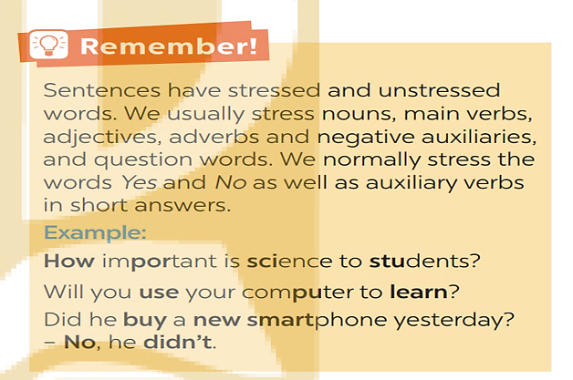
ACTIVITY 5. Listen and repeat the sentences. How many stressed words are there in each sentence.
- Play the recording for Ss to listen and repeat each sentence after the recording. Correct Ss’ pronunciation if necessary.  - Ask Ss to count the number of stressed words in each sentence. Check if Ss have counted enough stressed words in each of the sentences.  - Call on some Ss to read the sentences. Play the recording multiple times again if necessary.  * Teacher checks students’ answers and their pronunciation and gives feedback. | - T _ Ss ; Ss  * Answer key:  1. He is an inventor.  2. We won’t have a robot teacher next year.  3. She likes learning online.  4. Was she checking attendance when you came? - No, she wasn’t.  5. What did he invent?  Key: 1. 1 2. 5 3. 3 4. 6 5. 2
5. WRAP-UP & HOME WORK (2’)
- Ask Ss to summarise what they have learned in the lesson.
- Ask them to list some some verb phrases learned in the lesson.
- Ask them to list some other learnt words and phrases related to modern technologies.
* HOME WORK:
- Do more exercises in workbook.
- Prepare new lesson: Lesson 2: A CLOSER LOOK 2 .

==============================================

Date of planning: April 1st , 2025  Date of teaching: April 8th , 2025  WEEK: 30 | Period: 89 UNIT 11 : SCIENCE AND TECHNOLOGY  Lesson 3 : A CLOSER LOOK 2
I. OBJECTIVES: * By the end of this lesson, Ss will be able to gain the following:
1. Knowledge:
- To teach and introduce what direct speech and reported speech are.
- Realize some differences between a direct speech and a reported speech (statements).
- Be aware of changes in tenses, pronouns, time, and place expressions.
+ Vocabulary:The lexical items related to science and technology.
- Sentence stress ; Giving and responding to good news.
+ Grammar: Reported speech (statement)
2. Competence:
- Students will be able to develop communication skills and creativity
- Be co-operative and supportive in pair work and teamwork.
- Actively join in class activities.
3. Qualities:
- Have a positive attitude to using reported speech in daily life.
II. TEACHING AIDS:
- Teacher: Grade 8 text book, projector ; Unit 11.
- Students : Text books, workbook…
- Computer connected to the Internet
- Hoclieu.vn
III. PROCEDURE: Language analysis : REPORTED SPEECH
 | Direct speech | Reported speech
1. Definition | - a report of the exact words used by a speaker or writer.  - usually placed inside quotation marks and accompanied by a reporting verb, signal phrase, or quotative frame. | - the form of speech used to convey what was said by someone at some point of time.
2. Changes in tenses | 1. Present simple  2. Present continuous  3. Present perfect  4. Past simple  5. Past continuous  6. Past perfect  7. will/ 8. Can/ 9. may  10. must | 1. Past simple  2. Past continuous  3. Past perfect  4. Past perfect  5. Past perfect continuous  6. Past perfect  7. would/ 8. Could/ 9. might  10. had to
3. Changes in pronouns  (according to situations) | 1. I/ me  2. We/ us  3. You  4. He/she/it/ they…  5. this  6. these | 1. He/She/ him/her  2. They/ them  3. I/me  4. He/she/it/ they…  5. that  6. those
4. Changes in time and place expressions | 1. now  2. today  3. ago  4. tomorrow  5. this week  6. yesterday  7. last week  8. here | 1. then  2. that day  3. before  4. the following day/ the next day  5. that week  6. the day before/ the previous day  7. the week before/ the previous week  8. there
5. Structures | S1 said: “S2 + V2,”  “S2 + V2,” S1 said | S1 + said/ told sb + (that) +  S2 + V2 lùi thì

1. WARM UP & INTRODUCTION ( 3’- 5’)
* Objectives:
- To create an active atmosphere in the class before the lesson;
- To lead into the new lesson.
* Content: To have some warm-up activities to create a friendly and relaxed atmosphere to inspire Ss to warm up to the subject and new lesson.
* Outcome: Having a chance to speak English.
* Organisation : Teacher’s instructions …
Teacher’s Student’s activities | Content
+ Greeting  Game: MEMORIZING RULE:  - Work in 4 groups  - Look at the pictures in 30 seconds and try to remember what each people said.  - Write down on the posters what each of the people in the picture said.  - The group with the most correct answers is the winner.  Write the objectives in a corner of the board and leave them there till the end of the lesson, or put them on a slide to show Ss. | + Greeting ; - T_Ss.  - Learn how to do their tasks and open the notebooks and write the title of the lesson.
2. PRESENTATION/ NEW LESSON ( 12’- 15’)
* Objectives:
1. To help Ss understand direct speech and reported speech (statements);
- To help Ss realise some differences between direct speech and reported speech (statements).
* Content: Introduce the grammar point of the lesson. Reported speech
* Expected outcomes: Students know how to use the target grammar. Do exercises correctly.
* Organisation : Teacher’s instructions.
Grammar: * REMEMBER : REPORTED SPEECH
* Reported speech is used to report what someone said.
( Lời nói tường thuật được sử dụng để thuật lại những gì ai đó đã nói )
Example:
Mi said : “I want a new computer.”
→ Mi said (that) she wanted a new computer.
* When we turn a direct sentence into a reported one, we change:
( Khi chuyển một câu trực tiếp sang một câu tường thuật, chúng ta thay đổi:)
a) Verb forms ( Các hình thức động từ.)
Present simple (Thì hiện tại đơn)  Mi said, “ I love science.” | Past simple (Thì quá khứ đơn)  Mi said (that) she loved science.
Present continuous (Thì hiện tại tiếp diễn)  Mi said. “ I am learning English.” | Past continuous (Thì quá khứ tiếp diễn)  Mi said (that) she was learning English.
Will + V (Thì tương lai đơn)  "I will become a scientist,” he said. | Would + V  He said (that) he would become a scientist.
b) Time and place expressions. (Diễn đạt thời gian và địa điểm )
- now → then ; today → that day ; ago → before.
- tomorrow → the following day / the next day
- this week → that week ; here → there
c) pronouns according to situations. ( Đại từ tùy theo tình huống.)
I →he / she ; we → they me → him / her...
Teacher’s Student’s activities | Content
ACTIVITY 1: Look at part of the conversation in GETTING STARTED again. Then match Minh’s uncle’s direct speech with his reported speech.
- Ask Ss to work individually to look at the part of the conversation from GETTING STARTED  - Ask Ss to underline the sentences in GETTING STARTED  - Have Ss work in pairs to look at direct speech and reported speech boxes to match.  - Check the answers as a class.  - Ask some Ss to underline the differences in the pairs of sentences they have just matched.  - Emphasize will in direct speech is turned into would in the reported speech.  - Ask several Ss to read aloud full sentences. Correct their pronunciation if necessary.  * TEACHING POINT  - Have Ss work individually to read the Remember! box.  - Write examples of direct speech and reported speech on the board.  - Ask some Ss to point out the differences between pairs of sentences (direct and reported speech sentences)  - Remark on the differences in (1) verb form, (2) time expressions, (3) time and place expression, and (4) pronouns. | - T_Ss  * Key: 1. B 2. A
3. PRACTICE ( 15’)
* Objectives:
2. To help Ss be aware of how to change verb forms when they report information.
3. To help Ss be aware of the changes in time and place expressions when they report information.
4. To help Ss practise changing direct sentences into reported sentences.
* Content: Complete the sentences. Do exercises.
* Expected outcomes; Students understand how to use the target grammar. Do exercises correctly.
* Organisation :
Teacher’s Student’s activities | Content
ACTIVITY 2: Complete the second sentences using the correct verb form.
- Remind Ss that they should put the verb one tense back when they report something [backshifting].  - Have Ss work in pairs to complete the sentences with the correct verb forms.  - Ask some Ss to write their answers on the board.  - Check Ss' answers. Correct any mistakes and re-explain the rule if necessary.  - Have Ss read out loud sentences again and correct their pronunciation if necessary. | - T_Ss ; Answer key:  Key:  1. was  2. would take  3. was talking  4. were going  5. didn’t have
ACTIVITY 3: Complete the second sentences with the words and phrases from the box.
- Have Ss work individually to underline the expressions denoting time and place in the direct sentences  - Ask Ss to choose the correct word / phrase from the box to fill in each of the reported sentences.  - Remind them of the expressions they have just underlined in each of the direct speech sentences.  - Ask some Ss to read out loud the direct and reported speech sentences.  - Correct their pronunciation if necessary.  - Check the answers as a class. | - T_ Ss  - Ss to work individually.  * Answer key:  1. the next day  2. then  3. that day  4. that year  5. there
ACTIVITY 4: Complete the second sentence in each pair so that it means the same as the first one.
- Have Ss work individually for five minutes to complete the reported sentences. Then ask them to work in pairs to swap their answers.  - Ask some Ss to write their reported sentences on the board.  - Check the answers as a class.  - Have the class read out loud the sentences.  - Correct their pronunciation if necessary. | - T_ Ss.  * Answer key:  1. The scientist said that we would live much longer in the future.  2. Our teacher said that our school was going to have a new laboratory there.  3. My dad said that they were developing technology to monitor students better.  4. Tom said that there were no classes the next day because their teacher was ill.  5. The teacher said that they wanted some students to join the science club the next semester.
EXTRA ACTIVITY
As a quick review, elicit from Ss what types of changes are made in reported speech. Make sure they include: 1) changing the verb forms, 2) changing time expressions, and 3) changing place expressions as well as 4) changing the pronouns according to the situation.
Ss consider ail four of these types of changes and work in pairs to create a sentence in reported speech that includes at least three types of changes
Ss then give their sentences to another pair that writes the direct speech version of it.

4. PRODUCTION/ FURTHER PRACTICE ( 8’)
* Objectives:
5. To enable Ss to practise reporting speech;
- To create a lively atmosphere for learning.

* Content: GAME.
* Expected outcomes: Students ask and answer based on the tables.

* Organisation :
Teacher’s Student’s activities | Content
ACTIVITY 5: Work in pairs. One student says a sentence and the other changes that sentence into reported speech. Then swap roles
* GAME: He/ She said that…  - Divide the class into groups.  - Instruct Ss to play the game in groups.  - Give groups two minutes to prepare. Tell them that groups can write down their group’s sentences.  - Invite one group to read out or say aloud a direct speech sentence and the other to say out the sentence in reported speech, starting with She / He said...  - Remind them that the group that has the correct reported speech sentence has the right to read out their direct sentence for the other to turn into a reported one.  - Correct any grammar and pronunciation mistakes if necessary.  - The group with the most correct reported sentences wins.  * Teacher gives corrections and feedbacks. | 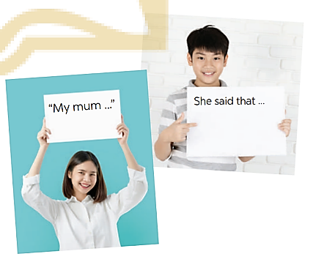  A. My mum said: “ I like making cakes in my free time ”  B. My mum sai that she liked making cakes in her free time.  …….
5. WRAP-UP & HOME WORK (2’)

- Ask Ss to summarise what they have learnt in the lesson.
- Have them say out loud the changes they need to make when they report a statement (verb forms, expressions of time and place, and pronouns).
* HOME WORK:
- Do more exercises in workbook.
- Prepare new lesson: Lesson 4 : COMMUNICATION.

==============================================

Date of planning: April 4th , 2025  Date of teaching: April 11th , 2025  WEEK: 30 | Period 90 UNIT 11 : SCIENCE AND TECHNOLOGY  Lesson 4 : COMMUNICATION
I. OBJECTIVES: * By the end of this lesson, Ss will be able to gain the following:
1. Knowledge:
- To introduce how to give and respond to good news.
- Know about the benefits and problems of online learning.
+ Vocabulary:The lexical items related to science and technology.
- Sentence stress; Giving and responding to good news.
+ Grammar: Reported speech (statement).
2. Competence:
- Develop competencies of communication, cooperation, and self-management.
- Be co-operative and supportive in pair work and teamwork.
- Actively join in class activities.
3. Qualities:
- Leaning how to give and respond to good news.
II. TEACHING AIDS:
- Grade 8 textbook, Unit 11: Communication.
- Computer connected to the Internet
- Projector / TV.
- Hoclieu.vn
III. PROCEDURE:
1. WARM UP & INTRODUCTION ( 3’- 5’)
* Objectives:
- To create an active atmosphere for the class before the lesson;
- To help Ss revise reported speech.
* Content: To have some warm-up activities to create a friendly and relaxed atmosphere to inspire Ss to warm up to the subject and new lesson. Jumbled conversation
*Expected outcomes: Having a chance to speak English. Students can play games.
* Organisation : Teacher’s instructions …

Teacher’s Student’s activities | Content
+ Greeting.  - Let Ss play a game. GAME  - Have one student stick slips of paper (with a direct speech sentence on each of the slips) to the board. Other Ss work in two different groups. Ss from each group take turn to report the sentence each time a slip of paper is stuck to the board. The group that has a wrong reported speech sentence loses their turn. The group that has the most correct reported speech sentences wins.  - T declares the winner(s) and says congratulations to the winner, then leads to the new lesson.  - Ask Ss to look at COMMUNICATION on page 86. | + Greeting . T_Ss.  GAME  + Students (Ss) listen and learn how to do the tasks.  Eg:  a) Lan said: “ I live in the city.”  => Lan said (that) she lived in the city  b) “I like surfing the net in my free time”, said Ha.  => Ha said that ……………………… .  - Open the book and write the tittle of the lesson.
2. PRESENTATION/ NEW LESSON ( 12’- 15’)
EVERYDAY ENGLISH
Giving and responding to good news
* Objectives:
- To introduce one way to give good news and two ways to respond to good news;
- To help Ss practise giving and responding to good news
* Content: Listen and read the conversation . Pay attention to the highlighted sentences.
* Expected outcomes: Students know how to use the structures for giving and responding to good new.
* Organisation : Teacher’s instructions.
Teacher’s Student’s activities | Content
ACTIVITY1: Listen and read the conversation, paying attention to the highlighted parts.
- Play the recording for Ss to listen and read the conversation between Nick and Mi.  - Ask Ss to pay attention to the highlighted sentences.  - Emphasise the ways to give and respond to good news:  - Great news for us.  - Great!  - Congratulations!  - Tell Ss that Great! and Congratulations! are different ways to respond to good news in different contexts.  - Tell them that if good news is general and good for everyone, we can say Great!; if the news is good for the speaker only, the responder may say Congratulations!  - Have Ss practice the conversation in pairs. | - T_Ss  Nick: Great news for us. We’ll have school clouds so we won’t have to carry lots of books to school.  Mi: Great!  Nick: And my dad promised to give me a new Ipad to read books from the school clouds.  Mi: Congratulations!  **To give and respond to good news, you can use:  + Great news for us.  + Great!  + Congratulations!
ACTIVITY 2: Work in pairs. Give news and respond to the news in the following situations
- Ask Ss to work in pairs to make similar conversation. Tell them to use the contexts given and the sample expressions.  - Give feedback on Ss’ conversation.  * Teacher listens to students’ pronunciation and gives feedback. | - T_Ss  - Work in pairs  1. You tell your classmate about the new vending machine at your school.  2. You tell your classmate about a new laptop that your dad gave you on your birthday.
EXTRA ACTIVITY
- Ss work in groups of three to make short conversations that include the phrases: That's great news!, Great!, and Congratulations!
- Their conversations should be between two people and be between four and six sentences long.
Ask Ss if they think of any other expressions to show giving and responding to good news
Some possible examples are: That's wonderful!; I'm happy to hear that. Wonderful!; Well done!

3. PRACTICE ( 15’)
Online learning
* Objectives:
3. To help Ss learn the language to describe the benefits and problems of online learning;
- To help Ss practise reading for specific information.
4. To helpSs practise talking about the benefits and problems of the learning platform.
* Content: Read the posts from some students about online learning and complete the table.
Talk about a platform you use for their online classes . What are the benefits and problems of using it?
* Expected outcomes: Ss can complete the tables and talk about “ What are the benefits and problems of using it”
* Organisation:
ACTIVITY 3: Work in pairs. Read the posts from some students about online learning and complete the table.
- Ask some Ss to read the posts aloud.  - Have Ss work in pairs to read the posts to get information from the post and to fill in the table below.  - Ask some pairs to read out their answers. Make corrections if necessary.  - Check the answers as a class.  - If time allows, ask some students to retell information from the posts or to role play the four friends to tell class about the platform their teacher uses for their classes. | - T_ Ss  * Answer key:  Benefits Problems  1. It’s convenient. 2. Students don’t have to get up early 3. It helps students become more. 4. It helps students avoid traffic jams 1. Some students don’t have computers or smart phones 2. The Internet connection is poor 3. It makes some students feel more stressed when learning online 4. Students can’t meet their classmates. 5. Some students get tired eyes and can’t concentrate well.
ACTIVITY 4: Work in groups. Talk about a platform you use for your online classes or one you know about. What are the benefits and problems of using it?
- Have Ss work in groups to talk about the benefits and problems of their online learning platform.  - Ask them to think of the platform they use and use the table in Activity 3 to make notes. Tell them to use adjectives or phrases as in Activity 3.  - Invite some Ss to tell about their online learning platforms. Correct any grammar or pronunciation mistakes if necessary. | - T_ Ss.  - Ss - Ss  * Our teacher uses Google Meet for video conferencing. It’s quite convenient, and we don’t have to get up early. Still , I prefer to study face to face. I want to see my classmate.  ……
4. PRODUCTION ( 8’)
Objectives:
5. To help Ss practise reporting the platform his / her friends use for online learning, the benefits and problems of that online learning platform;
- To help Ss practise reported speech.
* Content: Report the answers of one of your group members to the class .
* Expected outcomes: Ss can report the answers one of the group members to the class.
* Organisation:
Teacher’s Student’s activities | Content
ACTIVITY 5: Report the answers of one of your group members to the class .

- Have Ss work in groups to discuss their online learning platforms.  - Tell them that they can make notes about what their friends like and dislike about the platform their classes /teachers use.  - Ask them to use ideas from the posts and the table in Activity 3.  - Invite group representatives to report one of their group member’s answers.  - Give feedback on Ss’ reports.  * T corrects any grammar and pronunciation mistakes if necessary. | + T- Ss ; Ss -Ss  * You can conclude:  - The name of the platform you use for your online classes or one you know about.  - Its benefits  - Its problems  Example:  Lan said that her extra class used Microsoft Teams. She said that she and her classmates found it difficult to use. However, it is convenient to have online classes on Microsoft Teams when the weather is bad.
5. WRAP-UP & HOME WORK (2’)
+ Ask Ss what they have learnt and practised in this lesson.
+ Ask the to list one way to give good news and two ways to respond to good new.
+ Ask Ss to list orally the benefit and problems of online learning.
* HOME WORK:
- Do more exercises in workbook.
- Prepare new lesson: Lesson 5 : SKILLS_1.

====================================

Date of planning: April 7th , 2025  Date of teaching: April 14th , 2025  WEEK: 31 | Period 91 UNIT 11 : SCIENCE AND TECHNOLOGY  Lesson 5 : SKILLS 1/ Reading and speaking
I. OBJECTIVES: * By the end of this lesson, Ss will be able to gain the following:
1. Knowledge:
- Improve the skill of reading advertisements for details.
- Remember the lexical items related to some new technologies that are applied at schools
- Recognize how to make a conversation to ask and answer information about an invention or a technology
+ Vocabulary:The lexical items related to science and technology.
- Sentence stress; Giving and responding to good news.
+ Grammar: Reported speech (statement).
2. Competence:
- Develop their reading skill for specific and general information through ticking exercise and multiple choice questions.
- Practise asking and answering questions for information about an invention or a technology
- Develop competencies of communication, cooperation, and self-management.
- Be co-operative and supportive in pair work and teamwork.
- Actively join in class activities.
3. Qualities:
- Raise ss’ awareness of some new technologies that are applied at schools.
- Have a good attitude to applying and using new technology or inventions at schools.
II. TEACHING AIDS:
- Grade 8 textbook, Unit 11: Skills 1
- Computer connected to the Internet
- Projector / TV.
- Hoclieu.vn
III. PROCEDURE:
1. WARM UP & INTRODUCTION ( 3’- 5’)
* Objectives:
To create an active atmosphere in the class before the lesson;
To lead into the new lesson.
* Content: To have some warm-up activities to create a friendly and relaxed atmosphere to inspire Ss to warm up to the subject and new lesson.
* Outcome: Having a chance to speak English.
* Organisation : Teacher’s instructions …

Teacher’s Student’s activities | Content
+ Greeting  Brainstorming:  - Ask ss to name the technological applications your school uses.  OR; Let Ss play a game in two groups of four or five, Group A and Group B. Give each group a set of ten phrases on slips of paper with five about the benefits of online learning and five about the possible problems of online learning. Group A has to choose the right slips about the benefits to stick to the board. Group B has to choose the right slips about the problems to stick to the board.  - Stop the game when time is up.  - Ask each group to read out their answers. The group that has the most correct or appropriate answers wins.T declares the winner(s).  - Ask Ss to look at SKILLS 1 on page 120-121.  - Write the objectives in a corner of the board and leave them there till the end of the lesson, or put them on a slide to show Ss. | + Greeting ; T_Ss , Ss – Ss  Brainstorming:  Expected answers:  - Fingerprint scanner  - Face recognition  - Open the book and write the tittle of the lesson.
2. PRESENTATION/ NEW LESSON ( 12’- 15’)
A. READING
* Pre-reading
* Objectives:
- To introduce Ss to some new technologies;
- To help Ss practise describing pictures.
* Content: Learn some new words . Focus on the content of the reading.
* Outcome: Knowing more new words. Focusing on the content of the text.
* Organisation : Teacher’s instructions.
Teacher’s Student’s activities | Content
ACTIVITY 1: Work in pairs. Name the technological applications in the pictures. Can they be used in schools?
* Teach vocabulary:  + Teacher uses different techniques to teach vocab (situation, realia, translation.)  + Teacher introduces the vocabulary by:  - providing the pictures  - eliciting the definition of the words  + Teacher do the checking “Matching”  + Teacher reveals that these five words will appear in the reading text and asks students to open their textbook to discover further.  - Ask Ss to work individually to read the texts and to decide if the statements from text are about biometrics or nanolearning. Ask them to write B (Biometrics) or N (Nanolearning).  - Ask Ss to underline the key words in each of the statements then search for the information in the two texts.  - Have Ss to work in pairs to swap answers or to check answers together.  - Ask some Ss to read out loud the statements and say B or N. Ask them to show the parts in the reading where they find the answers.  - Check the answers as a class.  ** Have the class work in pairs to describe the pictures and say what technological applications the pictures are about. Check the answers as a class.  Ask Ss to discuss if these technologies can be used at schools. | - T_Ss  *Vocabulary:  1. biometrics (n) /ˌbaɪəʊˈmetrɪks/  Khoa học sinh trắc  2. truancy (n) /ˈtruːənsi/  Trốn học, nghỉ học không phép  3. Nanolearning (n) /’nænəʊlɜːnɪŋ/  Dạy học với bài dạy kích thước nhỏ  4. effortless(adj) /ˈefətləs/  Không cần nhiều nỗ lực  5. platform(v) /ˈplætfɔːm/ Nền tảng  6. cheating (n) /tʃiːtɪŋ/ Gian lận  *Suggested answers:    * Key:  1. eye tracking  2. fingerprint scanner  3. face recognition
3. WHILE READING ( 15’)
* Objectives:
- To introduce Ss to some new technologies that are applied at schools;
- To improve Ss' skill of reading advertisements for details.
3.To improve Ss' skill of reading for general and specific information.
* Content: Read the passage and tick (✓) B (Biometrics) or N (Nanolearning); Read the passage and choose the correct answer A, B, or C.
* Outcome: - Students understand content the text about the benefits of the two new technological applications ; Students’ speaking.
* Organisation :
Teacher’s Student’s activities | Content
ACTIVITY 2: Read the passage and tick (✓) B (Biometrics) or N (Nanolearning).
Ask Ss to lookatthe two headings Biometrics and Nanolearning and the pictures in 1 to guess what they are.  Explain the meanings of the two words. Explain these words in Vietnamese because these may be unfamiliar technologies to Ss.  Biometrics /.baioo metnks/: A science that use measurements of human features (eyes, fingerprint,...) to identify people.  Nanolearning = Nano + learning. Nano means very very small = one billionth. Nanolearning means learning small portions.  Ask Ss to work individually to read the texts and to decide if the statements are about biometrics or nanolearning. Ask them to tick B (Biometrics) or N (Nanolearning).  Ask Ss to underline the keywords in each of the statements, then search for the information in the two texts.  Have Ss work in pairs to swap answers or to check answers together.  Ask some Ss to read out loud the statements and say B or N. Ask them to show the parts in the reading where they find the answers.  Check the answers as a class. | - T_Ss  - Work individually.  Answer key:  Answer key:  1. N  2. B  3. B  4. N  5. N
ACTIVITY 3: Read the passage and choose the correct answer A, B, or C.

- Have Ss work individually for five minutes and choose the correct answers. Remind them to underline the keywords in the questions and the evidence for the answers in the texts.  - Ask Ss to take turns to give the answers. Ask them to show the parts in the reading texts where they find the answers.  - Check the answers as a class.  - T can also ask one or two Ss to say which technology they prefer and why or ask them to orally summarise each of the texts.  ** Teacher’s observation and feedback. | - T_ Ss  - Ss to work individually.  * Answer key:  1. A 2. B  3. C 4. B
EXTRA ACTIVITY
- Put Ss into pairs and have them reread the texts in 2 again.
- Each pair is to come up with four statements about the texts.
- Two of the statements will be true and two will be false. They are to be in mixed order.
- Ss then give these sentences to another pair who tries to figure out which ones are true and which ones are false.

4 . SPEAKING
* Objectives:
- To have Ss practise asking and answering questions about an invention;
- To prepare Ss for 5.
+ To have Ss practise asking and answering questions about an invention or a technology;
- To give Ss an opportunity to practise explaining how the invention or technology can help us;
- To improve Ss' confidence in speaking in front of the class.
* Content: : Discuss and match the questions ; Ask and answer questions .
* Outcome: Students understand about
* Organisation :
Teacher’s Student’s activities | Content
ACTIVITY 4 : Work in pairs. Discuss and match the questions in A with the answers in B, and then make a conversation about an invention.
- Have Ss work in pairs to match the questions in A with the answers in B.  - Have them practise asking and answering questions about biometrics in the example.  - Assist Ss to make full questions when necessary.  - Ask them to ask and answer questions about an invention or a technology they like or know.  - Ask some pairs to role-play it.  - Ask the class to offer feedback on their questions, answers, and pronunciation.  - Prepare cue cards about different inventions and ask Ss to practise asking and answering questions about those inventions .  - This activity helps prepare Ss for 5. | - T_ Ss. Ss- Ss  * Suggested outcome:  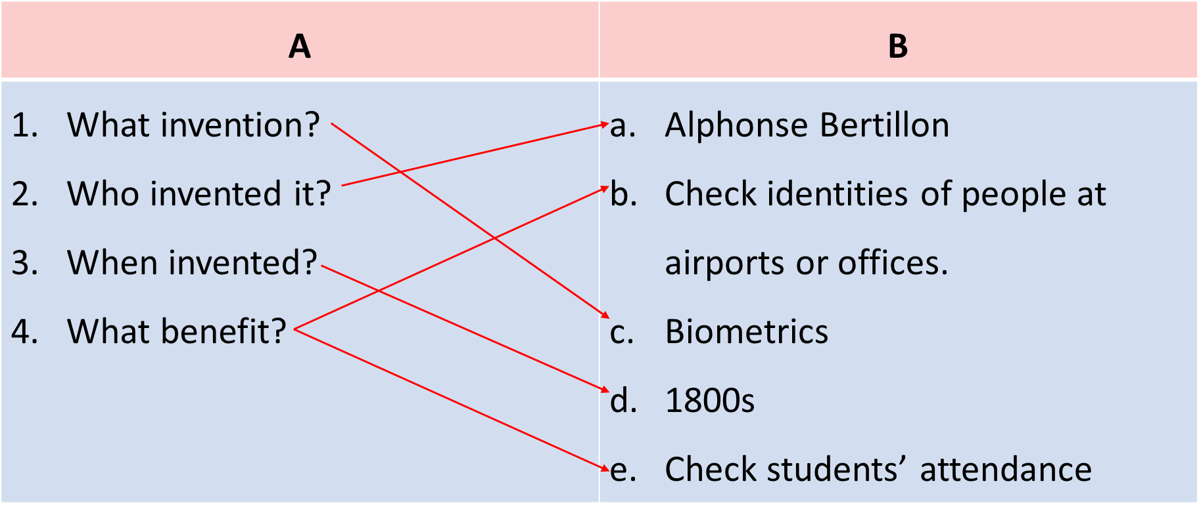  A: What invention do you like?  B: I like biometrics.  A: Who invented it?  B: Alphonse Bertillon  A: When did he invent it?  B: In 1880s  A: How can we use it?  B: It can help us check students’ attendance. We can also use it to check identities of people at airports or offices.
ACTIVITY 5: Work in groups. Ask and answer questions about a technology or an invention. Use the example in 4 as a cue. Then report your answers to the class.
- Have Ss work in groups to ask and answer questions about a invention or a technology;  - Ask them to explain what they can use the technology or invention for.  - Invite one representative of each group to report their group’s answers to the class.  - Give feedback on their reports in terms of language, reported verb forms, and pronunciation.  * T asks the class to give feedback on their questions and answers, and pronunciation. | * Suggested speaking:  Example:  Mi likes biometrics. Alphonse Bertillon invented it in 1800s. It is a very important technology. We use it to check students’ attendance. School also use it for Ss who borrow books and equipment. ….
5. WRAP-UP & HOME WORK (2’)
- Ask Ss to summarise what they have learnt in the lesson.
* HOME WORK:
- Learn by heart all the words that they have just learnt.
- Do more exercises in workbook.
- Prepare new lesson: Lesson 6 : A SKILLS _2.

==============================================

Date of planning: April 8th , 2025  Date of teaching: April 15th , 2025  WEEK: 31 | Period 92: UNIT 11 : SCIENCE AND TECHNOLOGY  Lesson 6 : SKILLS 2/ Listening and writing
I. OBJECTIVES: * By the end of this lesson, Ss will be able to gain the following:
1. Knowledge:
- Recognize listening skills for specific information about what a robot teacher can do and can’t do.
- Recognize how to write a paragraph expressing opinions about whether a robot teacher will replace human teachers at school.
+ Vocabulary:The lexical items related to science and technology.
- Sentence stress; Giving and responding to good news.
+ Grammar: Reported speech (statement).
2. Competence:
- improve the skill of listening for details.
- improve listening comprehension and note-taking skills.
- improve the writing skill of writing a paragraph expressing opinions.
- Develop competencies of communication, cooperation, and self-management.
- Be co-operative and supportive in pair work and teamwork.
- Actively join in class activities.
3. Qualities:
- Raise ss’ awareness of some new technologies that are applied at schools.
- Have a good attitude to applying and using new technology or inventions at schools.
II. TEACHING AIDS:
- Grade 8 textbook, Unit 11: Skills 2
- Computer connected to the Internet
- Projector / TV.
- Hoclieu.vn
III. PROCEDURE:

1. WARM UP & INTRODUCTION ( 3’- 5’)
* Aims:
- To create an active atmosphere in the class before the lesson;
- To lead into the new lesson.
* Content: To have some warm-up activities to create a friendly and relaxed atmosphere to inspire Ss to warm up to the subject and new lesson.
* Outcome: Having a chance to speak English.
* Organisation : Teacher’s instructions …
Teacher’s Student’s activities | Content
+ Greeting  + Chatting  + Let Ss play a game in two groups. Give each group a set of phrases on slips of paper about the use of Biometrics and Nanolearning. Each group has to choose the right slips about Biometrics and the right ones about Nanoleaning and stick to the right columns on the board. Stop the game when time is up. Ask each group to read out their answers. The group that the most correct and appropriate answers wins. T declares the winner(s).  + Teacher (T) asks Ss some questions about the previous lessons,  - T encourages Ss to talk in English as much as possible | + Greeting ; T_Ss.  + Chatting  + Students (Ss) listen and learn how to do the tasks.  - Open the book and write the tittle of the lesson.
2. PRESENTATION/ NEW LESSON ( 12’- 15’)
A. LISTENING
* Pre-listening
*Objectives : To help Ss brainstorm ideas for listening.
* Content: Listen and tick (✓) the things that you think a robot teacher can do.
* Expected outcomes: Students’ answers. Tick the things that you think a robot teacher can do.
* Organisation : Teacher’s instructions.
Teacher’s Student’s activities | Content
ACTIVITY 1: Listen and tick (✓) the things that you think a robot teacher can do

* Vocabulary pre-teaching  - Teacher introduces the vocabulary.  - Teacher explains the meaning of the new vocabulary by pictures or explanation.  - Ask Ss to work in pairs to tick the things that a robot teacher can do. Ask Ss to add more things a robot teacher can do.  Also ask Ss to list things robots in general can do (for example: doing boring housework, hard work in factories, delivering letters at workplaces, etc.) | - T_Ss  * Vocabulary  * Vocabulary:  1. emotional (adj): /ɪˌməʊʃənl/ thuộc tình cảm  2. interact with (v): /ˌɪntərˈækt wɪð/ tương tác  * Suggested answer:  + 1, 2  + A robot teacher can dance, teach subjects, play with students...
3. WHILE LISTENING ( 15’)
*Objectives :
2. To improve Ss' skill of listening for details.
3. To improve Ss' listening comprehention.
* Content: Do the filling while listening; Listen again and Tick T (True) or F (False).
* Expected outcomes: Students can practise listening and understanding specific information .
* Organisation :
Teacher’s Student’s activities | Content
ACTIVITY 2: Listen to the conversation and fill in each blank with ONE word.

- Teacher tells Ss they are going to listen to a conversation about a robot teacher and fill in each of the blanks with ONE word.  - Ask Ss to work individually to read the table and guess the possible words to fill in each of the blanks.  - Remind them to think of the part of speech of that word (noun, verb, adjective, adverb or number). and forms of nouns (singular, plural).  - Play the recording once for Ss to fill in the blanks. Remind Ss that they should write only ONE word for each blank.  - Check Ss’ answers and play the recording again for them to better understand the conversation between Tom and Lan.  - Stop or rewind the recording where necessary. | - T_Ss  * Suggested answers:  1. languages  2. maths  3. interact  4. behave  5. problems
ACTIVITY 3: Listen again and tick (✓) T (True) or F(False).

- Ask Ss to work in pairs to read the statements and underline the key words in the statements.  - Play the recording once. Give them two minutes to decide if the sentences are T (True) or F (False).  - Play the recording again .  - Check their answers as a class.  ** T checks the answers as a class and gives feedback. | - T_ Ss  1. T 2. T 3. F 4. F 5. F
4 . WRITING
*Objectives :
- To provide Ss with vocabulary and ideas about whether a robot teacher will replace human teachers at schools .
- To prepare Ss for the opinion writing in 5.
- To improve Ss’ skill of writing a paragraph expressing opinions about whether robots will replace teachers at schools.
* Content: Discuss if Ss agree or disagree that robots will soon replace teachers at school and give the reasons.
- Write a paragraph to express opinions about whether robots will replace teachers at schools.
* Expected outcomes:
- Give at least 3 reasons why you agree or disagree on whether robots will replace teachers at schools.
- Have a paragraph to express opinions about whether robots will replace teachers at schools.
* Organisation :
Teacher’s Student’s activities | Content
ACTIVITY 4 : Work in pairs. Discuss if you agree or disagree that robots will soon replace teachers at schools. Write the reasons in the table.
- Ask Ss to work in pairs to brainstorm ideas and fill in the blanks.  - Ask Ss to get ideas from the listening and add any more ideas they have.  - Ask some Ss to read out loud ideas for each column.  - Correct their pronunciation where necessary | - T_ Ss.  * Suggested answers:  Agree Disagree  1. Robots can better remember things than teachers. 2. Robots can talk for a longer time and not feel tired. 3. Robots can store more data and information and tell it to students. 4. Robots can interact well with students. 5. Robots don't make students embarrassed if they give wrong answers. 1. Robots can't understand students'emotions. 2. Robots can't teach students how to behave well. 3. Robots can't help solve problems between students. 4. Robots can't motivate students. 5. Robots don't have emotional connections with students.
ACTIVITY 5: Now write a paragraph (80-100 words) to express your opinion. Use the notes in 4.
- T records the ideas Ss have brainstormed in Activity 4 on the board.  - Ask Ss to work individually to write for 15 minutes. Tell them to use the information in Activity 4 and any other ideas they may think of. Remind Ss to choose only three ideas for their paragraph.  - T asks one student to read out his / her paragraph.  - If time allows, also ask Ss to work in groups to write on an A1 / A0 size piece of paper, then T organises a gallery walk. Ss walk round and offer feedback on peers’ writing in terms of ideas, grammar and connectors.  - Comment on their writing  ** T gives feedback on their writing in terms of spelling, grammatical mistakes, cohesion, and content. | * Suggested answer:  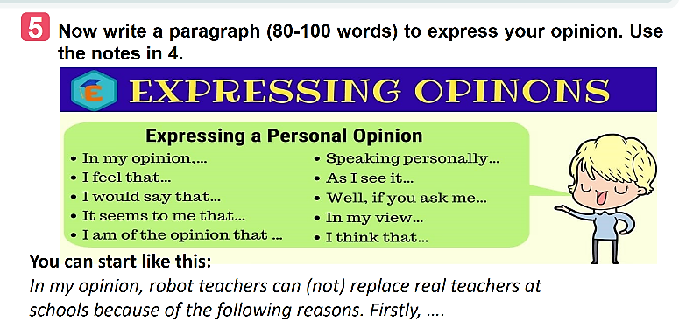
Suggested writing:
I disagree that robots will soon replace teachers at school. First, although robots can store much information to provide to students, they cannot teach students how to behave in the right ways in different situations. Second, a robot can only teach what is programmed, but cannot help students deal with problems, especially troubles among students' relationships. Third, a robot can speak, walk, do simple actions, but they cannot interact with students in the way human teachers do. Robots do not have emotions and feelings, so I believe they cannot help students to deal with problems related to feelings and emotions.
EXTRA ACTIVITY
- In groups of four, Ss discuss what they think it would be like if their teacher was a robot.
- Encourage them to come up with 4 - 6 ideas, then share their ideas with the rest of the class.

5. WRAP-UP & HOME WORK (2’)
- Ask Ss what they have learned in the lesson.
- Ss tell the whole class:
- What a robot teacher can do and what it can’t do.
- The reasons robot teachers can or can’t replace teachers at school.
- How to write a paragraph expressing opinions.
* HOME WORK:
- Learn the new words by heart.
- Rewrite the paragraph expressing opinions about whether a robot teacher can(not) replace teachers at school.
- Do exercises in workbook.
- Prepare new lesson: Lesson 7 : LOOKING BACK.

==============================================

Date of planning: April 11th , 2025  Date of teaching: April 18th , 2025  WEEK: 31 | Period 93 UNIT 11 : SCIENCE AND TECHNOLOGY  Lesson 7 : LOOKING BACK & PROJECT
I. OBJECTIVES: * By the end of this lesson, Ss will be able to gain the following:
1. Knowledge:
- Memorize the vocabulary about new technologies and words and phrases that are used to talk about inventions, discoveries, inventions, and creations.
- Review reported speech (statements)
- Brainstorm ideas about problems they have at home or at school
- Be creative to deal with problems by imagining an invention.
- Ss use what they have learnt from the unit to help them answer the questions. Ss need to see how far they have progressed and in which areas they need further practice.
- Apply what they have learnt (vocabulary and grammar) into practice through a project.
+ Vocabulary:The lexical items related to science and technology.
- Sentence stress; Giving and responding to good news.
+ Grammar: Reported speech (statement).
2. Competence:
- Use the vocabulary about new technologies and words and phrases that are used to talk about inventions, discoveries, inventions, and creations to do exercises.
- Apply the knowledge of reported speech (statements) to do exercises.
- Apply what they have learnt (vocabulary and grammar) into practice through a project.
- Be co-operative and supportive in pair work and teamwork.
- Actively join in class activities.
3. Qualities:
- Consolidate ss’ awareness of science and technology.
II. TEACHING AIDS:
- Grade 8 textbook, Unit 11: Looking back & project .
- Computer connected to the Internet.
- Projector / TV
- Hoclieu.vn
III. PROCEDURE:
1. WARM UP & INTRODUCTION ( 3’- 5’)
* Aims:
- To create an active atmosphere in the class before the lesson;
- To lead into the new lesson.
* Content: To have some warm-up activities to create a friendly and relaxed atmosphere to inspire Ss to warm up to the subject and new lesson.
* Outcome: Having a chance to speak English.
* Organisation : Teacher’s instructions …
Teacher’s Student’s activities | Content
+ Greeting:  Kim’s game:  - T asks students to work in groups of three or four students  - Get ss to watch a video clip and try to remember all the inventions mentioned in the clip without taking notes.  - After finishing watching the clip, Ss write down as inventions as possible.  - T gets ss to swap the posters and give correction after T shows the answers.  -The group with the most correct answers will win.  *T leads in the lesson. | + Greeting T_Ss. Ss - Ss  Answers:  10. The paper  9. The compass  8. The refrigeration  7. The printing press  6. Plumbing  5. Medicine  4. Engines  3. The wheel  2. Communication  1. Electricity  * Open the book and write the tittle of the lesson.
2. PRESENTATION/ NEW LESSON ( 12’- 15’)
A. PRACTICE EXERCISES
VOCABULARY
* Objectives:
- To help Ss review the vocabulary learnt.
- To help Ss review reported statements
- To help Ss rewrite the sentences. Using the words in BOLD.
* Content: Review some new words related to the topic. Review reported statements.
* Expected outcomes: Ss know how to use the words they have learnt in different contexts. Do exercises correctly.
* Organisation : Teacher’s instructions.
Teacher’s Student’s activities | Content
ACTIVITY 1: Circle the option that goes with each verb.
- Have Ss work individually to circle the option that can combine with the given verbs.  - Have Ss read out their phrases.  - Check answers as a class.  - Correct Ss’ pronunciation if necessary. | - T_Ss  *Answer key: 1. A 2. B 3. B 4. A  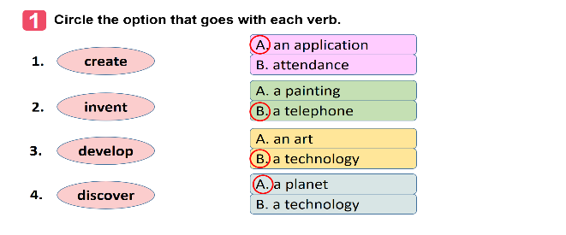
ACTIVITY 2: Fill in each gap with a word or phrase from the box. You may have to change the form of the word or phrase.
- Have Ss work individually to fill in each blank with the correct form of the words /phrases from the box.  - Check answers as a class.  - Ask some Ss to read aloud the sentences.  - Correct Ss’ pronunciation if necessary. | - T_Ss  * Key  1. robot teacher  2. application  3. face recognition  4. eye-tracking  5. check attendance
B. GRAMMAR
* Objectives:
- To help Ss review reported statements
- To help Ss rewrite the sentences. Using the words in BOLD.

* Content: Fine and correct mictakes. Rewrite the sentences, using the words in BOLD.

* Expected outcomes: Ss can do the exercises correctly.
* Organisation : Teacher’s instructions.
Teacher’s Students’ activities | Content
ACTIVITY 3: Which of the underlined parts in each question is incorrect? Find and correct it.
- Have Ss work individually to circle a mistake in each of the sentences. Remind them that only the underlined words will have mistakes.  - Then ask Ss to work in pairs to swap and check their answers.  - Check answers as a class.  - Ask one student to read out his/her sentences. Correct his her pronunciation if necessary.  - Confirm the correct answers as a class. | - T_ Ss  * Suggested answers:  1. B (discovers -> discovered)  2. B (is -> was)  3. B (will make ->) would make  4. C (a day ago ->a day before)  5. C ( next year -> the next/following year)
ACTIVITY 4 : Rewrite the following sentences, using the words in BOLD.
- Ask Ss to work individually to complete the sentences as requested in the book.  - Ask one or two Ss to go to the board and write their full sentences.  - Then ask the class to work in pairs. Tell them to swap their writings and check their partner’s answers.  - Check the sentences written on the board.  - Have all Ss correct their partner’s answers.  - Ask some Ss to read out their sentences. Correct Ss’ language and pronunciation if necessary. | - T_ Ss.  * Suggested answers:  1. Tom said they couldn’t connect to the Internet to work online there.  2. Mr. Thompson said (that) science was becoming a more important subject in schools then.  3. The headmaster said (that) the school would use a machine to check students’ attendance the following year.  4. The monitor said to the class (that) they were having a science competition that week.  5. The students said (that) they didn’t like robot teachers at all.
4. PRODUCTION/ PROJECT ( 8’)
YOUR INVENTION
* Objectives:
– To help Ss to brainstorm ideas about problems they have at home or at school;
– To raise Ss’ awareness of their ability to be creative to deal with the problems;
– To improve Ss’ teamwork and public speaking skills.
* Content: It is better for T to assign the project in earlier lessons. Make sure to guide them carefully and check their progress after each lesson. In the last lesson (LOOKING BACK), ask Ss to give their presentation.
* Expected outcomes: - Students’ speaking
* Organization:
Teacher’s Student’s activities | Content
1. Think about a problem you have at home or at school. Imagine an invention (a tool, a machine, an application…) that helps you deal with your problem.  - Have Ss work in groups of 3-4 students  - Ask Ss to read the instructions and suggestions carefully.  - Encourage Ss to think about a problem they have at home or at school and imagine an invention (a tool, a machine, an application…) that helps them deal with your problem.  2. Discuss and answer the following questions  -Have Ss work in groups to discuss a problem they have at home or at school. Ask them to think of an invention that can help them deal with their problem.  - Ask them to answer the suggested questions .  3. Prepare a poster presentation with pictures or a paper model of the invention and present it to your class.  - Tell Ss that they can draw pictures, create models or take photos to illustrate their invention. Ask groups of Ss to pin / tape / glue the pictures / photos / models and write how it can help them on a large piece of paper and present it to the class.  - If time is limited, T can assign the project in earlier lessons such as in GETTING STARTED lesson. Make sure you guide Ss in detail and check their progress after each lesson. In the last lesson (LOOKING BACK), ask Ss to present their poster.  ** T checks ss’ grammatical and spelling mistakes on their poster, listens to their presentation, and gives feedback. | * T should assign the project in earlier lessons such as in GETTING STARTED lesson. Make sure you guide them carefully and check their progress after each lesson. In the last lesson (LOOKING BACK), Ss to present their report to the class.  + Ss display all the posters on the wall or bulletin board ; Each group presents the poster they prepare to the whole class.  ** Students’ posters & presentations
5. WRAP-UP & HOME WORK (2’)
* Wrap-up
- Reviewing vocabulary in Unit 11
- Reviewing reported speech (Statements) .
+ NOW I CAN …
- Ask Ss to complete the self-assessment table.
- Identify any difficulties and provide further practice.
* HOME WORK:
- Do more exercises in workbook.
- Prepare new lesson: Unit 12 : LIFE ON OTHER PLANETS.

==============================================

