LESSON PLAN: ENGLISH 7 (GLOBAL SUCCESS)
Date of planning: 25/2/ 2025
Date of teaching: 25 /02/ / 2025
Period: 69 UNIT 9: FESTIVALS AROUND THE WORLD
Lesson 1: Getting started – A Tulip Festival
I. Objectives
By the end of this lesson, Ss will be able to gain:
1. Knowledge
- An overview about the topic “Festivals around the world”
- lexical items related to the topic “Festivals”: names of different festivals around the world
2. Core competence
- Develop communication skills and cultural awareness
- Be collaborative and supportive in pair work and teamwork
- Actively join in class activities
3. Personal qualities
- To teach Ss to work hard and love festivals around the world. the responsibility for community to protect our country’s Festivals.
- Develop self-study skills
II. Teaching aids
- Grade 7 textbook, Unit 9, Getting started
- Computer connected to the internet
- Projector/ TV/ pictures and cards
- sachmem.vn
III. PROCEDURES :
Activity 1: Warm-up (5’)
* Aim: To introduce and lead in the topic of the unit.
* Content: Chatting – Answer some questions.
* Products: Ss look at the picture and answer the questions.
* Organization of implementation:
Teacher’s and Ss’activities |  |  | Content
* Teacher shows the picture of the Tulip Festival and asks students some related questions:  ** Students raise hands to answer the questions.  *** Teacher and students discuss the questions.   Teacher accepts all students’ questions. |  |  | Chatting:  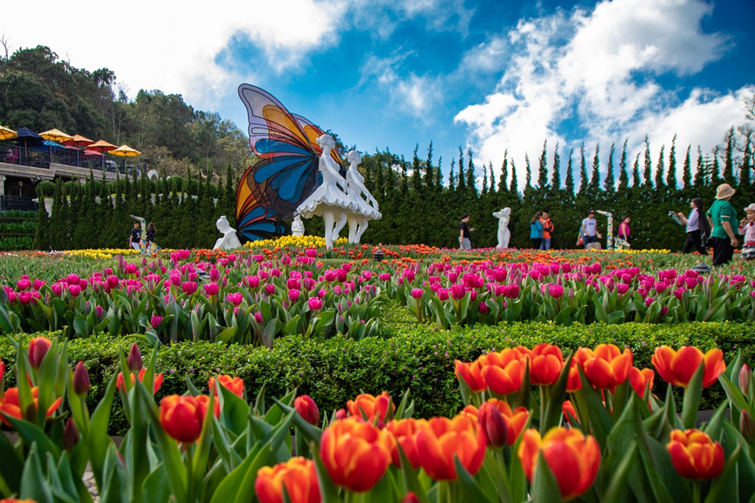  - What can you see in the picture?  - Can you guess the name of the festival?  - Have you ever heard of this festival? If yes, what do you know about it?
Activity 2: Presentation (5’)
(Pre-teach vocabulary)
* Aim: - To provide students with vocabulary.
- To help students well-prepared for the listening and reading tasks.
* Content: learn some vocabularies related to the topic.
* Products: Students read and understand the meaning of vocab.
* Organization of implementation:
Teacher’s and Ss’activities |  | Content
* Teacher introduces the vocabulary by giving definitions/ examples/ pictures of the words.  ** Teacher writes all students’ answers on the board.  *** Teacher circles or highlights the following words and discuss the meanings of these words:   Teacher checks students’ pronunciation and gives feedback. Teacher reveals that these words will appear in the reading text and asks students to open their textbook to discover further. |  | * Vocabulary  1. folk dance (n)  2. costume (n)  3. float (n)  4. parade (n)  5. feast (n)  6. fireworks display (n)
Activity 3: Practice
Task 1
* Aims: -To have students get to know the topic.
* Content: Listen and read the conversation.
* Products: Students read and understand the meaning of the conversation
Students know how to role play.
* Organization of implementation:
Teacher’s and Ss’activities |  | Content
* Teacher can play the recording more than once.  ** Students listen and read.  *** Teacher invites some pairs of students to read aloud.   Teacher checks students’ pronunciation and gives feedback. |  | Task 1: Listen and read (p.92).  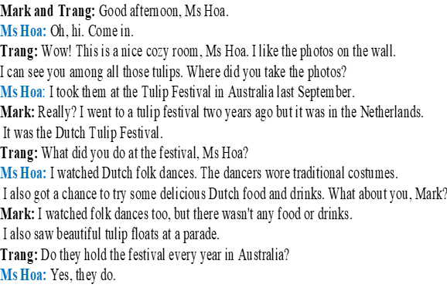
Task 2
* Aims: To have students get specific information of the text.
* Content: Read the activities and tick the correct column.
* Products: Students give the answers exactly.
* Organization of implementation:
Teacher’s and Ss’activities | Content
* Teacher tells students to read the conversation again and work independently to find the answers.  ** Students do the task individually.  *** Teacher allows students to share their answers before discussing as a class and encourages them to give evidence.   Teacher calls some students to give the answers and gives feedback. | Task 2: Read the conversation again. Who did the following activities? Tick the correct column. Sometimes you need to tick both  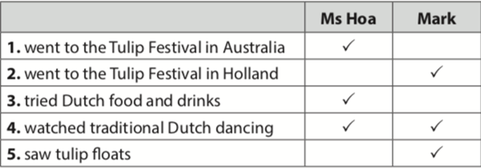
Task 3
* Aims: To introduce some more vocabulary related to the topic festivals.
* Content: Write a word or phrase from the box under each picture
* Products: Students say aloud the names of the cities and provide more information about them
* Organization of implementation:
Teacher’s and Ss’activities | Content
* Ask Ss to look at the pictures and say what they can see.  ** Have Ss work individually to match the words / phrases in the box with the pictures. *** Have them compare their answers with a partner. Ask for Ss' answers.   Confirm the correct answers.  - Have some Ss practise saying the words / phrases. | Task 3: Write a word or phrase from the box under each picture (p.93).  * Answer key:  1. parade  2. costumes  3. feast  4. float  5. fireworks display  6. folk dance
Task 4
* Aims: -To help Ss practise the words/phrases in 3.
* Content: Students fill in the blanks with the most suitable form of word/phrase.
* Products: Ss play in group actively and give the answers corectly.
* Organization of implementation:
Teacher’s and Ss’activities | Content
* Teacher asks students to complete the task by playing game “LN”  - Teacher divides the class into 2 groups.  ** Teacher asks students to choose the number and answer the questions quickly in 5 seconds.  - If students choose the lucky number, they don’t have to answer  - If students choose the Q , they have to answer exactly and will get 2 points.  ***Students fill in the blanks with the most suitable form of word/phrase.  ****The group has more points is the winner. | Task 4: Fill in each blank with a word or phrase from 3. You may have to change the form of the word or phrase (p.93).  Game: Lucky Numbers  * Answer key:  1. folk dances  2. fireworks display  3. feast  4. parades  5. floats; costumes
Activity 4: Production (5’)
Task 5
* Aims: To check Ss’ knowledge of some familiar festivals.
* Content: Match each description with a festival
* Products: Ss give the answers corectly.
* Organization of implementation:
Teacher’s and Ss’activities | Content
* Teacher lets Ss work in groups of 4-6.  ** Ss work in groups to find the answers.  *** Teacher can go around to help weaker students.   Teacher calls the first group to come up with the answers to share. | Task 5: Quiz. What festival is it? Match each description with a festival (p.93).  * Answer key:  1. e  2. a  3. d  4. c  5. b
Activity 5: Consolidation (3’)
* Aim: To consolidate what students have learnt in the lesson.
* Content:. Vocab about school things and Read and understand content of the conversation
* Products: Say aloud some words they remember from the lesson.
* Organization of implementation:
Teacher’s and Ss’activities | Content
Teacher asks students to talk about what they have learnt in the lesson. | - some new words  - Read and understand content of the conversation
* Homework (2’)
* Aim: To review the lesson and prepare for the next lesson.
* Content: Review the lesson and prepare for the next lesson and do exersie in the workbbook
* Products: Students’ textbooks and workbooks
* Organization of implementation:
Teacher’s and Ss’ activities | Content
- T reminds Ss to do homework and prepare the new lesson. | - Learn by heart all the new words.  - Name at least 3 festivals around the world.  - Prepare lesson 2 ( A closer look 1).
* Evaluation: …………………………………………………………………………………………………………………………………………………………………………………

Date of planning: 20/2/ 2025

Date of teaching: 26/2/ 2025
Week: 24 UNIT 9: FESTIVALS AROUND THE WORLD
Period: 70 Lesson 2: A closer look 1
I. OBJECTIVES:
By the end of this lesson, Ss will be able to gain:
1. Knowledge:
- Vocabulary: types of festivals and festival activities.
- Pronunciation: pronounce two-syllable words with correct stress.
2. Core competence
- Develop communication skills and creativity
- Be collaborative and supportive in pairwork and teamwork
- Actively join in class activities
3. Personal qualities
- Develop self-study skills
- To teach Ss to work hard and love festivals around the world. the responsibility for community to protect our country’s Festivals.
II. MATERIALS
- Grade 7 textbook, Unit 9, A closer look 1
- Computer connected to the internet
- Projector/ TV/ pictures
- sachmem.vn
III. PROCEDURES :
Activity 1: Warm-up (5’)
* Aim: To activate students’ prior knowledge and vocabulary related to the topic, the targeted vocabulary and its pronunciation.
* Content: Name the pictures
* Products: Students write correct words on the board.
* Organization of implementation:
Teacher’s and Ss’activities |  |  | Content
* Teacher divides the class into 2 teams. Each team will send a leader to play the game on the board.  - Teacher explains the instructions of the game:  - Each leader stands against the board.  - Teacher shows/ writes the names of the festivals (exercise 5 – page 93).  - Other members from each team describe the festivals and let the leader guess the names of the festivals.  - The team with more correct answers is the winner.  ** Students play in teams.  *** Students give the correct answers.   Teacher confirms the answers and gives feedback.  Teacher leads students into the lesson by telling them that “In today lesson, we are going to learn more words to describes festivals and pronounce two-syllable words with correct stress. |  |  | Game: Hot seat.  
Activity 2: Presentation (7’)
(Vocab-pre-teach)
* Aim: To teach students some vocabularies related the topic in the lesson.
* Content: Some vocabularies to describe fesstivals.
* Products: Read and understand the meaning of vocab.
* Organization of implementation:
Teacher’s and Ss’activities |  | Content
Vocabulary:  * Teacher introduces the vocabulary.  ** Teacher introduces the vocabulary by:  - providing the pictures  - providing the definition/example of the words.  *** Teacher asks students to repeat.   Teacher rubs out and checks. |  | * Vocabulary  1. Cannes Film Festival  2. Mid-Autumn Festival  3. Thanksgiving (n)  4. Easter (n)  5. carve (v)  6. perform (v)  * Checking vocab: < Rub out and remmember>
Activity 3: Practice (12’)
Task 1
* Aims: To present some types of festivals
* Content: Write under each picture a festival name from the box
* Products: Students write the correct words on the board.
* Organization of implementation:
Teacher’s and Ss’activities | Content
* Teacher has students to look at the pictures and asks them if they know the names of the festivals.  ** Teacher gets students to do the exercise in individuals.  *** Ask them to share their answers in pairs before checking the answers as a class.   Teacher then encourages students to explain their answers. Correct if necessary. | Task 1: Write under each picture a festival name from the box (p.94).  Answer key:  1. Halloween  2. Christmas  3. Mid-Autumn Festival  4. Cannes Film Festival  5. Easter  6. Thanksgiving
Task 2
* Aims: To present some festival activities.
* Content: Complete the table with the activites and the food related to four festivals.
* Products: Ss complete the table exactly. (Group board)
* Organization of implementation:
Teacher’s and Ss’activities | Content
* Teacher tells Ss that people celebrate festivals with different food and activities.  ** Teacher asks them to do the task individually.  *** Teacher asks students to share their answers in pairs before checking the answers as a class.   Teacher then encourages students to explain their answers. Correct if necessary. | Task 2: Complete the table below with the phrases from the box (p.94).
Task 3
* Aims: To give Ss further practice with words related to festivals and festivals activities.
* Content: Write the words and phrases under the correct pictures.
* Products: Ss write the words and phrases under the correct pictures.
* Organization of implementation:
Teacher’s and Ss’activities | Content
Task 3:T-Ss, Ss-Ss  * Teacher asks Ss to work in pairs to complete the sentences with the words/ phrases given.  ** Ss work in pairs.  *** Teacher allows students to cross check first.   Teacher invites some pairs to share their answers and gives feedback. | Task 3: Fill in each blank with a word or phrase from the box (p.94).  * Answer key:  1. Christmas  2. painting eggs  3. candy apples  4. Cannes Film Festival  5. Mid-Autumn Festival  6. turkey
Activity 4: PRONUNCIATION (5’)
* Aims: To help Ss identify how to pronounce two-syllable words with correct stress.
* Content: * Pronunciation: Stress in two-syllable words
* Products: Ss understand and know how to pronounce two-syllable words with correct stress.
* Organization of implementation:
Teacher’s and Ss’activities | Content
* Teacher helps Ss to understand what a syllable is.  ** Explain to them that a syllable is a unit of pronunciation having one vowel sound, with or without surrounding consonants, forming the whole part of a word.  *** Give some examples of one-, two- and three-syllable words.   Tell them that in this lesson, they just focus on two-syllable words and their common stress pattern. Have Ss name some more two-syllable words. | * Pronunciation: Stress in two-syllable words
Practice (8’)
Task 4
* Aims: -To help Ss practise pronouncing these words with correct stress.
* Content: Listen and repeat. Then underline the stressed syllable in each word
* Products: Ss write the words in the correct column on the board. ( posters)
* Organization of implementation:
Teacher’s and Ss’activities | Content
* Have some Ss read out the words in the table in the Student's Book first. Then play the recording for them to listen and repeat the words they hear.  ** Play the recording again for them to underline the stressed syllable in each word.  ***Invite Ss to share their answers. Write the correct answers on the board.  ****Ask Ss if they recognise any rules related to stress in two-syllable words. Share with them the most common rules: | Task 4: Listen and repeat. Then underline the stressed syllable in each word. (p.94).
Task 5
* Aims: To help Ss pronounce two-syllable words with correct stress in sentence.
* Content: Listen and repeat the sentences. Underline the stressed syllables in the bold words.
* Products: Students read the sentences in front of the class.
* Organization of implementation:
Teacher’s and Ss’activities | Content
* Teacher has Ss read quickly the sentences and plays the recording. Ask them to pay attention to the bold words and underline the stressed syllables.  ** Students practice in pairs or in groups.  *** Teacher goes around to offer help or correct pronunciation, if necessary.   Teacher calls some students to say the sentences in front of the class. Check their pronunciation if necessary. | Task 5: Listen and repeat the sentences. Underline the stressed syllables in the bold words  1.We're going to attend an Easter party at Nick's house.  2.The dancers will perform traditional dances at the festival.  3.At Christmas, people usually buy presents for their family.  4.Did you go to the Da Lat Flower Festival with your parents?  5. My aunt is clever and patient.
Activity 5: Production (3’)
* Aim: To test students' quick reaction to the targeted sounds.
* Content: * Game: “Up and down”
* Products: Students play in groups actively.
* Organization of implementation:
Teacher’s and Ss’ activities | Content
*Teacher explains the rules:  ** Students play the game in teams.  *** Teacher helps students in the game.   Teacher gives feedback. | * Game: “Up and down”  Teacher says 1-15 words containing two-syllable words. Students stand up for the ones with first main stress pattern, sit down for the second main stress pattern.
* Consolidation(2’)
* Aim: To consolidate what students have learnt in the lesson.
* Content: Vocab about some words to describe festivals and how to pronounce two-syllable words with correct stress in sentence.
* Products: Say aloud some words they remember from the lesson.
* Organization of implementation:
Teacher’s and Ss’ activities | Content
- Teacher asks students to talk about what they have learnt in the lesson | - Vocab about some words to describe festivals  - how to pronounce two-syllable words with correct stress in sentence.
* Homework (2’)
* Aim: To review the lesson and prepare for the next lesson.
* Content: Review the lesson and prepare for the next lesson and do exersie in the workbbook
* Products: Students’ textbooks and workbooks
* Organization of implementation:
Teacher’s and Ss’ activities | Content
- T reminds Ss to do homework and prepare the new lesson. | - Learn by heart all the new words.  - Do Exercise in the workbook.  - Prepare lesson 3 ( A closer look 2)..
* Evaluation: ……………………………………………………………………………………………………………………………………………………………………………………………………………..

Date of planning : 20/2 / 2025
Date of teaching : 28 /2/ 2025

Week :24 UNIT 9: FESTIVALS AROUND THE WORLD

Period 71: Lesson 3: A closer look 2
I. OBJECTIVES:
By the end of this lesson, Ss will be able to:
1. Knowledge:
- Practice Yes/No questions
2. Core competence:
- Develop communication skills and creativity
- Be collaborative and supportive in pair work and teamwork
- Actively join in class activities
3. Personal qualities
- Develop self-study skills
II. MATERIALS
- Grade 7 textbook, Unit 9, A closer look 2
- Computer connected to the internet
- Projector/ TV/ pictures and cards
- sachmem.vn
  - III. PROCEDURES : (STAGES)
Activity 1: Warm-up (5’)
* Aim: To activate students’ prior knowledge and to increase students’ interest.
- To introduce the targeted grammar: Yes/No questions.
* Content: Game: Sentence puzzling
* Products: Ss arrange the word cards to make meaningful sentences.
* Organization of implementation:
Teacher’s and Ss’activities |  |  | Content
* Warm up (group work)  * Teacher divides the class into 4 groups.  - Teacher delivers different sets of word cards to each group.  - Each group has to arrange the word cards to make meaningful sentences.  - 1 point for each correct answer.  ** Students play the game in groups.  *** Teacher and students discuss the answers.   Teacher confirms the answers and gives feedback.  Lead in :  - Teacher introduces the target of the lesson: Yes/No questions.  -Teacher says: “Today we are going to practice about Yes/No questions. |  |  | Game: Sentence puzzling  Set 1:  Are you eating moon cakes?  Set 2:  Did they eat moon cakes at the festival last year?  Set 3:  Can he eat all these moon cakes?  Set 4:  Does she go to school today?
Activity 2: Presentation (8’)
* Aim: To have students get to know about the Yes/No questions.
* Content: Present the target of the lesson: Yes/No questions.
* Products: Understand and how to make the Yes/No questions.
* Organization of implementation:
Teacher’s and Ss’activities | Content
* Teacher asks students to study the Grammar box.  Teacher draw students’ attention to the use and how to form a Yes/No question with an auxiliary verb or with a modal verb.  ** Teacher then asks some more able students to give some more examples.  *** Teacher and students discuss the answers.   Teacher confirms the answers and gives feedback. | * Pre - Grammar  Yes/No questions  We use put the auxiliary verb or modal verb before the subject.  Examples:  Are you tired?  Did you get many Christmas presents?  Can you eat all the cakes?
Activity 3: Practice (15’)
Task 1 + Task 2
* Aims: To check students’ understanding of the Yes/No questions.
To help Ss practise making Yes/No questions
* Content: - Fill in each blank with a correct auxiliary verb or modal verb.
- Change the sentences into Yes/No questions.
* Products: Ss write the correct answers on the board.
* Organization of implementation:
Teacher’s and Ss’activities |  | Content
Task 1:  * Teacher has students work individually.  ** Students work individually to complete the sentences.  *** Teacher lets students work in pairs and exchange the answers before checking with the whole class (explain each sentence if necessary).   Teacher confirms the answers and gives feedback.  Task 2:  * Teacher has students work individually.  ** Students work individually to complete the sentences.  *** Teacher lets students work in pairs and exchange the answers before checking with the whole class (explain each sentence if necessary).   Teacher confirms the answers and gives feedback. |  | Task 1: Fill in each blank with a correct auxiliary verb or modal verb (p.95).  * Answer key:  1. Do  2. Did  3. Are  4. Can  5. Does  Task 2: Change the sentences into Yes/No questions.  * Answer key:  1. Can your mother make a costume for you?  2. Will she bake a birthday cake for him?  3. Are the dragon dances interesting?  4. Does the Rio Carnival take place every year in Brazil?  5. Did they see a fireworks display on New Year’s Eve?
Task 3+ Task 4
* Aims: - To give further practice with Yes/No questions.
* Content: Match the questions with their answers .
* Products: Ss write the correct answers on the board.
* Organization of implementation
Teacher’s and Ss’activities |  | Content
Task 3  * Teacher asks students to read the instruction.  ** Teacher asks students to do the exercise individually and match the questions in column A with the answers in column B.  *** Teacher then has them work in pairs, comparing their sentences. Teacher can go around to help students.   Teacher confirms the answers and gives feedback.  Task 4:  * Teacher divides the class into 2 teams. Each team will send a leader to play the game on the board.  Teacher explains the instructions of the game:  Teacher gives each team a set of cards with phrases from the box.  The two leaders of the teams come to the board and pin the cards under the correct number.  Who can finish faster with the correct answer will be the winner.  ** Students play the games in team mode.  *** Teacher has students to write down the correct answer.   Teacher confirms the answers and gives feedback. Teacher can ask for translation to check their understanding. |  | Task 3: Match the questions in column A with their answers in column B (p.95).  1 - c  2 - a  3 - e  4 - b  5 - d  Task 4: Mark is talking to Trang about the Mid-autumn Festival. Fill in the blanks with Trang’s answers below.  Game: Who is faster?  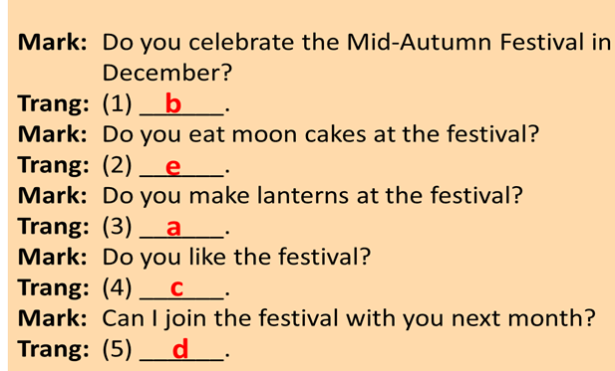
Activity 4: Production (5’)
Task 5:
* Aims: To help Ss practise producing Yes/No questions.
* Content: Game. Festival mystery. thinks of a festival he/she likes and use the Yes/No questions ask to find out what the festival is
* Products: Ss perform in front of the class,
* Organization of implementation:
Teacher’s and Ss’activities |  | Content
* Teacher has students work in groups.  ** One student thinks of a festival that he/she likes. Other students ask Yes/No questions to find out what the festival is.  The group leader keeps a record of the group’s performance.  *** Teacher move around to observe and pays attention to Ss’ yes/no questions.   Teacher asks some groups to perform in front of the class, confirms the answers and gives feedback. |  | Task 5: Game. Festival mystery. Work in groups. One student thinks of a festival he/she likes. Other students ask Yes/No questions to find out what the festival is  * Example:  A: Do many countries celebrate the festival?  B: Yes, they do.  A: Do children like the festival?  B: Do they paint eggs?  A: Yes, they do.  C: Is it Easter?  B: Yes, it is.
Activity 5: Consolidation (3’)
* Aim: To consolidate what students have learnt in the lesson.
* Content: Summarize the main content in the lesson.
* Products: Ss say what students have learnt in the lesson.
* Organization of implementation:
Teacher’s and Ss’activities |  | Content
Teacher asks students to talk about what they have learnt in the lesson. |  | * Grammar:  Yes/No questions
* Homework (2’)
* Aim: To revise the knowledge that students have gained in this lesson and prepare the new lesson
* Content: Review the lesson and prepare for the next lesson and do exersie in the workbbook
* Products: Students’ textbook and workbook
* Organization of implementation:
Teacher’s and Ss’ activities |  | Content
- T reminds Ss to do homework and prepare the new lesson. |  | - Do exercises in the workbook.  - Prepare lesson 4 ( Communication)
*- Evaluation: ……………………………………………………………………………………………………………………………………………………………………………………………………………

Date of planning : 1 /3/2025
Date of teaching : 4/3/ 2025

Week :25 UNIT 9: FESTIVALS AROUND THE WORLD

Period :72 Lesson 4 : Communication
I. OBJECTIVES:
By the end of this lesson, Ss will be able to:
- Express disappointment
- Understand the concept of festival symbols and their meanings
- Talk about the concept of festival symbols and their meanings
1. Knowledge:
a. Vocabulary: revise vocabulary on types of festivals and festival activities
b. Grammar: structures to express disappointment
2. Core competence:
- Develop communication skills and creativity
- Be collaborative and supportive in pair work and teamwork
- Actively join in class activities
3. Personal qualities
- Develop self-study skills
II. TEACHING AIDS
1. Textbooks, plan
2. Equipment: computer accessed to the Internet, smart TV, loudspeaker
3. sachmem.vn
  - III. PROCEDURES : (STAGES)
Activity 1: Warm-up (5’)
* Aim: To activate students’ knowledge and interest.
* Content: Game: pelmanism ( match the picture with the name of the festivals)
* Products: The group with more correct answers is the winner.
* Organization of implementation:
Teacher’s and Ss’activities | Content
* Teacher divides the class into 2 teams. Teacher shows pictures of some festivals on the slides.  ** Ss give the correct names of the festivals as fast as possible. The one with more correct answers is the winner.  *** Students work in team mode   Teacher checks and gives feedback. | * Game: Pelmanism: Name the festivals  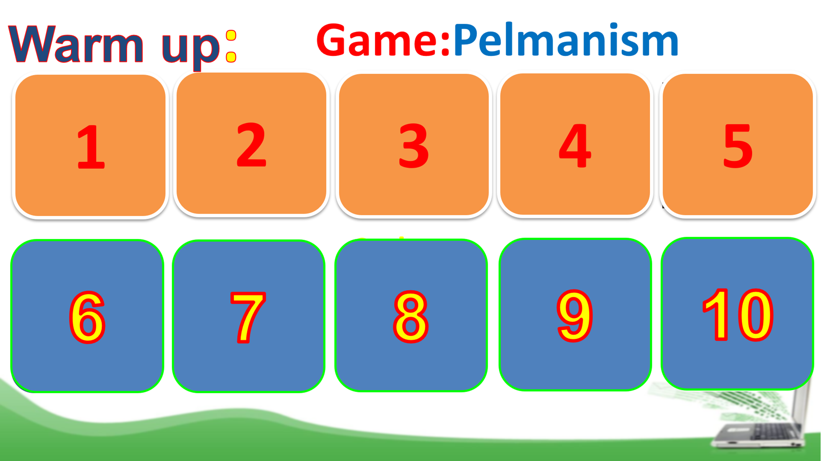
Activity 2: Presentation (10’)
* EVERYDAY ENGLISH - Expressing disappointment.
Task 1
* Aim: To help students get to know the ways to express disappointment.
* Content: Listen and read the conversation. Pay attention to the highlighted sentences.
* Products: Ss understand and know how to express disappointment
* Organization of implementation:
Teacher’s and Ss’activities | Content
Task 1  * Teacher lets students listen to the examples in Ex. 1 in the book.  ** Teacher draws their attention to the form of ways to express disappointment.  *** Teacher and students discuss the form of ways to express disappointment, and give some other expressions.   Teacher confirms the answers and gives feedback | Task 1: Listen and read the conversation. Pay attention to the highlighted sentences.  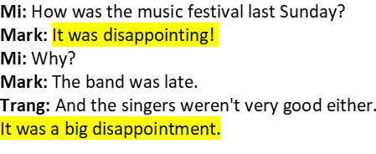  * Other expressions:  + That’s too bad!  + What a disaster!  + That’s so disappointing!
Activity 3: Practice (25’)
Task 2
* Aims: To help students practise the ways to express disappointment.
* Content: Make a similar conversation for each situation .
* Products: Ss role play in front of the class.
* Organization of implementation:
Teacher’s and Ss’activities |  | Content
Task 2  * Teacher has students work in groups to discuss and make similar conversation for each situation.  ** Students work in groups to discuss.  *** Teacher then asks students to exchange their answer among class.   Teacher moves around to observe, provides help and gives feedback. |  | Task 2: Work in groups. Make a similar conversation for each situation below.  * Situation 1:  - A: How was the film festival last Sunday?  - B: It was disappointing!  - A: Why?  - B: There were not many films I liked.
Task 3
* Aims: To help Ss understand the concept of festival symbols.
To provide Ss with some Christmas symbols and their meanings.
* Content: Listen to Mark talking about festival symbols. Fill in each blank with ONE word.
* Products: Ss write the correct answers on the board.
* Organization of implementation:
Teacher’s and Ss’activities |  | Content
Task 3:  * Teacher asks Ss what they think of when they talk about Christmas, i.e. Christmas symbols. Elicit answers from students.  Have Ss read the sentences given. Ask them to predict what word to use to fill in each blank. Write their answers on the board.  ** Students work individually. Then listen to the recording and check the answers.  *** Teacher invites some Ss to share their answers.   Teacher gives feedback and correction (if needed) |  | Task 3: Listen to Mark talking about festival symbols. Fill in each blank with ONE word.  * Answer key:  1. think  2. meaning  3. life  4. happiness  A lot of festivals have their own symbols. A festival symbol is an image we use or think of when we celebrate a festival. It usually has a special meaning. For example, when we talk about Christmas, we think of the Christmas tree. It's the symbol of a long life. We can also think of Santa Claus. He's the symbol of joy and happiness.
Task 4
* Aims: To help Ss understand the symbols and meanings of other festivals.
* Content: Match each festival with its symbol and meaning.
* Products: Students give their answers exactly.
* Organization of implementation:
Teacher’s and Ss’activities |  | Content
Task 4  * Teacher introduces some new words if necessary (prosperity, reunion).  ** Ss works in pairs to finish the task.  *** Teacher allows student to cross check first.   Teacher confirms the answers and gives feedback |  | Task 4: Work in pairs. Match each festival with its symbol and meaning.  * Answer key:  1. C-b  2. A-c  3. D-a  4. B-d
Activity 4: Production (5’)
* Aims: To let students practise talking about festival symbols and their meanings.
* Content: Choose a festival and talk about its symbol(s) and meaning.
* Products: Some Ss choose a festival and talk about its symbols and meanings.
* Organization of implementation:
Teacher’s and Ss’activities |  | Content
Task 5  * Teacher lets students group up and spend 5 minutes on taking notes of a festival.  ** Students work in groups.  *** All group members choose a festival and talk about its symbols and meanings.   Teacher moves around to observe and offers help if needed. |  | Task 5: Work in groups. Choose a festival and talk about its symbol(s) and meaning.  Example:  - When we talk about Christmas, we think of the Christmas tree. It is the symbol of a long life.  - - When we talk about Tet holiday, we often think of peach blossoms, apricot blossoms and kumquat trees.
Activity 5: Consolidation (3’)
* Aims: To consolidate what students have learnt in the lesson.
* Content: Summarize the main content in the lesson.
* Products: Students say what they have learnt in the lesson.
* Organization of implementation:
Teacher’s and Ss’activities |  | Content
Teacher asks students to talk about what they have learnt in the lesson. |  | - use lexical items related to festival activities and festival symbols  - express disappointment
* Homework (2’)
* Aim: To revise what they have learnt and prepare for the next lesson Skills 1.
* Content: Review the lesson and prepare for the next lesson and do exersie in the workbook.
* Products: Students’ textbook and workbook.
* Organization of implementation:
Teacher’s and Ss’ activities |  | Content
- T reminds Ss to do homework and prepare the new lesson. |  | - Do EX in the workbook.  - Prepare lesson 5 ( skills 1)
*- Evaluation: ………………………………………………………………………………………………………………………………………………………………………………………………………………

Date of planning : 2/3/ 2025
Date of teaching :5/3/ 2025

Week :25 UNIT 9: FESTIVALS AROUND THE WORLD

Period :73 Lesson 5 : Skills 1
I. OBJECTIVES: By the end of the lesson, students will be able to:
By the end of this lesson, Ss will be able to gain:
1. Knowledge:
- Develop reading skill about an unusual festival
- Develop speaking skill: talking about a festival they enjoy
2. Core competence:
- Develop communication skills and creativity
- Be collaborative and supportive in pair work and teamwork
- Develop presentation skill
- Actively join in class activities
3. Personal qualities
- Develop self-study skills
II. Teaching aids
- Grade 7 textbook, Unit 9, Skills 1
- Computer connected to the internet
- Projector/ TV/ pictures and cards
- sachmem.vn
III. PROCEDURES : (STAGES)
Activity 1: Warm-up (5’)
* Aim: To introduce the topic of reading; To enhance students’ skills of cooperating with team mates.
* Content: Look at the symbols and then write the names of the festivals
* Products: The team with more correct answers will be the winner.
* Organization of implementation:
Teacher’s and Ss’activities | Content
* Teacher divides the class into 2 teams.  -Each team has to run in a relay to the board to write the correct types of festivals and their symbols and meaning under the posters.  -The team with more correct answers will be the winner.  ** Students play the game in team mode.  *** Teacher and students discuss the answers.   Teacher confirms the answers and gives feedback. | Game: Who is faster?  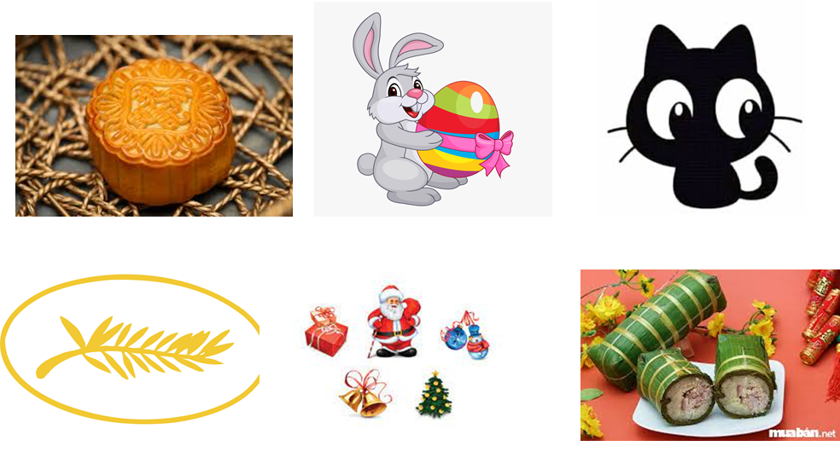
Activity 2: READING (15’)
* Pre -reading
Task 1
* Aim: To activate Ss' knowledge of the topic of the reading text.
* Content: Ss discuss what/who they see in the pictures and answer the questions.
* Products: Students give the answers correctly.
* Organization of implementation:
Teacher’s and Ss’activities | Content
Task 1  * Teacher has students work in pairs, look at the pictures in the book. Ask Ss to discuss what/who they see in the pictures and answer the questions.  ** Students works in pairs.  *** Teacher and students discuss the questions and answers.   Teacher accepts all students’ questions. | Task 1: Work in pairs. Look at the pictures. Which events do you think happen at the Twins Day Festival? (p.97)
* While -reading
Task 2
* Aims: To provide students with some lexical items before reading the text.
To develop the skill of guessing the meanings of new words in context.
* Content: Learn some vocab related the topic.
* Products: Read and understand the meaning of words.
* Organization of implementation:
Teacher’s and Ss’activities | Content
Checking the meaning of words  * Teacher introduces the vocabulary.  ** Teacher asks students to get the meaning in context and try to make up sentences with of the following words:  *** Teacher and students discuss the answers.   Teacher confirms student’s answers and checks their pronunciation and gives feedback.  Task 2:  * Teacher tells Ss what they are going to do. Ask Ss how to do the exercise and elicits answers from Ss.  If needed, tell them that to do the exercise they can follow these steps:  + Read the words in the left column  + Locate each word in the text  + Read around the word to get the general meaning  + Read the definitions in the right column, find the suitable meaning to match each word.  Ask Ss to repeat the steps (they can speak in Vietnamese).  ** Students read the text and do the task in individuals.  *** Teacher allows students to share their answers before discussing as a class and encourages them to give evidence.   Teacher calls some students to give the answer, explain which sentence give them the information. | Vocabulary  1. join (v)  2. feature (v)  3. performance (n)  Now quickly read the email below and check your answers.  Answer key:  Pictures 1 + 3: Twins Day Festival  Task 2: Match each word from the email in 1 with its meaning (p.98)  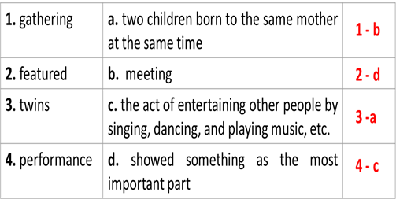
Task 3
* Aims: To develop reading skill for general and specific information.
* Content: Read the email again. Complete each sentence with no more than TWO words.
* Products: Ss play in groups actively and complete each sentence exactly.
* Organization of implementation :
Teacher’s and Ss’activities | Content
Task 3  * Teacher can set a longer time limit for students to read the text again and complete the sentences.  Briefly tell them the steps: read the sentences – underline key words – locate the key words in the text – find the words to complete the sentences.  ** Teacher asks students to work in individuals and find the answer.  *** Teacher allows students to share their answers before discussing as a class and encourages them to give evidence.   Teacher calls a student to write his/her answer on the board, then check sentence by sentence with class. | Task 3: Read the email again. Complete each sentence with no more than TWO words (p.98).  Game: Lucky number  * Answer key:  1. first weekend  2. countries  3. walked together  4. performance  5. Fun Run  6. exciting
Activity 3: SPEAKING (10’)
* Pre-Speaking
Task 4
* Aims: To help students identify how to ask and answer about a festival they attended.
* Content: Match the questions and answer about a festival someone joined.
* Products: Students’ correct answers.
* Organization of implementation:
Teacher’s and Ss’activities | Content
Task 4  * Teacher tells Ss they are going to ask and answer about a festival they attended and that this activity can serve as a model for them to follow in the writing task.  ** Teacher asks students to work individually and then check in pairs.  *** Teacher can go around to help weaker students.   Teacher call on some pairs to give the answers and check as the whole class. | Task 4: Match the questions and answer about a festival someone joined (p.98).  Answer key:  1. d  2. b  3. e  4. c  5. a
* While-Speaking
Task 5
* Aims: To help students form the ideas for their speaking
* Content: To give Ss practice in asking and answering about a festival Ss attended.
* Products: Students discuss in groups positively
* Organization of implementation:
Teacher’s and Ss’activities | Content
Task 5  * Teacher has students to work in pairs, ask and answer about a festival they attended.  ** Students work in pairs to do the task.  *** Teacher goes around to help students.   After finishing, teacher can call some pairs to give presentations in front of the class. | Task 5: Work in pairs. Ask and answer about a festival you and your friend joined, using the questions in 4 as cues. Tell the class about the festival your partner joined.  * Example:  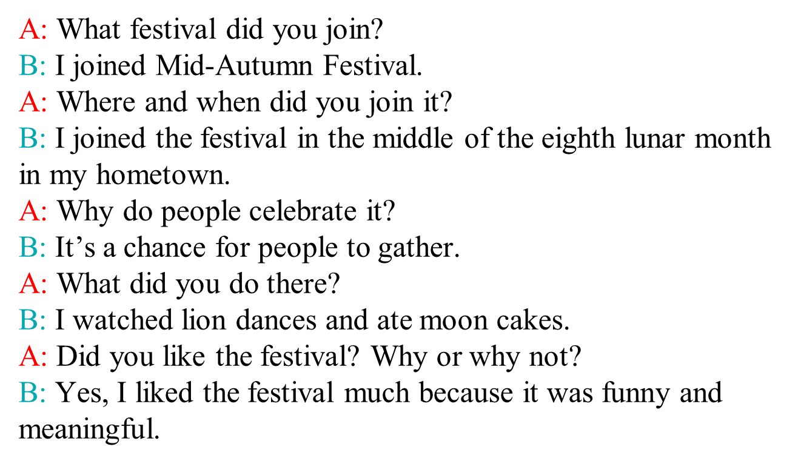
Activity 4: Post – Reading and Speaking (3’)
* Aims: To help students improve next time; To help some students enhance presentation skill
* Content: Share the information with the whole class.
* Products: Students present in front of the class fluently.
* Organization of implementation:
Teacher’s and Ss’activities | Content
* Teacher allows students to give comments for their friends and vote for the most interesting dialogue.  ** Students give comments for their friends and vote for the most interesting dialogue.  *** Teacher and students discuss.   Teacher gives feed-back and comments. | * Example:  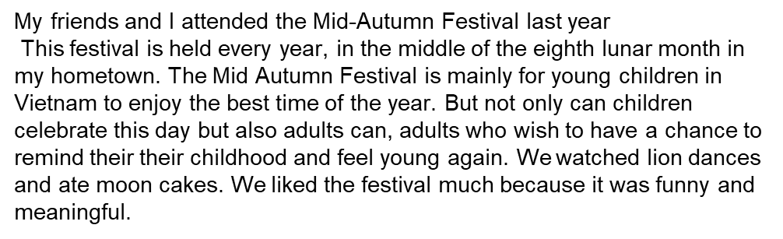
Activity 5: Consolidation
* Aims: To consolidate what students have learnt in the lesson.
* Content: Ss summarize what they have learnt with the two skills.
* Products: Students say what they have learnt with the two skills in front of the class.
* Organization of implementation:
Teacher’s and Ss’activities | Content
- Teacher asks students to talk about what they have learnt in the lesson. | - some vocab  - Talk about a a festival you and your friend joined.
* Homework (2’)
* Aim: To revise the knowledge that students have gained in this lesson.
* Content: Review the lesson and prepare for the next lesson .
* Products: Students’ textbook and workbook
* Organization of implementation:
- Teacher asks students to prepare the new lesson | - learn by heart vocab.  - Prepare for the next lesson: Unit 9-Skills 2.
*- Evaluation: ……………………………………………………………………………………………………………………………………………………………………………………………………………..

Date of planning : 2/3/ 2025
Date of teaching : 7 /3/ 2025

Week :26 UNIT 9: FESTIVALS AROUND THE WORLD

Period : 74 Lesson 6: Skills 2
I. OBJECTIVES:
By the end of this lesson, Ss will be able to gain:
- Listen for special information about a festival
- Write an email to describe a festival
1. Knowledge:
a. Vocabulary: types of festivals, festival activities
b. Grammar: review
2. Core competence:
- Develop communication skills and creativity
- Be collaborative and supportive in pair work and teamwork
- Actively join in class activities
3. Personal qualities
- Develop self-study skills
II. Teaching aids
1. Textbooks, plan
2. Equipment: computer accessed to the Internet, projector, loudspeaker
3. sachmem.vn
III. PROCEDURES : (STAGES)
Activity 1: Warm –up (5’)
* Aim: -To create an active atmosphere in the class before the lesson;
-To lead into the new lesson.
* Content: * Game: Bingo! - the names of some festivals
* Products: The student who has 3 words highlighted in a row yells “Bingo” and wins.
* Organization of implementation:
Teacher’s and Ss’activities |  |  | Content
GAME:  * Teacher tells the rules of the game:  Each student gets a piece of paper, draws a table with 3 rows and 3 columns, then fill in the table with names of some festivals randomly.  Teacher calls out the names of some festivals. Each time the teacher calls out a word, the students search for the right square on their paper and mark.  The student who has 3 words highlighted in a row yells “Bingo” and wins.  ** Students play the game in individuals  *** Teacher and students discuss the answers.   Teacher confirms the answers and gives feedback. |  |  | * Game: Bingo!  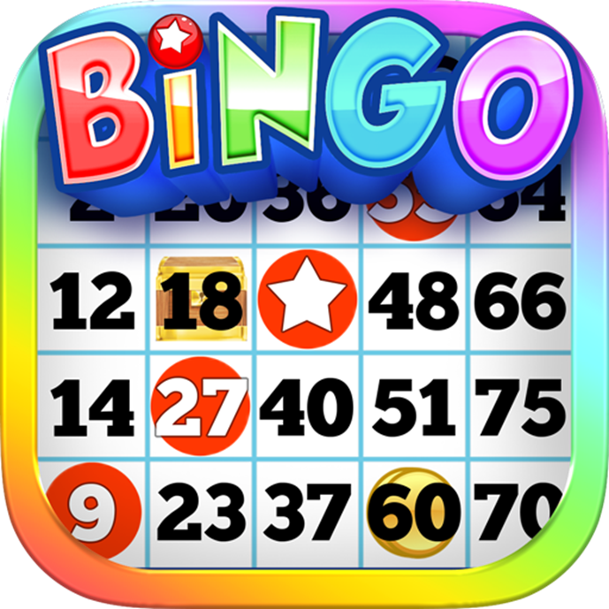
Activity 2: LISTENING
*Pre-Listening (5’)
Task 1
* Aim: To prepare Ss for the listening text.
* Content: Look at the animal. Discuss the questions with a partner.
* Products: Students discuss and give their answers.
* Organization of implementation:
Teacher’s and Ss’activities | Content
Task 1  * Teacher asks students to work in pairs, read the questions and answer.  ** Students quickly discuss with a partner.  *** Teacher allows Ss to cross check.   Teacher calls some Ss to give their answer on the board and elicits their answers. | Task 1: Look at the animal. Discuss the questions with a partner.  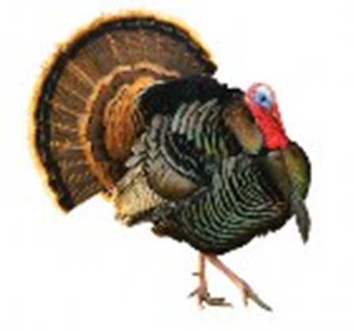  1. What is it?  2. What festival is it a part of?
* While -listening ( 10’)
Task 2
* Aims: To help Ss check their answer in Task 1.
* Content: Listen to Mark talking about how his family celebrates a festival. Check your answers.
* Products: Students listen and check their answers.
* Organization of implementation:
Teacher’s and Ss’activities |  | Content
Task 2  * Teacher tells Ss what they are going to listen to and plays the recording.  ** Students listen and check their answers.  *** Teacher allows students to peer check first.   Teacher confirms the answers and gives feedback. |  | Task 2: Listen to Mark talking about how his family celebrates a festival. Check your answers.  * Answer key:  1. A turkey  2. Thanksgiving
Task 3
* Aims: To help students develop listening skill for specific information (gap-filling).
* Content: Listening again and decide whether the following statements are true or false.
* Products: Students give the answers to the class and correct the mistakes
* Organization of implementation:
Teacher’s and Ss’activities |  | Content
Task 3  * Teacher asks students to read through the statements, have a guess before they listen to the recording the second time and write their guesses on the board.  ** Teacher plays the recording again. Ask students to listen and choose the correct answer.  *** Teacher lets students peer-check with a partner.   Teacher calls some students to give the answers to the class and correct the mistakes where necessary, encourages students to correct the false statements. |  | Task 3: Listening again and decide whether the following statements are true or false.  * Answer key:  1. F 2. F 3. T 4. F 5. T 6. T  Audio Script:  Hello everyone. I’m Mark. Today I’m going to talk about Thanksgiving, or Turkey Day. It’s a national holiday. People from Canada and the USA celebrate it every year to be thankful for successful harvests. In the USA, we celebrate it on the fourth Thursday of November. We usually prepare a feast for family and friends. Both adults and children take part in the food preparation. Some of the traditional foods are turkey, sweet potatoes, and cornbread. After the meal, we play board games together. My family usually takes this opportunity to help others. My parents volunteer to cook and serve food to homeless people. My sister and I read books to old people in a nursing home near our house.
Activity 3: WRITING
* Pre-Writing (5’)
Task 4
* Aims: To brainstorm ideas and make an outline for Ss’ writing.
* Content: Think about a festival that your family usually celebrates. Fill in the blanks with your answers
* Products: Ss complete the mind map on the group board.
* Organization of implementation:
Teacher’s and Ss’activities |  | Content
Task 4  * Teacher asks students to work individually to complete the mind map.  ** Students in individuals and decide on their festival.  *** Teacher goes around and helps if needed.   Teacher calls some Ss to give their answer (if time allows) and gives feedback. |  | Task 4: Think about a festival that your family usually celebrates. Fill in the blanks with your answers.  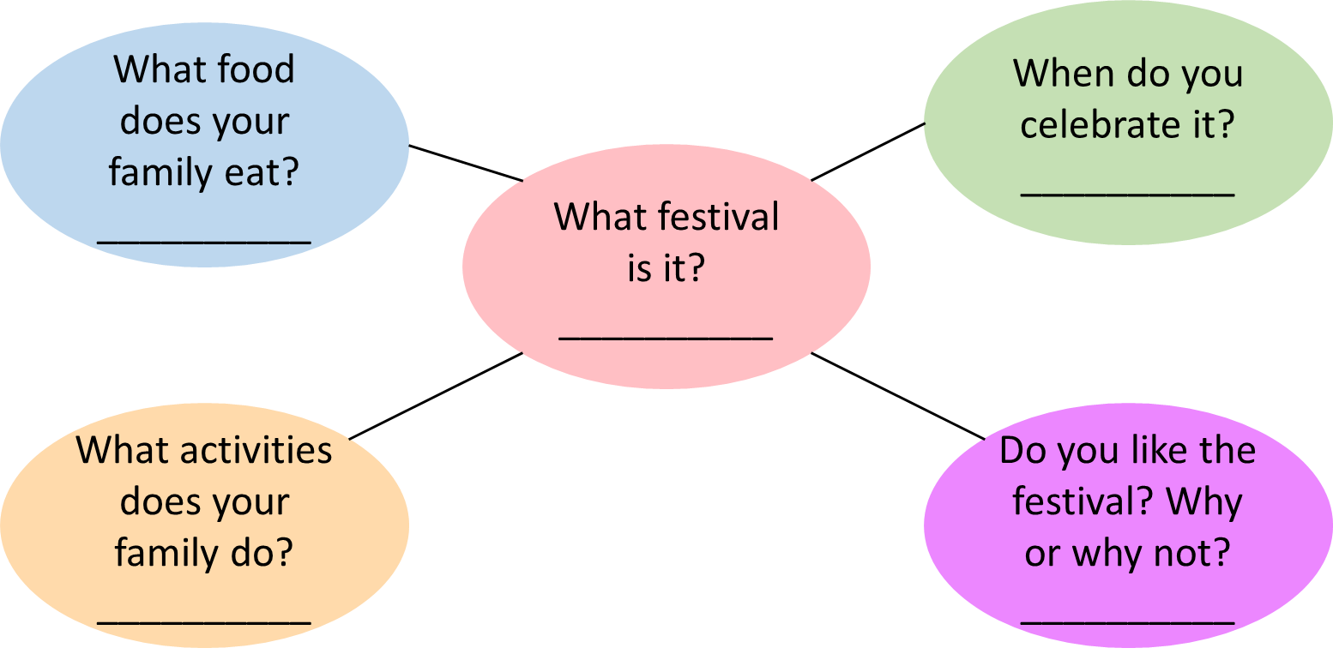
* While-Writing (5’)
Task 5
* Aim: To practise how to write a paragraph about a festival
* Content: Write an email of about 70 words to tell Mark about the festival.
* Products: Students’ writing and cross check. (individual work)
* Organization of implementation:
Teacher’s and Ss’activities |  | Content
Task 5  * Teacher shows a model of a short paragraph about a festival (T may use the audio script or reading passage-page 97). Then recalls students’ knowledge on the structure of an email.  ** T has Ss write their email in individuals based on the information in 4.  *** Teacher allows students to cross check first.   Teacher gives feedback. |  | Task 5: Write an email of about 70 words to tell Mark about the festival. Use the notes in 4.  Dear Mark,  How are you? I’m going to tell you about Mid Autumn Festival. It takes place in the middle of the eighth lunar month. My family and I often eat moon cakes, autumn fruits and watch lion dances. I like the festival very much because it was funny and meaningful.  I hope one day you can join the festival with us.  Cheers,
Activity 4: Post-Writing (2’)
* Aim: To peer check, cross check and final check students’ writing
* Content: Cross check students’ writing
* Products: Students’ writing on the posters.
* Organization of implementation:
Teacher’s and Ss’activities |  | Content
* Teacher asks students read their “production”.  ** Students listen to each other’s work.  *** Students then give comments to each other.   Teacher then gives feedback as a class discussion. |  | Task 6:  Class gallery  Giving peer-reflection & evaluation
Activity 5:Consolidation (2’)
* Aim: To consolidate what students have learnt in the lesson.
* Content: summarize the content of the lesson.
* Products: A student says what she/ he has learnt in the lesson.
* Organization of implementation:
Teacher’s and Ss’ activities |  | Content
- Teacher asks students to talk about what they have learnt in the lesson. |  | - listen for special information about a festival  - write an email to describe a festival.
* Homework (1’)
* Aim: To revise the knowledge that students have gained in this lesson.
* Content: Review the lesson and prepare for the next lesson and do exersie in the workbbook
* Products: Students’ textbook and workbook
* Organization of implementation
Teacher’s and Ss’ activities |  | Content
- Teacher asks students to rewrite their writing in their books.  - Teacher asks students to prepare the new lesson. |  | - Rewrite the writing in the notebook.  - Prepare “ Looking back and project”
*- Evaluation: …………………………………………………………………………………………………………………………………………………………………………………………………….

Date of planning : 8/3/ 2025
Date of teaching : 11 /3/ 2025

Week :26 UNIT 9: FESTIVALS AROUND THE WORLD

Period : 75 Lesson 7: Looking back and project
I. OBJECTIVES:
By the end of this lesson, Ss will be able to gain:
1. Knowledge
Review the vocabulary and grammar of Unit 9
Apply what they have learnt (vocabulary and grammar) into practice through a project
2. Core competence
- Develop communication skills and creativity
- Develop presentation skill
- Develop critical thinking skill
- Be collaborative and supportive in pair work and team work
- Actively join in class activities
3. Personal qualities
- Be more creative when doing the project
- Develop self-study skills
II. Teaching aids
- Grade 7 textbook, Unit 9, Looking back & Project
- Computer connected to the internet, Pictures, A0 paper
- Projector/ TV
- sachmem.vn
  - III. PROCEDURES : (STAGES)
Activity 1: Warm-up (5’)
* Aim: - To revise the vocabulary related to the topic and lead in the next part of the lesson.
- To enhance students’ skills of cooperating with team mates.
* Content: Write the names of the festivals
* Products: The group having more correct answers is the winner.(posters).
* Organization of implementation:
Teacher’s and Ss’activities |  |  | Content
Warm up  * Teacher divides the board, and divides the class into 2 teams.  ** Members of each team take turns and write as many types of festivals as possible in 2 minutes.  *** Students cross check their answers first.   Teacher confirms the answers and gives feedback. The group having more correct answers is the winner. |  |  | 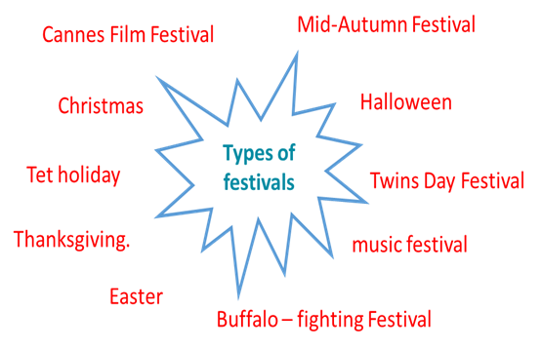
Activity 2 : VOCABULARY (12’)
Task 1 + Task 2
* Aim: To help students revise vocabulary items they have learnt in the Unit.
* Content: Circle the correct words or phrases in brackets.
Complete each sentence by filling in the blank with a word or phrase in the box.
* Products: Students say the correct key aloud ( individual work).
* Organization of implementation:
Teacher’s and Ss’activities | Content
Task 1  * Teacher encourages students to complete the task individually.  ** Students do the task individually.  *** Students exchange their textbooks with their partners.   Teacher gives feedback as a class discussion.  Task 2  * Teacher encourages students to complete the task individually.  ** Students do the task individually.  *** Students exchange their textbooks with their partners.   Teacher gives feedback as a class discussion. | Task 1: Circle the correct words or phrases in brackets.  * Answer key:  1. fireworks  2. Cannes Film Festival  3. painting  4. candy apples  5. Thanksgiving  Task 2: Complete each sentence by filling in the blank with a word or phrase in the box (p.100).  * Answer key:  1. lion dances  2. floats  3. costumes  4. Bunny  5. gathering
Activity 3: GRAMMAR (13’)
Task 3 + Task 4
* Aims: To help students revise Yes/No questions.
* Content: Choose the correct question A or B ; Answer the following questions about yourself.
* Products: Ss read aloud their answers.
* Organization of implementation:
Teacher’s and Ss’activities |  | Content
Task 3  * Teacher encourages students to complete the task individually.  ** Students do the task individually.  *** Students exchange their textbooks with their partners.   Teacher calls some Ss to read aloud their answers and gives feedback.  Task 4  * Teacher encourages students to complete the task individually.  ** Students do the task individually.  *** Students share their answer in groups of 3 of 4.   Teacher calls some Ss to read aloud their answers and gives feedback |  | Task 3: Choose the correct question A or B (p.100).  * Answer key:  1. A  2. B  3. A  4. B  5. B  Task 4: Answer the following questions about yourself.  1. Are you interested in festivals?  2. Do you eat banh chung at Tet?  3. Can you cook any traditional food?  4. Did you see a fireworks display last year?  5. Does your family gather together at Tet?
Activity 4: PROJECT (10’)
* Aim: To allow students to apply what they have learnt (vocabulary and grammar) into practice through a project.
* Content: Make a project : A NEW FESTIVAL
* Products: Students’ project on the posters.
* Organization of implementation:
Teacher’s and Ss’activities |  | Content
* Teacher has students work in groups and gives instructions to students as follow:  * Students do the project in groups.  *** Students vote for the best poster.   Teacher gives feedback. |  | * Posters exhibition: A NEW FESTIVAL  1. Choose one of your favourite festivals and design a poster for it, including:  – name of the festival  – the time/ place it takes place  – its meanings  – its activities  – pictures or photos to illustrate the festival  2. Organise them into an exhibition.  3. Vote for the best poster.
Activity 5: Consolidation (3’)
* Aim: To consolidate what students have learnt in the lesson.
* Content: Summarize the content of the lesson.
* Products: A student says the lesson’s content aloud.
* Organization of implementation:
Teacher’s and Ss’activities |  | Content
- Teacher asks students to talk about what they have learnt in the lesson. |  | - - revise vocabulary and grammar in unit 9  - make Project: A new festival
* Homework (2’)
* Aim: To revise the knowledge that students have gained in Unit 9 and To prepare for the next lesson
* Content: Review the lesson and prepare for the next lesson and do exersie in the workbbook
* Products: Students’ textbook and workbook.
* Organization of implementation:
Teacher’s and Ss’activities |  | Content
- Teacher asks students to revise old lesson and to do exercise in workbook.  - Teacher asks students to complete the project and prepare the new lesson. |  | - Complete the project  - Prepare for the next lesson: Review 3.

*- Evaluation: …………………………………………………………………………………………………………………………………………………………………………………………………….

