Date of planning: 7 - 01 -2025
Date of teaching : 14-01-2025
Period 55 UNIT 7: TRAFFIC
Lesson 1: Getting started – Meeting in the school yard
I. Objectives: By the end of the lesson, the students will be able to gain :
1. Knowledge:
- an overview about the topic Traffic
- vocabulary to talk about means of transport
a. Grammar : It indicate / should and shouldn’t
b. Vocabulary: Vocabulary about traffic problems
2. Competences:
- Use some words related to the topic Traffic; ask and answer about some means of transport
- Develop communication skills and enhance awareness of preserving the culture
- Be collaborative and supportive in pair work and team work
- Actively join in class activities
3. Qualities
-Help Ss develop awareness of travelling in town/ city
- Be concerned to the local traffic
II. TEACHING AIDS:
1. Materials: Textbooks, plan
2. Equipment: A laptop connected with TV, textbooks
III. PROCEDURES:

Activity 1: Warm-up (5’)
* Aim: To activate students’ knowledge on the topic of the unit.
To enhance students’ skills of cooperating with team mates.
* Content: Miming game
* Products: Students guess words correctly.
* Organization of implementation:
Teacher’s and Ss’activities | Content
*Warm up: T –Ss (Team work)  * Teacher gives instructions  ** In groups, Ss  - One of the students in the group go to the board.  *** Teacher secretly show 1 picture of a mean of transport to that student. He/She has to mime the picture and the other has to guess. Of course the other groups will also be allowed to guess.  - take turns go to the board until finish all the pictures.  **** Teacher checks and corrects if Ss pronounce the words incorrectly.  * Lead in: Teacher uses the picture and asks Ss questions to lead in the new lesson. | * Warm up: Miming game  Ex: cycle (ride a bike)  
Activity 2: Presentation (7’)
Pre teach vocabulary
* Aim: To introduce the vocabulary appearing in the text.
* Content: Learn some vocabularies related to the topic.
* Products: Students read and understand the meaning of vocab.
Students know how to to play the game “what and where”
* Organization of implementation
Teacher’s and Ss’activities | Content
T-Ss  * T asks Ss to look at the photos and answer the question  ** Ss say the words.  ***Teacher shows and says the words aloud and asks Ss to repeat them.  * *** Teacher asks Ss to translate the word into Vietnamese.  Concept check: Slap the board | * Vocabulary  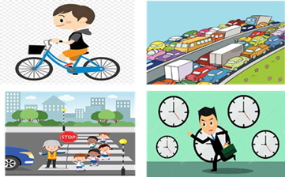  - cycle (v) /ˈsaɪkl/: đạp xe  - traffic jam (n.phr.) /ˈtræfɪk dʒæm/: tắc đường  - cross the road (v.phr.) /krɒs ðə rəʊd/: băng qua đường  - rush hour (n.phr.) /ˈrʌʃ aʊə(r)/: giờ cao điểm  * Checking vocab: < Slap the board >
Activity 3: Practice (23’)
Lead-in/ pre-read and listen
Task 1+Task 2
* Aims: - To get students interested in the topic; To set the context
- To help Ss understand the main idea of the text
* Content: Listen and read the conversation, choose the correct answer A, B, or C.
* Products: Students read and understand content of the conversation.
Ss choose the answers correctly.
* Organization of implementation:
Teacher’s and Ss’activities | Content
* Set the sences:  T-Ss  Look at the picture and the dialogue  a) Who are they in the dialogue?  b) Where are they?  T-Ss, Ss-Ss, T-Ss  * Teacher asks Ss to look at the picture (p.73), answer the question:  ** Ss work out and answer questions in pairs.  *** Ss share their answers as a whole class.  **** T asks them to read and listen to the conversation to check their answers. T encourages students to explain where they have found the answers from the conversation. | * Answer the questions:    a) They are Lan and Mark  b) They are at the schoolyard.  Task 1: Listen and read  Task 2: Read the conversation again and choose the correct answer:  1. How does Lan often go to school?  A. By bicycle.  B. By motorbike.  C. On foot.  2. It normally takes Lan ___ to get to school.  A. two minutes  B. ten minutes  C. twenty minutes  3. Lan and Mark agree to go cycling ______.  A. tomorrow  B. every day  C. at the weekend
Controlled practice
Task 3
* Aims: - To practise reading and listening for specific information, To practise scanning
- To develop Ss' knowledge of vocabulary
* Content: Write one word from the conversation to complete each sentence.
* Products: Students write correct words on the board. (work independently)
* Organization of implementation:
Teacher’s and Ss’activities | Content
T-Ss, Ss-Ss, T-Ss  * Teacher asks Ss to work individually to read and listen to the conversation and find the words and phrases and then share their answers with their partners who sit next to them. (peer check)  ** Ss do exercise 3 individually  *** Ss share and discuss with their partners to write all words/ phrases down on the notebooks.  **** Teacher corrects their answers as a class | Task 3: Write one word from the conversation to complete each sentence.  1. Last Sunday afternoon, Lan ______ round the lake near her home.  2. Mark says to Lan: “You ______ be careful, especially when you cross  the road.  3. Traffic ______ are a problem in big cities.  4. – ______ does your mum go shopping?  – She often walks.  5. This road is very ______ during the rush hours.  * Answers  1. cycled 2. should 3. jams  4. How 5. crowded
Task 4
* Aims: To help Ss revise and develop the vocabulary about means of transport.
* Content: Look at the pictures and write a word under each.
* Products: Ss read each word correctly.
* Organization of implementation:
Teacher’s and Ss’activities | Content
T – Ss  *Teacher asks students to Look at the pictures and write a word under each.  ** Have Ss work in pairs and write the means of transport under the right pictures.  *** Then T lets Ss read each word correctly.  **** Check and correct their pronunciation. | Task 4: Look at the pictures and write a word under each.  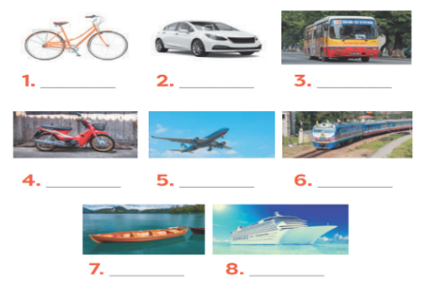  * Suggested answers:  1. bicycle 2. car 3. bus  4. motorbike 5. plane/air-plane  6. train 7. boat 8. Ship
Activity 4: Production (Less controlled practice) (5’)
Task 5
* Aims: To help Ss practising talking about how they go to school, To practise team working
- To give students authentic practice in using target language
* Content: Find someone who … Write your friends’ names in the blanks. Then report to the class.
* Products: Students write correct the adjectives words on the board.
* Organization of implementation:
Teacher’s and Ss’activities | Content
T-Ss, Ss-Ss  * Teacher gives Ss clear instructions in order to make sure Ss can do the survey effectively.  - ask students to look at the survey and think of the needed structures to ask their friends.  + Students goes around the class and ask at least 20 classmates and ask them  - observer Ss while they are role playing, note their language errors  ** Ss do as instructed  **** Teacher gives Ss feedback.  - choose some useful or excellent words/ phrases/ expressions/ word choices Ss have used to suggest other students use them  - choose some typical errors and correct as a whole class without nominating the students’ names | Task 5: Find someone who … Write your friends’ names in the blanks. Then report to the class  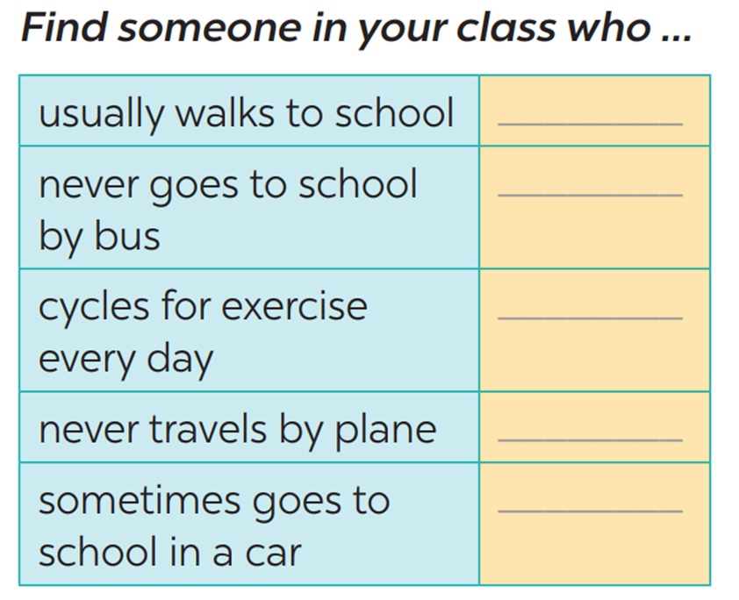  Eg: Do you usually walk to school?  Have you ever gone to school by bus/…?  Do you ride a bike to school?  Do you ever travel by plane?  Yes, I do.  No, never/notyet.
Activity 5: Consolidation (3’)
* Aim: To consolidate what students have learnt in the lesson.
* Content: Vocabulary of traffic and means of transport; read and understand content of the conversation
* Products: Say aloud some words they remember from the lesson.
* Organization of implementation:
Teacher’s and Ss’ activities | Content
- Teacher asks students to talk about what they have learnt in the lesson.  - Ss work indepently | - Vocabulary of traffic and means of transport.  - Reading for specific information and details  - Scanning
* Homework (2’)
* Aim: To revise the lesson and prepare for the next lesson.
* Content: Review the lesson and prepare for the next lesson and do exersie in the workbbook
Teacher’s and Ss’ activities | Content
- T reminds Ss to do homework and prepare the new lesson. | - Learn all the new words by heart.  - talk about the traffic in your neighbourhood  - Prepare lesson 2 ( A closer look 1).

*- Evaluation: ……………………………………………………………………………………………………………………………………………………………………………………………………...............

Date of planning: 7/1 /2025
Date of Teaching : 15,16 /1/2025
Period 56 : UNIT 7: TRAFFIC
Lesson 2: A closer look 1
I. Objectives: By the end of the lesson, the students will be able to gain :
1. Knowledge:
- Vocabulary on the verbs to use with means of transport
- Vocabulary to read the road signs
- Pronunciation: /aɪ/ and /eɪ/
a. Grammar :
b. Vocabulary: Vocabulary about road signs
2. Competences:
-Describe / name all the road signs and know some kinds of signs: informative, prohibitive, and warning
- Pronounce the sounds /aɪ/ and /eɪ/ correctly;
- Develop communication skills and cultural awareness
- Be collaborative and supportive in pair work and teamwork
- Actively join in class activities
3. Qualities
Help Ss develop awareness of understanding the road signs and obeying the traffic rules
II. TEACHING AIDS:
1. Materials: Textbooks, plan
2. Equipment: A laptop connected with TV, textbooks
III. PROCEDURES:
Activity 1: Warm-up (5’)
* Aim: To activate students’ prior knowledge and vocabulary related to the topic.
To lead in the lesson about vocabulary and pronunciation.
* Content: Game: JUMBLED WORDS
* Products: Ss make the correct words and write down onto the small boards.
* Organization of implementation:
Teacher’s and Ss’activities |  |  | Content
Warm-up: T - Ss  * Teacher gives instructions  ** In groups of 5, Ss will be given a small white board and marker.  - Teacher show the jumbled words onto the screen one by one  *** Students work in groups to make the correct words and write down onto the small boards. When they finish, they hold it up to show their answers to teacher.  - take turns to write until finish all the words.  **** Teacher checks and corrects if Ss write the words incorrectly. |  |  | Game: JUMBLED WORDS  *Answers:  1- otba -> boat  2- itanr -> train  3- npeilapra -> airplane  4- rsotrpca -> sport car  5- otmiroekb -> motorbike
Activity 2: Presentation (5’)
* Aim: To help students use key language more appropriately
* Content: Learn some vocabularies related to the topic.
* Products: Read and pronounce correctly and understand the meaning of words.
* Organization of implementation:
Teacher’s and Ss’activities |  | Content
Pre teach vocabulary  * Teacher use different techniques to teach vocab (pictures, situation, realia)  **Follow the seven steps of teaching vacab.  *** Repeat in chorus and individually  **** Copy all the words  * Checking vocab: < Rub out and remmember> |  | * Vocabulary  - road sign (n.phr.) /ˈrəʊd saɪn/: biển báo giao thông  - cycle lane (n.phr.) /ˈsaɪkl leɪn/: đường đi riêng cho xe đạp  - traffic light (n.phr.) /ˈtræfɪk laɪt/: đèn giao thông  - crossroads /ˈkrɒsrəʊdz/: (n) ngã tư  - pavement /ˈpeɪvmənt/ = (n) Footpath: vỉa hè
Activity 3: Practice (20’)
Task 1
* Aims: To revise / teach some collocations of a verb and a phrase related to the different means of transport.
* Content: Match the words in A with the phrases in B.
* Products: Students give their answers exactly.
* Organization of implementation:
Teacher’s and Ss’activities | Content
T - Ss  * Teacher asks Ss to look at the table (p.74), identify the form (verbs and nouns – means of transport):  ** Ss work out and answer questions in pairs.  *** Ss share their answers as a whole class.  **** T asks them to to check their answers.  _ Teacher asks students to make your own sentences with these phrases. Then tell share them to share their sentences with a partner and correct for them. | Task 1: Match the words in A with the phrases in B.  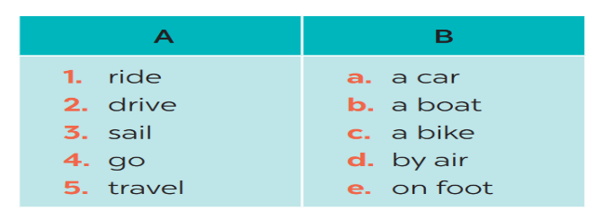*Answers:  1- C 2 – A 3 – B 4 – E 5 – D  - My father taught me how to ride a bike.  - My father usually drives a car to work.  - I sometimes go on foot to school.
Task 2
* Aims: - To practise identifying the meanings of road signs.
- To develop Ss' knowledge of vocabulary
* Content: Write the correct phrases under the signs
* Products: Ss write the correct phrases under the signs correctly.
* Organization of implementation:
Teacher’s and Ss’activities | Content
T - Ss, Ss - Ss  * Teacher asks Ss to look at the road signs and guess their meanings. Then work and share their answers with their partners who sit next to them. (peer check)  ** Ss do exercise 3 in pairs.  *** Ss share and discuss with their partners to write all words/ phrases down on the books.  **** Teacher corrects their answers as a class. | Task 2: Look at these road signs. Then write the correct phrases under the signs.  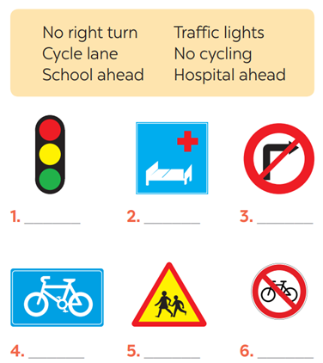  *Answers  1. traffic lights 2. Hospital ahead  3. No right turn 4. cycle lane  5. School ahead 6. No cycling
Task 3
* Aims: To give Ss practice in how to talk about road signs in real life.
* Content: Take turns to say which of the signs in 2 you see on the way to school.
* Products: Students say correct answers in front of the class.
* Organization of implementation:
Teacher’s and Ss’activities | Content
T-Ss, Ss-Ss  * Teacher gives suggestions and asks students to share their sentences.  ** Teacher nominates Ss to say the sentences aloud  *** Ss say the sentences aloud.  **** Teacher checks and gives the corrections if they have mistakes. | Task 3: Work in pairs. Take turns to say which of the signs in 2 you see on the way to school.  A: On the way to school, there are crossroads, so I see several traffic lights.  B: On my way to school, there is a school, so I see a “school ahead sign”.  ….
Activity 4: * PRONUNCIATION (10’)
Task 4
* Aims: To teach Ss how to pronounce the sounds /aɪ/ and /eɪ/ and practise pronouncing these sounds in words correctly.
* Content: Listen and repeat. Pay attention to the sounds /aɪ/ and /eɪ/.
* Products: Students pronounce words exactly.
* Organization of implementation:
Teacher’s and Ss’activities | Content
* Presentation: T - Ss  * First, T gives examples of the sounds /ai/ and /ei/. Ask Ss to observe the T's mouth when pronouncing the two sounds.  ** Then let Ss practise the sounds /aɪ/ and /eɪ/ together.  ***Play the recording and ask Ss to listen to these words and repeat.  ****Correct their pronunciation. Play the  recording as many times as necessary. | * PRONUNCIATION  Task 4: Listen and repeat. Pay attention to the sounds /aɪ/ and /eɪ/.  * Suggested answers:  /aɪ/ /eɪ/  cycle /ˈsaɪ.kəl/ fly /flaɪ/ fine /faɪn/ sign /saɪn/ motorbike /ˈməʊ.tə.baɪk sail /seɪl/ train /treɪn/ plane /pleɪn/ station /ˈsteɪ.ʃən / pavement /ˈpeɪv.mənt /
Task 5
* Aims: -To help Ss pronounce the sounds /aɪ/ and /eɪ/ correctly in context;
-To help Ss differentiate the sounds /aɪ/ and /eɪ/.
* Content: Underline the words with the sound /aɪ/ and circle the words with the sound /eɪ/. Then listen, check and repeat.
* Products: Students underline the words and read the words exactly.
* Organization of implementation:
Teacher’s and Ss’activities | Content
T - Ss, Ss-Ss  * Have Ss quickly read the sentences and underline the words with the sound /ai/ and circle the words with the sound /ei/.  **Then play the recording for Ss to listen and check what they have done.  ***Have them work in pairs to compare their answers. Check Ss' answers as a class.  - Play the recording again. Let Ss listen and repeat sentence by sentence. Tell them to pay attention to the words with the sounds /ai/ and /ei/.  **** Teacher gives Ss feedback.  - choose some typical errors and correct as a whole class | Task 5: Underline the words with the sound /aɪ/ and circle the words with the sound /eɪ/. Then listen, check and repeat  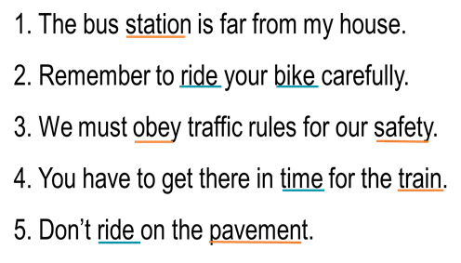
Activity 5: Consolidation (3’)
* Aim: To help Ss memorise the target language and skills that they have learned.
* Content: Vocab and how to pronounce the sounds /aɪ/ and /eɪ/
* Products: Say aloud what they remember from the lesson
* Organization of implementation:
Teacher’s and Ss’ activities | Content
T - Ss  Teacher asks students to talk about what they have learnt in the lesson | - Vocabulary of verbs and road signs  - Pronuciation: /aɪ/ and /eɪ/
* Homework (2’)
* Aim: To revise the lesson and prepare for the next lesson.
* Content: Revise Vocabulary and find 5 more words with /aɪ/ and 5 more words with /eɪ/.
Teacher’s and Ss’ activities | Content
- T reminds Ss to do homework and prepare the new lesson. | - Learn all the new words by heart.  - Do exercises in the workbook.  - Find 5 more words with /aɪ/ and 5 more words with /eɪ/.  - Prepare lesson 3 ( A closer look 2)..

*- Evaluation: ……………………………………………………………………………………………………………………………………………………………………………………………………

Date of planning: 7 -1 -2025

Date of teaching: 17/ 1/ 2025

Period 57 : UNIT 7: TRAFFIC

Lesson 3 : A closer look 2

I. Objectives : By the end of the lesson, the students will be able to:

1. Knowledge:
Know how to use It to indicate distance and use should and shouldn’t
a.Grammar : It indicate distance / should and shouldn’t
b. Vocabulary: Vocabulary about traffic problems
2. Competences:
- Ask and answer questions about distances;
- Know to use “should/shouldn't”to give advice;
- Develop communication skills and cultural awareness
- Be collaborative and supportive in pair work and teamwork
- Actively join in class activities
3. Qualities:
Help Ss develop awareness of understanding the road signs and obeying the traffic rules.
II. TEACHING AIDS:
1. Materials: Textbooks, plan
2. Equipment: A laptop connected with TV, textbooks
III. PROCEDURES:
Activity 1: Warm-up (5’)
* Aim: -To activate students’ knowledge on the topic of the unit
-To enhance students’ skills of cooperating with team mates
* Content: * Game: Pelmanism
* Products: Students plays in groups and choose two cards exactly.
* Organization of implementation:
Teacher’s and Ss’activities |  |  | Content
Warm up (group work)  * Teacher divides the class into two teams and gives instructions the game  *T assk each group to choose two cards in turn.  Flip the two selected student cards, if they match exactly, they will get 1 mark. If there is no match, turn it over and continue the game until all the cards are flipped.  The group with more points wins.  Lead in: - Teacher says: “This lesson today is going to tell you about “it indicating distance” |  |  | * Game: Pelmanism  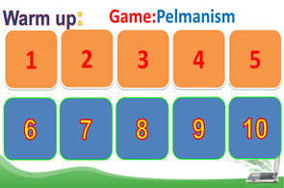  * Answers:  1- Cycle lane  2- School ahead  3- No cycling  4- No right turn  5- Hospital ahead
Activity 2: Presentation (15’)
Task 1
* Aim: To introduce students the form of the key grammar and how to use them appropriately
* Content: How to use “It” to indicate distance
* Products: know how to use “It” to indicate distance
* Organization of implementation:
Teacher’s and Ss’activities | Content
T-Ss  * Teacher draws students’ attention to the grammar point and the example  - Teacher asks Ss:  ** Ss read the grammar explicit and study the example.  *** Ss may discuss within groups/pairs before answering.  **** Teacher shows and says the sentences aloud and asks Ss to make similar sentences. | * IT INDICATING DISTANCE  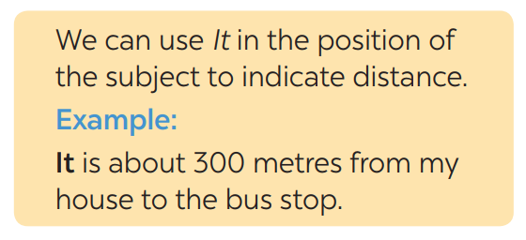  - What does the sentences tell us about?  Distance from his/her house to the bus stop  - What is the structure using in the sentence?  It be (about) + distance from A to B.
* Practice/ Controlled practice
Task 1
* Aim: To help Ss use “It” to write correct sentences
* Content: Write sentences with It. Use these cues.
* Products: Ss write the correct sentences on the board.
* Organization of implementation:
Teacher’s and Ss’activities | Content
Task 1.  * Teacher asks Ss to look at the example and the task.  ** Ss work out and answer questions individually.  *** Ss share their answers in pairs.  **** T asks them to to check their answers.  Then tell share them to share their sentences as a whole in class and correct for them. | Task 1. Write sentences with It. Use these cues.  EX: 500 metres / my house / nearest shop.  → It is about 500 metres from my house to the nearest shop.  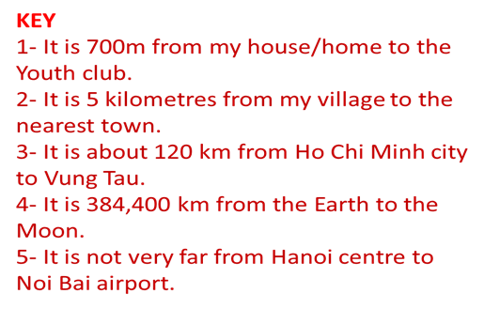
Task 2
* Aims: -To help Ss revise the question How far
-To help Ss use It to ask and answer questions about distance in their neighbourhood.
* Content: Work in pairs. Ask and answer questions about distances in your neighbourhood
* Products: Ss asks and answer in front of the class.
* Organization of implementation:
Teacher’s and Ss’activities |  | Content
Task 2:  * Teacher asks Ss to look at the example and identify the structure of the question: How far is it from … to …?  Then work with their partners who sit next to them to make similar conversations.  ** Ss do exercise 2 in pairs.  *** Ss write all conversations down on the notebooks.  **** Teacher corrects their answers as a class. |  | Task 2: Work in pairs. Ask and answer questions about distances in your neighbourhood  Eg:  A: How far is it from your home to your school?  B: It's about 3 kilometers from my home to my school.  * How far is it from + place 1 + to + place 2?  It is (+ about) + from + place 1 + to + place 2.  A: How far is it from your school to the market?  B: It's about 1 kilometer from my school to the market.
Activity 3: Should / shouldn't
Task 3
* Aims: To help Ss review the first use of the modal verb should/shouldn't
* Content: Choose the correct option in brackets (should/ shouldn’t)
* Products: Ss read aloud the sentences.
* Organization of implementation :
Teacher’s and Ss’ activities |  | Content
Task 3  T : we have already learnt should/shouldn't to give advice, so you repeat the usage of “should/shouldn't”  * Teacher draws students’ attention to the remember box. Teacher asks them to study the examples and identify the structure:  * Teacher gives suggestions and asks students to make some similar sentences using the structures.  *** Teacher nominates Ss to read aloud the sentences.  **** Teacher checks and gives the corrections if they have mistakes |  | Task 3: Choose the correct option in brackets.  *Form: S + should/shouldn’t + Vinf  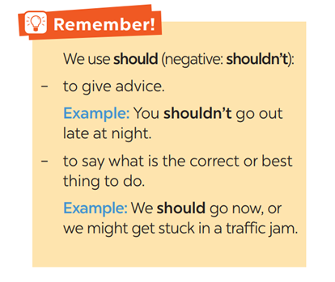  *Key:  1.should 2. should 3. shouldn't  4. should 5. shouldn't
Task 4
* Aims: To help Ss practise the uses of the modal verb should/shouldn't.
* Content: Complete each sentence, using should / shouldn’t.
* Products: Complete each sentence exactly
* Organization of implementation:
Teacher’s and Ss’ activities |  | Content
Task 4  * Teacher gives Ss time to do the exercise individually and peer check with their partner.  **Call on some Ss to read the sentences aloud  *** Other Ss comment’  **** Teacher checks and gives the corrections if they have mistakes. |  | Task 4: Complete each sentence, using should / shouldn’t.  * Answers:  1- shouldn’t 2- should 3- shouldn’t  4- should 5- should 6- shouldn’t
Activity 4: Production (5’)
Task 5
* Aims: To help Ss apply the uses of should / shouldn't in real context by making sentences using pictures and the cues.
* Content: Look at the pictures. Make sentences, using should / shouldn’t and the cues.
* Products: Ss write their answers on the board.
* Organization of implementation:
Teacher’s and Ss’activities |  | Content
Task 5  *Have Ss look at the pictures carefully. Provide the answer for the first item since it has a when phrase and Ss may not realise this.  ** Give them some time to work independently and write down the answers.  -Then let them work in groups to check and say out the sentences.  - T goes round giving help when and where necessary.  *** Some Ss may write their answers on the board.  **** Other Ss comment and T makes corrections. |  | - Task 5: Look at the pictures. Make sentences, using should / shouldn’t and the cues  * Answers:  1- He shouldn’t waste water.  2- They should wear their helmets.  3- She should be more careful.  4- They shouldn’t play football on the pavement.  5- They shouldn’t ride their bikes dangerously.
Activity 5: Consolidation (3’)
* Aim: To consolidate what students have learnt in the lesson.
* Content: Summarise the main grammar points of the lesson.
* Products: Students say what they have learnt in the lesson
* Organization of implementation:
Teacher’s and Ss’ activities |  | Content
- Teacher asks students to talk about what they have learnt in the lesson. |  | Summarise the main grammar points of the lesson.  - It indicating distance  - Should/shouldn’t
* Homework (2’)
* Aim: To revise the knowledge that students have gained in this lesson.
* Content: Review the lesson and prepare for the next lesson and do exercise in the workbook

Teacher’s and Ss’ activities |  | Content
- T reminds Ss to do homework and prepare the new lesson. |  | - Do exercise in the workbook.  - Prepare lesson 4 ( communication)

*- Evaluation: …………………………………………………………………………………………………………………………………………………………………………………………………….

Date of planning: 10 -1 -2025
Date of teaching: 21-1 -2025
UNIT 7: TRAFFIC
Period 58: Lesson 4: COMMUNICATION

I. Objectives: By the end of the lesson, the students will be able to:
1. Knowledge:
- Learn how to ask and answer about means of transport and some strange traffic rules.
- Practice using some grammar points and vocabulary related to the topic.
a. Grammar : structures to give compliments.
b. Vocabulary: vocabulary on community activities.
2. Competences:
- Asking and answering about means of transport.
- Develop communication skills
- Be collaborative and supportive in pair work and team work
- Actively join in class activities
3. Attitude: Help Ss
- Be benevolent and responsible
- Establish good habits in obeying traffic rules
II. TEACHING AIDS:
1. Materials: Textbooks, plan
2. Equipment: A laptop connected with TV, textbooks
III. PROCEDURES:

Activity 1: Warm-up (5’)
* Aim: To introduce the lesson.
* Content: Game: BRAINSTORMING
* Products: Students play a game by writing the names of means of transport
* Organization of implementation:
Teacher’s and Ss’activities |  |  | Content
* Warm up Team work  * Teacher divides class into 2 teams and asks them to think of “MEANS OF TRANSPORTS” (even the strangest ones).  ** Ss have 1 min to think of the words related to the topic or they can discuss with their partners.  *** Each member from each team turn by turn run to the board and write one word.  **** Teacher corrects their answers.  -The team which has more correct words will be the winner  + Lead in  To lead in the lesson about communication. |  |  | * Game: BRAINSTORMING  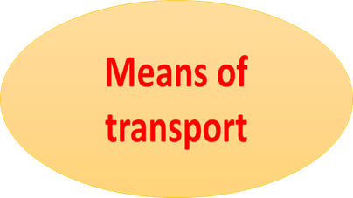  * Suggested answers:  Motorbike, bicycle, train, bus, plane, helicopter,…
Activity 2: Presentation (10’)
* EVERYDAY ENGLISH
Asking and answering about means of transport
* Aim: To let students know the structure to ask and answer about means of transport.
* Content: Listen and read the conversation, paying attention to the highlighted parts
* Products: Ss understand and know to how to ask and answer about means of transport
* Organization of implementation:
Teacher’s and Ss’activities |  | Content
Task 1  * Teacher plays the record for SS to listen and read the conversation about means of transport.  ** Ss listen and practice saying with their partners.  *** Teacher calls some pairs to read aloud.  **** Teacher corrects pronunciation if needed.  * Teacher asks Ss to pay attention to the highlighted parts and asks them some questions to elicit the new structure:  - Which tense do we use to ask and answer?  - Which question word do we use?  - …..  ** Ss answer teacher’s questions to find out new structure to ask and answer about means of transport to travel to places  *** Some students give the new structure to the teacher.  **** Teacher corrects and writes on the board: |  | Task 1: Listen and read the conversation, paying attention to the highlighted parts.  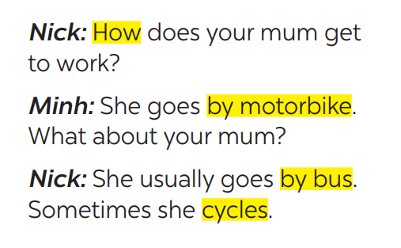  - Structure:  * to ask:  How do/does + S + go to …?  * to answer:  - S + go/goes by …  - S + V
* Practice (5’)
Task 2
* Aims: To help students practise on how to ask and answer about means of transport
* Content: Ask and answer about the means of transport your family members use every day.
* Products: Role play and practice in front of the class fluently.
* Organization of implementation:
Teacher’s and Ss’activities | Content
Task 2:  * Teacher has SS look at the situation in Ex 2 to make similar dialogue:  ** Ss work in pairs to make similar dialogue.  *** Teacher calls some pairs to present it in front of the class.  **** Teacher gives feedback and some comments. | Task 2: Work in pairs. Take turns to ask and answer about the means of transport your family members use every day.  * Suggested answers:  A: How does your father go to work?  B: He usually drives his car but sometimes he goes by bus. How about your father?  A: He walks because we live near his office.
Activity 3: (10’)
* STRANGE TRAFFIC RULES
* Aims: To provide Ss with some countries where the traffic rule is to keep to the left.
* Content: Tick the names of the countries where the traffic rule is to keep to the left side of the road.
* Products: Ss give their answers correctly.
* Organization of implementation:
Teacher’s and Ss’activities | Content
Task 3  * Explain to Ss that in many countries in the world, the traffic rule is to keep to the left side of the road instead of to the right.  **Ss work in groups and give the names of the countries where the traffic rule is to keep to the left side of the road.  *** Ask Ss to give their answers and correct them.  **** Teacher gives feedback and may give some more countries (Japan, Singapore, India, New Zealand, Malaysia, Indonesia, Bangladesh ...). | Task 3: Which countries below keep to the left? Tick the correct answers.  1. The United Kingdom ✓  2. The United States of America  3. Australia ✓  4. Thailand ✓  5. China
Task 4
* Aims: -To give Ss some listening practice;
-To provide Ss with some understanding of the traffic rule of keeping to the left.
* Content: listen again and complete the sentence with no more than THREE words.
* Products: Students complete the sentences exactly.
* Organization of implementation:
Teacher’s and Ss’activities | Content
Task 4  * Play the recording again.  ** Let Ss complete the sentence by themselves, then share their answers with a partner.  ***T goes round the class to give support if necessary.  ****Correct Ss' answers as a class. | Task 4: Listen and check your answers in 3. Then listen again and complete the sentence with no more than THREE words.  *Key:  One explanation is that some countries use the same system as the UK.  Audio script - Track 51:  The right side is the wrong side!  Do you know that there are many countries in the world where the traffic rule is to keep to the left? Some of these are the United Kingdom, Australia, Thailand, and so on. There are different explanations  for this. One explanation is that some countries use the same system as the UK.
Activity 4: Production (5’)
* Aims: -To provide Ss with some strange driving rules in the world;
-To give Ss some practice in talking about traffic rules.
* Content: Read, discuss which one do is the strangest rule?
* Products: Each group shares their answers with the class.
* Organization of implementation:
Teacher’s and Ss’activities | Content
Task  * Teacher has students work in groups to discuss which one they find strangest.  ** Ss work in groups.  *** 2-3 groups share their ides  **** Teacher encourages students to add more if they know. | Task 5: Read, discuss which one do is the strangest rule?  - Which one do you think is the strangest?
Activity 5: Consolidation (3’)
* Aims: To consolidate what students have learnt in the lesson.
* Content: Summarize the main content in the lesson.
* Products: Students say what they have learnt in the lesson.
* Organization of implementation:
Teacher’s and Ss’activities | Content
Teacher asks students to talk about what they have learnt in the lesson. | - how to ask and answer about means of transport  - recall some strange rules.
* Homework (2’)
* Aim: To revise what they have learnt and prepare for the next lesson Skills 1.
* Content: Review the lesson and prepare for the next lesson and do exersie in the workbook.
Teacher’s and Ss’ activities | Content
- T reminds Ss to do homework and prepare the new lesson. | - Do EX in the workbook.  - Prepare lesson 5 ( skills 1)
*- Evaluation: ………………………………………………………………………………………………………………………………………………………………………………………………………………….

Date of planning: 17-1-2025

Date of teaching: 22- 1 -2025

Period 59: UNIT 7: TRAFFIC

Lesson 6: SKILLS 1

I. Objectives : By the end of the lesson, the students will be able to:
- read for specific information about some rules about road safety
- talk about how to avoid traffic accidents
1. Knowledge:
a. Grammar : shoud / shouldn’t
b. Vocabulary: Vocabulary about traffic rules
2. Competences:
- know how to avoid traffic accidents
- Develop presentation skill
- Be collaborative and supportive in pair work and team work
- Actively join in class activities
3. Attitude: - Develop awareness of understanding the road signs and obeying the traffic rules.
II. TEACHING AIDS:
1. Materials: Textbooks, plan
2. Equipment: A laptop connected with TV, textbooks
III. PROCEDURES:

Activity 1: Warm-up (5’)
* Aim: To create a friendly and active atmosphere in the class before the lesson.
To lead in the topic of the reading text.
* Content: Game: Hangman
* Products: SS guess the word exactly.
* Organization of implementation:
Teacher’s and Ss’activities | Content
* Game  * Teacher divides class into 2 teams and asks them to think of the word which has 9 letters in it related the topic “ON THE ROAD”.  ** Ss have 1 min to think of the words related to the topic or they can discuss with their partners.  *** Each member from each team turn by turn guesses the letter in the secret word.  **** Teacher corrects their answers.  -The team which can find or guess the secret first will be the winner.  + Lead in:  - Teacher leads students into the lesson by telling what they are going to learn: “We are going to read a passage about some rules about road safety | * Game: Hangman  Which word has 9 letters in it related the topic “ON THE ROAD”?  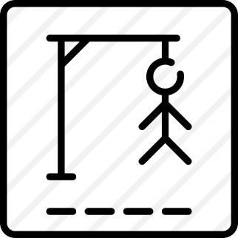  D A N G E R O U S
Activity 2: Pre-teach vocabulary (7’)
* Aim: - To prepare students with vocabulary related to the lesson; To lead in the reading skills.
* Content: Some vocabularies related the lesson.
* Products: Read and understand the meaning of the words.
* Organization of implementation:
Teacher’s and Ss’activities | Content
Pre teach vocabulary  * Teacher use different techniques to teach vocab (pictures, situation, realia)  ** Repeat in chorus and individually  *** Copy all the words  **** T checks vocab by technique  < Rub out and remember> | - * vocabulary:  - pedestrian (n) /pəˈdestrēən/: người đi bộ  - passenger (n) /ˈpasinjər/: hanh khách  - (to) obey / ōˈbā/: tuân thủ  - seatbelt (n) / ˈsēt ˌbelt/: dây an toàn  - zebra crossing /ˈziːbrə ˈkrɒsɪŋ/ (n.phr): vạch kẻ đường  - cyclist /ˈsaɪklɪst/ (n): người đi xe đạp  * Checking vocab: <R &R>
Activity 3: Pre- reading (5’)
Task 1
* Aims: To activate Ss' knowledge of the topic of the reading text (obeying traffic rules).
* Content: Look at the picture and answer the question.
* Products: Ss answer the question correctly.
* Organization of implementation:
Teacher’s and Ss’activities | Content
Task 1  * Tell Ss to look at the picture carefully.  ** Have them work in pairs to discuss the question: Why is it dangerous?  *** Encourage them to give their ideas (as many ideas as possible). It is not important whether they give the right answers or not; it is important that they speak in English.  - Teacher calls some Ss to check what they have discussed.  **** Teacher corrects and gives feedback. | Task 1: Look at the picture. Can you see anything that is dangerous?  * Answer key:  - The situation is very unsafe/dangerous.  - It’s dangerous to ride a bike so close to a car  - these students do not walk across the street at the zebra crossing
* While reading (10’)
Task 2
* Aims: To help Ss develop their reading skill for main ideas and specific information (scanning) and help them focus on the road safety rules
* Content: Read the text and choose the correct answer.
* Products: Students say the correct answer.
* Organization of implementation:
Teacher’s and Ss’activities | Content
Task 2  * Teacher has Ss read the first sentence of the text in detail to do the exercise and asks them how to do this kind of exercise.  ** Ss do the task independently  *** Teacher tells Ss to compare their answers in pairs before calling some of them to check.  **** Teacher confirms the correct answer and explains if needed. | Task 2: Read the following text and choose the correct answer.  * This text is about ______.  A. rules for pedestrians  B. traffic lights  C. traffic rules  * Keys: C ( This text is about traffic rules)
Task 3
* Aims: To help Ss develop their reading skill for specific information (scanning).
* Content: Read the text again and answer the questions.
* Products: Some pairs ask and answer in front of the class.
* Organization of implementation:
Teacher’s and Ss’activities | Content
Task 3  * Ask Ss to do the task individually. Tell them to read the passage two or three times, then read each question,  ** Ask Ss to work with a partner to discuss the answers.  *** Call on some pairs of Ss to ask and answer.  -Explain the new words and clarify anything difficult. T may ask questions to see if they understand the passage fully.  **** Check the answers as a class. | Task 3: Read the text again and answer the questions:  * Answer key:  1. They shoud cross the street at the zebra crossing.  2. We should always use the cycle lane.  3. We should give a signal before we turn while riding a bike  4. We must wait for buses to fully stop when you get on or off a bus.  5. We mustn’t stick any body parts out of the window when you are in a moving vehicle.
Activity 4: Post - Reading & Pre-Speaking (5’)
* Aims: To give Ss practice in asking and answering about obeying traffic rules.
* Content: Ask and answer the question: “When you are a road user, what should you NOT do?”
* Products: Some students present their answers to the class.
* Organization of implementation:
Teacher’s and Ss’activities | Content
Task 4  * Teacher asks Ss to work in groups and tells them to focus on the rules for road users in the text to talk about which one they have to obey every day.  ** Ss work in groups. Teacher goes around and listens and gives help if needed.  *** Teacher calls on some Ss to share their answers with the class.  **** Teacher listens and gives comment | Task 4: Work in groups. Ask and answer  the following question:  “When you are a road user, what should you NOT do?”  - I shouldn’t cross the road on a red light.  - I shouldn’t cycle in the pavement or footpath.  - I shouldn’t ride my bike fast.  - I shouldn’t carry a passenger in front of me.
* While -Speaking (5’)
* Aim: -To help Ss practise speaking about different situations that occur on the road.
-To provide Ss an opportunity to practise giving advices on dangerous situations on the road.
* Content: Discuss who is using the road safely, and who is acting dangerously.
* Products: Students gives their opinion correctly.
* Organization of implementation:
Teacher’s and Ss’activities | Content
Task 5  * Teacher has Ss work in groups and asks them to take turns to discuss the situations.  ** Ss work in groups to do the task. Teacher goes around, listens and gives help if needed.  *** Teacher calls on some groups to share their answers with the class.  **** Teacher comments | Task 5: Read the following sentences  about these people. Then work in groups. Discuss who is being safe, and who isn’t  - *Keys:  1.safely  2.dangerously (because he may have an accident because when it rains hard, the road is very slippery, easy to cause an accident if he drives fast)  3.safely  4.dangerously (it is difficult for him to see the road properly and to ride)  5.dangerously (she may have an accident because she loses concentration when cycling)
Activity 5: Consolidation (2’)
* Aims: To consolidate what students have learnt in the lesson.
* Content: summarize the main content in the lesson.
* Products: Students say what they have learnt in the lesson.
* Organization of implementation:
Teacher’s and Ss’ activities | Content
- Teacher asks students to talk about what they have learnt in the lesson. | - Some vocabularies related the lesson  - When you are a road user, what should and shouldn't you do?
*Homework (2’)
* Aim: To revise the knowledge that students have gained in this lesson.
* Content: Review the lesson and prepare for the next lesson and do exersie in the workbbook
Teacher’s and Ss’ activities | Content
- Teacher asks students to revise old lesson and to do exercise in workbook. | - Do exercise in workbook.  - Prepare for the next lesson: Skills 2.

Date of planning: 22 -1 -2025
Date of teaching: 4-2 -2025
Period 60: UNIT 7: TRAFFIC
Lesson 6: SKILLS 2

I. Objectives : By the end of the lesson, the students will be able to:
1. Knowledge:
+ Listening
use the lexical items related to the topic Traffic
listen for main ideas and specific information about traffic problems in Mumbai.
+ Writing: write about traffic problems in your area.
a. Grammar : The simple tense
b. Vocabulary: Vocabulary about traffic problems
2. Competences:
- Write a paragraph about the traffic problems in your town / city.
- Develop communication skills
- Be collaborative and supportive in pair work and team work
- Actively join in class activities
3. Attitude: Help Ss develop awareness of understanding the road signs and obeying the traffic rules.
II. TEACHING AIDS:
1. Materials: Textbooks, plan
2. Equipment: A laptop connected with TV, textbooks
III. PROCEDURES:
Activity 1: Warm-up (5’)
* Aim: To activate students’ prior knowledge and vocabulary related to the lesson.
* Content: Game: Brainstorming
* Products: Some students give their answers correctly.
* Organization of implementation:
Teacher’s and Ss’activities |  |  | Content
Warm up  * Teacher writes on the board the word “Traffic problems” and asks Ss some questions:  + What does this word mean?  + What do we have to suffer from these problems?  + Can you name some traffic problems?  ** Ss think of these questions and discuss with their partners if needed.  *** Teacher calls some students to give their answers.  **** Teacher listens and give comments.  + Lead in: Teacher introduces students the content of the lesson: “In the lesson today, we are going to listen to a person talking about traffic problems in his city - Mumbai.” |  |  | Game: BRAIN STORMING:  Traffic problems  * Keys:  - Drink alcohol  - Not obeying traffic laws  - traffic jam  - too many vehicles  - drive line up when riding on the road  - driving too fast, overtaking carelessly  - Cross the red light:  - many narrow roads
Activity 2: LISTENING
Pre-Listening (2’)
* Aim: To activate Ss' knowledge of the topic of the listening text (traffic problems).
* Content: Look at the picture and answer the questions.
* Products: Some students give the correct answers in front of the class.
* Organization of implementation:
Teacher’s and Ss’activities |  | Content
Task 1  * Teacher asks Ss to work in pairs to the problems they can find in the picture.  ** Ss work with their partner to do the task.  *** Teacher calls on some Ss to answer.  **** Teacher gives comments and leads Ss to task |  | Task 1: What can you see in this picture? What is special about it?  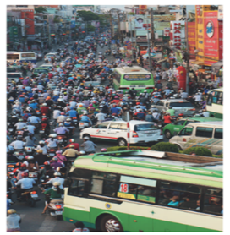  I can see a lot of vehicles on the road.  I can see a serious traffic jam.  I can see that some drivers don't obey traffic laws/rules.  I can see that it's very dangerous.
* While -listening (10’)
Task 2
* Aims: To help Ss practise listening for the main idea / general information.
* Content: Listen to the recording and choose the correct answer A, B, or C.
* Products: Students say the correct answers aloud.
* Organization of implementation:
Teacher’s and Ss’activities | Content
Task 2  * Teacher asks Ss to read and underline the key words.  ** Ss work independently to guess then listen to the recording once to check their guess.  *** Teacher calls on some students to give the answers the have listened. | Task 2: Task 2: Listen to the recording and choose the correct answer A, B, or C  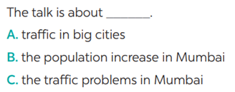  * Keys: C. the traffic problems in Mumbai
Task 3
* Aims: To help Ss practise listening for specific information (to find and write down some words while listening to the recording).
* Content: Listen again and write ONE word or number in each gap.
* Products: Students write the correct answers on the board.
* Organization of implementation:
Teacher’s and Ss’activities | Content
Task 3  * Tell Ss that they are going to listen to a passage about traffic problems in Mumbai, India.  ** Have Ss read through the sentences first. Ask them to guess the word / number to fill in each gap and write down their guesses.  ***Play the recording once or twice. Ask Ss to listen carefully and write down the correct answers.  **** Play the recording once more for Ss to check their answers. | Task 3: Listen again and write ONE word or number in each gap  1. Traffic _______ happen nearly every day in Mumbai.  2. One reason for the traffic _______ is the increase of the population.  3. Mumbai has nearly _______ million people.  4. The _______ in Mumbai are narrow.  5. Many road users do not _______ the traffic rules.  Keys:  l. jams 2. problem/jams 3. 20/twenty  4. roads 5. obey
* Post- listening (5’)
* Aims: To help Ss use what they have listened to life context.
* Content: Compare traffic problems in Mumbai to the traffic problems in Hanoi.
* Products: some Ss share their answers in front of the class.
* Organization of implementation:
Teacher’s and Ss’activities | Content
Discuss  * Teacher tells Ss to work in groups to discuss and compare traffic problems in Mumbai to the traffic problems in Hanoi. Write down onto the notebooks in full sentences  ** Ss work in groups. Teacher moves around and offers help if needed.  *** Teacher invites some Ss to share their answers.  **** Teacher corrects if needed. | * Discuss: Compare traffic problems in Mumbai to the traffic problems in Hanoi.  E.g. The traffic jams in Hanoi is as serious and frequent as they are in Mumbai.
Activity 3: WRITING
Pre-Writing (5’)
* Aims: To help Ss identify the traffic problems in their town / city to prepare for the writing task in 5.
* Content: Tick the traffic problems in big cities in Viet Nam.
* Products: Ss give out more problems that they see in their city.
* Organization of implementation:
Teacher’s and Ss’activities | Content
Task 4  * Teacher writes on the board “Your city’s Traffic Problems” and asks Ss to tick the traffic problems in big cities in Viet Nam and asks them to give out more problems that they see in their city.  ** Ss think of it and can discuss with their partners.  *** Teacher calls on some Ss to raise their ideas.  **** Teacher listens and confirms. | Task 4: Tick the traffic problems in big cities in Viet Nam  *Suggested answers:  Too many vehicles  Narrow roads  People’s awareness  …
While-Writing (5’)
* Aim: To help Ss practise writing a passage about 70 words about the traffic problems in their town / city.
* Content: Write a paragraph about 70 words about the traffic problems in their town / city.
* Products: Students’perfect writing on the posters.
* Organization of implementation
Teacher’s and Ss’activities | Content
Task 5  *Tell Ss to read the sentences they have written in 4.  ** Have them study the outline.  *** Ss practise writing a paragraph. Tell them to use proper connectors {first / firstly, second / secondly, etc.), and pay attention to grammar, use of words, spelling and punctuation.  **** T may collect some Ss' writings and mark them, then comment to the class.  + If there is not enough time for Ss to do their task in class, have them do it as homework. | Task 5: Write a paragraph of about 70 words about the traffic problems in your town/city.  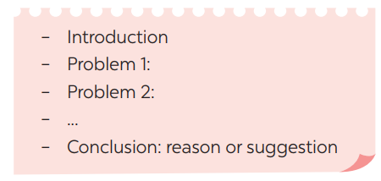  I live in Quang Ngai city. It is a small and busy city. There are lots of vehicles on the road all day. There are lots of cars, buses, taxis and trucks on high ways. Most people travel by motorbike. Every family has a motorbike. The traffic jam is often at about 7 a.m and 5 p.m because it’s the time when people go to work or school and come back home. There are sometimes accidents on the road. Therefore, to reduce these problems, we need to obey traffic rules to reduce accidents as much as possible.
Activity 4: Post-Writing (3’)
* Aim: To peer check, cross check and final check students’ writing.
* Content: Cross check students’ writing
* Products: Students check the others’ writing carefully.
* Organization of implementation:
Teacher’s and Ss’ activities | Content
*** Teacher asks students to exchange their textbooks to check their friends’ writing.  ****Teacher then gives feedback as a class discussion. | + Exchange their textbooks to check their friends’ writing.
Activity 5: Consolidation (2’)
* Aim: To consolidate what students have learnt in the lesson.
* Content: Summarize the main content in the lesson.
Teacher’s and Ss’ activities | Content
- Teacher asks students to talk about what they have learnt in the lesson. | - Listen information about traffic problems in Mumbai  - Write a paragraph about 70 words about the traffic problems in their town / city
* Homework (2)
* Aim: To revise the knowledge that students have gained in this lesson.
- To allow students finalize their versions after being checked by friends and teacher.
* Content: Review the lesson and prepare for the next lesson and do exercise in the workbook
- Teacher asks students to write down the paragraph in their books.  - Teacher asks students to prepare the new lesson. | - Rewrite the paragraph in the notebooks.  - Prepare Looking back and project.

* Evaluation: …………………………………………………………………………………………………………………………………………………………………………………………………

Date of planning: 25-1 -2025
Date of teaching: 5-2-2025

Period 61 : UNIT 7: TRAFFIC

Lesson 7 : LOOKING BACK & Project

I. Objectives: By the end of the lesson, the students will be able to:
1. Knowledge:
- Review the vocabulary and grammar of Unit 7
- Apply what they have learnt (vocabulary and grammar) into practice through a project
a. Grammar : It indicate distance / should and shouln’t
b. Vocabulary: Vocabulary about traffic problems and traffic rules
2. Competences:
- Develop communication skills
- Develop presentation skill and critical thinking skill
- Be collaborative and supportive in pair work and team work
- Actively join in class activities
3. Attitude: Help Ss Be more creative when doing the project
II. TEACHING AIDS:
1. Materials: Textbooks, plan
2. Equipment: A laptop connected with TV, textbooks
III. PROCEDURES:

Activity 1: Warm-up (5’)
* Aim: To activate students’ prior knowledge and vocabulary related to the topic.
  - * Content: Listen a song and answer the question.
* Products: Students write correct words on the board.
* Organization of implementation:
Teacher’s and Ss’activities |  |  | Content
Warm up  * Teacher has students watch a video and asks Ss to answer the question.  ** Ss listen and watch a video clip.  ***Teacher calls some students to answer the question and say some rules for road users.  **** Teacher confirms and leads them to do all the exercises in books. |  |  | - * Warm up: Listen a song and answer the question.  - What is the song about?  - say some rules for road users?
  - Activity 2: VOCABULARY (10’)
Task 1
* Aim: To help Ss revise the phrases indicating road signs.
* Content: Label each traffic sign.
* Products: Students write correct words on the board. (say the correct answers aloud)
* Organization of implementation:
Teacher’s and Ss’activities |  | Content
Task 1  * Teacher has Ss work individually.  ** Ss do this activity individually, then compare their answers with their partners.  *** Teacher asks for Ss’ answers.  **** Teacher confirms the correct ones |  | Task 1: Label each sign. Work in pairs.  What does each sign tell us to do?  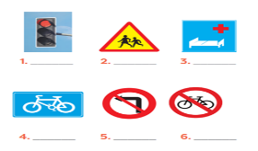  * Answer keys:  1. red light 2. school ahead  3. hospital ahead 4. cycle lane  5. No left turn 6. Do not cycle
Task 2
* Aims: To help Ss revise the vocabulary related to traffic.
* Content: Fill in each gap with one word to complete the sentences.
* Products: Students write the correct words on the board.
* Organization of implementation:
Teacher’s and Ss’activities | Content
Task 2  * T asks Ss to read the sentences first. Tell them to pay attention to the gaps, and what words they need to fill in them.  ** Ss write the answers in their notebooks, then compare their answers with their partners.  *** T asks some of them to write the words on the board.  **** T corrects the mistakes if necessary. | Task 2: Fill in each gap with one word to complete the sentences.  * Answer keys:  1. user  2. ride  3. passenger  4. drive/ fly  5. traffic
Activity 3: GRAMMAR (10’)
Task 3 + Task 4
* Aims: To help Ss revise the structure with “It “indicating distance and make sentences using cues. To help Ss revise the uses of modal verb should/shouldn't in sentences.
* Content: Write complete sentences, using these cues
* Products: Students write completed sentences on the board
* Organization of implementation:
Teacher’s and Ss’activities | Content
Task 3  * Teacher asks Ss to recall the structures of asking and answering about distance, and tell them to do Ex 3 in the book.  ** Ss do the exercise individually and swap with their partners.  *** Teacher calls some Ss to check their answer.  **** Teacher confirms the correct answer.  Task 4  * Teacher asks Ss to do the task.  ** Ss work individually to do the task.  *** Teacher calls Ss to give out their answers.  **** Teacher checks and confirms their answer.  -T may review the uses of can, could, might to the class. | Task 3: Write complete sentences, using these cues  * Key:  1.It is over 100 km from my home town to Ho Chi Minh City.  2.It is about 25 km from here to my grandparents' house.  3.It is not very far from our school to the city museum.  4.How far is it from your house to the gym?  5.Is it a long distance from Ha Noi to Ban Gioc Waterfall?  Task 4: Choose A, B, or C to complete the sentences.  + Notes:  - Should/ shouldn’t + V: dùng để khuyên ai nên làm gì hoặc khg nên làm gì  - would + V: dùng cho những hành động theo thói quen  - could: thường dùng trong câu hỏi, nhằm đưa ra một lời đề nghị  - can + V: diễn tả khả năng xảy ra của sự việc, cho phép ai đó làm gì  - might: diễn tả khả năng có thể xảy ra của sự vật  * Answer keys:  1. C 2. B 3. C  4. A 5. C 6. B
Activity 4: PROJECT(5’)
Task 5:
* Aims: To help Ss identify common traffic signs and make their own road signs.
* Content: Make a project about: “Trafic signs”
* Products: Students report the results to the class.
* Organization of implementation:
Teacher’s and Ss’activities | Content
Task 5  * Teacher asks Ss to show the signs they have prepared and identify the messages in each of the sign.  * Teacher also has Ss spend some time to make their own signs and practise presenting within their groups.  ** Ss discuss with their partners.  *** Some students raise their ideas and explain their answers.  **** Teacher listens and confirms.  Task 6:  * Teacher asks Ss to work in groups of 4 – 6 to stick their traffic signs onto the classroom’s wall and present about them.  ** Ss work in group to do the task.  *** Teacher calls some groups to present their signs to the class  **** Teacher confirms and corrects. | Task 5: Show the prepared signs. Make your own sign.    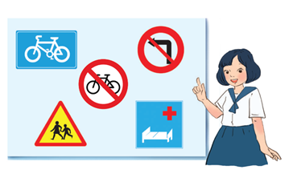  * Task 6: Traffic signs exhibition  - I saw some traffic signs on my way from home to school:  1. Red light  I see a red light on a traffic light when going through a crossroads. A "red light" sign means you have to stop.  2. School ahead  On my way to school, I see a “school ahead sign”. A "school ahead" sign means there is a school ahead.
Activity 5: Consolidation (2’)
* Aim: To consolidate what students have learnt in the lesson.
* Content: summarize what students have learnt in the lesson.
* Products: Say aloud what they have learnt in the lesson.
* Organization of implementation:
Teacher’s and Ss’activities | Content
- Teacher asks students to talk about what they have learnt in the lesson. | - - review the vocabulary and grammar of Unit 7  - Make a project about: “Trafic signs”
* Homework (2’)
* Aim: To revise the knowledge that students have gained in Unit7 and Prepare for the next lesson: Unit 8 – Getting started.
* Content: Review the lesson and prepare for the next lesson and do exercise in the workbook
Teacher’s and Ss’ activities | Content
- Teacher asks students to revise old lesson and to do exercise in workbook.  - Teacher asks students to complete the project and prepare the new lesson. | - Do exercise in workbook.  - Complete the project  - Prepare for the next lesson: Unit 8 –Lesson 1. Getting started.

*- Evaluation: …………………………………………………………………………………………………………………………………………………………………………………………………………………

