Date of planning : 1/12 / 2024
Date of teaching: 6/12 / 2024
Week 14: UNIT 6: A VISIT TO A SCHOOL
Period 42: Lesson 1: Getting started – A visit to Binh Minh Secondary School
I. OBJECTIVES:
By the end of this lesson, Ss will be able to gain:
1. Knowledge
- An overview about the topic A visit to a school
- Vocabulary to talk about school facilities
2. Competences
- Develop communication skills and cultural awareness
- Be collaborative and supportive in pair work and teamwork
- Actively join in class activities
3. Qualities
- The love of school; The awareness about importance of school; Be ready to talk about the school; Know some daily activities at school.
- Develop self-study skills.
II. TEACHING AIDS
1. Teacher: - Grade 7 textbook, Planning (Unit 6, Getting started)
- Smart TV/Pictures, sets of word cards
- sachmem.vn
2. Students: Text books, notebooks, posters, ….
III. PROCEDURES :
Activity 1: Warm-up (5’)
* Aim: To set the context for the listening and reading text.
To introduce the topic of the unit.
* Content: CHATTING (some Qs)
* Products: Ss discuss and answer some questions clearly.
* Organization of implementation:
Teacher’s and Ss’activities |  |  | Content
T – SS  * Teacher asks students some questions related to the topic:  ** Students raise hands to answer the questions.  *** Teacher and students discuss the questions.  **** Teacher accept all students’ questions.  + Lead in  * Teacher draws students’ attention to the picture in the textbook and asks them some questions about it:  ** Students raise hands to answer the questions.  *** Teacher and students discuss the questions.  **** Teacher accept all students’ questions. |  |  | * Warm up: CHATTING  1. Have you ever visited a famous school?  → Ss’ answers  2. What do you want to know when you have a visit to another school?  - Number of students and teachers  - School facilities  - School activities  - Subjects  - school timetables  ………………………  - What is the girl doing?  - What are they talking about?
Activity 2: Presentation (5’)
* Pre teach vocabulary
* Aim: to introduce new vocabulary
* Content: learn some vocabularies related to the topic.
* Products: Students read and understand the meaning of vocab.
* Organization of implementation:
Teacher’s and Ss’activities |  | Content
- T - Ss.  * Teacher introduces the vocabulary by giving definitions / examples of the words.  ** Teacher writes all students’ answers on the board.  *** Teacher circles or highlights the following words and discuss the meanings of these words:  **** Teacher checks students’ pronunciation and gives feedback. Teacher reveals that these words will appear in the reading text and asks students to open their textbook to discover further. |  | * Vocabulary  - lower secondary school (n.phr): trường trung học cơ sở  - member (n): thành viên  - remind (v): nhắc nhở/ gợi nhớ  - prepae (v) : chuẩn bị  - playground (n) : sân chơi  * Checking vocab: < Rub out and remember>
Activity 3: Practice: (20’)

Task 1
* Aims: To help students get the main idea of the text.
To help students scan the text for the information to fill the blanks.
* Content: Listen and read the dialouge
* Products: Students read and understand the meaning of the dialogue.
Students know how to role play
* Organization of implementation:
Teacher’s and Ss’activities | Content
T-Ss, Ss-Ss  * Teacher can play the recording more than once.  ** Students listen and read.  *** Teacher can invite some pairs of students to read aloud.  **** Teacher check students’ pronunciation and give feedback. | Task 1. Listen and read  * Role play.
Task 2
* Aims: To help Ss get the main idea of the text.
* Content: Read the conversation again and answer the questions.
* Products: Students say correct key aloud .
* Organization of implementation:
Teacher’s and Ss’activities | Content
Task 2: T-Ss, Ss-Ss  * Teacher tells students to read the conversation again and work independently to find the answers.  ** Students do the task individually.  *** Other Ss correct if the previous answers are incorrect.  **** Teacher calls some students to give the answers and gives feedback. | Task 2. Read the conversation again and answer the questions.  * Answer key:  1. B  2. C  3. C  4. B
Task 3
* Aims: To help students identify school facilities.
* Content: Name these places, using the words and phrases from the box.
* Products: Students’ correct answers on the board.
* Organization of implementation:
Teacher’s and Ss’activities | Content
Task 3: T-Ss, Ss-Ss  * Teacher divides the class into 2 teams. Teacher explains instructions of the game:  Teacher sticks 5 pictures on the board and gives each team a set of cards with names of places.  Members of each team take turns and stick the suitable card under each picture.  The team with more correct answers is the winner.  ** Students play the games in teams.  *** Teacher has students write down the correct answers on their books.  **** Teacher confirms the answers and gives feedback. Teacher can ask for translation to check their understanding. | Task 3: Name these places, using the words and phrases from the box.  Game: Who is faster?  * Answer key:  1. gym  2. computer room  3. school garden  4. playground  5. school library
Task 4
* Aims: To help Ss know how to use the words in Task 3 correctly.
* Content: Complete the sentences with the words and phrases in Task 3.
* Products: Ss write the correct anwers on the board.
* Organization of implementation:
Teacher’s and Ss’activities | Content
T-Ss, Ss-Ss  * Teacher asks students to work individually to complete the task.  ** Students fill in the blanks with the most suitable words/ phrases.  *** Teacher allows students to share answers before discussing as a class.  **** Teacher can ask for translation to check their understanding. | Task 4: Complete the sentences with the words and phrases in Task 3.  * Answer key:  1. playground  2. computer room  3. gym  4. school library  5. school garden
Activity 4: Production:(5’)
* Aims: - To help Ss practise talking about a visit to a school.
- To give students authentic practice in using target language.
* Content: Work in pairs. Ask and answer questions about Nick’s timetable, using when and where.
* Products: Students pratise in pairs; some pairs to practise in front of the class.
* Organization of implementation:
Teacher’s and Ss’activities | Content
T-Ss, Ss-Ss  * Teacher models this activity with a more able student first.  ** Teacher asks students to work in pairs.  *** Teacher can go around to help weaker students.  **** Teacher calls on some pairs to practise in front of the class. | Task 5: Work in pairs. Ask and answer questions about Nick’s timetable, using when and where.  * Example:  A: When does Nick have maths?  B: At 8 a.m. on Monday, Tuesday, and Friday.  A: And where does he have it?  B: In his classroom, room 302.
Activity 5: Consolidation (3’)
* Aim: To consolidate what students have learnt in the lesson.
* Content:.summarize the content of the lesson.
* Products: Say aloud some words they remember from the lesson.
* Organization of implementation:
Teacher’s and Ss’ activities | Content
- Teacher asks students to talk about what they have learnt in the lesson.  - Ss work indepently | - Some new words  - Read and understand content of the conversation
* Homework (2’)
* Aim: To revise the lesson and prepare for the next lesson.

Teacher’s and Ss’ activities | Content
- T reminds Ss to do homework and prepare the new lesson. | - Learn by heart all the new words.  - Read the dialogue again.  - Prepare lesson 2 ( A closer look 1).
*- Evaluation: …………………………………………………………………………………………………………………………………………………………………………………

Date of planning : 6/12 / 2024
Date of teaching : 10,11/12 / 2024
Week 15: UNIT 6: : A VISIT TO A SCHOOL
Period 43: Lesson 2: A closer look 1
I. OBJECTIVES
By the end of this lesson, Ss will be able to gain:
1. Knowledge:
- Vocabulary: school activities
- Pronunciation: correctly pronounce words that contain the sounds: /tʃ/ and /dʒ/
2. Competences
- pronounce the sounds /tʃ/ and /dʒ/ correctly;
- use some words to talk about one’s school;
- Develop communication skills and creativity
- Be collaborative and supportive in pair work and teamwork
- Actively join in class activities
3. Qualities
- the love for their country, know to preserve and be proud of their school.
- Develop self-study skills
II. TEACHING AIDS
1. Teacher: - Grade 7 textbook, Planning ( Unit 6- A closer look 1)
- Smart TV/Pictures, sets of word cards
- sachmem.vn
2. Students: Text books, notebooks, posters, ….
III. PROCEDURES : (STAGES)
Activity 1: Warm-up (5’)
* Aim: To activate students’ prior knowledge and vocabulary related to the topic, the targeted vocabularies and its pronunciation
* Content: * Game: PASS THE SECRET
* Products: Students write correct words on the board. (team work)
* Organization of implementation:
Teacher’s and Ss’activities |  |  | Content
- T - Ss  * Teacher explains the game rules.  ** Students play in teams. Teacher whispers some school facilities to one member from each team (school playground, computer room, gym, school library, …). The students have to pass the secrets to the person next to him / her. The last student of each team says the word out loud. The team finishing more quickly and with more correct answers is the winner.  *** Teacher and students discuss the answers.  **** Teacher confirms the answers and gives feedback. |  |  | * Game: PASS THE SECRET  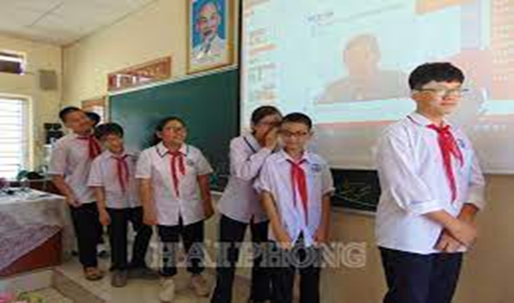  (school playground, computer room, gym, school library, flowers garden…).
Activity 2: Presentation (7’)
(Vocab- pre-teach)
* Aim: To enrich students’ vocabulary with the topic in the lesson.
* Content: Some vocabularies related the topic.
* Products: Read and understand the meaning of vocab.
* Organization of implementation:
Teacher’s and Ss’activities | Content
- T - Ss  * Teacher introduces the vocabulary.  ** Teacher introduces the vocabulary by:  - providing the pictures  - providing the definition of the words.  *** Teacher asks students to repeat.  **** Teacher rubs out and checks.  * Checking vocab: < What and where> | * Vocabulary:
  - entrance exam (n.phr.)  - facility (n)  - midterm (n)  - outdoor (adj)  - gifted (adj) | kỳ thi đầu vào  thiết bị, tiện nghi  giữa học kì  ngoài trời  năng khiếu
Activity 3: Practice (10’)

Task 1
* Aims: To practice the targeted language and activate the background knowledge.
* Content: Match the words in columns A and B to form phrases. Then say them aloud.
* Products: Ss say aloud the correct answers in front of the class.
* Organization of implementation:
Teacher’s and Ss’activities |  | Content
Task 1: T-Ss  * Teacher asks students to look at the two columns and checks if they understand the meanings of all the words. Remind students that these words / phrases will be used again in the upcoming lessons.  ** Teacher gets students to do the exercise in individuals.  *** Ask them to share their answers in pairs before checking the answers as a class.  **** Teacher then encourages students to explain their answers. Correct if necessary. |  | Task 1: Match the words in columns A and B to form phrases. Then say them aloud.  * Answer key:  1. d 2. c 3. b 4. e 5. a
Task 2
* Aims: To help students practice using the phrases related to the topic.
* Content: Complete the sentences with the phrases in Task 1.
* Products: Ss write the correct answers on the board.
* Organization of implementation:
Teacher’s and Ss’activities |  | Content
Task 2: T - Ss, Ss – Ss  * Teacher asks students what KEYWORD is and to pay attention to the KEYWORDS in Ex 2.  ** Teacher asks them to do Ex 2. Students do the task individually.  *** Teacher asks students to share their answers in pairs before checking the answers as a class.  **** Teacher then encourages students to explain their answers. Correct if necessary. |  | Task 2: Complete the sentences with the phrases in Task 1.  * Answer key:  1. gifted students  2. mid-term test  3. outdoor activities  4. school facilities  5. entrance examination
Task 3
* Aims: To let students practise asking and answering questions about their school.
* Content: Complete the sentences with the words in the box.
* Products: Ss read their correct sentences aloud .
* Organization of implementation:
Teacher’s and Ss’activities |  | Content
Task 3:T-Ss, Ss-Ss  * Teacher sets the scene, asks some Ss to explain and checks their understanding of their roles and the situations.  ** Then let some pairs role play the conversations in front of the class.  *** Teacher allows students to cross check first.  **** Teacher then checks pronunciation, if necessary. |  | Task 3: Work in pairs. Answer the questions about your school.    Eg: A: Can you name some gifted students in your school?  B: Minh, Ngan,….
Activity 4: * PRONUNCIATION (10’)
(Pre-teach the sounds /tʃ/ and /dʒ/.
Task 4
* Aims: To help students to identify how to pronounce the sounds /tʃ/ and /dʒ/.
* Content: PRONUNCIATION : Sounds /tʃ/ and /dʒ/.
* Products: Read and know how to pronounce the sounds /tʃ/ and /dʒ/.
* Organization of implementation:
Teacher’s and Ss’ activities |  | Content
Task 4:T-Ss, Ss-Ss  * Teacher shows a list of words on the screen and asks Ss to listen to the recording.  - Teacher asks them to note down the words they hear in the correct order. Give students a few minutes to look at the words and ask some Ss to repeat.  ** Teacher explains the difference between the sounds: /tʃ/ and /dʒ/.  Then asks Ss to practice pronouncing words in Ex. 4.  - Teacher plays the recording several times, if necessary, for students to listen and repeat the words.  *** Teacher allows students to cross check first.  **** Teacher then checks pronunciation and gives feedback, if necessary. |  | PRONUNCIATION  * Sounds /tʃ/ and /dʒ/.  (Teacher may let students watch the pronunciation video for this unit at this link: https://www.youtube.com/watch?v=Oq_9Hq-U8W0)  Task 4: Listen and repeat the words. What letters can we use to make the /dʒ/ sound?
Task 5
* Aims: To help students recognize the targeted sounds.
* Content: Listen and repeat the chant. Pay attention to the sounds /tʃ/ and /dʒ/.
* Products: Whole class practice reading the poem exactly.
* Organization of implementation:
Teacher’s and Ss’ activities |  | Content
Task 5 :T-Ss,  * Teacher plays the recording twice.  ** Students practice the chant in pairs or groups.  *** Teacher goes around to offer help or correct pronunciation, if necessary.  **** Teacher calls some students to say the sentences in front of the class. Check their pronunciation if necessary. |  | Task 5 Listen and repeat the chant. Pay attention to the sounds /tʃ/ and /dʒ/.  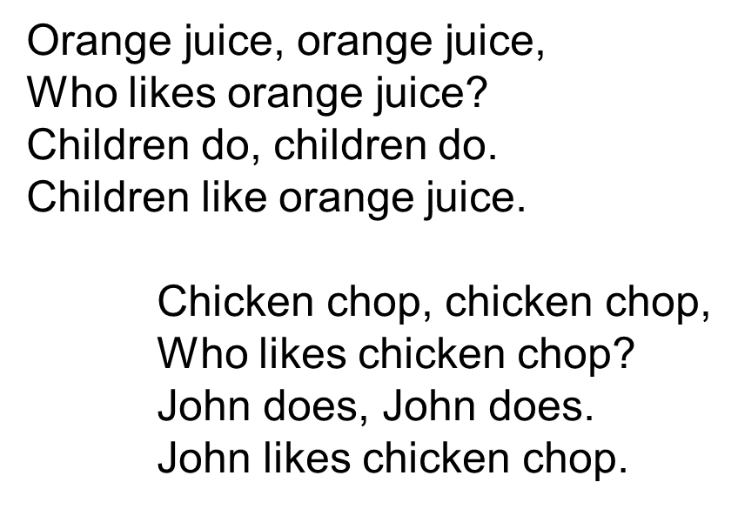
Activity 5: Production (5’)
* Aim: To test students' quick reaction to the targeted sounds.
* Content: game - Sentence race
* Products: Students pratise in groups.
* Organization of implementation:
Teacher’s and Ss’activities |  | Content
*Teacher explains the rules:  Teacher says 10 words in this order: maturity, teenager, exchange, project, jogging, chapped, originate, kitchen, picture, jeep.  ** Students play the game in teams.  *** Teacher helps students in the game.  **** Teacher gives feedback. |  | GAME: “UP AND DOWN”  Teacher says 10 words containing the sound /tʃ/ and /dʒ/. Students stand up for the ones with the /tʃ/ sound, sit down for /dʒ/ sound.
* Consolidation: (3’)
* Aim: To consolidate what students have learnt in the lesson.
* Content: Vocab and how to pronounce the sounds /s/ and /∫/
* Products: Say aloud what they remember from the lesson.
* Organization of implementation:
Teacher’s and Ss’ activities |  | Content
- Teacher asks students to talk about what they have learnt in the lesson |  | - Vocabulary and how to pronounce the /tʃ/ and /dʒ/.
* Homework (2’)
* Aim: To revise what they have learnt and prepare for the next lesson.

Teacher’s and Ss’ activities |  | Content
- T reminds Ss to do homework and prepare the new lesson. |  | - Learn by heart all the new words.  - Find some more words with the sounds /tʃ/ and /dʒ/.  - Prepare vocabulary for the next lesson: A closer look 2.

*- Evaluation: ……………………………………………………………………………………………………………………………………………………………………………………………………

Date of planning : 8/12 / 2024
Date of teaching : 11&12/12 / 2024
Week:15 UNIT 6: : A VISIT TO A SCHOOL
Period 44 : Lesson 3: A closer look 2

I. OBJECTIVES:
By the end of this lesson, Ss will be able to:
1. Knowledge:
- Use the prepositions of time and place
2. Competences:
- Know how to use the prepositions of time and place
- Develop communication skills and creativity
- Be collaborative and supportive in pair work and teamwork
- Actively join in class activities
3. Qualities:
- the love for their country, know to preserve and be proud of their school.
- Develop self-study skills
II. TEACHING AIDS
1. Teacher: - Grade 7 textbook, Planning (Unit 6, A closer look 2)
- Smart TV/Pictures, sets of word cards
- sachmem.vn
2. Students: Text books, notebooks, posters, ….
III. PROCEDURES: (STAGES)
Activity 1: Warm-up (5’)
* Aim: To activate students’ prior knowledge .
To introduce the targeted grammar: prepositions of place and prepositions of time.
* Content: Game: Pelmanism ( words and the meaning of words.)
* Products: Students’ correct choice. (team work)
* Organization of implementation:
Teacher’s and Ss’activities |  |  | Content
* Warm up (group work)  - T – Ss, Ss- Ss  * Teacher divides the class into 2 teams.  ** Teacher puts 12 sets of numbers, one includes word and the meaning of words.  ***Members from two teams choose the pair of number .  ****The group with the most correct word will be the winner  - Lead in :  These are the prepositions of time and place  Today we are going to learn abou how tot use the prepositions of time and place. |  |  | * Game: Pelmanism  EX . In the morning → Vào buổi sáng  On Monday → Vào thứ 2  At 5 o’clock → Vào lúc 5 h đúng  At home → ở nhà  On the table→ ở trên cái bàn  -
Activity 2: Presentation (7’)
Prepositions of time and place
* Aim: To have students get to know about the prepositions of time and place: in, on, at.
* Content: Present and explain how to use the prepositions of time and place: in, on, at.
* Products: Understand and know how to use the prepositions of time and place: in, on, at
* Organization of implementation:
Teacher’s and Ss’activities | Content
T – Ss, Ss- Ss  *Teacher asks students to study the Grammar box.  - Teacher draws students’ attention to the meaning and use of at, in, on.  ** Teacher then asks some more able students to give some more examples.  *** Students find out the form and the usage of prepositions of time and place  **** Teacher gives comments and writes on the board the form and the usage.  -T can have Ss some more examples about how to use the prepositions of time and place: in, on, at in other cases. | * Grammar  * Prepositions of time and place  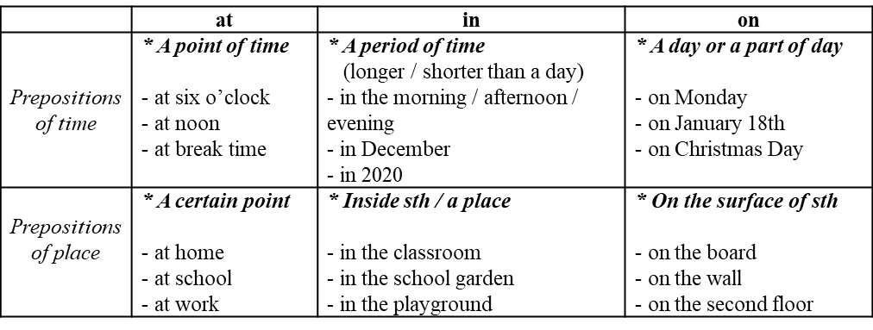
Activity 3: Practice (20’)
Task 1
* Aims: To check students’ understanding of the prepositions of time
* Content: Complete the sentences, using suitable prepositions of time.
* Products: Students say the correct answers aloud.
* Organization of implementation:
Teacher’s and Ss’activities |  | Content
T – Ss, Ss- Ss  * Teacher has students work individually.  ** Students work individually to complete the sentences.  *** Teacher lets students work in pairs and exchange the answers before checking with the whole class (explain each sentence if necessary).  **** Teacher confirms the answers and gives feedback. |  | Task 1: Complete the sentences, using suitable prepositions of time.  * Answer key:  1. at, at  2. in  3. in  4. on  5. at
Task 2
* Aims: To check students’ understanding of the prepositions of time.
* Content: Ask and answer the questions about your school.
* Products: Ask and answer the questions in front of the class fluently
* Organization of implementation:
Teacher’s and Ss’activities |  | Content
T –Ss  * Teacher has students read the questions individually. Remind them that the questions with when are used to ask about time and the prepositions of time (in, on, at) are used in the answers.  ** Students work in pairs to ask and answer the questions.  *** Teacher calls some pairs to ask and answer the questions in front of the class.  **** Teacher confirms the answers and gives feedback. |  | Task 2: Work in pairs. Ask and answer the questions about your school.  1. When does your school year start?  2. When do you have English lessons?  3. When do you usually celebrate Teachers’ Day?  4. When are you going to finish the school year?  * Suggested answer:  1. My school year starts in September.  2. I have English lessons on Monday and Friday.  3. I usually celebrate Teacher's Day on November 20th.  4. I am going to finish the school year in May.
Task 3
* Aims: To check students’ understanding of the prepositions of place.
* Content: Complete the sentences with at, in or on.
* Products: Ss write the correct answers on the board.
* Organization of implementation:
Teacher’s and Ss’activities |  | Content
T –Ss ; Ss- Ss  * Teacher asks students to read the instructions to understand how to do the activity.  ** Teacher asks students to do the exercise individually, draws their attention to the type of words after the gaps so that they can choose the appropriate prepositions (e.g. he … third floor shows the surface, so they write on in the gap).  *** Teacher then has them work in pairs, comparing their answers. Teacher can go around helping students.  **** If there is time, have some Ss write the answers on the board. T and other Ss comment. |  | Task 3: Complete the sentences with at, in or on.  * Answer keys:  1. on 2. At 3. In 4. At 5. on - in
Task 4
* Aims: To check students’ understanding of the prepositions of place.
* Content: Look at the pictures and answer the questions.
* Products: Some pairs to ask and answer the questions in front of the class correctly.
* Organization of implementation:
Teacher’s and Ss’activities |  | Content
T –Ss ; Ss- Ss  * Teacher has students read the instructions of the activity to understand what they are going to do. Remind them that questions with where are used to ask about places and prepositions of place (at, on, in) are used in the answers. Check comprehension.  ** Teacher asks students to do the exercise in pairs.  *** Then call on some pairs to ask and answer the questions in front of the class.  **** Teacher confirms the answers and gives feedback |  | Task 4: Work in pairs. Look at the pictures and answer the questions.  * Suggested answers:  1. At a school / lower secondary school  2. In the school garden  3. On the board  4. On the stage (of the school, in the meeting room)
Activity 4: Production ( 5’)
Task 5
* Aims: To help Ss distinguish the use of prepositions of place and prepositions of time.
* Content: Complete the passage with at, on, or in. Then discuss in groups.
* Products: Students’ correct answers and explain them exactly.
* Organization of implementation:
Teacher’s and Ss’activities |  | Content
* Teacher has one or two Ss say how the prepositions of time and place are used. Then ask them to read the instructions of the activity to understand what they are going to do.  ** Students do the task individually.  *** Teacher lets Ss discuss in groups and decide which prepositions express time and which ones express place. T goes around and corrects mistakes or gives help when necessary.  **** Teacher calls on some Ss to share their answers in front of the class. If time allows, select one or two Ss to read the complete passage in front of the class. T and other Ss comment. |  | Task 5: Complete the passage with at, on, or in. Then discuss in groups.  * Answer key:  1. in  2. in  3. at  4. at  5. on  6. on
Activity 5: Consolidation (3’):
* Aim: To consolidate what students have learnt in the lesson.
* Content: summarize the main content in the lesson.
* Products: Ss say what students have learnt in the lesson.
* Organization of implementation:
Teacher’s and Ss’activities |  | Content
Teacher asks students to talk about what they have learnt in the lesson. |  | * Grammar: How to use the prepositions of time and place
* Homework (2’)
* Aim: To revise the knowledge that students have gained in this lesson and prepare the new lesson
Teacher’s and Ss’ activities |  | Content
- T reminds Ss to do homework and prepare the new lesson. |  | - Do exercises in the workbook.  - Prepare lesson 4 ( communication)
*- Evaluation: …………………………………………………………………………………………………………………………………………………………………………………………………….

Date of planning : 9/12 / 2024
Date of teaching: 13/12 / 2024
Week: 15 UNIT 6: : A VISIT TO A SCHOOL
Period : 45 Lesson 4 : Communication
I. OBJECTIVES:
By the end of this lesson, Ss will be able to:
1. Knowledge:
- Vocabulary: revise vocabulary related to topic A visit to a school
- Grammar: structures to ask for details
2. Competences:
- Talk about one’s school
- Develop communication skills and creativity
- Be collaborative and supportive in pair work and teamwork
- Actively join in class activities
3. Qualities
- Students must love their school and be proud of their school.
II. TEACHING AIDS
1. Teacher: - Grade 7 textbook, Planning (Unit 6, communication)
- Smart TV/Pictures, sets of word cards
- sachmem.vn
2. Students: Text books, notebooks, posters, ….
III. PROCEDURES :
Activity 1: Warm-up (5’)
* Aim: To introduce the topic.
* Content: Game: Matching ( flags and the names of the countries).
* Products: Ss match flags and know the names of the countries correctly .
* Organization of implementation:
Teacher’s and Ss’activities |  |  | Content
* Warm up: T – Ss  * Teacher shows the picture and asks students questions:  ** Students raise hands to answer the questions.  *** Teacher and students discuss the questions.  **** Teacher gives feedbacks and leads in the new lesson. |  |  | * Game: chatting  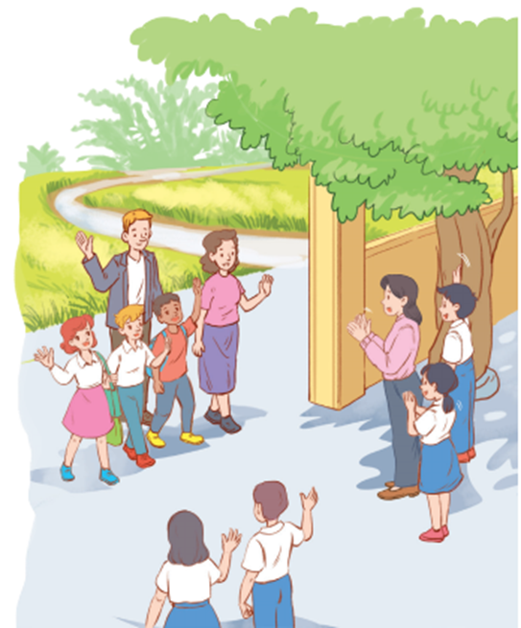  1. Who are they in the pictures  2. What are they doing?  → They are teachers and students from 2 different schools  → They are welcoming students and teachers from another school to visit their school.
Activity 2: Presentation ( 10’)
* EVERYDAY ENGLISH
* Pre- teach Vocab.

* Aim: To teach some vocab related the lesson.
* Content: Some vocab related to the lesson.
* Products: Read and understand the meaning of words.
* Organization of implementation:
Teacher’s and Ss’activities | Content
- T - Ss  * Teacher introduces the vocabulary.  ** Teacher introduces the vocabulary by:  providing the pictures  providing the definition of the words.  *** Teacher asks students to repeat.  **** Teacher rubs out and checks. | * Vocabulary:  - sport hall : hội trường thể thao  - learning resources : tài liệu học tập  - extra subjects: những môn học phụ  - get involved in : tham gia vào  - Laboratory: phòng thí nghiệm
Task 1
* Aims: To introduce ways to ask for details.
* Content: Listen and read the conversation. Pay attention to the highlighted sentence.
* Products: Students discuss the form of ways to ask for details.
* Organization of implementation:
Teacher’s and Ss’activities |  | Content
T –Ss : Ss- Ss  * Teacher lets students listen to the examples in Ex 1 in the book.  ** Teacher draws their attention to the form of ways to ask for details.  *** Teacher and students discuss the form of ways to ask for details.  **** Teacher confirms the answers and gives feedback. |  | Task 1: Listen and read the conversation. Pay attention to the highlighted sentence.  Mi: Are you doing anything this Sunday?  Phong: Not really.  Mi: Would you like to go with us to Binh Minh Lower Secondary School?  Phong: Sounds great! Can you tell me more?  Mi: We'll leave at 7 a.m. My friends David and Nick are coming too
Task 2
* Aims: To help students get to know the ways to ask for details.
* Content: Ask and answer questions about your visit to a famous school
* Products: Students role play in front of the class.
* Organization of implementation:
Teacher’s and Ss’activities |  | Content
T – Ss  * Teacher has students read the instructions to understand what they are going to do.  ** Students work in pairs to ask and answer questions about their visit to a famous school.  *** Teacher then asks students to exchange their answer among class.  **** Teacher gives feedback. |  | Task 2 :Work in pairs. Ask and answer questions about your visit to a famous school.  * Example:  A: Are you doing anything this weekend?  B: Not really.  A: Would you like to go with us to the Supermarket?  B: Sounds great! Can you tell me more?  A: We'll leave at 8 a.m. My friends Linh and Nhi are coming to
Activity 3: Practice
WELCOME TO OUR SCHOOL! (15’)
Task 3
* Aims: To let students brainstorm ideas about things they want to show their friends at school.
* Content: Make a list of what you want to show your overseas friends about your school.
* Product: Students discuss in groups to exchange ideas.
* Organization of implementation:
Teacher’s and Ss’activities |  | Content
Task 3: T – Ss.  * Teacher has students read the instructions to understand what they are going to do.  ** Students work as individuals.  *** Students discuss in groups to exchange ideas.  **** Teacher goes around and offers help, if necessary |  | Task 3: Make a list of what you want to show your overseas friends about your school.  - the school library  - computer rooms  - playground  - school garden  - soccer field .  - science Lab
Task 4
* Aims: To give students chances to practice asking and answering questions about their plans.
* Content: Ask and answer questions about your plan.
* Products: Students ask and answer questions about your plan in front of the class.
* Organization of implementation:
Teacher’s and Ss’activities |  | Content
Task 4: T - Ss, Ss – Ss  * Teacher gives instructions and asks students to read the example to understand how to start and end the conversation.  ** Students work in pairs, ask and answer questions about their plans.  *** Teacher allows students to share their answers with other pairs.  **** Teacher calls some pairs to act out the conversations in front of the class. Teacher and other Ss comment. |  | Task 4: Ask and answer questions about your plan.  * Example:  A: I'm going to show them the school library.  B: Sounds good. Can you tell me why?  A: I want them to see our learning resources. I think they're very modern.
Activity 4: Further practice
Task 5
* Aims: To let students practice talking about their school.
* Content: Read the passage and complete the table about a high school in the UK. Then discuss and fill in the information about your school.
* Products: Ss tell about Wilson School and their school in front of the class.
* Organization of implementation:
Teacher’s and Ss’activities |  | Content
* Teacher has read the instructions to understand what they are going to do. Remind them that they have to read the passage and fill the information from the passage in the column of Wilson High School.  Ask Ss to look at the table to understand what information they need to find in the passage (e.g. number of students and teachers, the subjects they study and the facilities the school has).  ** Ss read the passage individually and fill in the column of Wilson High School.  *** Teacher asks Ss to work in pairs and compare.  **** Teacher calls on one or two Ss to tell about Wilson School in front of the class.  *** Ss work in groups, discuss and fill in the table information about their school.  **** Teacher goes around and listen, make suggestions and corrections if needed |  | Task 5: Read the passage and complete the table about a high school in the UK. Then discuss and fill in the information about your school.  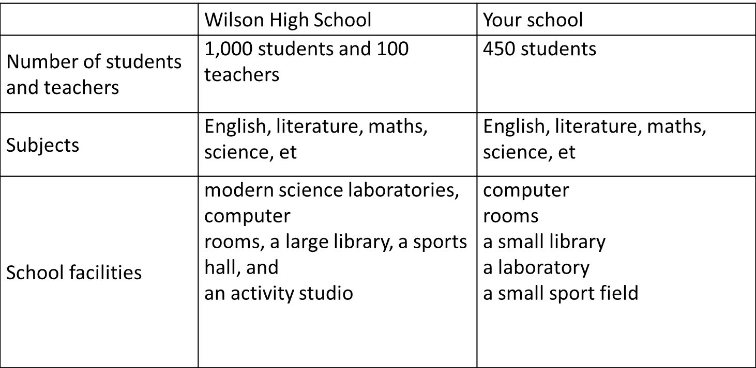
Activity 5 : Consolidation (3’)
* Aims: To consolidate what students have learnt in the lesson.
* Content: Summarize the content of the lesson
* Products: Ss say aloud what they have learnt .
* Organization of implementation:
Teacher’s and Ss’activities |  | Content
Teacher asks students to talk about what they have learnt in the lesson. |  | - vocabulary related to school  - structures to ask for details  - Talk about one’s school
* Homework (2’)
* Aim: To revise the knowledge that students have gained in this lesson. And prepare for the next lesson: Skills 1.
Teacher’s and Ss’ activities |  | Content
- T reminds Ss to do homework and prepare the new lesson. |  | - Revise some Tasks in the textbook  - Do some Exercises in the workbook  - To prepare for the next lesson: Unit 6 Skills 1.
*- Evaluation: ………………………………………………………………………………………………………………………………………………………………………………………………………..

Date of planning : 12/12 / 2024
Date of teaching : 17/12 / 2024
Week: 16 UNIT 6: : A VISIT TO A SCHOOL
Period :46 Lesson 5 : Skills 1
I. OBJECTIVES:
By the end of this lesson, Ss will be able to:
1. Knowledge:
- Develop reading skill about a famous school
- Develop speaking skill.
2. Competences:
- Develop communication skills and creativity
- Be collaborative and supportive in pair work and teamwork
- Develop presentation skill
- Talking about one’s school
3. Qualities
- Develop self-study skills,
- Students love, preserve and be proud of their school.
II. TEACHING AIDS
1. Teacher: - Grade 7 textbook, Planning (Unit 6 - skills 1)
- Smart TV/Pictures, sets of word cards
- sachmem.vn
2. Students: Text books, notebooks, posters, ….
III. PROCEDURES : (STAGES)
Activity 1 : Warm-up (5’)
* Aim: To help students be excited in class. - To introduce the topic of reading; To enhance students’ skills of cooperating with teammates.
* Content: GAME: WHO IS FASTER? ( write the correct school facilities under the posters)
* Products: Students say the answers correctly.
* Organization of implementation:
Teacher’s and Ss’activities | Content
T- Ss  * Teacher divides the class into 2 teams.  - Members from each team take turns to the board to write the correct school facilities under the posters.  - The team with more correct answers will be the winner.  ** Students play the game in team mode.  *** Teacher and students discuss the answers.  **** Teacher confirms the answers and gives feedback. | * Warm-up: GAME: WHO IS FASTER?  * Answer key:  1. school playground  2. school gym  3. computer room  4. school library  5. music room  6. swimming pool
Activity 2 :READING ( 20’)
* Pre – teach vocab
* Aim: To provide students with some lexical items before reading the text.
To let students find out the meanings of these lexical items themselves based on provided context.
* Content: Learn some vocab related the topic.
* Products: Read and understand the meaning of words.
* Organization of implementation:
Teacher’s and Ss’activities | Content
T –Ss :  * Teacher introduces the vocabulary.  ** Teacher asks students to get the meaning in context and try to make up sentences with the following words:  *** Teacher and students discuss the answers.  **** Teacher confirms student’s answers and checks their pronunciation and gives feedback.  * Checking vocab: | * Vocabulary  1. found (v)/faʊnd/ : thành lập  2. well-known (adj)/ˌwel ˈnəʊn/: nổi tiếng  3. royal (adj)/ˈrɔɪəl/ :thuộc về hoàng gia  4. projector (n) /prəˈdʒektər/: máy chiếu  *Checking: Call on words in El
* Pre- reading
Task 1
* Aims: To introduce the topic of reading.
* Content: Look at the pictures and answer the questions.
* Products: Ss anwer the questions correctly.
* Organization of implementation:
Teacher’s and Ss’activities | Content
T –Ss  * Teacher asks students to work in pairs, look at the pictures and answer the questions. Encourage them to focus on the details / ideas of the photos (color of the buildings, locations, surroundings, …)  1. What can you see in the picture?  2. What do you know about them?  ** Students work in pairs, look at the pictures and answer the questions.  *** Teacher and students discuss the questions and answers.  **** Teacher accepts all students’ questions. | Task 1: Look at the pictures and answer the questions.  1. What can you see in the picture?  2. What do you know about them?  * Suggested answers:  1. I can see a school. ( some buildings and the gate of the school)  2. This is Quoc Hoc - Hue, an old school of Viet Nam in Hue.
* While – reading
Task 2
* Aims: To develop reading skill for specific information.
To help Ss broaden and deepen their knowledge about New Years.
* Content: Read the passages and decide who says sentences 1 – 5.
* Products: Ss say the correct answers aloud.
* Organization of implementation:
Teacher’s and Ss’activities | Content
Task 2:T –Ss , Ss-Ss  * Teacher asks students to open the book, read through the text and do the task. Teacher sets a time limit for Ss to read and do the task individually.  ** Students read the text and do the task individually.  *** Teacher allows students to share their answers in pairs before discussing as a class and encourages them to give evidence.  **** Teacher calls some students to give the answer, explains which sentence gives them the information. | Task 2: Read the passage and answer the questions.  * Answer key:  1. It’s in Hue (on the bank of the Huong River).  2. They were Ho Chi Minh, Vo Nguyen Giap, Xuan Dieu.  3. They are intelligent and hard-working.  4. It has two English labs.
Task 3
* Aims: To develop the reading skill for specific information
* Content: Read the passage again and complete the table. Then report it to the class
* Products: Work in groups and give the correct answers.
* Organization of implementation :
Teacher’s and Ss’activities | Content
T –Ss , Ss- Ss  * Teacher can set a longer time limit for students to read the text again.  Teacher asks students to look at the table to understand what information they have to find in the text (e.g. the name, the location, the students, and the school facilities). Explain that this task helps them focus on the information they are going to find in the text.  ** Students work in individuals to fill the table.  *** Teacher allows students to compare their answers in groups before reporting to the class.  **** Teacher selects one or two Ss to report the information in the table in front of the class. The class listens and comments. | Task 3: Read the passage again and complete the table. Then report it to the class  * Answer key:
  Name | Quoc Hoc – Hue
  Location | on the bank of the Huong River, in Hue
  Students | intelligent and hard-working
  School facilities | over 50 classrooms (with TVs, projectors, computers), a swimming pool, a library, two English labs, four computer rooms, and many other modern facilities.
Activity 3: SPEAKING (10’)
Pre –speaking
Task 4
* Aims: To help students form the ideas for their speaking.
* Content: Ask and answer questions about the information in the table.
* Products: Answer the questionss exactly.
* Organization of implementation :
Teacher’s and Ss’activities | Content
T - Ss, Ss – Ss  * Teacher has Ss read the instructions to identify how to do the task, then asks them to look at the table to understand what information they are going to discuss (e.g. the name, location, students, and the facilities of their school).  ** Teacher asks students to work in pairs, asking and answering questions about the information in the table.  *** Teacher can go around to help weaker students.  **** Teacher calls on some pairs to practise in front of the class. | Task 2: Read the passage and answer the questions.  1. What's the full name of the school?  2. Where is it?  3. What are the students like?  4. What facilities does the school have?  * Answer key:  1. The full name of the school is Hung Vuong Lower Secondary School.  2. It is at 120, Hung Vuong Street.  3. The students are hard-working and intelligent.  4. It has 20 classrooms, one library, 2 computer rooms, one gym and one garden.
*While –Speaking
Task 5
* Aims: To help students use what they practice to give a long talk about their school.
* Content: Work in groups. Tell about your school.
* Products: some groups give presentations in front of the class.
* Organization of implementation:
Teacher’s and Ss’activities | Content
T - Ss, Ss – Ss  * Teacher has students work in groups, talk about their schools based on the information from Task 4.  ** Students work in groups to do the task.  *** Teacher goes around to help students.  **** After finishing, teacher can call some groups to give presentations in front of the class. | Task 5: Work in groups. Tell about your school.  The full name of the school is Hoa Hoi Primary and Secondary School. It is in Hoa Hoi commune, Phu Hoa district, Phu Yen Province . The students are hard working and lovely. It has 20 classrooms, two libraries, 2 computer rooms, three laboratories: physics, Chemistry, Biology, a school gym, a school playground and a school garden.
Activity 4: POST-READING AND SPEAKING ( 5’)
* Aims: - To help students improve next time.
- To help some students enhance their presentation skill.
* Content: Give comments for their friends and vote for the most interesting and informative presentation.
* Products: Give comments exactly and clearly.
* Organization of implementation:
Teacher’s and Ss’activities | Content
T - Ss, Ss – Ss  * Teacher allows students to give comments for their friends and vote for the most interesting and informative presentation.  ** Students give comments for their friends and vote for the most interesting and informative presentation.  *** Teacher and students discuss the presentations.  **** Teacher gives feedback and comments. | What do you think about your presentation?  Who is the best presenter?
Activity 5: Consolidation (3’)
* Aims: To consolidate what students have learnt in the lesson.
* Content: Ss summarize what they have learnt with the two skills.
* Products: Students say what they have learnt with the two skills in font of the class.
* Organization of implementation:
Teacher’s and Ss’activities | Content
T - Ss, Ss – Ss  - Teacher asks students to talk about what they have learnt in the lesson. | - some words related the topic of the lesson.  - read the test about a famous school  - Talk about my school
* Homework (2’)
* Aim: To revise the knowledge that students have gained in this lesson.
Teacher’s and Ss’activities | Content
- Teacher asks students to prepare the new lesson | - Do Ex in WB  - Prepare: Skills 2
*- Evaluation: …………………………………………………………………………………………………………………………………………………………………………………

Date of planning : 15/12 / 2024
Date of teaching : 18,19/12 / 2024
Week 16: UNIT 6: A VISIT TO A SCHOOL

Period :47 Lesson 6: Skills 2

I. OBJECTIVES:
By the end of this lesson, Ss will be able to:
1. Knowledge:
- listen for general and specific information about school activities.
- write a paragraph about outdoor activities at one’s school.
2. Competences:
- Develop communication skills and creativity
- Be collaborative and supportive in pair work and teamwork
- Actively join in class activities
3. Qualities
- Develop self-study skills
- Students love, preserve and be proud of their school.
II. TEACHING AIDS
1. Teacher: - Grade 7 textbook, Planning (Unit 6- Skills 2)
- Smart TV/Pictures, sets of word cards
- sachmem.vn
2. Students: Text books, notebooks, posters, ….
III. PROCEDURES : (STAGES)
Activity 1: Warm-up (5’)
* Aim: - Check students’ knowledge related the previous lesson
- To introduce the topic of listening.
* Content: Watch a clip and write activities about Tet
* Products: Students' answers on the posters
* Organization of implementation
Teacher’s and Ss’activities |  |  | Content
T- Ss  * Teacher divides the class into 2 teams and asks members of each team to look at the screen and answer the questions.  - The team which has more points or can guess the hidden word first will be the winner.  ** Students listen and follow teacher’s instructions.  *** Students play in teams and discuss before giving the answers.  **** Teacher confirms the answers and gives feedback. |  |  | * Warm-up: Game: The hidden word  O U T D O O R  1. What is this?  _ _ _ _ _ _ _ _ _ _ (PLAYGROUND)  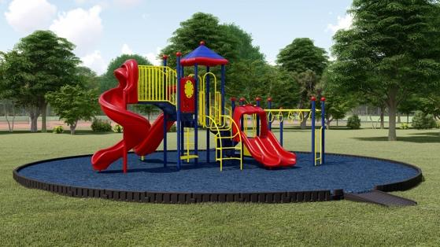  2. My favourite _ _ _ _ _ _ _ is maths. (SUBJECT)  3. Mi and Phong are members of Go Green _ _ _ _. (CLUB)  4. Quoc Hoc - Hue was _ _ _ _ _ _ _ in 1986. (FOUNDED)  5. The school year usually begins _ _ September 5th every year. (ON)
Activity 2: LISTENING (10’)
* Pre -listening
Task 1:
* Aim: To lead in the lesson.
* Content: Look at the pictures and discuss the questions.
* Products: Discuss in groups and give the answers corectly.
* Organization of implementation:
Teacher’s and Ss’activities | Content
T- Ss  * Teacher asks students to look at the pictures and think about the outdoor activities they do (e.g. clean the streets in picture a, grow vegetables in picture b) and why they do these activities (e.g. to clean the environment, …)  ** Students quickly discuss with a partner.  *** Teacher asks some pairs to act out the dialogue in front of the class.  **** Teacher gives feedback. | Task 1: Work in pairs. Look at the pictures and discuss the questions.  1. They are collecting the garbage and planting trees.  2. Because they want to clean the environment.
While -listening
Task 2
* Aims: To help students develop listening skill for general information.
* Content: Listen to an interview between a reporter and two students. Choose the best ans wer to complete each sentence.
* Products: Students say the correct answers.
* Organization of implementation:
Teacher’s and Ss’activities |  | Content
T –Ss : Ss- Ss  * Teacher asks students to read the instructions and identify how to do the task, then has students read the questions and guess the option that can be used to complete the sentences.  ** Teacher plays the recording once or twice, if necessary.  ** Students listen and circle the answer.  *** Teacher allows students to peer check first.  **** Teacher confirms the answers and gives feedback. |  | Task 2: Listen to an interview between a reporter and two students. Circle the appropriate option (A, B, or C) to complete each sentence.  * Answer key:  1. C  2. B  3. A  4. A
Task 3
* Aims: To help students develop listening skill for specific information
To help students combine listening and writing at the same time.
* Content: Listen again and answer the questions.
* Products: Ss give the answers correctly.
* Organization of implementation
Teacher’s and Ss’activities |  | Content
T - Ss, Ss – Ss  * Teacher asks students to read the questions and to focus on the key information and underline the keywords.  ** Teacher plays the audio again. Ask students to listen and give short answers.  *** Teacher lets students peer-check with a partner.  **** Teacher calls some students to give the answers to the class and correct the mistakes where necessary, encourages students to explain their answers, and shares some tips on finding the information. |  | Task 3: Listen to the interview again and answer the questions.  * Answer key:  1. They encourage their classmates to recycle glass, cans, and paper.  2. The reporter thinks their activities protect the environment.  3. They grow vegetables in the school garden after school.
Activity 3: WRITING (10’)
* Pre - writing
Task 4
* Aims: To prepare language material for students to write about school’s outdoor activities.
* Content: Ask and answer questions about your school’s outdoor activities.
* Products: Ss answer the questions and take notes clearly
* Organization of implementation:
Teacher’s and Ss’activities |  | Content
T-Ss, Ss-Ss  * Teacher asks students to read the questions individually. Draw the attention to three pieces of information.  ** Students work in pairs, answer the questions and take notes.  *** Teacher goes around and helps if needed.  **** Others comment and write them in their notebooks |  | Task 4: Ask and answer questions about your school’s outdoor activities.  1. What outdoor activities do you take part in at school?  2. Which outdoor activity do you like the best?  3. Why do you like doing it?  * Answer key:  1. I take part in many outdoor activities in my school like planting trees, picking up rubbish, recycling old paper.  2. My favourite outdoor activity is planting trees.  3. Because it is good for the environment and makes me feel happy.
* While - writing
Task 5
* Aims: To teach students how to write a passage about school’s outdoor activities..
* Content: Write a paragraph about their school’s outdoor activities.
* Products: Students’ writing in their notebooks.
* Organization of implementation:
Teacher’s and Ss’activities |  | Content
T - Ss, Ss – Ss  * Teacher shows a model of a short paragraph about a school’s outdoor activity. Then recalls students’ knowledge on the structure of a paragraph.  ** Teacher tells students to write a paragraph about their school’s outdoor activities using the suggested ideas in Task 4. Teacher gives students some time to arrange the work within the groups and give each group a A2-sized plain card with some colors.  Teacher allows students time to write a paragraph (about 70 words).  *** Teacher allows students to cross check first.  **** Teacher gives feedback. |  | Task 5: Write a paragraph about an outdoor activity at your school.  I study at Hoa Hoi Primary and lower Secondary school. It is in Hoa Hoi commune, Phu Hoa District, Phu Yen Province. In my school, I take part in many outdoor activities in my school like planting trees, picking up rubbish and old paper. We also have other activities in the school such as football, basketball and many more. Planting trees is my favourite outdoor activity. It makes me a more responsible and creative. It also protects our environment.
Activity 4: POST-LISTENING & WRITING ( 5’)
* Aim: To cross check and final check students’ writing.
* Content:. Share your writing with the class
* Products: Students’s perfect writing
* Organization of implementation:

Teacher’s and Ss’activities |  | Content
T - Ss, Ss – Ss  * Teacher asks students to stick their “productions” onto the board.  ** Students can go and see others’ work.  *** Students then give comments to each other.  **** Teacher then gives feedback as a class discussion. |  | Share your writing with the class
Activity 5: Consolidation (3’)
* Aim: To consolidate what students have learnt in the lesson.
* Content: talk about what they have learnt in the lesson.
* Products: Students’s answers.
* Organization of implementation:
Teacher’s and Ss’ activities |  | Content
- Teacher asks students to talk about what they have learnt in the lesson. |  | - listen for general and specific information about school activities.  - write a paragraph about outdoor activities at one’s school.
* Homework (2’)
* Aim: To revise the knowledge and rewrite their writing in the notebooks.
- Teacher asks students to write down the paragraph in their notebooks.  - Teacher asks students to prepare the new lesson. |  | - Rewrite your writing.  - Do the exercises in workbook.  - Prepare LOOKING BACK AND PROJECT..
* Evaluation: …………………………………………………………………………………………………………………………………………………………………………………………………….

Date of planning : 12/12 / 2024
Date of teaching : 20/12 / 2024
Week: 18 UNIT 6: A VISIT TO A SCHOOL
Period : 48 Lesson 7: Looking back and project
I. OBJECTIVES:
By the end of this lesson, Ss will be able to:
1. Knowledge
- Review the vocabulary and grammar of Unit 6
- Apply what they have learnt (vocabulary and grammar) into practice through a project
2. Competences
- Develop communication skills and creativity
- Develop presentation skill
- Develop critical thinking skill
- Be collaborative and supportive in pair work and team work
- Actively join in class activities
- Ability of using structures to ask for details.
3. Qualities
- Be more creative when doing the project
- Develop self-study skills
II. TEACHING AIDS
1. Teacher: - Grade 7 textbook, Planning (Unit 6 -Looking back and project)
- Smart TV/Pictures, sets of word cards
- sachmem.vn
2. Students: Text books, notebooks, posters, ….
IV. PROCEDURES : (STAGES)
Activity 1: Warm - up (5’)
* Aim: To revise the vocabulary related to the topic and lead in the next part of the lesson.
- To enhance students’ skills of cooperating with teammates.
* Content: game – Brainstorming (write as many school facilities as possible )
* Products: Students work in groups and write the correct words on the board.
* Organization of implementation:
Teacher’s and Ss’activities | Content
T –Ss ; Ss - Ss  * Teacher divides the board, and divides the class into 2 teams.  ** Members of each team take turns and write as many school facilities as possible in 2 minutes.  *** Students cross check their answers first.  **** Teacher confirms the answers and gives feedback. The group having more correct answers is the winner. | * Warm up: BRAINSTORMING: SCHOOL FACILITIES  * Suggested answer:  - playground  - computer room  - library  - sport field  - swimming pool  - gym  ……………..
Activity 2: * PRACTICE ( VOCABULARY)
Task 1,2 (10’)
* Aim: Task 1: To help students revise the vocabulary .
To help students use the words/ phrases in 1 to complete the sentences.
* Content: - Find the words and phrases from this unit that match these definitions
- Complete the sentences with the words and phrases
* Products: Ss say the correct answers exactly.
* Organization of implementation:
Teacher’s and Ss’activities |  | Content
- T –Ss , Ss -Ss  * Teacher encourages students to complete the task individually.  ** Students do the task individually.  *** Students exchange their textbooks with their partners.  **** Teacher gives feedback as a class discussion.  * Teacher asks students to work in pairs, discussing what word/phrase can be used to complete each of the sentences.  ** Students work in pairs and discuss.  *** Teacher call some students to read aloud the complete sentences.  **** Teacher gives feedback and comment. |  | Task 1: Find the words and phrases from this unit that match these definitions (p.68).  * Answer key:  1. well-known  2. (school) facilities  3. an entrance exam  4. gifted students  5. outdoor activities  Task 2: Complete the sentences with the words and phrases in 1 (page 68).  * Answer key:  1. gifted students  2. outdoor activities  3. (school) facilities  4. an entrance exam  5. well-known
Activity 3: GRAMMAR (10’)

Task 3+ Task 4
* Aims: To help students revise prepositions of time and place.
To help students revise the use prepositions of time and place in context
* Content: Complete the sentences with appropriate prepositions or place of time
* Products: students say aloud the correct answers.
* Organization of implementation:
Teacher’s and Ss’activities |  |  | Content
T – Ss, Ss -Ss  * Teacher has ss read the instruction to know what they have to do. Draw their attention to the prepositions of time and place that they have learnt in the unit and which one can be used to complete the sentences.  ** Students complete the task individually.  *** Students exchange their textbooks with their partners.  **** Teacher gives feedback as a class discussion.  * Teacher asks students to do individually first.  ** Students complete the task individually.  *** Teacher then asks them to check their answers with a partner before discussing the answers as a class.  **** Teacher reminds students to keep a record of their original answers so that they can use that information in their Now I can... statement. |  |  | Task 3: Complete the sentences with appropriate prepositions or place of time.  * Answer key:  1. on  2. in  3. in  4. on  5. at  Task 4: Read the passage and fill in the gaps with prepositions of time or place.  * Answer key:  1. at  2. in  3. in  4. On  5. in  6. at
Activity 4: Project (5’)
* Aims: To allow students to apply what they have learnt (vocabulary and grammar) into practice through a project.
* Content: Make * PROJECT “ My favourite school”
* Products: Students’ project on the posters.
* Organization of implementation:
Teacher’s and Ss’activities |  |  | Content
T - Ss, Ss – Ss  * Teacher has students work in groups and gives instructions to students as follow:  1. Search for a school you would like to study at, then find information about that school to complete the table:  2. Discuss and take notes in groups.  3. Look at the table and tell the class about that school  * Students do the project in groups.  *** Students vote present about the school  **** Teacher gives feedback. |  |  | * PROJECT: My favourite school  * Presentation:  I want to study at Hung Vương Secondary school. It is one of the most famous schools with many achievements in Tuy Hoa City. It is located at 45 Nguyen Hue street TH city.  The studenst in this school have to learn many subjects like Literature, Maths, English, History, Science, Physical Education, Art, Music, Physics. Besides, they also take part in many outdoor activities such as camping, playing sports, recycling old papers, planting trees, cleaning the environment. They have to pass an entrance exam to enter the school. The school has over 22 classrooms with TVs, projectors, and computers. It also has a modern library, two computer rooms, large laboratory, a big garden, and many other modern facilities. The school is one of the largest and most beautiful schools in Phu Yen.
  Name of the school | Hung Vuong Secondary School
  Location | 42 Nguyen Hue, Tuy Hoa city
  Subjects at school | Literature, Maths, EL, Science, Physical Education, Art, Music, Physical
  School facilities | Library, computer rooms, , playground, soccer field, school garden,
  Outdoor activities | Camping, playing soccer, recycling paper, planting trees, cleaning the environment
Activity 5: Consolidation (2’)
* Aim: To consolidate what students have learnt in the lesson.
* Content: Summarize the content of the lesson.
* Products: A student says the lesson’s content aloud.
* Organization of implementation:
Teacher’s and Ss’activities |  |  | Content
- Teacher asks students to talk about what they have learnt in the lesson. |  |  | - revise vocabulary related to a school.  - Grammar: revise the use prepositions of time and place in context
IV. Homework (2’)
* Aim: To revise the knowledge that students have gained in Unit 6 and To prepare for the next lesson
Teacher’s and Ss’ activities |  |  | Content
- Teacher asks students to revise old lesson and to do exercise in workbook.  - Teacher asks students to complete the project and prepare the new lesson. |  |  | - Complete the project  - Prepare REVIEW 2
*- Evaluation: …………………………………………………………………………………………………………………………………………………………………………………………………….

