LESSON PLAN

ENGLISH 7 (GLOBAL SUCCESS)
Date of planning: 4/10/2024
Date of teaching: 11/10/ 2024
Week 6
Period 16 UNIT 3: COMMUNITY SERVICE
Lesson 1: Getting started – Sounds like great work!
I. OBJECTIVES:
By the end of this lesson, Ss will be able to gain:
1. Knowledge
- An overview about the topic “Community service”
- lexical items related to community activities
2. Competences
- Develop communication skills and enhance awareness of preserving the culture
- Be collaborative and supportive in pair work and teamwork
- Actively join in class activities
3. Qualities
- Develop self-study skills
- Raise students’ awareness of the need to keep their neighbourhood green
II. TEACHING AIDS
1. Teacher: - Grade 7 textbook, Planning ( Unit 3- Getting started )
- A laptop connected with Smart TV, sets of word cards
- sachmem.vn
2. Students: Text books, notebooks
III. PROCEDURES : (STAGES)
Activity 1: Warm-up (5’)
* Aim: To revise old lesson and to introduce the new lesson.
* Content: Picture describing
* Products: Ss understand and say activities about “ Community service”
* Organization of implementation:
Teacher’s and Ss’activities |  |  | Content
* Warm up: T – SS  * Teacher shows the picture and asks students questions:  ** Students raise hands to answer the questions.  *** Teacher and students discuss the questions.   Teacher accepts all students’ questions and explains the term “Community service” .  Lead in:  - T introduces the topic of the lesson.  Today we are going to learn about “Community service”  * Teacher draws students’ attention to the picture in the textbook and asks them about “community activities”.  ** Students raise hands to answer the questions. |  |  | * Picture describing  - What can you infer from this picture?    Community service  (The work that people do to help others without paying)  + pick up litter  + help homeless people  + clean the street  + donate clothes , books, money,…  + plant trees, vegetables,..
Activity 2: PRESENTATION (5’)
Pre teach vocabulary
* Aim: - To provide students with vocabulary.
- To help students well-prepared for the listening and reading tasks.
* Content: learn some vocabularies related to the topic.
* Products: Students read and understand the meaning of vocab.
* Organization of implementation:
Teacher’s and Ss’activities |  | Content
* Pre teach vocabulary  - Teacher use different techniques to teach vocab (pictures, situation, realia)  - Follow the seven steps of teaching vacab.  - Repeat in chorus and individually  - Copy all the words  * Checking vocab: < what and where> |  | * Vocabulary  - community activity (n.phr.): hoạt động cộng đồng  - donate (v): quyên góp, ủng hộ  - nursing home (n.phr.): viện dưỡng lão  - homeless (adj): vô gia cư  * Checking vocab: < what and where>
Activity 3: PRACTICE (20’)
Task 1
* Aims: To set the context for the introductory conversation;
- To introduce the topic of the unit.
* Content: Listen and read the conversation.
* Products: Students read and understand the meaning of the conversation
Students know how to role play
* Organization of implementation:
Teacher’s and Ss’activities | Content
- T-Ss  - Set the context:  Have Ss look at the conversation and the picture, and answer some questions,  - Encourage Ss to answer, but do not confirm whether their answers are right.  * Teacher can play the recording more than once.  ** Students listen and read.  *** Teacher can invite some pairs of students to read aloud.   Teacher check students’ pronunciation and give feedback.  - To help Ss understand the main idea of the conversation, ask Ss to answer the question: | - Set the context:  e.g. What can you see in the pictures?  Where do you think the boys and the girls are? What do you think they are doing?  + In picture 1: I can see a boy with a box. He is arranging books and toys (and may be clothes).  + In picture 2: I can see a girl and some small children. They are in a classroom. The girl is teaching the small children.  + In picture 3: I can see two girls and a boy. They are in the garden.They are gardening.  Task 1. Listen and read  - What are Tom and Minh talking about?  (They are talking about community activities in their school.)
Task 2 (5’)
* Aims: - To help students read for specific information about Minh and Tom’s community activities
* Content: Read the conversation again and tick the appropriate box.
* Products: Ss tick the appropriate boxes. Some pairs say the answers aloud
* Organization of implementation:
Teacher’s and Ss’activities | Content
Task 2: T-Ss, Ss-Ss, T-Ss  * Teacher tells students to read the conversation again and work in pairs to find the answers.  ** Students can underline the words and phrases about community activities then work together for one or two minutes to check the words / phrases they have underlined.  ***Have pairs tick the appropriate boxes. Ask pairs to say the answers aloud: Mirth's club picks up litter; Tom's club donates books, etc.  Make sure they pronounce the words / phrases correctly.  ****Check the answers as a class. | Task 2: Read the conversation again and tick the appropriate box.  * Answer key:  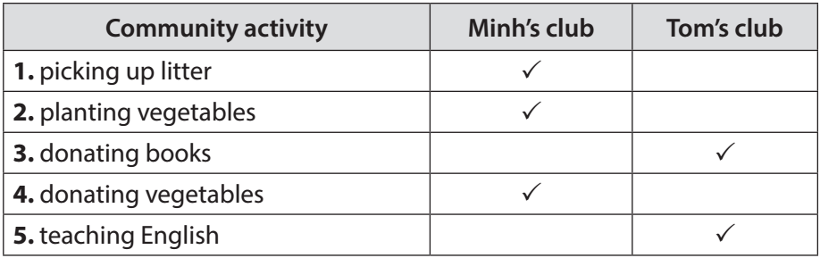
Task 3
* Aims: - To help students use phrases related to community activities.
- To help students further understand the text.
* Content: Complete the phrases under the pictures with the verbs below..
* Products: Students say the phrases aloud and pronounce the words and phrases correctly.
* Organization of implementation:
Teacher’s and Ss’activities | Content
Task 3:T-Ss, Ss-Ss  Teacher asks students to work individually to complete the phrases under the pictures with the given verbs.  ** Students work individually to complete the task.  *** Teacher allows students to share answers before discussing as a class.   Teacher asks students to say the phrases aloud and makes sure they pronounce the words and phrases correctly. Teacher can ask for translation to check their understanding. | Task 3: Complete the phrases under the pictures with the verbs below.  * Answer key:  1. pick up  2. help  3. recycle  4. donate  5. clean
Task 4
* Aims: To help students use the vocabulary related to community activities in the right contexts.
* Content: Complete the sentences with the correct words or phrases below.
* Products: Students read aloud the full sentences.
* Organization of implementation:
Teacher’s and Ss’activities | Content
Task4:T-Ss, Ss-Ss  * Teacher asks students to work independently to complete each sentence with a word or phrase from the box.  ** Students fill in the blanks with the most suitable words / phrases.  *** Teacher allows students to share answers before discussing as a class.   Teacher can ask students to read aloud the full sentences and correct their pronunciation if needed. | Task 4 : Complete the sentences with the correct words or phrases below.  * Answer key:  1. homeless children  2. litter  3. old people  4. taught  5. planted
Activity 4: PRODUCTION (5’)
Task 5:
* Aims: - To help students review and reuse the learnt vocabulary.
- To create a fun atmosphere in the class.
* Content: Vocabulary Ping-pong game.
* Products: Play game in groups . The team that makes the most correct sentences wins.
* Organization of implementation:
Teacher’s and Ss’activities | Content
Task 5:T-Ss, Ss-Ss  * Teacher instructs students to play the Vocabulary Ping-Pong game:  - Ask Ss to think of the topic Community Service.  - One student from team A shouts out a word or phrase related to the topic. Then one student from team B makes a sentence with that word or phrase. Then switch roles.  - The team that cannot give a phrase or make a correct sentence loses and the other team gets a point.  ** Students play the game.  *** Teacher can go around to help weaker students.   Teacher stops the game when time is up. The team that makes the most correct sentences wins. | Task 5: Vocabulary Ping-pong game.  * Example:  Team A: Litter  Team B: We often pick up litter in the park. Trees.  Team A: We plan trees in our school every year. Book.  Team B : We donate books to poor children. Bottles  ………..
Activity 5: CONSOLIDATION (3’)
* Aim: To consolidate what students have learnt in the lesson.
* Content: Vocabulay related to community activities.
* Products: Say aloud some words they remember from the lesson.
* Organization of implementation:
Teacher’s and Ss’ activities | Content
- Teacher asks students to talk about what they have learnt in the lesson.  - Ss work indepently | - Some new words  - Read and understand content of the conversation
IV. HOMEWORK (2’)
* Aim: To review the lesson and prepare for the next lesson.
Teacher’s and Ss’ activities | Content
- T reminds Ss to do homework and prepare the new lesson. | - Learn by heart all the new words.  - Read the dialogue again.  - Prepare lesson 2 ( A closer look 1).
*- Complements …………………………………………………………………………………………………………………………………………………………………………………

Date of planning: 4/10/2024
Date of teaching: 15&16/10/ 2024
Week 6: UNIT 3: COMMUNITY SERVICE

Period 17: Lesson 2: A closer look 1

I. OBJECTIVES:
By the end of this lesson, students will be able to gain:
1. Knowledge:
a- Vocabulary: Use words related to community activities.
b- Pronunciation: Correctly pronounce the sounds: /t/, /d/, /ɪd/ in isolation and in context
2. Competences
- Develop communication skills and creativity
- Be collaborative and supportive in pair work and teamwork
- Actively join in class activities
3. Qualities
- Develop self-study skills
- Raise students’ awareness of the need to keep their neighbourhood green.
II. TEACHING AIDS
1. Teacher: - Grade 7 textbook, Planning ( Unit 3, A closer look 1)
- Smart TV/Pictures, sets of word cards
- sachmem.vn
2. Students: Text books, notebooks, posters, ….
3. Method: Ask and answer ; group works; individual ……
  - III. PROCEDURES : (STAGES)
Activity 1: Warm-up (5’)
* Aim: To recall students’ vocabulary on community activities
* Content: Match the verbs with the correct nouns.
* Products: The group with the most correct answers wins.
* Organization of implementation:
Teacher’s and Ss’activities |  |  | Content
- T – Ss, Ss - Ss  * Teacher has students play in two groups and explains the game rules.  ** Each group will have a list of verbs and nouns. Students match the verbs they have with the correct nouns.  *** Teacher and students discuss the answers. The group with the most correct answers wins.   Teacher confirms the answers and gives feedback.  - Lead in : Today we are going to learn some words related to community activities. |  |  | MATCHING GAME: Set of word cards:  recycle help plant  trees vegetables small children old people  books bottles cans homeless children
Activity 2: PRESENTATION (7’)
* Pre teach vocabulary
* Aim: To introduce the new words.
* Content:
* Products: Read and understand the meaning of vocab.
* Organization of implementation:
Teacher’s and Ss’activities | Content
- T – Ss,  * Pre teach vocabulary  * Teacher introduces the vocabulary.  ** Teacher introduces the vocabulary by:  - providing the pictures  providing the definition of the words  *** Teacher asks students to repeat.  *** Teacher rubs out and checks  - Ss concept checking | * VOCABULARY:  1. exchange (v): trao đổi  2. pick up (phr. v): nhặt lên  3. tutor (v): dạy kèm  * Checking vocab: < Matching>
Activity 3. PRACTICE (15’)
Task 1
* Aims: To introduce some verbs and verb phrases that are often used to describe community activities.
* Content: Match the verbs in A with words / phrases in B
* Products: Students read out their answers .
* Organization of implementation:
Teacher’s and Ss’activities |  | Content
Task 1: T-Ss  * Teacher has read aloud the verbs in A and words / phrases in B.  ** Students work in pairs to match the verbs in A with words / phrases in B.  *** Teacher asks them to share their answers in pairs before checking the answers as a class.   Teacher invites students to take turns to read out their answers and corrects their pronunciation if needed. |  | Task 1: MATCH A VERB IN A WITH A WORD OR PHRASE IN B. (Ex 1, p. 30)  * Answer key:  1. e  2. a  3. d  4. c  5. b
Task2
* Aims: To allow students to use the learnt words / phrases in contexts.
* Content: Complete each of the sentences with a suitable word / phrase from the box
* Products: Ss swap their answer to peer check first and say the correct answers .
* Organization of implementation:
Teacher’s and Ss’activities |  | Content
Task 2: T - Ss, Ss - Ss  * Teacher asks students to work individually to complete each of the sentences with a suitable word / phrase from the box. All of these words / phrases have been learnt in.  ** Students do the task individually.  *** Teacher allows students to swap their textbooks to peer check first.   Teacher confirms the answers and gives feedback, if necessary. |  | Task 2: COMPLETE EACH OF THE SENTENCES WITH A SUITABLE WORD OR PHRASE FROM THE BOX.  * Answer key:  1. litter  2. used paper for notebooks  3. water  4. donate  5. tutor
Task 3
* Aims: To have students practise producing full sentences using the learnt words / phrases.
* Content: Use the phrases from the box to write full sentences under the correct picture.
* Products: Ss write answers on the board.
* Organization of implementation:
Teacher’s and Ss’activities |  | Content
Task 3:T-Ss, Ss-Ss  * Teacher asks students to work individually to write full sentences, using the given phrases.  ** Students read aloud the six phrases and match with the appropriate pictures.  *** Teacher asks students to work in pairs to swap their answers and peer check.   Teacher checks their answers as a class. |  | Task 3: USE THE PHRASES FROM THE BOX TO WRITE FULL SENTENCES UNDER THE CORRECT PICTURE. (Ex 3, p. 30)  Answer key:  1. She’s reading books to the elderly.  2. They’re giving gifts to old people.  3. They’re exchanging used paper for notebooks.  4. They’re donating clothes to poor children.  5. She’s planting trees in the park.
Activity 4. PRONUNCIATION (10’)
Task 4:
* Aims: - To help students identify how to pronounce the sounds /t/, /d/ and /ɪd/.
- To help students practise pronouncing the sounds in words
* Content: Listen and repeat. Pay attention to the sounds /t/, /d/ and /ɪd/
* Products: Read and know how to pronounce the sounds t/, /d/ and /ɪd/
* Organization of implementation:
Teacher’s and Ss’activities |  | Content
Task 4:T-Ss, Ss-Ss  * Teacher has students listen to the recording once first.  ** Students listen to the recordings and read out the words.  *** Teacher plays the recording for them to listen and repeat each word as a class, then as individuals.   Teacher check students’ pronunciation if needed.  + Teacher shows students tips to pronounce with V-ed |  | PRONUNCIATION: /t/, /d/, and /id/  TASK 4: LISTEN AND REPEAT. PAY ATTENTION TO THE SOUNDS /t/, /d/ AND /ɪd/. (Ex 4, p. 30)  /t/ /d/ /ɪd/  cooked passed helped watered cleaned volunteered collected donated provided  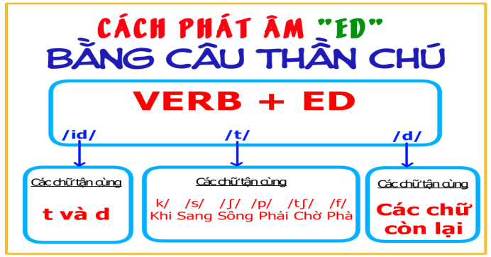
Task 5:
* Aims: To help students practise pronouncing the sounds /t/, /d/ and /ɪd/ in sentences
* Content: Listen to the sentences and pay attention to the underlined parts. Tick the appropriate sounds. Practise the sentences.
* Products: Whole class practise and tick the appropriate sounds.
* Organization of implementation:
Teacher’s and Ss’activities |  | Content
Task 5 :T-Ss,  * Teacher has some students read the sentences first and asks them to pay attention to the underlined parts.  ** Teacher plays the recording for Ss to listen then have them tick the appropriate sounds.  ***Teacher invites some Ss to share their answers. Confirm the correct ones.   Teacher plays the recording again and ask students to repeat each sentence after the recording. Teacher confirms the answers. |  | TASK 5: LISTEN TO THE SENTENCES AND PAY ATTENTION TO THE UNDERLINED PARTS. TICK THE APPROPRIATE SOUNDS. PRACTISE THE SENTENCES (Ex 5, p. 31).  * Answer key:  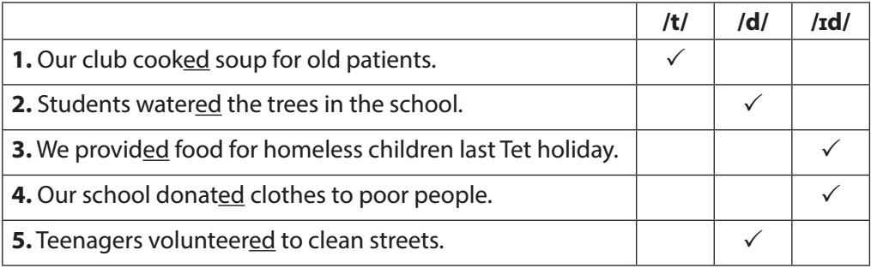
Activity 5. PRODUCTION(5’)
* Aim: To test students' quick reaction to the targeted sounds.
* Content: *Game: Broken telephone
* Products: Students plays in groups.
* Organization of implementation:
Teacher’s and Ss’ activities |  | Content
* Teacher explains the rules:  Teacher divides the class into 2 teams and asks them to stand in 2 lines. The first student from each line will be told some words with the /t/, /d/ and /ɪd/ sounds. Team members have to whisper one by one till the last. The last student from each line runs to the board and write down the words in the correct columns. The faster one with correct answers will be the winner.  ** Students play the game.  *** Teacher helps students in the game.   Teacher gives feedback. |  | * GAME: BROKEN TELEPHONE  * Suggested key:  /t/ /d/ /ɪd/  picked, booked, helped tutored, watered, exchanged donated, planted
Activity 6* CONSOLIDATION (3’)
* Aim: To consolidate what students have learnt in the lesson.
* Content: Vocab about personalities and how to pronounce the sounds /t/, /d/ and /ɪd/
* Products: Say aloud some words they remember from the lesson.
* Organization of implementation:
Teacher’s and Ss’ activities |  | Content
- Teacher asks students to talk about what they have learnt in the lesson |  | - Vocabulary about community activities  pronounce the sounds /t/, /d/ and /ɪd/
IV. HOMEWORK (2’)
* Aim: To review the lesson and prepare for the next lesson.

Teacher’s and Ss’ activities |  | Content
- T reminds Ss to do homework and prepare the new lesson. |  | - Learn by heart all the new words.  - What can you do to make your neighborhood to be a greener place? Write at least 3 activities.  - Prepare lesson 3 ( A closer look 2)..
*- Complements ……………………………………………………………………………………………………………………………………………………………………………………………………

Date of planning: 4/10/2024
Date of teaching: 16&17/10/ 2024
Week :6 UNIT 3: COMMUNITY SERVICE

Period 18: Lesson 3: A closer look 2
I. OBJECTIVES:
By the end of this lesson, Ss will be able to gain:
1. Knowledge:
* Vocab: Some words related community activities.
* Grammar: - Understand the use of the past simple tense
- Practice using the past simple to talk about past activities
2. Competences:
- Develop communication skills and creativity
- Be collaborative and supportive in pair work and teamwork
- Actively join in class activities
3. Qualities
- Develop self-study skills
- Raise students’ awareness of the need to keep their neighbourhood green.
II. TEACHING AIDS
1. Teacher: - Grade 7 textbook, Planning ( Unit 3, A closer look 2)
- Smart TV/Pictures, sets of word cards
- sachmem.vn
2. Students: Text books, notebooks, posters, ….
  - III. PROCEDURES : (STAGES)
Activity1: Warm-up (5’)
* Aim: To activate students’ prior knowledge related to the targeted grammar: the past simple.
* Content: Chatting ( Ask Ss some questions)
* Products: Students use the past simple to answer the questions correctly.
* Organization of implementation:
Teacher’s and Ss’activities |  |  | Content
* Warm up  - T - Ss  * Teacher asks students some questions:  ** Students answer the questions, using the past simple.  *** Teacher and students discuss the answers.   Teacher corrects students answers if needed and confirms the use of the past simple (to talk about completed actions in the past).  Lead in  - Teacher says: “This lesson today we are going to revise the past simple”  ” |  |  | * Warm-up : Chatting  What did you do last weekend?  What did you watch yesterday?  Who did you meet two days ago?  * Students’ answer.
Activity 2: PRESENTATION (7’)
* Aim: To review students’ knowledge of the past simple tense.
* Content: * Grammar :
* Products: Understand and how to use the present continuous.
* Organization of implementation:
Teacher’s and Ss’activities |  | Content
T -- Ss  * Teacher asks students to study the Grammar box.  - Teacher draws students’ attention to the meaning and use of the past simple.  ** Teacher asks SS to remind the form of the past simple.  * **Teacher then asks some more able students to give some more examples.   Teacher confirms the answers and gives feedback. |  | UNIT 3:  Lesson 3 : A closer look 2  * Grammar : Review the past simple.  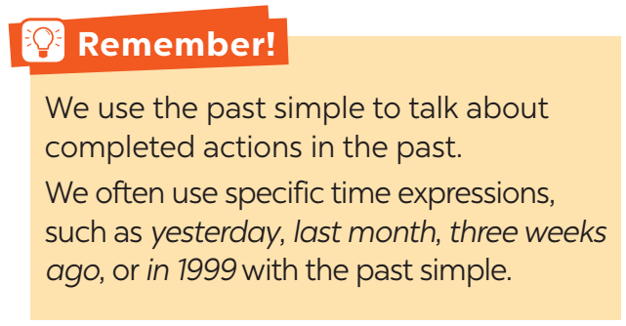  Positive S + V-ed / V ( cột 2)  Negative S + did not / didn’t + V  Questions and short answers Did + S + V ? - Yes, S + did. - No, S + didn’t.
Activity 3: PRACTICE (20’)
Task 1
* Aims: To review students’ knowledge of the past simple tense.
* Content: Circle the correct answer A, B, or C to complete each sentence.
* Products: Ss read aloud full sentences with the correct answers
* Organization of implementation:
Teacher’s and Ss’activities | Content
Task 1:T –Ss , Ss- Ss  * Teacher has students work individually.  ** Students work individually to to complete the sentences with the past simple form of the given verbs.  *** Teacher lets students work in pairs and exchange the answers before checking with the whole class (explain each sentence if necessary).   Teacher confirms the answers and gives feedback. | Task 1: Circle the correct answer A, B, or C to complete each sentence.  * Answer key:  1. B  2. C  3. B  4. A  5. C
Task 2:
* Aims: To raise students’ awareness of the past simple tense and past forms of some verbs
* Content: Complete the sentences with the past simple form of the given verbs.
* Products: Ss exchange the answers and then write the correct answers on the board.
* Organization of implementation :
Teacher’s and Ss’activities | Content
Task 2: T - Ss, Ss - Ss  * Teacher has students work individually.  ** Students work individually to complete the sentences.  *** Teacher lets students work in pairs and exchange the answers before checking with the whole class (explain each sentence if necessary).   Teacher confirms the answers and gives feedback. | Task 2: Complete the sentences with the past simple form of the given verbs.  * Answer key:  1. took  2. Did … join  3. helped  4. sent  5. volunteered
Task 3
* Aims: To help students distinguish between the present simple, present continuous and past simple in specific contexts.
* Content: Complete the sentences with the correct forms of the verbs from the box.
* Products: Ss write the correct answers on the board.
* Organization of implementation:
Teacher’s and Ss’activities | Content
* T-Ss, Ss-Ss  * Teacher asks the whole class to read aloud the verbs in the box then has students work individually to complete the sentences with the correct forms of the verbs from the box.  ** Students work individually to complete the task.  *** Teacher then has them work in pairs, comparing their sentences. Teacher can go around to help students.   Teacher confirms the answers and gives feedback. | Task 3: Complete the sentences with the correct forms of the verbs from the box.  * Answer key:  1. cook  2. Did … plant  3. are picking up  4. recycled  5. read
Task 4* Aims: To help students write full sentences using the correct forms of the verbs.
* Content: Write complete sentences from the prompts.
* Products: Students write full sentences on the board.
* Organization of implementation:
Teacher’s and Ss’activities | Content
* T-Ss, Ss-Ss  * Teacher has students work independently.  ** Teacher asks students to do the exercise individually.  *** Teacher lets students work in pairs and exchange the answers before checking with the whole class (explain each sentence if necessary).   Teacher confirms the answers and gives feedback.  . | Task 4: Write complete sentences from the prompts.  * Answer key:  1. Last year, our club donated books to children in rural areas.  2. Children sent thank-you cards to us a week ago.  3. I taught two children in grade 2 last summer.  4. Last spring, we helped the elderly in a nursing home.  5. We helped people in flooded areas last year.
Activity 4: PRODUCTION (5’)
* Aims: - To enable students to ask and answer questions related to past activities.
- To help students be aware of some community activities that students in other countries do.
* Content: Practise asking and answering questions based on the fact sheet.
* Products: Some pairs ask and answer in front of the class.
* Organization of implementation:
Teacher’s and Ss’activities | Content
T - Ss, Ss – Ss  * Teacher introduces the Red Cross projects and activities in 2016 and 2020 and has students work in pairs for 5 minutes to practise asking and answering questions based on the fact sheet.  ** Students use the past simple when they ask and answer questions about the past activities.  *** Teacher invites some pairs to make short conversations as an example.   Teacher corrects any grammar and pronunciation mistakes if necessary. | Taskk 5: Work in groups. Tom is from the Red Cross. Look at the fact sheet and ask Tom about his projects in 2016 and 2020.  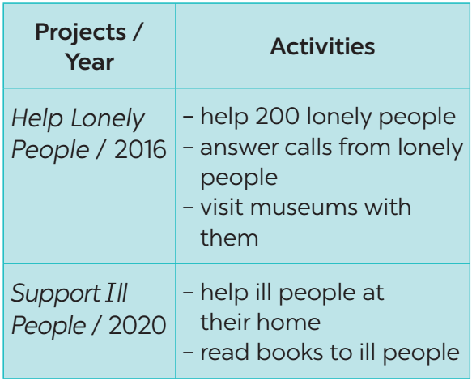  * Example:  Tom: I’m from the Red Cross. I worked on the Help Lonely People project in 2016.  Lan: What did you do?  Tom: We helped 200 lonely people…
Activity 5: CONSOLIDATION(3’)
* Aim: To consolidate what students have learnt in the lesson.
* Content: Summarize the main content in the lesson.
* Products: Ss say what students have learnt in the lesson.
* Organization of implementation:
Teacher’s and Ss’ activities | Content
Teacher asks students to talk about what they have learnt in the lesson. | - Grammar: revise the past simple.
IV. HOMEWORK (2’)
* Aim: To revise the knowledge that students have gained in this lesson and prepare the new lesson
Teacher’s and Ss’ activities | Content
- T reminds Ss to do homework and prepare the new lesson. | - Do exercises in the workbook.  - Prepare lesson 4 ( communication)
*- Complements …………………………………………………………………………………………………………………………………………………………………………………………………….
Date of planning: 14/10/2024
Date of teaching: 18/10/ 2024(Dạy bù)
Week 7 : UNIT 3: COMMUNITY SERVICE

Period 19: Lesson 4 : Communication
I. OBJECTIVES:
By the end of this lesson, Ss will be able to:
- know how to give compliments
- discuss and present the benefits of community activities
1. Knowledge:
- Vocabulary: vocabulary on community activities.
- Grammar: structures to give compliments.
2. Competences:
- Develop communication skills and creativity
- Be collaborative and supportive in pair work and teamwork
- Actively join in class activities
3. Qualities
- Develop self-study skills
- Raise students’ awareness of the need to keep their neighbourhood green
II. TEACHING AIDS
1. Teacher: - Grade 7 textbook, Planning (Unit 3- communication)
- A laptop connected with Smart TV, sets of word cards
- sachmem.vn
2. Students: Text books, notebooks, posters, ….
3. Method: Ask and answer ; group works; individual ……
  - III. PROCEDURES : (STAGES)
Activity 1: WARM –UP (5’)
* Aim: To review students’ knowledge of the past simple tense.
* Content: ALPHABET GAME ( Using the past simple to make sentneces with the alphabet)
* Products: Students make sentneces exactly.( Group has the most correct answers is win)
* Organization of implementation:
Teacher’s and Ss’activities |  |  | Content
* Warm up  * Teacher divides the class into 4 groups. Students take turns to use the past simple in a sentence. The first letter of the verbs must follow the sequence of the alphabet.  ** Students work in groups to play the game. If a student from a group can’t think of one verb, he/she is out of the game. The next student from other groups continues with the next letter.  *** Teacher goes around to help weaker students.   Teacher gives compliments to the group which has the most correct answers.  Lead in Teacher says: “This lesson today we are going to learn how to give compliments” |  |  | * ALPHABET GAME  * Example:  A: He asked me my name.  B: I bought a hat.  C: I came here last month.  well done/  You are wonderful
Activity 2. PRESENTATION (7’)
* EVERYDAY ENGLISH
How to give compliments
Task 1
* Aim: To introduce two ways to give compliments.
* Content: Listen and read the dialogue.
* Products: Role play and practise.
* Organization of implementation:
Teacher’s and Ss’activities | Content
* Teacher asks students to look at the conversation in GETTING STARTED and check if they find any phrases or clauses that Minh and Tom use to compliment the other for doing something good deeds.  ** When students have found the clause “Sounds like great work!”, teacher tells them that they can use this to make compliments. Teacher asks students to think about more ways to give compliments.  *** Teacher and students discuss the answers.   Teacher confirms the answers  Task 1:T –Ss  * Teacher plays the recording for Ss to listen and read the dialogue between Lan and Mark.  ** Students pay attention to the highlighted parts.  *** Teacher emphasizes the use of the compliments.   Teacher confirms the answers and gives feedback. | * Look at the conversation in GETTING STARTED and find any phrases or clauses that Minh and Tom use to compliment the other for doing something good deeds.  + That's fantastic.;  + Sounds like great work!,  TASK 1: LISTEN AND READ THE DIALOGUE BETWEEN LAN AND MARK. PAY ATTENTION TO THE HIGHLIGHTED PARTS. (Ex 1, p. 32)  *2 ways to give compliments:  - Sounds like great work!  - Wonderful!
Activity 3. PRACTICE (15’)
Task 2
* Aims: To help students practise giving compliments.
* Content: Work in pairs. Make similar conversations.
* Products: Role play and practise in front of the class
* Organization of implementation:
Teacher’s and Ss’activities |  | Content
Task 2:T –Ss : Ss- Ss  * Teacher has students work in pairs to make similar dialogues.  ** Students work in pairs to make similar dialogues, using the contexts given and the sample compliments.  *** Teacher asks some pairs to practice the dialogue so that the whole class can give comments.   Teacher gives feedback as a class. |  | Task 2: Work in pairs. Make similar conversations.  * Example:  Mi: What did you do to help your community last summer, Tom?  Tom: My friends and I cleaned and decorated parts of our neighbourhood.  Mi: Sounds like great work! I helped lonely elderly people in the area.  Tom: Wonderful!
Task 3
* Aims: To help students learn more about some benefits of community activities.
- To help students practise reading for specific ideas.
* Content: Read the poster about the volunteer activities. Write the project number (1-3) next to its benefits (A-E).
* Products: Some pairs read out their answers.
* Organization of implementation:
Teacher’s and Ss’activities |  | Content
Task 3: T - Ss, Ss – Ss  . * Teacher has students work in pairs to read the poster and asks them questions like:  - How many projects does Lending Hand offer?  - What activities can you do / join in Projects 1, 2 and 3?  ** Students work in pairs to write the number of the projects (1 - 3) next to the benefits (A - E).  *** Teacher asks some pairs to to read out their answers.   Teacher gives feedback and correction (if needed). |  | Task 3: Read the poster about the volunteer activities. Write the project number (1-3) next to its benefits (A-E).  Changing our neighbourhood  * Answer key:  1. B, E  2. C, D  3. A
Task 4:
* Aims: To help students practise asking and answering questions about which activities they want to join and why; To help students practisce giving reasons.
* Content: Ask and answer which activities in Task 3 you want to join. Give reasons.
* Product: Some pairs role-play, asking and answering questions in front of the class.
* Organization of implementation:
Teacher’s and Ss’activities |  | Content
Task 4: T - Ss, Ss – Ss  * Teacher asks students to work in pairs to ask and answer questions about which activities they want to join and why.  ** Students work in pairs to do the task. They can use the example in the Student’s book. They should clarify any other benefits they can think of.  *** Teacher invites some pairs to role-play, asking and answering questions in front of the class.   Teacher corrects any grammar or pronunciation mistakes if necessary. |  | Task 4: Ask and answer which activities in Task 3 you want to join. Give reasons.  * Example:  Minh: Which activity do you want to join?  Lan: I want to join some clean-up activities.  Minh: Why do you want to join these activities?  Lan: Because they make the neighbourhood cleaner.
Activity 4. PRODUCTION( 5’)
Task 5
* Aims: - To help students practise asking and answering questions about which activities they choose to join and the benefits of those activities; To help students practise giving reasons; To help students practise reporting.
* Content: Present your group’s answer to the class.
* Products: Some group representatives report their group’s answers as class
* Organization of implementation:
Teacher’s and Ss’activities |  | Content
Task 5: T - Ss, Ss - Ss  * Teacher lets students work in groups discuss which activity each member of their group chooses and the benefits of each activity.  ** Students can give more than one benefit to any activity or any benefits they can think of in addition to those they find in the Student’s book.  *** Teacher invites group representatives to report their group’s answers.   Teacher gives feedback on their reports. |  | Task 5: Discuss which activity each member of your group chooses and the benefit(s) of the activity. Present your group’s answer to the class.  * Example:  Mai wants to donate food to street children because this helps feed them. Lan wants to join clean-up activities because these activities make our neighbourhood cleaner…
Activity 5. CONSOLIDATION (3’)
* Aims: To consolidate what students have learnt in the lesson.
* Content: Summarize the content of the lesson
* Products: Say aloud what students have learnt .
* Organization of implementation:
Teacher’s and Ss’activities |  | Content
Teacher asks students to talk about what they have learnt in the lesson. |  | - know how to give compliments  - the benefits of community activities
IV. HOMEWORK (2’)
* Aim: To revise the knowledge that students have gained in this lesson. And prepare for the next lesson: Skills 1.
Teacher’s and Ss’ activities |  | Content
- T reminds Ss to do homework and prepare the new lesson. |  | - revise the old lesson.  - Think about some environmental problems in your neighbourhood and the activities you want to do to solve those problems.  - Prepare lesson 5 ( skills 1)
*- Complements ……………………………………………………………………………………………………………………………………………………………………………………………………………..

Date of planning: 14/10/2024

Date of teaching: 18/10/ 2024

Week 7 :

Period 20: UNIT 3: COMMUNITY SERVICE

Lesson 5 : Skills 1
I. OBJECTIVES:
By the end of this lesson, Ss will be able to:
1. Knowledge:
- Develop reading skill for specific information about community activities at a school
- Develop speaking skill: Talking about the reasons why students join different community activities
2. Competences:
- Develop communication skills and creativity
- Be collaborative and supportive in pair work and teamwork
- Develop presentation skill
- Actively join in class activities
3. Qualities
- Develop self-study skills
- Raise students’ awareness of the need to keep their neighbourhood green.
II. TEACHING AIDS
1. Teacher: - Grade 7 textbook, Planning (Unit 3, Skills 1)
- a laptop connected with Smart TV/Pictures, sets of word cards
- sachmem.vn
2. Students: Text books, notebooks, posters, ….
  - III. PROCEDURES : (STAGES)
Activity 1. WARM -UP (5’)
* Aim: - To remind students of some community activities.
- To enhance students’ skills of cooperating with team mates.
* Content: Chatting: some questions about going camping.
* Products: Students answer the questions individually.
* Organization of implementation:
Teacher’s and Ss’activities | Content
- T- Ss  * Teacher divides the class into 2 teams.  - Each team will have to run in a relay to the board to match the correct description with each picture.  - The team with more correct answers will be the winner.  ** Students play the game in team mode.  *** Teacher and students discuss the answers.   Teacher confirms the answers and gives feedback | * GAME: WHO IS FASTER?  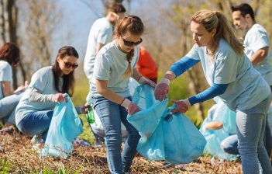  1. collecting rubbish 2. donating clothes  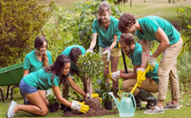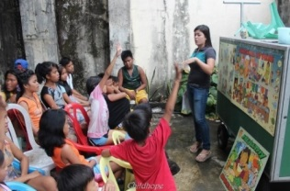  3. planting tree 4. tutoring homeless children  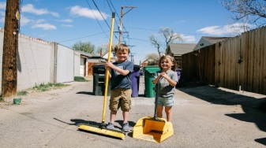  5. helping old people 6. cleaning the street
Activity 2: Pre –reading (10’)
Pre- teaching vocabulary
* Aim:. To provide students with some lexical items before reading the text.
* Content: Learn some vocab related the topic.
* Products: Read and understand the meaning of words.
* Organization of implementation:
Teacher’s and Ss’activities | Content
T –Ss :  - Pre teach vocabulary  - Teacher use different techniques to teach vocab .  - Repeat in chorus and individually  - Copy all the words | - * vocabulary:  - monthly (adj/adv): hằng tháng  - proud of (adj): hài lòng, tự hào
Task 1
* Aim: - To remind students of some community activities;
- To help Ss brainstorm some more community activities
* Content: Learn some vocab related the topic.
* Products: Read and understand the meaning of words.
* Organization of implementation:
Teacher’s and Ss’activities | Content
* Teacher has the class read out loud the three activities.  ** Students work in pairs to circle the activities they would like to do at their school.  *** Students can name some more activities they would like to do at their school if the class is more fluent.   Teacher accepts all students’ answers. | Task 1: Circle the activities you would like to do at your school.  A: What would you like to do at your school?  B: I would like to grow vegetables in the school garden.
Activity 3. WHILE -READING (10’)
Task 2: (3’)
* Aims: - To improve students’ knowledge of vocabulary related to community activities.
- To improve students’ skill of reading for details.
* Content: Read the passage and match the highlighted words with their meanings.
* Products: Ss match the highlighted words with their meanings in the box exactly.
* Organization of implementation:
Teacher’s and Ss’activities | Content
Task 2:T –Ss : Ss- Ss  -Ask Ss to work individually to read the passage and find the highlighted words.  - Have Ss match the highlighted words with their meanings in the box. Remind them to use the context to help them.  -Check the answers as a class | Task 2: Read the passage and match the highlighted words with their meanings.  * Answer key:  1. donate  2. exchange  3. monthly  4. proud  5. tutor
Task 3: (5’)
* Aims: To develop reading skill for specific information.
* Content: : Read the passage again and tick True or False.
* Products: Students’ correct answers on the board
* Organization of implementation :
Teacher’s and Ss’activities | Content
Task 3: T - Ss, Ss – Ss  * Teacher asks some students to read out loud the sentences in the table.  ** Students work individually for some minutes and tick T (True) or F (False).  *** Teacher allows students to share their answers before discussing as a class and encourages them to give evidence.   Teacher calls a student to write his/her answer on the board, then check sentence by sentence with class. | Task 3: Read the passage again and tick True or False.  * Answer key:  1. T  2. F  3. T  4. F  5. T  .
Activity 4. PRE-SPEAKING
Task 4
* Aims: To enable students to review and reuse the name of some community activities;
- To give students an opportunity to practise explaining their reasons
* Content: Write the names of the projects you think they should join in the Projects column.
* Products: Students decide project they should join and give some reasons for their choice.
* Organization of implementation:
Teacher’s and Ss’activities | Content
Task 4: T – Ss, Ss – Ss  * Teacher asks students work in pairs to read the sentences in the table. Ask some Ss to stand up to answer the questions:  ** Students work in pairs to to discuss and decide which student should join which project in the reading.  *** Students should give some reasons for their choice.   Teacher confirms the answers and gives feedback if necessary. | Task 4: Read about these students. Write the names of the projects you think they should join in the Projects column.  * What did you learn about Nick / Ann / Minh / Mark / Tom?  * Answer key:  1. C  2. A  3. B  4. D  5. E
Activity 5. WHILE-SPEAKING
Task 5
* Aims: To give Ss an opportunity to practice explaining reasons.
* Content: Discuss which project in Task 4 you would like to join, and why. Report your group’s answers to the class.
* Products: Some groups give presentations in front of the class.
* Organization of implementation:
Teacher’s and Ss’activities | Content
Task5: T – Ss, Ss – Ss  * Teacher has students work in groups to discuss which project each of them would like to join.  ** Students work in groups to discuss which project that each of them would like to join and give reasons.  *** Teacher goes around to help students.   After finishing, teacher can call some groups to give presentations in front of the class. | Task 5: Discuss which project in Task 4 you would like to join, and why. Report your group’s answers to the class.  * Example:  Lan will join the Tutoring project because she is good at maths and English. She also loves children.
Activity6. POST-READING AND SPEAKING
Task 5
* Aims: - To help students improve next time.
- To help some students enhance presentation skill.
* Content: Students give comments and vote for the most interesting and informative presentation.
* Products: Students’ comments on their friend's presentation exactly.
* Organization of implementation:
Teacher’s and Ss’activities | Content
T – Ss, Ss – Ss  * Teacher allows students to give comments for their friends and vote for the most interesting and informative presentation.  ** Students give comments for their friends and vote for the most interesting and informative presentation.  *** Teacher and students discuss the presentations.   Teacher gives feedback and comments. | * Students’ comments on their friend's presentation
Activity 7. CONSOLIDATION (2’)
* Aims: To consolidate what students have learnt in the lesson.
* Content: Ss summarize what they have learnt with the two skills.
* Products: Students say what they have learnt with the two skills in front of the class.
* Organization of implementation:
- Teacher asks students to talk about what they have learnt in the lesson. | - some vocab  - reading the text about community activities at a school  -Talking about the reasons why students join different community
IV. HOMEWORK (2’)
* Aim: To revise the knowledge that students have gained in this lesson.
- Teacher asks students to prepare the new lesson | - learn by heart vocab.  - Prepare for the next lesson: Unit 3-Skills 2.  - Plan some school activities for next summer holiday.
*- Complements …………………………………………………………………………………………………………………………………………………………………………………

Date of planning: 18/10/2024

Date of teaching: 23&24/10/ 2024

Week 7 : UNIT 3: COMMUNITY SERVICE

Period 21: Lesson 6: Skills 2
I. OBJECTIVES:
By the end of this lesson, Ss will be able to:
1. Knowledge:
- listen for specific information about some community activities and their benefits;.
- write an email about community activities one did last summer.
2. Competence:
- Develop communication skills and creativity
- Be collaborative and supportive in pair work and teamwork
- Actively join in class activities
3. Qualities
- Develop self-study skills
- Raise students’ awareness of the need to keep their neighbourhood green.
II. TEACHING AIDS
1. Teacher: - Grade 7 textbook, Planning (Unit 3, Skills 2)
- A laptop connected with Smart TV/Pictures, sets of word cards
- sachmem.vn
2. Students: Text books, notebooks, posters, ….
3. Method: Ask and answer ; group works; individual ……
  - III. PROCEDURES : (STAGES)
Activity 1. WARM-UP (5’)
* Aim: To lead in the topic of the lesson: school community activities in summer.
* Content:
* Products: Students go to the board and rearrange words.
* Organization of implementation:
Teacher’s and Ss’activities |  | Content
* Warm - up  T - Ss  * Teacher reminds student of the homework of the previous lesson: Plan some school activities for next summer holiday.  ** Students raise hands to talk about their plans.  *** Teacher asks the whole class to discuss and give feedback on their friends’ plans.   Teacher chooses some useful and feasible and leads in the topic of the lesson: school activities in summer. |  | * CHATTING & HOMEWORK CHECKING  * Example:  - picking up litter  - planting trees  - donating old clothes, old books,….  - tutoring poor children.  ……………….
Activity 2. PRE - LISTENING (5’)

Task 1:
* Aim: To help Ss brainstorm key words/ phrases for listening;
- To help Ss practise describing pictures, using vocabulary related to community activities.
* Content: Question: What community activities are the children doing in the pictures?
* Products: Ss describe the pictures to the class.
* Organization of implementation:
Teacher’s and Ss’activities | Content
T - Ss, Ss - Ss  * Teacher asks students to work in pairs to describe the pictures or discuss what the teenagers are doing in the pictures.  ** Students discuss with a partner.  *** Teacher elicits as many learnt vocabularies as possible and asks one or two students to re-describe the pictures to the class.   Teacher gives feedback and tell students that they are going to listen to a talk between Tom and Kate about the community activities they did last summer. | Task 1: What community activities are the children doing in the pictures?  * Suggested answer:  a. reading books to the elderly  b. picking up litter  c. planting trees
Activity 3. WHILE - LISTENING ( 10’)
Task 2
* Aims: To draw students’ attention to listening skills: predicting, identifying keywords, and listening for specific details.
* Content: Listen and circle the correct answers.
* Products: Note down to describe the two girls. Underline keywords ( work indepently)
* Organization of implementation:
Teacher’s and Ss’activities | Content
Task 2: T - Ss, Ss - Ss  * Teacher asks students to work individually to read through Questions 1 to 4 and underline the key words.  ** Teacher plays the recording once for students to listen and circle the answers.  *** Teacher allows student to peer check first, then plays the recording a second time for pairs to check their answers again.   Teacher confirms the answers and gives feedback | Task 2: Listen and circle the correct answers.  * Keywords in the questions:  - Question 1: Linda, friends, taught  - Question 2: Linda, friends, elderly  - Question 3: Tom, friends, picked up  - Question 4: Tom, friends  * Answer key:  1. C  2. B  3. C  4. A
Task 3:
* Aims: To help students develop listening skill for specific information (gap-filling)..
* Content: Listen again and fill in the blanks.
* Products: Students’ answers on the board.
* Organization of implementation:
Teacher’s and Ss’activities | Content
- T-Ss, Ss-Ss  * Teacher asks students to read the conversation and to focus on the key information and underline the keywords to predict the words / phrases they will need to fill in each blank.  - Teacher tells students to think about the part of speech of the words / phrases they will need to use for each blank (e.g. adjective, verb or noun).  - Teacher reminds students of the possible plural and singular forms of nouns  - Teacher remind students that they should write no more than TWO words for each blank.  ** Teacher plays the recording again. Ask students to listen and fill in the blanks.  *** Teacher lets students peer-check with a partner.   Teacher calls some students to give the answers to the class and correct the mistakes where necessary, encourages students to explain their answers, share some tips on finding the information. | Task 3: Listen again and fill in each blank with no more than two words.  * Answer key:  1. fun 2. good time 3. skills  * Audio script:  Tom: So, what did your club do last year?  Linda: We tutored 3rd grade children and helped old people.  Tom: Fantastic! What did you tutor?  Linda: We taught English and maths.  Tom: Awesome! Was it difficult?  Linda: Yes. But we had a lot of fun.  Tom: I see! How did you help the elderly?  Linda: We cooked for them and did some cleaning, too.  Tom: Great! I’m sure they benefited from it.  Linda: Thanks! It made us feel useful. How about you?  Tom: We picked up paper and bottles in a nearby park. We also planted some trees.  Linda: Fabulous! Did you water them too?  Tom: Sure. We watered them very often the first few weeks and enjoyed watching them grow.  Linda: Glad to hear it, Tom.  Tom: Yes. It was a really good time. We worked and played together, and we learnt some skills, too.
Activity 4. PRE - WRITING (5’)
Task 4
* Aims: To provide students with a sample of an email ; To improve students’ reading skills.
- To prepare students for the writing activity.
* Content: Read Tom’s email to Nam about his school activities last summer.
* Products: Read and understand the content and the format of an email
* Organization of implementation:
Teacher’s and Ss’activities | Content
- T-Ss, Ss-Ss  * Teacher asks students to work individually to read the email.  - Teacher asks students questions that elicit the format of an email:  - Teacher asks students to underline the main activities that Tom and his friends did and ask them to underline the words / phrases that show their feelings, and words / phrases that show the benefits of their activities.  ** Students work individually as directed.  *** Teacher asks students to work in pairs to discuss and peer check the results.   Teacher gives feedback and confirms the structure of an email as a class. | * Task 4: Read Tom’s email to Nam about his school activities last summer.  + Who is writing to whom?  Tom is writing to Nam.  + What is the subject of the third paragraph of the email?  School activities last summer.
Activity 5. WHILE-WRITING (5’)
* Aim: To improve students’ writing skills.
* Content: Write an email of about 70 words to Tom about your school activities last summer.
* Products: Students’ writing on the posters and cross check
* Organization of implementation:
Teacher’s and Ss’activities | Content
- T-Ss, Ss-Ss  * Teacher asks students to work in pairs to list:  - the activities they did and how they feel about doing them;  - the benefits that they got from their community activities last summer.  ** Students work in pairs to write on an A1 / A2 size piece of paper.  *** Teacher allows students to cross check first.   Teacher goes around to help (if necessary). | Task 5: Write an email of about 70 words to Tom about your school activities last summer.  To: tom@webmail.com  Subject: School activities last summer  Dear Tom,  Things are good. We also did some interesting activities last summer. I and my brother donated books and clothes for a charity organization.  In here , I met the orphan’s children. I played with them. Then I gave candies to them.  They were all very happy and so did I  Please write back to me.  See you soon,
Activity 6. POST - LISTENING & WRITING (5’)
* Aim: To peer check, cross check and final check students’ writing
* Content:. Cross check students’ writing
* Products: Students’ writing on the posters.
* Organization of implementation:
Teacher’s and Ss’ activities | Content
- T-Ss, Ss-Ss  Giving peer-reflection & evaluation  * Teacher asks students to stick their emails onto the board.  ** Students can go and see others’ work.  *** Students then give comments to each other.   Teacher then gives feedback as a class discussion. | Task 6: CLASS GALLERY  * Cross check students’ writing
Activity 7. CONSOLIDATION (2’)
* Aim: To consolidate what students have learnt in the lesson.
* Content: summarize the content of the lesson.
* Products: A student says what she/ he has learnt in the lesson.
* Organization of implementation:
Teacher’s and Ss’ activities | Content
- Teacher asks students to talk about what they have learnt in the lesson. | - listen about some community activities and their benefits;.  - write an email about community activities one did last summer.
IV. HOMEWORK(2’)
* Aim: To revise the knowledge that students have gained in this lesson.
- Teacher asks students to rewrite their writing in their books.  - Teacher asks students to prepare the new lesson. | - Rewrite the writing in the notebook.  - Prepare “ Looking back and project”
*- Complements ………………………………………………………………………………………………………………………………………………………………………………………………………………

Date of planning: 20/10/2024

Date of teaching:24, 25/10/ 2024

Week 8 : UNIT 3: COMMUNITY SERVICE

Period 22: Lesson 7: Looking back and project
I. OBJECTIVES:
By the end of this lesson, Ss will be able to:
1. Knowledge
- Review the vocabulary and grammar of Unit 3
- Apply what they have learnt (vocabulary and grammar) into practice through a project
2. Core competence
- Develop communication skills and creativity
- Develop presentation skill
- Develop critical thinking skill
- Be collaborative and supportive in pair work and team work
- Actively join in class activities
3. Qualities
- Be more creative when doing the project
- Develop self-study skills
- Raise students’ awareness of the need to keep their neighbourhood green.
II. TEACHING AIDS
1. Teacher: - Grade 7 textbook, Planning (Unit 3 - Looking back and project)
- A laptop connected with Smart TV/Pictures, sets of word cards
- sachmem.vn
2. Students: Text books, notebooks, posters, ….
3. Method: Ask and answer ; group works; individual ……
  - III. PROCEDURES : (STAGES)
Activity 1: WARM -UP (5’)
* Aim: - To revise the vocabulary related to the topic and lead in the next part of the lesson.
- To enhance students’ skills of cooperating with teammates.
* Content: Game Who’s faster ( give description for each picture)
* Products:
* Organization of implementation:
Teacher’s and Ss’activities | Content
* Warm up  - T -Ss  * Teacher shows the pictures and asks students to give descriptions to them. Teacher can divide the class into 2 teams and runs the game- Who’s faster.  ** Members of each team take turns to raise hands to give description for each picture.  *** Students discuss their friends’ answers.   Teacher confirms the answers and gives feedback. The group having more correct answers is the winner. | *Warm-up - Game: Who’s faster  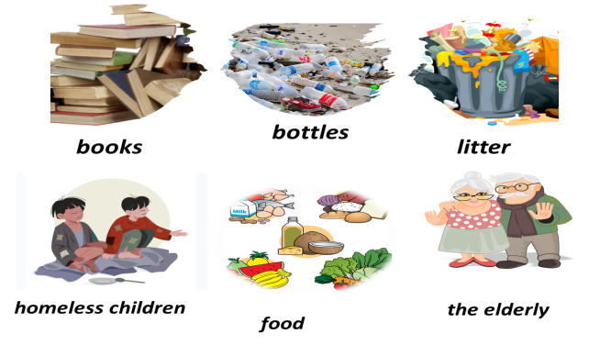
Activity 2: PRACTICE

* LOOKING BACK
1. VOCABULARY( 10’)
Task 1+ Task 2
* Aim: To help students revise the vocabulary learnt.
- To help students match the correct verbs with the appropriate nouns / noun phrases to make phrases about community activities.
- To help students use the correct phrases about community activities in the correct contexts.
* Content: Complete the table with the words and phrases .
* Products: Students say the correct key aloud ( individual work).
* Organization of implementation:
Teacher’s and Ss’activities |  | Content
- T –Ss :  * Teacher encourages students to complete the task individually.  ** Students do the task individually.  *** Students exchange their textbooks with their partners.   Teacher gives feedback as a class discussion.  - T –Ss  * Teacher asks students to complete the task individually.  ** Students do the task individually to put the correct phrases in the blanks.  *** Students exchange their textbooks with their partners.   Teacher gives feedback as a class discussion. |  | Task 1: Complete the table with the words and phrases from the box.  * Answer key:  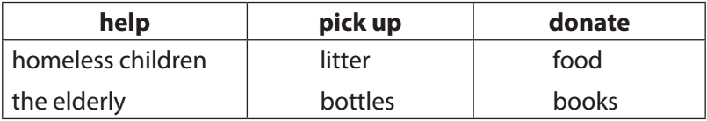  Task 2: Complete each sentence with one phrase from Task 1. Remember to use the correct forms of the verbs.  * Answer key:  1. donated food  2. picked up bottles  3. helped the elderly  4. donated books  5. helped homeless children
2. GRAMMAR (10’)
Task 3 + Task 4
* Aims: To help students revise the past simple form of some verbs.
To help students improve their writing about community activities.
* Content: Use the correct form of the verbs from the box to complete the passage.
* Products: Students’ correct answers on the board. (individual work)
* Organization of implementation:
Teacher’s and Ss’activities |  | Content
- T –Ss ; Ss – Ss  * Teacher encourages students to complete the task individually.  ** Students complete the passage using the correct forms of the verbs in the box.  *** Students exchange their textbooks with their partners.   Teacher gives feedback as a class discussion.  - T –Ss ; Ss – Ss  * Teacher asks students to do individually first.  ** Students complete the task individually.  *** Teacher then asks them to check their answers with a partner before discussing the answers as a class.   Teacher confirms the answers and corrects students’ pronunciation if necessary. |  | Task 3: Use the correct form of the verbs from the box to complete the passage.  * Answer key:  1. had  2. collected  3. sold  4. donated  5. went  Task 4: Write full sentences about the activities the students did to help their community last year  * Answer key:  1. Mi sang and danced for the elderly at a nursing home.  2. Mark and his friends collected books and set up a community library.  3. Lan and Mai grew and donated vegetables to a primary school.  4. Minh and his friends gave food to young patients in a hospital.  5. Tom made and sent postcards to the elderly at Christmas.
3. PROJECT (10’)
* Aims: - To help students identify problems that their neighbourhood is facing and brainstorm possible solutions to deal with those problems.
- To raise students’ awareness of the need to keep their neighbourhood green
- To improve students’ teamwork and public speaking skills.
* Content: make project “My class yearbook”
* Products: Students’ answers on the posters
* Organization of implementation:
Teacher’s and Ss’activities |  | Content
- T –Ss ; Ss – Ss  * Teacher has students work in groups and gives instructions to students as follow:  - discuss some environmental problems their neighbourhood is facing and how you are going to solve the problems.  - look at the pictures as clues to brainstorm ideas.  * Students discuss in groups then present the environmental problem to the class.  *** Students vote for the best performance.   Teacher gives feedback. |  | * PROJECT  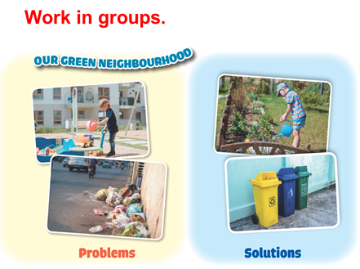  1. Think about some environmental problems in your neighborhood  2. Discuss and find the answers to the questions  . What problems can you find?  . What do you want to do to solve the problems?  . How are you going to do them?  3. Present them to your class
Activity 3: CONSOLIDATION (2’)
* Aim: To consolidate what students have learnt in the lesson.
* Content: summarize the content of the lesson.
* Products: A student says the lesson’s content aloud.
* Organization of implementation:
Teacher’s and Ss’activities |  | Content
- Teacher asks students to talk about what they have learnt in the lesson. |  | - - revise vocabulary and grammar in unit 3  - Make project about some environmental problems.
IV. HOMEWORK (2’)
Aim: To revise the knowledge that students have gained in Unit 3 and To prepare for the next lesson
Teacher’s and Ss’ activities |  | Content
- Teacher asks students to revise old lesson and to do exercise in workbook.  - Teacher asks students to complete the project and prepare the new lesson. |  | - Complete the project  - Prepare for the next lesson: Review 1.
*- Complements …………………………………………………………………………………………………………………………………………………………………………………………………….

