Week: 22
English 3 – Class 3A, 3B
UNIT 13: MY HOUSE - LESSON 1 (1,2,3) - Period 85
Date of teaching: 10/02/2025
A. OBJECTIVES: By the end of the lesson, Ss will be able to:
1. Knowledge:
–use the words living room, bedroom, kitchen, bathroom, here, there
–use Where’s the…? – It’s here/ there. to ask and answer questions about the location of a room in a house
- Vocabulary: living room, bedroom, kitchen, bathroom, here, there
- Model sentences: A: Where’s the……….?
B: It’s here/ there.
- Skills: speaking and listening
2. Competences:
- Critical Thinking: talk about house
- Co-operation: ready to help friends in pair work/ group work.
- Sociability: Talk to each other, say good words to others.
3. Attributes:
- Kindness: Help partners to complete learning tasks.
- Honesty: tell the truth about feelings and emotions
B. MATERIALS:
- Teacher: Teacher’s guide Pages 161, 162, audio Tracks 22, 23, website sachmem.vn, laptop, pictures, textbook, lesson plan, TV.
- Students: Pupil’s book Page 18, notebooks, workbooks, school things.
C. PROCEDURES:
Teacher’s activities | Students’ activities | Contents
1.Warm- up: (3’) Game: Let’s sing  *Aims: to review and create a friendly and active atmosphere before beginning the lesson.  - Play the recording for pupils to repeat  - Ask Ss to sing in groups  - Say “Open your book page 18” and look at “Unit 13, Lesson 1 (1,2,3)”.  2. Presentation (16’)  Activity 1. * Vocabulary.  *Aims: to know the vocabulary in front of starting the new lesson.  -T elicits the new words  (picture), (translation)  - T models (3 times).  - T writes the words on the board.  - Checking: remember and say  Activity 2. 1. Listen, point and repeat:  *Aims: to understand and correctly repeat the sentences in two pictures focusing on asking and answering about the location of a room in a house.  - Have Ss look at Pictures and identify the characters in the pictures.  - Play the audio twice for pupils to repeat. Correct their pronunciation where necessary.  - Have Ss to practice the dialogue  - T invites a few pairs to the front of the class to practice.  - T checks pronunciation for ss.  3.Practice: (7’)  Activity 3 2. Listen, point and say.  *Aims: to correctly say the words and use Where’s the……..? − It’s here / there. to ask and answer questions about the location of a room in a house.  - T asks Ss look at pictures and helps Ss know the new structure from the dialogue.  - T explains, models and gives meaning.  - Have Ss repeat the model sentences.  - Check comprehension names of rooms.  - Run through all the pictures.  - Have the model.  - Ask Ss to work in pairs.  - T controls and corrects.  - Invite a few pairs to point at the relevant character in each picture, and act out his/her role.  - T gives feedbacks.  4.Production: (7’)  Activity 4. 3. Let’s talk.  *Aims: to enhance the correct use of Where’s the……? − It’s here / there. to ask and answer questions about the location of a room in a house in a freer context.  - T asks ss to guess each character and what the children say.  +How many rooms are there?  +What rooms are they?  +Where’s the ……….?  - T models  - T asks Ss to work in pairs to ask and answer  - Invite some pupils to present their exchanges.  - Give feedbacks  *Consolidation  *Aims: to consolidate and wrap up the content of the lesson.  - T asks Ss to play the game  - T praises some Ss who are hardworking / active/ good…. as well as encourage others to try more.  5. Homework. (2’)  - Learn new words by heart  - Prepare: Unit 13, Lesson 1 (4,5,6). | - Ss listen and sing.  - Ss open their books  -Ss listen and answer  - - Ss listen and repeat  + Choral repetition (3 times).  + Individual repetition (3 ss)  - Ss take note  - Ss look, remember and say  -Look at the pictures and get to know the characters in them.  -Ss listen and repeat in chorus (twice)  -Ss work in pairs to practice  -Ss practice the dialogue  -Ss listen  -Ss look at the picture and answer.  -Ss listen  -Ss listen and repeat  - Ss look, listen and repeat in chorus  -Ss work in pairs to practice  -Ss point and say  -Ss listen  -Ss look at the picture and answer  + There are four rooms  + They are living room, kietchen, bedroom, bathroom.  + It’s here/ there  -Ss note  -Ss work in pairs  -Ss perform in front of the class.  - Ss listen  -Ss listen and clap their hands  -Ss listen and take note | 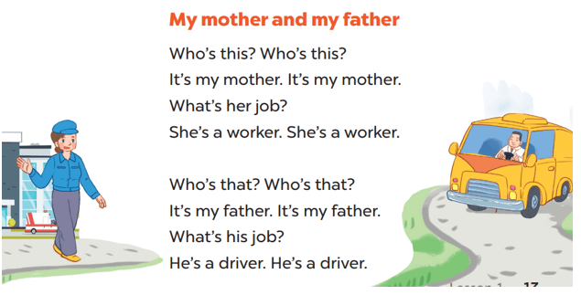  * Vocabulary.  + living room : phòng khách  + bedroom : phòng ngủ  + kitchen : phòng bếp  + bathroom : phòng tắm  + house : ngôi nhà  + here : ở đây  + there : ở kia  1. Listen, point and repeat:  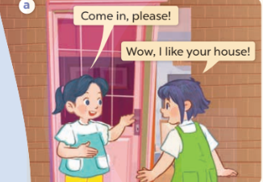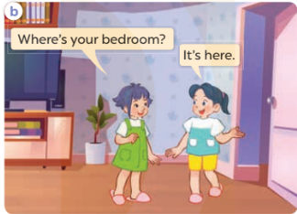  2. Listen, point and say.  * Model sentences:  A: Where’s the ………?  B: It’s here/ there.  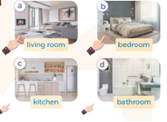  3. Let’s talk.  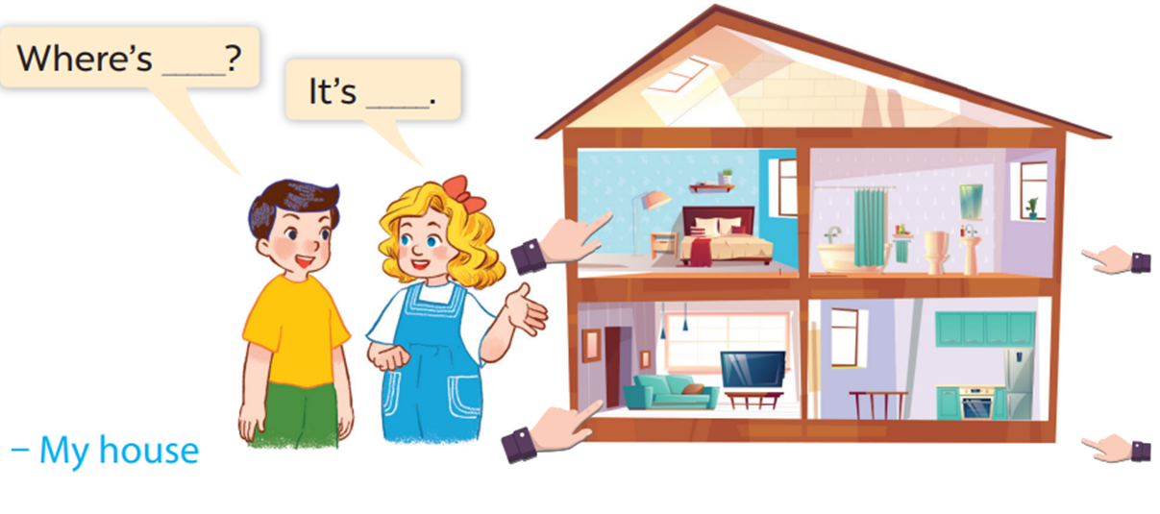  * Play: What’s behind the square  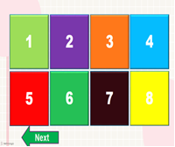
D. ADJUSTMENTS (if necessary):
………………………………………………………………………………………….…..…………………………………………………………………………...………………………………………….….....

Week: 22
English 3 – Class 3A, 3B
UNIT 13: MY HOUSE - LESSON 1 (4,5,6) - Period 86
Date of teaching: 10/02/2025
A. OBJECTIVES: By the end of the lesson, Ss will be able to:
1. Knowledge:
- listen to and understand simple exchanges in relation to the topic “My house”
- read and write about the location of rooms in a house and things in a room.
- Vocabulary: Review
- Skills: speaking, listening, reading and writing.
2. Competences:
- Co-operation: ready to help friends in pair work/ group work.
- Self-control and independent learning: perform listening tasks.
3. Attributes:
- Kindness: Help partners to complete learning tasks.
- Honesty: tell the truth about feelings and emotions.
- Diligence: complete learning tasks.
B. MATERIALS:
- Teacher: Teacher’s guide Pages 163, 164; Tracks 24, 25; laptop, pictures, textbook, lesson plan, TV.
- Students: Pupil’s book Page 19, notebooks, workbooks, school things.
C. PROCEDURES:
Teacher’s activities | Students’ activities | Contents
1.Warm- up: (5’) Game: “Passing the ball”  *Aims: to create a friendly and active atmosphere in the class to beginning the lesson.  - Divide class into 3 teams.  - Each team has 1 sticky ball.  - Play the music, ss in each team take turn to pass the ball.  - After the music ends, 3 ss have the ball – stand up and say the name, using the sentence model.  - Say “Open your book page 19” and look at “Unit 13, Lesson 1 (4,5,6)”.  2.Presentation: (10’)  Activity 1. 4. Listen and circle:  *Aims: to listen to and understand which pupils ask and answer questions about the location of a room in a house and circle the correct pictures  - Elicit the name of the room in each picture  - T ask Ss to guess the answers.  + T writes Ss’ guessing on the board.  - Play the recording and get Ss to swap books with their partners.  + Play the recording again to check answers together as a class.  + Write the answers on the board for Ss to correct their answers. Then checks Ss’ guessing.  - Play the recording, sentence by sentence, for the class to listen and repeat in chorus.  2.Practice: (10’)  Activity 2. 5. Look, complete and read.  *Aims: to complete four gapped exchanges with the help of picture cues.  - Have Ss look at the pictures and identify the rooms  - Have Ss look at the four incomplete exchanges and elicits the missing words in the sentences.  - T models with sentence 1  + Ask Ss what is missing in the sentence.  + Have Ss look at the picture and complete the gap, then read the completed sentence in chorus.  -Have Ss work in groups and complete the sentences 2,3 and 4.  - Ask a few Ss to stand up and read the completed sentences aloud.  -T gives feedbacks.  2.Production: (7’)  Activity 3. 6. Let’s sing.  *Aims: to sing the song Where is it? with the correct melody and pronunciation.  - Introduce the title and lyrics of the song: “Where is it? ” song.  - Play the recording for Ss to listen to the whole song.  + Have them repeat the title and lyrics line by line.  - Play the recording all the way through for Ss to listen to pronunciation and melody of the song.  - Play the recording line by line for Ss to listen, repeat  - Play the recording for Ss to sing and do actions.  - Ask Ss to practice singing and doing actions in pairs or groups.  - Invite groups to perform the song  -T gives feedback.  *Consolidation  *Aims: to consolidate and wrap up the content of the lesson.  - T asks ss to answer to review new words and the structures  - T praises some Ss who are hardworking / active/ good…. as well as encourage others to try more.  3. Homework. (3’)  - Learn the number by heart  - Prepare the new lesson: Unit 13, Lesson 2 (1,2,3). | - Ss listen and keep the puppet  - Ss listen to music and play the game  -Ss listen  - Ss open their books  -Look at the pictures and say:  -Ss guess the answers  - Ss listen to the tape and circle  - Ss listen again, circle and swap books with their partners.  - Ss check their answers and guessing  -Ss listen and repeat.  -Ss say: (a living room, a kitchen, a bathroom and a bedroom).  -Ss look and answer  -Ss answer: living room  -Ss look, complete and read the completed sentence in chorus.  -Ss complete the sentence  -Ss read aloud  - Ss look and listen.  -Ss listen to the song  - Ss repeat without the action.  -Ss listen to melody of the song  - Ss listen and sing line by line.  - Ss sing and do actions.  + Ss work in groups (two groups) to sing.  -Ss perform in front of the class.  -Ss listen  -Ss answer the questions  -Ss listen and clap their hands  -Ss listen and take note | 4. Listen and circle:  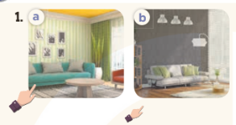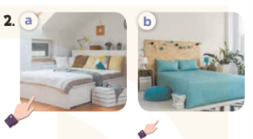  Key: 1.a 2.b  5. Look, complete and read.  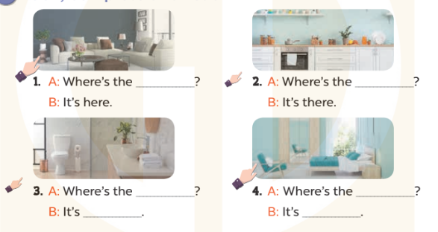  Key:  1. living room  2. kitchen  3. bathroom; there  4. bedroom; here  6. Let’s sing.  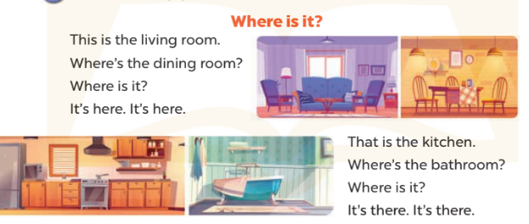
D. ADJUSTMENTS (if necessary):
………………………………………………………………………………………….…..……………………………………………………………………………...………………………………………….…..
Week: 22
English 3 – Class 3A, 3B
UNIT 13: MY HOUSE - LESSON 2 (1,2,3) - Period 87
Date of teaching: 11/02/2025

A. OBJECTIVES: By the end of the lesson, Ss will be able to:
1. Knowledge:
- use the words table, chair, book, lamp, in and on in the target sentence patterns
- use Where are the….? – They’re…. to ask and answer questions about the locations of things in a room
- Vocabulary: table, chair, book, lamp, in, on
- Model sentences: A: Where are the tables?
B: They’re in the living room.
- Skills: speaking and listening
2. Competences:
- Critical Thinking: talk about house
- Co-operation: ready to help friends in pair work/ group work.
- Oral Communication: speak about someone, ask and answer the questions
3. Attributes:
- Kindness: Help partners to complete learning tasks.
- Honesty: tell the truth about feelings and emotions
B. TEACHING AIDS:
- Teacher: Teacher’s guide Pages 165, 166; Tracks 26,27, laptop, pictures, textbook, lesson plan, TV.
- Students: Pupil’s book Page 20, notebooks, workbooks, school things.
C. PROCEDURES:
Teacher’s activities | Students’ activities | Contents
1.Warm- up: (3’) Game: Guess the pictures  *Aims: to create a friendly and active atmosphere to beginning the lesson.  - Write any word on the board.  - The first pupil has to take the last four or three letters of that word and form a new word.  - The second pupil does the same, and the chain continues until a pupil is unable to form a word.  - The pupil who fails to form a word or misspells it is out of the game.  - Say “Open your book page 20” and look at “Unit 13, Lesson 2 (1,2,3)”.  2. Presentation (16’)  Activity 1. Vocabulary.  *Aims: Ss will be able to know the vocabulary in front of starting the new lesson.  -T elicits the new words: (realia), (visual)  - T models (3 times).  - T writes the words on the board.  - Checking: Rub out and remember  Activity 2. 1. Listen, point and repeat:  *Aims: to understand and correctly repeat the sentences in two (pictures) to ask and answer questions about the locations of things in a room.  - Have Ss look at Pictures a and b and identify the characters in the pictures.  - Play the audio twice (sentence by sentence). Correct their pronunciation where necessary.  - Have Ss to practice the diaguage  - T invites a few pairs to the front of the class to practice.  - T checks pronunciation for ss.  3.Practice: (7’)  Activity 3. 2. Listen, point and say.  *Aims: Ss will be able to correctly say the words and use Where are the….? – They’re ……. to ask and answer questions about the locations of things in a room.  - T asks Ss look at picture b and helps Ss know the structure from the dialogue.  - T introduces new structure for Ss.  - T explains, models and gives meaning.  - Have Ss repeat the model sentences.  - Elicit and check comprehension the name of each character.  - Play the recording  - Have Ss to practise:  + have the model  - Ask Ss to work in pairs.  - T controls and corrects.  - Invite a few pairs to point at the relevant character in each picture, and act out  - T gives feedbacks.  4.Production: (7’)  Activity 4. 3. Let’s talk.  *Aims: to enhance the correct use of Where are the ….? – They’re…….. to ask and answer questions about the locations of things in a room in a freer context.  - T asks ss to attend to the picture.  + What can you see in the picture?  +What are they? +Where are they?  - T asks to ask and answer (groups of four)  - Invite some groups to perform.  - Give feedbacks  *Consolidation  *Aims: to consolidate and wrap up the content of the lesson.  - T review the vocabulary and model sentences.  - T praise and encourage others to try more.  5. Homework. (2’)  - Learn the number by heart  - Prepare the new lesson: Unit 13, Lesson 2 (4,5,6). | - Ss listen  - Ss play the game  - Ss open their books  -Ss listen and answer  - - Ss listen and repeat  + Choral repetition (3 times).  + Individual repetition (3 ss)  - Ss take note  - Ss look, remember and write  -Look at the pictures and get to know the characters  -Ss listen and repeat in chorus (twice)  -Ss work in pairs to practice  -Ss practice the diaguage  -Ss listen  -Ss look at the picture and answer  -Ss work in groups  -Ss perform in front of the class.  -Ss answer the questions  -Ss listen and clap their hands  -Ss listen and take note | * Vocabulary.  + table : cái bàn  + chair : cái ghế  + lamp : cái đèn  + on : trên  + in : trong  1. Listen, point and repeat:  2. Listen, point and say.  A: Where are the tables?  B: They’re in the living room.  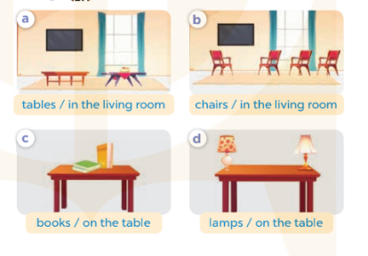  3. Let’s talk.  Where are…..?  They’re ……  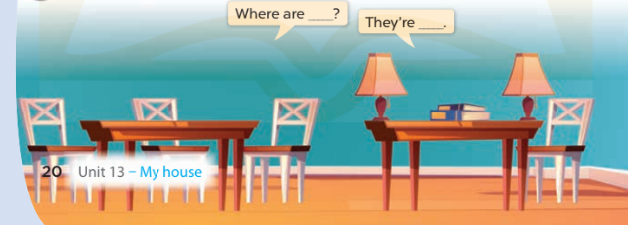
D. ADJUSTMENTS (if necessary):
………………………………………………………………………………………….…..……………………………………………………………………………...………………………………………….…..

Week: 22
English 3 – Class 3A, 3B
UNIT 13: MY HOUSE - LESSON 2 (4,5,6) - Period 88
Date of teaching: 11/02/2025
A. OBJECTIVES: By the end of the lesson, Ss will be able to:
1. Knowledge:
- listen to and understand simple exchanges in relation to the topic “My house”
- read and write about the location of rooms in a house and things in a room.
- Vocabulary: Review
- Skills: speaking, listening, reading and writing.
2. Competences:
- Critical Thinking: talk about rooms in a house and things in a room.
- Co-operation: ready to help friends in pair work/ group work.
- Self-control and independent learning: perform listening tasks.
3. Attributes:
- Kindness: Help partners to complete learning tasks.
- Honesty: tell the truth about feelings and emotions.
- Diligence: complete learning tasks.
B. MATERIALS:
- Teacher: Teacher’s guide Pages 167, 168; audio Tracks 28; website sachmem.vn, posters, laptop, pictures, textbook, lesson plan, TV or projector.
- Students: Pupil’s book Page 21, notebooks, workbooks, school things.
C. PROCEDURES:
Teacher’s activities | Students’ activities | Contents
1.Warm- up: (5’) Sing a song: “My house”  *Aims: to create a friendly and active atmosphere in the class to beginning the lesson.  - Show the song on the screen.  - Ask pupils to listen, sing and dance the song.  - Say “Open your book page 21” and look at “Unit 13, Lesson 2 (4,5,6)”.  2.Practice: (27’)  Activity 1. 4. Listen and number:  *Aims: to listen to and understand which two characters ask and answer questions about the locations of things in a room and number the correct pictures.  - Elicit the names and ages of the characters in the pictures.  - T ask Ss to guess the answers.  + T writes Ss’ guessing on the board.  - Play the recording and get Ss to swap books with their partners.  + Play the recording again to check answers together as a class.  + Write the answers on the board for Ss to correct their answers. Then checks Ss’ guessing.  - Play the recording, sentence by sentence, for the class to listen and repeat in chorus.  Activity 2. 5. Look, circle and read.  *Aims: to circle the correct answers to the gapped exchanges with the help of picture cues.  - Have Ss look at the pictures and identify the rooms and things in the pictures.  - T models with sentence 1.  + Have Ss look at the sentence.  + Ask them what is missing in the answer (tables).  + Have Ss circle the correct options  + Have Ss read the completed sentence in chorus.  -Have Ss work in pairs and circle the sentences 2, 3 and 4.  - Invite pairs of pupils to stand up and read aloud the sentences.  -T gives feedbacks.  Activity 3. 6. Let’s play.  *Aims: to review vocabulary and structure words in relation to the topic “My house” and use them in the sentence patterns Where’s…….? − It’s here / there. and Where are …….?– They’re ……. by playing the game Bingo.  - Explain how to play the game:  + Draw a 3 x 3 Bingo grid on the board and a list of the vocabulary words for reviewing.  + Get Ss to copy the grid onto a paper sheet and fill their grids with the vocabulary words.  + one pupil will have crossed out all of his or her words and should out “Bingo!” to show that he / she has finished.  - When time runs out, invite a few pairs to stand up and take turns asking and answering questions using the sentence patterns  *Consolidation  *Aims: to consolidate and wrap up the content of the lesson.  - T reviews the lesson  - T praises some Ss who are hardworking / active/ good…. as well as encourage others to try more.  3. Homework. (3’)  - Prepare the new lesson: Unit 13, Lesson 3 (1,2,3). | - Sing and dance the song in chorus.  - Ss open their books  -Look at the pictures and say:  -Ss guess the answers  - Ss listen to the tape and write number  - Ss listen again, write number and swap books with their partners.  - Ss check their answers and guessing  -Ss listen and repeat.  -Ss look at the pictures and say  -Ss listen and answer  -Ss read and complete  -Ss work in pairs  -Ss read  - Ss listen  -Ss play the game  - Ss play the game  -Ss listen and answer  -Ss listen and take note | https://www.youtube.com/watch?v=qZyJPZxsmZk  4. Listen and number:  Key: 1.c 2. d 3. a 4. b  5. Look, circle and read.  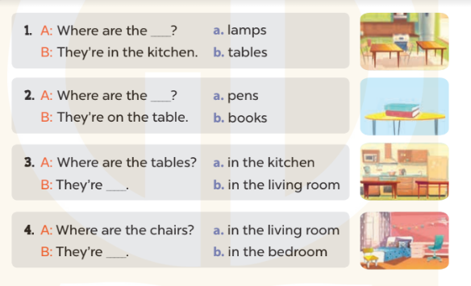  Key: 1. b 2. b 3. a 4. b  6. Let’s play.  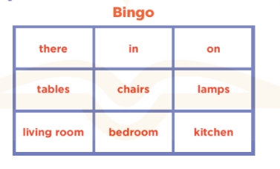  Where’s …….? − It’s here / there.  Where are …….? – They’re…….

D. ADJUSTMENTS (if necessary):
………………………………………………………………………………………….…..……………………………………………………………………………...………………………………………….…..

