Week: 20
English 3 – Class 3A, 3B
UNIT 11: MY FAMILY - LESSON 3 (1,2,3) - Period 77
Date of teaching: 20/01/2025
A. OBJECTIVES: By the end of the lesson, Ss will be able to:
1. Knowledge:
- correctly repeat the sounds of the letters o and ure in isolation, the words old and sure, and the sentences How old is your brother? and Are you sure? with the correct pronunciation and intonation.
- identify the target words old and sure while listening.
- say the chant with the correct rhythm and pronunciation.
- Vocabulary: Review
- Skills: speaking, listening, reading and writing.
2. Competences:
- Co-operation: ready to help friends in pair work/ group work.
- Self-control and independent learning: perform listening tasks.
3. Attributes:
- Kindness: Help partners to complete learning tasks.
- Honesty: tell the truth about feelings and emotions
B. MATERIALS:
- Teacher: Teacher’s guide Pages 147, 148; audio Tracks 9, 10, 11; website sachmem.vn, posters, laptop, pictures, textbook, lesson plan, TV or projector.
- Students: Pupil’s book Page 10, notebooks, workbooks, school things.
C. PROCEDURES:
Teacher’s activities | Students’ activities | Contents
1.Warm- up: (5’) Game: What is missing?  *Aims: to create a friendly and active atmosphere in the class to beginning the lesson.  - Divide the class into teams.  - Place some flashcards on the board  - Have Ss from the teams close their eyes.  + Remove one of the pictures.  + Ss have to remember and say the missing pictures.  +Give the first team to guess correctly one point.  +The team that gets the most points wins.  - Say “Open your book page 10” and look at “Unit 11, Lesson 3 (1,2,3)”.  2. Presentation (9’)  Activity 1. Listen and repeat:  *Aims: to correctly pronounce the sounds of the letters o and ure in isolation, in the words old and sure, and in the sentences How old is your brother? and Are you sure?  - T gives instruction to the letter, the words and the sentences  - Play the recording for the letter o, ure.  - Encourage Ss to point at the letter/ word/ sentence while listening.  - Play the recording again and encourage Ss to listen and repeat.  - T calls some Ss to practice.  - T gives feedbacks.  3.Practice: (10’)  Activity 2. Listen and circle.  *Aims: to identify the target words old and sure while listening.  - Elicit the sentences and explain that they have to listen.  - T ask Ss to guess the answers.  - Play the recording  - Ask Ss to swap books with their partners.  - Play the recording again to check answers  + Write the answers on the board for Ss to correct their answers.  - Play the recording, for the class to listen and repeat in chorus.  - Invite one or two Ss to stand up and read the completed sentences.  4. Production. (9’)  Activity 3. Let’s chant  *Aims: to say the chant with the correct rhythm and pronunciation.  - Introduce the title and lyrics of the chant.  - Play the recording for Ss to listen to the whole chant; Ask Ss to attend to o and ure, old and sure.  - Play the recording for Ss to listen to pronunciation and melody.  - Play the recording for Ss to chant and clap along.  - Ask Ss to practice chant and clap along in pairs or groups.  - Invite groups to perform the chant  -T gives feedback.  *Consolidation  *Aims: to consolidate and wrap up the content of the lesson.  - T praises some Ss who are hardworking / active/ good…. as well as encourage others to try more.  5. Homework. (2’)  - Practice the chant more.  -Prepare a picture of their family  - Prepare the new lesson: Unit 11, Lesson 3 (4,5,6). | - Ss listen  -Ss play game  - Ss open their books  - Ss recognize the differences about color of letter  - Ss listen and point  - Ss listen again and repeat  -Ss practice  -Ss listen  -Ss listen  -Ss guess the answers  - Ss listen to the tape and circle  - swap books with their partners.  - Ss check their answers and guessing  -Ss listen and repeat.  -Ss read the sentences  - Ss look and listen.  -Ss listen to the chant  - Ss listen and repeat line by line without clap their hands  -Ss note the sounds, words  - Ss listen and chant line by line.  - Ss chant and clap along.  - Ss work in groups (two groups) to chant  -Ss perform in front of the class.  -Ss listen  -Ss listen and clap their hands  -Ss listen and take note | flashcards on the board (father, mother, brother, sister, thirteen, fifteen…).  Activity 1. Listen and repeat:  -o / ure  - old / sure,  - How old is your brother? -Are you sure?  Activity 2. Listen and circle.  Key: 1.a 2.a  Activity 3. Let’s chant  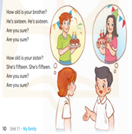
D. ADJUSTMENTS (if necessary):
………………………………………………………………………………………….…..……………………………………………………………………………...………………………………………….…..

Week: 20
English 3 – Class 3A, 3B
UNIT 11: MY FAMILY - LESSON 3 (4,5,6) - Period 78
Date of teaching: 20/01/2025

A. OBJECTIVES: By the end of the lesson, Ss will be able to:
1. Knowledge:
- read and complete a paragraph with the words in the box.
- read, understand and complete a gapped text.
- collect a picture of their family and show it to the class by telling the class about their family members.
- Vocabulary: Review
- Skills: speaking, listening, reading and writing.
2. Competences:
- Critical Thinking: talk about someone
- Co-operation: ready to help friends in pair work/ group work.
- Self-control and independent learning: perform reading tasks.
3. Attributes:
- Kindness: Help partners to complete learning tasks.
- Honesty: tell the truth about feelings and emotions.
- Diligence: complete learning tasks.
B. MATERIALS:
- Teacher: Teacher’s guide Pages 148, 149, website sachmem.vn, posters, laptop, pictures, textbook, lesson plan, TV or projector.
- Students: Pupil’s book Page 11, notebooks, workbooks, school things.
C. PROCEDURES:
Teacher’s activities | Students’ activities | Contents
1.Warm- up: (5’) Game: Matching  *Aims: to review the vocabulary and structure about greet and respond to greetings.  -T divides class into 2 teams  - Ss in 2 teams take turn to open the boxes to match the questions and answers to their pictures (open: click the numbers -close: click the red signs).  - Ss of each team will get points if their matching is correct.  - Say “Open your book page 11” and look at “Unit 11, Lesson 3 (4, 5, 6)”.  2.Practice: (8’)  Activity 1. Read and complete:  *Aims: to read and complete a paragraph with the words in the box.  - Tell Ss about the activity: find the missing word from the box.  - Ask Ss to model 1, write the missing word on the board and get the class to read the completed sentence together.  - Have Ss work in pairs and complete  - Tell Ss to swap books with a partner, then check answers together as a class.  - Write the correct answers on the board for pupils to correct their answers.  - Invite Ss to read the complete text aloud  -T gives feedbacks.  3.Production: (19’)  Activity 2. Let’s write  *Aims: to read, understand and complete a gapped text.  - Explain to the class the goal of this activity.  - Ask Ss to read each gapped sentence, guess the missing information and complete the sentence with their own personal information.  - Give Ss time to write their answers  - Ask Ss to swap and correct their answers in pairs.  - Check the answers as a class.  Activity 3. Project.  *Aims: to collect a picture of their family and show it to the class by telling the class about their family members.  - Explain the goal of this activity to Ss.  - Point at the picture and explain what they should do to complete the project.  - Tell Ss to work in groups.  - Give the class time to introduce about the family members.  - Gie example:  - Invite some Ss to show their pictures to the class and tell the class.  *Consolidation  *Aims: to consolidate and wrap up the content of the lesson.  - T asks ss to answer the following questions:  + What have you learnt from the lesson today?  +What are the core values of the lesson?  - T praises some Ss who are hardworking / active/ good…. as well as encourage others to try more.  4. Homework. (3’)  - Prepare the new lesson: Unit 12: Lesson 1 (1,2,3). | - Ss listen  -Ss play game  - Ss open their books  -Ss listen  - Ss read and complete  -Ss work in pairs  -Ss swap books and check  -Ss check the correct their answers  -Ss read  -Ss listen  -Ss read and answer  -Ss write  -Ss swap books and check their answers  -Ss check  -Ss listen  -Ss listen  -Ss work in groups  -Ss show the picture and say.  -Ss perform in front of the class.  -Ss answer the questions  -Ss listen and clap their hands  -Ss listen and take note | Review: father, brother, fifteen, sister, eighteen…  Activity 1. Read and complete:  Key: 1. my 2.sister 3.old 4.I’m  Activity 2. Let’s write  My name is……………..….  I’m………………....years old. My brother/ sister is………..  He/ She is……..…..years old  Activity 3. Project.  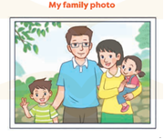  This is my family. This is my father. This is my mother. This is my sister, she is four years old. And this is me, I’m eight years old.
D. ADJUSTMENTS (if necessary):
………………………………………………………………………………………….…..……………………………………………………………………………...…………

Week: 20
English 3 – Class 3A, 3B
UNIT 12: JOBS - LESSON 1 (1,2,3) - Period 79
Date of teaching: 21/01/2025
A. OBJECTIVES: By the end of the lesson, Ss will be able to:
1. Knowledge:
- understand and correctly repeat the sentences in two communicative contexts (pictures) to ask and answer questions about the job of a family member.
- correctly say the words and use What’s his / her job? – He’s / She’s ……….. to ask and answer questions about someone’s job.
- enhance the correct use of What’s his / her job? – He’s / She’s ………. to ask and answer questions about someone’s job in a freer context.
- Vocabulary: doctor, driver, teacher, worker, job
- Model sentences: A: What’s his / her job? B: He’s / She’s ……….
- Skills: speaking and listening
2. Competences:
- Critical Thinking: talk about jobs
- Co-operation: ready to help friends in pair work/ group work.
- Oral Communication: speak about jobs, ask and answer the questions.
3. Attributes:
- Kindness: Help partners to complete learning tasks.
- Honesty: tell the truth about feelings and emotions
B. MATERIALS:
- Teacher: Teacher’s guide Pages 150, 151, audio Tracks 12, 13, website sachmem.vn, posters, laptop, pictures, textbook, lesson plan, TV or projector.
- Students: Pupil’s book Page 12, notebooks, workbooks, school things.
C. PROCEDURES:
Teacher’s activities | Students’ activities | Contents
1.Warm- up: (3’) Game: jigsaw puzzle  *Aims: to create a friendly and active atmosphere in the class to beginning the lesson.  - Divide class into 4 groups:  - Ask Ss look at the pieces of picture.  - Ask Ss go to the board and jigsaw puzzle into the correct picture  -T checks who’s the winner?  - Ask Ss look at the pieces of picture  - Say “Open your book page 12” and look at “Unit 12, Lesson 1 (1,2,3)”.  2. Presentation: (16’)  Activity 1. * Vocabulary.  *Aims: to know the vocabulary in front of starting the new lesson.  -T elicits new words: (situation), (picture)  - T models (3 times).  - T writes the words on the board.  - Checking: Rub out and remember  Activity 2. 1. Listen, point and repeat:  *Aims: to understand and correctly repeat the sentences in two pictures to ask and answer questions about the job of a family member.  - Have Ss look at Pictures and identify the characters in the pictures.  - Play the audio twice. Correct their pronunciation where necessary.  - Have Ss to practice the dialogue  - T invites a few pairs to the front of the class to practice.  - T checks pronunciation for ss.  3.Practice: (7’)  Activity 3 2. Listen, point and say.  *Aims: to use What's his / her job? – He’s / She’s …….. to ask and answer questions about someone’s job.  - T asks Ss look at pictures, and introduces new structure for Ss.  - T explains, models and gives meaning.  - Elicit and check comprehension  - Run through the questions and answers  - Have Ss to practice in pairs.  - T controls and corrects.  - Invite a few pairs to act out his/her role.  - T gives feedbacks.  4.Production: (7’)  Activity 4. 3. Let’s talk.  *Aims: to enhance the correct use of What's his / her job? – He’s / She’s …….. in a freer context.  - Hold up the flash cards, elicit the question and answer about his or her job.  - Have Ss look at the picture.  - Point at the adults in the picture and elicit mother and father and the questions What’s his job? and What’s her job?  - Give Ss time to practise in pairs to ask and answer  - Go around the classroom to offer support.  - Invite some pairs to the front of the class to perform their conversations.  *Consolidation  *Aims: to consolidate and wrap up the content of the lesson.  - T review the vocabulary and model sentences.  5. Homework. (2’)  - Learn the number by heart  - Prepare the new lesson: Unit 12, Lesson 1 (4,5,6). | - Ss listen  - Ss play the game  - Ss open their books  - - Ss listen, answer and repeat  + Choral repetition (3 times).  + Individual repetition (3 ss)  - Ss take note  - Ss look, remember and write  -Look at the pictures and get to know the characters in the pictures.  -Ss listen and repeat in chorus (twice)  -Ss work in pairs to practice  -Ss practice the dialogue  -Ss look at the picture and answer.  -Ss listen  -Ss listen and repeat  -Ss repeat  - Ss work in pairs to practice  -Ss point and say  -Ss listen.  -Ss listen and answer  -Ss look at the picture  - Ss listen and asnwer  -Ss work in pairs  -Ss perform in front of the class.  - Ss listen  -Ss listen and take note |   * Vocabulary.  + doctor : bác sĩ  + driver : tài xế  + teacher : giáo viên  + worker : công nhân  + job : nghề nghiệp  1. Listen, point and repeat:  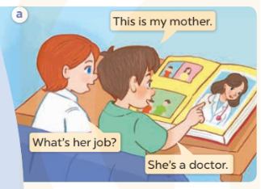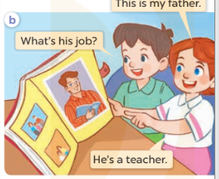  2. Listen, point and say.  * Model sentences:  A: What's his / her job?  B: He’s/ She’s a doctor.  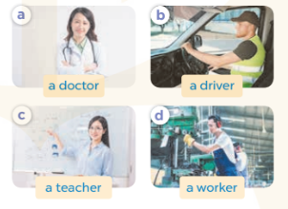  3. Let’s talk.  What's his / her job?  He’s / She’s …….  - the flash cards for doctor, driver, teacher and worke
D. ADJUSTMENTS (if necessary):
………………………………………………………………………………………….…..……………………………………………………………………………...………………………………………….…..
Week: 20
English 3 – Class 3A, 3B
UNIT 12: JOBS - LESSON 1 (4,5,6) - Period 80
Date of teaching: 21/01/2025
A. OBJECTIVES: By the end of the lesson, Ss will be able to:
1. Knowledge:
- listen to and understand two communicative contexts to ask and answer questions about the jobs of family members and tick the correct pictures.
- complete the two gapped sentences and two gapped dialogues with the help of the picture cues.
- sing the song My mother and my father with the correct melody and pronunciation.
- Vocabulary: Review
- Skills: speaking, listening, reading and writing.
2. Competences:
- Co-operation: ready to help friends in pair work/ group work.
- Self-control and independent learning: perform listening tasks.
3. Attitude/ Qualities:
- Kindness: Help partners to complete learning tasks.
- Honesty: tell the truth about feelings and emotions.
- Diligence: complete learning tasks.
B. TEACHING AIDS:
- Teacher: Teacher’s guide Pages 152, 153; audio Tracks 14, 15; website sachmem.vn, posters, laptop, pictures, textbook, lesson plan, TV or projector.
- Students: Pupil’s book Page 13, notebooks, workbooks, school things.
C. PROCEDURES:
Teacher’s activities | Students’ activities | Contents
1.Warm- up: (5’) Game: “Throw the ball”  *Aims: to create a friendly and active atmosphere in the class to beginning the lesson.  - Divide the class into 2 teams.  - Stick the pictures of activities on the board.  - T says a word, a pupil from each team has to point/throw the ball to the right picture and says the word three times.  + The one says faster will get points.  - Encourage pupils take part in the game.  - Give points for pupils.  - Say “Open your book page 13” and look at “Unit 12, Lesson 1 (4,5,6)”.  2.Practice: (18’)  Activity 1. 4. Listen and tick:  *Aims: to and understand two communicative contexts to ask and answer questions about the jobs of family members and tick the correct pictures.  - Elicit the word for each family member  - T ask Ss to guess the answers.  + T writes Ss’ guessing on the board.  - Play the recording  - Play the recording again and get Ss to swap books with their partners.  - check answers together as a class.  + Write the answers on the board for Ss to correct their answers. Then checks Ss’ guessing.  - Play the recording for the class to listen and repeat in chorus.  Activity 2. 5. Look, complete and read.  *Aims: to complete two sentences and two gapped dialogues with the help of the relevant picture cues.  - Have Ss look at the pictures, the four incomplete sentences and dialogues and elicits the missing words in the sentences.  - T models with sentence 1  -Have Ss work in groups and complete the sentences 2,3 and 4.  - Ask a few Ss to stand up and read the completed sentences aloud.  -T gives feedbacks.  3.Practice: (9’)  Activity 3. 6. Let’s sing.  *Aims: to sing the song My mother and my father with the correct pronunciation and melody.  - Introduce the title and lyrics of the song: “My mother and my father” song.  - Play the recording for Ss to listen to the whole song.  - Play the recording all the way through for Ss to listen to pronunciation and melody of the song.  - Play the recording for Ss to sing and do actions.  - Ask Ss to practice singing and doing actions in pairs or groups.  - Invite groups to the front of the classroom to perform the song  -T gives feedback.  *Consolidation  *Aims: to consolidate and wrap up the content of the lesson.  - T asks ss to answer the following questions to review the lesson - T praises some Ss who are hardworking / active/ good…. as well as encourage others to try more.  5. Homework. (3’)  - Learn the number by heart  - Prepare the new lesson: Unit 12, Lesson 2 (1,2,3). | - Ss listen  -Ss play the game  -Ss listen  - Ss open their books  -Look at the pictures and say:  -Ss guess the answers  - Ss listen again, tick and swap books with their partners.  - Ss check their answers and guessing  -Ss listen and repeat.  Ss look at the picture and say  -Ss look and answer  -Ss look, complete and read the completed sentence in chorus.  -Ss complete the sentence  -Ss read aloud  -Ss listen to the song  - Ss listen and repeat line by line without the action.  -Ss listen to melody of the song  - Ss sing and do actions.  + Ss work in groups (two groups) to sing.  -Ss perform in front of the class.  -Ss listen  -Ss answer the questions  -Ss listen and clap their hands  -Ss listen and take note | 4. Listen and tick:  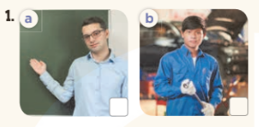  Key: 1.a 2.b  5. Look, complete and read.  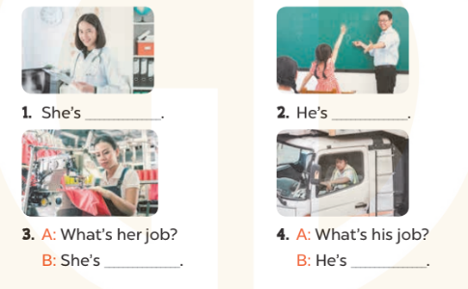  Key:  1. a doctor 2. a teacher  3. a worker 4. a driver  6. Let’s sing  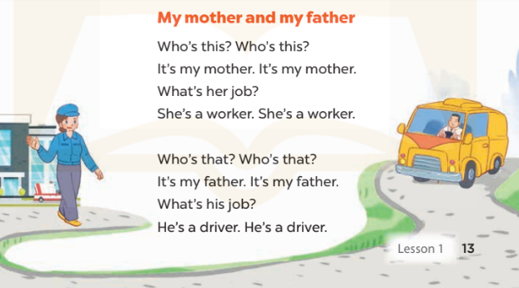
D. ADJUSTMENTS (if necessary):
………………………………………………………………………………………….…..……………………………………………………………………………...………………………………………….…..

