Week 20 Preparing date: January 19th. 2025
Period 77 Teaching date: January 21st, 2025

Unit 11: My home
Lesson 3 (1, 2, 3)
A. OBJECTIVES: By the end of the lesson, Ss will be able to:
1. Knowledge:
- correctly repeat the sounds of the letters i and ee in isolation, the words big and street, and the sentences They live in a big village. and They live in Green Street. with the correct pronunciation and intonation.
- identify the target words big and street while listening.
- say the chant with the correct rhythm and pronunciation.
- Vocabulary: Review
- Skills: speaking, listening, reading and writing.
2. Competences:
- Co-operation: ready to help friends in pair work/ group work.
- Self-control and independent learning: perform listening tasks.
3. Attitude/ Qualities:
- Kindness: Help partners to complete learning tasks.
- Honesty: tell the truth about feelings and emotions
B. TEACHING AIDS:
- Teacher: Teacher’s guide Pages 167, 168; audio Tracks 8,9,10; website hoclieu.vn, posters, laptop, pictures, textbook, lesson plan, TV or projector.
- Students: Pupil’s book Page 10, notebooks, workbooks, school things.
C. PROCEDURES:
Stages/Time | Teacher’s activities | Students’ activities
1.Warm- up:  (5’)  2. Presentation  (9’)  3.Practice: (19’)  4. Homework. (2’) | Game: What is missing?  *Aims: to create a friendly and active atmosphere in the class to beginning the lesson.  *Procedure:  - Divide the class into teams.  - Place some flashcards on the board (street, village, big, small, road…).  - Have Ss from the teams close their eyes.  + Remove one of the pictures.  + Ss have to remember and say the missing pictures.  +Give the first team to guess correctly one point.  +The team that gets the most points wins.  - Say “Open your book page 10” and look at “Unit 11, Lesson 3 (1,2,3)”.  Activity 1. Listen and repeat:  *Aims: Ss will be able to correctly pronounce the sounds of the letters i and ee in isolation, in the words big and street, and in the sentences They live in a big village. and They live in Green Street with correct pronunciation and intonation.  *Procedure:  - T gives instruction to the letter i and ee in isolation, in the words big and street, and in the sentences They live in a big village. and They live in Green Street  - Play the recording for the letter I, ee  - Encourage Ss to point at the letter/ word/ sentence while listening.  - Play the recording again and encourage Ss to listen and repeat.  - Do this several times until Ss feel confident.  - T calls some Ss to practice.  - T gives feedbacks.  Activity 2. Listen and circle.  *Aims: Ss will be able to identify the target words big and street while listening.  *Procedure:  - Elicit the sentences and explain that they have to listen.  - T ask Ss to guess the answers.  + T writes Ss’guessing on the board.  - Listen to the tape:  + Play the recording  + Play the recording again and get Ss to swap books with their partners.  + Play the recording again to check answers together as a class.  + Write the answers on the board for Ss to correct their answers. Then checks Ss’ guessing.  - Play the recording, sentence by sentence, for the class to listen and repeat in chorus.  - Invite one or two Ss to stand up and read the completed sentences.  Key: 1.a 2.b  Activity 3. Let’s chant  *Aims: Ss will be able to say the chant with the correct rhythm and pronunciation.  *Procedure:  - Introduce the title and lyrics of the chant.  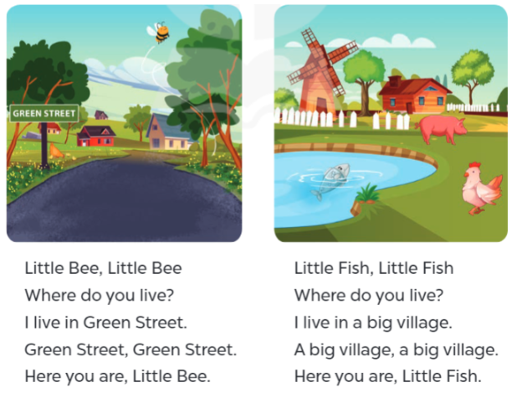  - Play the recording for Ss to listen to the whole chant.  + Have Ss repeat the title and lyrics line by line.  + Ask Ss to attend to the sounds of the letters i and ee and the words big and street.  - Play the recording all the way through for Ss to listen to pronunciation and melody.  - Play the recording line by line for Ss to listen and repeat  - Play the recording for Ss to chant and clap along.  - Ask Ss to practice chant and clap along in pairs or groups.  - Invite groups to the front of the classroom to perform the chant  -T gives feedback.  *Consolidation  *Aims: Ss will be able consolidate and wrap up the content of the lesson.  *Procedure:  - T asks ss to answer the following questions:  + What have you learnt from the lesson today?  - T praises some Ss who are hardworking / active/ good…. as well as encourage others to try more.  - Prepare a picture of their family  - Prepare the new lesson: Unit 11, Lesson 3 (4,5,6). | - Ss listen  -Ss play game  -Ss play game  - Ss open their books  - Ss recognize the differences about color of letter  - - Ss listen  - Ss listen and point  - Ss listen again and repeat  -Ss listen again and repeat  -Ss practice  -Ss listen  -Ss listen and say  -Ss guess the answers  - Ss listen to the tape and circle  - Ss listen again, circle and swap books with their partners.  - Ss check their answers and guessing  -Ss write the correct answer  -Ss listen and repeat.  -Ss read the sentences  - Ss look and listen.  -Ss listen to the chant  - Ss listen and repeat line by line without clap their hands  -Ss note the sounds, words  -Ss listen to melody of the chant  - Ss listen and chant line by line.  - Ss chant and clap along.  - Ss work in groups (two groups) to chant  -Ss perform in front of the class.  -Ss listen  .  -Ss answer the questions  -Ss listen and clap their hands  -Ss listen and take note
D. ADJUSTMENTS (if necessary):
………………………………………………………………………………………….…..……………………………………………………………………………...………………………………………

Week 20 Preparing date: January 19th. 2025
Period 78 Teaching date: January 21st, 2025

Unit 11: My home
Lesson 3 (4, 5, 6)
A. OBJECTIVES: By the end of the lesson, Ss will be able to:
1. Knowledge:
- Identify the specific information by scanning the text and circle the correct answers.
- Write about a student’s home.
- Present picture to the class at the Project time.
- Vocabulary: Review
- Skills: speaking, listening, reading and writing.
2. Competences:
- Co-operation: ready to help friends in pair work/ group work.
- Self-control and independent learning: perform reading tasks.
3. Attitude/ Qualities:
-Show their pride about their places/ address.
B. TEACHING AIDS:
- Teacher: Teacher’s guide Pages 168, 169, website hoclieu.vn, posters, laptop, pictures, textbook, lesson plan, TV or projector.
- Students: Pupil’s book Page 11, notebooks, workbooks, school things.
C. PROCEDURES:
Stages/Time | Teacher’s activities | Students’ activities
1.Warm- up: (5’)  2.Practice: (8’)  3.Production: (19’)  4. Homework. (3’) | Game: Spin the wheel  *Aims: to review the vocabulary and structure about greet and respond to greetings.  *Procedure:  - Have Ss spin the wheel and say the words with the target sound  - Say “Open your book page 11” and look at “Unit 11, Lesson 3 (4, 5, 6)”.  Activity 1. Read and circle:  *Aims: Ss will be able to read and show the understanding of the text by circling the correct options to fill in the blanks.  *Procedure:  - Explain and check comprehension.  - Model sentence 1.  +First, have Ss read Sentence 1 and decide what information they need to find in the text.  + Then, have them read the text carefully and find the information about the flat where the writer lives to decide if option a or b is correct.  + Circle the correct option.  - Ask Ss to do the task independently.  - Get Ss to swap their books with a partner and check their answers before checking as a class.  - Invite one or two pupils to read the text in front of the class.  Key: 1. b 2.a 3.b 4.a  Activity 2. Let’s write  *Aims: Ss will be able to use the target language to complete a gapped text about the place where pupils live.  *Procedure:  - Explain to the class the goal of this activity.  - Ask Ss to read each gapped sentence, guess the missing information and complete the sentence with their own personal information.  - Give Ss time to write their answers  - Ask Ss to swap and correct their answers in pairs.  - Check the answers as a class.  Key: Pupils’ answer.  Example: I live in a small house with my parents. It is in Nghia Lam Village. It is big. There are not manyvbuilding there, but there are a lot of trees, flowers and it has fresh air. I love my house.  Activity 3. Project.  *Aims: Ss will be able to draw a picture of the place where they live and present it to the class, using the target language.  *Procedure:  - Explain the goal of this activity to Ss.  - Point at the picture and explain what they should do to complete the project.  - Tell Ss to work in groups.  - Give the class time to introduce about your beautiful home.  +Example: I live in a small house with my parents. It is in Nghia Lam Village. It is big. There are not manyvbuilding there, but there are a lot of trees, flowers and it has fresh air. I love my house.  - Invite some Ss to show their pictures to the class and tell the class.  *Consolidation  *Aims: Ss will be able consolidate and wrap up the content of the lesson.  *Procedure:  - T asks ss to answer the following questions:  + What have you learnt from the lesson today?  +What are the core values of the lesson?  - T praises some Ss who are hardworking / active/ good…. as well as encourage others to try more.  - Prepare the new lesson: Unit 12: Lesson 1 (1,2,3). | - Ss listen and play the game  - Ss open their books  -Ss listen  - Ss read and answer  -Ss read and find the information  -Ss circle  -Ss do the task  -Ss swap books and check the correct answers  -Ss read the text in fornt of the class  -Ss listen  -Ss read and answer  -Ss write  -Ss swap books and check their answers  -Ss check  -Ss listen  -Ss work in groups  -Ss show the picture and say.  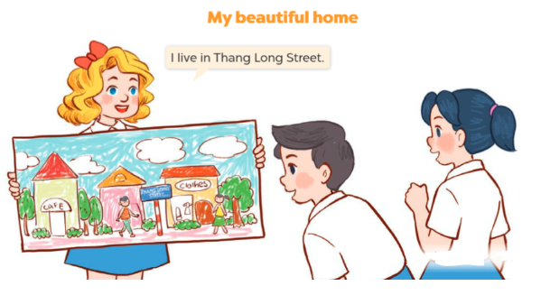  -Ss perform in front of the class.  -Ss answer the questions  -Ss listen and clap their hands  -Ss listen and take note
D. ADJUSTMENTS (if necessary):
………………………………………………………………………………………….…..……………………………………………………………………………...…………………………………………
Week 20 Preparing date: January 22nd, 2025
Period 79 Teaching date: February 4th, 2025

Unit 12: Jobs
Lesson 1 (1, 2, 3)
A. OBJECTIVES: By the end of the lesson, Ss will be able to:
1. Knowledge:
- understand and correctly repeat the sentences in two communicative contexts (pictures) to ask and answer questions about jobs
- Use What does he / she do? – He’s / She’s ….. to ask and answer questions about jobs.
- Vocabulary: actor, policeman, office worker
- Model sentences: A: What’s does he/ she do?
B: He’s / She’s a policeman
- Skills: speaking and listening
2. Competences:
- Critical Thinking: talk about jobs
- Co-operation: ready to help friends in pair work/ group work.
Oral Communication: speak about jobs, ask and answer the questions.
3. Attitude/ Qualities:
- Kindness: Help partners to complete learning tasks.
- Honesty: tell the truth about feelings and emotions
B. TEACHING AIDS:
- Teacher: Teacher’s guide Pages 170, 171, audio Tracks 11, 12, website hoclieu.vn, posters, laptop, pictures, textbook, lesson plan, TV or projector.
- Students: Pupil’s book Page 12, notebooks, workbooks, school things.
C. PROCEDURES:
Stages/Time | Teacher’s activities | Students’ activities
1.Warm- up:  (5’)  2. Presentation  (16’)  3.Practice: (7’)  4.Production: (5’)  5. Homework. (2’) | Game: jigsaw puzzle  *Aims: to create a friendly and active atmosphere in the class to beginning the lesson.  *Procedure:  - Divide class into 4 groups: Doreamon, Nobita, Xuka and Xeko.  - Ask Ss look at the pieces of picture.  - Ask Ss go to the board and jigsaw puzzle into the correct picture    -T checks who’s the winner?  - Ask Ss look at the pieces of picture  - Say “Open your book page 12” and look at “Unit 12, Lesson 1 (1,2,3)”.  Activity 1. Vocabulary.  *Aims: Ss will be able to know the vocabulary in the new lesson.  *Procedure:  -T elicits the new words  + actor : diễn viên (nam) (picture)  + policeman : cảnh sát (nam) (picture)  + office worker : nhân viên văn phòng (picture)  - T models (3 times).  - T writes the words on the board.  - Checking: Rub out and remember  Activity 2. Look, listen and repeat:  *Aims: Ss will be able to understand and correctly repeat the sentences in two communicative contexts (pictures) to ask and answer questions about the job of a family member.  *Procedure:  - Have Ss look at Pictures a and b and identify the characters in the pictures.  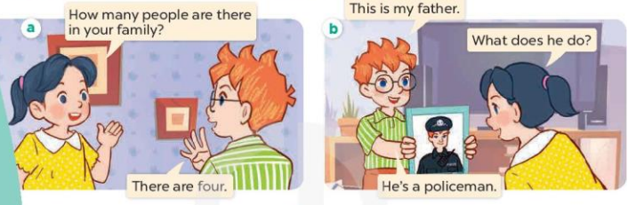  - Play the audio twice (sentence by sentence). Correct their pronunciation where necessary.  - Have Ss to practice the dialogue  - T invites a few pairs to the front of the class to practice.  - T checks pronunciation for ss.  Activity 3 Listen, point and say.  *Aims: Ss will be able to correctly say the words and use What does he/she do? – He’s / She’s …… to ask and answer questions about someone’s job.  *Procedure:* Model sentences:  - T asks Ss look at picture b and helps Ss know the structure from the dialogue.  - T introduces new structure for Ss.  - T explains, models and gives meaning.  - Have Ss repeat the model sentences.  A: What’s does he/ she do?  B: He’s / She’s a policeman  *Drill pictures  - Elicit and check comprehension the name of each character.  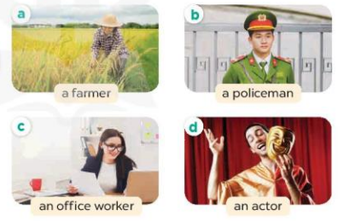  - Run through all the pictures.  - Run through model sentences.  + Run through the questions.  + Run through the answers  - Have Ss to practise:  + T says asks and Ss answer (change role).  + Ss – Ss (change role).  - Ask Ss to work in pairs.  - T controls and corrects.  - Invite a few pairs to come to the front of the classroom, point at the relevant character in each picture, and act out his/her role.  - Encourage Ss to practise speaking English.  - T gives feedbacks.  Activity 4. Let’s talk.  *Aims: Ss will be able to enhance the correct use of What does he/ she do? – He’s / She’s …….. to ask and answer questions about someone's job in a freer context.  *Procedure:  - Hold up the flash cards for policeman, farmer, office worker, teacher, actor to elicit the question and answer about his or her job.    - Have Ss look at the picture.  - Point at the adults in the picture and elicit the character and the questions What does he/ she do?  - Give Ss time to practise in pairs to ask and answer What does he/ she do? He’s / She’s …….  - Invite some pairs to the front of the class to perform their conversations.  *Consolidation  *Aims: Ss will be able consolidate and wrap up the content of the lesson.  *Procedure:  - T asks ss to answer the following questions:  + What have you learnt from the lesson today?  - T review the vocabulary and model sentences.  - T praises some Ss who are hardworking / active/ good…. as well as encourage others to try more  - Learn the vocabulary by heart  - Prepare the new lesson: Unit 12, Lesson 1 (4,5,6). | - Ss listen  - Ss play the game  - Ss open their books  -Ss listen and answer  - - Ss listen and repeat  + Choral repetition (3 times).  + Individual repetition (3 ss)  - Ss take note  - Ss look, remember and write  -Look at the pictures and get to know the characters in the pictures.  + Picture a:  Mai: How many people are there in your family?  Ben: There are four.  + Picture b:  Ben: This is my father.  Mai: What does he do?  Ben: He’s a policeman.  -Ss listen and repeat in chorus (twice)  -Ss work in pairs to practice  -Ss practice the dialogue  -Ss listen  -Ss look at the picture and answer.  -Ss listen  -Ss listen and repeat  - Ss look, listen and answer  + Picture a. A woman working on a farm + Picture b. A policeman  + Picture c. A woman working in an office  + Picture d. A man acting in a film  -Ss practice in chorus  -Ss practice in chorus and groups  -Ss practice in chorus and groups  -Ss work in pairs to practice  -Ss listen  -Ss point and say  -Ss listen.  -Ss listen and answer  -Ss look at the picture  - Ss listen and asnwer  -Ss work in pairs, ask and answer  -Ss perform in front of the class.  -Ss answer the questions  - Ss listen  -Ss listen and clap their hands  -Ss listen and take note

D. ADJUSTMENTS (if necessary):
………………………………………………………………………………………….…..……………………………………………………………………………...………………………………………….

Week 20 Preparing date: January 22nd, 2025
Period 80 Teaching date: February 4th, 2025

Unit 12: Jobs
Lesson 1 (4, 5, 6)
A. OBJECTIVES:
By the end of the lesson, Ss will be able to:
1. Knowledge:
- listen to and demonstrate understanding of simple communicative contexts in relation to the topic “Jobs”.
- read and write about jobs of family members.
- sing the song My lovely family with the correct melody and pronunciation.
- Vocabulary: Review
- Skills: speaking, listening, reading and writing.
2. Competences:
- Co-operation: ready to help friends in pair work/ group work.
- Self-control and independent learning: perform listening tasks.
3. Attitude/ Qualities:
- Kindness: Help partners to complete learning tasks.
- Honesty: tell the truth about feelings and emotions.
- Diligence: complete learning tasks.
B. TEACHING AIDS:
- Teacher: Teacher’s guide Pages 172, 173; audio Tracks 13, 14; website hoclieu.vn, posters, laptop, pictures, textbook, lesson plan, TV or projector.
- Students: Pupil’s book Page 13, notebooks, workbooks, school things.
C. PROCEDURES:
Stages/Time | Teacher’s activities | Students’ activities
1.Warm- up:  (5’)  2.Practice: (27’)  3. Homework. (3’) | Game: “Throw the ball”  *Aims: to create a friendly and active atmosphere in the class to beginning the lesson.  *Procedure:  - Divide the class into 2 teams.  - Stick the pictures of activities on the board.  - T says a word, a pupil from each team has to point/throw the ball to the right picture and says the word three times.  + The one says faster will get points.  - Encourage pupils take part in the game.  - Give points for pupils.  - Say “Open your book page 13” and look at “Unit 12, Lesson 1 (4,5,6)”.  Activity 1. Listen and tick or cross:  *Aims: Ss will be able to listen to and understand four communicative contexts in which pupils ask and answer questions about the jobs of family members.  *Procedure:  - Elicit the word for the jobs    - T ask Ss to guess the answers.  + T writes Ss’guessing on the board.  - Listen to the tape:  + Play the recording  + Play the recording again and get Ss to swap books with their partners.  + Play the recording again to check answers together as a class.  + Write the answers on the board for Ss to correct their answers. Then checks Ss’ guessing.  - Play the recording, sentence by sentence, for the class to listen and repeat in chorus.  Key: 1.x 2.v 3.v 4.x  Activity 2. Look, complete and read.  *Aims: Ss will be able to complete four gapped exchanges with the help of picture cues.  *Procedure:  - Have Ss look at the pictures and identify the jobs in the pictures.  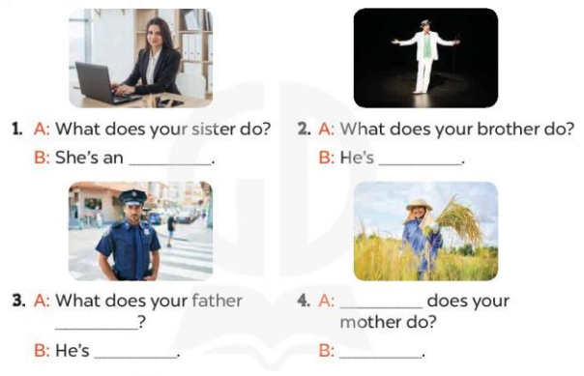  - Have Ss look at the four incomplete sentences and dialogues and elicits the missing words in the sentences.  - T models with sentence 1  + Ask Ss what is missing in the sentence.  + Have Ss look at the picture and complete the gap, then read the completed sentence in chorus.  -Have Ss work in groups and complete the sentences 2,3 and 4.  - Ask a few Ss to stand up and read the completed sentences aloud.  -T gives feedbacks.  Key:1.office worker 2.An actor  3.do; a policeman 4.What; she’s a farmer  Activity 3. Let’s sing.  *Aims: Ss will be able to sing the song My lovely family with the correct pronunciation and melody.  *Procedure:  - Introduce the title and lyrics of the song: “My lovely family” song.  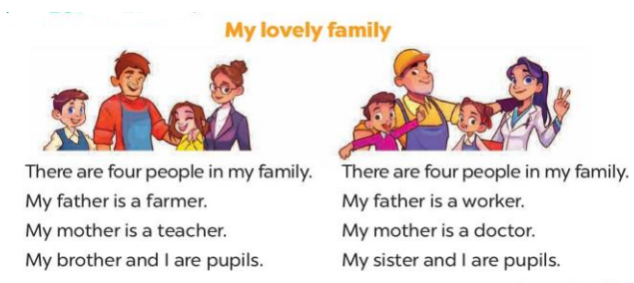  - Play the recording for Ss to listen to the whole song.  + Have them repeat the title and lyrics line by line.  + Tell Ss to point at the relevant character while singing his or her name.  - Play the recording all the way through for Ss to listen to pronunciation and melody of the song.  - Play the recording line by line for Ss to listen, repeat and point at the relevant character.  - Play the recording for Ss to sing and do actions.  - Ask Ss to practice singing and doing actions in pairs or groups.  - Invite groups to the front of the classroom to perform the song  -T gives feedback.  *Consolidation  *Aims: Ss will be able consolidate and wrap up the content of the lesson.  *Procedure:  - T asks ss to answer the following questions:  + What have you learnt from the lesson today?  +What are the core values of the lesson? (if the teacher can take from the lesson).  - T praises some Ss who are hardworking / active/ good…. as well as encourage others to try more.  - Learn the number by heart  - Prepare the new lesson: Unit 12, Lesson 2 (1,2,3). | - Ss listen  - Ss play the game  -Ss listen  - Ss open their books  -Look at the pictures and say:  + Picture 1: teacher  + Picture 2: policeman  + Picture 3: office worker  + Picture 4: actor  -Ss guess the answers  - Ss listen to the tape and tick or cross  - Ss listen again, tick/ cross and swap books with their partners.  - Ss check their answers and guessing  -Ss check Ss’ guesing  -Ss listen and repeat.  -Ss look at the picture and say  -Ss look and answer  -Ss answer: office worker  -Ss look, complete and read the completed sentence in chorus.  -Ss work in groups and complete the sentence  -Ss read aloud  - Ss look and listen.  -Ss listen to the song  - Ss listen and repeat line by line without the action.  -Ss point to the character while singing  -Ss listen to melody of the song  - Ss listen and sing line by line.  - Ss sing and do actions.  + Ss work in groups (two groups) to sing.  -Ss perform in front of the class.  -Ss listen  -Ss answer the questions  -Ss listen and clap their hands  -Ss listen and take note
D. ADJUSTMENTS (if necessary):
………………………………………………………………………………………….…..…………

