Week 12 Preparing date: November 24th, 2024
Period 45 Teaching date: November 26th, 2024

Unit 7: Our timetables
Lesson 1(4, 5, 6)
A. OBJECTIVES: By the end of the lesson, Ss will be able to:
1. Knowledge:
- Identity specific information by listen to conversation related to topic school subjects.
- Fill in the gaps using given picture cues.
- Recall some vocabularies related to topic school subject by doing the puzzle.
- Vocabulary: Review
- Skills: speaking, listening, reading and writing.
2. Competences:
- Critical Thinking: self-introduce
- Co-operation: ready to help friends in pair work/ group work.
- Self-control and independent learning: perform listening tasks.
3. Attitude/ Qualities:
- Kindness: Help partners to complete learning tasks.
- Show their responsibility to follow the timetable and prepare their subjects before school.
B. TEACHING AIDS:
- Teacher: Teacher’s guide Pages 102,103,104; audio Tracks 69; website hoclieu.vn, posters, laptop, pictures, textbook, lesson plan, TV or projector.
- Students: Pupil’s book Page 51, notebooks, workbooks, school things.
C. PROCEDURES:
Stages/Time | Teacher’s activities | Students’ activities
1.Warm- up:  (5’)  2.Practice: (27’)  3. Homework. (3’) | Game: Slap the board  *Aims: to create a friendly and active atmosphere in the class to beginning the lesson.  *Procedure:  - Divide class into 2 groups: Tom and Jerry.  - How to play:  + Each group chooses five Ss to play.  + Class will read aloud.  + Look at the picture, listen and slap the picture you heard.  + Who faster will get 1 mark.  + Which group with higher mark is the winner.  - Say “Open your book page 51” and look at “Unit 7, Lesson 1 (4,5,6)”.  Activity 1. Listen and tick or cross:  *Aims: Ss will be able to listen to and understand four communicative contexts in which pupils ask and answer questions about the subjects they have and tick or cross the pictures.  *Procedure:  - Draw pupils’ attention to the pictures and ask questions: What subject is it? 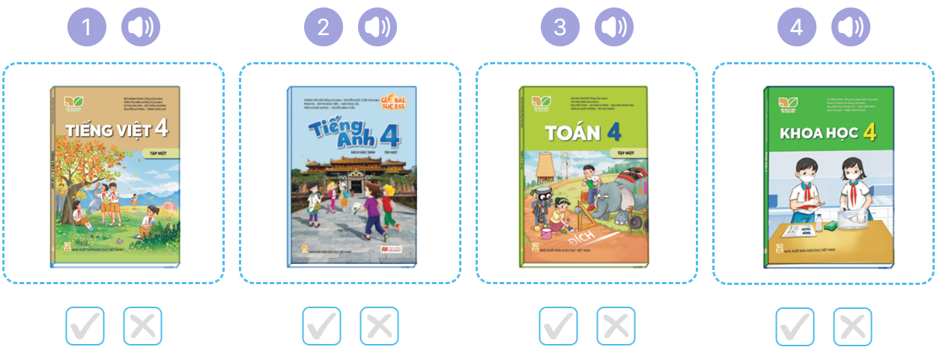  - Remind them to look at the book covers of the subjects and tick or cross the boxes while listening.  - Play the recording all the way through.  - Play the recording for pupils to listen and tick or cross the boxes.  - Get pupils to swap books with a partner to check their answers.  - Check the answer together.  - Play the recording, sentence by sentence, for pupils to listen and repeat in chorus.  Key: 1. v 2. x 3. v 4. x  Activity 2. Look, complete and read  *Aims: Ss will be able to complete four gapped exchanges with the help of picture cues.  *Procedure:  - Get Ss to look at the pictures and identify the subjects in each picture.  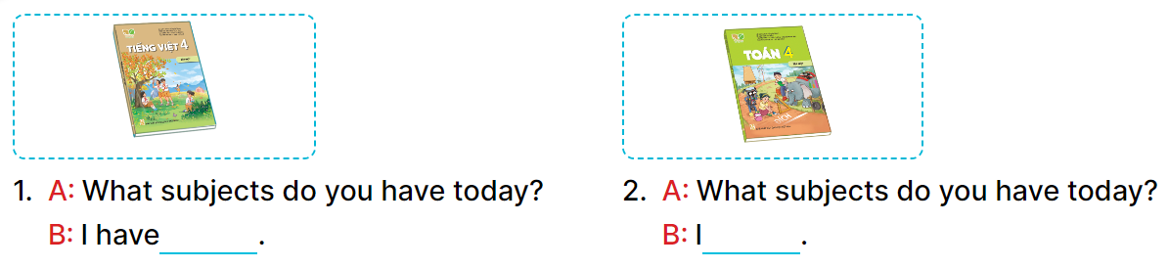  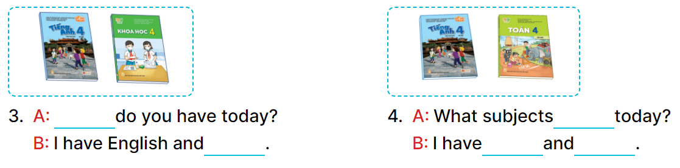  - Have Ss look at the four incomplete sentences. Elicit and model with picture 1  + Ask Ss to read the sentence 1 in chorus.  + Ask Ss what word is missing in the gap (Vietnamese). Then have them complete the sentence (I have Vietnamese).  - Have Ss work in pairs and complete the sentences 2, 3, 4.  - Ask a few Ss to stand up and read the sentences aloud.  -T gives feedbacks.  Key:  1. Vietnamese 2. have maths  3. What subjects; science  4. do you have; English; maths  Activity 3. Let’s play  *Aims: Ss will be able to review the target vocabulary items using the puzzle, then ask and answer questions about the subjects pupils have at school.  *Procedure:  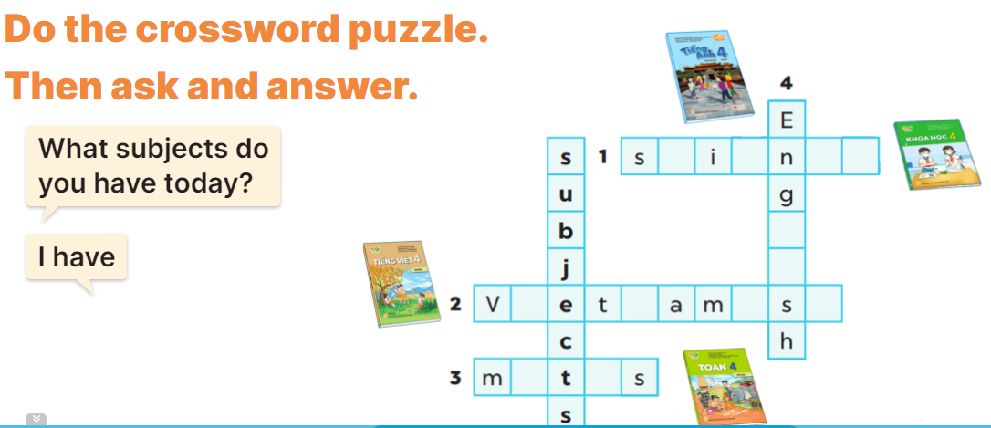  - Tell pupils the goal of the puzzle and how to play it. Then have them look at the spaces in the puzzle and given letters as well as picture cues to find appropriate lettersto complete the words.  - Give pupils a time limit to do the puzzle individually.  - Have pupils work in pairs. One points at the completed words or the clues and asks What subjects do you have today? and their partner answers I have ………  - Invite a few pairs to the front of the classroom to ask and answer questions about what subjects they have today.  Key: 1. science 2. Vietnamese 3. maths 4. English.  *Consolidation  *Aims: Ss will be able consolidate and wrap up the content of the lesson.  *Procedure:  - T asks ss to answer the following questions:  + What have you learnt from the lesson today?  +What are the core values of the lesson? (if the teacher can take from the lesson).  - T praises some Ss who are hardworking / active/ good…. as well as encourage others to try more.  - Practice part 5 again.  - Prepare the new lesson: Unit 7, Lesson 2 (1,2,3). | - Ss listen  -Ss play game  - Ss play game  -Ss play game  - Ss open their books  -Look at the pictures and say:  + Picture 1: A Vietnamese textbook  + Picture2: An English textbook  + Picture 3: A maths textbook  + Picture 4: A science textbook  -Ss listen to the teacher  - Ss listen to the tape and tick or cross  - Ss listen to the tape and tick or cross  - Ss listen again, tick and swap books with their partners.  - Check answer  -Ss listen and repeat.  -Ss look at the picture and say  -Ss look and answer  -Ss read  -Ss say and write  -Ss work in pairs and complete  -Ss read aloud  - Ss listen to the teacher  -Ss play game  -Ss play game  -Ss answer the questions  -Ss listen and clap their hands  -Ss listen and take note
D. ADJUSTMENTS (if necessary):
………………………………………………………………………………………….…..……………………………………………………………………………...……………………………………..
Week 12 Preparing date: November 24th, 2024
Period 46 Teaching date: November 26th, 2024

Unit 7: Our timetables
Lesson 2 (1, 2, 3)
A. OBJECTIVES:
By the end of the lesson, Ss will be able to:
1. Knowledge:
- Identify the situation between Nam and Lucy (setting, participants, topic).
- Use the word “art, music, science” in relation to topic “school subjects” to talk about school timetable.
- Use sentence pattern “When do you have….? I have it on……..” to ask and answer about school timetable.
- Vocabulary: art, music, history and geography.
- Skills: speaking and listening
2. Competences:
- Critical Thinking: self-introduce
- Co-operation: ready to help friends in pair work/ group work.
- Sociability: Talk to each other, say good words to others.
3. Attitude/ Qualities:
- Kindness: Help partners to complete learning tasks.
- Honesty: tell the truth about feelings and emotions
B. TEACHING AIDS:
- Teacher: Teacher’s guide Pages 104,105, audio Tracks 71, 72, website hoclieu.vn, posters, laptop, pictures, textbook, lesson plan, TV or projector.
- Students: Pupil’s book Page 52, notebooks, workbooks, school things.
C. PROCEDURES:
Stages/Time | Teacher’s activities | Students’ activities
1.Warm- up:  (3’)  2. Presentation  (16’)  3.Practice: (7’)  4.Production: (7’)  5. Homework. (2’) | Matching game  *Aims: to create a friendly and active atmosphere in the class to beginning the lesson.  *Procedure:  - Using pictures and flashcards, get 3 pupils hold the pictures and 3 more hold the sentences.  - Ask them to find and match. Praise the ones who finish the matching.  - Then ask the class to look and say aloud.  - Say “Open your book page 52” and look at “Unit 7, Lesson 2 (1,2,3)”.  Activity 1. Vocabulary.  *Aims: Ss will be able to know the vocabulary in the new lesson.  *Procedure:  -T elicits the new words  + art : môn Mĩ thuật (realia)  + music : môn Âm nhạc (realia)  + history and geography :môn lịch sử và địa lý (realia)  - T models (3 times).  - T writes the words on the board.  - Checking: Rub out and remember  Activity 2. Look, listen and repeat:  *Aims: Ss will be able to understand and correctly repeat the sentences in two communicative contexts in which characters ask and answer questions about a school timetable.  *Procedure:  - Ask pupils to look at Pictures a and b and identify the characters.  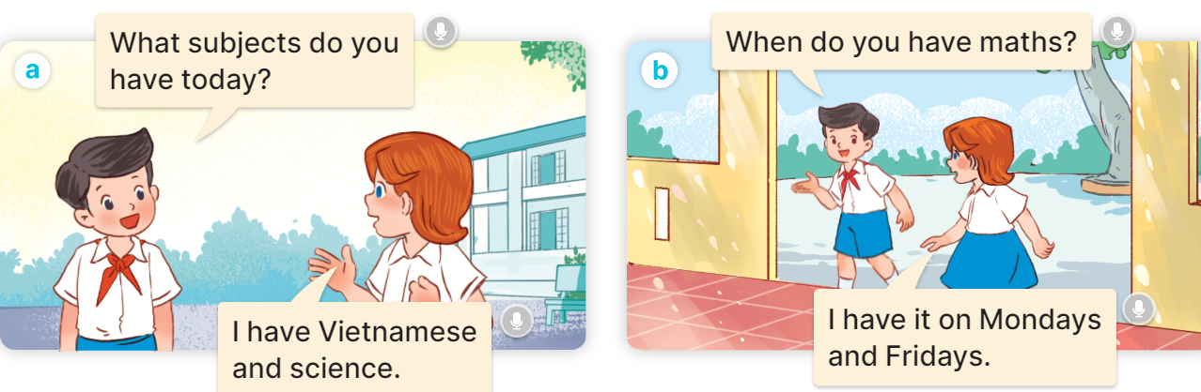  - Play the audio twice (sentence by sentence). Correct their pronunciation where necessary.  - Have Ss to practice the dialogue  - T invites a few pairs to the front of the class to practice.  - T checks pronunciation for ss.  Activity 3 Listen, point and say.  *Aims: Ss will be able to correctly say the words and use When do you have ………? – I have it on …….. to ask and answer questions about a timetable.  *Procedure:  * Model sentences:  - T asks Ss look at picture b and helps Ss know the structure from the dialogue.  - T introduces new structure for Ss.  - T explains, models and gives meaning.  - Have Ss repeat the model sentences.  A: When do you have Art?  B:I have it on Monday.  *Drill pictures  - Have Ss look at the pictures and identify the subjects and days of week  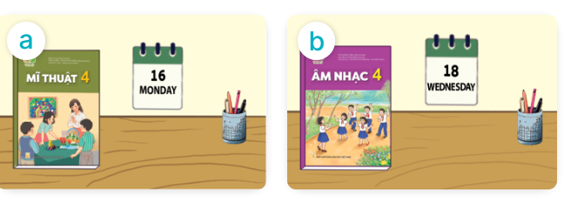  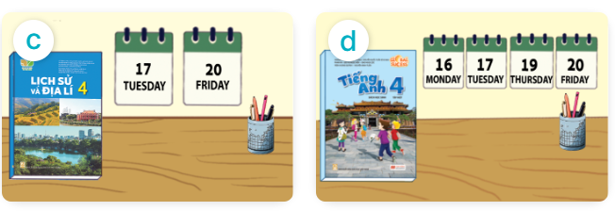  - Run through all the pictures.  - Run through model sentences.  - Have Ss to practise:  + T asks, Ss answer picture a  + Ss ask, T answers picture b  + Group A ask, group B answer picture c  + Group B ask, group A answer picture d  - Ask Ss to work in pairs.  - T controls and corrects.  - Invite a few pairs to come to the front of the classroom and point at the pictures and say the questions and answers in front of the class.  - T gives feedbacks.  Activity 4. Let’s talk.  *Aims: Ss will be able to enhance the correct use of When do you have ……? – I have it on ………. to ask and answer questions about a timetable in a freer context  *Procedure:  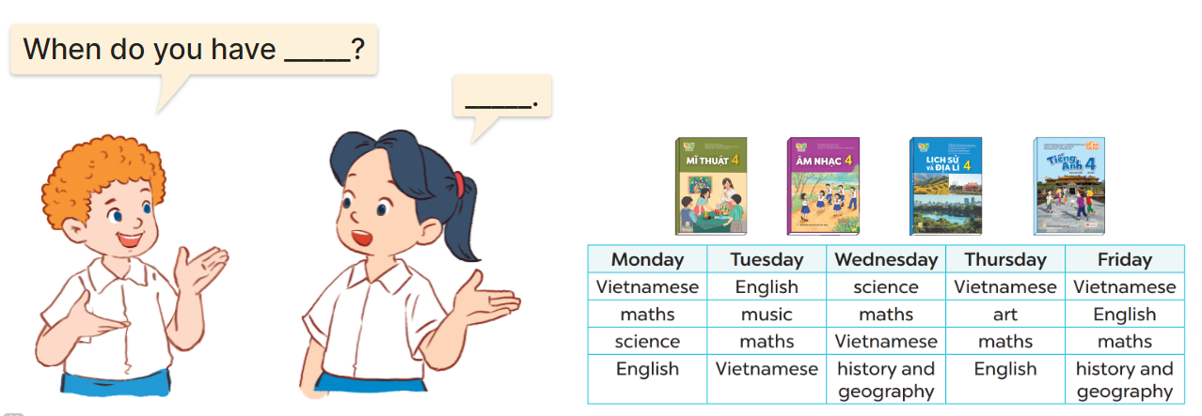  - Have Ss look at the picture and elicit the question and the answer in context.  + Who are they?  + What are they talking about?  - Elicit the missing words and write them on the board. Get pupils to say the completed sentences.  - Put Ss work in pairs to give and respond to instructions.  - Invite some pairs of Ss to the front of the class to ask and answer.  *Consolidation  *Aims: Ss will be able consolidate and wrap up the content of the lesson.  *Procedure:  - T asks ss to answer the following questions:  + What have you learnt from the lesson today?  +What are the core values of the lesson? (if the teacher can take from the lesson).  - T review the vocabulary and model sentences.  - T praises some Ss who are hardworking / active/ good…. as well as encourage others to try more.  - Learn the vocabulary and model sentences by heart  - Prepare the new lesson: Unit 7, Lesson 2 (4,5,6). | - Ss listen and matching  -Ss play game  - Ss open their books  -Ss listen and answer  - - Ss listen and repeat  + Choral repetition (3 times).  + Individual repetition (3 ss)  - Ss take note  - Ss look, remember and write  -Look at the pictures and say  + In picture a:  Nam: What subjects do you have today? Lucy: I have Vietnamese and science  + In picture b:  Nam: When do you have maths?  Lucy: I have it on Mondays and Fridays  -Ss listen and repeat in chorus (twice)  -Ss work in pairs to practice  -Ss practice the dialogue  -Ss listen  -Ss look at the picture and answer.  -Ss listen  -Ss listen and repeat  -Ss repeat  - Ss look, listen and answer  + Picture a: An art textbook and a calendar displaying Monday  + Picture b: A music textbook and a calendar displaying Wednesday.  + Picture c: A science textbook and two calendars displaying Tuesday and Friday.  + Picture d: An English textbook and three calendars displaying Monday, Tuesday and Thursday  -Ss listen and repeat  -Ss practice in chorus  -Ss practice in chorus  -Ss work in pairs to practice  -Ss point and say  -Ss listen.  -Ss look at the picture and answer  + a boy and a girl talking about a timetable  -Ss listen and answer  -Ss work in pairs  -Ss ask and answer  -Ss answer the questions  - Ss listen  -Ss listen and clap their hands  -Ss listen and take note
D. ADJUSTMENTS (if necessary):
………………………………………………………………………………………….…..……………………………………………………………………………...……………

Week 12 Preparing date: November 27th, 2024
Period 47 Teaching date: November 29th, 2024

Unit 7: Our timetables
Lesson 2 (4, 5, 6)
A. OBJECTIVES: By the end of the lesson, Ss will be able to:
1. Knowledge:
- Identify the specific information by listening 2 conversations about school timetable to tick the correct pictures.
- Using clue pictures to complete the gaps;
- Perform the song “What subjects do you have today?” in interesting ways, using appropriate and meaningful gestures.
- Vocabulary: Review
- Skills: speaking, listening, reading and writing.
2. Competences:
- Co-operation: ready to help friends in pair work/ group work.
- Self-control and independent learning: perform listening tasks.
3. Attitude/ Qualities:
- Show their responsibility to follow the timetable and prepare their subjects before school.
B. TEACHING AIDS:
- Teacher: Teacher’s guide Pages 106,107; audio Tracks 72; website hoclieu.vn, posters, laptop, pictures, textbook, lesson plan, TV or projector.
- Students: Pupil’s book Page 53, notebooks, workbooks, school things.
C. PROCEDURES:
Stages/Time | Teacher’s activities | Students’ activities
1.Warm- up:  (5’)  2.Practice: (27’)  3. Homework. (3’) | Game: Slap the board  *Aims: to create a friendly and active atmosphere in the class to beginning the lesson.  *Procedure:  - Divide class into 2 groups  - How to play:  + Each group chooses five Ss to play.  + Class will read aloud.  + Look at the picture, listen and slap the picture you heard.  + Who faster will get 1 mark.  + Which group with higher mark is the winner.  - T gives feedback.  - Say “Open your book page 53” and look at “Unit 7, Lesson 2 (4,5,6)”.  Activity 1. Listen and tick:  *Aims: Ss will be able to listen to and understand two communicative contexts in which pupils ask and answer questions about timetables and tick the correct pictures  *Procedure:  - Ask pupils to look at Pictures 1a and 1b and identify a part of the timetables and the subject.  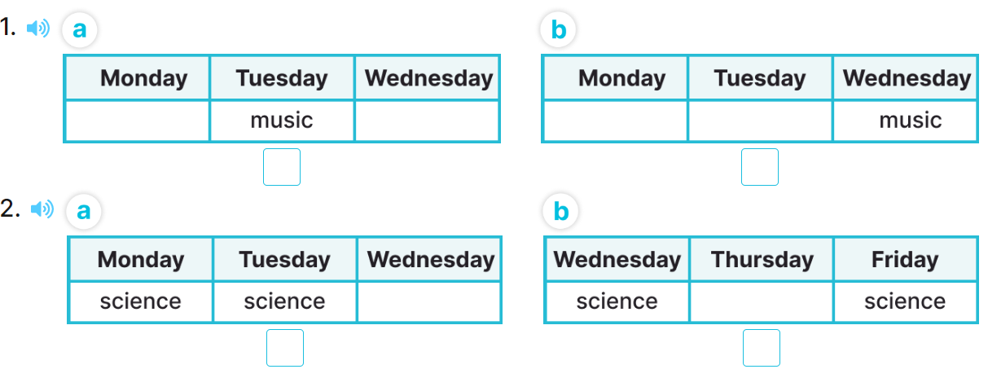  - T ask Ss to guess the answers.  + T writes Ss’guessing on the board.  - Listen to the tape:  + Play the recording  + Play the recording again and get Ss to swap books with their partners.  + Play the recording again to check answers together as a class.  + Write the answers on the board for Ss to correct their answers. Then checks Ss’ guessing.  - Play the recording, sentence by sentence, for the class to listen and repeat in chorus.  Key: 1. a 2. B  Activity 2. Look, complete and read  *Aims: Ss will be able to complete two gapped exchanges with the help of picture cues.  *Procedure:  - Have pupils read the sentences and guess the missing words  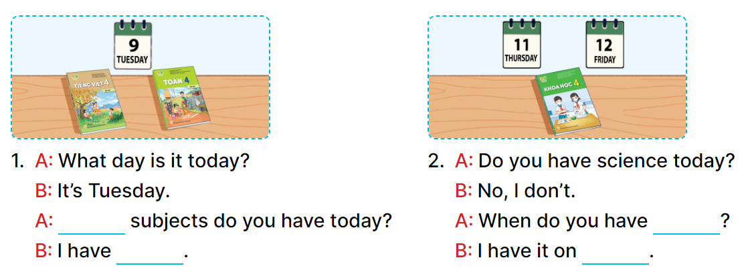  - Model the first gapped exchange.  - Elicit the names of the subjects that can be used to fill in the gaps (What, Vietnamese and maths).  - Give pupils look at the picture and fill in the gaps independently.  - Get pupils to swap books with a partner and check their answers before checking as a class.  - Invite one pupil to write the answers on the board.  - Invite four pairs of pupils to act out the complete exchanges in front of the class.  Key:  1. What, Vietnamese and maths  2. science, Thursday and Friday  Activity 3. Let’s sing  *Aims: Ss will be able to sing the song When subjects do you have today? with the correct pronunciation, rhythm, and melody.  *Procedure:  - Introduce the title and lyrics of the song: “ What subjects do you have today?”  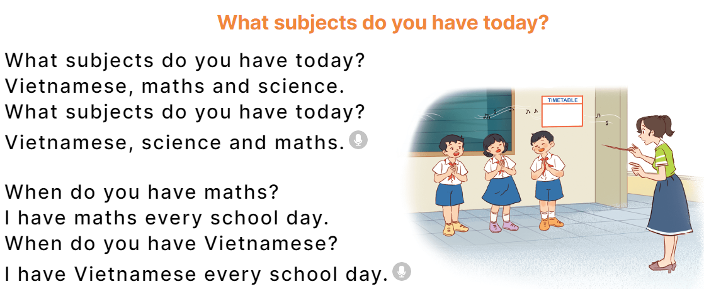  - Play the recording for Ss to listen to the whole song.  + Have them repeat the title and lyrics line by line.  + Tell Ss to point at the pictures while singing.  - Play the recording all the way through for Ss to listen to pronunciation and melody of the song.  - Play the recording line by line for Ss to listen, repeat and point to the pictures  - Play the recording for Ss to sing and do actions.  - Ask Ss to practice singing and doing actions in pairs or groups.  - Invite groups to the front of the classroom to perform the song  -T gives feedback.  *Consolidation  *Aims: Ss will be able consolidate and wrap up the content of the lesson.  *Procedure:  - T asks ss to answer the following questions:  + What have you learnt from the lesson today?  +What are the core values of the lesson? (if the teacher can take from the lesson).  - T praises some Ss who are hardworking / active/ good…. as well as encourage others to try more.  - Prepare the new lesson: Unit 7, Lesson 3 (1,2,3). | - Ss read the words  - Ss play game  -Ss play game  - Ss open their books  -Look at the pictures and say:  + Picture 1a. A part of the timetable in which music is taught on Tuesdays  + Picture 1b. A part of the timetable in which music is taught on Wednesdays  + Picture 2a. A part of the timetable in which science is taught on Wednesdays and Thursdays  + Picture 2b. A part of the timetable in which science is taught on Wednesdays and Fridays  -Ss guess the answers  - Ss listen to the tape and tick  - Ss listen again, tick and swap books with their partners.  -SS listen again and check  - Ss check their answers and guessing  -Ss listen and repeat.  -Ss look at the picture and say  -Ss look and pay attention  -Ss answer  -Ss say and fill in the gaps  -Ss work in pairs and swap books and check  -Ss write on the board  -SS ask and asnwer  - Ss listen  -Ss listen to the song  - Ss listen and repeat line by line without the action.  -Ss point to the pictures while singing  -Ss listen to melody of the song  - Ss listen and sing line by line.  - Ss sing and do actions.  + Ss work in groups (two groups) to sing.  -Ss perform in front of the class.  -Ss listen  -Ss answer the questions  -Ss listen and clap their hands  -Ss listen and take note
D. ADJUSTMENTS (if necessary):
…………………………………………………………………………………………………………………………………………………………………………………….……………………………………

Week 12 Preparing date: November 27th, 2024
Period 48 Teaching date: November 29th, 2024

Unit 7: Our timetables
Lesson 3 (1, 2, 3)
A. OBJECTIVES:
By the end of the lesson, Ss will be able to:
1. Knowledge:
- Correctly pronounce the sound of the letters se and ce in isolation, in the words Vietnamese and science and in the correct sentences “When do you have Vietnamese” and “We have science today”
- Identify the specific information by listening 2 sentences to identify the target word;
- Perform the chant in interesting ways, using appropriate and meaningful gestures
- Vocabulary: Review
- Skills: speaking, listening, reading and writing.
2. Competences:
- Co-operation: ready to help friends in pair work/ group work.
- Sociability: Talk to each other, say good words to others.
3. Attitude/ Qualities:
- Show their responsibility to follow the timetable and prepare their subjects before school.
B. TEACHING AIDS:
- Teacher: Teacher’s guide Pages 104,105; audio Tracks 74, 75, 76; website hoclieu.vn, posters, laptop, pictures, textbook, lesson plan, TV or projector.
- Students: Pupil’s book Page 54, notebooks, workbooks, school things.
C. PROCEDURES:
Stages/Time | Teacher’s activities | Students’ activities
1.Warm- up:  (5’)  2. Presentation  (9’)  3.Practice: (19’)  4. Homework. (2’) | Game: Pass the ball  *Aims: to create a friendly and active atmosphere in the class to beginning the lesson.  *Procedure:  - Divide the class into 3 teams.  - Each team has 1 sticky ball.  - Play the music, Ss in each team take turns to pass the ball.  + After the music ends, 3 Ss have the ball – stand up and say the name, using the sentence model.  - Say “Open your book page 54” and look at “Unit 7, Lesson 3 (1,2,3)”.  Activity 1. Listen and repeat:  *Aims: Ss will be able to correctly repeat the sounds of the consonant clusters se and ce in isolation, in the words Vietnamese and science and in the sentences When do you have Vietnamese” and “We have science today”with the correct pronunciation and intonation  *Procedure:  - T gives instruction to the letter se and ce, Vietnamese and science and in the sentences When do you have Vietnamese” and “We have science today”  - Play the recording for the letter se, ce.  - Encourage Ss to point at the letter/ word/ sentence while listening.  - Play the recording again and encourage Ss to listen and repeat.  - Do this several times until Ss feel confident.  - T calls some Ss to practice.  - T gives feedbacks.  Activity 2. Listen and circle  *Aims: Ss will be able to identify the target words Vietnamese and science while listening.  *Procedure:  - Elicit the sentences and the gap-fill options.  - T ask Ss to guess the answers.  + T writes Ss’guessing on the board.  - Listen to the tape:  + Play the recording  + Play the recording again and get Ss to swap books with their partners.  + Play the recording again to check answers together as a class.  + Write the answers on the board for Ss to correct their answers. Then checks Ss’ guessing.  - Play the recording, sentence by sentence, for the class to listen and repeat in chorus.  - Invite one or two Ss to stand up and read the completed sentences.  Key: 1.b 2.a  Activity 3. Let’s chant  *Aims: Ss will be able to say the chant with the correct rhythm and pronunciation  *Procedure:  - Introduce the title and lyrics of the chant.  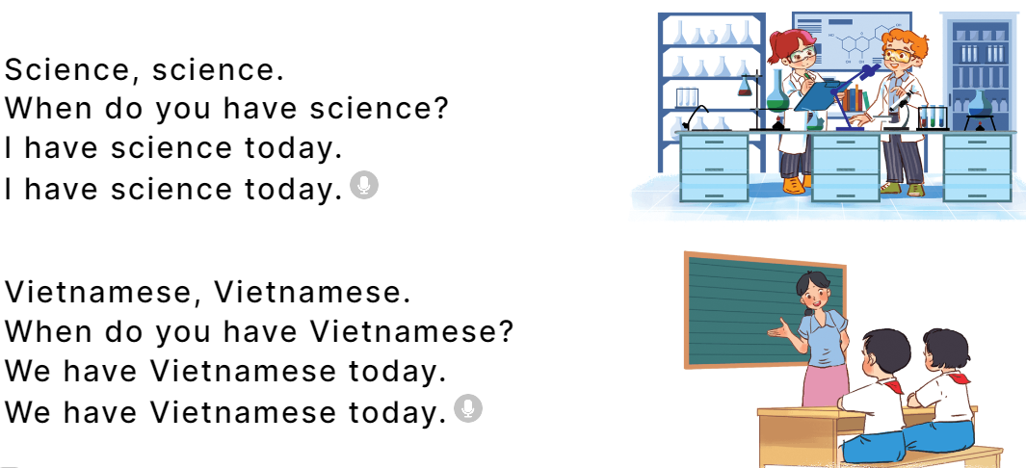  - Play the recording for Ss to listen to the whole chant.  + Have them repeat the title and lyrics line by line.  + Ask Ss to attend to the sounds of the letters se and ce and the words Vietnamese and science.  - Play the recording all the way through for Ss to listen to pronunciation and melody.  - Play the recording line by line for Ss to listen and repeat  - Play the recording for Ss to chant and clap along.  - Ask Ss to practice chant and clap along in pairs or groups.  - Invite groups to the front of the classroom to perform the chant  -T gives feedback.  *Consolidation  *Aims: Ss will be able consolidate and wrap up the content of the lesson.  *Procedure:  - T asks ss to answer the following questions:  + What have you learnt from the lesson today?  +What are the core values of the lesson? (if the teacher can take from the lesson).  - T praises some Ss who are hardworking / active/ good…. as well as encourage others to try more.  - Practice the chant more.  - Prepare the new lesson: Unit 7, Lesson 3 (4,5,6). | - Ss listen  -Ss play game  - Ss open their books  - Ss recognize the differences about color of letter  - - Ss listen  - Ss listen and point  - Ss listen again and repeat  -Ss listen again and repeat  -Ss practice  -Ss listen  -Ss listen and say:  + Number 1: When do you have …….?  + Number 2: They have ….today.  -Ss guess the answers  - Ss listen to the tape and circle  - Ss listen again, circle and swap books with their partners.  - Ss check their answers and guessing  -Ss listen and repeat.  -Ss read the sentences  - Ss look and listen.  -Ss listen to the chant  - Ss listen and repeat line by line without clap their hands  -Ss note the sounds, words  -Ss listen to melody of the chant  - Ss listen and chant line by line.  - Ss chant and clap along.  - Ss work in groups (two groups) to chant  -Ss perform in front of the class.  -Ss listen  -Ss answer the questions  -Ss listen and clap their hands  -Ss listen and take note

D. ADJUSTMENTS (if necessary):
………………………………………………………………………………………….…..……………………………………………………………………………...……………

