Week 6 Preparing date: October 13th , 2024
Period 21 Teaching date: October 15th , 2024

Unit 3: My week
Lesson 3 (1, 2, 3)
A. OBJECTIVES:
By the end of the lesson, Ss will be able to:
1. Knowledge:
- correctly repeat the sounds of the letter u in isolation, in the word music (/ju/) as in the sentence I listen to music on Saturdays, and the word Sunday (/ʌ/) as in I do housework on Sundays.
- identify the target words music and Sunday while listening.
- say the chant with the correct pronunciation and rhythm.
- Vocabulary: Review
- Skills: speaking, listening, reading and writing.
2. Competences:
- Listening: listen and recognize someone, then repeat
- Co-operation: ready to help friends in pair work/ group work.
- Sociability: Talk to each other, say good words to others.
3. Attitude/ Qualities:
- Kindness: Help partners to complete learning tasks.
- Honesty: tell the truth about feelings and emotions
B. TEACHING AIDS:
- Teacher: Teacher’s guide Pages 51,52,53; audio Tracks 33, 34,35; website hoclieu.vn, posters, laptop, pictures, textbook, lesson plan, TV or projector.
- Students: Pupil’s book Page 26, notebooks, workbooks, school things.
C. PROCEDURES:
Stages/Time | Teacher’s activities | Students’ activities
1.Warm- up:  (5’)  2. Presentation  (9’)  3.Practice: (19’)  4. Homework. (2’) | Game: Find and circle the words  *Aims: to create a friendly and active atmosphere in the class to beginning the lesson.  *Procedure:  - Divide class into 2 groups  - Ask Ss to find and circle the words and characters that they learnt.  - Which groups find the best correct words is winner.  - Give Ss time to play the game.  Rows: lunch, Tuesday  Columns: Music, Sunday  -T checks who’s winner?  - Say “Open your book page 26” and look at “Unit 3, Lesson 3 (1,2,3)”.  Activity 1. Listen and repeat:  *Aims: Ss will be able to correctly repeat the sounds of the letter u in isolation, in the words music and Sunday, and in the sentences I listen to music on Saturdays. and I do housework on Sundays. with the correct pronunciation and intonation.  *Procedure:  - T gives instruction to the letter u in isolation, the words music and Sunday, and the sentences I listen to music on Saturdays. and I do housework on Sundays  - Play the recording for the letter u  - Encourage Ss to point at the letter/ word/ sentence while listening.  - Play the recording again and encourage Ss to listen and repeat.  - Do this several times until Ss feel confident.  - T calls some Ss to practice.  - T gives feedbacks.  Activity 2. Listen and circle  *Aims: Ss will be able to identify the target words music and Sunday while listening.  *Procedure:  - Tell pupils that they are going to listen to the recording and circle the correct options.  -Get them to read the options and guess the sentences they may hear in the recording.  - Play the recording for pupils to listen.  - Play the recording again for pupils to listen and circle the correct options.  - Tell pupils to swap books with a partner, then check the answers together as a class.  -Write the correct answers on the board.  - Play the recording again for pupils to double-check their answers.  - Invite one or two pupils to stand up, listen to and repeat the sentences.  Key: 1.a 2.b  Activity 3. Let’s chant  *Aims: Ss will be able to say the chant with the correct pronunciation and rhythm.  *Procedure:  - Introduce the title and lyrics of the chant.  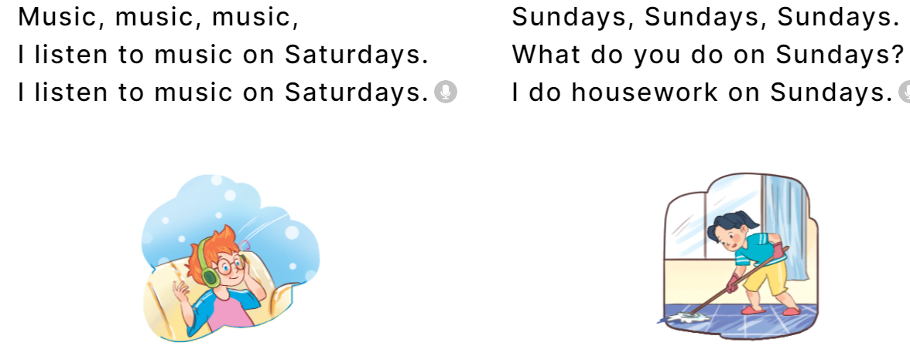  - Play the recording for Ss to listen to the whole chant.  + Have them repeat the title and lyrics line by line.  + Ask Ss to attend to the sounds of the letters u and the words music and Sunday.  - Play the recording all the way through for Ss to listen to pronunciation and melody.  - Play the recording line by line for Ss to listen and repeat  - Play the recording for Ss to chant and clap along.  - Ask Ss to practice chant and clap along in pairs or groups.  - Invite groups to the front of the classroom to perform the chant  -T gives feedback.  *Consolidation  *Aims: Ss will be able consolidate and wrap up the content of the lesson.  *Procedure:  - T asks ss to answer the following questions:  + What have you learnt from the lesson today?  +What are the core values of the lesson? (if the teacher can take from the lesson).  - T review the vocabulary and model sentences.  - T praises some Ss who are hardworking / active/ good…. as well as encourage others to try more.  - Practice the chant more.  - Draw and colour three pictures of your friends.  - Prepare the new lesson: Unit 3, Lesson 3 (4,5,6). | - Ss listen  -Ss listen the rules  - Ss play the game  - Ss open their books  - Ss recognize the differences about color of letter  - - Ss listen  - Ss listen and point  - Ss listen again and repeat  -Ss listen again and repeat  -Ss practice  -Ss listen  -Ss listen and circle  -Ss read and guess the answers  - Ss listen to the tape and circle.  - Ss listen again and circle the correct answers  - Ss listen and swap books with their partners.  -Ss write the correct answer  - Ss check their answers  -Ss listen and repeat.  - Ss look and listen.  -Ss listen to the chant  - Ss listen and repeat line by line without clap their hands  -Ss note the sounds, words  -Ss listen to melody of the song  - Ss listen and chant line by line.  - Ss chant and clap along.  - Ss work in groups (two groups) to chant  -Ss perform in front of the class.  -Ss listen  -Ss answer the questions  - Ss listen  -Ss listen and clap their hands  -Ss listen and take note
  L | U | N | C | H | R | S | C | S | T
  H | C | T | H | N | O | H | C | U | H
  C | L | U | A | A | M | A | O | N | I
  L | E | L | N | N | U | T | S | D | N
  A | A | W | K | E | S | O | E | A | K
  S | N | J | Z | R | I | I | I | Y | B
  S | R | O | E | E | C | V | C | A | H
  S | T | U | E | S | D | A | Y | A | Y
  D | T | S | S | R | I | O | T | S | M
D. ADJUSTMENTS (if necessary):
Week 6 Preparing date: October 13th, 2024
Period 22 Teaching date: October 15th, 2024

Unit 3: My week
Lesson 3 (4, 5, 6)
A. OBJECTIVES:
By the end of the lesson, Ss will be able to:
1. Knowledge:
- read and show understanding of a text and complete a table about Nam’s week.
- complete a paragraph about what pupils do on certain days of the week by writing the target words in the gaps.
- draw two pictures about weekend activities at home and present them to the class by using the target language.
- Vocabulary: Review
- Skills: speaking, listening, reading and writing.
2. Competences:
- Co-operation: ready to help friends in pair work/ group work.
- Self-control and independent learning: perform listening tasks.
3. Attitude/ Qualities:
- Kindness: Help partners to complete learning tasks.
- Honesty: tell the truth about feelings and emotions.
- Diligence: complete learning tasks.
B. TEACHING AIDS:
- Teacher: Teacher’s guide Pages 53,54, website hoclieu.vn, posters, laptop, pictures, textbook, lesson plan, TV or projector.
- Students: Pupil’s book Page 27, notebooks, workbooks, school things.
C. PROCEDURES:
Stages/Time | Teacher’s activities | Students’ activities
1.Warm- up: (5’)  2.Practice: (8’)  3.Production: (19’)  4. Homework. (3’) | Game: “Chant”  *Aims: to create a friendly and active atmosphere in the class to beginning the lesson.  *Procedure:  - Ask Ss chant and do the actions in Unit 3, Lesson 3 page 26 in groups.  - Give point for the groups and encourage them.  - Say “Open your book page 27” and look at “Unit 3, Lesson 3 (4,5,6)”.  Activity 1. Read and complete:  *Aims: Ss will be able to read and show understanding of a text and complete a table about Nam’s week.  *Procedure:  - Draw pupils’ attention to the words provided in the table and the four gaps about Nam’s activities on some days of the week.  - Ask pupils to read the text and complete the table with the missing words.  - Set a time limit for pupils to read the text again and look for specific information to fill in the gaps in the table.  - Tell pupils to swap their answers with a partner.  - Check answers together as a class.  - Write the answers on the board.  - T gives feedbacks.  Key: 1. Go to school 2. go to school  3. do housework 4. Watch TV  Activity 2. Let’s write  *Aims: Ss will be able to complete a paragraph about what pupils do on certain days of the week by writing the target words in the gaps.  *Procedure:  - Ask pupils to read the gapped text and fill in the gaps with their own information.  - Tell pupils that the gaps in the text should focus on their activities and the days on which they do the activities.  - Have pupils do the first gapped sentence together as an example.  - Ask them to read the sentence and elicit the names and write their names in the gap.  - Give pupils time to complete the text independently.  - Get pupils to swap their books with a partner and check their answers before checking as a class.  - Invite a few pupils to read their completed texts in front of the class  Key: 1. Is  2. This is my  3. That’s my teacher  Activity 3. Project.  *Aims: Ss will be able to draw two pictures about weekend activities at home and present them to the class by using the target language.  *Procedure:  - Ask Ss to draw two pictures about weekend activities at home.  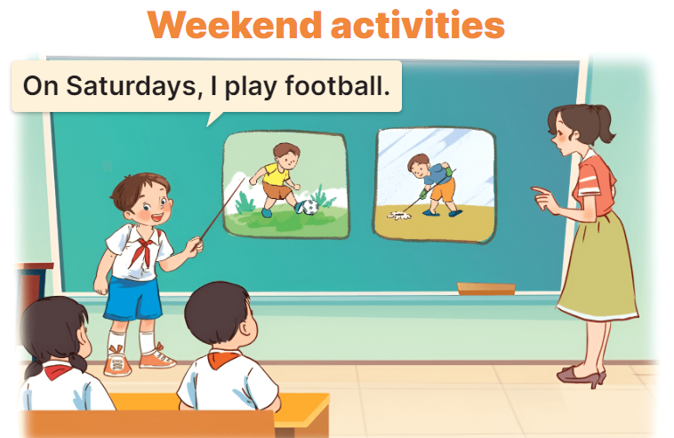  - Tell pupils the goal of the activity.  - Have pupils work in groups of five or six.  -Each pupil looks at his / her notes and tell the group about what he / she does on Saturdays and Sundays.  - Invite a few pupils to look at the notes in their tables and tell the class about them.  - T gives feedback.  *Consolidation  *Aims: Ss will be able consolidate and wrap up the content of the lesson.  *Procedure:  - T asks ss to answer the following questions:  + What have you learnt from the lesson today?  +What are the core values of the lesson? (if the teacher can take from the lesson).  - T praises some Ss who are hardworking / active/ good…. as well as encourage others to try more.  - Prepare the new lesson: Unit 4, Lesson 1 (1,2,3). | - Ss listen and chant  - Ss open their books  - Ss pay attention the text and the table  -Ss read and complete  -Ss read again and fill in the gaps  -Ss swap books and check  -Ss check the correct their answers  -Ss write the answers on the board  -Ss listen  -Ss read the gapped text and fill in the gaps  Ex: I am Huong. I go to school on Mondays, Tuesdays, Wednesdays, Thursday and Fridays. I do housework on Satursdays. On Sundays I play football and listen to music. What do you do at the weekend?  -Ss write the answer  -Ss swap books and check their answer  -Ss read the sentences  - Ss drew and coloured draw two pictures at home.  -Ss listen to the teacher  -Ss work in groups and say  -Ss present their pictures  Ex: Hello, everyone. My name’s Huong. I study at Nghia Lam Primary School. I’m in class 4D. Today, I would like to talk about My weekend: On Saturdays, I play footballwith my friends. On Sundays, I do housework and watch TV.  -Ss answer the questions  -Ss listen and clap their hands  -Ss listen and take note
D. ADJUSTMENTS (if necessary):
………………………………………………………………………………………….…..……………………………………………………………………………...…………
Week 6 Preparing date: October 16th, 2024
Period 23 Teaching date: October 18th, 2024

Unit 4: My birthday party
Lesson 1 (1, 2, 3)
A. OBJECTIVES:
By the end of the lesson, Ss will be able to:
1. Knowledge:
- understand and correctly repeat the sentences in two communicative contexts focusing on asking and answering questions about birthdays.
- correctly say the words and use When’s your birthday? – It’s in …... to ask and answer questions about someone’s birthday.
- enhance the correct use of When’s your birthday? – It’s in ……... to ask and answer questions about someone’s birthday in a freer context.
- Vocabulary: January, February, March, April, May, June, birthday.
- Skills: speaking and listening
2. Competences:
- Co-operation: ready to help friends in pair work/ group work.
- Sociability: Talk to each other, say good words to others.
3. Attitude/ Qualities:
- Kindness: Help partners to complete learning tasks.
- Honesty: tell the truth about feelings and emotions
B. TEACHING AIDS:
- Teacher: Teacher’s guide Pages 55,56,57 audio Tracks 36,37; website hoclieu.vn, posters, laptop, pictures, textbook, lesson plan, TV or projector.
- Students: Pupil’s book Page 28, notebooks, workbooks, school things.
C. PROCEDURES:
Stages/Time | Teacher’s activities | Students’ activities
1.Warm- up:  (5’)  2. Presentation  (16’)  3.Practice: (7’)  4.Production: (7’)  5. Homework. (2’) | Sing: Happy birthday to you  *Aims: to create a friendly and active atmosphere in the class to beginning the lesson  *Procedure:  - Show the song on the screen.  https://www.youtube.com/watch?v=90w2RegGf9w  - Ask pupils to listen, sing and dance the song.  - Say “Open your book page 28” and look at “Unit 4, Lesson 1 (1,2,3)”.  Activity 1. Vocabulary.  *Aims: Ss will be able to know the vocabulary in the new lesson.  *Procedure:  -T elicits the new words  + January :tháng 1 (siuation)  + February :tháng 2 (situation)  + March :tháng 3 (translation)  + April :tháng 4 (translation)  + May :tháng 5 (situation)  + June :tháng 6 (translation)  +birthday : ngày sinh, sinh nhật (picture)  - T models (3 times).  - T writes the words on the board.  - Checking: Rub out and remember  Activity 2. 1. Look, listen and repeat:  *Aims: Ss will be able to understand and correctly repeat the sentences in two communicative contexts focusing on asking and answering questions about birthdays  *Procedure:  - Have Ss look at Pictures a and b and identify the characters in the pictures.  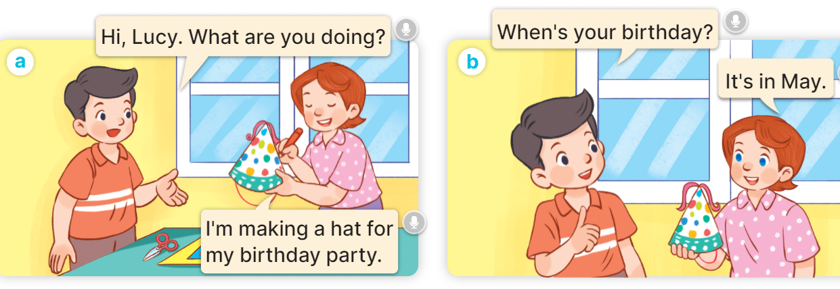  - Play the audio twice (sentence by sentence). Correct their pronunciation where necessary.  - Have Ss to practice the dialogue  - T invites a few pairs to the front of the class to practice.  - T checks pronunciation for ss.  Activity 3 Listen, point and say.  *Aims: Ss will be able to correctly say the words and use When’s your birthday? – It’s in …… to ask and answer questions about someone’s birthday.  *Procedure:  * Model sentences:  - T asks Ss look at picture b and helps Ss know the structure from the dialogue.  - T introduces new structure for Ss.  - T explains, models and gives meaning.  -Have Ss repeat the model sentences.  A: When’s your birthday?  B: It’s in May.  *Drill pictures  - Have pupils look at the pictures and elicit the names of the months.      - Run through all the pictures.  - Run through model sentences.  - Have Ss to practise:  + T asks the first picture, Ss answer  + Ss asks the second picture, T answers  + Group A asks the third picture, group B answers  + Group B asks the last picture, group A answers.  - Ask Ss to work in pairs.  - T controls and corrects.  - Invite a few pairs to come to the front of the classroom, point at the pictures, and say the questions and answers in front of the class.  - T gives feedbacks.  Activity 4. Let’s talk.  *Aims: Ss will be able to enhance the correct use of When’s your birthday? – It’s in …….. to ask and answer questions about someone’s birthday in a freer context.  *Procedure:  - Have pupils say the names of the months in the picture.  + When’s your birthday? – It’s in ……..  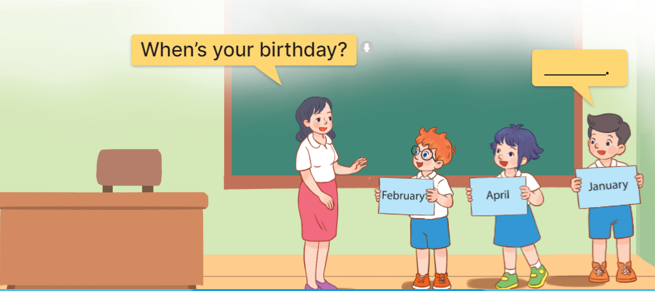  - Elicit the missing words in the speech bubble and write them on the board.  - Have pupils look at the bubbles to understand how the sentence pattern is used.  - Have pupils role-play to practise asking the questions and giving their answers in pairs, using picture cues.  - Make sure pupils understand the structure and say them with the right pronunciation and intonation.  - Invite some pupils to practise asking and answering questions in front of the class.  *Consolidation  *Aims: Ss will be able consolidate and wrap up the content of the lesson.  *Procedure:  - T asks ss to answer the following questions:  + What have you learnt from the lesson today?  +What are the core values of the lesson? (if the teacher can take from the lesson).  - T review the vocabulary and model sentences.  - T praises some Ss who are hardworking / active/ good…. as well as encourage others to try more.  - Learn the vocabulary and model sentences by heart  -Prepare the new lesson: Unit 4 Lesson1:4,5,6 | - Ss sing and dance the song  - Ss open their books  -Ss listen and answer  - - Ss listen and repeat  + Choral repetition (3 times).  + Individual repetition (3 ss)  - Ss take note  - Ss look, remember and match  -Look at the pictures and get to know the characters in the pictures.  + In picture a:  Nam: Hi, Lucy. What are you doing?  Lucy: I’m making a hat for my birthday party.  + In picture b:  Nam: When’s your birthday?  Lucy: It’s in May.  -Ss listen and repeat in chorus (twice)  -Ss work in pairs to practice  -Ss practice the dialogue  -Ss listen  -Ss look at the picture and answer.  -Ss listen  -Ss listen and repeat  -Ss repeat to parts of the body.  - Ss look, listen and answer  +Picture a: a calendar showing January.  + Picture b: a calendar showing February.  + Picture c: a calendar showing March.  + Picture d: a calendar showing April.  -Ss listen and repeat  -Ss practice in chorus  -Ss practice in chorus  -Ss work in pairs to practice  -Ss listen  -Ss point and say the questions  -Ss listen.  -Ss look at the bubbles and picture and answer  + It’s in ……..  -Ss listen and pay attention  - Ss answer  -Ss work in pairs, ask and answer  -SS ask and answerwith the right pronunciation and intonation.  -Ss perform in front of the class.  -Ss answer the questions  - Ss listen  -Ss listen and clap their hands  -Ss listen and take note
D. ADJUSTMENTS (if necessary):
………………………………………………………………………………………….…..……………………………………………………………………………...…………………………

Week 6 Preparing date: October 16th, 2024
Period 23 Teaching date: October 18th, 2024

Unit 4: My birthday party
Lesson 1 (1, 2, 3)
A. OBJECTIVES:
By the end of the lesson, Ss will be able to:
1. Knowledge:
- ask and answer questions about someone’s birthday, using sentence patterns: When’s your birthday? – It’s in … .
- Vocabulary: January, February, March, April, May, June, birthday, party, when
- Skills: speaking and listening
2. Competences:
- Co-operation: ready to help friends in pair work/ group work.
- Sociability: Talk to each other, say good words to others.
3. Attitude/ Qualities:
- Kindness: Help partners to complete learning tasks.
- Honesty: tell the truth about feelings and emotions
B. TEACHING AIDS:
- Teacher: Teacher’s book, textbook, audio Tracks 36,37, pictures, laptop, TV or projector.
- Students: Pupil’s books , notebooks, school things.
C. PROCEDURES:
Stages/Time | Teacher’s activities | Students’ activities
1.Warm- up:  (5’)  2. Presentation  (15’)  3.Practice: (7’)  4.Production: (7’)  5. Homework. (1’) | - Greeting, introducing the Teachers to Ss  - Game: Pastimes: Days of the week  *Aims: to check the vocabulary Ss learned, to create a friendly and active atmosphere in the class to the beginning of the new lesson  *Procedure:  T introduces the game and devides the Ss into two teams  T says the rule of the game clearly  T guides Ss to play the game  T remarks and praises the team who is the winner  T introduces the new lesson:  Unit 4: MY BIRTHDAY PARTY  Lesson 1 (Part 1,2,3)  Activity 1. 1. Look, listen and repeat:  *Aims: Ss will be able to:  - know some new words about months of the year  - understand and correctly repeat the sentences in two communicative contexts focusing on asking and answering questions about birthdays  *Procedure:  - T asks Ss to look at Pictures a and b and identify the characters in the pictures.  - T plays the audio twice for Ss to listen to the dialogue between Nam and Lucy  - T plays the audio again for Ss to listen and repeat the dialogue.  - T asks Ss to practice the dialogue in pairs  - T invites some pairs of Ss to play the roles of Nam and Lucy  -T teaches new words:  + birthday : ngày sinh, sinh nhật  + party : buổi tiệc  + when : khi nào  + January : tháng 1 ( translation)  + February : tháng 2 ( translation)  + March : tháng 3 ( translation)  + April : tháng 4 ( translation)  + May : tháng 5 ( translation)  + June : tháng 6 ( translation)  + July : tháng 7  + August : tháng 8  + September : tháng 9  + October : tháng 10  + November : tháng 11  + December : tháng 12  - T writes the words on the board.  - - T guides Ss to read new words (in chorus, in individual).  - Checking vocabulary: Rub out and remember  Activity 2 Listen, point and say.  *Aims: Ss will be able to use sentence patterns : - When’s your birthday?  - It’s in …  to ask and answer questions about someone’s birthday.  *Procedure:  - T asks Ss to look at picture b and helps Ss to know new sentence patterns from the context  - T writes the new sentence patterns on the board  + Hỏi- Trả lời về sinh nhật:  A: When’s your birthday?  B: It’s in + tháng..  EX: When’s your birthday?  It’s in May.  - T asks Ss read the model sentences.  *Drill pictures  - T asks Ss to look at the pictures and say the names of the months .  - T plays the audio for Ss to listen  - T makes a model of asking and answering with a student using picture a:  + T: When’s your birthday?  + S: It’s in January.  - T asks Ss to practise asking and answering in pairs (using the cues)  - T controls and corrects.  - T invites some pairs of Ss to point at the pictures and say the questions and answers in front of the class.  Activity 3. Let’s talk.  *Aims: Ss will be able to use vocabulary about months of the year and sentence patterns “ When’s your birthday?”  “ It’s in … “ to ask and answer questions about someone’s birthday in a freer context.  *Procedure:  - T asks Ss to ask their classmates questions about his/ her birthday freely using sentence patterns they have just learnt.  - T invites some pairs of pupils to perform in front of the class.  *Consolidation  *Aims: Ss will be able consolidate and wrap up the content of the lesson.  *Procedure:  - T asks Ss to answer the following question:  “What have you learnt from the lesson today?”  - T asks Ss to do an exercise  Complete the missing letters and the words  - Ap_il  - M_r_h  - _ebru_ry  - ___’s your birthday? - It’s in April.  - When’s your ____ ? - My birthday is in May.  - When’s your birthday? - It’s __March.  - When’s your birthday?  ____ in January.  - Learn the vocabulary and sentence patterns by heart  -Prepare the new lesson: Unit 4 Lesson1:4,5,6 | - Ss listen to T’s guiding and play the game in 2 teams  - Ss open their books  -Look at the pictures and get to know the characters in the pictures.  - Ss listen to the dialogue  -Ss listen and repeat sentence by sentence (in chorus, in groups)  -Ss practice reading the dialogue in pairs  -Some pairs of Ss play the roles of Nam and Lucy  - Ss write new words  -Ss practice reading new words  - Ss listen to T’s explaining  - Ss write the new sentence patterns  - Ss read the model sentences  - Ss look at the pictures and say the names of the months .  -Ss listen to the audio  - One student works in pair with The T  -Ss practice in pairs  - Some pairs perform in front of the class  -Ss work in pairs (asking and answering questions about their birthdays)  - Some pairs perform:  +S1: When’s your birthday?  +S2: It’s in …  - Ss answer the T’s question  -Ss fill in the blanks with the letters / the words and explain why.  -Ss listen to the T and take note

Week 6 Preparing date: October 16th, 2024
Period 24 Teaching date: October 18th, 2024

Unit 4: My birthday party
Lesson 1 (4, 5, 6)
A. OBJECTIVES:
By the end of the lesson, Ss will be able to:
1. Knowledge:
- listen to and understand four communicative contexts in which pupils ask and answer questions about their birthdays and number the correct pictures.
- complete four target gapped exchanges with the help of picture cues.
- sing the song When's your birthday? with the correct pronunciation, rhythm and melody.
- Vocabulary: Review
- Skills: speaking, listening, reading and writing.
2. Competences:
- Co-operation: ready to help friends in pair work/ group work.
- Self-control and independent learning: perform listening tasks.
3. Attitude/ Qualities:
- Kindness: Help partners to complete learning tasks.
- Honesty: tell the truth about feelings and emotions.
- Diligence: complete learning tasks.
B. TEACHING AIDS:
- Teacher: Teacher’s guide Pages 57,58,59,60; audio Tracks 39, 40; website hoclieu.vn, posters, laptop, pictures, textbook, lesson plan, TV or projector.
- Students: Pupil’s book Page 29, notebooks, workbooks, school things.
C. PROCEDURES:
Stages/Time | Teacher’s activities | Students’ activities
1.Warm- up:  (5’)  2.Practice: (27’)  3. Homework. (3’) | Game: Slap the board  *Aims: to create a friendly and active atmosphere in the class to beginning the lesson.  *Procedure:  - Divide class into 2 groups: Tom and Jerry.  - How to play:  + Each group chooses five Ss to play.  + Class will read aloud.  + Look at the picture, listen and slap the picture you heard.  + Who faster will get 1 mark.  + Which group with higher mark is the winner.  - Say “Open your book page 29” and look at “Unit 4, Lesson 1 (4,5,6)”.  Activity 1. Listen and number:  *Aims: Ss will be able to listen to and understand four communicative contexts in which pupils ask and answer questions about their birthdays and number the correct pictures.  *Procedure:  - Elicit the name of the month in each picture.  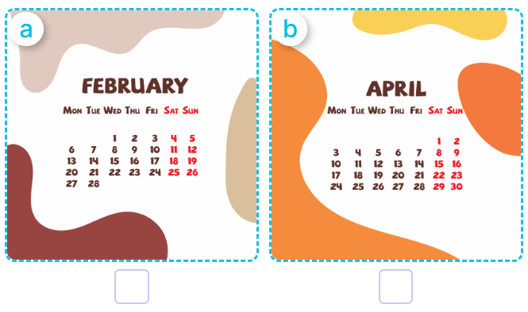  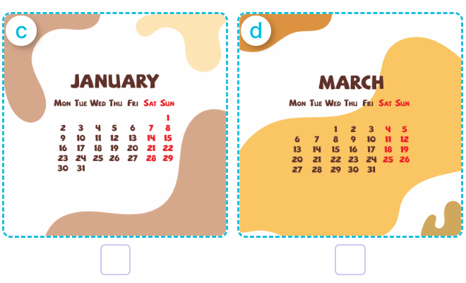  - T ask Ss to guess the answers.  + T writes Ss’guessing on the board.  - Listen to the tape:  + Play the recording  + Play the recording again and get Ss to swap books with their partners.  + Play the recording again to check answers together as a class.  + Write the answers on the board for Ss to correct their answers. Then checks Ss’ guessing.  - Play the recording, sentence by sentence, for the class to listen and repeat in chorus.  Key: 1.b 2.a 3.d 4.c  Activity 2. Look, complete and read.  *Aims: Ss will be able to complete four target gapped exchanges with the help of picture cues.  *Procedure:  - Get Ss to look at the pictures and identify the body parts in the pictures.  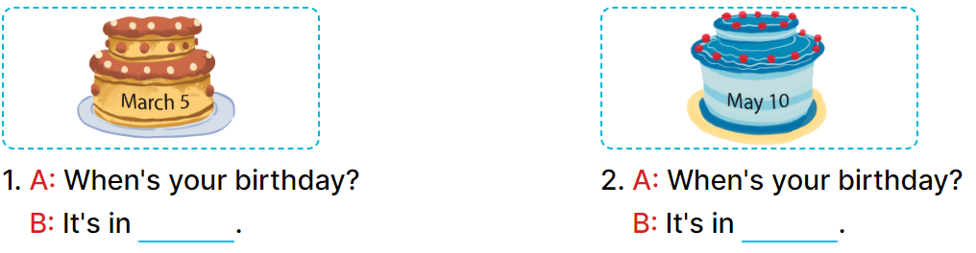  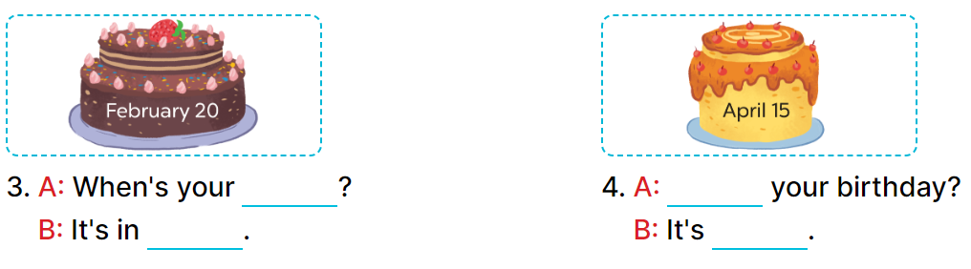  - Have Ss look at the four incomplete dialogues and elicits the missing words in the sentences.  - T models with picture 1  + Ask Ss what is missing in the sentence.  + Have Ss look at the picture and complete the gap, then read the completed sentence in chorus.  -Have Ss work in groups and complete the picture 2, 3 and 4.  - Ask a few Ss to stand up and read the completed sentences aloud.  -T gives feedbacks.  Key: 1. March 2. May  3. birthday; February  4. When’s; in April  Activity 3. Let’s sing.  *Aims: Ss will be able to sing the song When's your birthday? with the correct pronunciation, rhythm and melody.  *Procedure:  - Introduce the title and lyrics of the song: “ When's your birthday? ”  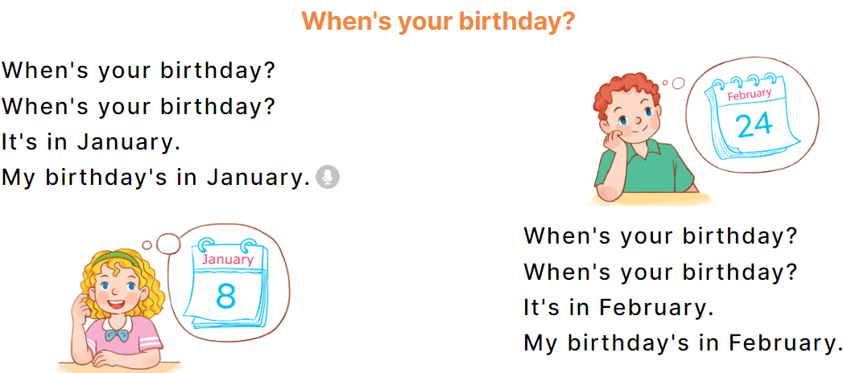  - Play the recording for Ss to listen to the whole song.  + Have them repeat the title and lyrics line by line.  + Tell Ss to point at the parts of their body while singing his or her name.  - Play the recording all the way through for Ss to listen to pronunciation and melody of the song.  - Play the recording line by line for Ss to listen, repeat and point to the part of their body  - Play the recording for Ss to sing and do actions.  - Ask Ss to practice singing and doing actions in pairs or groups.  - Invite groups to the front of the classroom to perform the song  -T gives feedback.  *Consolidation  *Aims: Ss will be able consolidate and wrap up the content of the lesson.  *Procedure:  - T asks ss to answer the following questions:  + What have you learnt from the lesson today?  +What are the core values of the lesson? (if the teacher can take from the lesson).  - T praises some Ss who are hardworking / active/ good…. as well as encourage others to try more.  - Practice part 5 again.  - Prepare the new lesson: Unit 4, Lesson 2 (1,2,3). | - Ss listen to the rule  - Ss play game  - Ss listen  - Ss open their books  -Look at the pictures and say:  + Picture a: a calendar showing February.  + Picture b: a calendar showing April.  + Picture c: a calendar showing January  + Picture d: a calendar showing March  -Ss guess the answers  - Ss listen to the tape and number  - Ss listen again, number and swap books with their partners.  -Ss listen again and check.  - Ss check their answers and guessing  -Ss listen and repeat.  -Ss look at the picture and say  -Ss look and answer  -Ss answer: It’s in March…………  -Ss look, complete and read the completed sentence in chorus.  -Ss complete the sentences  -Ss read aloud  - Ss look and listen.  -Ss listen to the song  - Ss listen and repeat line by line without the action.  -Ss point to the parts of their body while singing  -Ss listen to melody of the song  - Ss listen and sing line by line.  - Ss sing and do actions.  + Ss work in groups (two groups) to sing.  -Ss perform in front of the class.  -Ss listen  -Ss answer the questions  -Ss listen and clap their hands  -Ss listen and take note

D. ADJUSTMENTS (if necessary):

………………………………………………………………………………………….…..……………………………………………………………………………...…………………………

