Week 20 Preparing date: 18/01/2025
Period 78 Teaching date: 22/01/2025 -Class 5B

Unit 11: Family time
Lesson 3 (4, 5, 6)
A. OBJECTIVES:
By the end of the lesson, Ss will be able to:
1. Knowledge:
- read and understand a paragraph about a family trip in the past by answering four questions
- complete a paragraph about someone’s family’s weekend trip by writing the target words in the gaps
- make a photo journal by sticking some photos/ pictures of the activities he/ she did somewhere with friends the previous summer, and tell the class about it.
- Vocabulary: Review
- Skills: speaking, listening, reading and writing.
2. Competences:
- Communication and collaboration: work in pairs and groups to complete the learning tasks.
- Self-control and independent learning: perform reading and writing tasks.
3. Attitude/ Qualities:
- Show their love and interest in outdoor activities.
- Raise their awareness of doing outdoor activities carefully.
B. TEACHING AIDS:
- Teacher: Teacher’s guide Pages 190, 191, 192; website hoclieu.vn, posters, laptop, pictures, textbook, lesson plan, TV or projector.
- Students: Student’s book Page 11, notebooks, workbooks, school things.
C. PROCEDURES:
Stages/Time | Teacher’s activities | Students’ activities
1.Warm- up and review: (5’)  2.Practice: (8’)  3.Production(16’)  4. Fun corner and wrap- up (4’)  5.Homework  (2’) | Game: “Memory Chain”  *Aims: to create a friendly and active atmosphere in the class to beginning the lesson.  *Procedure:  -Tell ss they are going to remember the four questions in a chain.  - Divide the class into two groups. Each group has eight ss.  - Ask eight ss from each group to take turns playing the game.  - Have Student A say the first question, then have student B say the next question and so on. If a student forgets a sentence, the group must start from student A again.  - The winning group is the first one to have all members finish speaking. Praise the winner.  - Say “Open your book page 11” and look at “Unit 11, Lesson 3 (4,5,6)”.  Activity 1. Read and answer:  *Aims: Ss will be able to read and understand a paragraph about a family trip in the past by answering four questions.  *Procedure:  - Have ss read the questions carefully. Tell them to read Question 1 and pay attention to keywords such as Where, Linda’s family, go. and answer the question.  - Set a time limit for sls to do the rest of the task independently.  - Get ss to swap books with the partner and check the answers before checking as a class.  - Invite some pairs to take turns asking and answering the questions.  - Ask ss some more questions.  Ex:  When did Linda’s family go to Ha Long Bay? What did they do there on Sunday?  Did they explore the caves and eat seafood?  Key:  1. They went to Ha Long Bay.  2. They sunbathed, took some photos and swam in the sea.  3. They took a boat trip around the bay on Sunday.  4. They bought some souvenirs for their friends  Activity 2. Let’s write  *Aims: Ss will be able to complete a paragraph about someone’s family’s weekend trip by writing the target words in the gaps.  *Procedure:  - Ask ss to read the gapped sentences and fill in the gaps with information about someone’s family’s weekend trip.  - Ask Ss to read the first sentence, then elicit where they went the previous weekend (Ex: Sa Pa) and write the first sentence (Last weekend, my family went to Sa Pa.)  - Give Ss time to complete the rest of the paragraph independently.  - Get Ss to swap their books with a partner and check their spelling.  - Invite a student to read his / her completed paragraph aloud  - In groups, have ss share the activities that their family did last weekend.  - Ask Ss share with the class.  Key: Pupil’s answer  Ex: Last weekend, my family went to Sa Pa. On Saturday, we visited Sa Pa Town and went to see the mountains. We took lots of photos there. On Sunday, we went shopping in the town. My brother bought a shirt and I bought some souvenirs for my friends. Our trip was a lot of fun!  Activity 3. Project.  *Aims: Ss will be able to make a photo journal by sticking some photos/pictures of the activities he/ she did somewhere with friends the previous summer, and tell the class about it.  *Procedure:  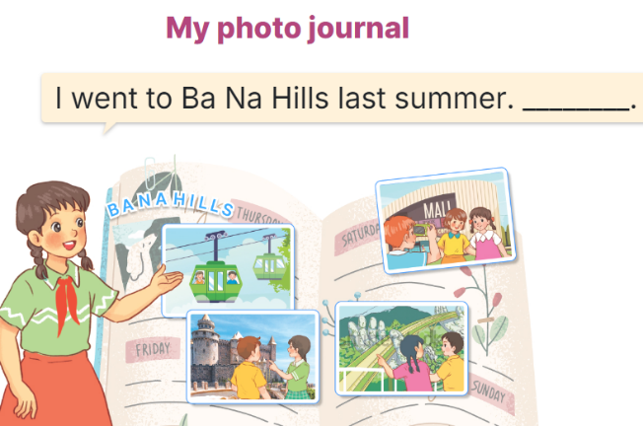  - Explain that each pupil has to show his/her photo journal which includes some photos/ pictures of friends and their activities (they have prepared at home) and tell the class about where they went and what they did there.  - Have Ss work in groups of five or six. Each student shows his / her photo journal to the group and describes what he/she and friends did somewhere last summer.  - Invite a few ss representing some groups to show their photo journals and tell the class about the activities of the friends in the photos/ pictures, Ex: I went to Ba Na Hills last summer with my friends. We took the cable car. We visited Golden Bridge…  - Have the rest of the class give comments and praise ss if they perform well.  Game: Serial reading  - Show the text on the board.  - Divide the class into groups of four.  - Have ss work in groups and read the text serially.  - Invite some ss to the front of the class and perform their work.  - Praise ss to encourage their performance.  - Learn by heart vocabulary, structure  - Do exercise Unit 11 part E in workbook  -Prepare Unit 12: Lesson 1 (1,2,3) | - Ss listen  - Ss listen to the rules  -Ss play game  Ex:  'When did you 'go to 'Sydney?  'What did he 'do in 'Paris?  'When did she 'go to 'England?  'What did they 'do in 'Thailand?  - Ss open their books  - Ss read the questions carefully. Ss read Question 1 and look at keywords and scan the text for relevant information.  - Ss do the task independently.  - Ss swap books and check the answers before checking as a class.  - Ss ask and answer the questions.  - Ss answer the questions.  - Ss read the gapped sentences and fill in the gaps.  - Ss do the first gapped sentence.  - Ss complete the paragraph independently.  - Ss swap their books and check their spelling.  - Ss read the paragraphs aloud  - Ss share the activities that their family did last weekend.  -Ss share with the class.  - Ss listen to the teacher’s explanation.  - Ss work in and describes what he/she and friends did somewhere last summer.  - Ss tell the class about the activities of the friends in the photos/ pictures.  - Ss congratulate  -Ss listen to the teacher  -Ss play the game  -Ss congratulate the winner
D. ADJUSTMENTS (if necessary):
………………………………………………………………………………………….…..……………………………………………………………………………...……

