Week 19 Preparing date: 11/01/2025
Period 76 Teaching date: 16/01/2025 – Class 5C

Unit 11: Family time
Lesson 2 (4, 5, 6)
A. OBJECTIVES:
By the end of the lesson, Ss will be able to:
1. Knowledge:
- listen to and understand two communicative contexts about where someone went and what someone did in the past and circle the correct options.
- complete two gaped exchanges with the help of picture cues.
- reinforce the use of target vocabulary for asking and answering questions about past activities and travel destinations by playing the When and What game.
- Vocabulary: Review
- Skills: speaking, listening, reading and writing.
2. Competences:
- Communication and collaboration: work in pairs and groups to complete the learning tasks.
3. Attitude/ Qualities:
- Show their love and interest in outdoor activities.
- Raise their awareness of doing outdoor activities carefully.
B. TEACHING AIDS:
- Teacher: Teacher’s guide Pages 181, 182 audio Tracks 7; website hoclieu.vn, posters, laptop, pictures, textbook, lesson plan, TV or projector.
- Students: Student’s book Page 9, notebooks, workbooks, school things.
C. PROCEDURES:
Stages/ Time | Teacher’s activities | Students’ activities
1.Warm- up and review: (4’)  2.Practice: (25’)  3. Fun corner and wrap- up (4’)  4.Homework (2’) | Play a game: Multiple choice (ppt)  *Aims: to revise the learnt words and structure  *Procedure:  - Place several flashcards (take a boat trip around the bay, eat seafood, see some interesting places, buy souvenirs) and the options on the board.  - Have ss take turns choosing the correct answer for each picture.  - If they choose the correct answers, they will get gifts from the teacher.  - Praise ss if they do the game well,  - Say “Open your book page 9” and look at “Unit 11, Lesson 2 (4,5,6)”.  Activity 1. Listen and circle:  *Aims: Ss will be able to listen to and understand two communicative contexts about where someone went and what someone did in the past and circle the correct options.  *Procedure:  - Draw ss’ attention to the conversations and the answer options.  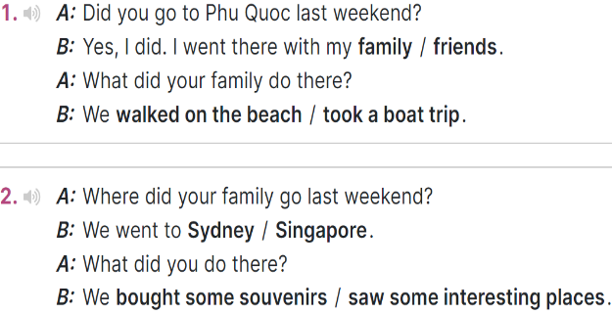  - T ask Ss to guess the answers.  + T writes Ss’guessing on the board.  - Listen to the tape:  + Play the recording  + Play the recording again and get Ss to swap books with their partners.  + Play the recording again to check answers together as a class.  + Write the answers on the board for Ss to correct their answers. Then checks Ss’ guessing.  - Play the recording, sentence by sentence, for the class to listen and repeat in chorus.  Key: 1. family; took a boat trip  2. Sydney; saw some interesting places  Activity 2. Read and complete  *Aims: Ss will be able to complete two gapped exchanges with the help of picture cues  *Procedure:  - Have ss look at the pictures and identify the places, the characters and the activities in the pictures.  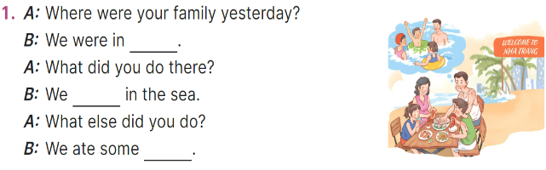  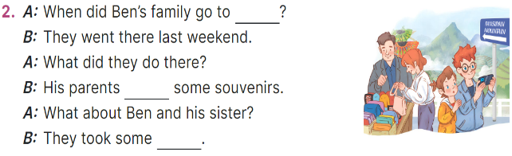  - Have Ss look at the 2 incomplete exchanges and elicits the missing words in the sentences.  - T models with the first gapped  + Ask Ss what is missing in the sentence (Nha Trang).  + Have Ss look at the picture and identify the needed information (We were in Nha Trang.).  - Have Ss work in pairs and complete  - Get Ss to swap books with a partner and check their answers before checking as a class.  Key: 1. a dolphin, Why  2. pizza, don’t, a sandwich  Activity 3. Let’s play.  *Aims: Ss will be able to reinforce the use of target vocabulary for asking and answering questions about past activities and travel destinations by playing the When and What game  *Procedure:  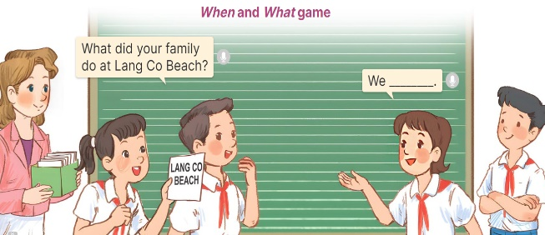  - Tell ss that they are going to play the When and What game and use the past tense form of irregular verbs such as take, eat, buy, swim and go.  - Divide ss into Team A and Team B and explain the rules  - Team A and Team B switch roles  - Set a time limit for ss to play the game. When the time is up, the team that has provided more correct answers is the winner.  - Invite a few groups to the front of the class to play the game.  Game: Pass the balls  - Give two different coloured balls to two pupils, a red ball (ask the question) and a yellow ball (answer the question).  - Ask ss to listen to music and pass the balls.  - Stop music suddenly.  - The teacher raises a picture. Have the student with a red ball make a question. Have the student with a yellow ball answer the question.  - Praise ss if they do the activity well.  - Learn by heart vocabulary, structure  - Do exercise Unit 11 part E in workbook  -Prepare Unit 11(cont.): Lesson 3 (1,2,3) | - Ss pay attention.  -Ss play the game  -Ss play the game  - Ss congratulate to the winner  - Ss open their books  - Look at the pictures and say  -Ss guess the answers  - Ss listen to the tape and match  - Ss listen again, match and swap books with their partners.  - Ss check their answers and guessing  - Ss answer and check  -Ss listen and repeat.  - students with disabilities only read vocabulary( Where, family, yesterday,we, sea,when,sister)  -Ss look at the picture and say  -Ss follow the teacher demonstrating the exchange 1.  -Ss read and answer  -Ss work in pairs and fill in the gaps  - Ss swap books and check  -Ss listen and pay attention  - Ss play the game  -Ss play the game  -Ss play the game  -Ss play the game  Ex:  A: What did your family do in Sydney?  Pupil B: We saw some interesting places.
D. ADJUSTMENTS (if necessary):
………………………………………………………………………………………….…..……………………………………………………………………………...……

