Week 24 Preparing date: 22/02/ 2025
Period 95 Teaching date: 26/02/2025 – Class 4A

Unit 14: Daily activities
Lesson 3 (1, 2, 3)
A. OBJECTIVES:
By the end of the lesson, Ss will be able to:
1. Knowledge:
- correctly repeat the sounds of the letters tch and sh in isolation, the words watch and wash and the sentences When do you watch TV? and I wash my clothes in the evening. with the correct pronunciation and intonation.
- identify the target words watch and wash while listening.
- say the chant with the correct rhythm and pronunciation.
- Vocabulary: Review
- Skills: speaking, listening, reading and writing.
2. Competences:
- Co-operation: ready to help friends in pair work/ group work.
- Self-control and independent learning: perform listening tasks.
3. Attitude/ Qualities:
- Kindness: Help partners to complete learning tasks.
- Honesty: tell the truth about feelings and emotions
B. TEACHING AIDS:
- Teacher: Teacher’s guide Pages 206, 207; audio Tracks 38, 39, 40; website hoclieu.vn, posters, laptop, pictures, textbook, lesson plan, TV or projector.
- Students: Pupil’s book Page 28, notebooks, workbooks, school things.
C. PROCEDURES:
Stages/Time | Teacher’s activities | Students’ activities
1.Warm- up:  (5’)  2. Presentation  (9’)  3.Practice: (19’)  4. Homework. (2’) | Game: Pass the bomb game (ppt)  *Aims: to create a friendly and active atmosphere in the class to beginning the lesson.  *Procedure:  - Teacher gives students an object to pass around.  - Whoever got the object when the bomb goes off will have to answer the question  - Say “Open your book page 28” and look at “Unit 14, Lesson 3 (1,2,3)”.  Activity 1. Listen and repeat:  *Aims: Ss will be able to correctly pronounce the sounds of the letters tch and sh in isolation, in the words watch and wash, and in the sentences When do you watch TV? and I wash my clothes in the evening with correct pronunciation and intonation.  *Procedure:  - T gives instruction to the letters tch and sh in isolation, in the words watch and wash, and in the sentencesWhen do you watch TV? and I wash my clothes in the evening.  - Play the recording for the letter tch, sh  - Encourage Ss to point at the letter/ word/ sentence while listening.  - Play the recording again and encourage Ss to listen and repeat.  - Do this several times until Ss feel confident.  - T calls some Ss to practice.  - T gives feedbacks.  Activity 2. Listen and circle.  *Aims: Ss will be able to identify the target words watch and wash while listening.  *Procedure:  - Elicit the sentences and explain that they have to listen.  - T ask Ss to guess the answers.  + T writes Ss’guessing on the board.  - Listen to the tape:  + Play the recording  + Play the recording again and get Ss to swap books with their partners.  + Play the recording again to check answers together as a class.  + Write the answers on the board for Ss to correct their answers. Then checks Ss’ guessing.  - Play the recording, sentence by sentence, for the class to listen and repeat in chorus.  - Invite one or two Ss to stand up and read the completed sentences.  Key: 1.c 2.b  Activity 3. Let’s chant  *Aims: Ss will be able to say the chant with the correct rhythm and pronunciation.  *Procedure:  - Introduce the title and lyrics of the chant.  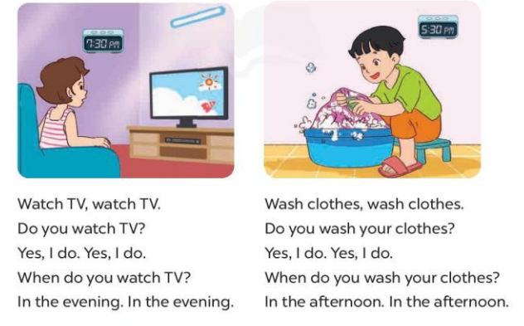  - Play the recording for Ss to listen to the whole chant.  + Have them repeat the title and lyrics line by line.  + Ask Ss to attend to the sounds of the letters tch and sh and the words watch and wash.  - Play the recording all the way through for Ss to listen to pronunciation and melody.  - Play the recording line by line for Ss to listen and repeat  - Play the recording for Ss to chant and clap along.  - Ask Ss to practice chant and clap along in pairs or groups.  - Invite groups to the front of the classroom to perform the chant  -T gives feedback.  *Consolidation  *Aims: Ss will be able consolidate and wrap up the content of the lesson.  *Procedure:  - T asks ss to answer the following questions:  + What have you learnt from the lesson today?  +What are the core values of the lesson? (if the teacher can take from the lesson).  - T praises some Ss who are hardworking / active/ good…. as well as encourage others to try more.  - Practice the chant more.  - Prepare the new lesson: Unit 14, Lesson 3 (4,5,6). | - Ss listen  -Ss play game  - Ss open their books  - Ss recognize the differences about color of letter  - - Ss listen  - Ss listen and point  - Ss listen again and repeat  -Ss listen again and repeat  -Ss practice  -Ss listen  -Ss listen and say  -Ss guess the answers  - Ss listen to the tape and circle  - Ss listen again, circle and swap books with their partners.  - Ss check their answers and guessing  -Ss write the answer  -Ss listen and repeat.  -Ss read the sentences  - Ss look and listen.  -Ss listen to the chant  - Ss listen and repeat line by line without clap their hands  -Ss note the sounds, words  -Ss listen to melody of the chant  - Ss listen and chant line by line.  - Ss chant and clap along.  - Ss work in groups (two groups) to chant  -Ss perform in front of the class.  -Ss listen  -Ss listen.  -Ss answer the questions  -Ss listen and clap their hands  -Ss listen and take note

D. ADJUSTMENTS (if necessary):
………………………………………………………………………………………….…..……………………………………………………………………………...………………………………………….…..……………………………………………………………………………….……………………………………………………………………...

