Week 24 Preparing date: 22/02/ 2025
Period 94 Teaching date: 24/02/2025 – Class 4A

Unit 14: Daily activities
Lesson 2 (4, 5, 6)
A. OBJECTIVES:
By the end of the lesson, Ss will be able to:
1. Knowledge:
- use the phrases wash the clothes, clean the ﬂoor, help with the cooking and wash the dishes in relation to the topic “Daily activities”
- listen to and demonstrate understanding of simple communicative contexts in relation to the topic “Daily activities”
- Vocabulary: Review
- Skills: speaking, listening, reading and writing.
2. Competences:
- Co-operation: ready to help friends in pair work/ group work.
- Self-control and independent learning: perform listening tasks.
3. Attitude/ Qualities:
- Kindness: Help partners to complete learning tasks.
- Diligence: complete learning tasks.
B. TEACHING AIDS:
- Teacher: Teacher’s guide Pages 203, 204; audio Tracks 37, website hoclieu.vn, posters, laptop, pictures, textbook, lesson plan, TV or projector.
- Students: Pupil’s book Page 27, notebooks, workbooks, school things.
C. PROCEDURES:
Stages/Time | Teacher’s activities | Students’ activities
1.Warm- up:  (5’)  2.Practice: (27’)  3. Homework. (3’) | “Listen and draw” (ppt)  *Aims: to create a friendly and active atmosphere in the class to beginning the lesson.  *Procedure:  - Teacher plays the audios, ss listen and draw pictures in their white board/ paper.  - Say “Open your book page 27” and look at “Unit 14, Lesson 2 (4,5,6)”.  Activity 1. Listen and number:  *Aims: Ss will be able to listen to and understand four exchanges about what activities characters do at a specific time of the day and number the correct pictures.  *Procedure:  - Elicit the activity that the girl is doing in each picture.  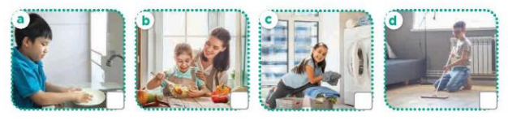  - T ask Ss to guess the answers.  + T writes Ss’guessing on the board.  - Listen to the tape:  + Play the recording  + Play the recording again and get Ss to swap books with their partners.  + Play the recording again to check answers together as a class.  + Write the answers on the board for Ss to correct their answers. Then checks Ss’ guessing.  - Play the recording, sentence by sentence, for the class to listen and repeat in chorus.  Key: 1.c 2. a 3. d 4. b  Activity 2. Look, complete and read.  *Aims: Ss will be able to complete two gapped exchanges with the help of picture cues and sentences  *Procedure:  - Elicit the missing words in the question and answer from the picture cue and sentence.  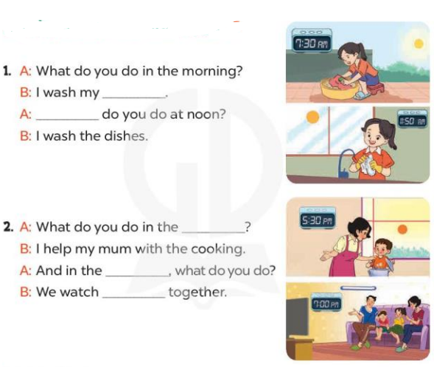  - T models with sentence 1.  + Have Ss look at the sentence.  + Ask them what is missing in the answer ( clothes).  + Have Ss complete the gap.  + Have Ss read the completed sentence in chorus.  -Have Ss work in pairs and complete the sentences 2.  - Invite pairs of pupils to stand up and read aloud the sentences.  -T gives feedbacks.  Key: 1. Clothes; What  2. afternoon; evening; TV  Activity 3. Let’s play- Miming game  *Aims: Ss will be able to review asking and answering questions about what activity someone does at a specific time of the day by playing Miming game.  *Procedure:  - Explain how the game is played.  + Write the question on the board What do you do in the ...?  +Ask one player from each team to come to the front of the class and whisper the answer to the question he / she wants to revise to the two players.  +They take turns miming the sentences they are told for their team to guess.  +The team gets one point if their guess is correct.  +The game continues until the time is up. + The team with the most points at the end of the game wins.  - Write all correct answers on the board, under the question What do you do in the …?  - When the game is over, get pairs of pupils to take turns asking and answering the question What do you do in the morning / afternoon / evening? using the answers on the board.  *Consolidation  *Aims: Ss will be able consolidate and wrap up the content of the lesson.  *Procedure:  - T asks ss to answer the following questions:  + What have you learnt from the lesson today?  +What are the core values of the lesson? (if the teacher can take from the lesson).  - T praises some Ss who are hardworking / active/ good…. as well as encourage others to try more.  - Prepare the new lesson: Unit 14, Lesson 3 (1,2,3). | - Ss listen and play the game  - Ss open their books  -Look at the pictures and say:  + Picture a. a boy washing dishes  + Picture b. a girl helping her mum with the cooking  + Picture c. a girl washing clothes  + Picture d. a boy cleaning the floor  -Ss guess the answers  - Ss listen to the tape and write number  - Ss listen again, write number and swap books with their partners.  - Ss check their answers and guessing  - Ss write the correct answer  -Ss listen and repeat.  -Ss look at the pictures and say  -Ss listen and answer  -Ss complete the gap  -Ss read and complete  -Ss work in pairs  -Ss read aloud the sentence  - Ss look and listen.  -Ss listen to the rule of the game  -Ss listen  -Ss play the game  -Ss ask and answer  -Ss answer the questions  -Ss listen and take note

D. ADJUSTMENTS (if necessary):
………………………………………………………………………………………….…..……………………………………………………………………………...………………………………………….…..……………………………………………………………………………….……………………………………………………………………...

