Week 23 Preparing date: 15 /02/ 2025
Period 92 Teaching date: 21 / 02 / 2025 – Class 3A

Unit 14: My bedroom
Lesson 1 (4, 5, 6)
A. OBJECTIVES:
By the end of the lesson, Ss will be able to:
1. Knowledge:
- listen to and understand two communicative contexts in which pupils describe things in the bedroom and tick the correct pictures.
- complete the four gapped sentence patterns with the help of picture cues.
- revise the target vocabulary items through the game Memory game.
- Vocabulary: Review
- Skills: speaking, listening, reading and writing.
2. Competences:
- Co-operation: ready to help friends in pair work/ group work.
- Self-control and independent learning: perform listening tasks.
3. Attitude/ Qualities:
- Kindness: Help partners to complete learning tasks.
- Honesty: tell the truth about feelings and emotions.
- Diligence: complete learning tasks.
B. TEACHING AIDS:
- Teacher: Teacher’s guide Pages 174; audio Tracks 34; website sachmem.vn, posters, laptop, pictures, textbook, lesson plan, TV or projector.
- Students: Pupil’s book Page 25, notebooks, workbooks, school things.
C. PROCEDURES:
Stages/Time | Teacher’s activities | Students’ activities
1.Warm- up:  (5’)  2.Practice: (27’)  3. Homework. (3’) | Sing a song: “If you happy and you know it”  *Aims: to create a friendly and active atmosphere in the class to beginning the lesson.  *Procedure:  - Show the song on the screen.  https://www.youtube.com/watch?v=zyMWcWqmhRc  - Ask pupils to listen, sing and dance the song.  - Say “Open your book page 25” and look at “Unit 14, Lesson 1 (4,5,6)”.  Activity 1. Listen and tick:  *Aims: Ss will be able to listen to and understand two communicative contexts in which pupils describe things in the bedroom and tick the correct pictures.  *Procedure:  - Elicit the name of the things in the room in each picture 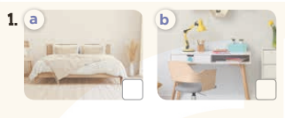  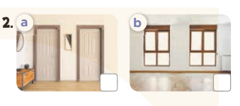  - T ask Ss to guess the answers.  + T writes Ss’guessing on the board.  - Listen to the tape:  + Play the recording  + Play the recording again and get Ss to swap books with their partners.  + Play the recording again to check answers together as a class.  + Write the answers on the board for Ss to correct their answers. Then checks Ss’ guessing.  - Play the recording, sentence by sentence, for the class to listen and repeat in chorus.  Key: 1.a 2.b  Activity 2. Look, complete and read.  *Aims: Ss will be able to complete the four gapped sentence patterns with the help of picture cues.  *Procedure:  - Have Ss look at the first picture and ask them some questions such as What’s this? and Where is it?  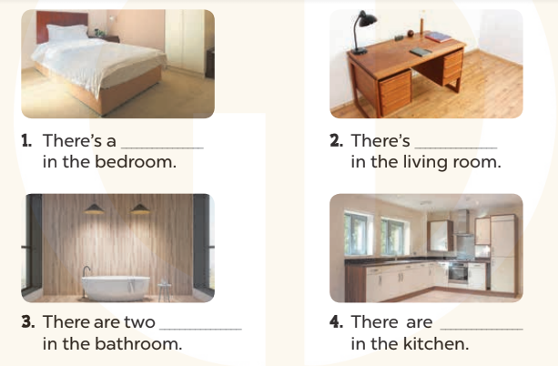  - Have Ss look at the four incomplete sentnces and elicits the missing words in the sentences.  - T models with sentence 1  + Ask Ss what is missing in the sentence.  + Have Ss look at the picture and complete the gap, then read the completed sentence in chorus.  -Have Ss work in groups and complete the sentences 2,3 and 4.  - Ask a few Ss to stand up and read the completed sentences aloud.  -T gives feedbacks.  Key:  1. bed 2. a desk  3. lamps 4. two windows  Activity 3. Let’s play  *Aims: Ss will be able to revise the target vocabulary items through the game Memory game.  *Procedure:  - Tell Ss that they are going to look at the cards for 60 seconds, memorise the words, then remember as many of the words as possible.  -Explain how the game is played.  - Put the cards on a desk or stick them on the board. Then cover them with a piece of cloth  - Divide the class into groups. Remove the cloth and show the cards for 60 seconds. Then cover them again.  - Have the groups say the names of the things aloud. For each correct word, give them a star or a point.  -The group with the most stars / points wins.  *Consolidation  *Aims: Ss will be able consolidate and wrap up the content of the lesson.  *Procedure:  - T asks ss to answer the following questions:  + What have you learnt from the lesson today?  +What are the core values of the lesson? (if the teacher can take from the lesson).  - T praises some Ss who are hardworking / active/ good…. as well as encourage others to try more.  - Prepare the new lesson: Unit 14, Lesson 2 (1,2,3). | - Sing and dance the song in chorus.  - Ss open their books  -Look at the pictures and say:  + Picture 1a: a bed in the bedroom  + Picture 1b: a desk in the bedroom  + Picture 2a: two doors in the bedroom  + Picture 2b: two windows in the bedroom  -Ss guess the answers  - Ss listen to the tape and circle  - Ss listen again, circle and swap books with their partners.  - Ss check their answers and guessing  -Ss listen and repeat.  -Ss look at the picture and answer  -Ss look and answer  -Ss answer: bed  -Ss look, complete and read the completed sentence in chorus.  -Ss complete the sentence  -Ss read aloud  - Ss look and listen.  - Ss listen  -Ss look and listen  -Ss play the game  -Ss answer the questions  -Ss listen and clap their hands  -Ss listen and take note

D. ADJUSTMENTS (if necessary):
………………………………………………………………………………………….…..……………………………………………………………………………...………………………………………….…..……………………………………………………………………………….……………………………………………………………………...

