Week 23 Preparing date:15/02/ 2025
Period 91 Teaching date: 19/02/2025 – Class : 4A

Unit 14: Daily activities
Lesson 1 (1, 2, 3)
A. OBJECTIVES:
By the end of the lesson, Ss will be able to:
1. Knowledge:
- use the phrases in the morning, at noon, in the afternoon, in the evening in relation to the topic “Daily activities”
- use When do you watch TV? – I watch TV ………. to ask and answer questions about when someone watches TV;
- Vocabulary: in the morning, in the afternoon, in the evening, at noon
- Model sentences:
A: When do you watch TV?
B: I watch TV in the evening.
- Skills: speaking and listening
2. Competences:
- Co-operation: ready to help friends in pair work/ group work.
- Sociability: Talk to each other, say good words to others.
3. Attitude/ Qualities:
- Kindness: Help partners to complete learning tasks.
- Honesty: tell the truth about feelings and emotions
B. TEACHING AIDS:
- Teacher: Teacher’s guide Pages 196,197, audio Tracks 31, 32, website hoclieu.vn, posters, laptop, pictures, textbook, lesson plan, TV or projector.
- Students: Pupil’s book Page 24, notebooks, workbooks, school things.
C. PROCEDURES:
Stages/Time | Teacher’s activities | Students’ activities
1.Warm- up:  (5’)  2. Presentation  (16’)  3.Practice: (7’)  4.Production: (5’)  5. Homework. (2’) | Game: Guessing game (PPT)  *Aims: to create a friendly and active atmosphere in the class to beginning the lesson.  *Procedure:  - Look at the picture and guess the answer for the question.  - Say “Open your book page 24” and look at “Unit 14, Lesson 1 (1,2,3)”.  Activity 1. Vocabulary.  *Aims: Ss will be able to know the vocabulary in the new lesson.  *Procedure:  -T elicits the new words  + in the morning : vào buổi sáng (explain)  + in the afternoon: vào buổi chiều (situation)  + in the evening: vào buổi tối (situation)  + at noon : vào buổi trưa (example)  - T models (3 times).  - T writes the words on the board.  - Checking: Rub out and remember  Activity 2. Look, listen and repeat:  *Aims: Ss will be able to understand and correctly repeat the sentences in two communicative contexts focusing on asking and answering questions about when someone watches TV.  *Procedure:  - Have Ss look at Pictures a and b and identify the time of the day in the pictures.  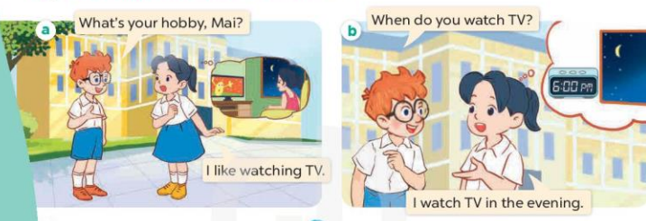  - Play the audio twice (sentence by sentence). Correct their pronunciation where necessary.  - Have Ss to practice the dialogue  - T invites a few pairs to the front of the class to practice.  - T checks pronunciation for ss.  Activity 3 Listen, point and say.  *Aims: Ss will be able to correctly say the phrases and use When do you watch TV? – I watch TV ……….to ask and answer questions about when someone watches TV.  *Procedure:  * Model sentences:  - T asks Ss look at picture b and helps Ss know the structure from the dialogue.  - T introduces new structure for Ss.  - T explains, models and gives meaning.  -Have Ss repeat the model sentences.  A: When do you watch TV?  B: I watch TV in the evening.  *Drill pictures  - Elicit the time of the day from pupils (looking at the clock and the sun in the pictures).  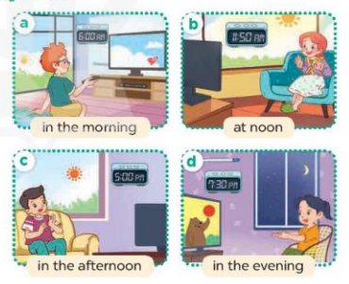  - Run through all the pictures.  - Run through model sentences.  - Have Ss to practise  - Ask Ss to work in pairs.  - T controls and corrects.  - Invite a few pairs to come to the front of the classroom, point at the relevant character in each picture, and act out his/her role.  - Encourage Ss to practise speaking English.  - T gives feedbacks.  Activity 4. Let’s talk.  *Aims: Ss will be able to enhance the correct use of When do you watch TV? – I watch TV ……..to ask and answer questions about when someone watches TV in a freer context.  *Procedure:  - Draw Ss’ attention to the clocks and the sun for the answers I watch TV in the morning / at noon / in the afternoon / in the evening.  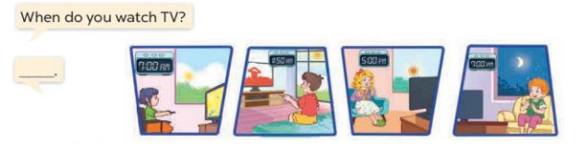  - Get pupils to repeat the questions and answers several times.  - Have Ss to work in pairs, point at the diﬀerent pictures in this section, ask and answer the question When do you watch TV?  - Invite some pairs to take turns asking and answering questions about when someone watches TV in front of the class.  *Consolidation  *Aims: Ss will be able consolidate and wrap up the content of the lesson.  *Procedure:  - T asks ss to answer the following questions:  + What have you learnt from the lesson today?  - T review the vocabulary and model sentences.  - T praises some Ss who are hardworking / active/ good…. as well as encourage others to try more  - Prepare the new lesson: Unit 14, Lesson 1 (4,5,6). | - Ss play the game  - Ss open their books  -Ss listen and answer  - - Ss listen and repeat  + Choral repetition (3 times).  + Individual repetition (3 ss)  - Ss take note  - Ss look, remember and write  -Look at the pictures and get to know the time of day in the pictures.  + Picture a:  Ben: What’s your hobby, Mai?  Mai: I like watch TV.  + Picture b:  Ben: When do you watch TV?  Mai: I watch TV in the evening.  -Ss listen and repeat in chorus (twice)  -Ss work in pairs to practice  -Ss practice the dialogue  -Ss listen  -Ss look at the picture and answer.  -Ss listen  -Ss listen and repeat  -Ss repeat  - Ss look, listen and answer  + Picture a. a boy watching TV in the morning  + Picture b. a girl watching TV at noon  + Picture c. a boy watching TV in the afternoon  + Picture d. a girl watching TV in the evening  -Ss practice in chorus  -Ss practice in chorus  -Ss work in pairs to practice  -Ss point and say, ask and answer  -Ss listen.  -Ss listen  -Ss look at the picture and answer  -Ss repeat the questions and answers  -Ss work in pairs, point and ask and answer  -Ss perform in front of the class.  -Ss answer the questions  - Ss listen  -Ss listen and clap their hands  -Ss listen and take note
D. ADJUSTMENTS (if necessary):
………………………………………………………………………………………….…..……………………………………………………………………………...………………………………………….…..…………………………………………………………

