Week 21 Preparing date: 01/02/ 2025
Period 81 Teaching date: 03/02/ 2025- Class 4A

Unit 12: Jobs
Lesson 2 (1, 2, 3)
A. OBJECTIVES:
By the end of the lesson, Ss will be able to:
1. Knowledge:
- Use the words actor, farmer, nurse, office worker, policeman, factory, farm, hospital, and nursing home in relation to the topic "Jobs";
- Use Where does he / she work? – He / She works …… to ask and answer questions about places of work.
- Vocabulary: farm, nursing home, gardener.
- Model sentences:
A: Where does he/ she work?
B: He/ She works at a nursing home.
- Skills: speaking and listening
2. Competences:
- Critical Thinking: talk about jobs
- Co-operation: ready to help friends in pair work/ group work.
- Oral Communication: speak about someone, ask and answer the questions
3. Attitude/ Qualities:
- Kindness: Help partners to complete learning tasks.
B. TEACHING AIDS:
- Teacher: Teacher’s guide Pages 174, 175; audio Tracks 15,16, website hoclieu.vn, posters, laptop, pictures, textbook, lesson plan, TV or projector.
- Students: Pupil’s book Page 14, notebooks, workbooks, school things.
C. PROCEDURES:
Stages/Time | Teacher’s activities | Students’ activities
1.Warm- up:  (3’)  2. Presentation  (16’)  3.Practice: (7’)  4.Production: (7’)  5. Homework. (2’) | Game: Pass the ball  *Aims: to create a friendly and active atmosphere in the class to beginning the lesson.  *Procedure:  - T gives Ss a ball.  - T asks Ss to listen to music and transfer a ball around the class.  - When the music stops, Ss who keep a ball have to practice with partner using: What does he/ she do? and He’s/ She’s……..  - T gives feedback.  - Say “Open your book page 8” and look at “Unit 12, Lesson 2 (1,2,3)”.  Activity 1. Vocabulary.  *Aims: Ss will be able to know the vocabulary in front of starting the new lesson.  *Procedure:  -T elicits the new words  + nursing home : viện dưỡng lão (picture)  + farm : nông trại (situation)  + gardener : nười làm vườn (situation)  - T models (3 times).  - T writes the words on the board.  - Checking: Rub out and remember  Activity 2. Look, listen and repeat:  *Aims: Ss will be able to understand and correctly repeat the sentences in two communicative contexts in which pupils ask and answer questions about the place of work of a family member.  *Procedure:  - Have Ss look at Pictures a and b and identify the characters and jobs in the pictures.  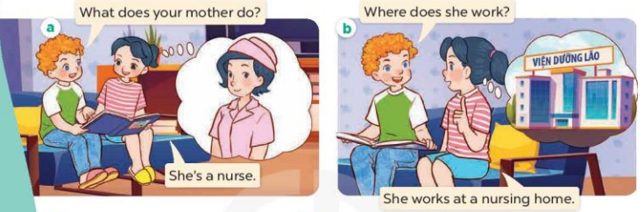  - Play the audio twice (sentence by sentence). Correct their pronunciation where necessary.  - Have Ss to practice the diaguage  - T invites a few pairs to the front of the class to practice.  - T checks pronunciation for ss.  Activity 3. Listen, point and say.  *Aims: Ss will be able to correctly say the phrases and use Where does he / she work? – He / She works ……. to ask and answer questions about places of work.  *Procedure:  * Model sentences:  - T asks Ss look at picture b and helps Ss know the structure from the dialogue.  - T introduces new structure for Ss.  - T explains, models and gives meaning.  - Have Ss repeat the model sentences.  A: Where does he/ she work?  B: He/ She works at a nursing home.  *Drill pictures  - Elicit and check comprehension the name of each character.  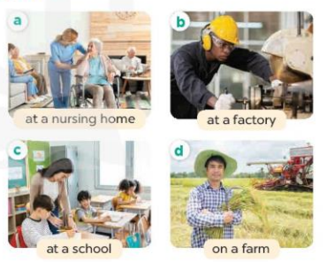  - Run through all the pictures.  - Run through model sentences.  +Run through the question sentences  +Run through the answer sentences  - Have Ss to practise:  + T asks, Ss answer picture a  + Ss ask, T answers picture b  + Group A ask, group B answer picture c  + Group B ask, group A answer picture d  - Ask Ss to work in pairs.  - T controls and corrects.  - Invite a few pairs to come to the front of the classroom, point at the relevant character in each picture, and act out his/her role.  - T gives feedbacks.  Activity 4. Let’s talk.  *Aims: Ss will be able to enhance the correct use of Where does he / she work?  – He / She works ………. to ask and answer questions about someone’s job in a freer context.  *Procedure:  - Have Ss look at the pictures and elicit the jobs  + What can you see in the picture?  +Who are they?  +What does he/she do?    - T fills the gaps and writes the sentences on the board.  - T models  - T asks Ss use of Where does he/ she work? to ask and answer (pairs)  - Invite some groups to perform.  - Give feedbacks  *Consolidation  *Aims: Ss will be able consolidate and wrap up the content of the lesson.  *Procedure:  - T asks ss to answer the following questions:  + What have you learnt from the lesson today?  - T review the vocabulary and model sentences.  - Learn the vocabulary by heart  - Prepare the new lesson: Unit 12, Lesson 2 (4,5,6). | - Ss listen and keep the ball  - Ss listen to music and play the game  - Ss open their books  -Ss listen and answer  - - Ss listen and repeat  +Choral repetition(3 times).  +Individual repetition (3 ss)  - Ss take note  - Ss look, remember and write  -Look at the pictures and get to know the characters in the pictures.  + In picture a:  Bill: What does your mother do? Mai: She’s a nurse  – In picture b:  Bill: Where does she work?  Mai: She works at a nursing home.  -Ss listen and repeat in chorus (twice)  -Ss work in pairs to practice  -Ss practice the diaguage  -Ss listen  -Ss look at the picture and answer.  -Ss listen  -Ss listen and repeat  -Ss repeat  - Ss look, listen and answer  + Picture a. A woman working at a nursing home  + Picture b. A man working at a factory  + Picture c. A woman teaching at a school  + Picture d. A man working on a farm  -Ss practice in chorus  - Ss practice in chorus  - Ss practice in chorus  -Ss work in pairs to practice  -Ss listen  -Ss go to the board and role play.  -Ss listen  -Ss look at the picture and answer  + a woman working at a nursing home, a man teaching in a classroom, a woman working at a factory, a man working on a farm  -Ss note  - Ss say the completed sentences.  -Ss work in pairs, ask and answer  -Ss perform in front of the class.  -Ss answer the questions  -Ss listen and clap their hands  -Ss listen and take note

D. ADJUSTMENTS (if necessary):
………………………………………………………………………………………….…..……………………………………………………………………………...………………………………………….…..……………………………………………………………………………….……………………………………………………………………...

