Week 20 Preparing date: 18/01/2025
Period 79 Teaching date: 22/01/ 2025 – Class 4A

Unit 12: Jobs
Lesson 1 (1, 2, 3)
A. OBJECTIVES:
By the end of the lesson, Ss will be able to:
1. Knowledge:
- understand and correctly repeat the sentences in two communicative contexts (pictures) to ask and answer questions about jobs
- Use What does he / she do? – He’s / She’s ….. to ask and answer questions about jobs.
- Vocabulary: actor, policeman, office worker
- Model sentences:
A: What’s does he/ she do?
B: He’s / She’s a policeman
- Skills: speaking and listening
2. Competences:
- Critical Thinking: talk about jobs
- Co-operation: ready to help friends in pair work/ group work.
Oral Communication: speak about jobs, ask and answer the questions.
3. Attitude/ Qualities:
- Kindness: Help partners to complete learning tasks.
- Honesty: tell the truth about feelings and emotions
B. TEACHING AIDS:
- Teacher: Teacher’s guide Pages 170, 171, audio Tracks 11, 12, website hoclieu.vn, posters, laptop, pictures, textbook, lesson plan, TV or projector.
- Students: Pupil’s book Page 12, notebooks, workbooks, school things.
C. PROCEDURES:
Stages/Time | Teacher’s activities | Students’ activities
1.Warm- up:  (5’)  2. Presentation  (16’)  3.Practice: (7’)  4.Production: (5’)  5. Homework. (2’) | Game: jigsaw puzzle  *Aims: to create a friendly and active atmosphere in the class to beginning the lesson.  *Procedure:  - Divide class into 4 groups: Doreamon, Nobita, Xuka and Xeko.  - Ask Ss look at the pieces of picture.  - Ask Ss go to the board and jigsaw puzzle into the correct picture    -T checks who’s the winner?  - Ask Ss look at the pieces of picture  - Say “Open your book page 12” and look at “Unit 12, Lesson 1 (1,2,3)”.  Activity 1. Vocabulary.  *Aims: Ss will be able to know the vocabulary in the new lesson.  *Procedure:  -T elicits the new words  + actor : diễn viên (nam)  (picture)  + policeman : cảnh sát (nam)  (picture)  + office worker : nhân viên văn phòng (picture)  - T models (3 times).  - T writes the words on the board.  - Checking: Rub out and remember  Activity 2. Look, listen and repeat:  *Aims: Ss will be able to understand and correctly repeat the sentences in two communicative contexts (pictures) to ask and answer questions about the job of a family member.  *Procedure:  - Have Ss look at Pictures a and b and identify the characters in the pictures.  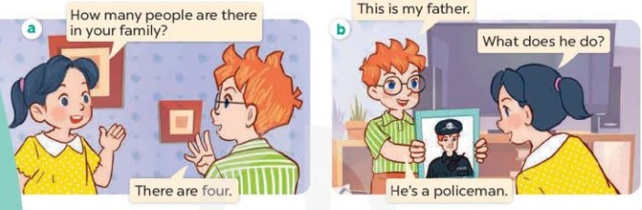  - Play the audio twice (sentence by sentence). Correct their pronunciation where necessary.  - Have Ss to practice the dialogue  - T invites a few pairs to the front of the class to practice.  - T checks pronunciation for ss.  Activity 3 Listen, point and say.  *Aims: Ss will be able to correctly say the words and use What does he/she do? – He’s / She’s …….. to ask and answer questions about someone’s job.  *Procedure:  * Model sentences:  - T asks Ss look at picture b and helps Ss know the structure from the dialogue.  - T introduces new structure for Ss.  - T explains, models and gives meaning.  - Have Ss repeat the model sentences.  A: What’s does he/ she do?  B: He’s / She’s a policeman  *Drill pictures  - Elicit and check comprehension the name of each character.  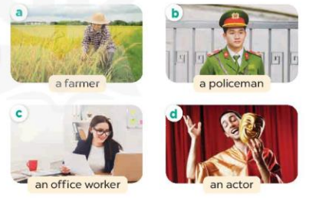  - Run through all the pictures.  - Run through model sentences.  + Run through the questions.  + Run through the answers  - Have Ss to practise:  + T says asks and Ss answer (change role).  + Ss – Ss (change role).  - Ask Ss to work in pairs.  - T controls and corrects.  - Invite a few pairs to come to the front of the classroom, point at the relevant character in each picture, and act out his/her role.  - Encourage Ss to practise speaking English.  - T gives feedbacks.  Activity 4. Let’s talk.  *Aims: Ss will be able to enhance the correct use of What does he/ she do? – He’s / She’s …….. to ask and answer questions about someone's job in a freer context.  *Procedure:  - Hold up the flash cards for policeman, farmer, office worker, teacher, actor to elicit the question and answer about his or her job.    - Have Ss look at the picture.  - Point at the adults in the picture and elicit the character and the questions What does he/ she do?  - Give Ss time to practise in pairs to ask and answer What does he/ she do? He’s / She’s …….  - Invite some pairs to the front of the class to perform their conversations.  *Consolidation  *Aims: Ss will be able consolidate and wrap up the content of the lesson.  *Procedure:  - T asks ss to answer the following questions:  + What have you learnt from the lesson today?  - T review the vocabulary and model sentences.  - T praises some Ss who are hardworking / active/ good…. as well as encourage others to try more.  - Learn the vocabulary by heart  - Prepare the new lesson: Unit 12, Lesson 1 (4,5,6). | - Ss listen  - Ss play the game  - Ss open their books  -Ss listen and answer  - - Ss listen and repeat  + Choral repetition (3 times).  + Individual repetition (3 ss)  - Ss take note  - Ss look, remember and write  -Look at the pictures and get to know the characters in the pictures.  + Picture a:  Mai: How many people are there in your family?  Ben: There are four.  + Picture b:  Ben: This is my father.  Mai: What does he do?  Ben: He’s a policeman.  -Ss listen and repeat in chorus (twice)  -Ss work in pairs to practice  -Ss practice the dialogue  -Ss listen  -Ss look at the picture and answer.  -Ss listen  -Ss listen and repeat  -Ss repeat  - Ss look, listen and answer  + Picture a. A woman working on a farm + Picture b. A policeman  + Picture c. A woman working in an office  + Picture d. A man acting in a film  -Ss practice in chorus  -Ss practice in chorus and groups  -Ss practice in chorus and groups  -Ss work in pairs to practice  -Ss listen  -Ss point and say  -Ss listen.  -Ss listen  -Ss listen and answer  -Ss look at the picture  - Ss listen and asnwer  -Ss work in pairs, ask and answer  -Ss perform in front of the class.  -Ss answer the questions  - Ss listen  -Ss listen and clap their hands  -Ss listen and take note

D. ADJUSTMENTS (if necessary):
………………………………………………………………………………………….…..……………………………………………………………………………...………………………………………….…..……………………………………………………………………………….……………………………………………………………………...

