Week 19 Preparing date: 11/01/2025
Period 74 Teaching date: 13/01/2025 – Class 4A

Unit 11: My home
Lesson 1 (4, 5, 6)
A. OBJECTIVES:
By the end of the lesson, Ss will be able to:
1. Knowledge:
- Identity specific information by listening to conversation related to topic my home.
- Fill in the gaps using given picture cues.
- Recall some vocabulary related to the topic “my home” by playing the whispering game.
- Vocabulary: Review
- Skills: speaking, listening, reading and writing.
2. Competences:
- Co-operation: ready to help friends in pair work/ group work.
- Self-control and independent learning: perform listening tasks.
3. Attitude/ Qualities:
- Kindness: Help partners to complete learning tasks.
- Honesty: tell the truth about feelings and emotions.
- Diligence: complete learning tasks.
B. TEACHING AIDS:
- Teacher: Teacher’s guide Pages 160, 161, 162; audio Tracks 3; website hoclieu.vn, posters, laptop, pictures, textbook, lesson plan, TV or projector.
- Students: Pupil’s book Page 7, notebooks, workbooks, school things.
C. PROCEDURES:
Stages/Time | Teacher’s activities | Students’ activities
1.Warm- up:  (5’)  2.Practice: (27’)  3. Homework. (3’) | Game: “Passing the picture”  *Aims: to create a friendly and active atmosphere in the class to beginning the lesson.  *Procedure:  - T gives Ss a picture about some places  - T asks Ss to listen to music and transfer a puppet around the class.  - When the music stops, Ss who keep a picture have to practice with partner using: I live………..  - T gives feedback.  - Say “Open your book page 7” and look at “Unit 11, Lesson 1 (4,5,6)”.  Activity 1. Listen and tick or cross:  *Aims: Ss will be able to listen to and understand four communicative contexts in which the characters talk about where they live and tick or cross the correct pictures.  *Procedure:  - Elicit the names of the streets or roads, and the house numbers 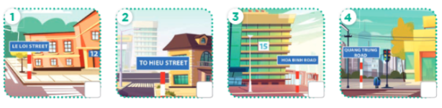  - T ask Ss to guess the answers.  + T writes pupils’guessing on the board.  - Listen to the tape:  + Play the recording  + Play the recording again and get pupils to swap books with their partners.  + Play the recording again to check answers together as a class.  + Write the answers on the board for Ss to correct their answers. Then checks Ss’ guessing.  - Play the recording, sentence by sentence, for the class to listen and repeat in chorus.  Key: 1.v 2.x 3.x 4.v  Activity 2. Look, complete and read.  *Aims: Ss will be able to complete four gapped exchanges with the help of picture cues.  *Procedure:  - Have Ss read the exchange and guess the missing word in the answer.  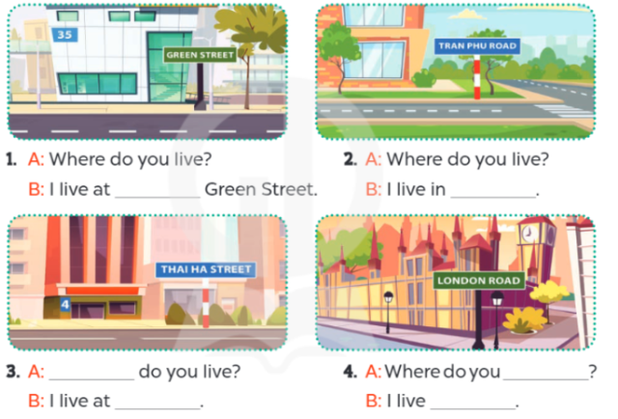  - Have Ss look at the four incomplete sentences and elicits the missing words in the sentences.  - T models with sentence 1  + Ask Ss what is missing in the sentence.  + Have Ss look at the picture and complete the gap, then read the completed sentence in chorus.  -Have Ss work in groups and complete the sentences 2,3 and 4.  - Ask a few Ss to stand up and read the completed sentences aloud.  -T gives feedbacks.  Key:  1. 35  2. Tran Phu Road  3. Where; 4 Thai Ha Street.  4. live; in London Road  Activity 3. Let’s play.  *Aims: Ss will be able to practise the target vocabulary and sentence patterns by playing the game Whispering.  *Procedure:  - Invite two or three teams of four pupils to the front. Each team makes a line.  - Show a sentence to the last pupil of each team.  + Ask them to whisper the sentence to the next pupil.  + The pupil continues whispering until the one at the front of the line gets the sentence.  + The pupil at the front of the line shouts out the sentence or writes the sentence on the board.  + If it is correct, the team gets one star.  - Play the game with other teams in the class.  *Consolidation  *Aims: Ss will be able consolidate and wrap up the content of the lesson.  *Procedure:  - T asks ss to answer the following questions:  + What have you learnt from the lesson today?  +What are the core values of the lesson? (if the teacher can take from the lesson).  - T praises some Ss who are hardworking / active/ good…. as well as encourage others to try more.  - Learn the vocabulary by heart  - Prepare the new lesson: Unit 11, Lesson 2 (1,2,3). | - Ss listen and keep the picture  - Ss listen to music and play the game  -Ss listen  - Ss open their books  -Look at the pictures and say:  + Picture 1. A house at 12 Le Loi Street + Picture 2. A house in To Hieu Street  + Picture 3. A house at 15 Hoa Binh Road  + Picture 4. A house in Quang Trung Road  -Ss guess the answers  - Ss listen to the tape and tick/ cross  - Ss listen again, tick/ cross and swap books with their partners.  - Ss check their answers and guessing  -Ss write the answer  -Ss listen and repeat.  -Ss look at the picture and say  -Ss look and answer  -Ss answer: thirty-five  -Ss say the missing word  -Ss look, complete and read the completed sentence in chorus.  -Ss complete the sentences  -Ss read aloud  -Ss listen  -Ss listen  -Ss play the game  -Ss play the game  -Ss answer the questions  -Ss listen and clap their hands  -Ss listen and take note
D. ADJUSTMENTS (if necessary):
………………………………………………………………………………………….…..……………………………………………………………………………...………………………………………….…..…………………………………………………………

