Week 24 Preparing date: 22 /02 /2025
Period 93 Teaching date: : 24 /02 / 2025 – Class 3A

Unit 14: My bedroom
Lesson 2 (1, 2, 3)
A. OBJECTIVES:
By the end of the lesson, Ss will be able to:
1. Knowledge:
- understand and correctly repeat the sentences in two communicative contexts (pictures) to describe things in the room.
- correctly say the words and use The …….. is ……. / The …… are …….. to describe things in the room.
- enhance the correct use of The ……..is ……….. / The ……..are ……….to describe things in the room in a freer context.
- Vocabulary: big, small, old, new
- Model sentences:
The door is big.
The chairs are new.
- Skills: speaking and listening
2. Competences:
- Co-operation: ready to help friends in pair work/ group work.
- Oral Communication: speak about someone, ask and answer the questions
3. Attitude/ Qualities:
- Kindness: Help partners to complete learning tasks.
- Honesty: tell the truth about feelings and emotions
B. TEACHING AIDS:
- Teacher: Teacher’s guide Pages 176, 177; audio Tracks 35,36, website sachmem.vn, posters, laptop, pictures, textbook, lesson plan, TV or projector.
- Students: Pupil’s book Page 26, notebooks, workbooks, school things.
C. PROCEDURES:
Stages/Time | Teacher’s activities | Students’ activities
1.Warm- up:  (3’)  2. Presentation  (16’)  3.Practice: (7’)  4.Production: (7’)  5. Homework. (2’) | Game: Who says fast?  *Aims: to create a friendly and active atmosphere in the class to beginning the lesson.  *Procedure:  - T holds a school thing card and a sentence with a missing word.  - Ask Ss to guess the answer as fast as possible.  - Then have Ss do the same with the rest.  - This can be played in groups to make it more interesting.  - Say “Open your book page 26” and look at “Unit 14, Lesson 2 (1,2,3)”.  Activity 1. Vocabulary.  *Aims: Ss will be able to know the vocabulary in front of starting the new lesson.  *Procedure:  -T elicits the new words  + big : to, lớn (picture)  + small : nhỏ, bé (picture)  + new : mới (picture)  + old : cũ (picture)  - T models (3 times).  - T writes the words on the board.  - Checking: Rub out and remember  Activity 2. Listen, point and repeat:  *Aims: Ss will be able to understand and correctly repeat the sentences in two communicative contexts (pictures) to describe things in the room.  *Procedure:  - Have Ss look at Pictures a and b and identify the characters in the pictures.  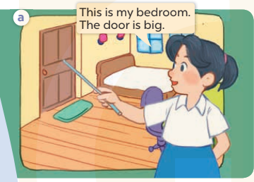  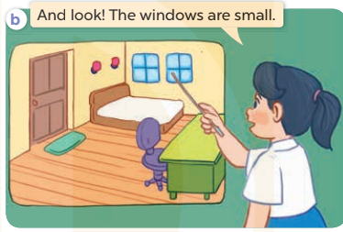  - Play the audio twice (sentence by sentence). Correct their pronunciation where necessary.  - Have Ss to practice the diaguage  - T invites a few pairs to the front of the class to practice.  - T checks pronunciation for ss.  Activity 3. Listen, point and say.  *Aims: Ss will be able to correctly say the words and use The …. is …... / The …….are ……. to describe things in the room.  *Procedure:  * Model sentences:  - T asks Ss look at picture a, b and helps Ss know the structure from the dialogue.  - T introduces new structure for Ss.  - T explains, models and gives meaning.  - Have Ss repeat the model sentences.  The door is big.  The chairs are new.  *Drill pictures  - Have Ss look at the pictures and elicit the things in the room.  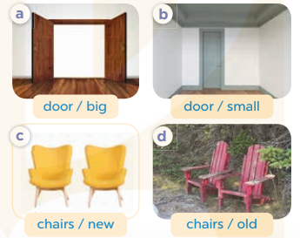  - Run through all the pictures.  - Run through model sentences.  - Have Ss to practise:  - Ask Ss to work in pairs.  - T controls and corrects.  - Invite a few pairs to come to the front of the classroom, point at the relevant character in each picture, and act out his/her role.  - T gives feedbacks.  Activity 4. Let’s talk.  *Aims: Ss will be able to enhance the correct use of The …… is ……. / The……. are ……..to describe things in the room in a freer context.  *Procedure:  - Have Ss look at the things in a bedroom and say their names. 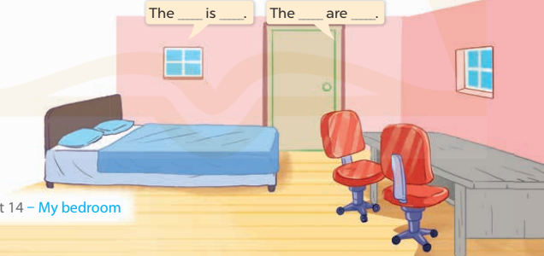  + What can you see in the picture?  +What are they?  - T fills the gaps and writes the sentences on the board.  - T models  - T asks Ss use of The bed is new. The chair are new. to introduce the things in the room.  - Invite some groups to perform.  - Give feedbacks  *Consolidation  *Aims: Ss will be able consolidate and wrap up the content of the lesson.  *Procedure:  - T asks ss to answer the following questions:  + What have you learnt from the lesson today?  +What are the core values of the lesson? (if the teacher can take from the lesson).  - T review the vocabulary and model sentences.  - T praises some Ss who are hardworking / active/ good…. as well as encourage others to try more.  - Learn the number by heart  - Prepare the new lesson: Unit 14, Lesson 2 (4,5,6). | - Ss listen  - Ss play the game  - Ss open their books  -Ss listen and answer  - - Ss listen and repeat  + Choral repetition (3 times).  + Individual repetition (3 ss)  - Ss take note  - Ss look, remember and write  -Look at the pictures and get to know the characters in the pictures.  + In picture a: Mai says This is my bedroom. The door is big.  – In picture b: Mai says And look! The windows are small.  -Ss listen and repeat in chorus (twice)  -Ss work in pairs to practice  -Ss practice the diaguage  -Ss listen  -Ss look at the picture and answer.  -Ss listen  -Ss listen and repeat  -Ss repeat  - Ss look, listen and answer  + Picture a: a big door  + Picture b: a small door  + Picture c: two new chairs + Picture d: two old chairs  -Ss practice in chorus  - Ss practice in chorus  -Ss work in pairs to practice  -Ss listen  -Ss point and sa  -Ss go to the board and role play.  -Ss listen  -Ss look at the picture and answer  + A bedroom with a bed, a desk, a door, two chairs and two windows  -Ss note  - Ss say the completed sentences.  -Ss work in groups  -Ss perform in front of the class.  -Ss answer the questions  - Ss listen  -Ss listen and clap their hands  -Ss listen and take note

D. ADJUSTMENTS (if necessary):
………………………………………………………………………………………….…..……………………………………………………………………………...………………………………………….…..……………………………………………………………………………….……………………………………………………………………...

