Week 23 Preparing date: 15 /02/ 2025
Period 91 Teaching date: 21 / 02 / 2025 – Class 3A

Unit 14: My bedroom
Lesson 1 (1, 2, 3)
A. OBJECTIVES:
By the end of the lesson, Ss will be able to:
1. Knowledge:
– understand and correctly repeat the sentences in two communicative contexts (pictures) focusing on quantities of things in a room
- correctly say the words and use There’s / There are……… in the room. to talk about quantities of things in a room;
-enhance the correct use of There’s / There are…….. in the room. to talk about quantities of things in a room in a freer context.
- Vocabulary: desk, bed, door, window
- Model sentences:
There’s a desk in the room.
There are two doors in the room.
- Skills: speaking and listening
2. Competences:
- Critical Thinking: talk about things in bedroom.
- Co-operation: ready to help friends in pair work/ group work.
- Sociability: Talk to each other, say good words to others.
3. Attitude/ Qualities:
- Kindness: Help partners to complete learning tasks.
- Honesty: tell the truth about feelings and emotions
B. TEACHING AIDS:
- Teacher: Teacher’s guide Pages 172, 173, audio Tracks 32, 33, website sachmem.vn, posters, laptop, pictures, textbook, lesson plan, TV or projector.
- Students: Pupil’s book Page 24, notebooks, workbooks, school things.
C. PROCEDURES:
Stages/Time | Teacher’s activities | Students’ activities
1.Warm- up:  (3’)  2. Presentation  (16’)  3.Practice: (7’)  4.Production: (7’)  5. Homework. (2’) | Game: jigsaw puzzle  *Aims: to create a friendly and active atmosphere in the class to beginning the lesson.  *Procedure:  - Divide class into 4 groups: Doreamon, Nobita, Xuka and Xeko.  - Ask Ss look at the pieces of picture.  - Ask Ss go to the board and jigsaw puzzle into the correct picture    -T checks who’s the winner?  - Ask Ss look at the pieces of picture  - Say “Open your book page 24” and look at “Unit 14, Lesson 1 (1,2,3)”.  Activity 1. Vocabulary.  *Aims: Ss will be able to know the vocabulary in front of starting the new lesson.  *Procedure:  -T elicits the new words  + desk : cái bàn học sinh  (realia)  + bed : cái giường (picture)  + door : cửa ra vào (realia)  + window : cửa sổ (realia)  - T models (3 times).  - T writes the words on the board.  - Checking: Rub out and remember  Activity 2. Listen, point and repeat:  *Aims: Ss will be able to understand and correctly repeat the sentences in two communicative contexts (pictures) focusing on quantities of things in a room.  *Procedure:  - Have Ss look at Pictures a and b and identify the characters in the pictures.  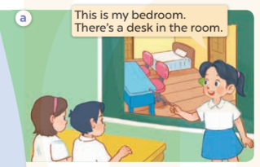  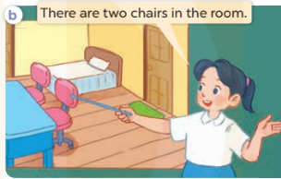  - Play the audio twice (sentence by sentence). Correct their pronunciation where necessary.  - Have Ss to practice the dialogue  - T invites a few pairs to the front of the class to practice.  - T checks pronunciation for ss.  Activity 3 Listen, point and say.  *Aims: Ss will be able to correctly say the words and use There’s / There are ……. in the room. to talk about quantities of things in a room.  *Procedure:  * Model sentences:  - T asks Ss look at picture a , b and helps Ss know the structure from the dialogue.  - T introduces new structure for Ss.  - T explains, models and gives meaning.  -Have Ss repeat the model sentences.  There’s a desk in the room.  There are two doors in the room  *Drill pictures  - Elicit and check comprehension the name of the thing in the room.  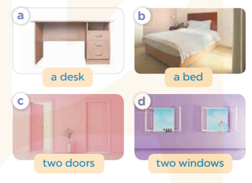  - Run through all the pictures.  - Run through model sentences.  - Have Ss to practise  - Ask Ss to work in pairs.  - T controls and corrects.  - Invite a few pairs to come to the front of the classroom, point at the relevant character in each picture, and act out his/her role.  - Encourage Ss to practise speaking English.  - T gives feedbacks.  Activity 4. Let’s talk.  *Aims: Ss will be able to enhance the correct use of There’s / There are ……… in the room. to talk about quantities of things in a room in a freer context.  *Procedure:  - T asks ss to look at the things in the bedroom and elicit their names  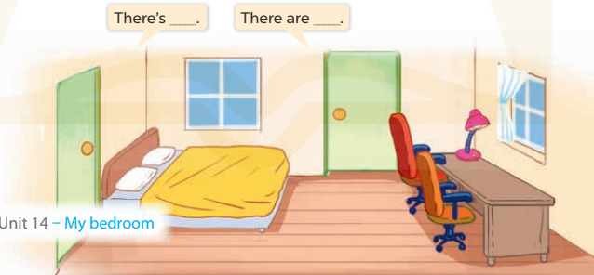  + What can you see in the picture?  - T fills the gaps and writes the sentences on the board.  - T models  - T asks Ss to work in pairs to ask and answer  - Invite some pupils to the front of the class to present their exchanges.  - Give feedbacks  *Consolidation  *Aims: Ss will be able consolidate and wrap up the content of the lesson.  *Procedure:  - T asks ss to answer the following questions:  + What have you learnt from the lesson today?  - T review the vocabulary and model sentences.  - T praises some Ss who are hardworking / active/ good…. as well as encourage others to try more.  - Learn the number by heart  - Prepare the new lesson: Unit 14, Lesson 1 (4,5,6). | - Ss listen  - Ss play the game  - Ss open their books  -Ss listen and answer  - - Ss listen and repeat  + Choral repetition (3 times).  + Individual repetition (3 ss)  - Ss take note  - Ss look, remember and write  -Look at the pictures and get to know the characters in the pictures.  + Mai says This is my bedroom. There’s a desk in the room. in picture a.  + Mai says There are two chairs in the room. in picture b.  -Ss listen and repeat in chorus (twice)  -Ss work in pairs to practice  -Ss practice the dialogue  -Ss listen  -Ss look at the picture and answer.  -Ss listen  -Ss listen and repeat  -Ss repeat  - Ss look, listen and repeat  -Ss practice in chorus  -Ss work in pairs to practice  -Ss point and say  -Ss listen.  -Ss listen  -Ss look at the picture and answer  + singular things (ex: a bed, a desk)  + multiple things (ex: two chairs, two windows).  -Ss note  - Ss say the completed sentences.  -Ss work in pairs  -Ss perform in front of the class.  -Ss answer the questions  - Ss listen  -Ss listen and clap their hands  -Ss listen and take note

D. ADJUSTMENTS (if necessary):
………………………………………………………………………………………….…..……………………………………………………………………………...………………………………………….…..……………………………………………………………………………….……………………………………………………………………...

