Week 23 Preparing date: 15 /02/ 2025
Period 90 Teaching date: 17 / 02 / 2025 – Class 3A

Unit 13: My house
Lesson 3 (4, 5, 6)
A. OBJECTIVES:
By the end of the lesson, Ss will be able to:
1. Knowledge:
- read a paragraph and complete sentences with the words from the paragraph
- read, understand and complete a gapped text using the information from a picture cue
- make a model house and tell the class about it.
- Vocabulary: Review
- Skills: speaking, listening, reading and writing.
2. Competences:
- Critical Thinking: talk about things in the house.
- Co-operation: ready to help friends in pair work/ group work.
- Self-control and independent learning: perform reading tasks.
3. Attitude/ Qualities:
- Kindness: Help partners to complete learning tasks.
- Honesty: tell the truth about feelings and emotions.
- Diligence: complete learning tasks.
B. TEACHING AIDS:
- Teacher: Teacher’s guide Pages 170, 171, website sachmem.vn, posters, laptop, pictures, textbook, lesson plan, TV or projector.
- Students: Pupil’s book Page 23, notebooks, workbooks, school things.
C. PROCEDURES:
Stages/Time | Teacher’s activities | Students’ activities
1.Warm- up:  (5’)  2.Practice: (8’)  3.Production: (19’)  4. Homework. (3’) | Game: Guessing  *Aims: to review the vocabulary and structure about greet and respond to greetings.  *Procedure:  - Divide the class into 4 teams.  - Look at the cards (1-8), there are pictures behind them.  + Let Ss guess the pictures then say aloud the rooms and things in the house.  + Who can make it will have points for the team. (Spin the lucky wheel to get the points)  - Encourage Ss to take part in the game and practice speaking English.  - Give points for Ss.  - Say “Open your book page 11” and look at “Unit 13, Lesson 3 (4, 5, 6)”.  Activity 1. Read and complete:  *Aims: Ss will be able to read a paragraph and complete sentences with the words from the paragraph *Procedure:  - Tell Ss about this activity.  - Get Ss to scan the paragraph and find the missing words.  - Ask Ss attend to the blank in sentence 1 and find the missing word.  - Write the missing word on the board and get the class to read the completed sentence together.  - Have Ss work in pairs and complete  - Tell Ss to swap books with a partner, then check answers together as a class.  - Write the correct answers on the board for pupils to correct their answers.  - Invite Ss to read the complete sentences aloud  -T gives feedbacks.  Key: 1.the bedroom  2. the kitchen  3. the kitchen 4. the table  Activity 2. Let’s write  *Aims: Ss will be able to read, understand and complete a gapped text using the information from a picture cue  *Procedure:  - Explain to the class the goal of this activity.  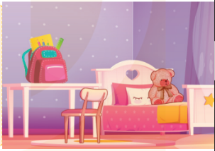  - Ask Ss to read each gapped sentence, guess the missing information and complete the sentence with their own personal information.  - Give Ss time to write their answers  - Ask Ss to swap and correct their answers in pairs.  - Check the answers as a class.  Key: Pupils’ answer.  Activity 3. Project.  *Aims: Ss will be able to make a model house and tell the class about it.  *Procedure:  - Tell Ss about this activity. Check their dool’s houses.  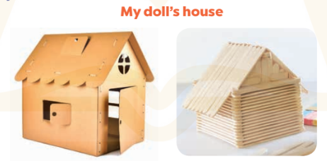  - Stick a sample of a doll’s house on the board and write the presentation language under it.  -Give Ss repeat the sentences until they can say them by themselves.  - Give Ss time to practise their presentations by themselves.  - Invite a student to the front of the classroom to model the presentation.  - Give Ss work in groups to present their doll’s houses.  - Invite a few SS from different groups to present their doll’s houses in front of the classroom.  -Give Ss display of doll’s houses and vote for the best decorated one.  *Consolidation  *Aims: Ss will be able consolidate and wrap up the content of the lesson.  *Procedure:  - T asks ss to answer the following questions:  + What have you learnt from the lesson today?  +What are the core values of the lesson?  - T praises some Ss who are hardworking / active/ good…. as well as encourage others to try more.  - Prepare the new lesson: Unit 14: Lesson 1 (1,2,3). | - Ss listen  -Ss play game  - Ss open their books  -Ss listen  - Ss read and answer  -Ss read and complete  -Ss write the first word  -Ss work in pairs  -Ss swap books and check  -Ss check the correct their answers  -Ss read  -Ss listen  -Ss listen  -Ss read and answer  -Ss write  Look at my bedroom. The table is………the bedroom. My school bag is……….the table. The teddy bear is……………..  -Ss swap books and check their answers  -Ss check  -Ss listen  -Ss note  -Ss repeat the sentences  -Ss practice  -Ss present  -Ss work in groups  -Ss present in front of class.  -Ss vote the most beautiful ones  -Ss answer the questions  -Ss listen and clap their hands  -Ss listen and take note
D. ADJUSTMENTS (if necessary):
………………………………………………………………………………………….…..……………………………………………………………………………...…………

