Week 22 Preparing date: 08/02/2025
Period 86 Teaching date:10/02/2025

Unit 13: My house
Lesson 1 (4, 5, 6)
A. OBJECTIVES:
By the end of the lesson, Ss will be able to:
1. Knowledge:
- listen to and understand simple exchanges in relation to the topic “My house”
- read and write about the location of rooms in a house and things in a room.
- Vocabulary: Review
- Skills: speaking, listening, reading and writing.
2. Competences:
- Co-operation: ready to help friends in pair work/ group work.
- Self-control and independent learning: perform listening tasks.
3. Attitude/ Qualities:
- Kindness: Help partners to complete learning tasks.
- Honesty: tell the truth about feelings and emotions.
- Diligence: complete learning tasks.
B. TEACHING AIDS:
- Teacher: Teacher’s guide Pages 163, 164; audio Tracks 24, 25; website sachmem.vn, posters, laptop, pictures, textbook, lesson plan, TV or projector.
- Students: Pupil’s book Page 19, notebooks, workbooks, school things.
C. PROCEDURES:
Stages/Time | Teacher’s activities | Students’ activities
1.Warm- up:  (5’)  2.Practice: (27’)  3. Homework. (3’) | Game: “Passing the ball”  *Aims: to create a friendly and active atmosphere in the class to beginning the lesson.  *Procedure:  - Divide class into 3 teams.  - Each team has 1 sticky ball.  - Play the music, ss in each team take turn to pass the ball.  - After the music ends, 3 ss have the ball – stand up and say the name, using the sentence model.  - Say “Open your book page 19” and look at “Unit 13, Lesson 1 (4,5,6)”.  Activity 1. Listen and circle:  *Aims: Ss will be able to listen to and understand two communicative contexts in which pupils ask and answer questions about the location of a room in a house and circle the correct pictures  *Procedure:  - Elicit the name of the room in each picture 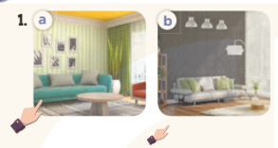  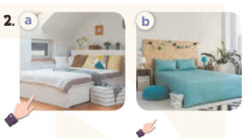  - T ask Ss to guess the answers.  + T writes Ss’guessing on the board.  - Listen to the tape:  + Play the recording  + Play the recording again and get Ss to swap books with their partners.  + Play the recording again to check answers together as a class.  + Write the answers on the board for Ss to correct their answers. Then checks Ss’ guessing.  - Play the recording, sentence by sentence, for the class to listen and repeat in chorus.  Key: 1.a 2.b  Activity 2. Look, complete and read.  *Aims: Ss will be able to complete four gapped exchanges with the help of picture cues.  *Procedure:  - Have Ss look at the pictures and identify the rooms (a living room, a kitchen, a bathroom and a bedroom).  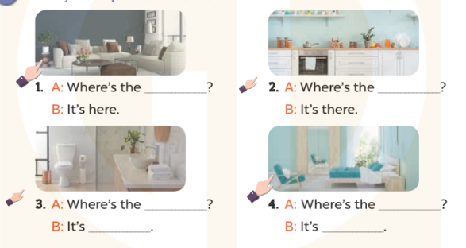  - Have Ss look at the four incomplete exchanges and elicits the missing words in the sentences.  - T models with sentence 1  + Ask Ss what is missing in the sentence.  + Have Ss look at the picture and complete the gap, then read the completed sentence in chorus.  -Have Ss work in groups and complete the sentences 2,3 and 4.  - Ask a few Ss to stand up and read the completed sentences aloud.  -T gives feedbacks.  Key:  1. living room 2. kitchen  3. bathroom; there 4. bedroom; here  Activity 3. Let’s sing.  *Aims: Ss will be able to sing the song Where is it? with the correct melody and pronunciation.  *Procedure:  - Introduce the title and lyrics of the song: “Where is it? ” song.  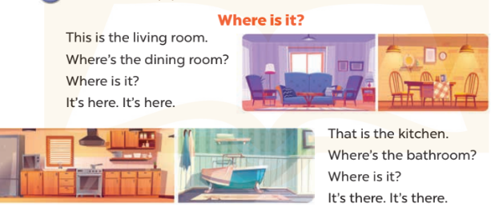  - Play the recording for Ss to listen to the whole song.  + Have them repeat the title and lyrics line by line.  + Tell Ss to point at the relevant character while singing his or her name.  - Play the recording all the way through for Ss to listen to pronunciation and melody of the song.  - Play the recording line by line for Ss to listen, repeat and point at the relevant character.  - Play the recording for Ss to sing and do actions.  - Ask Ss to practice singing and doing actions in pairs or groups.  - Invite groups to the front of the classroom to perform the song  -T gives feedback.  *Consolidation  *Aims: Ss will be able consolidate and wrap up the content of the lesson.  *Procedure:  - T asks ss to answer the following questions:  + What have you learnt from the lesson today?  +What are the core values of the lesson? (if the teacher can take from the lesson).  - T praises some Ss who are hardworking / active/ good…. as well as encourage others to try more.  - Learn the number by heart  - Prepare the new lesson: Unit 13, Lesson 2 (1,2,3). | - Ss listen and keep the puppet  - Ss listen to music and play the game  -Ss listen  - Ss open their books  -Look at the pictures and say:  + Picture 1a: a hand pointing at a nearby living room  + Picture 1b: a hand pointing at distant living room  + Picture 2a: a hand pointing at a nearby bedroom  + Picture 2b: a hand pointing at a distant bedroom  -Ss guess the answers  - Ss listen to the tape and circle  - Ss listen again, circle and swap books with their partners.  - Ss check their answers and guessing  -Ss listen and repeat.  -Ss look at the picture and say:  -Ss look and answer  -Ss answer: living room  -Ss look, complete and read the completed sentence in chorus.  -Ss complete the sentence  -Ss read aloud  - Ss look and listen.  -Ss listen to the song  - Ss listen and repeat line by line without the action.  -Ss point to the character while singing  -Ss listen to melody of the song  - Ss listen and sing line by line.  - Ss sing and do actions.  + Ss work in groups (two groups) to sing.  -Ss perform in front of the class.  -Ss listen  -Ss answer the questions  -Ss listen and clap their hands  -Ss listen and take note

D. ADJUSTMENTS (if necessary):
………………………………………………………………………………………….…..……………………………………………………………………………...………………………………………….…..……………………………………………………………………………….……………………………………………………………………...

