Week 22 Preparing date: 08/02/2025
Period 85 Teaching date:10/02/2025

Unit 13: My house
Lesson 1 (1, 2, 3)
A. OBJECTIVES:
By the end of the lesson, Ss will be able to:
1. Knowledge:
–use the words living room, bedroom, kitchen, bathroom, here, there
–use Where’s the……….? – It’s here/ there. to ask and answer questions about the location of a room in a house
- Vocabulary: living room, bedroom, kitchen, bathroom, here, there
- Model sentences:
A: Where’s the……….?
B: It’s here/ there.
- Skills: speaking and listening
2. Competences:
- Critical Thinking: talk about house
- Co-operation: ready to help friends in pair work/ group work.
- Sociability: Talk to each other, say good words to others.
3. Attitude/ Qualities:
- Kindness: Help partners to complete learning tasks.
- Honesty: tell the truth about feelings and emotions
B. TEACHING AIDS:
- Teacher: Teacher’s guide Pages 161, 162, audio Tracks 22, 23, website sachmem.vn, posters, laptop, pictures, textbook, lesson plan, TV or projector.
- Students: Pupil’s book Page 18, notebooks, workbooks, school things.
C. PROCEDURES:
Stages/Time | Teacher’s activities | Students’ activities
1.Warm- up:  (3’)  2. Presentation  (16’)  3.Practice: (7’)  4.Production: (7’)  5. Homework. (2’) | Game: jigsaw puzzle  *Aims: to create a friendly and active atmosphere in the class to beginning the lesson.  *Procedure:  - Divide class into 4 groups: Doreamon, Nobita, Xuka and Xeko.  - Ask Ss look at the pieces of picture.  - Ask Ss go to the board and jigsaw puzzle into the correct picture  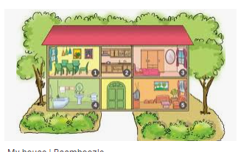  -T checks who’s the winner?  - Ask Ss look at the pieces of picture  - Say “Open your book page 18” and look at “Unit 13, Lesson 1 (1,2,3)”.  Activity 1. Vocabulary.  *Aims: Ss will be able to know the vocabulary in front of starting the new lesson.  *Procedure:  -T elicits the new words  + living room : phòng khách  (picture)  + bedroom : phòng ngủ (situation)  + kitchen : phòng bếp (picture)  + bathroom : phòng tắm (picture)  + house : ngôi nhà (translation)  + here : ở đây (situation)  + there : ở kia (translation)  - T models (3 times).  - T writes the words on the board.  - Checking: Rub out and remember  Activity 2. Listen, point and repeat:  *Aims: Ss will be able to understand and correctly repeat the sentences in two communicative contexts (pictures) focusing on asking and answering about the location of a room in a house.  *Procedure:  - Have Ss look at Pictures a and b and identify the characters in the pictures.  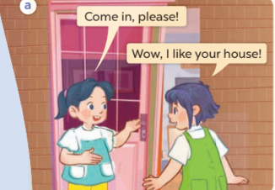  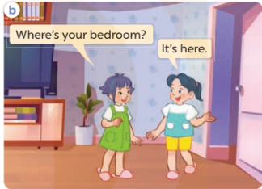  - Play the audio twice (sentence by sentence). Correct their pronunciation where necessary.  - Have Ss to practice the dialogue  - T invites a few pairs to the front of the class to practice.  - T checks pronunciation for ss.  Activity 3 Listen, point and say.  *Aims: Ss will be able to correctly say the words and use Where’s the……..? − It’s here / there. to ask and answer questions about the location of a room in a house.  *Procedure:  * Model sentences:  - T asks Ss look at picture a , b and helps Ss know the structure from the dialogue.  - T introduces new structure for Ss.  - T explains, models and gives meaning.  -Have Ss repeat the model sentences.  A: Where’s the bedroom?  B: It’s here/ there.  *Drill pictures  - Elicit and check comprehension the name of the rooms.  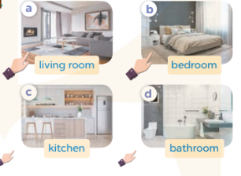  - Run through all the pictures.  - Run through model sentences.  + Run through the questions.  + Run through the answers  - Have Ss to practise:  + T says asks and Ss answer (change role).  + Ss – Ss (change role).  - Ask Ss to work in pairs.  - T controls and corrects.  - Invite a few pairs to come to the front of the classroom, point at the relevant character in each picture, and act out his/her role.  - Encourage Ss to practise speaking English.  - T gives feedbacks.  Activity 4. Let’s talk.  *Aims: Ss will be able to enhance the correct use of Where’s the……? − It’s here / there. to ask and answer questions about the location of a room in a house in a freer context.  *Procedure:  - T asks ss to guess each character and what the children say.  + What can you see in the picture?  +How many rooms are there in the picture?  +What rooms are they?  +Where’s the ……….?  - T fills the gaps and writes the sentences on the board.  - T models  - T asks Ss to work in pairs to ask and answer  - Invite some pupils to the front of the class to present their exchanges.  - Give feedbacks  *Consolidation  *Aims: Ss will be able consolidate and wrap up the content of the lesson.  *Procedure:  - T asks ss to answer the following questions:  + What have you learnt from the lesson today?  - T review the vocabulary and model sentences.  - T praises some Ss who are hardworking / active/ good…. as well as encourage others to try more.  - Learn the number by heart  - Prepare the new lesson: Unit 13, Lesson 1 (4,5,6). | - Ss listen  - Ss play the game  - Ss open their books  -Ss listen and answer  - - Ss listen and repeat  + Choral repetition (3 times).  + Individual repetition (3 ss)  - Ss take note  - Ss look, remember and write  -Look at the pictures and get to know the characters in the pictures.  + Mai says Come in, please!Linh says Wow, I like your house! in picture a.  + Linh asks Where’s your bedroom? Mai answers It’s here. in picture b.  -Ss listen and repeat in chorus (twice)  -Ss work in pairs to practice  -Ss practice the dialogue  -Ss listen  -Ss look at the picture and answer.  -Ss listen  -Ss listen and repeat  -Ss repeat  - Ss look, listen and repeat  -Ss practice in chorus  -Ss work in pairs to practice  -Ss point and say  -Ss listen.  -Ss listen  -Ss look at the picture and answer  +I can see a house  + There are four rooms  + They are living room, kietchen, bedroom, bathroom.  + It’s here/ there  -Ss note  - Ss say the completed sentences.  -Ss work in pairs  -Ss perform in front of the class.  -Ss answer the questions  - Ss listen  -Ss listen and clap their hands  -Ss listen and take note

D. ADJUSTMENTS (if necessary):
………………………………………………………………………………………….…..……………………………………………………………………………...………………………………………….…..……………………………………………………………………………….……………………………………………………………………...

