Week 21 Preparing date: 01/02/2025
Period 82 Teaching date: 03/02/2025 – Class 3A

Unit 12: Jobs
Lesson 2 (4, 5, 6)
A. OBJECTIVES:
By the end of the lesson, Ss will be able to:
1. Knowledge:
- listen to and understand four communicative. contexts to ask and answer questions about someone's job and number the correct pictures.
- correctly the four gapped dialogues with the help of the picture cues.
- revise the target vocabulary and sentence patterns by playing the game Clap for ‘yes’.
- Vocabulary: Review
- Skills: speaking, listening, reading and writing.
2. Competences:
- Critical Thinking: talk about someone
- Co-operation: ready to help friends in pair work/ group work.
- Self-control and independent learning: perform listening tasks.
3. Attitude/ Qualities:
- Kindness: Help partners to complete learning tasks.
- Honesty: tell the truth about feelings and emotions.
- Diligence: complete learning tasks.
B. TEACHING AIDS:
- Teacher: Teacher’s guide Pages 156, 157; audio Tracks 18; website sachmem.vn, posters, laptop, pictures, textbook, lesson plan, TV or projector.
- Students: Pupil’s book Page 15, notebooks, workbooks, school things.
C. PROCEDURES:
Stages/Time | Teacher’s activities | Students’ activities
1.Warm- up:  (5’)  2.Practice: (27’)  3. Homework. (3’) | Sing a song: “throw the ball”  *Aims: to create a friendly and active atmosphere in the class to beginning the lesson.  *Procedure:  - Divide the class into 2 teams.  - Stick the pictures of jobs on the board.  + T says a word, a pupil from each team has to point/throw the ball to the right picture and says the word three times.  + The one says faster will get points.  - Encourage Ss to take part in the game.  - Give points for Ss.  - Say “Open your book page 15” and look at “Unit 12, Lesson 2 (4,5,6)”.  Activity 1. Listen and number:  *Aims: Ss will be able to listen to and understand four communicative contexts to ask and answer questions about someone's job and number the correct pictures.  *Procedure:  - Elicit the names and jobs of the characters in the pictures.  - Point at the pictures respectively to explain the context.      - T ask Ss to guess the answers.  + T writes Ss’guessing on the board.  - Listen to the tape:  + Play the recording  + Play the recording again and get Ss to swap books with their partners.  + Play the recording again to check answers together as a class.  + Write the answers on the board for Ss to correct their answers. Then checks Ss’ guessing.  - Play the recording, sentence by sentence, for the class to listen and repeat in chorus.  Key: 1.d 2. b 3. a 4. c  Activity 2. Look, complete and read.  *Aims: Ss will be able to complete four gapped dialogues with the help of picture cues.  *Procedure:  - Have Ss look at the pictures and ask identify the jobs in the pictures.  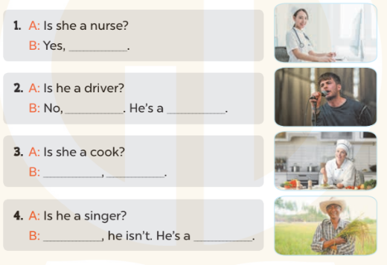  - T models with sentence 1.  + Have Ss look at the sentence.  + Ask them what is missing in the answer (she is).  + Have Ss complete the gap.  + Have Ss read the completed sentence in chorus.  -Have Ss work in pairs and complete the sentences 2, 3 and 4.  - Invite pairs of pupils to stand up and read aloud the sentences.  -T gives feedbacks.  Key: 1. she is 2. he isn't; singer  3. Yes, she is 4. No; farmer  Activity 3. Let’s play.  *Aims: Ss will be able to revise the target vocabulary and sentence patterns by playing the game Clap for ‘yes’.  *Procedure:  - Hold up a flash card for driver and ask Ss Is he a driver? and elicit the answer Yes, he is. Ask Ss to clap their hands and repeat the answer.  -Ask Ss to clap their hands and say Yes, he / she is. if the answer is Yes.  - Keep holding a flash card for driver and ask another question to elicit No, he isn’t. Ask Ss to stamp their feet and repeat the answer. Ask Ss to stamp their feet and say No, he / she isn’t. if the answer is No.  - Repeat the procedure with the other flash cards.  - Invite a few Ss to the front of the class and ask questions.  *Consolidation  *Aims: Ss will be able consolidate and wrap up the content of the lesson.  *Procedure:  - T asks ss to answer the following questions:  + What have you learnt from the lesson today?  +What are the core values of the lesson? (if the teacher can take from the lesson).  - T praises some Ss who are hardworking / active/ good…. as well as encourage others to try more.  - Prepare the new lesson: Unit 12, Lesson 3 (1,2,3). | - Ss listen and play the game  - Ss open their books  -Look at the pictures and say:  + Picture a: a nurse  + Picture b: a cook  + Picture c: a singer  + Picture d: a farmer  -Ss guess the answers  - Ss listen to the tape and write number  - Ss listen again, write number and swap books with their partners.  - Ss check their answers and guessing  -Ss listen and repeat.  -Ss look at the pictures and say  -Ss listen and answer  -Ss read and complete  -Ss work in pairs  -Ss read  - Ss listen  -Ss play the game  - Ss play the game  -Ss listen and answer  -Ss listen and take note

D. ADJUSTMENTS (if necessary):
………………………………………………………………………………………….…..……………………………………………………………………………...………………………………………….…..……………………………………………………………………………….……………………………………………………………………...

