Week 19 Preparing date: 11/01/ 2025
Period 76 Teaching date: 17/01/2025

Unit 11: My family
Lesson 2 (4, 5, 6)
A. OBJECTIVES:
By the end of the lesson, Ss will be able to:
1. Knowledge:
- listen to and demonstrate understanding of simple communicative contexts in relation to the topic “My family”
- read and write about family members and their ages
- Vocabulary: Review
- Skills: speaking, listening, reading and writing.
2. Competences:
- Critical Thinking: talk about someone
- Co-operation: ready to help friends in pair work/ group work.
- Self-control and independent learning: perform listening tasks.
3. Attitude/ Qualities:
- Kindness: Help partners to complete learning tasks.
- Honesty: tell the truth about feelings and emotions.
- Diligence: complete learning tasks.
B. TEACHING AIDS:
- Teacher: Teacher’s guide Pages 145, 146; audio Tracks 8; website sachmem.vn, posters, laptop, pictures, textbook, lesson plan, TV or projector.
- Students: Pupil’s book Page 9, notebooks, workbooks, school things.
C. PROCEDURES:
Stages/Time | Teacher’s activities | Students’ activities
1.Warm- up:  (5’)  2.Practice: (27’)  3. Homework. (3’) | Sing a song: “how are you”  *Aims: to create a friendly and active atmosphere in the class to beginning the lesson.  *Procedure:  - Show the song on the screen.  https://www.youtube.com/watch?v=O13gITUS5t4  - Ask pupils to listen, sing and dance the song.  - Say “Open your book page 9” and look at “Unit 11, Lesson 2 (4,5,6)”.  Activity 1. Listen and number:  *Aims: Ss will be able to listen to and understand four communicative contexts in which pupils ask their teachers for permission *Procedure:  - Elicit the names and ages of the characters in the pictures.      - T ask Ss to guess the answers.  + T writes Ss’guessing on the board.  - Listen to the tape:  + Play the recording  + Play the recording again and get Ss to swap books with their partners.  + Play the recording again to check answers together as a class.  + Write the answers on the board for Ss to correct their answers. Then checks Ss’ guessing.  - Play the recording, sentence by sentence, for the class to listen and repeat in chorus.  Key: 1.a 2. d 3. b 4. c  Activity 2. Look, complete and read.  *Aims: Ss will be able to complete four gapped dialogues with the help of picture cues.  *Procedure:  - Have Ss look at the pictures and ask them pay attention to the cakes with candles or numbers  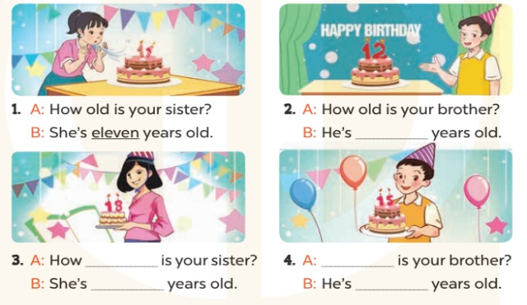  - T models with sentence 1.  + Have Ss look at the sentence.  + Ask them what is missing in the answer (eleven).  + Have Ss complete the gap.  + Have Ss read the completed sentence in chorus.  -Have Ss work in pairs and complete the sentences 2, 3 and 4.  - Invite pairs of pupils to stand up and read aloud the sentences.  -T gives feedbacks.  Key: 1. eleven 2. twelve  3.old; eighteen  4. How old; fifteen  Activity 3. Let’s play.  *Aims: Ss will be able to review vocabulary related to the topic “My family” by playing the game Board race.  *Procedure:  - Tell the Ss the goal of the game and how to play it. Ask them to revise all vocabulary learnt in Unit 11.  - Invite two groups of four pupils to the front of the class to demonstrate the game.  - Two Ss play in each round, one from each group.  - Give the Ss time to play the game in two groups of four.  - Circulate round the class during the activity and offer help where necessary  - Give Ss time to play the game.  - Give feedbacks  *Consolidation  *Aims: Ss will be able consolidate and wrap up the content of the lesson.  *Procedure:  - T asks ss to answer the following questions:  + What have you learnt from the lesson today?  +What are the core values of the lesson? (if the teacher can take from the lesson).  - T praises some Ss who are hardworking / active/ good…. as well as encourage others to try more.  - Prepare the new lesson: Unit 11, Lesson 3 (1,2,3). | - Sing and dance the song in chorus.  - Ss open their books  -Look at the pictures and say:  + Picture a: a 13-year-old girl  + Picture b: an 18-year-old girl  + Picture c: a 14-year-old boy  + Picture d: a 20-year-old man.  -Ss guess the answers  - Ss listen to the tape and write number  - Ss listen again, write number and swap books with their partners.  - Ss check their answers and guessing  -Ss listen and repeat.  -Ss look at the pictures and say  -Ss listen and answer  -Ss read and complete  -Ss work in pairs  -Ss read  - Ss listen  -Ss play the game  - Ss play the game  -Ss listen and answer  -Ss listen and take note

D. ADJUSTMENTS (if necessary):
………………………………………………………………………………………….…..……………………………………………………………………………...………………………………………….…..……………………………………………………………………………….……………………………………………………………………...

