Week 19 Preparing date: 11/01/2025
Period 77 Teaching date: 16/01/2025 – Class 5C

Unit 11: Family time
Lesson 3 (1, 2, 3)
A. OBJECTIVES:
By the end of the lesson, Ss will be able to:
1. Knowledge:
- stress the correct words in Wh-questions in the questions 'When did they 'go to 'London? and 'What did they 'do in 'Finland?;
- identify and underline the missing stressed word in four questions, and to say the questions with the correct stress while listening
- say the chant with the correct pronunciation, word stress and rhythm.
- Vocabulary: Review
- Skills: speaking, listening, reading and writing.
2. Competences:
- Communication and collaboration: work in pairs and groups to complete the learning tasks.
- Self-control and independent learning: perform pronunciation and listening tasks.
3. Attitude/ Qualities:
- Show their love and interest in outdoor activities.
- Raise their awareness of doing outdoor activities carefully.
B. TEACHING AIDS:
- Teacher: Teacher’s guide Pages 188, 189, 190; audio Tracks 8, 9, 10; website hoclieu.vn, posters, laptop, pictures, textbook, lesson plan, TV or projector.
- Students: Students’ book Page 10, notebooks, workbooks, school things.
C. PROCEDURES:
Stages/Time | Teacher’s activities | Students’ activities
1.Warm- up and review: (5’)  2. Presentation (9’)  3.Practice: (15’)  3. Fun corner and wrap- up (4’)  4.Homework  (2’) | Game: Pass the balls  *Aims: to revise the learnt words and structures.  *Procedure:  - Give two different coloured balls to two ss, a red ball (ask the question) and a yellow ball (answer the question).  - Ask ss to listen to music and pass the balls.  - Stop music suddenly.  - The teacher raises a picture. Have the student with a red ball make a question. Have the student with a yellow ball answer the question.  - Praise ss if they do the activity well.  - Say “Open your book page 10” and look at “Unit 11, Lesson 3 (1,2,3)”.  Activity 1. Listen and repeat:  *Aims: Ss will be able to stress the correct words in Wh-questions in the questions 'When did they 'go to 'London? and 'What did they 'do in 'Finland? *Procedure:  - T gives instruction the sentences 'When did they 'go to 'London? and 'What did they 'do in 'Finland?  - Play the recording and encourage Ss to point to the word and sentence while listening  - Play the recording again and encourage Ss to listen and repeat.  - Have Ss work in pairs or groups to do this several times until Ss feel confident.  - T invites some Ss to practice.  Activity 2. Listen and underline one more stressed word. Then repeat  *Aims: Ss will be able to identify and underline the missing stressed word in four questions, and to say the questions with the correct stress while listening.  *Procedure:  - Tell ss the goal of the activity and explain that they have to listen to the recording and underline one more stressed word.  - Play the recording all the way through for ss to listen to the questions.  - Play the recording again for ss to underline one more stressed word of the questions.  - Tell ss to swap books with a partner, then check the answers together as a class.  - Have ss discuss with pupils if they can spot a pattern to what words are stressed in Wh-questions (the wh-question word, the main verb and the place).  - Play the recording again for ss to double-check their answers.  - Invite one or two ss to stand up and repeat the correct answers.  Key: 1. Sydney 2. Paris  3. When 4. Do  Activity 3. Let’s chant  *Aims: Ss will be able to say the chant with the correct pronunciation, word stress and rhythm  *Procedure:  - Introduce the title and lyrics of the chant.  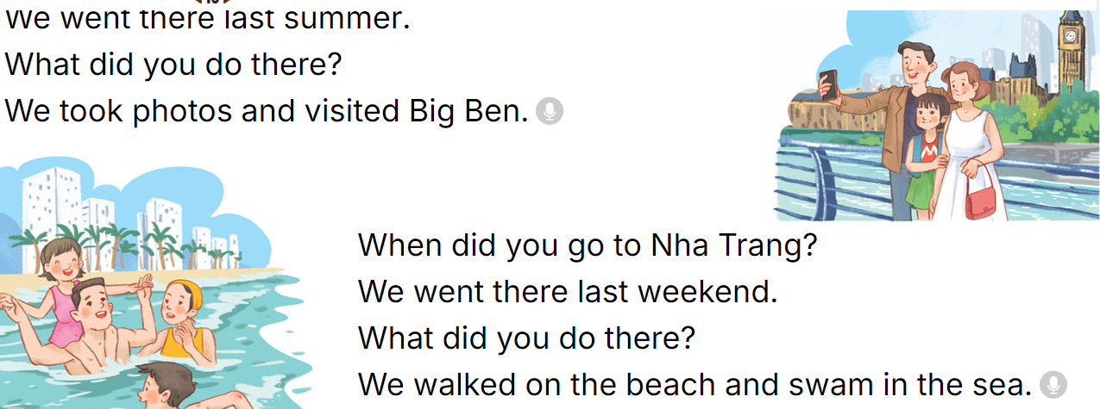  - Play the recording for Ss to listen to the whole chant.  + Have them repeat the title and lyrics line by line.  + Ask Ss to attent the word stress in the Wh-questions  - Play the recording all the way through for Ss to listen to pronunciation and melody.  - Play the recording line by line for Ss to listen and repeat  - Play the recording for Ss to chant and clap along.  - Ask Ss to practice chant and clap along in pairs or groups.  - Invite groups to the front of the classroom to perform the chant  Game: Whisper  - Tell ss how the game is played. Give an example.  - Divide the class into two groups.  - Have ss from each group stand or sit in a row.  - Whisper a sentence to the first student in each row.  - Have the first student whisper the sentence to the second student  - Have groups continue whispering the sentence until it reaches the last student.  - The last student in the row has to say out the correct sentence.  - Give the first group saying the sentence correctly one point.  - The group with more points wins. Praise the winner.  - Learn by heart vocabulary, structure  - Do exercise Unit 11 part E in workbook  -Prepare Unit 11(cont.): Lesson 3 (4,5,6) | - Ss listen  -Ss listen the rules  - Ss play the game  Ex:  A: What did your family do in Sydney?  B: We saw some interesting places.  - Ss open their books  - - Ss pay attention  - Ss listen and point  - Ss listen again and repeat  -Ss work in pairs and practice  -Ss say the language in front of the class  - Ss listen to the teacher’s explanation.  - Ss listen to the questions  - Ss listen again and underline one more stressed word of the questions.  - Ss swap books and check the answers as a class.  -Ss listen to the teacher’s instruction.  - Ss listen again to double-check their answers.  - Ss stand up and repeat the correct answers.  - students with disabilities only read the chant and clap their hands follow the music  - Ss listen to the chant  - Ss listen and repeat line by line without clap their hands  - Ss note the rhythm and pronunciation.  -Ss listen to melody of the chant  - Ss listen and chant line by line.  - Ss chant and clap along.  - Ss work in groups (two groups) to chant  -Ss perform in front of the class.  -Ss listen  -Ss play the game  Ex:  Round 1. 'When did you 'go to 'Sydney?/ 'What did he 'do in 'Paris?  Round 2. 'When did she 'go to 'England?/ 'What did they 'do in 'Thailand?  -Ss praise the winner
D. ADJUSTMENTS (if necessary):
………………………………………………………………………………………….…..……………………………………………………………………………...………………………………………….…..………………………………………………

Week 19 Period 78

Unit 11: Family time
Lesson 3 (4, 5, 6)
A. OBJECTIVES:
By the end of the lesson, Ss will be able to:
1. Knowledge:
- read and understand a paragraph about a family trip in the past by answering four questions
- complete a paragraph about someone’s family’s weekend trip by writing the target words in the gaps
- make a photo journal by sticking some photos/ pictures of the activities he/ she did somewhere with friends the previous summer, and tell the class about it.
- Vocabulary: Review
- Skills: speaking, listening, reading and writing.
2. Competences:
- Communication and collaboration: work in pairs and groups to complete the learning tasks.
- Self-control and independent learning: perform reading and writing tasks.
3. Attitude/ Qualities:
- Show their love and interest in outdoor activities.
- Raise their awareness of doing outdoor activities carefully.
B. TEACHING AIDS:
- Teacher: Teacher’s guide Pages 190, 191, 192; website hoclieu.vn, posters, laptop, pictures, textbook, lesson plan, TV or projector.
- Students: Student’s book Page 11, notebooks, workbooks, school things.
C. PROCEDURES:
Stages/Time | Teacher’s activities | Students’ activities
1.Warm- up and review: (5’)  2.Practice: (8’)  3.Production(16’)  4. Fun corner and wrap- up (4’)  5.Homework  (2’) | Game: “Memory Chain”  *Aims: to create a friendly and active atmosphere in the class to beginning the lesson.  *Procedure:  -Tell ss they are going to remember the four questions in a chain.  - Divide the class into two groups. Each group has eight ss.  - Ask eight ss from each group to take turns playing the game.  - Have Student A say the first question, then have student B say the next question and so on. If a student forgets a sentence, the group must start from student A again.  - The winning group is the first one to have all members finish speaking. Praise the winner.  - Say “Open your book page 11” and look at “Unit 11, Lesson 3 (4,5,6)”.  Activity 1. Read and answer:  *Aims: Ss will be able to read and understand a paragraph about a family trip in the past by answering four questions.  *Procedure:  - Have ss read the questions carefully. Tell them to read Question 1 and pay attention to keywords such as Where, Linda’s family, go. and answer the question.  - Set a time limit for sls to do the rest of the task independently.  - Get ss to swap books with the partner and check the answers before checking as a class.  - Invite some pairs to take turns asking and answering the questions.  - Ask ss some more questions.  Ex:  When did Linda’s family go to Ha Long Bay? What did they do there on Sunday?  Did they explore the caves and eat seafood?  Key:  1. They went to Ha Long Bay.  2. They sunbathed, took some photos and swam in the sea.  3. They took a boat trip around the bay on Sunday.  4. They bought some souvenirs for their friends  Activity 2. Let’s write  *Aims: Ss will be able to complete a paragraph about someone’s family’s weekend trip by writing the target words in the gaps.  *Procedure:  - Ask ss to read the gapped sentences and fill in the gaps with information about someone’s family’s weekend trip.  - Ask Ss to read the first sentence, then elicit where they went the previous weekend (Ex: Sa Pa) and write the first sentence (Last weekend, my family went to Sa Pa.)  - Give Ss time to complete the rest of the paragraph independently.  - Get Ss to swap their books with a partner and check their spelling.  - Invite a student to read his / her completed paragraph aloud  - In groups, have ss share the activities that their family did last weekend.  - Ask Ss share with the class.  Key: Pupil’s answer  Ex: Last weekend, my family went to Sa Pa. On Saturday, we visited Sa Pa Town and went to see the mountains. We took lots of photos there. On Sunday, we went shopping in the town. My brother bought a shirt and I bought some souvenirs for my friends. Our trip was a lot of fun!  Activity 3. Project.  *Aims: Ss will be able to make a photo journal by sticking some photos/pictures of the activities he/ she did somewhere with friends the previous summer, and tell the class about it.  *Procedure:  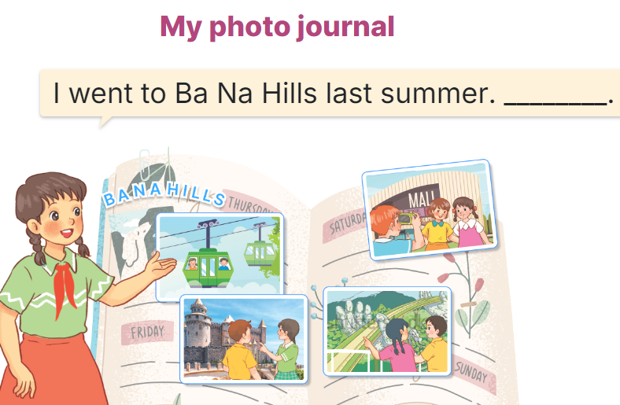  - Explain that each pupil has to show his/her photo journal which includes some photos/ pictures of friends and their activities (they have prepared at home) and tell the class about where they went and what they did there.  - Have Ss work in groups of five or six. Each student shows his / her photo journal to the group and describes what he/she and friends did somewhere last summer.  - Invite a few ss representing some groups to show their photo journals and tell the class about the activities of the friends in the photos/ pictures, Ex: I went to Ba Na Hills last summer with my friends. We took the cable car. We visited Golden Bridge…  - Have the rest of the class give comments and praise ss if they perform well.  Game: Serial reading  - Show the text on the board.  - Divide the class into groups of four.  - Have ss work in groups and read the text serially.  - Invite some ss to the front of the class and perform their work.  - Praise ss to encourage their performance.  - Learn by heart vocabulary, structure  - Do exercise Unit 11 part F in workbook  -Prepare Unit 12: Lesson 1 (1,2,3) | - Ss listen  - Ss listen to the rules  -Ss play game  Ex:  'When did you 'go to 'Sydney?  'What did he 'do in 'Paris?  'When did she 'go to 'England?  'What did they 'do in 'Thailand?  - Ss open their books  - Ss read the questions carefully. Ss read Question 1 and look at keywords and scan the text for relevant information.  - Ss do the task independently.  - Ss swap books and check the answers before checking as a class.  - Ss ask and answer the questions.  - Ss answer the questions.  - Ss read the gapped sentences and fill in the gaps.  - Ss do the first gapped sentence.  - Ss complete the paragraph independently.  - Ss swap their books and check their spelling.  - Ss read the paragraphs aloud  - Ss share the activities that their family did last weekend.  -Ss share with the class.  - students with disabilities only draw the pictures about journal  - Ss listen to the teacher’s explanation.  - Ss work in and describes what he/she and friends did somewhere last summer.  - Ss tell the class about the activities of the friends in the photos/ pictures.  - Ss congratulate  -Ss listen to the teacher  -Ss play the game  -Ss congratulate the winner
D. ADJUSTMENTS (if necessary):
………………………………………………………………………………………….…..……………………………………………………………………………...……

