Week 19
Period 73

Unit 11: Family time
Lesson 1 (1, 2, 3)
A. OBJECTIVES:
By the end of the lesson, Ss will be able to:
1. Knowledge:
- understand and correctly repeat the sentences in two communicative contexts focusing on asking and answering questions about whether someone did something in the past.
- correctly say the words and use Did you ……? - Yes, I ……. I …….. to ask and answer questions about whether someone did something in the past;
- correctly use Did you ……? - Yes, I …… I …….. to ask and answer questions about whether someone did something in the past in a freer context
- Vocabulary: take a photo, collect seashells, walk on the beach, buy postcards.
- Structures: A: Did you swim?
B: Yes, I did. I swam with my mother.
- Skills: speaking and listening
2. Competences:
- Communication and collaboration: work in pairs and groups to complete the learning tasks.
- Self-control and independent learning: perform pronunciation and speaking tasks.
3. Attitude/ Qualities:
- Show their love and interest in outdoor activities.
- Raise their awareness of doing outdoor activities carefully.
B. TEACHING AIDS:
- Teacher: Teacher’s guide Pages 178, 179, 180, 181, audio Tracks 1, 2, website hoclieu.vn, posters, laptop, pictures, textbook, lesson plan, TV or projector.
- Students: Students’ book Page 6, notebooks, workbooks, school things.
C. PROCEDURES:
Stages/  Time | Teacher’s activities | Students’ activities
1.Warm- up and review: (3’)  2. Presentation (13’)  3.Practice: (7’)  4. Production: (6’)  5. Fun corner and wrap- up (4’)  6.Homework (2’) | Sing a song: Chicken dance  *Aims: to create a friendly and active atmosphere in the class to beginning the lesson.  *Procedure:  - Show the song on the screen.  https://www.youtube.com/watch?v=WZJAIkmT3Rg&t=10s  - Ask Ss to listen, sing and dance the song  - Say “Open your book page 6” and look at “Unit 11, Lesson 1 (1,2,3)”.  Activity 1. Vocabulary.  *Aims: Ss will be able to know the vocabulary in the new lesson.  *Procedure:  -T elicits the new words  + take photos: chụp hình (mime)  + collect seashells : nhặt vỏ sò  (picture)  + walk on the beach : đi bộ trên bãi biển (picture)  +buy postcards: mua bưu thiếp  (picture)  - T models (3 times).  - T writes the words on the board.  - Checking: Rub out and remember  Activity 2. Look, listen and repeat:  *Aims: Ss will be able to understand and correctly repeat the sentences in two communicative contexts focusing  on asking and answering questions about whether someone did something in the past.  *Procedure:  - Have Ss look at Pictures a and b and identify the characters and their activities in the pictures.  + Who are they?  + Where are they?  + What are they talking about?  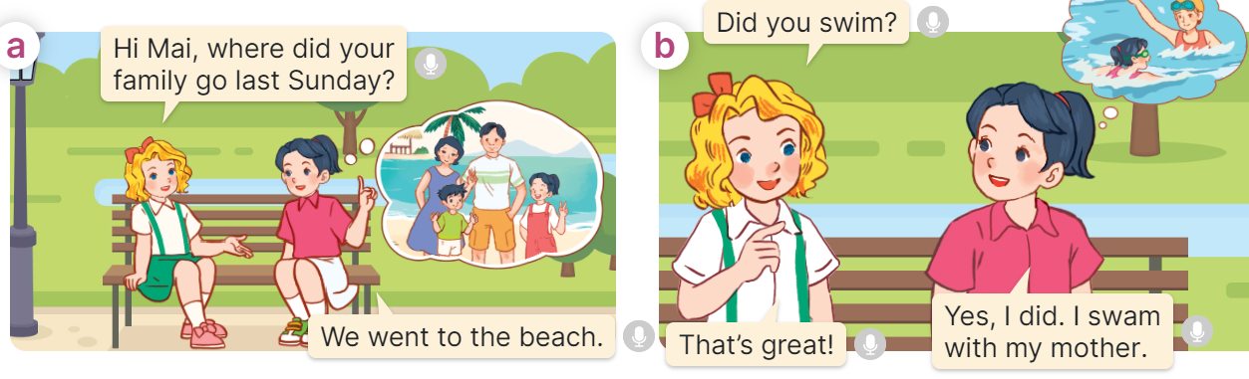  - Play the audio twice (sentence by sentence). Correct their pronunciation where necessary.  - Have Ss to practice the dialogue  - T invites a few pairs to the front of the class to practice.  - T checks pronunciation for ss.  Activity 3 Listen, point and say.  *Aims: Ss will be able to correctly say the words and use Did you …….? - Yes, I …... I …… to ask and answer questions about whether someone did something in the past.  *Procedure:  * Structures:  - T asks Ss look at picture b in activity 1 and helps Ss know the structure from the dialogue.  - T introduces new structures for Ss.  - T explains, models and gives meaning.  - Have Ss repeat the structure  A: Did you swim?  B: Yes, I did. I swam with my mother.  *Drill pictures  - Have Ss look at the picture and identify the characters and their activities in the past.  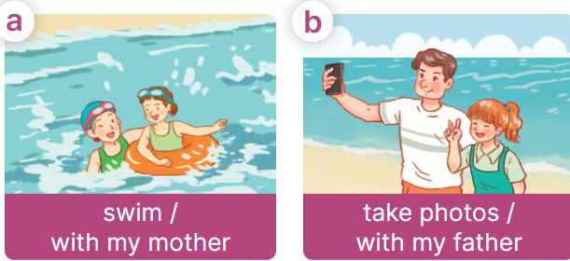  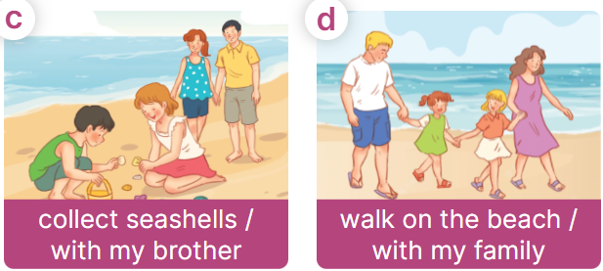  - Explain that the question and answer are used to express the activity someone did in the past and that swam is the past tense of the verb swim  + swim – swam + take – took  + collect – collected  + walk - walked  - Have Ss point at pictures, listen and run through all the pictures.  - Have Ss point at the bubbles, listen and run through model sentences.  - Have Ss to practise:  + T asks the first picture, Ss answer  + Ss asks the second picture, T answers  + Group A asks the third picture, group B  answers  + Group B asks the last picture, group A  - Ask Ss to work in pairs to practise asking and answering the question Did you ……?  B: Yes, I ……. I ………  - T controls and corrects.  - Invite a few pairs to point at the pictures and say the questions and answers in front of the class.  Activity 4. Let’s talk.  *Aims: Ss will be able to correctly use Did you …….? - Yes, I ……... I …... to ask and answer questions about whether someone did something in the past in a freer context.  *Procedure:  - Have ss look at the picture and ask questions to help them identify the context  +What can you see in the picture?  +What are they doing?  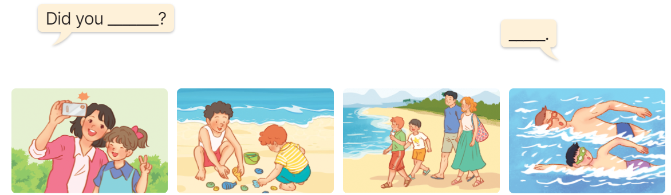  - Elicit the answer in the speech bubble and write it on the board. Get Ss to say the completed sentences.  - Have Ss role-play to practise asking the questions and giving their answers in pairs, using the picture cue.  - Invite a few pairs to point at the pictures and ask and answer questions.  Game: Lucky animals  - Divide the class into two groups.  - Have two ss from each group take turns to choose an animal and do the task.  - If the group chooses a lucky animal, they will get points and continue the next turn.  - Get corresponding points for their group.  - Continue with the other ss.  - The group that gets the most points wins. Praise the winner.  - Learn by heart vocabulary, structure  - Do exercise Unit 11 part A,B in workbook  -Prepare Unit 11(cont.): Lesson 1(4,5,6) | - Sing and dance the song together.  - Ss listen and open their books  -Ss listen and answer  - students with disabilities only read vocabulary( take photos, collect seashells,  walk on the beach, buy postcards)  - - Ss listen and repeat  + Choral repetition (3 times).  + Individual repetition (3 ss)  - Ss take note  - Ss look, remember and write  -Look at the pictures and say  +In picture a:  Mary: Hi Mai, where did your family go last Sunday?  Mai: We went to the beach.  + In picture b:  Mary: Did you swim?  Mai: Yes, I did. I swam with my mother.  Mary: That’s great!  -Ss listen and repeat in chorus (twice)  -Ss work in pairs to practice  -Ss come to the front of the classroom to practice.  -Ss listen  - Ss look at the picture and answer.  -Ss listen  -Ss listen and repeat  -Ss repeat to the structures  - Ss look, listen and repeat  +Picture a: a girl swimming with her mother.  + Picture b: a girl taking photos with his father.  + Picture c: a girl collecting seashells with her brother.  + Picture d: a girl walking on the beach with her family.  -Ss listen to the teacher’s instructions  -Ss point at pictures, listen and repeat  -Ss point at the bubbles, listen and repeat  -Ss practice in chorus  -Ss practice in chorus  -Ss work in pairs to practise asking and answering the question  - Pairs of Ss point at the pictures and say in front of the class  -Ss look at the picture and answer  + a girl taking photos with her mother; a boy collecting seashells with his brother; a boy walking on the beach with his family; a boy swimming with his father  - Ss say the completed sentences.  -Ss work in pairs to ask and answer  -Ss perform in front of the class.  - Ss listen  -Ss listen and play the game  Ex:  A: Did you swim?  B: Yes, I did. I swam with my father.  -Ss continue to play the game.  -Ss praise the winner.
D. ADJUSTMENTS (if necessary):
………………………………………………………………………………………….…..……………………………………………………………………………...……

Week 19
Period 74

Unit 11: Family time
Lesson 1 (4, 5, 6)
A. OBJECTIVES:
By the end of the lesson, Ss will be able to:
1. Knowledge:
- listen to and understand four communicative contexts about people doing activities in the past and match four characters with the correct pictures.
- read and circle the correct answers with the help of the picture cues.
- listen to and complete the song Did you swim last Sunday? and to sing it with the correct pronunciation, rhythm and melody.
- Vocabulary: Review
- Skills: speaking, listening, reading and writing.
2. Competences:
- Communication and collaboration: work in pairs and groups to complete the learning tasks.
- Self-control and independent learning: perform listening and reading tasks.
3. Attitude/ Qualities:
- Show their love and interest in outdoor activities.
- Raise their awareness of doing outdoor activities carefully.
B. TEACHING AIDS:
- Teacher: Teacher’s guide Pages 181, 182, 183; audio Tracks 7; website hoclieu.vn, posters, laptop, pictures, textbook, lesson plan, TV or projector.
- Students: Student’s book Page 7, notebooks, workbooks, school things.
C. PROCEDURES:
 | Teacher’s activities | Students’ activities
1.Warm- up and review: (5’)  2.Practice: (23’)  3. Fun corner and wrap- up (5’)  4.Homework (2’) | Game: Card passing  *Aims: to revise the learned structures.  *Procedure:  - Stick the cards on the board. Ask ss to say the words related to the cards.  - Hand out the cards to different ss around the class.  - Play the song “Hello song” and ask ss to pass the cards to the ss next to them while the music is playing.  - Stop the music suddenly. Invite a student who is holding the card to ask the question “Did you swim yesterday?”. Ask another student to answer, ex: Yes, I did. I swam with my sister.  - Play the music again and repeat the activity.  - Say “Open your book page 7” and look at “Unit 11, Lesson 1 (4,5,6)”.  Activity 1. Listen and match:  *Aims: Ss will be able to listen to and understand four communicative contexts about people doing activities in the past and match four characters with the correct pictures.  *Procedure:  - Elicit the characters’ names and the activities in the pictures.  +What’s his/ her name?  +What are they doing?  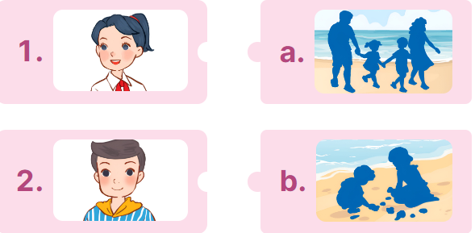  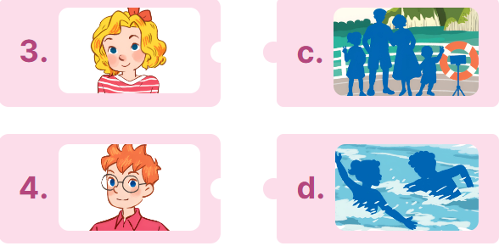  - T ask Ss to guess the answers.  + T writes Ss’guessing on the board.  - Listen to the tape:  + Play the recording  + Play the recording again for pupils to do the task.  + Play the recording a third time for pupils to check their answers.  - Get Ss to swap books with their partner, then check answers as a class.  + Write the answers on the board for Ss to correct their answers. Then checks Ss’ guessing.  - Have ss explain the answers.  Key: 1. a 2. d 3.b 4.a  Activity 2. Read and circle.  *Aims: Ss will be able to read and circle the correct answers with the help of the picture cues  *Procedure:  - Get Ss to look at the pictures and identify the characters  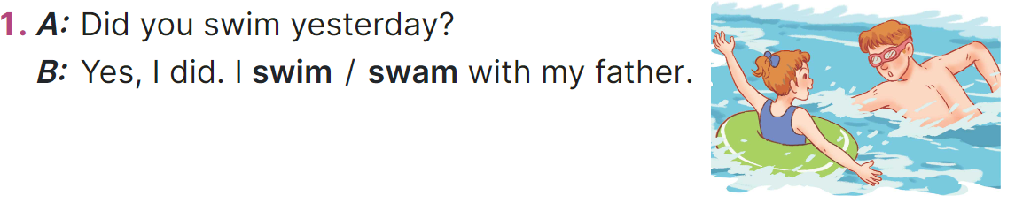  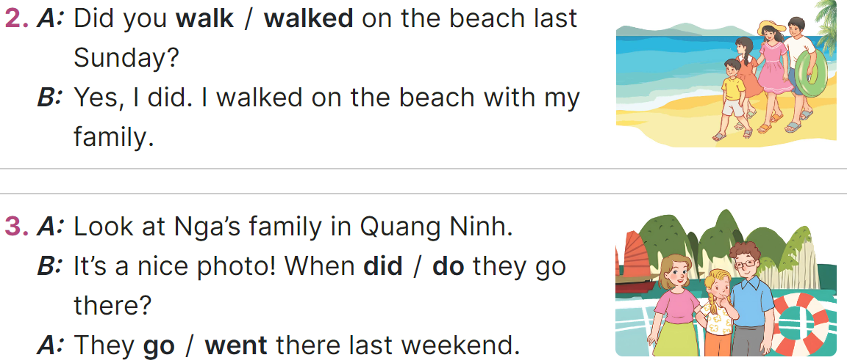  - Have Ss look at the three incomplete exchanges and elicits the options  - T models with sentence 1  + Have Ss circle the correct answer (swam)  + Have Ss look at the picture and identify the needed information (swam).  - Have Ss work in groups and complete the sentences 2, 3 and 4.  - Get Ss to swap books with a partner and check their answers before checking as a class.  -T gives feedbacks.  Key:  1. swam; 2. walk;  3. did; went; 4. were; buy  Activity 3. Listen, complete and sing  *Aims: Ss will be able to listen to and complete the song Did you swim last Sunday? and to sing it with the correct pronunciation, rhythm and melody  *Procedure:  - Introduce the title and lyrics of the song:“Did you swim last Sunday?”  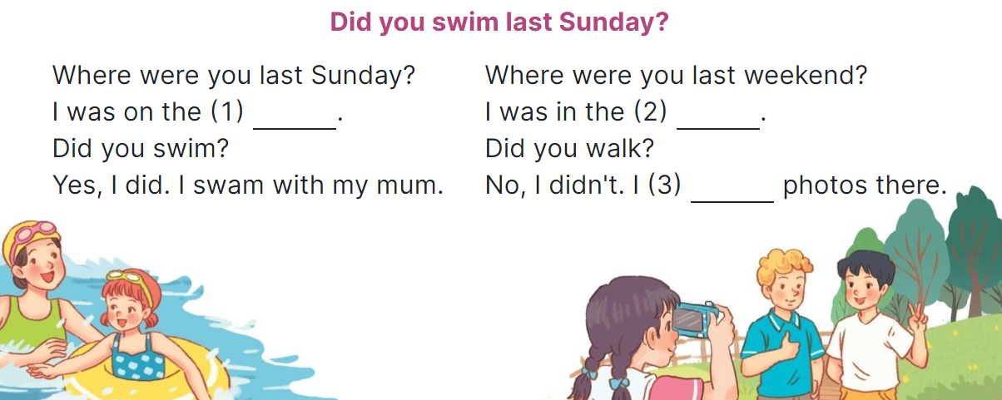  - Tell ss the aim of the activity  - Draw ss’ attention to the gapped sentences and guess the missing words and complete the sentences.  - Play the recording all the way through for ss to listen to the whole song.  - Play the recording again for them to fill in the gaps with the missing words.  - Check answers together as a class.  - Play the recording line by line for ss to listen and repeat.  - Invite a few groups to the front of the class to sing the song.  Key: 1. beach 2. park 3. took  Game: Who’s faster?  - Explain how the game is played: each group will make a question and an answer for a picture given.  - Model the activity. Stick a phrase on the board (swim/ last Sunday). Have two ss come to the board and write the question and answer.  - Divide the class into four groups. Give each group a piece of paper and a picture. Give two minutes for pupils to do the task.  - Have each group stick the piece of paper on the board. Check the answers as the class.  - The group finishing first and having correct answers wins. Praise the winner.  - Learn by heart vocabulary, structure  - Do exercise Unit 11 part C in workbook  -Prepare Unit 11(cont.): Lesson 2 (1,2,3) | - Ss listen to the teacher’s instruction  - Ss play the game  - Continue playing the game.  - Ss open their books  -Look at the pictures and say:  + 1. Mai 2. Nam  3. Lucy 4. Ben  + Picture a: a family walking on the beach  + Picture b: a boy and a girl collecting seashells  + Picture c: a family taking photos.  + Picture d: a boy and a girl swimming in the sea  -Ss guess the answers  - Ss listen to the tape  - Ss listen again and do the task.  - Ss listen and check their answers  - Ss swap books with their partner, then check answers as a class and guessing  -Ss explain the answers  - students with disabilities only read vocabulary( take photos, collect seashells,  walk on the beach, buy postcards)  -Ss look at the picture and identify the characters  -Ss look at the exchanged and pay attention  -Ss look and choose the correct answer  -Ss listen and pay attention  -Ss complete the sentences  -Ss swap books with a partner and check their answers before checking as a class.  -Ss listen  - Ss listen and pay attention  - students with disabilities only read vocabulary( Where, you, last Sunday,swim, walk, last weekend)  - Ss listen to the teacher’s instruction.  - Ss look at the gapped sentences and guess the missing words and complete the sentences.  - Ss listen to the song  - Ss listen and fill in the gaps with missing words.  - Ss check answers together as a class.  - Ss listen to the recording, line by line, and repeat.  - Ss come to the front of the class to sing the song.  - Ss listen  -Ss listen and play the game  Ex:  A: Did you swim last Sunday?  B: Yes, I did. I swam with my mother.  - Ss continue playing the game
D. ADJUSTMENTS (if necessary):
………………………………………………………………………………………….…..……………………………………………………………………………...……

Week 19
Period 75

Unit 11: Family time
Lesson 2 (1, 2, 3)
A. OBJECTIVES:
By the end of the lesson, Ss will be able to:
1. Knowledge:
- understand and correctly repeat the sentences in two communicative contexts focusing on asking and answering questions about what someone did somewhere in the past.
- correctly say the words and use What did your family do in ____? - We ___. to ask and answer questions about what someone did somewhere in the past.
- correctly use What did your family do in _____? - ___. and What did your family do there? – ……. in a freer context.
- Vocabulary: take a boat trip around the bay, eat seafood, see some interesting places and buy souvenirs.
- Structures: A: What did your family do in Ha Long?
B: We took a boat trip around the bay.
- Skills: speaking and listening
2. Competences:
- Critical thinking and creativity: learn how to ask and answer questions about what someone did somewhere in the past correctly and fluently.
- Communication and collaboration: work in pairs and groups to complete the learning tasks.
3. Attitude/ Qualities:
- Show their love and interest in outdoor activities.
- Raise their awareness of doing outdoor activities carefully.
B. TEACHING AIDS:
- Teacher: Teacher’s guide Pages 183, 184, 185, 196; audio Tracks 5, 6, website hoclieu.vn, posters, laptop, pictures, textbook, lesson plan, TV or projector.
- Students: Students’ book Page 8, notebooks, workbooks, school things.
C. PROCEDURES:
Stages/ Time | Teacher’s activities | Students’ activities
1.Warm- up and review: (3’)  2. Presentation (15’)  3.Practice: (6’)  4. Production: (5’)  5. Fun corner and wrap- up (4’)  6.Homework (2’) | Game: Lucky star game  *Aims: to revise the sentence structures about someone who did something in the past.  *Procedure:  - Divide the class into 2 groups: boys and girls.  - Tell ss they are going to look at the pictures and ask and answer the questions about the pictures.  - Have two ss from each group take turns to choose a star and do the task.  - If they ask and answer the question correctly, they will get one point. If they don’t ask and answer the question correctly, the other group will ask and answer.  - If the group chooses a lucky star, they will get one point and continue the next turn.  - Get corresponding points for their group.  - Continue with the other pupils.  - The group that gets the most points will win. Praise the winner.  - Say “Open your book page 8” and look at “Unit 11, Lesson 2 (1,2,3)”.  Activity 1. Vocabulary.  *Aims: Ss will be able to know the vocabulary in the new lesson.  *Procedure:  -T elicits the new words  + take a boat trip around the bay : đi du lịch bằng tàu thuỷ vòng quanh vịnh (picture)  + eat seafood : ăn hải sản (picture)  + see some interesting places: thăm 1 vài nơi thú vị (picture)  + buy souvenirs.: mua quà lưu niệm  (example)  - T models (3 times).  - T writes the words on the board.  - Checking: Rub out and remember  Activity 2. Look, listen and repeat:  *Aims: Ss will be able to understand and correctly repeat the sentences in two communicative contexts focusing on asking and answering questions about what someone did somewhere in the past.  *Procedure:  - Have Ss look at Pictures a and b and identify the place, characters and their activities in the pictures.  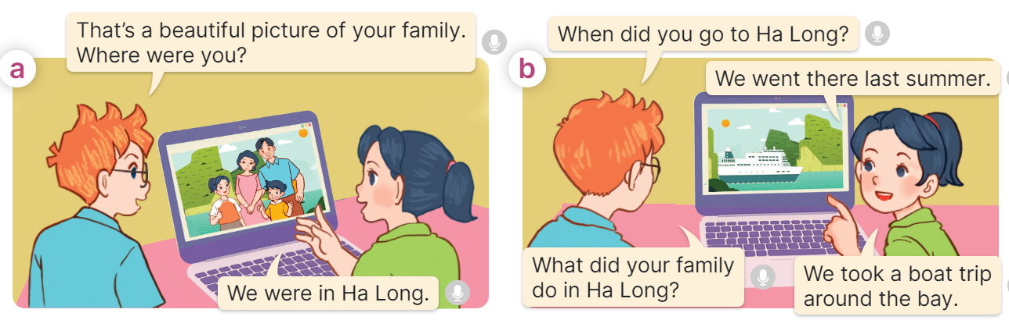  - Play the recording for them to listen.  - Play the recording again (sentence by sentence) for Ss to listen and repeat Correct their pronunciation where necessary.  - Invite a few pairs to the front of the classroom to listen to and repeat the sentences.  - T checks pronunciation for ss.  Activity 3. Listen, point and say.  *Aims: Ss will be able to correctly say the words and use What did your family do in ….? - We …... to ask and answer questions about what someone did somewhere in the past.  *Procedure:  * Structures:  - T asks Ss look at picture b and helps Ss know the structure from the dialogue.  - T introduces new structure for Ss.  - T explains, models and gives meaning.  - Have Ss repeat the structures.  A: What did your family do in Ha Long?  B: We took a boat trip around the bay.  *Drill pictures  - Have Ss look at the pictures and elicit the activities of the characters in each picture.  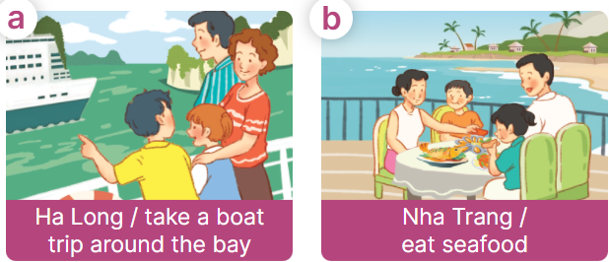    - Explain that the answer is used to express the activity someone did in the past and that took is the past tense of the verb take  + take – took + eat – ate  + see – saw + buy - bought  - Have Ss point at pictures, listen and run through all the pictures.  - Have Ss point at the bubbles, listen and run through model sentences.  - Have Ss to practise:  + T asks the first picture, Ss answer  + Ss asks the second picture, T answers  + Group A asks the third picture, group B  answers  + Group B asks the last picture, group A  - Ask Ss to work in pairs to practise asking and answering the question What did your family do in ….? - We …...  - T controls and corrects.  - Invite a few pairs to point at the pictures and say the questions and answers in front of the class.  - T gives feedbacks.  Activity 4. Let’s talk.  *Aims: Ss will be able to correctly use What did your family do in _____? - ___. and What did your family do  there? – ___. in a freer context.  *Procedure:  - Ask questions to help them identify the context.  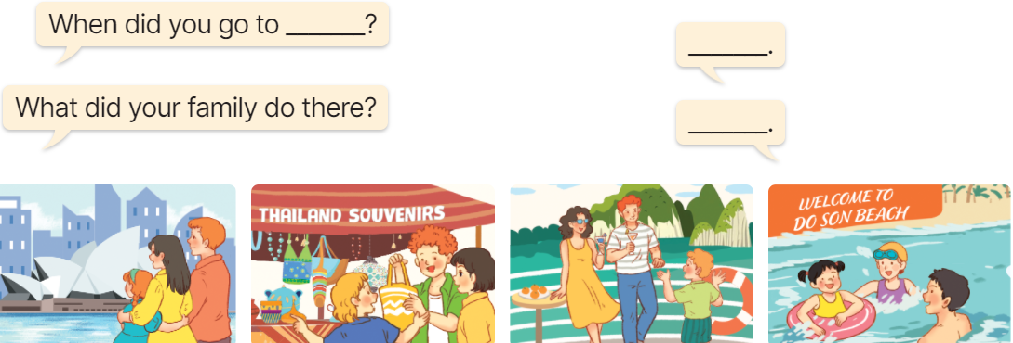  - Elicit the answer in the speech bubble and write it on the board. Get Ss to say the completed sentences.  - Have Ss role-play to practise asking the questions and giving their answers in pairs, using the picture cue What did your family do in _____? - ___. and What did your family do there? – ___.  - Invite a few pairs to point at the pictures and ask and answer questions.  - Invite some pairs of ss to ask and answer questions about the real activities: when and what someone’s family did in the past.  Game: Matching the word with the correct picture  - Tell ss how the game is played. Give an example.  - Put the pictures on the board. Point to each picture one at a time for ss to say the time.  - Give cards with phrases to different pupils. Ask them to come to the front of the class and put their card below the appropriate picture, ex: the pupil with the card “buy souvenirs” puts his / her card below the picture “a picture of someone buying souvenirs”.  - Praise ss if they do the activity well.  - Learn by heart vocabulary, structure  - Do exercise Unit 11 part D in workbook  -Prepare Unit 11(cont.): Lesson 2 (4,5,6) | - Ss listen to teacher’s instruction  - Ss play the game  Ex:  A: Did you take a photo yesterday?  B: Yes, I did. I took a photo with my sister.  - Ss open their books  -Ss listen and answer  - students with disabilities only read vocabulary( take a boat trip around the bay,  eat seafood, see some interesting places, buy souvenirs)  - - Ss listen and repeat  + Choral repetition (3 times).  + Individual repetition (3 ss)  - Ss take note  - Ss look, remember and write  -Look at the pictures and get to know the characters in the pictures.  + In picture a:  Ben: That’s a beautiful picture of your family. Where were you?  Mai: We were in Ha Long.  – In picture b:  Ben: When did you go to Ha Long?  Mai: We went there last summer.  Ben: What did your family do in Ha Long?  Mai: We took a boat trip round the bay.  -Ss listen  -Ss listen and repeat in chorus  - Pairs of Ss listen and repeat  -Ss listen  -Ss look at the picture and answer.  -Ss listen  -Ss listen and repeat  -Ss repeat to the structures.  - students with disabilities only read vocabulary( take a boat trip around the bay,  eat seafood, see some interesting places, buy souvenirs)  - Ss look, listen and answer  a. family taking a boat trip around Ha Long  b. a family eating seafood in Nha Trang  c. a family visiting Sydney  d. a family buying souvenirs in Singapore  -Ss listen to the teacher’s instruction  -Ss point at pictures, listen and repeat  -Ss point at the bubbles, listen and repeat  -Ss practice in chorus  -Ss practice in chorus  -Ss work in pairs to practise asking and answering the question  - Pairs of Ss point at the pictures and say in front of the class  -Ss look at the picture and answer  + a family visiting some interesting places in Sydney; a family buying souvenirs at the souvenir shop in Thailand; a family taking a boat trip at Ha Long Bay; a family swimming in the sea in Do Son  - Ss say the completed sentences.  -Ss work in pairs to ask and answer  +We went there last summer.  + We visited some interesting places.  -Ss perform in front of the class.  - Ss ask and answer about their family.  -Ss listen to the teacher  - Ss play the game  - Continue playing the game.
D. ADJUSTMENTS (if necessary):
………………………………………………………………………………………….…..……………………………………………………………………………...……

Week 19 Period 76

Unit 11: Family time
Lesson 2 (4, 5, 6)
A. OBJECTIVES:
By the end of the lesson, Ss will be able to:
1. Knowledge:
- listen to and understand two communicative contexts about where someone went and what someone did in the past and circle the correct options.
- complete two gaped exchanges with the help of picture cues.
- reinforce the use of target vocabulary for asking and answering questions about past activities and travel destinations by playing the When and What game.
- Vocabulary: Review
- Skills: speaking, listening, reading and writing.
2. Competences:
- Communication and collaboration: work in pairs and groups to complete the learning tasks.
3. Attitude/ Qualities:
- Show their love and interest in outdoor activities.
- Raise their awareness of doing outdoor activities carefully.
B. TEACHING AIDS:
- Teacher: Teacher’s guide Pages 181, 182 audio Tracks 7; website hoclieu.vn, posters, laptop, pictures, textbook, lesson plan, TV or projector.
- Students: Student’s book Page 9, notebooks, workbooks, school things.
C. PROCEDURES:
Stages/ Time | Teacher’s activities | Students’ activities
1.Warm- up and review: (4’)  2.Practice: (25’)  3. Fun corner and wrap- up (4’)  4.Homework (2’) | Play a game: Multiple choice (ppt)  *Aims: to revise the learnt words and structure  *Procedure:  - Place several flashcards (take a boat trip around the bay, eat seafood, see some interesting places, buy souvenirs) and the options on the board.  - Have ss take turns choosing the correct answer for each picture.  - If they choose the correct answers, they will get gifts from the teacher.  - Praise ss if they do the game well,  - Say “Open your book page 9” and look at “Unit 11, Lesson 2 (4,5,6)”.  Activity 1. Listen and circle:  *Aims: Ss will be able to listen to and understand two communicative contexts about where someone went and what someone did in the past and circle the correct options.  *Procedure:  - Draw ss’ attention to the conversations and the answer options.  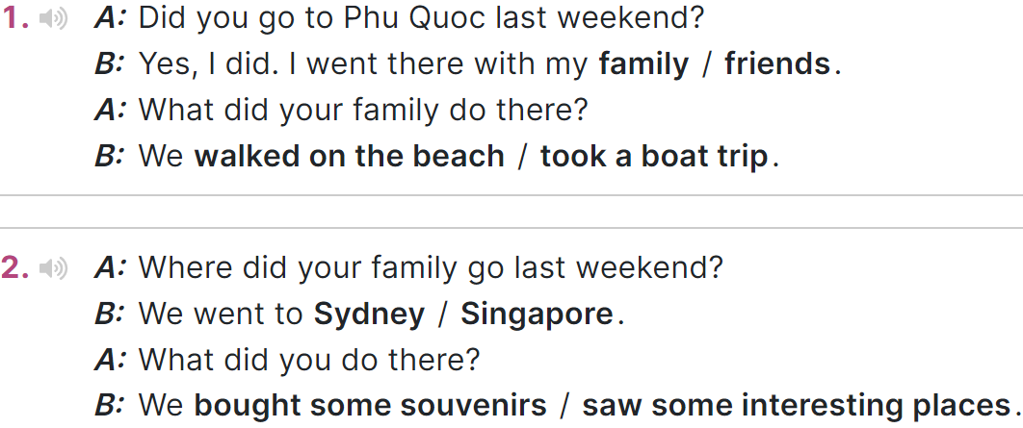  - T ask Ss to guess the answers.  + T writes Ss’guessing on the board.  - Listen to the tape:  + Play the recording  + Play the recording again and get Ss to swap books with their partners.  + Play the recording again to check answers together as a class.  + Write the answers on the board for Ss to correct their answers. Then checks Ss’ guessing.  - Play the recording, sentence by sentence, for the class to listen and repeat in chorus.  Key: 1. family; took a boat trip  2. Sydney; saw some interesting places  Activity 2. Read and complete  *Aims: Ss will be able to complete two gapped exchanges with the help of picture cues  *Procedure:  - Have ss look at the pictures and identify the places, the characters and the activities in the pictures.  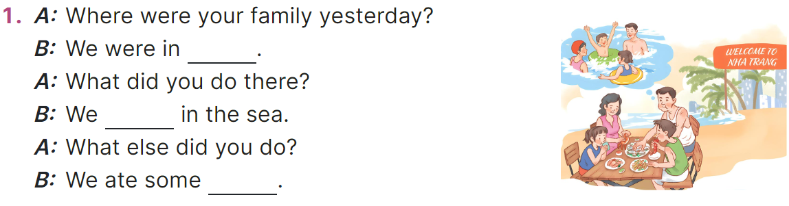  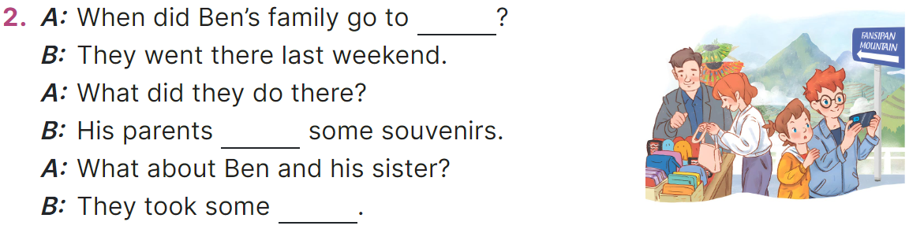  - Have Ss look at the 2 incomplete exchanges and elicits the missing words in the sentences.  - T models with the first gapped  + Ask Ss what is missing in the sentence (Nha Trang).  + Have Ss look at the picture and identify the needed information (We were in Nha Trang.).  - Have Ss work in pairs and complete  - Get Ss to swap books with a partner and check their answers before checking as a class.  Key: 1. a dolphin, Why  2. pizza, don’t, a sandwich  Activity 3. Let’s play.  *Aims: Ss will be able to reinforce the use of target vocabulary for asking and answering questions about past activities and travel destinations by playing the When and What game  *Procedure:  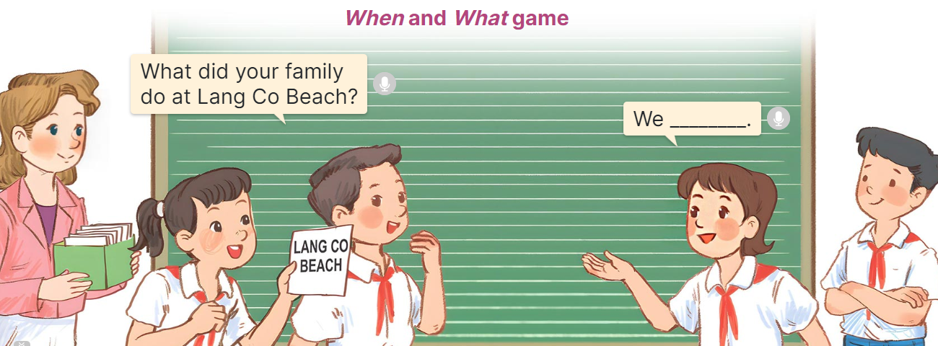  - Tell ss that they are going to play the When and What game and use the past tense form of irregular verbs such as take, eat, buy, swim and go.  - Divide ss into Team A and Team B and explain the rules  - Team A and Team B switch roles  - Set a time limit for ss to play the game. When the time is up, the team that has provided more correct answers is the winner.  - Invite a few groups to the front of the class to play the game.  Game: Pass the balls  - Give two different coloured balls to two pupils, a red ball (ask the question) and a yellow ball (answer the question).  - Ask ss to listen to music and pass the balls.  - Stop music suddenly.  - The teacher raises a picture. Have the student with a red ball make a question. Have the student with a yellow ball answer the question.  - Praise ss if they do the activity well.  - Learn by heart vocabulary, structure  - Do exercise Unit 11 part E in workbook  -Prepare Unit 11(cont.): Lesson 3 (1,2,3) | - Ss pay attention.  -Ss play the game  -Ss play the game  - Ss congratulate to the winner  - Ss open their books  - Look at the pictures and say  -Ss guess the answers  - Ss listen to the tape and match  - Ss listen again, match and swap books with their partners.  - Ss check their answers and guessing  - Ss answer and check  -Ss listen and repeat.  - students with disabilities only read vocabulary( Where, family, yesterday,we, sea,when,sister)  -Ss look at the picture and say  -Ss follow the teacher demonstrating the exchange 1.  -Ss read and answer  -Ss work in pairs and fill in the gaps  - Ss swap books and check  -Ss listen and pay attention  - Ss play the game  -Ss play the game  -Ss play the game  -Ss play the game  Ex:  A: What did your family do in Sydney?  Pupil B: We saw some interesting places.
D. ADJUSTMENTS (if necessary):
………………………………………………………………………………………….…..……………………………………………………………………………...……

Week 19 Preparing date: 11/01/2025
Period 77 Teaching date: 16/01/2025 – Class 5C

Unit 11: Family time
Lesson 3 (1, 2, 3)
A. OBJECTIVES:
By the end of the lesson, Ss will be able to:
1. Knowledge:
- stress the correct words in Wh-questions in the questions 'When did they 'go to 'London? and 'What did they 'do in 'Finland?;
- identify and underline the missing stressed word in four questions, and to say the questions with the correct stress while listening
- say the chant with the correct pronunciation, word stress and rhythm.
- Vocabulary: Review
- Skills: speaking, listening, reading and writing.
2. Competences:
- Communication and collaboration: work in pairs and groups to complete the learning tasks.
- Self-control and independent learning: perform pronunciation and listening tasks.
3. Attitude/ Qualities:
- Show their love and interest in outdoor activities.
- Raise their awareness of doing outdoor activities carefully.
B. TEACHING AIDS:
- Teacher: Teacher’s guide Pages 188, 189, 190; audio Tracks 8, 9, 10; website hoclieu.vn, posters, laptop, pictures, textbook, lesson plan, TV or projector.
- Students: Students’ book Page 10, notebooks, workbooks, school things.
C. PROCEDURES:
Stages/Time | Teacher’s activities | Students’ activities
1.Warm- up and review: (5’)  2. Presentation (9’)  3.Practice: (15’)  3. Fun corner and wrap- up (4’)  4.Homework  (2’) | Game: Pass the balls  *Aims: to revise the learnt words and structures.  *Procedure:  - Give two different coloured balls to two ss, a red ball (ask the question) and a yellow ball (answer the question).  - Ask ss to listen to music and pass the balls.  - Stop music suddenly.  - The teacher raises a picture. Have the student with a red ball make a question. Have the student with a yellow ball answer the question.  - Praise ss if they do the activity well.  - Say “Open your book page 10” and look at “Unit 11, Lesson 3 (1,2,3)”.  Activity 1. Listen and repeat:  *Aims: Ss will be able to stress the correct words in Wh-questions in the questions 'When did they 'go to 'London? and 'What did they 'do in 'Finland? *Procedure:  - T gives instruction the sentences 'When did they 'go to 'London? and 'What did they 'do in 'Finland?  - Play the recording and encourage Ss to point to the word and sentence while listening  - Play the recording again and encourage Ss to listen and repeat.  - Have Ss work in pairs or groups to do this several times until Ss feel confident.  - T invites some Ss to practice.  Activity 2. Listen and underline one more stressed word. Then repeat  *Aims: Ss will be able to identify and underline the missing stressed word in four questions, and to say the questions with the correct stress while listening.  *Procedure:  - Tell ss the goal of the activity and explain that they have to listen to the recording and underline one more stressed word.  - Play the recording all the way through for ss to listen to the questions.  - Play the recording again for ss to underline one more stressed word of the questions.  - Tell ss to swap books with a partner, then check the answers together as a class.  - Have ss discuss with pupils if they can spot a pattern to what words are stressed in Wh-questions (the wh-question word, the main verb and the place).  - Play the recording again for ss to double-check their answers.  - Invite one or two ss to stand up and repeat the correct answers.  Key: 1. Sydney 2. Paris  3. When 4. Do  Activity 3. Let’s chant  *Aims: Ss will be able to say the chant with the correct pronunciation, word stress and rhythm  *Procedure:  - Introduce the title and lyrics of the chant.  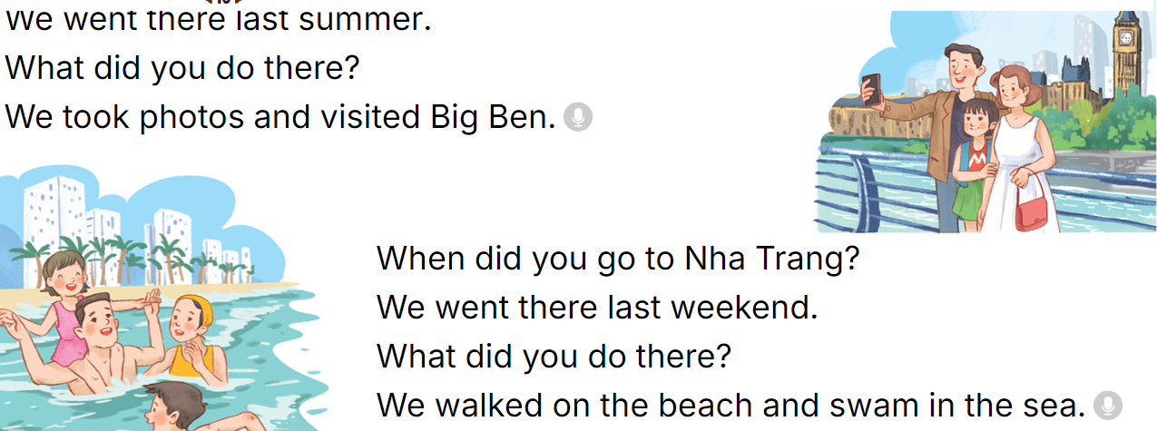  - Play the recording for Ss to listen to the whole chant.  + Have them repeat the title and lyrics line by line.  + Ask Ss to attent the word stress in the Wh-questions  - Play the recording all the way through for Ss to listen to pronunciation and melody.  - Play the recording line by line for Ss to listen and repeat  - Play the recording for Ss to chant and clap along.  - Ask Ss to practice chant and clap along in pairs or groups.  - Invite groups to the front of the classroom to perform the chant  Game: Whisper  - Tell ss how the game is played. Give an example.  - Divide the class into two groups.  - Have ss from each group stand or sit in a row.  - Whisper a sentence to the first student in each row.  - Have the first student whisper the sentence to the second student  - Have groups continue whispering the sentence until it reaches the last student.  - The last student in the row has to say out the correct sentence.  - Give the first group saying the sentence correctly one point.  - The group with more points wins. Praise the winner.  - Learn by heart vocabulary, structure  - Do exercise Unit 11 part E in workbook  -Prepare Unit 11(cont.): Lesson 3 (4,5,6) | - Ss listen  -Ss listen the rules  - Ss play the game  Ex:  A: What did your family do in Sydney?  B: We saw some interesting places.  - Ss open their books  - - Ss pay attention  - Ss listen and point  - Ss listen again and repeat  -Ss work in pairs and practice  -Ss say the language in front of the class  - Ss listen to the teacher’s explanation.  - Ss listen to the questions  - Ss listen again and underline one more stressed word of the questions.  - Ss swap books and check the answers as a class.  -Ss listen to the teacher’s instruction.  - Ss listen again to double-check their answers.  - Ss stand up and repeat the correct answers.  - students with disabilities only read the chant and clap their hands follow the music  - Ss listen to the chant  - Ss listen and repeat line by line without clap their hands  - Ss note the rhythm and pronunciation.  -Ss listen to melody of the chant  - Ss listen and chant line by line.  - Ss chant and clap along.  - Ss work in groups (two groups) to chant  -Ss perform in front of the class.  -Ss listen  -Ss play the game  Ex:  Round 1. 'When did you 'go to 'Sydney?/ 'What did he 'do in 'Paris?  Round 2. 'When did she 'go to 'England?/ 'What did they 'do in 'Thailand?  -Ss praise the winner
D. ADJUSTMENTS (if necessary):
………………………………………………………………………………………….…..……………………………………………………………………………...………………………………………….…..………………………………………………

Week 19 Period 78

Unit 11: Family time
Lesson 3 (4, 5, 6)
A. OBJECTIVES:
By the end of the lesson, Ss will be able to:
1. Knowledge:
- read and understand a paragraph about a family trip in the past by answering four questions
- complete a paragraph about someone’s family’s weekend trip by writing the target words in the gaps
- make a photo journal by sticking some photos/ pictures of the activities he/ she did somewhere with friends the previous summer, and tell the class about it.
- Vocabulary: Review
- Skills: speaking, listening, reading and writing.
2. Competences:
- Communication and collaboration: work in pairs and groups to complete the learning tasks.
- Self-control and independent learning: perform reading and writing tasks.
3. Attitude/ Qualities:
- Show their love and interest in outdoor activities.
- Raise their awareness of doing outdoor activities carefully.
B. TEACHING AIDS:
- Teacher: Teacher’s guide Pages 190, 191, 192; website hoclieu.vn, posters, laptop, pictures, textbook, lesson plan, TV or projector.
- Students: Student’s book Page 11, notebooks, workbooks, school things.
C. PROCEDURES:
Stages/Time | Teacher’s activities | Students’ activities
1.Warm- up and review: (5’)  2.Practice: (8’)  3.Production(16’)  4. Fun corner and wrap- up (4’)  5.Homework  (2’) | Game: “Memory Chain”  *Aims: to create a friendly and active atmosphere in the class to beginning the lesson.  *Procedure:  -Tell ss they are going to remember the four questions in a chain.  - Divide the class into two groups. Each group has eight ss.  - Ask eight ss from each group to take turns playing the game.  - Have Student A say the first question, then have student B say the next question and so on. If a student forgets a sentence, the group must start from student A again.  - The winning group is the first one to have all members finish speaking. Praise the winner.  - Say “Open your book page 11” and look at “Unit 11, Lesson 3 (4,5,6)”.  Activity 1. Read and answer:  *Aims: Ss will be able to read and understand a paragraph about a family trip in the past by answering four questions.  *Procedure:  - Have ss read the questions carefully. Tell them to read Question 1 and pay attention to keywords such as Where, Linda’s family, go. and answer the question.  - Set a time limit for sls to do the rest of the task independently.  - Get ss to swap books with the partner and check the answers before checking as a class.  - Invite some pairs to take turns asking and answering the questions.  - Ask ss some more questions.  Ex:  When did Linda’s family go to Ha Long Bay? What did they do there on Sunday?  Did they explore the caves and eat seafood?  Key:  1. They went to Ha Long Bay.  2. They sunbathed, took some photos and swam in the sea.  3. They took a boat trip around the bay on Sunday.  4. They bought some souvenirs for their friends  Activity 2. Let’s write  *Aims: Ss will be able to complete a paragraph about someone’s family’s weekend trip by writing the target words in the gaps.  *Procedure:  - Ask ss to read the gapped sentences and fill in the gaps with information about someone’s family’s weekend trip.  - Ask Ss to read the first sentence, then elicit where they went the previous weekend (Ex: Sa Pa) and write the first sentence (Last weekend, my family went to Sa Pa.)  - Give Ss time to complete the rest of the paragraph independently.  - Get Ss to swap their books with a partner and check their spelling.  - Invite a student to read his / her completed paragraph aloud  - In groups, have ss share the activities that their family did last weekend.  - Ask Ss share with the class.  Key: Pupil’s answer  Ex: Last weekend, my family went to Sa Pa. On Saturday, we visited Sa Pa Town and went to see the mountains. We took lots of photos there. On Sunday, we went shopping in the town. My brother bought a shirt and I bought some souvenirs for my friends. Our trip was a lot of fun!  Activity 3. Project.  *Aims: Ss will be able to make a photo journal by sticking some photos/pictures of the activities he/ she did somewhere with friends the previous summer, and tell the class about it.  *Procedure:  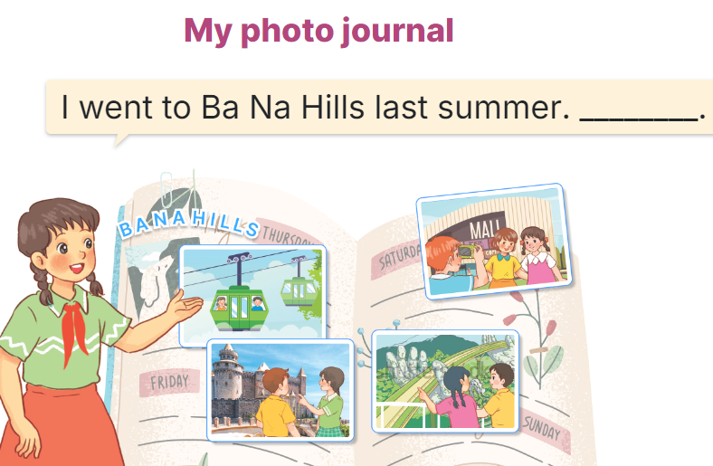  - Explain that each pupil has to show his/her photo journal which includes some photos/ pictures of friends and their activities (they have prepared at home) and tell the class about where they went and what they did there.  - Have Ss work in groups of five or six. Each student shows his / her photo journal to the group and describes what he/she and friends did somewhere last summer.  - Invite a few ss representing some groups to show their photo journals and tell the class about the activities of the friends in the photos/ pictures, Ex: I went to Ba Na Hills last summer with my friends. We took the cable car. We visited Golden Bridge…  - Have the rest of the class give comments and praise ss if they perform well.  Game: Serial reading  - Show the text on the board.  - Divide the class into groups of four.  - Have ss work in groups and read the text serially.  - Invite some ss to the front of the class and perform their work.  - Praise ss to encourage their performance.  - Learn by heart vocabulary, structure  - Do exercise Unit 11 part F in workbook  -Prepare Unit 12: Lesson 1 (1,2,3) | - Ss listen  - Ss listen to the rules  -Ss play game  Ex:  'When did you 'go to 'Sydney?  'What did he 'do in 'Paris?  'When did she 'go to 'England?  'What did they 'do in 'Thailand?  - Ss open their books  - Ss read the questions carefully. Ss read Question 1 and look at keywords and scan the text for relevant information.  - Ss do the task independently.  - Ss swap books and check the answers before checking as a class.  - Ss ask and answer the questions.  - Ss answer the questions.  - Ss read the gapped sentences and fill in the gaps.  - Ss do the first gapped sentence.  - Ss complete the paragraph independently.  - Ss swap their books and check their spelling.  - Ss read the paragraphs aloud  - Ss share the activities that their family did last weekend.  -Ss share with the class.  - students with disabilities only draw the pictures about journal  - Ss listen to the teacher’s explanation.  - Ss work in and describes what he/she and friends did somewhere last summer.  - Ss tell the class about the activities of the friends in the photos/ pictures.  - Ss congratulate  -Ss listen to the teacher  -Ss play the game  -Ss congratulate the winner
D. ADJUSTMENTS (if necessary):
………………………………………………………………………………………….…..……………………………………………………………………………...……

Week 19
Period 73

Unit 11: Family time
Lesson 1 (1, 2, 3)
A. OBJECTIVES:
By the end of the lesson, Ss will be able to:
1. Knowledge:
- understand and correctly repeat the sentences in two communicative contexts focusing on asking and answering questions about whether someone did something in the past.
- correctly say the words and use Did you ……? - Yes, I ……. I …….. to ask and answer questions about whether someone did something in the past;
- correctly use Did you ……? - Yes, I …… I …….. to ask and answer questions about whether someone did something in the past in a freer context
- Vocabulary: take a photo, collect seashells, walk on the beach, buy postcards.
- Structures: A: Did you swim?
B: Yes, I did. I swam with my mother.
- Skills: speaking and listening
2. Competences:
- Communication and collaboration: work in pairs and groups to complete the learning tasks.
- Self-control and independent learning: perform pronunciation and speaking tasks.
3. Attitude/ Qualities:
- Show their love and interest in outdoor activities.
- Raise their awareness of doing outdoor activities carefully.
B. TEACHING AIDS:
- Teacher: Teacher’s guide Pages 178, 179, 180, 181, audio Tracks 1, 2, website hoclieu.vn, posters, laptop, pictures, textbook, lesson plan, TV or projector.
- Students: Students’ book Page 6, notebooks, workbooks, school things.
C. PROCEDURES:
Stages/  Time | Teacher’s activities | Students’ activities
1.Warm- up and review: (3’)  2. Presentation (13’)  3.Practice: (7’)  4. Production: (6’)  5. Fun corner and wrap- up (4’)  6.Homework (2’) | Sing a song: Chicken dance  *Aims: to create a friendly and active atmosphere in the class to beginning the lesson.  *Procedure:  - Show the song on the screen.  https://www.youtube.com/watch?v=WZJAIkmT3Rg&t=10s  - Ask Ss to listen, sing and dance the song  - Say “Open your book page 6” and look at “Unit 11, Lesson 1 (1,2,3)”.  Activity 1. Vocabulary.  *Aims: Ss will be able to know the vocabulary in the new lesson.  *Procedure:  -T elicits the new words  + take photos: chụp hình (mime)  + collect seashells : nhặt vỏ sò  (picture)  + walk on the beach : đi bộ trên bãi biển (picture)  +buy postcards: mua bưu thiếp  (picture)  - T models (3 times).  - T writes the words on the board.  - Checking: Rub out and remember  Activity 2. Look, listen and repeat:  *Aims: Ss will be able to understand and correctly repeat the sentences in two communicative contexts focusing  on asking and answering questions about whether someone did something in the past.  *Procedure:  - Have Ss look at Pictures a and b and identify the characters and their activities in the pictures.  + Who are they?  + Where are they?  + What are they talking about?  - Play the audio twice (sentence by sentence). Correct their pronunciation where necessary.  - Have Ss to practice the dialogue  - T invites a few pairs to the front of the class to practice.  - T checks pronunciation for ss.  Activity 3 Listen, point and say.  *Aims: Ss will be able to correctly say the words and use Did you …….? - Yes, I …... I …… to ask and answer questions about whether someone did something in the past.  *Procedure:  * Structures:  - T asks Ss look at picture b in activity 1 and helps Ss know the structure from the dialogue.  - T introduces new structures for Ss.  - T explains, models and gives meaning.  - Have Ss repeat the structure  A: Did you swim?  B: Yes, I did. I swam with my mother.  *Drill pictures  - Have Ss look at the picture and identify the characters and their activities in the past.  - Explain that the question and answer are used to express the activity someone did in the past and that swam is the past tense of the verb swim  + swim – swam + take – took  + collect – collected  + walk - walked  - Have Ss point at pictures, listen and run through all the pictures.  - Have Ss point at the bubbles, listen and run through model sentences.  - Have Ss to practise:  + T asks the first picture, Ss answer  + Ss asks the second picture, T answers  + Group A asks the third picture, group B  answers  + Group B asks the last picture, group A  - Ask Ss to work in pairs to practise asking and answering the question Did you ……?  B: Yes, I ……. I ………  - T controls and corrects.  - Invite a few pairs to point at the pictures and say the questions and answers in front of the class.  Activity 4. Let’s talk.  *Aims: Ss will be able to correctly use Did you …….? - Yes, I ……... I …... to ask and answer questions about whether someone did something in the past in a freer context.  *Procedure:  - Have ss look at the picture and ask questions to help them identify the context  +What can you see in the picture?  +What are they doing?  - Elicit the answer in the speech bubble and write it on the board. Get Ss to say the completed sentences.  - Have Ss role-play to practise asking the questions and giving their answers in pairs, using the picture cue.  - Invite a few pairs to point at the pictures and ask and answer questions.  Game: Lucky animals  - Divide the class into two groups.  - Have two ss from each group take turns to choose an animal and do the task.  - If the group chooses a lucky animal, they will get points and continue the next turn.  - Get corresponding points for their group.  - Continue with the other ss.  - The group that gets the most points wins. Praise the winner.  - Learn by heart vocabulary, structure  - Do exercise Unit 11 part A,B in workbook  -Prepare Unit 11(cont.): Lesson 1(4,5,6) | - Sing and dance the song together.  - Ss listen and open their books  -Ss listen and answer  - - Ss listen and repeat  + Choral repetition (3 times).  + Individual repetition (3 ss)  - Ss take note  - Ss look, remember and write  -Look at the pictures and say  +In picture a:  Mary: Hi Mai, where did your family go last Sunday?  Mai: We went to the beach.  + In picture b:  Mary: Did you swim?  Mai: Yes, I did. I swam with my mother.  Mary: That’s great!  -Ss listen and repeat in chorus (twice)  -Ss work in pairs to practice  -Ss come to the front of the classroom to practice.  -Ss listen  - Ss look at the picture and answer.  -Ss listen  -Ss listen and repeat  -Ss repeat to the structures  - Ss look, listen and repeat  +Picture a: a girl swimming with her mother.  + Picture b: a girl taking photos with his father.  + Picture c: a girl collecting seashells with her brother.  + Picture d: a girl walking on the beach with her family.  -Ss listen to the teacher’s instructions  -Ss point at pictures, listen and repeat  -Ss point at the bubbles, listen and repeat  -Ss practice in chorus  -Ss practice in chorus  -Ss work in pairs to practise asking and answering the question  - Pairs of Ss point at the pictures and say in front of the class  -Ss look at the picture and answer  + a girl taking photos with her mother; a boy collecting seashells with his brother; a boy walking on the beach with his family; a boy swimming with his father  - Ss say the completed sentences.  -Ss work in pairs to ask and answer  -Ss perform in front of the class.  - Ss listen  -Ss listen and play the game  Ex:  A: Did you swim?  B: Yes, I did. I swam with my father.  -Ss continue to play the game.  -Ss praise the winner.
D. ADJUSTMENTS (if necessary):
………………………………………………………………………………………….…..……………………………………………………………………………...……

Week 19 Period 74
Unit 11: Family time
Lesson 1 (4, 5, 6)
A. OBJECTIVES:
By the end of the lesson, Ss will be able to:
1. Knowledge:
- listen to and understand four communicative contexts about people doing activities in the past and match four characters with the correct pictures.
- read and circle the correct answers with the help of the picture cues.
- listen to and complete the song Did you swim last Sunday? and to sing it with the correct pronunciation, rhythm and melody.
- Vocabulary: Review
- Skills: speaking, listening, reading and writing.
2. Competences:
- Communication and collaboration: work in pairs and groups to complete the learning tasks.
- Self-control and independent learning: perform listening and reading tasks.
3. Attitude/ Qualities:
- Show their love and interest in outdoor activities.
- Raise their awareness of doing outdoor activities carefully.
B. TEACHING AIDS:
- Teacher: Teacher’s guide Pages 181, 182, 183; audio Tracks 7; website hoclieu.vn, posters, laptop, pictures, textbook, lesson plan, TV or projector.
- Students: Student’s book Page 7, notebooks, workbooks, school things.
C. PROCEDURES:
 | Teacher’s activities | Students’ activities
1.Warm- up and review: (5’)  2.Practice: (23’)  3. Fun corner and wrap- up (5’)  4.Homework (2’) | Game: Card passing  *Aims: to revise the learned structures.  *Procedure:  - Stick the cards on the board. Ask ss to say the words related to the cards.  - Hand out the cards to different ss around the class.  - Play the song “Hello song” and ask ss to pass the cards to the ss next to them while the music is playing.  - Stop the music suddenly. Invite a student who is holding the card to ask the question “Did you swim yesterday?”. Ask another student to answer, ex: Yes, I did. I swam with my sister.  - Play the music again and repeat the activity.  - Say “Open your book page 7” and look at “Unit 11, Lesson 1 (4,5,6)”.  Activity 1. Listen and match:  *Aims: Ss will be able to listen to and understand four communicative contexts about people doing activities in the past and match four characters with the correct pictures.  *Procedure:  - Elicit the characters’ names and the activities in the pictures.  +What’s his/ her name?  +What are they doing?  - T ask Ss to guess the answers.  + T writes Ss’guessing on the board.  - Listen to the tape:  + Play the recording  + Play the recording again for pupils to do the task.  + Play the recording a third time for pupils to check their answers.  - Get Ss to swap books with their partner, then check answers as a class.  + Write the answers on the board for Ss to correct their answers. Then checks Ss’ guessing.  - Have ss explain the answers.  Key: 1. a 2. d 3.b 4.a  Activity 2. Read and circle.  *Aims: Ss will be able to read and circle the correct answers with the help of the picture cues  *Procedure:  - Get Ss to look at the pictures and identify the characters  - Have Ss look at the three incomplete exchanges and elicits the options  - T models with sentence 1  + Have Ss circle the correct answer (swam)  + Have Ss look at the picture and identify the needed information (swam).  - Have Ss work in groups and complete the sentences 2, 3 and 4.  - Get Ss to swap books with a partner and check their answers before checking as a class.  -T gives feedbacks.  Key:  1. swam; 2. walk;  3. did; went; 4. were; buy  Activity 3. Listen, complete and sing  *Aims: Ss will be able to listen to and complete the song Did you swim last Sunday? and to sing it with the correct pronunciation, rhythm and melody  *Procedure:  - Introduce the title and lyrics of the song:“Did you swim last Sunday?”  - Tell ss the aim of the activity  - Draw ss’ attention to the gapped sentences and guess the missing words and complete the sentences.  - Play the recording all the way through for ss to listen to the whole song.  - Play the recording again for them to fill in the gaps with the missing words.  - Check answers together as a class.  - Play the recording line by line for ss to listen and repeat.  - Invite a few groups to the front of the class to sing the song.  Key: 1. beach 2. park 3. took  Game: Who’s faster?  - Explain how the game is played: each group will make a question and an answer for a picture given.  - Model the activity. Stick a phrase on the board (swim/ last Sunday). Have two ss come to the board and write the question and answer.  - Divide the class into four groups. Give each group a piece of paper and a picture. Give two minutes for pupils to do the task.  - Have each group stick the piece of paper on the board. Check the answers as the class.  - The group finishing first and having correct answers wins. Praise the winner.  - Learn by heart vocabulary, structure  - Do exercise Unit 11 part C in workbook  -Prepare Unit 11(cont.): Lesson 2 (1,2,3) | - Ss listen to the teacher’s instruction  - Ss play the game  - Continue playing the game.  - Ss open their books  -Look at the pictures and say:  + 1. Mai 2. Nam  3. Lucy 4. Ben  + Picture a: a family walking on the beach  + Picture b: a boy and a girl collecting seashells  + Picture c: a family taking photos.  + Picture d: a boy and a girl swimming in the sea  -Ss guess the answers  - Ss listen to the tape  - Ss listen again and do the task.  - Ss listen and check their answers  - Ss swap books with their partner, then check answers as a class and guessing  -Ss explain the answers  -Ss look at the picture and identify the characters  -Ss look at the exchanged and pay attention  -Ss look and choose the correct answer  -Ss listen and pay attention  -Ss complete the sentences  -Ss swap books with a partner and check their answers before checking as a class.  -Ss listen  - Ss listen and pay attention  - Ss listen to the teacher’s instruction.  - Ss look at the gapped sentences and guess the missing words and complete the sentences.  - Ss listen to the song  - Ss listen and fill in the gaps with missing words.  - Ss check answers together as a class.  - Ss listen to the recording, line by line, and repeat.  - Ss come to the front of the class to sing the song.  - Ss listen  -Ss listen and play the game  Ex:  A: Did you swim last Sunday?  B: Yes, I did. I swam with my mother.  - Ss continue playing the game
D. ADJUSTMENTS (if necessary):
………………………………………………………………………………………….…..……………………………………………………………………………...……

Week 19
Period 75

Unit 11: Family time
Lesson 2 (1, 2, 3)
A. OBJECTIVES:
By the end of the lesson, Ss will be able to:
1. Knowledge:
- understand and correctly repeat the sentences in two communicative contexts focusing on asking and answering questions about what someone did somewhere in the past.
- correctly say the words and use What did your family do in ____? - We ___. to ask and answer questions about what someone did somewhere in the past.
- correctly use What did your family do in _____? - ___. and What did your family do there? – ……. in a freer context.
- Vocabulary: take a boat trip around the bay, eat seafood, see some interesting places and buy souvenirs.
- Structures: A: What did your family do in Ha Long?
B: We took a boat trip around the bay.
- Skills: speaking and listening
2. Competences:
- Critical thinking and creativity: learn how to ask and answer questions about what someone did somewhere in the past correctly and fluently.
- Communication and collaboration: work in pairs and groups to complete the learning tasks.
3. Attitude/ Qualities:
- Show their love and interest in outdoor activities.
- Raise their awareness of doing outdoor activities carefully.
B. TEACHING AIDS:
- Teacher: Teacher’s guide Pages 183, 184, 185, 196; audio Tracks 5, 6, website hoclieu.vn, posters, laptop, pictures, textbook, lesson plan, TV or projector.
- Students: Students’ book Page 8, notebooks, workbooks, school things.
C. PROCEDURES:
Stages/ Time | Teacher’s activities | Students’ activities
1.Warm- up and review: (3’)  2. Presentation (15’)  3.Practice: (6’)  4. Production: (5’)  5. Fun corner and wrap- up (4’)  6.Homework (2’) | Game: Lucky star game  *Aims: to revise the sentence structures about someone who did something in the past.  *Procedure:  - Divide the class into 2 groups: boys and girls.  - Tell ss they are going to look at the pictures and ask and answer the questions about the pictures.  - Have two ss from each group take turns to choose a star and do the task.  - If they ask and answer the question correctly, they will get one point. If they don’t ask and answer the question correctly, the other group will ask and answer.  - If the group chooses a lucky star, they will get one point and continue the next turn.  - Get corresponding points for their group.  - Continue with the other pupils.  - The group that gets the most points will win. Praise the winner.  - Say “Open your book page 8” and look at “Unit 11, Lesson 2 (1,2,3)”.  Activity 1. Vocabulary.  *Aims: Ss will be able to know the vocabulary in the new lesson.  *Procedure:  -T elicits the new words  + take a boat trip around the bay : đi du lịch bằng tàu thuỷ vòng quanh vịnh (picture)  + eat seafood : ăn hải sản (picture)  + see some interesting places: thăm 1 vài nơi thú vị (picture)  + buy souvenirs.: mua quà lưu niệm  (example)  - T models (3 times).  - T writes the words on the board.  - Checking: Rub out and remember  Activity 2. Look, listen and repeat:  *Aims: Ss will be able to understand and correctly repeat the sentences in two communicative contexts focusing on asking and answering questions about what someone did somewhere in the past.  *Procedure:  - Have Ss look at Pictures a and b and identify the place, characters and their activities in the pictures.  - Play the recording for them to listen.  - Play the recording again (sentence by sentence) for Ss to listen and repeat Correct their pronunciation where necessary.  - Invite a few pairs to the front of the classroom to listen to and repeat the sentences.  - T checks pronunciation for ss.  Activity 3. Listen, point and say.  *Aims: Ss will be able to correctly say the words and use What did your family do in ….? - We …... to ask and answer questions about what someone did somewhere in the past.  *Procedure:  * Structures:  - T asks Ss look at picture b and helps Ss know the structure from the dialogue.  - T introduces new structure for Ss.  - T explains, models and gives meaning.  - Have Ss repeat the structures.  A: What did your family do in Ha Long?  B: We took a boat trip around the bay.  *Drill pictures  - Have Ss look at the pictures and elicit the activities of the characters in each picture.  - Explain that the answer is used to express the activity someone did in the past and that took is the past tense of the verb take  + take – took + eat – ate  + see – saw + buy - bought  - Have Ss point at pictures, listen and run through all the pictures.  - Have Ss point at the bubbles, listen and run through model sentences.  - Have Ss to practise:  + T asks the first picture, Ss answer  + Ss asks the second picture, T answers  + Group A asks the third picture, group B  answers  + Group B asks the last picture, group A  - Ask Ss to work in pairs to practise asking and answering the question What did your family do in ….? - We …...  - T controls and corrects.  - Invite a few pairs to point at the pictures and say the questions and answers in front of the class.  - T gives feedbacks.  Activity 4. Let’s talk.  *Aims: Ss will be able to correctly use What did your family do in _____? - ___. and What did your family do  there? – ___. in a freer context.  *Procedure:  - Ask questions to help them identify the context.  - Elicit the answer in the speech bubble and write it on the board. Get Ss to say the completed sentences.  - Have Ss role-play to practise asking the questions and giving their answers in pairs, using the picture cue What did your family do in _____? - ___. and What did your family do there? – ___.  - Invite a few pairs to point at the pictures and ask and answer questions.  - Invite some pairs of ss to ask and answer questions about the real activities: when and what someone’s family did in the past.  Game: Matching the word with the correct picture  - Tell ss how the game is played. Give an example.  - Put the pictures on the board. Point to each picture one at a time for ss to say the time.  - Give cards with phrases to different pupils. Ask them to come to the front of the class and put their card below the appropriate picture, ex: the pupil with the card “buy souvenirs” puts his / her card below the picture “a picture of someone buying souvenirs”.  - Praise ss if they do the activity well.  - Learn by heart vocabulary, structure  - Do exercise Unit 11 part D in workbook  -Prepare Unit 11(cont.): Lesson 2 (4,5,6) | - Ss listen to teacher’s instruction  - Ss play the game  Ex:  A: Did you take a photo yesterday?  B: Yes, I did. I took a photo with my sister.  - Ss open their books  -Ss listen and answer  - - Ss listen and repeat  + Choral repetition (3 times).  + Individual repetition (3 ss)  - Ss take note  - Ss look, remember and write  -Look at the pictures and get to know the characters in the pictures.  + In picture a:  Ben: That’s a beautiful picture of your family. Where were you?  Mai: We were in Ha Long.  – In picture b:  Ben: When did you go to Ha Long?  Mai: We went there last summer.  Ben: What did your family do in Ha Long?  Mai: We took a boat trip round the bay.  -Ss listen  -Ss listen and repeat in chorus  - Pairs of Ss listen and repeat  -Ss listen  -Ss look at the picture and answer.  -Ss listen  -Ss listen and repeat  -Ss repeat to the structures.  - Ss look, listen and answer  a. family taking a boat trip around Ha Long  b. a family eating seafood in Nha Trang  c. a family visiting Sydney  d. a family buying souvenirs in Singapore  -Ss listen to the teacher’s instruction  -Ss point at pictures, listen and repeat  -Ss point at the bubbles, listen and repeat  -Ss practice in chorus  -Ss practice in chorus  -Ss work in pairs to practise asking and answering the question  - Pairs of Ss point at the pictures and say in front of the class  -Ss look at the picture and answer  + a family visiting some interesting places in Sydney; a family buying souvenirs at the souvenir shop in Thailand; a family taking a boat trip at Ha Long Bay; a family swimming in the sea in Do Son  - Ss say the completed sentences.  -Ss work in pairs to ask and answer  +We went there last summer.  + We visited some interesting places.  -Ss perform in front of the class.  - Ss ask and answer about their family.  -Ss listen to the teacher  - Ss play the game  - Continue playing the game.
D. ADJUSTMENTS (if necessary):
………………………………………………………………………………………….…..……………………………………………………………………………...……

Week 19
Period 76

Unit 11: Family time
Lesson 2 (4, 5, 6)
A. OBJECTIVES:
By the end of the lesson, Ss will be able to:
1. Knowledge:
- listen to and understand two communicative contexts about where someone went and what someone did in the past and circle the correct options.
- complete two gaped exchanges with the help of picture cues.
- reinforce the use of target vocabulary for asking and answering questions about past activities and travel destinations by playing the When and What game.
- Vocabulary: Review
- Skills: speaking, listening, reading and writing.
2. Competences:
- Communication and collaboration: work in pairs and groups to complete the learning tasks.
3. Attitude/ Qualities:
- Show their love and interest in outdoor activities.
- Raise their awareness of doing outdoor activities carefully.
B. TEACHING AIDS:
- Teacher: Teacher’s guide Pages 181, 182 audio Tracks 7; website hoclieu.vn, posters, laptop, pictures, textbook, lesson plan, TV or projector.
- Students: Student’s book Page 9, notebooks, workbooks, school things.
C. PROCEDURES:
Stages/ Time | Teacher’s activities | Students’ activities
1.Warm- up and review: (4’)  2.Practice: (25’)  3. Fun corner and wrap- up (4’)  4.Homework (2’) | Play a game: Multiple choice (ppt)  *Aims: to revise the learnt words and structure  *Procedure:  - Place several flashcards (take a boat trip around the bay, eat seafood, see some interesting places, buy souvenirs) and the options on the board.  - Have ss take turns choosing the correct answer for each picture.  - If they choose the correct answers, they will get gifts from the teacher.  - Praise ss if they do the game well,  - Say “Open your book page 9” and look at “Unit 11, Lesson 2 (4,5,6)”.  Activity 1. Listen and circle:  *Aims: Ss will be able to listen to and understand two communicative contexts about where someone went and what someone did in the past and circle the correct options.  *Procedure:  - Draw ss’ attention to the conversations and the answer options.  - T ask Ss to guess the answers.  + T writes Ss’guessing on the board.  - Listen to the tape:  + Play the recording  + Play the recording again and get Ss to swap books with their partners.  + Play the recording again to check answers together as a class.  + Write the answers on the board for Ss to correct their answers. Then checks Ss’ guessing.  - Play the recording, sentence by sentence, for the class to listen and repeat in chorus.  Key: 1. family; took a boat trip  2. Sydney; saw some interesting places  Activity 2. Read and complete  *Aims: Ss will be able to complete two gapped exchanges with the help of picture cues  *Procedure:  - Have ss look at the pictures and identify the places, the characters and the activities in the pictures.  - Have Ss look at the 2 incomplete exchanges and elicits the missing words in the sentences.  - T models with the first gapped  + Ask Ss what is missing in the sentence (Nha Trang).  + Have Ss look at the picture and identify the needed information (We were in Nha Trang.).  - Have Ss work in pairs and complete  - Get Ss to swap books with a partner and check their answers before checking as a class.  Key: 1. a dolphin, Why  2. pizza, don’t, a sandwich  Activity 3. Let’s play.  *Aims: Ss will be able to reinforce the use of target vocabulary for asking and answering questions about past activities and travel destinations by playing the When and What game  *Procedure:  - Tell ss that they are going to play the When and What game and use the past tense form of irregular verbs such as take, eat, buy, swim and go.  - Divide ss into Team A and Team B and explain the rules  - Team A and Team B switch roles  - Set a time limit for ss to play the game. When the time is up, the team that has provided more correct answers is the winner.  - Invite a few groups to the front of the class to play the game.  Game: Pass the balls  - Give two different coloured balls to two pupils, a red ball (ask the question) and a yellow ball (answer the question).  - Ask ss to listen to music and pass the balls.  - Stop music suddenly.  - The teacher raises a picture. Have the student with a red ball make a question. Have the student with a yellow ball answer the question.  - Praise ss if they do the activity well.  - Learn by heart vocabulary, structure  - Do exercise Unit 11 part E in workbook  -Prepare Unit 11(cont.): Lesson 3 (1,2,3) | - Ss pay attention.  -Ss play the game  -Ss play the game  - Ss congratulate to the winner  - Ss open their books  - Look at the pictures and say  -Ss guess the answers  - Ss listen to the tape and match  - Ss listen again, match and swap books with their partners.  - Ss check their answers and guessing  - Ss answer and check  -Ss listen and repeat.  -Ss look at the picture and say  -Ss follow the teacher demonstrating the exchange 1.  -Ss read and answer  -Ss work in pairs and fill in the gaps  - Ss swap books and check  -Ss listen and pay attention  - Ss play the game  -Ss play the game  -Ss play the game  -Ss play the game  Ex:  A: What did your family do in Sydney?  Pupil B: We saw some interesting places.
D. ADJUSTMENTS (if necessary):
………………………………………………………………………………………….…..……………………………………………………………………………...……

