LESSON PLAN
WEEK: 18 | FROM : 06/01/2025 TO 10/01/2025
Date | Time | Number | Class | Period | Name of the lesson
Monday  06/01 | Morning | 2 | 4A | 69 | Review 2 (part 1,2)
 |  | 3 | 4A | 70 | Review 2(part 3,4,5)
 |  | 4 | 3A | 69 | Review 2(part 1,2)
 |  | 5 | 3A | 70 | Review 2(part 3,4,5)
 | Afternoon | 4 | 4B | 69 | Review 2(part 1,2)
Tuesday  07/01 | Morning | 1 | 5B | 69 | Review 2 (part 1,2)
 |  | 2 | 5B | 70 | Review 2(part 3,4,5)
 |  | 3 | 5C | 69 | Review 2(part 1,2)
 |  | 4 | 5C | 70 | Review 2(part 3,4,5)
 | Afternoon | 4 | 3A | 71 | Fun Time + Review from Unit 1-Unit 10
Wednesday  08/01/ 2025 | Morning | 1 | 4A | 71 | Extension activities +Review from Unit 1-Unit 10
 |  | 2 | 4A | 72 | The first term test+ Exercise
 |  | 3 | 4B | 70 | Review 2 (part 3,4,5)
 |  | 4 | 4B | 71 | Extension activities +Review from Unit 1-Unit 10
Thursday  09/01 | Morning | 1 | 5C | 71 | Extension activities +Review from Unit 1-Unit 10
 |  | 2 | 5C | 72 | The first term test + Exercise
 |  | 3 | 5B | 71 | Extension activities +Review from Unit 1-Unit 10
 |  | 4 | 5B | 72 | The first term test + Exercise
 |  | 5 | 4B | 72 | The first term test+ Exercise
 | Afternoon | 4 | 3A | 72 | The first term test, Exercise
Week 18 Preparing date: 04/01/2025
Period 69

Review 2
Parts 1, 2
A. OBJECTIVES:
By the end of the lesson, Ss will be able to:
1. Knowledge:
- listen to and understand five communicative contexts in which characters talk about familiar topics such as our school, our favourite school activities, location of school things, where someone went, what someone did, and tick the correct pictures
- ask and answer questions using picture cues or personal information.
- Vocabulary: Review
- Skills: speaking, listening, reading and writing.
2. Competences:
- Communication and collaboration: work in pairs and teams to complete the learning tasks.
- Self-control and independent learning: perform reading and writing tasks.
3. Attitude/ Qualities:
- Study hard to review the vocabulary and sentence patterns they have learnt.
- Be honest in the learning tasks.
B. TEACHING AIDS:
- Teacher: Teacher’s guide Pages 171, 172, 173; Track 106; website hoclieu.vn, posters, laptop, pictures, textbook, lesson plan, TV or projector.
- Students: Student’s book Page 74, notebooks, workbooks, school things.
C. PROCEDURES:
Stages/  Time | Teacher’s activities | Students’ activities
1.Warm- up: (5’)  2.Practice: (24’)  3. Fun corner and wrap- up (4’)  4.Homework  (2’) | Game: Whispering  *Aims: to revise the sentence structures they have learnt.  *Procedure:  - Divide class into 2 groups.  - Ask 5 Ss in each group stand in a straight line.  - T says a word or phrase to the first student in this line.  - Then, the first student whispers what she/ he hear to the second person in line; the second one whispers what he/ she hears to the third one and so on until the last student in group hears the word or phrase.  - The last student says the word or phrase out loud.  - The faster group has correct word or phrase is the winner.  - Say “Open your book page 74” and look at Review 2.  Activity 1. Listen and tick:  *Aims: Ss will be able to listen to and understand five communicative contexts in which characters talk about familiar topics such as our school, our favourite school activities, location of school things, where someone went, what someone did, and tick the correct pictures.  *Procedure:  - Draw Ss’ attention to the pictures and elicit the informations  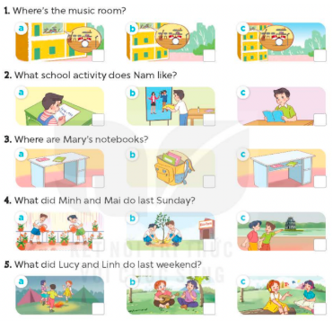  - Play the recording for Ss to do the task. (three times)  - Get Ss to swap books with a partner, then check answers as a class.  - Write the correct answers on the board.  - Play the recording for S to double-check their answers.  - Play the recording, have Ss listen and repeat in chorus.  Key: 1. a 2. a 3. c 4. b 5. a  Activity 2. Ask and answer:  *Aims: Ss will be able to ask and answer questions using picture cues personal information.  *Procedure:  - Draw ss’ attention to look at the picture, the questions and elicit the answer.  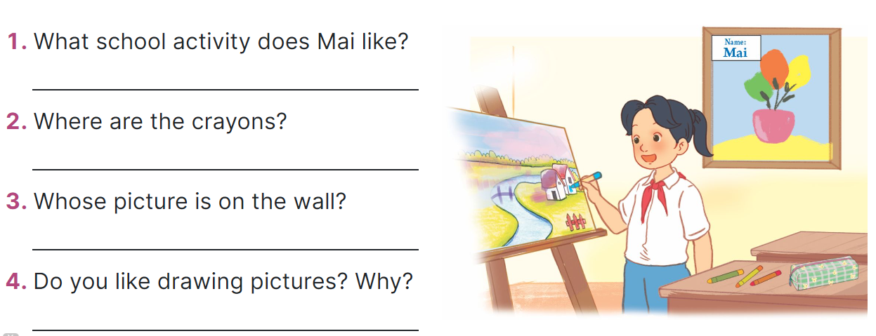  - Have Ss look at the picture to answer the question.  - Have Ss work in pairs to role-play the four exchanges.  - Invite pairs of Ss to stand up and take it in turns to role-play the target exchanges.  Suggested answers:  1. She likes drawing pictures.  2. They’re on the desk.  3. It’s Mai’s.  4. For example: Yes, I do. Because I think it’s interesting.  Game: “Pass the ball”  - Give two different colored balls to two pupils, a blue ball (ask the question) and a white ball (answer the question).  - Ask Ss to listen to music and pass the balls.  - Stop music suddenly. Have the student with a blue ball make a question. Have the student with a white ball answer the question.  - Repeat the game several times.  -Prepare Review 2: Parts 3, 4, 5 | - Ss listen  -Ss play game  -Ss play game  -Ss praise the winner  - Ss open their books  - Ss listen and say  + Picture 1a: a music room on 1st floor  + Picture 1b: a music room on 2nd floor  + Picture 1c: a music room on 3rd floor  + Picture 2a: Nam doing maths  + Picture 2b: Nam doing crafts  + Picture 2c: Nam reading a book  + Picture 3a: two notebooks on a desk  + Picture 3b: two notebooks in a school bag  + Picture 3c: two notebooks in a desk  + Picture 4a: Minh and Mai watering the flowers  + Picture 4b: Minh and Mai planting trees  + Picture 4c: Minh and Mai walking around Hoan Kiem Lake  + Picture 5a: Lucy and her friends dancing  + Picture 5b: Lucy and Linh playing the guitar and singing  + Picture 5: Lucy and Linh listening to music  - Ss listen to the recording and do the task.  - Ss swap books with a partner, then check answers as a class.  - Ss listen to the recording to double-check their answers.  - Ss listen to the recording and repeat  -Look at the pictures and say  - Ss look at and answer.  - Ss work in pairs to role play  - Ss role play  -Ss listen to the teacher  -Ss play the game  Ex: A: Where did you go last Sunday?  B: I went to Ba Na Hills  -Ss continue playing the game.
D. ADJUSTMENTS (if necessary):
………………………………………………………………………………………….…..……………………………………………………………………………...…….
Week 18
Period 70

Review 2
Parts 3, 4, 5
A. OBJECTIVES:
By the end of the lesson, Ss will be able to:
1. Knowledge:
- read and match five pairs of target sentence patterns.
- read a text about Lan’s trip with her class to Ba Na Hills and number the sentences in order (from 1 to 4)
- write a short paragraph about someone’s trip the previous Sunday.
- Vocabulary: Review
- Skills: speaking, listening, reading and writing.
2. Competences:
- Communication and collaboration: work in pairs and teams to complete the learning tasks.
- Self-control and independent learning: perform reading and writing tasks.
3. Attitude/ Qualities:
- Study hard to review the vocabulary and sentence patterns they have learnt.
- Be honest in the learning tasks.
B. TEACHING AIDS:
- Teacher: Teacher’s guide Pages 174, 175; website hoclieu.vn, posters, laptop, pictures, textbook, lesson plan, TV or projector.
- Students: Student’s book Page 75, notebooks, workbooks, school things.
C. PROCEDURES:
Stages/Time | Teacher’s activities | Students’ activities
1.Warm- up and review: (5’)  2.Practice: (16’)  3.Production: (8’)  4. Fun corner and wrap- up (4’)  5. Homework  (2’) | Game: Kim’s game  *Aims: to revise the sentence structures they have learnt.  *Procedure:  - Divide the class into two teams.  - Display many words and phrases on the board. Give ss two minutes to memorise these words and phrases.  Ex: play the guitar, dance around the campfire, listen to music, read books, plant trees, crayon, glue stick, friendly, active, clever, pencil sharpener, ...  - Turn the word cards face down on the board. In their teams, the ss try to write down many words as they can remember.  - Check the answers as the class.  - Count the points for each team and announce the winner. The team with the most points wins.  - Say “Open your book page 75” and look at Review 2.  Activity 1. Read and match  *Aims: Ss will be able to read and match five pairs of target sentence patterns  *Procedure:  - Tell Ss about this activity. Point at sentence 1, elicit the answer and models.  - Give Ss work in pairs to do the sentence 2,3,4,5.  - Tell Ss to swap their books with their partners, then check answers together as a class.  - Write the correct answers on the board for Ss to correct their answers.  - Invite some pairs to stand up and read the matched exchanges aloud.  Key: 1. e 2. d 3. a 4. b 5. c  Activity 2. Read and number  *Aims: Ss will be able to read a text about Lan’s trip with her class to Ba Na Hills and number the sentences in order (from 1 to 4).  *Procedure:  - Elicit the words showing the sequences of activities, ex: first, then, after that  - Have ss read the text and the jumbled sentences below the text and number the sentences from 1 to 4.  - Set a time limit for ss to do the task.  - Get ss to swap their answers with a partner, then check answers together as a class.  Key:  2. a. They visited the old buildings and the wax museum.  4. b. They went home late in the afternoon.  3. c. They played some games at the amusement park.  1. d. Lan and her classmates walked on the Golden Bridge and liked the cable car ride.  Activity 3. Let’s write  *Aims: Ss will be able to write a short paragraph about someone’s trip the previous Sunday.  *Procedure:  - Ask ss to read the guiding questions  - Model the first question together and ask ss to read the question and elicit where they went the previous Sunday.  - Give ss time to complete the paragraph independently.  - Get ss to swap their writings with a partner  - Invite a few Ss to read their writings in front of the class.  Suggested answer:  Last Sunday, I went to Hoan Kiem Lake with my friends. In the morning, we walked around the lake. We visited Ngoc Son Temple. In the afternoon, we went to see the water puppet show at the water puppet theatre by the lake. Our trip was a lot of fun!  Game: Hot seat  - Tell ss that they are going to listen to music and answer the question.  - Divide the class into five groups.  - Elect one student from each group to sit in the Hot Seat, facing the classroom with the board behind him/her.  - Write a word on the board. One of the group members of the pupil in the Hot Seat must help the student guess the word by describing it. They have a limited amount of time and cannot say, spell or draw the word.  - Continue until each group member has described a word to the student in the Hot Seat.  -Prepare : Extension activities | - Ss listen and pay attention  -Ss play game  -Ss praise the winner.  - Ss open their books  -Ss look at the sentence 1 and say  -Ss work in pairs and match  -Ss swap their books and match  -Ss check their answer  -Ss read aloud  - Ss pay attention and follow the teacher’s instructions.  - Ss read the text and the jumbled sentences  - Ss do the task.  - Ss swap books and check answers  - Ss read the guiding questions.  - Ss read the question and and write the first sentence.  - Ss complete the paragraph independently.  - Ss swap their writings  - Ss read their writings in front of the class.  -Ss listen to the teacher  -Ss play the game  Ex: A: What did you do yesterday?  B: We………..  -Ss continue playing the game.
D. ADJUSTMENTS (if necessary):
………………………………………………………………………………………….…..……………………………………………………………………………...…….
Week 18
Period 71

Extension activities
A. OBJECTIVES:
By the end of the lesson, Ss will be able to:
1. Knowledge:
- revise vocabulary related to activities by correctly categorising activities.
- write details about a holiday.
- review the target vocabulary and sentence patterns by playing a board game.
- Vocabulary: Review
- Skills: speaking, writing and listening
2. Competences:
- Co-operation: ready to help friends in pair work/ group work.
- Sociability: Talk to each other, say good words to others.
3. Attitude/ Qualities:
- Kindness: Help partners to complete learning tasks.
B. TEACHING AIDS:
- Teacher: Teacher’s guide Pages 175, 176, 177; website hoclieu.vn, posters, laptop, pictures, textbook, lesson plan, TV or projector.
- Students: Student’s book Page 76, 77, notebooks, workbooks, school things.
C. PROCEDURES:
Stages/  Time | Teacher’s activities | Students’ activities
1.Warm- up: (3’)  2. Practice (28’)  3. Fun corner and wrap- up (4’) | Game: Pass the cards  *Aims: to create a friendly and active atmosphere in the class to beginning the lesson.  *Procedure:  - Give a card to a student.  - Play music. Have that student pass the card to the next one.  - Stop music suddenly. Have the student holding a card to ask a question and invite another student to answer the question.  - Repeat the game several times.  - Say “Open your book page 76, 77” and look at “Extension activites”.  Activity 1. Write the activities in the correct places  *Aims: Ss will be able to revise vocabulary related to activities by correctly categorising activities.  *Procedure:  - Have Ss read the activities in the word box aloud and check understanding.  - Model the activity and ask: When do you do ice skating? Where? What kind of holiday is its?  - Have Ss work in pairs and complete the activity.  - Have Ss check their answers in groups of four.  - Ask ss write the answer on the board, taking turns until the category boxes are complete.  Key:  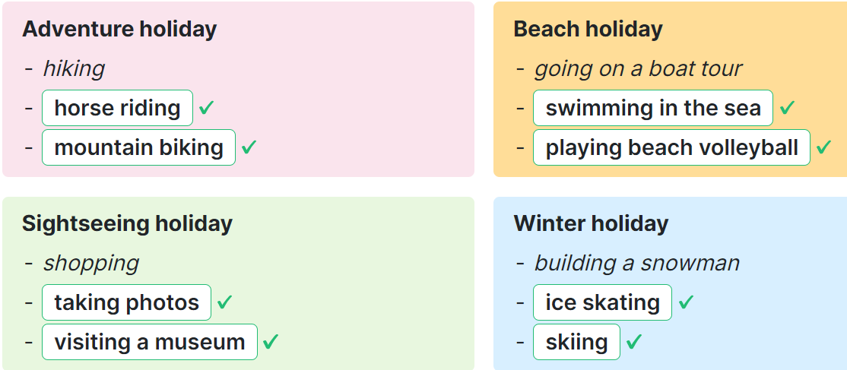  Activity 2. Answer the questions about your last holiday.  *Aims: Ss will be able to write detail about a holiday.  *Procedure:  - Tell Ss the goal of the activity.  - Have Ss read the questions and elicit and answer.  - Have Ss time to complete the activity independenlty.  - Have ss check their answer in pairs, before checking as a class.  Suggested answer:  1. I went to Da Nang.  2. It was a sightseeing holiday.  3. I went with my family.  4. I went swimming, went to a seafood market and played volleyball.  5. Yes, I did. Because I really love the beach and traveling.  Activity 3. Board game. Roll a dice. Listen and answer.  *Aims: Ss will be able to review the target vocabulary and sentence patterns by playing a board game.  *Procedure:  - Tell Ss the goal of the activity  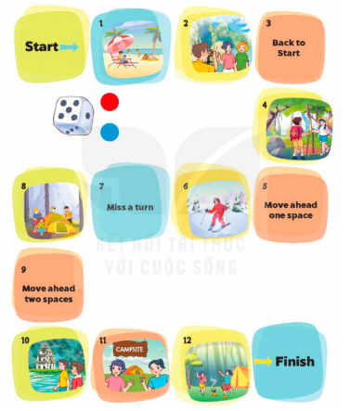  - Divide class into four groups  - Each group rolls the dice in turn. A member of each group moves the group’s counter forward by the number of spaces indicated by the dice.  - When a counter lands on a space with a picture, ask the corresponding question.  + If they do not give a correct answer, their counter must be moved back two spaces and their turn ends  - The game continues until one or all groups reach the “Finish” space.  Key:  1.It’s a beach holiday.  2.They tak photos.  4.Yes, they do.  6.It’s a winter holiday.  8.They put up the tent.  10.Yes, they did.  11.Yes, they were  12.They danced around the campfire.  Sing a song: A ram sam sam  - Show the song on the screen.  https://www.youtube.com/watch?v=SwjvlJCelN0  - Ask Ss to listen, sing and dance the song. | - Ss listen  - Ss play the game  Ex: A: Where did you go last weekend?  B: I went to Ly Son Island.  -Ss continue playing the game  -Ss open the book  -Ss read and say  - - Ss answer: I do it on winter holiday and write ice skating on the board  -Ss do the task  -Ss check together  -Ss write the answer  -Ss listen to the teacher  -Ss read and answer  -Ss read and do the task  -Ss check the answer together  -Ss pay attention  -Ss listen to the teacher  -Ss play the game  -Ss play the game  -Ss play the game  - Ss listen, sing and dance together
D. ADJUSTMENTS (if necessary):
………………………………………………………………………………………….…..……………………………………………………………………………...……

Week 18
Period 72

The first term test

A. OBJECTIVES:
By the end of the lesson, Ss will be able to:
1. Knowledge:
- Check Ss’ comprehension about this theme and get marks.
- Vocabulary: Review
- Model sentences: Review
- Skills: speaking, writing, reading and listening
2. Competences:
- Co-operation: ready to help friends in pair work/ group work.
- Sociability: Talk to each other, say good words to others.
3. Attitude/ Qualities:
- Kindness: Help partners to complete learning tasks.
- Honesty: tell the truth about feelings and emotions
B. TEACHING AIDS:
- Teacher: Textbook, lesson plan, TV or projector, wordsheets.
- Students: School things.
C. PROCEDURES:
Stages/  Time | Teacher’s activities | Students’ activities

35’ | Give the students papers test to do | Whole class to do the test.
D. ADJUSTMENTS (if necessary):
……………………………………………………………………………………….…..……………………………………………………………………………...……

Week 18 Preparing date: 04/01/2025
Period 69 Teaching date: 07/01/2025 – Class 5C

Review 2
Parts 1, 2
A. OBJECTIVES:
By the end of the lesson, Ss will be able to:
1. Knowledge:
- listen to and understand five communicative contexts in which characters talk about familiar topics such as our school, our favourite school activities, location of school things, where someone went, what someone did, and tick the correct pictures
- ask and answer questions using picture cues or personal information.
- Vocabulary: Review
- Skills: speaking, listening, reading and writing.
2. Competences:
- Communication and collaboration: work in pairs and teams to complete the learning tasks.
- Self-control and independent learning: perform reading and writing tasks.
3. Attitude/ Qualities:
- Study hard to review the vocabulary and sentence patterns they have learnt.
- Be honest in the learning tasks.
B. TEACHING AIDS:
- Teacher: Teacher’s guide Pages 171, 172, 173; Track 106; website hoclieu.vn, posters, laptop, pictures, textbook, lesson plan, TV or projector.
- Students: Student’s book Page 74, notebooks, workbooks, school things.
C. PROCEDURES:
Stages/  Time | Teacher’s activities | Students’ activities
1.Warm- up: (5’)  2.Practice: (24’)  3. Fun corner and wrap- up (4’)  4.Homework  (2’) | Game: Whispering  *Aims: to revise the sentence structures they have learnt.  *Procedure:  - Divide class into 2 groups.  - Ask 5 Ss in each group stand in a straight line.  - T says a word or phrase to the first student in this line.  - Then, the first student whispers what she/ he hear to the second person in line; the second one whispers what he/ she hears to the third one and so on until the last student in group hears the word or phrase.  - The last student says the word or phrase out loud.  - The faster group has correct word or phrase is the winner.  - Say “Open your book page 74” and look at Review 2.  Activity 1. Listen and tick:  *Aims: Ss will be able to listen to and understand five communicative contexts in which characters talk about familiar topics such as our school, our favourite school activities, location of school things, where someone went, what someone did, and tick the correct pictures.  *Procedure:  - Draw Ss’ attention to the pictures and elicit the informations  - Play the recording for Ss to do the task. (three times)  - Get Ss to swap books with a partner, then check answers as a class.  - Write the correct answers on the board.  - Play the recording for S to double-check their answers.  - Play the recording, have Ss listen and repeat in chorus.  Key: 1. a 2. a 3. c 4. b 5. a  Activity 2. Ask and answer:  *Aims: Ss will be able to ask and answer questions using picture cues personal information.  *Procedure:  - Draw ss’ attention to look at the picture, the questions and elicit the answer.  - Have Ss look at the picture to answer the question.  - Have Ss work in pairs to role-play the four exchanges.  - Invite pairs of Ss to stand up and take it in turns to role-play the target exchanges.  Suggested answers:  1. She likes drawing pictures.  2. They’re on the desk.  3. It’s Mai’s.  4. For example: Yes, I do. Because I think it’s interesting.  Game: “Pass the ball”  - Give two different colored balls to two pupils, a blue ball (ask the question) and a white ball (answer the question).  - Ask Ss to listen to music and pass the balls.  - Stop music suddenly. Have the student with a blue ball make a question. Have the student with a white ball answer the question.  - Repeat the game several times.  -Prepare : Review 2 (Parts 3, 4, 5) | - Ss listen  -Ss play game  -Ss play game  -Ss praise the winner  - Ss open their books  - Ss listen and say  + Picture 1a: a music room on 1st floor  + Picture 1b: a music room on 2nd floor  + Picture 1c: a music room on 3rd floor  + Picture 2a: Nam doing maths  + Picture 2b: Nam doing crafts  + Picture 2c: Nam reading a book  + Picture 3a: two notebooks on a desk  + Picture 3b: two notebooks in a school bag  + Picture 3c: two notebooks in a desk  + Picture 4a: Minh and Mai watering the flowers  + Picture 4b: Minh and Mai planting trees  + Picture 4c: Minh and Mai walking around Hoan Kiem Lake  + Picture 5a: Lucy and her friends dancing  + Picture 5b: Lucy and Linh playing the guitar and singing  + Picture 5: Lucy and Linh listening to music  - Ss listen to the recording and do the task.  - Ss swap books with a partner, then check answers as a class.  - Ss listen to the recording to double-check their answers.  - Ss listen to the recording and repeat  - students with disabilities only draw the pictures about activities ( plant the tree, sing, water the flowers…. )  -Look at the pictures and say  - Ss look at and answer.  - Ss work in pairs to role play  - Ss role play  -Ss listen to the teacher  -Ss play the game  Ex: A: Where did you go last Sunday?  B: I went to Ba Na Hills  -Ss continue playing the game.
D. ADJUSTMENTS (if necessary):
………………………………………………………………………………………….…..……………………………………………………………………………...…….
Week 18 Preparing date: 04/01/2025
Period 70 Teaching date: 07/01/2025 – Class 5C

Review 2
Parts 3, 4, 5
A. OBJECTIVES:
By the end of the lesson, Ss will be able to:
1. Knowledge:
- read and match five pairs of target sentence patterns.
- read a text about Lan’s trip with her class to Ba Na Hills and number the sentences in order (from 1 to 4)
- write a short paragraph about someone’s trip the previous Sunday.
- Vocabulary: Review
- Skills: speaking, listening, reading and writing.
2. Competences:
- Communication and collaboration: work in pairs and teams to complete the learning tasks.
- Self-control and independent learning: perform reading and writing tasks.
3. Attitude/ Qualities:
- Study hard to review the vocabulary and sentence patterns they have learnt.
- Be honest in the learning tasks.
B. TEACHING AIDS:
- Teacher: Teacher’s guide Pages 174, 175; website hoclieu.vn, posters, laptop, pictures, textbook, lesson plan, TV or projector.
- Students: Student’s book Page 75, notebooks, workbooks, school things.
C. PROCEDURES:
Stages/Time | Teacher’s activities | Students’ activities
1.Warm- up and review: (5’)  2.Practice: (16’)  3.Production: (8’)  4. Fun corner and wrap- up (4’)  5.Homework  (2’) | Game: Kim’s game  *Aims: to revise the sentence structures they have learnt.  *Procedure:  - Divide the class into two teams.  - Display many words and phrases on the board. Give ss two minutes to memorise these words and phrases.  Ex: play the guitar, dance around the campfire, listen to music, read books, plant trees, crayon, glue stick, friendly, active, clever, pencil sharpener, ...  - Turn the word cards face down on the board. In their teams, the ss try to write down many words as they can remember.  - Check the answers as the class.  - Count the points for each team and announce the winner. The team with the most points wins.  - Say “Open your book page 75” and look at Review 2.  Activity 1. Read and match  *Aims: Ss will be able to read and match five pairs of target sentence patterns  *Procedure:  - Tell Ss about this activity. Point at sentence 1, elicit the answer and models.  - Give Ss work in pairs to do the sentence 2,3,4,5.  - Tell Ss to swap their books with their partners, then check answers together as a class.  - Write the correct answers on the board for Ss to correct their answers.  - Invite some pairs to stand up and read the matched exchanges aloud.  Key: 1. e 2. d 3. a 4. b 5. c  Activity 2. Read and number  *Aims: Ss will be able to read a text about Lan’s trip with her class to Ba Na Hills and number the sentences in order (from 1 to 4).  *Procedure:  - Elicit the words showing the sequences of activities, ex: first, then, after that  - Have ss read the text and the jumbled sentences below the text and number the sentences from 1 to 4.  - Set a time limit for ss to do the task.  - Get ss to swap their answers with a partner, then check answers together as a class.  Key:  2. a. They visited the old buildings and the wax museum.  4. b. They went home late in the afternoon.  3. c. They played some games at the amusement park.  1. d. Lan and her classmates walked on the Golden Bridge and liked the cable car ride.  Activity 3. Let’s write  *Aims: Ss will be able to write a short paragraph about someone’s trip the previous Sunday.  *Procedure:  - Ask ss to read the guiding questions  - Model the first question together and ask ss to read the question and elicit where they went the previous Sunday.  - Give ss time to complete the paragraph independently.  - Get ss to swap their writings with a partner  - Invite a few Ss to read their writings in front of the class.  Suggested answer:  Last Sunday, I went to Hoan Kiem Lake with my friends. In the morning, we walked around the lake. We visited Ngoc Son Temple. In the afternoon, we went to see the water puppet show at the water puppet theatre by the lake. Our trip was a lot of fun!  Game: Hot seat  - Tell ss that they are going to listen to music and answer the question.  - Divide the class into five groups.  - Elect one student from each group to sit in the Hot Seat, facing the classroom with the board behind him/her.  - Write a word on the board. One of the group members of the pupil in the Hot Seat must help the student guess the word by describing it. They have a limited amount of time and cannot say, spell or draw the word.  - Continue until each group member has described a word to the student in the Hot Seat.  -Prepare Extension activities | - Ss listen and pay attention  -Ss play game  -Ss praise the winner.  - Ss open their books  - students with disabilities only read the questions and answers  -Ss look at the sentence 1 and say  -Ss work in pairs and match  -Ss swap their books and match  -Ss check their answer  -Ss read aloud  - Ss pay attention and follow the teacher’s instructions.  - Ss read the text and the jumbled sentences  - Ss do the task.  - Ss swap books and check answers  - Ss read the guiding questions.  - Ss read the question and and write the first sentence.  - Ss complete the paragraph independently.  - Ss swap their writings  - Ss read their writings in front of the class.  -Ss listen to the teacher  -Ss play the game  Ex: A: What did you do yesterday?  B: We………..  -Ss continue playing the game.
D. ADJUSTMENTS (if necessary):
………………………………………………………………………………………….…..……………………………………………………………………………...…….

Week 18 Preparing date: 04/01/2025
Period 71 Teaching date: 09/01/2025 – Class 5C

Extension activities
A. OBJECTIVES:
By the end of the lesson, Ss will be able to:
1. Knowledge:
- revise vocabulary related to activities by correctly categorising activities.
- write details about a holiday.
- review the target vocabulary and sentence patterns by playing a board game.
- Vocabulary: Review
- Skills: speaking, writing and listening
2. Competences:
- Co-operation: ready to help friends in pair work/ group work.
- Sociability: Talk to each other, say good words to others.
3. Attitude/ Qualities:
- Kindness: Help partners to complete learning tasks.
B. TEACHING AIDS:
- Teacher: Teacher’s guide Pages 175, 176, 177; website hoclieu.vn, posters, laptop, pictures, textbook, lesson plan, TV or projector.
- Students: Student’s book Page 76, 77, notebooks, workbooks, school things.
C. PROCEDURES:
Stages/  Time | Teacher’s activities | Students’ activities
1.Warm- up: (3’)  2. Practice (28’)  3. Fun corner and wrap- up (4’) | Game: Pass the cards  *Aims: to create a friendly and active atmosphere in the class to beginning the lesson.  *Procedure:  - Give a card to a student.  - Play music. Have that student pass the card to the next one.  - Stop music suddenly. Have the student holding a card to ask a question and invite another student to answer the question.  - Repeat the game several times.  - Say “Open your book page 76, 77” and look at “Extension activites”.  Activity 1. Write the activities in the correct places  *Aims: Ss will be able to revise vocabulary related to activities by correctly categorising activities.  *Procedure:  - Have Ss read the activities in the word box aloud and check understanding.  - Model the activity and ask: When do you do ice skating? Where? What kind of holiday is its?  - Have Ss work in pairs and complete the activity.  - Have Ss check their answers in groups of four.  - Ask ss write the answer on the board, taking turns until the category boxes are complete.  Key:  Activity 2. Answer the questions about your last holiday.  *Aims: Ss will be able to write detail about a holiday.  *Procedure:  - Tell Ss the goal of the activity.  - Have Ss read the questions and elicit and answer.  - Have Ss time to complete the activity independenlty.  - Have ss check their answer in pairs, before checking as a class.  Suggested answer:  1. I went to Da Nang.  2. It was a sightseeing holiday.  3. I went with my family.  4. I went swimming, went to a seafood market and played volleyball.  5. Yes, I did. Because I really love the beach and traveling.  Activity 3. Board game. Roll a dice. Listen and answer.  *Aims: Ss will be able to review the target vocabulary and sentence patterns by playing a board game.  *Procedure:  - Tell Ss the goal of the activity  - Divide class into four groups  - Each group rolls the dice in turn. A member of each group moves the group’s counter forward by the number of spaces indicated by the dice.  - When a counter lands on a space with a picture, ask the corresponding question.  + If they do not give a correct answer, their counter must be moved back two spaces and their turn ends  - The game continues until one or all groups reach the “Finish” space.  Key:  1.It’s a beach holiday.  2.They tak photos.  4.Yes, they do.  6.It’s a winter holiday.  8.They put up the tent.  10.Yes, they did.  11.Yes, they were  12.They danced around the campfire.  Sing a song: A ram sam sam  - Show the song on the screen.  https://www.youtube.com/watch?v=SwjvlJCelN0  - Ask Ss to listen, sing and dance the song. | - Ss listen  - Ss play the game  Ex: A: Where did you go last weekend?  B: I went to Ly Son Island.  -Ss continue playing the game  -Ss open the book  -Ss read and say  - - Ss answer: I do it on winter holiday and write ice skating on the board  -Ss do the task  -Ss check together  -Ss write the answer  -Ss listen to the teacher  -Ss read and answer  -Ss read and do the task  -Ss check the answer together  - students with disabilities only draw the pictrures about activities  -Ss pay attention  -Ss listen to the teacher  -Ss play the game  -Ss play the game  -Ss play the game  - Ss listen, sing and dance together
D. ADJUSTMENTS (if necessary):
………………………………………………………………………………………….…..……………………………………………………………………………...……

Week 18 Preparing date: 04/01/2025
Period 72 Teaching date: 09/01/2025 – Class 5C

The first term test

A. OBJECTIVES:
By the end of the lesson, Ss will be able to:
1. Knowledge:
- Check Ss’ comprehension about this theme and get marks.
- Vocabulary: Review
- Model sentences: Review
- Skills: speaking, writing, reading and listening
2. Competences:
- Co-operation: ready to help friends in pair work/ group work.
- Sociability: Talk to each other, say good words to others.
3. Attitude/ Qualities:
- Kindness: Help partners to complete learning tasks.
- Honesty: tell the truth about feelings and emotions
B. TEACHING AIDS:
- Teacher: Textbook, lesson plan, TV or projector, wordsheets.
- Students: School things.
C. PROCEDURES:
Stages/  Time | Teacher’s activities | Students’ activities

35’ | Give the students papers test to do | Whole class to do the test.
D. ADJUSTMENTS (if necessary):
……………………………………………………………………………………….…..……………………………………………………………………………...……

