Week 18
Period 71

Extension activities
A. OBJECTIVES:
By the end of the lesson, Ss will be able to:
1. Knowledge:
- revise vocabulary related to activities by correctly categorising activities.
- write details about a holiday.
- review the target vocabulary and sentence patterns by playing a board game.
- Vocabulary: Review
- Skills: speaking, writing and listening
2. Competences:
- Co-operation: ready to help friends in pair work/ group work.
- Sociability: Talk to each other, say good words to others.
3. Attitude/ Qualities:
- Kindness: Help partners to complete learning tasks.
B. TEACHING AIDS:
- Teacher: Teacher’s guide Pages 175, 176, 177; website hoclieu.vn, posters, laptop, pictures, textbook, lesson plan, TV or projector.
- Students: Student’s book Page 76, 77, notebooks, workbooks, school things.
C. PROCEDURES:
Stages/  Time | Teacher’s activities | Students’ activities
1.Warm- up: (3’)  2. Practice (28’)  3. Fun corner and wrap- up (4’) | Game: Pass the cards  *Aims: to create a friendly and active atmosphere in the class to beginning the lesson.  *Procedure:  - Give a card to a student.  - Play music. Have that student pass the card to the next one.  - Stop music suddenly. Have the student holding a card to ask a question and invite another student to answer the question.  - Repeat the game several times.  - Say “Open your book page 76, 77” and look at “Extension activites”.  Activity 1. Write the activities in the correct places  *Aims: Ss will be able to revise vocabulary related to activities by correctly categorising activities.  *Procedure:  - Have Ss read the activities in the word box aloud and check understanding.  - Model the activity and ask: When do you do ice skating? Where? What kind of holiday is its?  - Have Ss work in pairs and complete the activity.  - Have Ss check their answers in groups of four.  - Ask ss write the answer on the board, taking turns until the category boxes are complete.  Key:  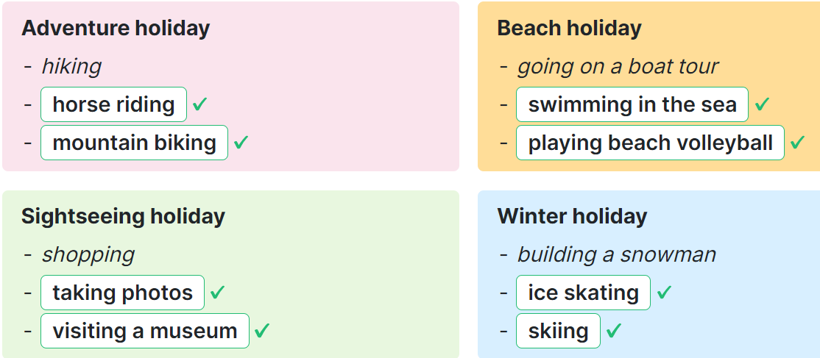  Activity 2. Answer the questions about your last holiday.  *Aims: Ss will be able to write detail about a holiday.  *Procedure:  - Tell Ss the goal of the activity.  - Have Ss read the questions and elicit and answer.  - Have Ss time to complete the activity independenlty.  - Have ss check their answer in pairs, before checking as a class.  Suggested answer:  1. I went to Da Nang.  2. It was a sightseeing holiday.  3. I went with my family.  4. I went swimming, went to a seafood market and played volleyball.  5. Yes, I did. Because I really love the beach and traveling.  Activity 3. Board game. Roll a dice. Listen and answer.  *Aims: Ss will be able to review the target vocabulary and sentence patterns by playing a board game.  *Procedure:  - Tell Ss the goal of the activity  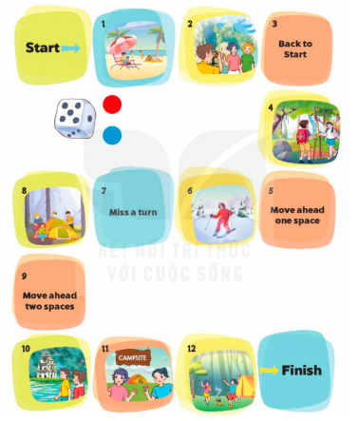  - Divide class into four groups  - Each group rolls the dice in turn. A member of each group moves the group’s counter forward by the number of spaces indicated by the dice.  - When a counter lands on a space with a picture, ask the corresponding question.  + If they do not give a correct answer, their counter must be moved back two spaces and their turn ends  - The game continues until one or all groups reach the “Finish” space.  Key:  1.It’s a beach holiday.  2.They tak photos.  4.Yes, they do.  6.It’s a winter holiday.  8.They put up the tent.  10.Yes, they did.  11.Yes, they were  12.They danced around the campfire.  Sing a song: A ram sam sam  - Show the song on the screen.  https://www.youtube.com/watch?v=SwjvlJCelN0  - Ask Ss to listen, sing and dance the song. | - Ss listen  - Ss play the game  Ex: A: Where did you go last weekend?  B: I went to Ly Son Island.  -Ss continue playing the game  -Ss open the book  -Ss read and say  - - Ss answer: I do it on winter holiday and write ice skating on the board  -Ss do the task  -Ss check together  -Ss write the answer  -Ss listen to the teacher  -Ss read and answer  -Ss read and do the task  -Ss check the answer together  - students with disabilities only draw the pictrures about activities  -Ss pay attention  -Ss listen to the teacher  -Ss play the game  -Ss play the game  -Ss play the game  - Ss listen, sing and dance together
D. ADJUSTMENTS (if necessary):
………………………………………………………………………………………….…..……………………………………………………………………………...……

Week 18 Period 72

The first term test

A. OBJECTIVES:
By the end of the lesson, Ss will be able to:
1. Knowledge:
- Check Ss’ comprehension about this theme and get marks.
- Vocabulary: Review
- Model sentences: Review
- Skills: speaking, writing, reading and listening
2. Competences:
- Co-operation: ready to help friends in pair work/ group work.
- Sociability: Talk to each other, say good words to others.
3. Attitude/ Qualities:
- Kindness: Help partners to complete learning tasks.
- Honesty: tell the truth about feelings and emotions
B. TEACHING AIDS:
- Teacher: Textbook, lesson plan, TV or projector, wordsheets.
- Students: School things.
C. PROCEDURES:
Stages/  Time | Teacher’s activities | Students’ activities

35’ | Give the students papers test to do | Whole class to do the test.
D. ADJUSTMENTS (if necessary):
……………………………………………………………………………………….…..……………………………………………………………………………...……

