Week 15
Period 57
Unit 9: Our sports day
Lesson 1 (4, 5, 6)
A. OBJECTIVES:
By the end of the lesson, Ss will be able to:
1. Knowledge:
- use the words and phrase December, July, June, November, October, September, sports day in relation to the topic "Our sports day".
- listen to and demonstrate understanding of simple exchanges in relation to the topic "Our sports day".
- Vocabulary: Review
- Skills: speaking, listening, reading and writing.
2. Competences:
- Written Communication: complete the sentences.
- Self-control and independent learning: perform listening tasks.
- Communication and collaboration: work in pairs or groups.
3. Attitude/ Qualities:
- Kindness: Help partners to complete learning tasks.
- Honesty: tell the truth about feelings and emotions.
B. TEACHING AIDS:
- Teacher: Teacher’s guide Pages 128, 129, 130; audio Tracks 89, 90; website hoclieu.vn, posters, laptop, pictures, textbook, lesson plan, TV or projector.
- Students: Pupil’s book Page 63, notebooks, workbooks, school things.
C. PROCEDURES:
Teacher’s activities | Students’ activities
1.Warm- up: (5’)  Slap the board  *Aims: to create a friendly and active atmosphere in the class to beginning the lesson.  *Procedure:  - Divide class into 2 groups: Tom and Jerry.  - How to play:  + Each group chooses five Ss to play.  + Class will read aloud.  + Look at the picture, listen and slap the picture you heard.  + Who faster will get 1 mark.  + Which group with higher mark is the winner.  - T gives feedback.  - Say “Open your book page 63” and look at “Unit 9, Lesson 1 (4,5,6)”.  2.Practice: (27’)  Activity 1. Listen and match:  *Aims: Ss will be able to listen to and understand three communicative contexts in which characters ask and answer questions about sports days and match three characters with three correct pictures.  *Procedure:  - Draw pupils’ attention to the pictures of the characters and the months.  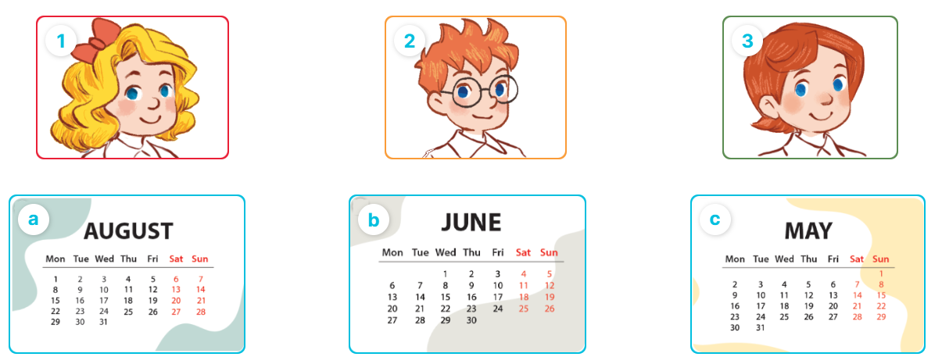  - Play the recording and ask pupils to listen and draw a line to match the character.  Ex: (Mary) with the month (Picture b).  - Play the recording again for pupils to do the task.  - Play the recording a third time to give pupils another listening opportunity if needed.  - Get pupils to swap books with a partner, then check answers together as a class.  - Write the correct answers on the board.  - Play the recording again for pupils to listen and double-check their answers.  - Play the recording, sentence by sentence, for the class to listen and repeat individually and in chorus.  Key: 1. b 2. c 3.a  Activity 2. Look, complete and read  *Aims: Ss will be able to complete four target sentence patterns in four exchanges with the help of picture cues.  *Procedure:  - Have pupils look at the pictures and identify the months.  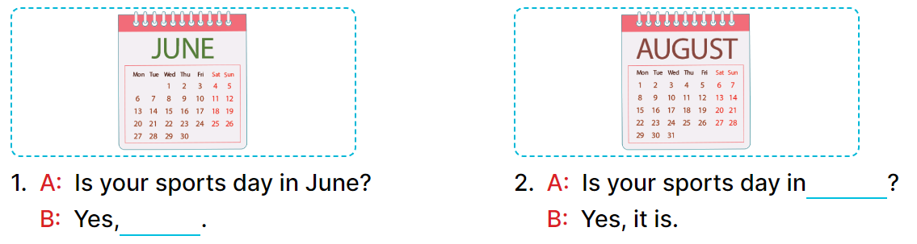  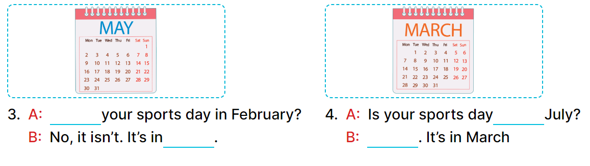  - Have Ss look at the four incomplete dialogue. Elicit and model with picture 1  + Ask Ss to read the sentence 1 in chorus.  + Ask Ss what word is missing in the gap (it is). Then have them complete the sentence (Yes, it is).  -Have Ss work in pairs and complete the sentences 2, 3, 4.  - Ask a few Ss to stand up and read the sentences aloud.  -T gives feedbacks.  Key:  1. it is 2. April  3. Is; May 4. in; No, it isn’t  Activity 3. Let’s sing  *Aims: Ss will be able to sing the song Our sports day with the correct pronunciation, rhythm and melody  *Procedure:  - Draw pupils’ attention to the title and lyrics of the song.  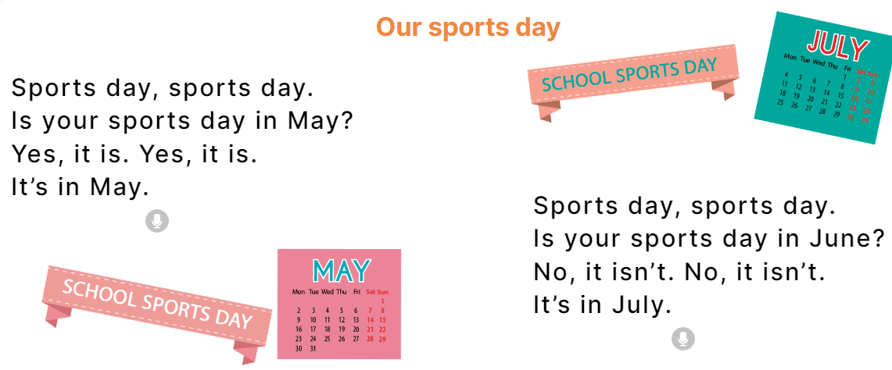  - Play the recording all the way through.  - Play the recording, line by line, for pupils to listen and repeat.  - Introduce actions for pupils to do while they sing along with the recording.  - Play the recording all the way through for pupils to sing along.  - Put pupils into groups to make up their own actions for the song.  - Invite groups to the front of the class to perform, while the rest of the class sings and / or claps along.  Key: 1. red 2. blue  3. yellow 4. brown  *Consolidation  *Aims: Ss will be able consolidate and wrap up the content of the lesson.  *Procedure:  - T asks ss to answer the following questions:  + What have you learnt from the lesson today?  +What are the core values of the lesson? (if the teacher can take from the lesson).  - T praises some Ss who are hardworking / active/ good…. as well as encourage others to try more.  3. Homework. (3’)  - Practice part 5 again.  - Prepare the new lesson: Unit 9, Lesson 2 (1,2,3). | - Ss listen  -Ss listen  - Ss play game  -Ss congratuate the winner  - Ss open their books  -Look at the pictures and say:  1. Mary 2. Ben 3. Lucy  +Picture a. a calendar sheet of April  +Picture b. a calendar sheet of June  +Picture c. a calendar sheet of May  -Ss listen and draw a line to match the character  - Ss listen again and match  - Ss listen again  - Ss swap books and check their answers  -Ss write the correct answer  -Ss listen again and double-check their answers.  -Ss listen and repeat.  -Ss look at the picture and say  + a yellow pencil, a red pencil case, a brown school bag and a blue pen.  -Ss look and answer  -Ss read  -Ss say and write  -Ss work in pairs and complete  -Ss read aloud  -Ss listen  - Ss listen to all the song  -Ss listen and sing line by line  - Ss sing and do action  - Ss listen and sing along  - Ss sing in groups and do action  -Ss sing in front of the class  -Ss answer the questions  -Ss listen and clap their hands  -Ss listen and take note
D. ADJUSTMENTS (if necessary):
………………………………………………………………………………………….…..……………………………………………………………………………...………………………………………….…..……………………………………………………………………………….……………………………………………………………………...

Week 15
Period 58

Unit 9: Our sports day
Lesson 2 (1, 2, 3)
A. OBJECTIVES:
By the end of the lesson, Ss will be able to:
1. Knowledge:
- use the words and phrase December, July, June, November, October, September, sports day in relation to the topic "Our sports day".
- use When's your sports day? – It's in ……... to ask and answer questions about when a sport day is;
- listen to and demonstrate understanding of simple exchanges in relation to the topic "Our sports day"
- Vocabulary: December, November, October, September
- Skills: speaking and listening
2. Competences:
- Self-control and independent learning: perform listening tasks.
- Communication and collaboration: work in pairs or groups.
3. Attitude/ Qualities:
- Develop their interests in sports and show their responsibility by raising awareness of time and date.
B. TEACHING AIDS:
- Teacher: Teacher’s guide Pages 130, 131, audio Tracks 91, 92, website hoclieu.vn, posters, laptop, pictures, textbook, lesson plan, TV or projector.
- Students: Pupil’s book Page 64, notebooks, workbooks, school things.
C. PROCEDURES:
Teacher’s activities | Students’ activities
1.Warm- up: (3’)  Lucky number  *Aims: to create a friendly and active atmosphere in the class to beginning the lesson.  *Procedure:  - Divide the class into 2 teams (boys and girls).  - Each team takes turns to choose a number.  - They need to ask and answer with the picture corresponding to that number to get points.  - The group with more points at the end of the game will be the winner.  - Praise the winner, encourage the other team.  - Say “Open your book page 64” and look at “Unit 9, Lesson 2 (1, 2, 3)”.  2. Presentation (16’)  Activity 1. Vocabulary.  *Aims: Ss will be able to know the vocabulary in the new lesson.  *Procedure:  -T elicits the new words  + September : tháng 9 (situation)  + October : tháng 10 (translation)  + November: tháng 11 (situation)  + December: tháng 12 (translation)  - T models (3 times).  - T writes the words on the board.  - Checking: Rub out and remember  Activity 2. Look, listen and repeat:  *Aims: Ss will be able to understand and correctly repeat the sentences in two communicative contexts focusing on asking and answering questions about when a sports day is.  *Procedure:  - Have Ss look at Pictures a and b and identify the characters (Minh and Lucy) in the pictures.  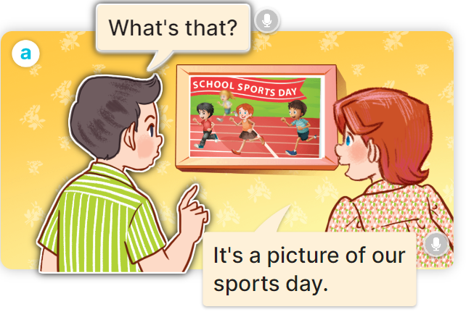  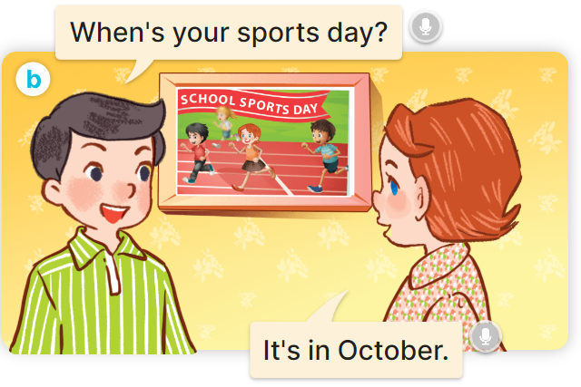  - Play the audio twice (sentence by sentence). Correct their pronunciation where necessary.  - Have Ss to practice the dialogue  - T invites a few pairs to the front of the class to practice.  - T checks pronunciation for ss.  Activity 3 Listen, point and say.  *Aims: Ss will be able to correctly say the words and use When's your sports day? – It's in……… to ask and answer questions about when a sports day is.  *Procedure:  * Model sentences:  - T asks Ss look at picture b and helps Ss know the structure from the dialogue.  - T introduces new structure for Ss.  - T explains, models and gives meaning.  - Have Ss repeat the model sentences.  A:When's your sports day? B:It's in Ocotber.  3.Practice: (7’)  *Drill pictures  - Have pupils look at the pictures and elicit the name of each month.      - Run through all the pictures.  - Run through model sentences.  +Run through question sentence  +Run through answer sentence  - Have Ss to practise:  + T asks, Ss answer picture a  + Ss asks, T answers picture b  + Group A ask, group B answer picture c  + Group B ask, group A answer picture d  - Ask Ss to work in pairs.  - T controls and corrects.  - Invite a few pupils to stand up, point at each school thing in the picture and say the sentence aloud.  - T gives feedbacks  4.Production: (7’)  Activity 4. Let’s talk.  *Aims: Ss will be able to enhance the correct use of When's your sports day? – It's in ……. to ask and answer questions about when a sports day is in a freer context.  *Procedure:  - Have Ss look at the picture and elicit the question and the answer in context.    - Elicit the missing words in the second speech bubble and write them on the board.  - Get pupils to say the completed sentences.  - Have pupils look at the bubbles to understand how the sentence pattern is used.  - Have pupils role-play to practise asking the questions and giving their answers in pairs, using picture cues.  - Invite a few pupils to stand up, point at each month in the picture and say the sentence aloud.  *Consolidation  *Aims: Ss will be able consolidate and wrap up the content of the lesson.  *Procedure:  - T asks ss to answer the following questions:  + What have you learnt from the lesson today?  +What are the core values of the lesson? (if the teacher can take from the lesson).  - T review the vocabulary and model sentences.  - T praises some Ss who are hardworking / active/ good…. as well as encourage others to try more.  5. Homework. (2’)  - Learn the vocabulary and model sentences by heart  - Prepare the new lesson: Unit 9, Lesson 2 (4,5,6). | - Ss listen  -Ss play game  -Ss clap the hands  -Ss open their books  -Ss listen and answer  - - Ss listen and repeat  + Choral repetition (3 times).  + Individual repetition (3 ss)  - Ss take note  - Ss look, remember and write  -Look at the pictures and say  + In picture a:  Nam: What’s that?  Lucy: It’s a picture of our sports day.  + In picture b:  Nam: When's your sports day?  Lucy: It's in October.  -Ss listen and repeat in chorus (twice)  -Ss work in pairs to practice  -Ss practice the dialogue  -Ss listen  -Ss look at the picture and answer.  -Ss listen  -Ss listen and repeat  -Ss repeat  - Ss look, listen and answer  + Picture a. a calendar showing September  + Picture b. a calendar showing October  + Picture c. a calendar showing November  + Picture d. a calendar showing December  -Ss listen and repeat  -Ss practice in chorus, individuals.  -Ss practice in chorus, individuals.  -Ss work in pairs  -Ss listen to the teacher  -Ss point and say  -Ss listen.  -Ss look at the picture and answer  + a school sports day and the months of the year.  -Ss pay attention  -Ss say the completed sentences  -Ss pay attention  -Ss work in pairs, point and ask and answer using When’s your sports day?  -Ss ask and answer in front of the class  -Ss answer the questions  - Ss listen  -Ss listen and clap their hands  -Ss listen and take note
D. ADJUSTMENTS (if necessary):
………………………………………………………………………………………….…..……………………………………………………………………………...………………………………………….…..…………………………………………………………

Week 15

Period 59

Unit 9: Our sports day
Lesson 2 (4, 5, 6)
A. OBJECTIVES:
By the end of the lesson, Ss will be able to:
1. Knowledge:
- use When's your sports day? – It's in _____. to ask and answer questions about when a sport day is;
- listen to and demonstrate understanding of simple exchanges in relation to the topic "Our sports day".
- Vocabulary: Review
- Skills: speaking, listening, reading and writing.
2. Competences:
- Co-operation: ready to help friends in pair work/ group work.
- Self-control and independent learning: perform listening tasks.
3. Attitude/ Qualities:
- Kindness: Help partners to complete learning tasks.
- Diligence: complete learning tasks.
B. TEACHING AIDS:
- Teacher: Teacher’s guide Pages 132,133; audio Tracks 93; website hoclieu.vn, posters, laptop, pictures, textbook, lesson plan, TV or projector.
- Students: Pupil’s book Page 65, notebooks, workbooks, school things.
C. PROCEDURES:
Teacher’s activities | Students’ activities
1.Warm- up: (5’)  Game: The football game  *Aims: to create a friendly and active atmosphere in the class to beginning the lesson.  *Procedure:  - Give each pair some Blue-Tak or something to stick the cards on the wall with.  - Ask pupils to randomly stick their cards all over the walls around the room.  - Then bring everyone into the middle of the room.  - Shout out "January" and everyone has to race over to a January card and touch it.  - Then “February” and so on (in the correct order) until you make it through all the months.  - Play another round, this time faster.  - Say “Open your book page 65” and look at “Unit 9, Lesson 2 (4,5,6)”.  2.Practice: (27’)  Activity 1. Listen and tick:  *Aims: Ss will be able to listen to and understand two communicative contexts in which pupils ask and answer questions about when a sports day is and tick the correct pictures.  *Procedure:  - Elicit the month in each picture.  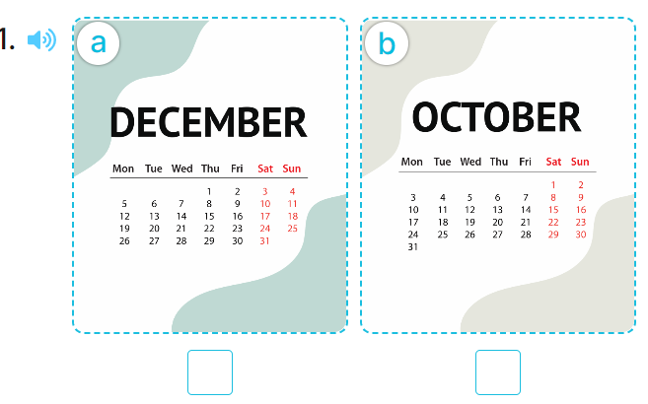  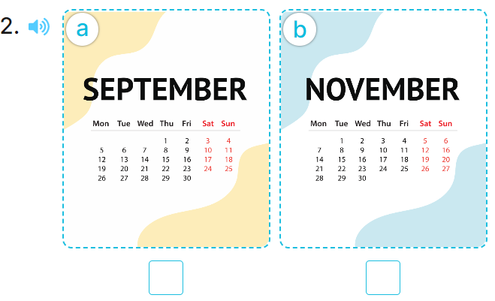  - T ask Ss to guess the answers.  + T writes Ss’guessing on the board.  - Listen to the tape:  + Play the recording  + Play the recording again and get Ss to swap books with their partners.  + Play the recording again to check answers together as a class.  + Write the answers on the board for Ss to correct their answers. Then checks Ss’ guessing.  - Play the recording, sentence by sentence, for the class to listen and repeat in chorus.  Key: 1. b 2.a  Activity 2. Look, complete and read  *Aims: Ss will be able to complete two gapped dialogues with the help of picture cues.  *Procedure:  - Have pupils look at the pictures and identify the event and the month in each picture.  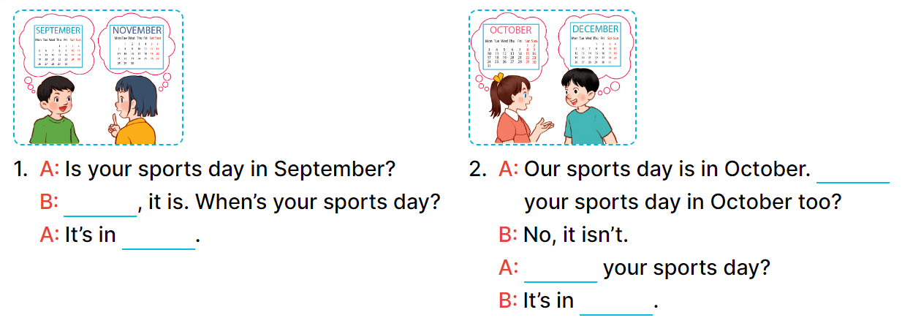  - Have Ss look at the four dialogues and the pictures. Elicit and model with number 1  + Get Ss to read number 1 in chorus.  + Ask them what A and B are talking about.  + Write the word notebook on the board.  + Tell Ss to identify the picture of a notebook (Yes, November).  + Then write number 1 with Yes, November.  -Have Ss work in pairs and complete the sentences 2.  - Ask a few Ss to stand up and read the sentences aloud.  -T gives feedbacks.  Key:  1. Yes; November  2. Is; When’s; December  Activity 3. Let’s play  *Aims: Ss will be able to review vocabulary for months by playing the game Who’s faster?  *Procedure:  - Tell pupils that they are going to play the game Who’s faster? in groups.  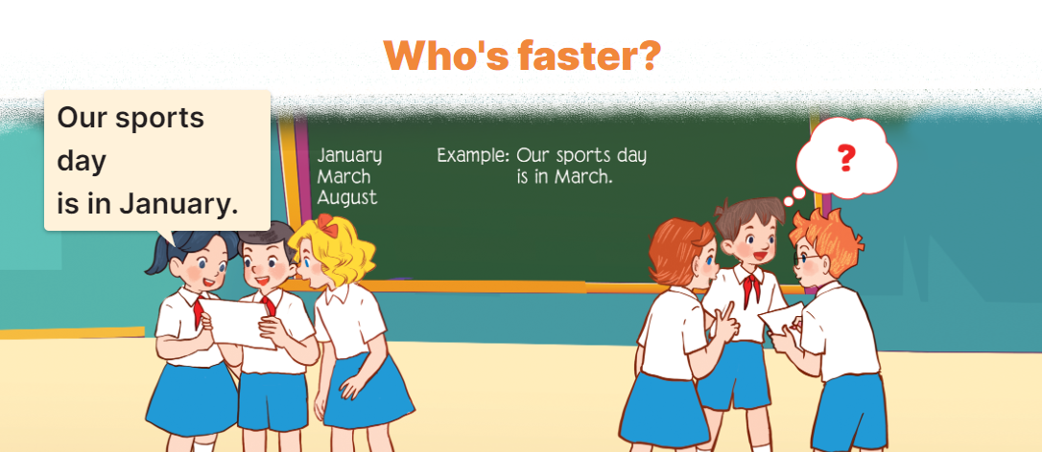  - Explain how to play the game:  + Each group makes sentences using month words and reads them aloud to the class.  - Model, write three month words on the board and a sentence.  Ex: March, May, July.  Our sports day in in May.  - Divide the class into grooups of five.  - Ask groups to look at the words and the example on the board.  - Have groups make two sentences with the two words January and August, then read the sentences aloud to the class.  -The group that makes correct sentences faster wins.  *Consolidation  *Aims: Ss will be able consolidate and wrap up the content of the lesson.  *Procedure:  - T asks ss to answer the following questions:  + What have you learnt from the lesson today?  +What are the core values of the lesson? (if the teacher can take from the lesson).  - T praises some Ss who are hardworking / active/ good…. as well as encourage others to try more.  3. Homework. (3’)  - Practice part 5 again.  - Prepare the new lesson: Unit 9, Lesson 3 (1,2,3). | - Ss listen  - Ss play game  -Ss play game  - Ss open their books  -Look at the pictures and say:  + Picture 1a. a calendar showing December  + Picture 1b. a calendar showing October  + Picture 2a. a calendar showing September  + Picture 2b. a calendar showing November  -Ss guess the answers  - Ss listen to the tape and tick  - Ss listen again, tick and swap books with their partners.  - Ss check their answers and guessing  -Ss write the answer  -Ss listen and repeat.  -Ss look at the picture and say  -Ss look and answer  -Ss read  -Ss answer  -Ss write  -Ss listen and write  -Ss work in pairs and complete  -Ss read aloud  -Ss listen the rule  - Ss listen  -Ss play the game  -Ss listen  -Ss answer the questions  -Ss listen and clap their hands  -Ss listen and take note
D. ADJUSTMENTS (if necessary):
………………………………………………………………………………………….…..……………………………………………………………………………...………………………………………….…..……………………………………………………………………………….……………………………………………………………………...

Week 15
Period 60
Unit 9: Our sports day
Lesson 3 (1, 2, 3)
A. OBJECTIVES:
By the end of the lesson, Ss will be able to:
1. Knowledge:
- correctly pronounce the sounds of the letter y in isolation, in the words February and July, and in the sentences Our sports day is in February. and My birthday is in July.
- use Is your sports day in ……. – Yes, it is. / No, it isn’t. It’s in ……. to ask and answer questions about sports days
- use When's your sports day? – It's in ……. to ask and answer questions about when a sport day is
- Vocabulary: Review
- Skills: speaking, listening, reading and writing.
2. Competences:
- Co-operation: ready to help friends in pair work/ group work.
- Sociability: Talk to each other, say good words to others.
3. Attitude/ Qualities:
- Kindness: Help partners to complete learning tasks.
- Honesty: tell the truth about feelings and emotions
B. TEACHING AIDS:
- Teacher: Teacher’s guide Pages 134, 135; audio Tracks 94, 95, 96; website hoclieu.vn, posters, laptop, pictures, textbook, lesson plan, TV or projector.
- Students: Pupil’s book Page 66, notebooks, workbooks, school things.
C. PROCEDURES:
Teacher’s activities | Students’ activities
1.Warm- up: (5’)  Game: Find and circle the words  *Aims: to create a friendly and active atmosphere in the class to beginning the lesson.  *Procedure:  J M V K E P S C B J  U C T H N E K C L A  L L U A A V Y O U N  Y E L N N N A S U U  A B R K A K L E S A  S C D K O K K I Y R  S R F E B R U A R Y  L C Y C L I N G A Y  D T S S R S O T S M  A C E B F Z Z Y W  - Divide class into 2 groups  - Ask Ss to find and circle the words that they learnt.  - Which groups find the best correct words is winner.  - Give Ss time to play the game.  Rows: February, cycling.  Columns: July, sky, January  -T checks who’s winner?  - Say “Open your book page 66” and look at “Unit 9, Lesson 3 (1,2,3)”.  2. Presentation (9’)  Activity 1. Listen and repeat:  *Aims: Ss will be able to correctly repeat the sounds of the letter y in isolation, in the words July and February, and in the sentences Our sports day is in February. and My birthday is in July. with correct pronunciation and intonation.  *Procedure:  - T gives instruction to the letter y, the words February and July, and in the sentences Our sports day is in February. and My birthday is in July.  - Play the recording for the letter y.  - Encourage Ss to point at the letter/ word/ sentence while listening.  - Play the recording again and encourage Ss to listen and repeat.  - Do this several times until Ss feel confident.  - T calls some Ss to practice.  - T gives feedbacks.  3.Practice: (19’)  Activity 2. Listen and circle.  *Aims: Ss will be able to identify the target words July and February while listening.  *Procedure:  - Elicit the sentences and the gap-fill options.  - T ask Ss to guess the answers.  + T writes Ss’guessing on the board.  - Listen to the tape:  + Play the recording  + Play the recording again and get Ss to swap books with their partners.  + Play the recording again to check answers together as a class.  + Write the answers on the board for Ss to correct their answers. Then checks Ss’ guessing.  - Play the recording, sentence by sentence, for the class to listen and repeat in chorus.  - Invite one or two Ss to stand up and read the completed sentences.  Key: 1.a 2.b  Activity 3. Let’s chant  *Aims: Ss will be able to say the chant with the correct rhythm and pronunciation  *Procedure:  - Introduce the title and lyrics of the chant.  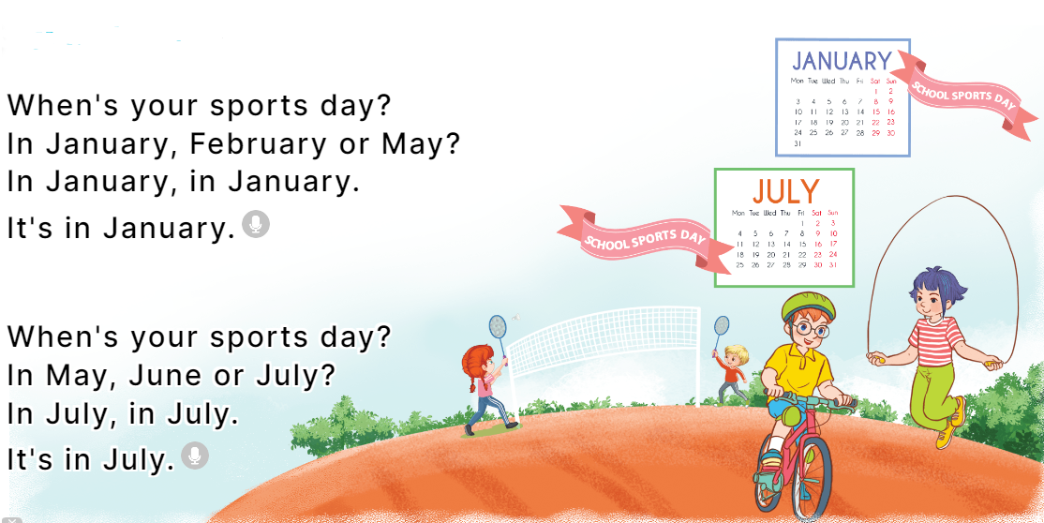  - Play the recording for Ss to listen to the whole chant.  + Have them repeat the title and lyrics line by line.  + Ask Ss to attend to the sounds of the letters y and the words February and July.  - Play the recording all the way through for Ss to listen to pronunciation and melody.  - Play the recording line by line for Ss to listen and repeat  - Play the recording for Ss to chant and clap along.  - Ask Ss to practice chant and clap along in pairs or groups.  - Invite groups to the front of the classroom to perform the chant  -T gives feedback.  *Consolidation  *Aims: Ss will be able consolidate and wrap up the content of the lesson.  *Procedure:  - T asks ss to answer the following questions:  + What have you learnt from the lesson today?  +What are the core values of the lesson? (if the teacher can take from the lesson).  - T praises some Ss who are hardworking / active/ good…. as well as encourage others to try more.  4. Homework. (2’)  - Practice the chant more.  - Collect three school things  - Prepare the new lesson: Unit 9, Lesson 3 (4, 5, 6). | - Ss listen  -Ss play game  - Ss open their books  - Ss recognize the differences about color of letter  - - Ss listen  - Ss listen and point  - Ss listen again and repeat  -Ss listen again and repeat  -Ss practice  -Ss listen  -Ss listen and say:  + Number 1: Is your sports day in July?  + Number 2: I like January.  -Ss guess the answers  - Ss listen to the tape and circle  - Ss listen again, circle and swap books with their partners.  - Ss check their answers and guessing  -Ss listen and repeat.  -Ss read the sentences  - Ss look and listen.  -Ss listen to the chant  - Ss listen and repeat line by line without clap their hands  -Ss note the sounds, words  -Ss listen to melody of the chant  - Ss listen and chant line by line.  - Ss chant and clap along.  - Ss work in groups (two groups) to chant  -Ss perform in front of the class.  -Ss listen  -Ss answer the questions  -Ss listen and clap their hands  -Ss listen and take note

D. ADJUSTMENTS (if necessary):
………………………………………………………………………………………….…..……………………………………………………………………………...………………………………………….…..…………………………………………………………

