Week 14
Period 53
Unit 8: My favourite subjects
Lesson 2 (4, 5, 6)
A. OBJECTIVES:
By the end of the lesson, Ss will be able to:
1. Knowledge:
- use the words and phrases art, music, PE, IT, an English teacher, a maths teacher, a painter and a singer in relation to the topic “My favourite subjects”.
– listen to and demonstrate understanding of simple communicative contexts in relation to the topic “My favourite subjects”.
- Vocabulary: Review
- Skills: speaking, listening, reading and writing.
2. Competences:
- Critical Thinking: self-introduce
- Co-operation: ready to help friends in pair work/ group work.
- Self-control and independent learning: perform listening tasks.
3. Attitude/ Qualities:
- Kindness: Help partners to complete learning tasks.
- Diligence: complete learning tasks.
B. TEACHING AIDS:
- Teacher: Teacher’s guide Pages 119, 120, 121; audio Tracks 83; website hoclieu.vn, posters, laptop, pictures, textbook, lesson plan, TV or projector.
- Students: Pupil’s book Page 59, notebooks, workbooks, school things.
C. PROCEDURES:
Teacher’s activities | Students’ activities
1.Warm- up: (5’)  Game: Pass the ball  *Aims: to create a friendly and active atmosphere in the class to beginning the lesson.  *Procedure:  - T gives Ss a ball.  - T asks Ss to listen to music and transfer a ball around the class.  - When the music stops, Ss who keep a ball have to answer the question using: Why do you like……? and Because I……  - T gives feedback.  - Say “Open your book page 59” and look at “Unit 8, Lesson 2 (4,5,6)”.  2.Practice: (27’)  Activity 1. Listen and number:  *Aims: Ss will be able to listen to and understand four communicative contexts in which pupils gives reasons why they like the school subject, and number the correct pictures.  *Procedure:  - Elicit the favourite subject and the reason for liking it.  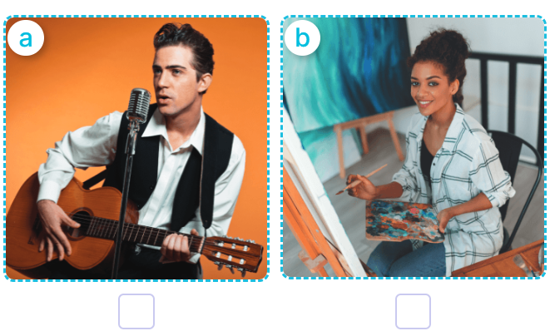  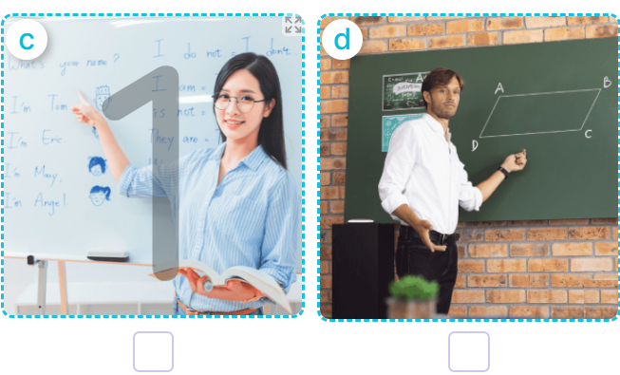  - T ask Ss to guess the answers.  + T writes Ss’guessing on the board.  - Listen to the tape:  + Play the recording  + Play the recording again and get Ss to swap books with their partners.  + Play the recording again to check answers together as a class.  + Write the answers on the board for Ss to correct their answers. Then checks Ss’ guessing.  - Play the recording, sentence by sentence, for the class to listen and repeat in chorus.  Key: 1. b 2. d 3. a 4. c  Activity 2. Look, complete and read  *Aims: Ss will be able to complete two dialogues about their favourite subjects and the reasons why pupils like them with the help of picture cues  *Procedure:  - Get Ss to look at the pictures and ask them what the girl and the boy are doing 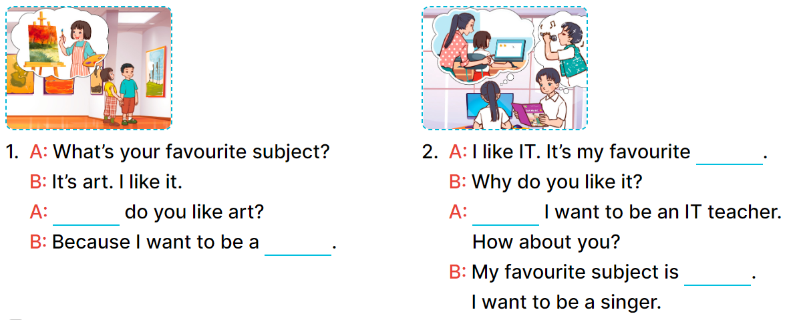  - Model and elicit the missing words from the Exchange 1 (Why, painter).  -Have pupils to do the task individually.  - Get pupils swap books with their partners and check the answers before checking as a class.  - Invite a few pairs to stand up and read the sentences aloud.  Key:  - Why/ painter  - Subject; because; music  Activity 3. Let’s play  Sentence making  *Aims: Ss will be able to practice making meaningful and grammatically correct sentences about future jobs by playing the game “sentence making”.  *Procedure:  - Tell pupils the goal of the game and how to play it. 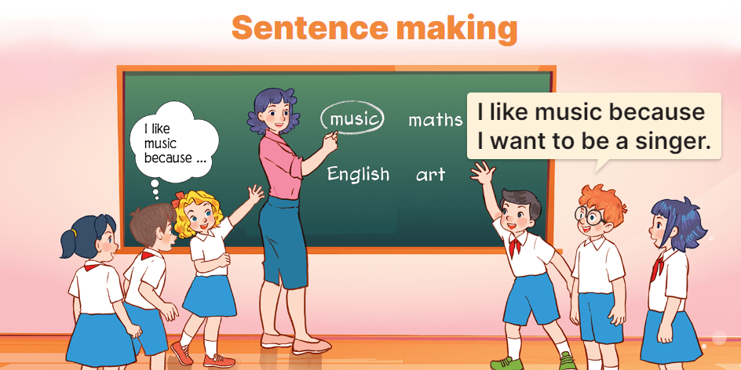  - How to play the game:  + When the teacher circles or says one of the words on the board, the groups make as many sentence as possible.  + The group that gives the correct sentences more quickly gets one point or one star for one correct sentence.  + The group with more points or stars is the winner.  - Divide the class into groups of three or four pupils to play.  *Consolidation  *Aims: Ss will be able consolidate and wrap up the content of the lesson.  *Procedure:  - T asks ss to answer the following questions:  + What have you learnt from the lesson today?  +What are the core values of the lesson? (if the teacher can take from the lesson).  - T praises some Ss who are hardworking / active/ good…. as well as encourage others to try more  3. Homework. (3’)  - Practice part 5 again.  - Prepare the new lesson: Unit 8, Lesson 3 (1,2,3). | - Ss listen  - Ss play game  -Ss play game  - Ss open their books  -Look at the pictures and say:  + Picture a: A male singer singing  + Picture b: A female painter working  + Picture c: An English teacher writing  + Picture d: A maths teacher writing  -Ss guess the answers  - Ss listen to the tape and write  - Ss listen again, write and swap books with their partners.  - Ss check their answers and guessing  -Ss listen and repeat.  -Ss look at the picture and say  -Ss look and answer  -Ss do the task  -Ss swap books and check their answer  -Ss read the sentences aloud  - Ss listen  - Ss listen  - Ss play game  - Ss play game  -Ss answer the questions  -Ss listen and clap their hands  -Ss listen and take note
D. ADJUSTMENTS (if necessary):
………………………………………………………………………………………….…..……………………………………………………………………………...………………………………………….…..……………………………………………………………………………….……………………………………………………………………...

Week 14

Period 54

Unit 8: My favourite subjects
Lesson 3 (1, 2, 3)
A. OBJECTIVES:
By the end of the lesson, Ss will be able to:
1. Knowledge:
- correctly pronounce the sounds of the letters ke and te in isolation, in the words like and write, and in the sentences I like English. and Let's write.
– use the words and phrases art, music, PE, IT, an English teacher, a maths teacher, a painter and a singer in relation to the topic “My favourite subjects”
– use Why do you like …….? – Because I want to be …….. to ask for and give reasons for liking a school subject
– listen to and demonstrate understanding of simple communicative contexts in relation to the topic “My favourite subjects”
- Vocabulary: Review
- Skills: speaking, listening, reading and writing.
2. Competences:
- Co-operation: ready to help friends in pair work/ group work.
- Sociability: Talk to each other, say good words to others.
3. Attitude/ Qualities:
- Kindness: Help partners to complete learning tasks.
- Honesty: tell the truth about feelings and emotions
B. TEACHING AIDS:
- Teacher: Teacher’s guide Pages 121,122; audio Tracks 84, 85, 86; website hoclieu.vn, posters, laptop, pictures, textbook, lesson plan, TV or projector.
- Students: Pupil’s book Page 60, notebooks, workbooks, school things.
C. PROCEDURES:
Teacher’s activities | Students’ activities
1.Warm- up: (5’)  Game: Find and circle the words  *Aims: to create a friendly and active atmosphere in the class to beginning the lesson.  *Procedure:  L I K E E W S C M T  H C T H N R H C A H  C L U A A I A O K I  L E L N N T T S E N  A A W K E E O E E K  A C D E G H O S V B  F A V O U R I T E H  B I K E I A S D A Y  D T S S R S N O T E  A C E B F E Z Y W  - Divide class into 2 groups  - Ask Ss to find and circle the words that they learnt.  - Which groups find the best correct words is winner.  - Give Ss time to play the game.  Rows: like, bike, note, favourite  Columns: write, make  -T checks who’s winner?  - Say “Open your book page 60” and look at “Unit 8, Lesson 3 (1,2,3)”.  2. Presentation (9’)  Activity 1. Listen and repeat:  *Aims: Ss will be able to correctly repeat the sounds of the letter cluster ke and letter te in isolation, in the words like and write, and in the sentences I like English. and Let’s write with correct pronunciation and intonation.  *Procedure:  - T gives instruction to the letter ke and te, like and write, and in the sentences I like English. and Let’s write.  - Play the recording for the letter ke, te.  - Encourage Ss to point at the letter/ word/ sentence while listening.  - Play the recording again and encourage Ss to listen and repeat.  - Do this several times until Ss feel confident.  - T calls some Ss to practice.  - T gives feedbacks.  3.Practice: (19’)  Activity 2. Listen and circle.  *Aims: Ss will be able to identify the target words like and write while listening.  *Procedure:  - Elicit the sentences and the gap-fill options.  - T ask Ss to guess the answers.  + T writes Ss’guessing on the board.  - Listen to the tape:  + Play the recording  + Play the recording again and get Ss to swap books with their partners.  + Play the recording again to check answers together as a class.  + Write the answers on the board for Ss to correct their answers. Then checks Ss’ guessing.  - Play the recording, sentence by sentence, for the class to listen and repeat in chorus.  - Invite one or two Ss to stand up and read the completed sentences.  Key: 1.a 2.b  Activity 3. Let’s chant  *Aims: Ss will be able to say the chant with the correct rhythm and pronunciation  *Procedure:  - Introduce the title and lyrics of the chant.  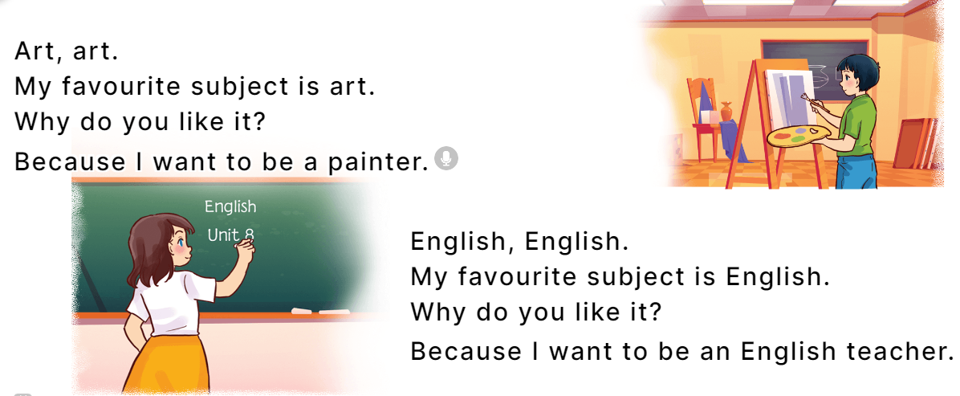  - Play the recording for Ss to listen to the whole chant.  + Have them repeat the title and lyrics line by line.  + Ask Ss to attend to the sounds of the letters ke and te and the words like and write.  - Play the recording all the way through for Ss to listen to pronunciation and melody.  - Play the recording line by line for Ss to listen and repeat  - Play the recording for Ss to chant and clap along.  - Ask Ss to practice chant and clap along in pairs or groups.  - Invite groups to the front of the classroom to perform the chant  -T gives feedback.  *Consolidation  *Aims: Ss will be able consolidate and wrap up the content of the lesson.  *Procedure:  - T asks ss to answer the following questions:  + What have you learnt from the lesson today?  +What are the core values of the lesson? (if the teacher can take from the lesson).  - T praises some Ss who are hardworking / active/ good…. as well as encourage others to try more.  4. Homework. (2’)  - Practice the chant more.  - Collect three school things  - Prepare the new lesson: Unit 8, Lesson 3 (4, 5, 6). | - Ss listen  -Ss play game  - Ss open their books  - Ss recognize the differences about color of letter  - - Ss listen  - Ss listen and point  - Ss listen again and repeat  -Ss listen again and repeat  -Ss practice  -Ss listen  -Ss listen and say  -Ss guess the answers  - Ss listen to the tape and circle  - Ss listen again, circle and swap books with their partners.  - Ss check their answers and guessing  -Ss listen and repeat.  -Ss read the sentences  - Ss look and listen.  -Ss listen to the chant  - Ss listen and repeat line by line without clap their hands  -Ss note the sounds, words  -Ss listen to melody of the chant  - Ss listen and chant line by line.  - Ss chant and clap along.  - Ss work in groups (two groups) to chant  -Ss perform in front of the class.  -Ss listen  -Ss listen.  -Ss answer the questions  -Ss listen and clap their hands  -Ss listen and take note

D. ADJUSTMENTS (if necessary):
………………………………………………………………………………………….…..……………………………………………………………………………...………………………………………….…..……………………………………………………………………………….……………………………………………………………………...

Week 14
Period 55

Unit 8: My favourite subjects
Lesson 3 (4, 5, 6)
A. OBJECTIVES:
By the end of the lesson, Ss will be able to:
1. Knowledge:
- read and write about someone’s favourite subject.
- do a survey on their classmates’ favourite subjects and the reasons why they like these subjects and present it to their classmates at Project time.
- Vocabulary: Review
- Skills: speaking, listening, reading and writing.
2. Competences:
- Critical Thinking: complete a task in reading a text.
- Co-operation: ready to help friends in pair work/ group work.
- Self-control and independent learning: perform listening tasks.
3. Attitude/ Qualities:
- Kindness: Help partners to complete learning tasks.
- Diligence: complete learning tasks.
B. TEACHING AIDS:
- Teacher: Teacher’s guide Pages 123, 124, 125; website hoclieu.vn, posters, laptop, pictures, textbook, lesson plan, TV or projector.
- Students: Pupil’s book Page 61, notebooks, workbooks, school things.
C. PROCEDURES:
Teacher’s activities | Students’ activities
1.Warm- up: (5’)  Game: “Chant”  *Aims: to review the vocabulary and structure about greet and respond to greetings.  *Procedure:  - Ask Ss chant and do the actions in Unit 8, Lesson 3 page 60 in groups.  - Give point for the groups and encourage them.  - Say “Open your book page 61” and look at “Unit 8, Lesson 3 (4, 5, 6)”.  2.Practice: (8’)  Activity 1. Read and complete:  *Aims: Ss will be able to read a paragraph and decide whether the sentences are true or false.  *Procedure:  - Have pupils read all the sentences under the paragraph.  - Have pupil read Sentence 1 and pay attention to the keywords name and Peter, then scan the paragraph for the information.  + If it is the same, they should put a tick in the True box.  + If the information is not the same, they should put a tick in the False box.  -Ask pupils to do the activity independently.  - Get pupils to swap books with their partners and check their answers before checking as a class.  - Invite some pupils to stand up and read the paragraph aloud.  Key: 1. True 2. False 3. True 4. False  3.Production: (19’)  Activity 2. Let’s write  *Aims: Ss will be able to read, understand and complete a paragraph about their favourite subjects.  *Procedure:  - Tell pupils what they are going to do.  - Then get them to read the incomplete paragraph.  - Elicit what the paragraph is about (someone’s favourite subject and the reason why he / she likes it).  - Get pupils to fill the first gap with their name as an example.  -Have pupils to complete the paragraph independently.  - Get pupils to swap books with their partners and check the answers in pairs or groups.  - Have a few pupils to stand up and read their writing aloud.  - Invite a few pupils to read their completed texts in front of the class.  Key: Pupils’ answer  Ex: My name is Huong. I have English, PE, music, art and maths today. My favorite subject is English. I like it because I want to be an English teacher. What is your favorite subject?  Activity 3. Project.  *Aims: Ss will be able to do a survey on their classmates’ favourite subjects and the reasons why they like these subjects and present them to the class  *Procedure:  - Tell Ss about the activity.  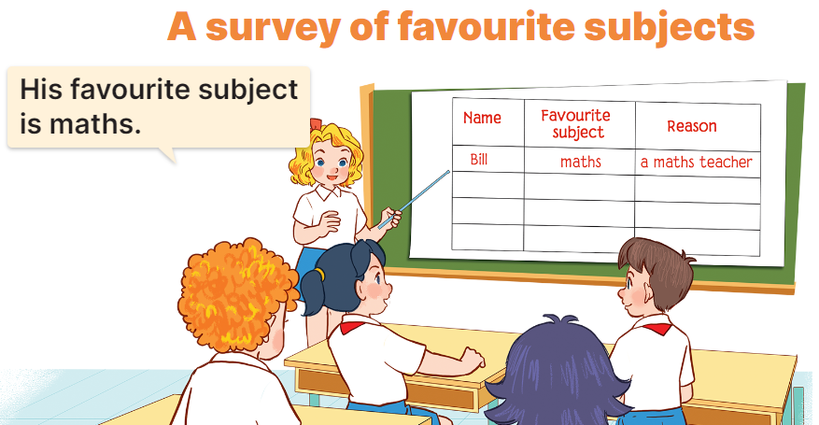  - Get pupils to work in groups to show their surveys on their classmates’ favourite subjects and the reasons why they like these subjects which they have prepared at home as homework.  - Invite a pupil to the front of the class to model the presentation.  Ex: Look at Bill. His favourite subject is maths. He likes it because he wants to be a maths teacher.  - Have the pupils repeat the language a few times to help them feel confident when they present.  - Have pupils to present the project in their groups.  - Invite a few pupils to the front of the class to present their projects.  *Consolidation  *Aims: Ss will be able consolidate and wrap up the content of the lesson.  *Procedure:  - T asks ss to answer the following questions:  + What have you learnt from the lesson today?  +What are the core values of the lesson? (if the teacher can take from the lesson).  - T praises some Ss who are hardworking / active/ good…. as well as encourage others to try more.  4. Homework. (3’)  - Prepare the new lesson: Unit 9, Lesson 1 (1, 2, 3). | - Ss listen and chant  - Ss open their books  - Ss read the paragraph  -Ss read and complete the first sentence  -Ss do the task  -Ss swap their answers  -Ss check their answer  -Ss read aloud  -Ss look and listen  -Ss read  -Ss listen and pay attention  -Ss fill the first gap  -Ss do the task  -Ss swap books and check their answer  -Ss check the answer  -Ss read aloud  -Ss listen and pay attention  -Ss work in groups and show their survey  -Ss report the survey  -Ss repeat the languege  -Ss present into groups  -Ss present in front of the class.  -Ss answer the questions  -Ss listen and clap their hands  -Ss listen and take note
D. ADJUSTMENTS (if necessary):
………………………………………………………………………………………….…..……………………………………………………………………………...…………

Week 14
Period 56
Unit 9: Our sports day
Lesson 1 (1, 2, 3)
A. OBJECTIVES:
By the end of the lesson, Ss will be able to:
1. Knowledge:
- use the words and phrase December, July, June, November, October, September, sports day in relation to the topic "Our sports day"
- use Is your sports day in ……..? – Yes, it is. / No, it isn’t. It’s in ……. to ask and answer questions about sports days;
- listen to and demonstrate understanding of simple exchanges in relation to the topic "Our sports day"
- Vocabulary: June, July, August.
- Skills: speaking and listening
2. Competences:
- Self-control and independent learning: perform listening tasks.
- Communication and collaboration: work in pairs or groups.
3. Attitude/ Qualities:
- Kindness: Help partners to complete learning tasks.
- Honesty: tell the truth about feelings and emotions
B. TEACHING AIDS:
- Teacher: Teacher’s guide Pages 125,126,127, audio Tracks 87, 88, website hoclieu.vn, posters, laptop, pictures, textbook, lesson plan, TV or projector.
- Students: Pupil’s book Page 62, notebooks, workbooks, school things.
C. PROCEDURES:
Teacher’s activities | Students’ activities
1.Warm- up: (3’)  Sing a song  *Aims: to create a friendly and active atmosphere in the class to beginning the lesson.  *Procedure:  https://www.youtube.com/watch?v=Fe9bnYRzFvk  - Have pupils listen and sing the song “Months of the Year”  - Say “Open your book page 62” and look at “Unit 9, Lesson 1 (1,2,3)”.  2. Presentation (16’)  Activity 1. Vocabulary.  *Aims: Ss will be able to know the vocabulary in the new lesson.  *Procedure:  -T elicits the new words  + June : tháng 6 (situation)  + July : tháng 7 (translation)  + August :tháng 8 (situation)  - T models (3 times).  - T writes the words on the board.  - Checking: Rub out and remember  Activity 2. Look, listen and repeat:  *Aims: Ss will be able to understand and correctly repeat the sentences in two communicative contexts focusing on asking and answering questions about sports days *Procedure:  - Have pupils look at Pictures a and b and identify the characters in the pictures.  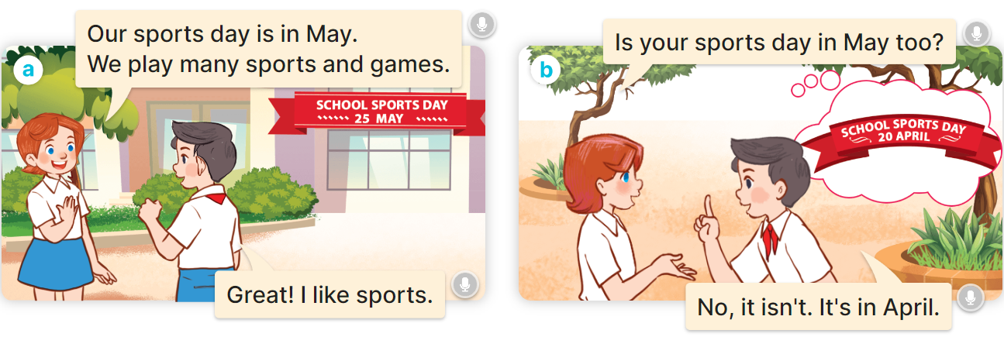  - Play the audio twice (sentence by sentence). Correct their pronunciation where necessary.  - Have Ss to practice the dialogue  - T invites a few pairs to the front of the class to practice.  - T checks pronunciation for ss.  Activity 3 Listen, point and say.  *Aims: Ss will be able to correctly say the words and use Is your sports day in …….? – Yes, it is. / No, it isn’t. It’s in …... to ask and answer questions about sports days.  *Procedure:  * Model sentences:  - T asks Ss look at picture b and helps Ss know the structure from the dialogue.  - T introduces new structure for Ss.  - T explains, models and gives meaning.  - Have Ss repeat the model sentences.  A: Is your sports day in May?  B: Yes, it is. / No, it isn’t. It’s in June  3.Practice: (7’)  *Drill pictures  - Have pupils look at the pictures and elicit the names of the months in the pictures.  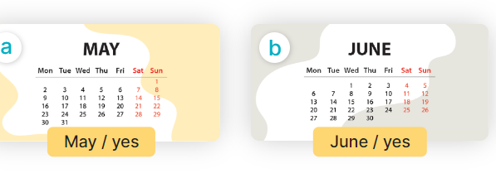  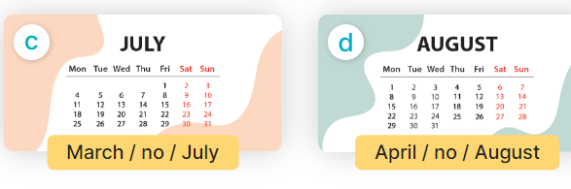  - Run through all the pictures.  - Run through model sentences.  +Run through question sentence  +Run through answer sentence  - Have Ss to practise:  + T asks, Ss answer picture a  + Ss asks, T answers picture b  + Group A ask, group B answer picture c  + Group B ask, group A answer picture d  - Ask Ss to work in pairs.  - T controls and corrects.  - Invite a few pupils to stand up, point at each school thing in the picture and say the sentence aloud.  - T gives feedbacks.  4.Production: (7’)  Activity 4. Let’s talk.  *Aims: Ss will be able to enhance the correct use of Is your sports day in ………? – Yes, it is. / No, it isn’t. It’s in ……... to ask and answer questions about sports days  *Procedure:  - Have Ss look at the picture and say the names of the months in the picture.  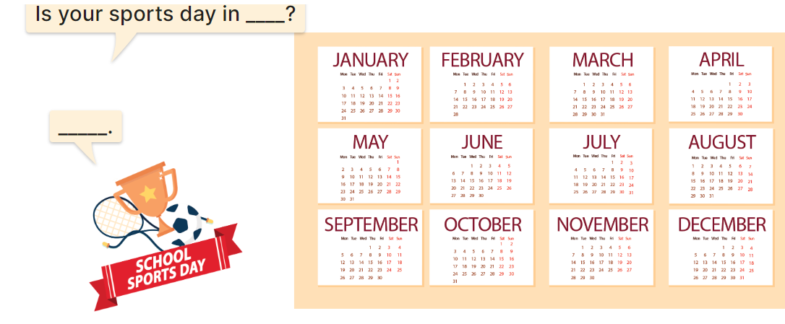  - Have pupils look at the bubbles to understand how the sentence pattern is used. - Have pupils role-play to practise asking the questions and giving their answers in pairs, using picture cues.  - Invite some pupils to practise asking and answering questions in front of the class.  - Have pupils ask and answer questions about what their friend(s) do on school sports day, using the structure learnt.  ex: What do you do on sports day? – I ……..  *Consolidation  *Aims: Ss will be able consolidate and wrap up the content of the lesson.  *Procedure:  - T asks ss to answer the following questions:  + What have you learnt from the lesson today?  +What are the core values of the lesson? (if the teacher can take from the lesson).  - T review the vocabulary and model sentences.  - T praises some Ss who are hardworking / active/ good…. as well as encourage others to try more.  5. Homework. (2’)  - Learn the vocabulary and model sentences by heart  - Prepare the new lesson: Unit 9, Lesson 1 (4,5,6). | - Ss listen  -Ss sing and dance  -Ss open the books  -Ss listen and answer  - - Ss listen and repeat  + Choral repetition (3 times).  + Individual repetition (3 ss)  - Ss take note  - Ss look, remember and write  -Look at the pictures and say  + In picture a:  Lucy: Our sports day is in May. We play many sports and games.  Nam: Great! I like sports.  + In picture b:  Lucy: Is your sports day in May too?  Nam: No, it isn't. It's in April.  -Ss listen and repeat in chorus (twice)  -Ss work in pairs to practice  -Ss practice the dialogue  -Ss listen  -Ss look at the picture and answer.  -Ss listen  -Ss listen and repeat  -Ss repeat  - Ss look, listen and answer  + Picture a: a calendar sheet of April  + Picture b: a calendar sheet of May  + Picture c: a calendar sheet of June  + Picture d: a calendar sheet of July  -Ss listen and repeat  -Ss practice in chorus, individuals.  -Ss practice in chorus, individuals.  -Ss work in pairs  -Ss point and say  -Ss listen.  -Ss look at the picture and answer  + a picture of a sports day and calendar sheets of the months of the year.  -Ss look at the bubbles and say  -Ss work in pairs, point and ask and answer  -SS practice to ask amd amswer  -Ss ask and answer about what their friend(s) do on school sports day  -Ss answer the questions  - Ss listen  -Ss listen and clap their hands  -Ss listen and take note
D. ADJUSTMENTS (if necessary):
………………………………………………………………………………………….…..……………………………………………………………………………...………………………………………….…..……………………………………………………………………………….……………………………………………………………………...

