Week 13

Period 51
Unit 8: My favourite subjects
Lesson 1 (4, 5, 6)
A. OBJECTIVES:
By the end of the lesson, Ss will be able to:
1. Knowledge:
- use the words and phrases art, music, PE, IT in relation to the topic “My favourite subjects”.
– use What’s your favourite subject? – It’s ……... to ask and answer questions about someone’s favourite subject.
– listen to and demonstrate understanding of simple communicative contexts in relation to the topic “My favourite subjects”.
– read and write about someone’s favourite subject.
- Vocabulary: Review
- Skills: speaking, listening, reading and writing.
2. Competences:
- Written Communication: complete the sentences.
- Self-control and independent learning: perform listening tasks.
- Communication and collaboration: work in pairs or groups.
3. Attitude/ Qualities:
- Kindness: Help partners to complete learning tasks.
- Diligence: complete learning tasks.
B. TEACHING AIDS:
- Teacher: Teacher’s guide Pages 114, 115,116; audio Tracks 83; website hoclieu.vn, posters, laptop, pictures, textbook, lesson plan, TV or projector.
- Students: Pupil’s book Page 57, notebooks, workbooks, school things.
C. PROCEDURES:
Teacher’s activities | Students’ activities
1.Warm- up: (5’)  Sentence Puzzle  *Aims: to create a friendly and active atmosphere in the class to beginning the lesson.  *Procedure:  - Divide the class into groups of four.  - Give each group a sentence that is broken/cut in to pieces.  - Ask Ss to arrange them to make a complete sentence, then read it aloud.  - The group makes it first will be the winner.  - Say “Open your book page 57” and look at “Unit 8, Lesson 1 (4,5,6)”.  2.Practice: (27’)  Activity 1. Listen and tick or cross:  *Aims: Ss will be able to listen to and understand four communicative contexts in which pupils ask and answer questions about their favourite subjects, and tick or cross the pictures.  *Procedure:  - Elicit the subjects in each picture.  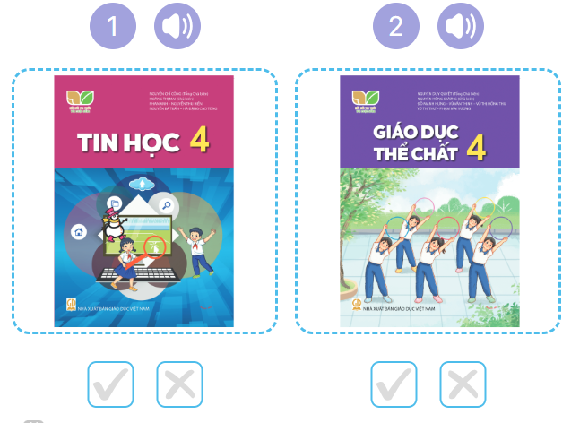  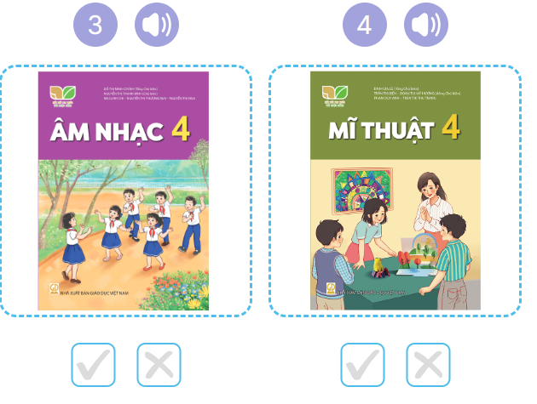  - T ask Ss to guess the answers.  + T writes Ss’guessing on the board.  - Listen to the tape:  + Play the recording  + Play the recording again and get Ss to swap books with their partners.  + Play the recording again to check answers together as a class.  + Write the answers on the board for Ss to correct their answers. Then checks Ss’ guessing.  - Play the recording, sentence by sentence, for the class to listen and repeat in chorus.  Key: 1. v 2. x 3.v 4.x  Activity 2. Look, complete and read  *Aims: Ss will be able to complete four exchanges about characters’ favourite subjects with the help of picture cues *Procedure:  - Ask pupils to look at the pictures and identify the subjects. 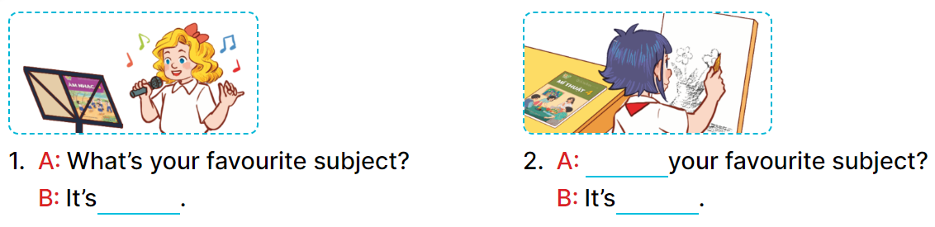  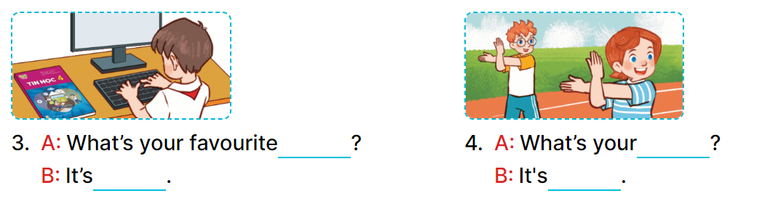  - Have Ss look at the four incomplete sentences. Elicit and model with picture 1  + Ask Ss to read the sentence 1 in chorus.  + Ask Ss what word is missing in the gap (music). Then have them complete the sentence (It’s music).  -Have Ss work in pairs and complete the sentences 2, 3, 4.  - Ask a few Ss to stand up and read the sentences aloud.  -T gives feedbacks.  Key:  1. music 2. What’s; art  3. subject; IT  4. favourite subject; PE  Activity 3. Let’s sing  *Aims: Ss will be able to sing the song My favourite subject with the correct pronunciation, rhythm and melody. *Procedure:  - Have pupils read the song to familiarize themselves with the lyrics  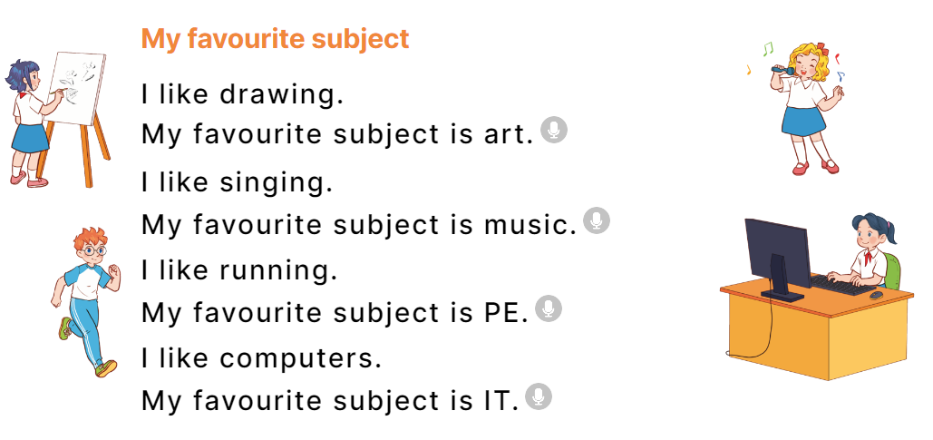  - Play the recording for Ss to listen to the whole song.  + Have them repeat the title and lyrics line by line.  + Tell Ss to point at the pictures while singing.  - Play the recording all the way through for Ss to listen to pronunciation and melody of the song.  - Play the recording line by line for Ss to listen, repeat and point to the pictures  - Play the recording for Ss to sing and do actions.  - Ask Ss to practice singing and doing actions in pairs or groups.  - Invite groups to the front of the classroom to perform the song  -T gives feedback.  *Consolidation  *Aims: Ss will be able consolidate and wrap up the content of the lesson.  *Procedure:  - T asks ss to answer the following questions:  + What have you learnt from the lesson today?  +What are the core values of the lesson? (if the teacher can take from the lesson).  - T praises some Ss who are hardworking / active/ good…. as well as encourage others to try more.  3. Homework. (3’)  - Practice part 5 again.  - Prepare the new lesson: Unit 8, Lesson 2 (1,2,3). | - Ss listen  -Ss listen  - Ss arrange and read aloud  -Ss congratuate the winner  - Ss open their books  -Look at the pictures and say:  + Picture 1: An IT textbook  + Picture 2: A PE textbook  + Picture 3: A music textbook  + Picture 4: . An art textbook  -Ss guess the answers  - Ss listen to the tape and tick/ cross  - Ss listen again, tick/ cross and swap books with their partners.  - Ss check their answers and guessing  -Ss listen and repeat.  -Ss look at the picture and say  -Ss look and answer  -Ss read  -Ss say and write  -Ss work in pairs and complete  -Ss read aloud  -Ss read the song  -Ss listen to the song  - Ss listen and repeat line by line without the action.  -Ss point to the pictures while singing  -Ss listen to melody of the song  - Ss listen and sing line by line.  - Ss sing and do actions.  + Ss work in groups (two groups) to sing.  -Ss perform in front of the class.  -Ss listen  -Ss answer the questions  -Ss listen and clap their hands  -Ss listen and take note
D. ADJUSTMENTS (if necessary):
………………………………………………………………………………………….…..……………………………………………………………………………...………………………………………….…..……………………………………………………………………………….……………………………………………………………………...

Week 13
Preparing date: 30/11/2004
Teaching date: 5/12/2004
Period 52

Unit 8: My favourite subjects
Lesson 2 (1, 2, 3)
A. OBJECTIVES:
By the end of the lesson, Ss will be able to:
1. Knowledge:
- – use the words and phrases art, music, PE, IT, an English teacher, a maths teacher, a painter and a singer in relation to the topic “My favourite subjects”.
– use Why do you like ……..? – Because I want to be ……... to ask for and give reasons for liking a school subject.
– listen to and demonstrate understanding of simple communicative contexts in relation to the topic “My favourite subjects”.
- Vocabulary: English teacher, maths teacher, painter
- Skills: speaking and listening
2. Competences:
- Critical Thinking: self-introduce
- Co-operation: ready to help friends in pair work/ group work.
- Sociability: Talk to each other, say good words to others.
3. Attitude/ Qualities:
- Kindness: Help partners to complete learning tasks.
- Honesty: tell the truth about feelings and emotions
B. TEACHING AIDS:
- Teacher: Teacher’s guide Pages 116, 117, 118, audio Tracks 81, 82, website hoclieu.vn, posters, laptop, pictures, textbook, lesson plan, TV or projector.
- Students: Pupil’s book Page 58, notebooks, workbooks, school things.
C. PROCEDURES:
Teacher’s activities | Students’ activities
1.Warm- up: (3’)  Pass the subjects  *Aims: to create a friendly and active atmosphere in the class to beginning the lesson.  *Procedure:  - Review the previous lesson by having the class pass the school things with the music.  - When the music stops, who have subjects have to say the sentence: I like music.  - Say “Open your book page 52” and look at “Unit 8, Lesson 2 (1, 2, 3)”.  2. Presentation (16’)  Activity 1. Vocabulary.  *Aims: Ss will be able to know the vocabulary in the new lesson.  *Procedure:  -T elicits the new words  + English teacher : giáo viên tiếng anh (example)  + maths teacher: giáo viên Toán (example)  + painter :họa sĩ (example)  - T models (3 times).  - T writes the words on the board.  - Checking: Rub out and remember  Activity 2. Look, listen and repeat:  *Aims: Ss will be able to understand and correctly repeat the sentences in two communicative contexts focusing on asking for and giving reasons for liking a school subject, English.  *Procedure:  - Have Ss look at Pictures a and b and identify the characters and the reason why Nam likes English. 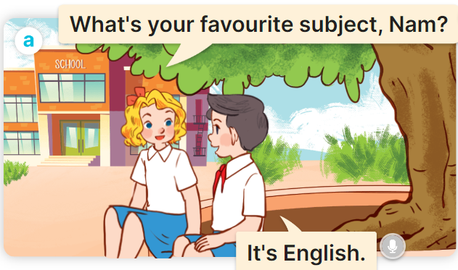  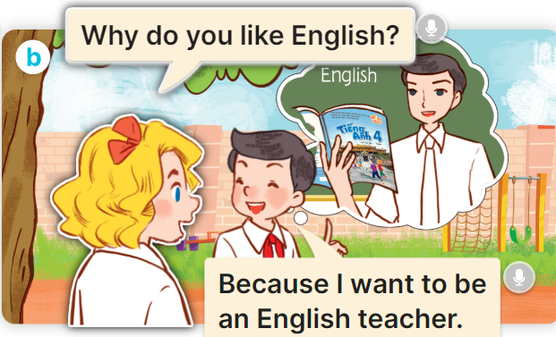  - Play the audio twice (sentence by sentence). Correct their pronunciation where necessary.  - Have Ss to practice the dialogue  - T invites a few pairs to the front of the class to practice.  - T checks pronunciation for ss.  Activity 3 Listen, point and say.  *Aims: Ss will be able to correctly say the words and phrases and use Why do you like …….? – Because I want to be ……. to ask for and give reasons for liking a school subject, English.  *Procedure:  * Model sentences:  - T asks Ss look at picture b and helps Ss know the structure from the dialogue.  - T introduces new structure for Ss.  - T explains, models and gives meaning.  -Have Ss repeat the model sentences.  A: Why do you like English.?  B: Because I want to be an English teacher  3.Practice: (7’)  *Drill pictures  - Have Ss look at the pictures and elicit the reason why each pupil likes his / her favourite subject.  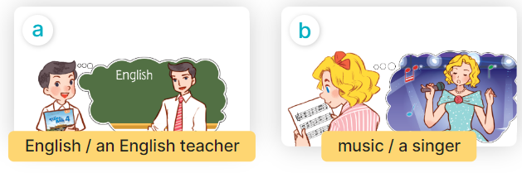  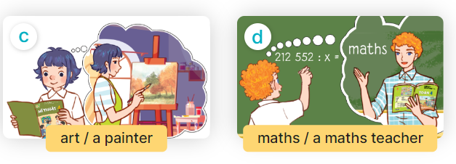  - Run through all the pictures.  - Run through model sentences.  +Run through question sentence  +Run through answer sentence  - Have Ss to practise:  + T asks, Ss answer picture a  + Ss asks, T answers picture b  + Group A ask, group B answer picture c  + Group B ask, group A answer picture d  - Ask Ss to work in pairs.  - T controls and corrects.  - Invite a few pairs to come to the front of the classroom and point at the pictures and say the questions and answers in front of the class.  - T gives feedbacks.  4.Production: (7’)  Activity 4. Let’s talk.  *Aims: Ss will be able to enhance the correct use of Why do you like …….? – Because I want to be …….. ask for and give reasons for liking a school subjects in a freer context.  *Procedure:  - Have pupils look at the picture and explain that a group of four pupils are in the playground  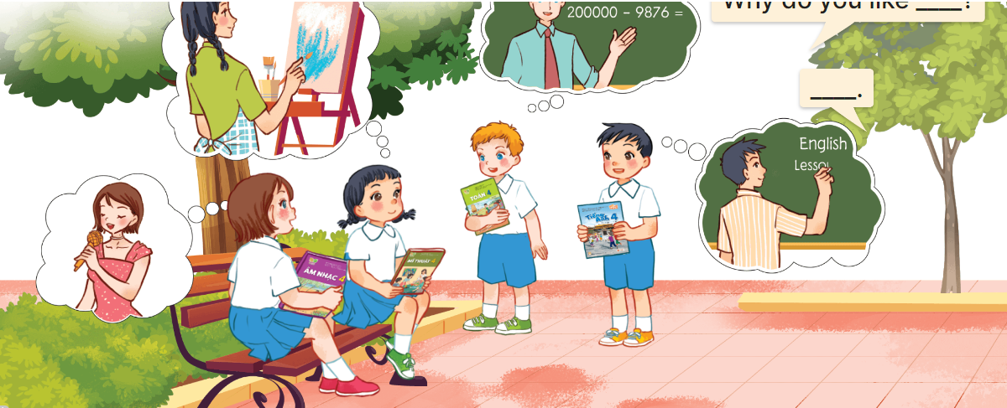  - Ask pupils to look at the first girl with black hair with the art textbook and ask pupils to identify her favourite subject (art) and what she want to be in the future (painter).  - Divide the class into two groups to role-play the girls/ boys and an interviewer.  - Have pupils work in pairs to practise asking and answering the question  Why do you like……? – ……...  - Invite pairs of pupils to the front of the classroom to take turns asking for and giving reasons why they like the subject.  *Consolidation  *Aims: Ss will be able consolidate and wrap up the content of the lesson.  *Procedure:  - T asks ss to answer the following questions:  + What have you learnt from the lesson today?  +What are the core values of the lesson? (if the teacher can take from the lesson).  - T review the vocabulary and model sentences.  - T praises some Ss who are hardworking / active/ good…. as well as encourage others to try more.  5. Homework. (2’)  - Learn the vocabulary and model sentences by heart  - Prepare the new lesson: Unit 8, Lesson 2 (4,5,6). | - Ss listen  - Ss play game  -Ss open their books  -Ss listen and answer  - - Ss listen and repeat  + Choral repetition (3 times).  + Individual repetition (3 ss)  - Ss take note  - Ss look, remember and write  -Look at the pictures and say  + In picture a:  Mary: What’s your favourite subject, Nam?  Nam: It’s English  + In picture b:  Mary: Why do you like English?  Nam: Because I want to be an English teacher.  -Ss listen and repeat in chorus (twice)  -Ss work in pairs to practice  -Ss practice the dialogue  -Ss listen  -Ss look at the picture and answer.  -Ss listen  -Ss listen and repeat  -Ss repeat  - Ss look, listen and answer  + Picture a: English / an English teacher  + Picture b: music / a singer  + Picture c: art / a painter  + Picture d: maths / a maths teacher  -Ss listen and repeat  -Ss practice in chorus  -Ss practice in chorus  -Ss work in pairs to practice  -Ss point and say  -Ss listen.  -Ss look at the picture and answer  + Four pupils with textbooks in hand asking each other for and giving reasons for liking a school subject  -Ss look at the picture and answer  -Ss work in groups to ask and answer.  -SS ask and answer  -Ss answer the questions  - Ss listen  -Ss listen and clap their hands  -Ss listen and take note
D. ADJUSTMENTS (if necessary):
………………………………………………………………………………………….…..……………………………………………………………………………...………………………………………….…..……………………………………………………………………………….……………………………………………………………………...

