Week 11
Period 43

Unit 6: Our school facilities
Lesson 3 (4, 5, 6)
A. OBJECTIVES:
By the end of the lesson, Ss will be able to:
1. Knowledge:
- use the words city, mountains, town, village in relation to the topic "Our school facilities".
- use Where’s your school? – It’s in the …... to ask and answer questions about the location of a school;
- read and demonstrate understanding of simple communicative contexts in relation to the topic “Our school facilities”.
- write and draw about school locations and describe the surrounding.
- Vocabulary: Review
- Skills: speaking, listening, reading and writing.
2. Competences:
- Co-operation: ready to help friends in pair work/ group work.
- Self-control and independent learning: perform listening tasks.
3. Attitude/ Qualities:
- Show pride in where they’re from and great respect for other people’s locations by using appropriate gesture and intonation when asking and answering about school locations
B. TEACHING AIDS:
- Teacher: Teacher’s guide Pages 98, 99; website hoclieu.vn, posters, laptop, pictures, textbook, lesson plan, TV or projector.
- Students: Pupil’s book Page 49, notebooks, workbooks, school things.
C. PROCEDURES:
Teacher’s activities | Students’ activities
1.Warm- up: (5’)  Game: “Chant”  *Aims: to review the vocabulary and structure about greet and respond to greetings.  *Procedure:  - Ask Ss chant and do the actions in Unit 6, Lesson 3 page 48 in groups.  - Give point for the groups and encourage them.  - Say “Open your book page 49” and look at “Unit 6, Lesson 3 (4, 5, 6)”.  2.Practice: (8’)  Activity 1. Read and complete:  *Aims: Ss will be able to read a paragraph about a school and complete four gapped sentences about its location and facilities.  *Procedure:  - Elicit and introduce the context.  - Have Ss read aloud the words to fill in.  - Model the first blank with Ss to make sure that they know how to do the task.  - Give Ss enough time to complete the text.  - Check the answers as a class.  - Have Ss read the text aloud.  Key: 1. village 2. three  3. garden 4. big playground  3.Production: (19’)  Activity 2. Let’s write  *Aims: Ss will be able to read, understand and complete a gapped paragraph about their own school locations and facilities.  *Procedure:  - Explain to the class the goal of this activity.  - Have pupils to guess the missing information and complete the sentence with their own information.  - Give pupils time to write their answers.  - Get pupils to swap books and correct their answers in pairs.  - Invite a pupil to stand up and read his / her completed sentences.  Key: Pupils’ answer  Ex: My school is big. There are three buildings at my school. There is a big garden. My school has a playground. We can play football, badminton and volleyball there. I love my school!  Activity 3. Project.  *Aims: Ss will be able to draw pupils’ schools and its facilities and present their drawings to the class  *Procedure:  - Point at the sample drawing and explain that pupils are going to talk about the drawings of their schools including its location and some of its facilities.  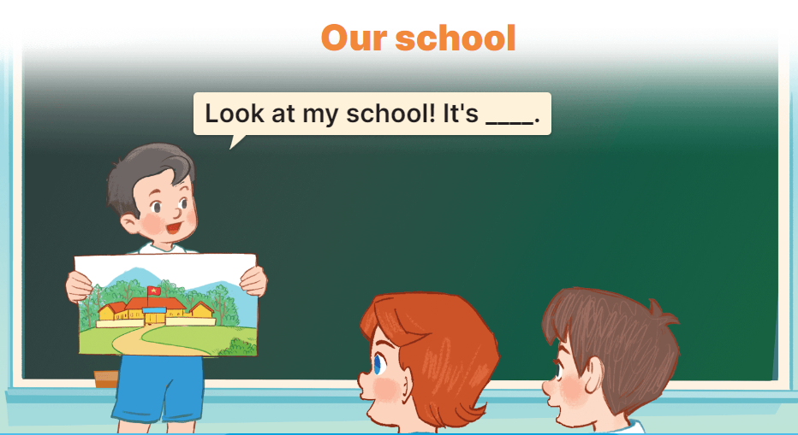  - Have pupils show their drawings that they have prepared for the project.  - Give pupils time to practise their presentations by themselves.  - Give pupils some time to use their drawings to practise presenting in groups.  - Select a few pupils to give their presentations in front of the class.  - Get other pupils to give comments, and give corrections and feedback as necessary.  *Consolidation  *Aims: Ss will be able consolidate and wrap up the content of the lesson.  *Procedure:  - T asks ss to answer the following questions:  + What have you learnt from the lesson today?  +What are the core values of the lesson? (if the teacher can take from the lesson).  - T praises some Ss who are hardworking / active/ good…. as well as encourage others to try more.  4. Homework. (3’)  - Prepare the new lesson: Unit 7, Lesson 1 (1, 2, 3). | - Ss listen and chant  - Ss open their books  - Ss listen and answer  -Ss read the words and fill  -Ss fill in the gap  -Ss complete the text  -Ss check their answer  -Ss read aloud  -Ss listen  -Ss guess the missing word  -Ss write the answers  -Ss swap books and check the answer  -SS read aloud  -Ss listen  -Ss show the picture  -Ss practice  -Ss work in groups and practice  -Ss present in front of the class  -Ss comments, and give corrections  -Ss answer the questions  -Ss listen and clap their hands  -Ss listen and take note
D. ADJUSTMENTS (if necessary):
………………………………………………………………………………………….…..……………………………………………………………………………...…………

Week 11
Period 44

Unit 7: Our timetables
Lesson 1 (1, 2, 3)
A. OBJECTIVES:
By the end of the lesson, Ss will be able to:
1. Knowledge:
- use the words English, maths, science, Vietnamese in relation to the topic “Our timetable”
- use What subjects do you have today? – I have ……. to ask and answer questions about school subjects
- Vocabulary: English, maths, science, Vietnamese, subject
- Skills: speaking and listening
2. Competences:
- Co-operation: ready to help friends in pair work/ group work.
- Sociability: Talk to each other, say good words to others.
3. Attitude/ Qualities:
- Show their responsibility to follow the timetable and prepare their subjects before school.
B. TEACHING AIDS:
- Teacher: Teacher’s guide Pages 100, 101, audio Tracks 67, 68, website hoclieu.vn, posters, laptop, pictures, textbook, lesson plan, TV or projector.
- Students: Pupil’s book Page 50, notebooks, workbooks, school things.
C. PROCEDURES:
Teacher’s activities | Students’ activities
1.Warm- up: (3’)  Sing: Baby shark  *Aims: to create a friendly and active atmosphere in the class to beginning the lesson.  *Procedure:  - Show the song on the screen.  https://www.youtube.com/watch?v=XqZsoesa55w  - Ask Ss to listen, sing and dance the song.  - Say “Open your book page 50” and look at “Unit 7, Lesson 1 (1,2,3)”.  2. Presentation (16’)  Activity 1. Vocabulary.  *Aims: Ss will be able to know the vocabulary in the new lesson.  *Procedure:  -T elicits the new words  + English : môn tiếng anh (realia)  + Vietnamese : môn tiếng việt (realia)  + Maths :môn toán (realia)  + Science : môn khoa học (realia)  + subject : môn học (translation)  - T models (3 times).  - T writes the words on the board.  - Checking: Rub out and remember  Activity 2. Look, listen and repeat:  *Aims: Ss will be able to understand and correctly repeat the sentences in two communicative contexts in which characters ask and answer questions about what subjects they have.  *Procedure:  - Have Ss look at Pictures a and b and identify names of the speakers in the pictures.  + Who is he / she?  + Where is he / she?  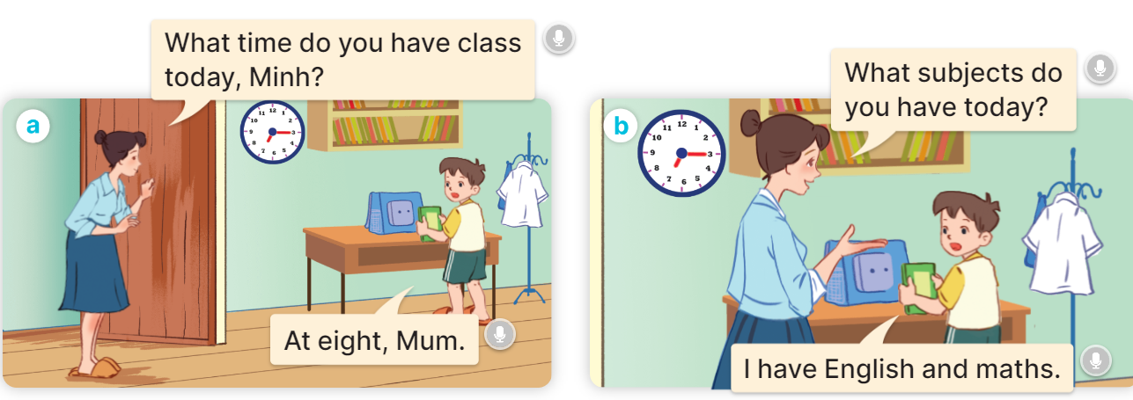  - Play the audio twice (sentence by sentence). Correct their pronunciation where necessary.  - Have Ss to practice the dialogue  - T invites a few pairs to the front of the class to practice.  - T checks pronunciation for ss.  Activity 3 2. Listen, point and say.  *Aims: Ss will be able to correctly say the words and use What subjects do you have today? – I have …….. to ask and answer questions about school subjects. *Procedure:  * Model sentences:  - T asks Ss look at picture b and helps Ss know the structure from the dialogue.  - T introduces new structure for Ss.  - T explains, models and gives meaning.  -Have Ss repeat the model sentences.  A: What subjects do you have today?  B: I have English.  3.Practice: (7’)  *Drill pictures  - Ask pupils to look at Pictures a, b, c and d and identify the names of the subjects.  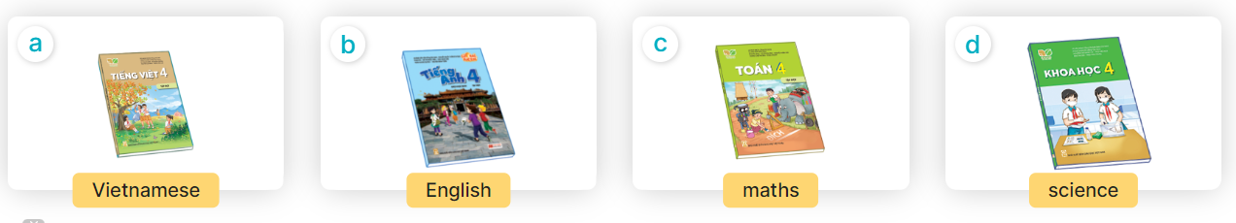  - Play the recording for pupils to listen to and repeat the words under the pictures in chorus and individually.  - Play the recording for pupils to listen to and repeat the sentences in both bubbles a few times.  - Let pupils practise asking and answering questions in pairs.  - Invite a few pairs to point at the pictures and ask and answer questions about what subject they have today.  4.Production: (7’)  Activity 4. Let’s talk.  *Aims: Ss will be able to enhance the correct use of What subjects do you have today? – I have …… to ask and answer questions about school subjects in a freer context.  *Procedure:  - Ask questions to help them identify the context  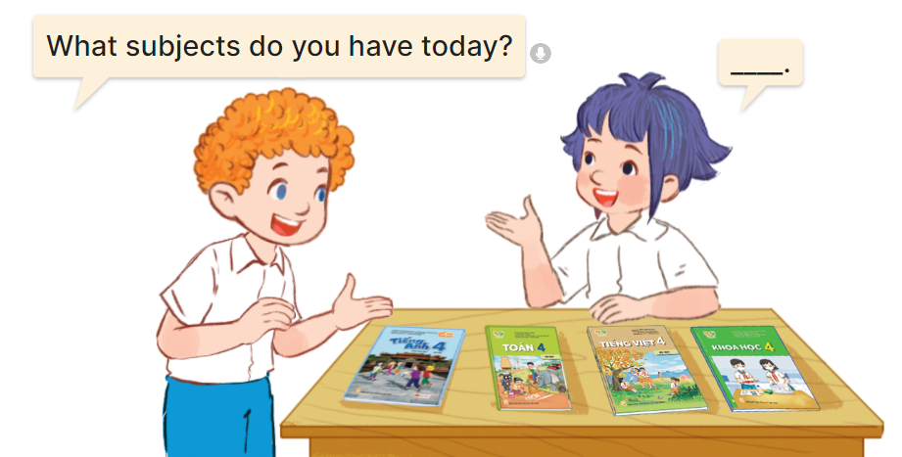  - Elicit the missing words in the speech bubble and write them on the board.  - Get pupils to say the completed sentences.  - Put pupils into pairs to practice the exchanges.  - Invite a few pairs to point at the pictures and ask and answer questions about school subjects.  *Consolidation  *Aims: Ss will be able consolidate and wrap up the content of the lesson.  *Procedure:  - T asks ss to answer the following questions:  + What have you learnt from the lesson today?  +What are the core values of the lesson? (if the teacher can take from the lesson).  - T review the vocabulary and model sentences.  - T praises some Ss who are hardworking / active/ good…. as well as encourage others to try more.  5. Homework. (2’)  - Learn the vocabulary and model sentences by heart  - Prepare the new lesson: Unit 7, Lesson 1 (4,5,6). | - Ss sing and dance the song  - Ss open their books  -Ss listen and answer  - - Ss listen and repeat  + Choral repetition (3 times).  + Individual repetition (3 ss)  - Ss take note  - Ss look, remember and write  -Look at the pictures and say  + In picture a:  Mum: What time do you have school today, Minh?  Minh: At eight, Mum.  + In picture b:  Mum: What subjects do you have today?  Minh: I have English and maths.  -Ss listen and repeat in chorus (twice)  -Ss work in pairs to practice  -Ss practice the dialogue  -Ss listen  -Ss look at the picture and answer.  -Ss listen  -Ss listen and repeat  -Ss repeat  - Ss look, listen and answer  + Picture a: A Vietnamese textbook  + Picture b: An English textbook  + Picture c: A maths textbook  + Picture d: A science textbook  -Ss listen and repeat  -Ss listen and repeat  -Ss practice  -Ss point, ask and answer.  -Ss look at the picture and answer  + a boy and a girl talking about school subjects with four textbooks (Vietnamese, English, maths, science) on a desk  -Ss listen and answer  -Ss say the completed sentences  -Ss work in pairs  -SS point, ask and answer.  -Ss answer the questions  - Ss listen  -Ss listen and clap their hands  -Ss listen and take note
D. ADJUSTMENTS (if necessary):
………………………………………………………………………………………….…..……………………………………………………………………………...………………………………………….…..……………………………………………………………………………….……………………………………………………………………...

