Week 8 Period 29

Unit 5: Things we can do
Lesson 1 (1, 2, 3)
A. OBJECTIVES:
By the end of the lesson, Ss will be able to:
1. Knowledge:
- understand and correctly repeat the sentences in two communicative contexts (pictures) in which pupils ask and answer questions about someone’s abilities.
- correctly say the phrases and use Can you …….? – Yes, I can. / No, I can’t. to ask and answer questions about someone’s abilities.
- enhance the correct use of Can you ……..? – Yes, / No, ……... to ask and answer questions about pupils’ abilities in a freer context.
- Vocabulary: ride a bike, ride a horse, play the piano, play the guitar.
- Skills: speaking and listening
2. Competences:
- Critical Thinking: self-introduce
- Co-operation: ready to help friends in pair work/ group work.
- Sociability: Talk to each other, say good words to others.
3. Attitude/ Qualities:
- Kindness: Help partners to complete learning tasks.
- Show pride in what they can do and great respect for other people’s abilities by using appropriate gestures and intonation when asking and answering about abilities.
B. TEACHING AIDS:
- Teacher: Teacher’s guide Pages 68,69,70, audio Tracks 46,47, website hoclieu.vn, posters, laptop, pictures, textbook, lesson plan, TV or projector.
- Students: Pupil’s book Page 34, notebooks, workbooks, school things.
C. PROCEDURES:
Teacher’s activities | Students’ activities
1.Warm- up: (3’)  Sing: The hobby song  *Aims: to create a friendly and active atmosphere in the class to beginning the lesson.  *Procedure:  - Show the song on the screen.  https://www.youtube.com/watch?v=90LfcLAjLiI  - Ask Ss to listen, sing and dance the song.  - Say “Open your book page 34” and look at “Unit 5, Lesson 1 (1,2,3)”.  2. Presentation(16’)  Activity 1. Vocabulary.  *Aims: Ss will be able to know the vocabulary in the new lesson.  *Procedure:  -T elicits the new words  + ride a bike : đạp xe (picture)  + ride a horse : cưỡi ngựa (picture)  + play the piano :chơi đàn pi-a-no (mime)  + play the guitar : chơi đàn ghi ta (mime)  - T models (3 times).  - T writes the words on the board.  - Checking: Matching  Activity 2. Look, listen and repeat:  *Aims: Ss will be able to understand and correctly repeat the sentences in two communicative contexts (pictures) in which pupils ask and answer questions about someone’s abilities.  *Procedure:  - Have Ss look at Pictures a and b and identify the characters in the pictures.  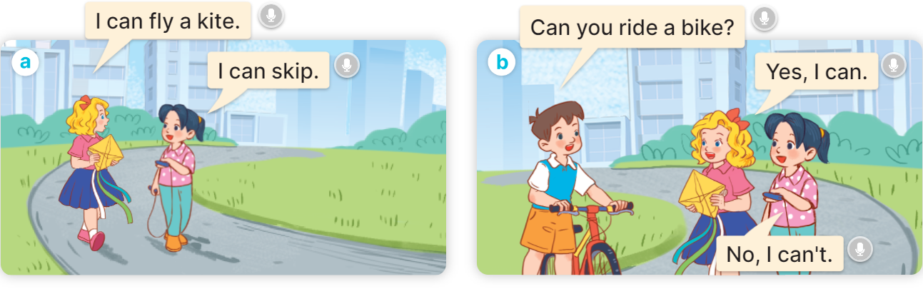  - Play the audio twice (sentence by sentence). Correct their pronunciation where necessary.  - Have Ss to practice the dialogue  - T invites a few pairs to the front of the class to practice.  - T checks pronunciation for ss.  Activity 3 2. Listen, point and say.  *Aims: Ss will be able to correctly say the phrases and use Can you ……...? – Yes, I can. /No, I can’t. to ask and answer questions about someone’s abilities  *Procedure:  * Model sentences:  - T asks Ss look at picture a and helps Ss know the structure from the dialogue.  - T introduces new structure for Ss.  - T explains, models and gives meaning.  - Have Ss repeat the model sentences.  A: Can you ride a bike?  B: Yes, I can./ No, I can’t.  3.Practice: (7’)  *Drill pictures  - Elicit and check comprehension the name of each character.  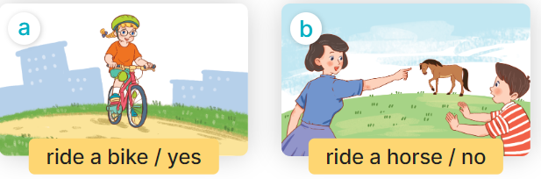  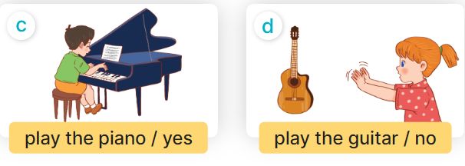  - Run through all the pictures.  - Run through model sentences.  - Have Ss to practise:  + T asks, Ss answer picture a  + Ss ask, T answers picture b  + Group A ask, group B answer picture c  + Group B ask, group A answer picture d  - Ask Ss to work in pairs.  - T controls and corrects.  - Invite a few pairs to come to the front of the classroom and point at the pictures and say the questions and answers in front of the class.  - T gives feedbacks.  4.Production: (7’)  Activity 4. Let’s talk.  *Aims: Ss will be able to enhance the correct use of Can you …. ? – Yes, / No, …... to ask and answer questions about pupils’ abilities in a freer context.  *Procedure:  - T asks ss to guess each character and what the children say.  + What can you see in the picture?  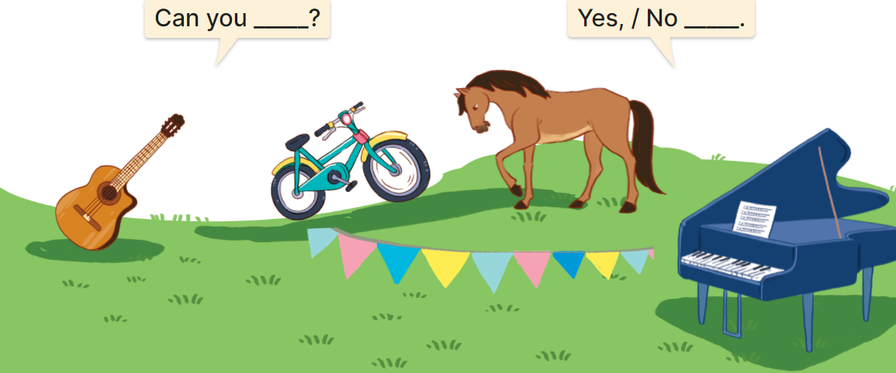  - T fills the gaps and writes the sentences on the board.  - T models  - T asks Ss to ask and answer questions using Can you? –Yes/ No, ………...  - Invite some pairs to perform.  - Give feedbacks  *Consolidation  *Aims: Ss will be able consolidate and wrap up the content of the lesson.  *Procedure:  - T asks ss to answer the following questions:  + What have you learnt from the lesson today?  +What are the core values of the lesson? (if the teacher can take from the lesson).  - T review the vocabulary and model sentences.  - T praises some Ss who are hardworking / active/ good…. as well as encourage others to try more.  5. Homework. (2’)  - Learn the vocabulary and model sentences by heart  - Prepare the new lesson: Unit 5, Lesson 1 (4,5,6). | - Ss sing and dance the song  - Ss open their books  -Ss listen and answer  - - Ss listen and repeat  + Choral repetition (3 times).  + Individual repetition (3 ss)  - Ss take note  - Ss look, remember and match  -Look at the pictures and get to know the characters in the pictures.  + In picture a:  Mary: I can fly a kite.  Mai: I can skip.  + In picture b:  Minh: Can you ride a bike?  Mary: Yes, I can.  Mai: No, I can't.  -Ss listen and repeat in chorus (twice)  -Ss work in pairs to practice  -Ss practice the dialogue  -Ss listen  -Ss look at the picture and answer.  -Ss listen  -Ss listen and repeat  -Ss repeat to the the sentences  - Ss look, listen and answer  + Picture a: a girl riding a bike  + Picture b: a boy who can’t ride a horse  + Picture c: a boy playing the piano  + Picture d: a girl who can’t play the guitar  -Ss listen and repeat  -Ss practice in chorus  -Ss practice in chorus  -Ss work in pairs to practice  -Ss point and say  -Ss listen.  -Ss look at the picture and answer  A summer camp poster. There are four activities in the poster.  -Ss note  - Ss say the completed sentences.  -Ss work in pairs  -Ss perform in front of the class.  -Ss answer the questions  - Ss listen  -Ss listen and clap their hands  -Ss listen and take note

D. ADJUSTMENTS (if necessary):
………………………………………………………………………………………….…..……………………………………………………………………………...………………………………………….…..……………………………………………………………………………….……………………………………………………………………...

Week 8
Period 30
Unit 5: Things we can do
Lesson 1 (4, 5, 6)
A. OBJECTIVES:
By the end of the lesson, Ss will be able to:
1. Knowledge:
- listen to and understand two communicative contexts in which pupils ask and answer questions about someone’s abilities and tick the correct pictures.
- complete four gapped exchanges with the help of picture cues.
- practise the target vocabulary and sentence patterns by playing the game Can you ...?
- Vocabulary: Review
- Skills: speaking, listening, reading and writing.
2. Competences:
- Critical Thinking: self-introduce
- Co-operation: ready to help friends in pair work/ group work.
- Self-control and independent learning: perform listening tasks.
3. Attitude/ Qualities:
- Kindness: Help partners to complete learning tasks.
- Honesty: tell the truth about feelings and emotions.
- Diligence: complete learning tasks.
B. TEACHING AIDS:
- Teacher: Teacher’s guide Pages 70,71,72; audio Tracks 48; website hoclieu.vn, posters, laptop, pictures, textbook, lesson plan, TV or projector.
- Students: Pupil’s book Page 35, notebooks, workbooks, school things.
C. PROCEDURES:
Teacher’s activities | Students’ activities
1.Warm- up: (5’)  Game: Lucky number  *Aims: to create a friendly and active atmosphere in the class to beginning the lesson.  *Procedure:  - Divide the class into 3 groups.  - Pupils from each team choose a number, then ask and answer with the picture in that number.  - Pupil or teacher clicks the “play” button to roll the dice and clicks the “stop” button to get points.  - After 9 numbers, the group with the most points is the winner  - Say “Open your book page 35” and look at “Unit 5, Lesson 1 (4,5,6)”.  2.Practice: (27’)  Activity 1. Listen and tick:  *Aims: Ss will be able to listen to and understand two communicative contexts in which pupils ask and answer questions about someone’s abilities and tick the correct pictures.  *Procedure:  - Elicit the names of the characters in the pictures.  - Point at the pictures respectively to explain the context.  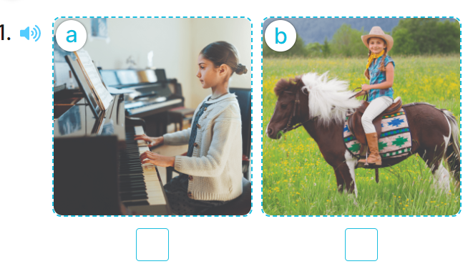  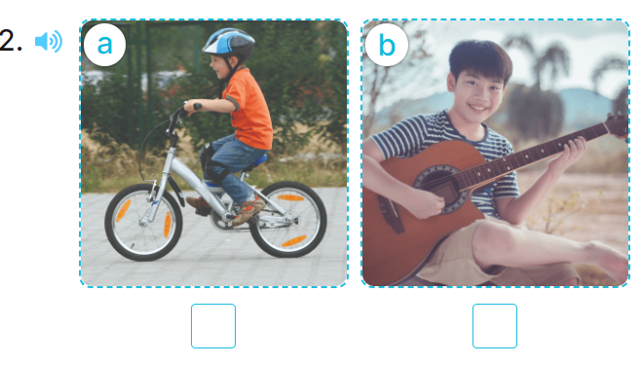  - T ask Ss to guess the answers.  + T writes Ss’guessing on the board.  - Listen to the tape:  + Play the recording  + Play the recording again and get Ss to swap books with their partners.  + Play the recording again to check answers together as a class.  + Write the answers on the board for Ss to correct their answers. Then checks Ss’ guessing.  - Play the recording, sentence by sentence, for the class to listen and repeat in chorus.  Key: 1. b 2. b  Activity 2. Look, complete and read  *Aims: Ss will be able to complete four gapped exchanges with the help of picture cues.  *Procedure:  - Have pupils read the exchange and guess the missing words in the answer.  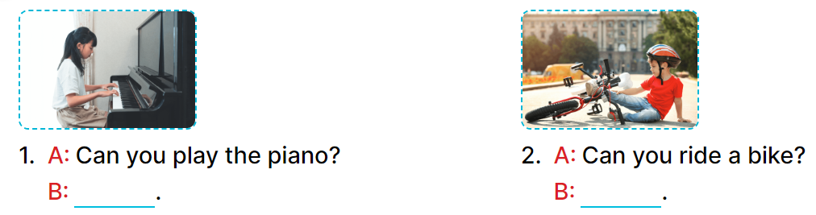  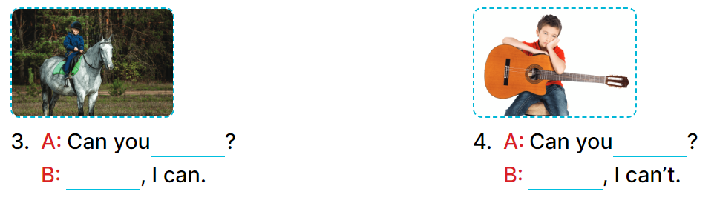  - Have Ss look at the four sentences and the pictures. Elicit with picture 1  - Give pupils time to do the task independently.  - Get pupils to swap books with a partner and check their answers before checking as a class.  - Nominate a pupil to write the answers on the board.  - Invite four pairs of pupils to act out four complete exchanges in front of the class.  Key:  1. Yes, I can 2. No, I can’t  3. ride a horse; Yes 4. play the guitar; No  Activity 3. Let’s play  *Aims: Ss will be able to practise the target vocabulary and sentence patterns by playing the game Can you ...?  *Procedure:  - Invite two groups, each with six pupils, to play the game.  -Tell pupils the goal of the game and how to play it.  + Each group has two minutes to play.  + The teacher holds up a flash card (ride a bike), the first pair looks at the picture, one pupil asks (ex: Can you ride a bike?) and another pupil replies as quickly as possible. +Check with the whole class if the question is correct or not, and ask the group to demonstrate the action.  + The pair who has played goes to the end of the line.  + The second pair moves up and continues with the next flash card.  + For each pair, the group gets three stars, one star for the question, one for the answer and one for the group action.  - Play the game with other groups in the class. The group with the most stars is the winner.  *Consolidation  *Aims: Ss will be able consolidate and wrap up the content of the lesson.  *Procedure:  - T asks ss to answer the following questions:  + What have you learnt from the lesson today?  +What are the core values of the lesson? (if the teacher can take from the lesson).  - T praises some Ss who are hardworking / active/ good…. as well as encourage others to try more.  3. Homework. (3’)  - Practice part 5 again.  - Prepare the new lesson: Unit 5, Lesson 2 (1,2,3). | - Ss listen and pay attention  - Ss play game  -Ss play game  - Ss open their books  -Look at the pictures and say:  + Picture 1a: a girl playing the piano.  + Picture 1b: a girl riding a horse + Picture 2a: a boy riding a bike  + Picture 2b: a boy playing the guitar  -Ss guess the answers  - Ss listen to the tape and tick  - Ss listen again, tick and swap books with their partners.  - Ss check their answers and guessing  -Ss write the correct answer.  -Ss listen and repeat.  -Ss look at the picture and say  -Ss look and answer  -Ss do the task  -Ss work in pairs and swap books  -Ss write the answer on the board  -Ss act out  - Ss listen  -Ss play game  - Ss listen and play game  -Ss answer the questions  -Ss listen and clap their hands  -Ss listen and take note
D. ADJUSTMENTS (if necessary):
………………………………………………………………………………………….…..……………………………………………………………………………...………………………………………………………………………………………………….………
Week 8
Period 31
Unit 5: Things we can do
Lesson 2 (1, 2, 3)
A. OBJECTIVES:
By the end of the lesson, Ss will be able to:
1. Knowledge:
- understand and correctly repeat the sentences in two communicative contexts (pictures) in which the characters talk about abilities and lack of abilities.
- correctly say the words and use Can he / she …….? – Yes, he / she can. / No, he / she can’t, but he / she can ……. to talk about abilities and lack of abilities.
- enhance the correct use of Can he / she ……..? – Yes, …... / No, ……, but ……... to talk about abilities and lack of abilities in a freer context.
- Vocabulary: roller skate
- Skills: speaking and listening
2. Competences:
- Critical Thinking: self-introduce
- Co-operation: ready to help friends in pair work/ group work.
- Sociability: Talk to each other, say good words to others.
3. Attitude/ Qualities:
- Kindness: Help partners to complete learning tasks.
- Honesty: tell the truth about feelings and emotions
B. TEACHING AIDS:
- Teacher: Teacher’s guide Pages 72,73,74; audio Tracks 49, 50, website hoclieu.vn, posters, laptop, pictures, textbook, lesson plan, TV or projector.
- Students: Pupil’s book Page 36, notebooks, workbooks, school things.
C. PROCEDURES:
Teacher’s activities | Students’ activities
1.Warm- up: (3’)  Game: Guessing game  *Aims: to create a friendly and active atmosphere in the class to beginning the lesson.  *Procedure:  - Divide the class into 3 teams.  - Pupils take turns to answer the questions.  - They look at the objects and guess what activity they can do with the objects.  - If they have the correct answers, they get the points for their teams. If the answer is not correct, another team answers  - Say “Open your book page 36” and look at “Unit 5, Lesson 2 (1,2,3)”.  2. Presentation (16’)  Activity 1. Vocabulary.  *Aims: Ss will be able to know the vocabulary in the new lesson.  *Procedure:  -T elicits the new words  + roller skate : trượt pa tin (picture)  - T models (3 times).  - T writes the words on the board.  - Checking: What and where  Activity 2. Look, listen and repeat:  *Aims: Ss will be able to understand and correctly repeat the sentences in two communicative contexts (pictures) in which the characters talk about abilities and lack of abilities.  *Procedure:  - Have Ss look at Pictures a and b and identify the characters and predict the activities that Linh can do on the sports day.  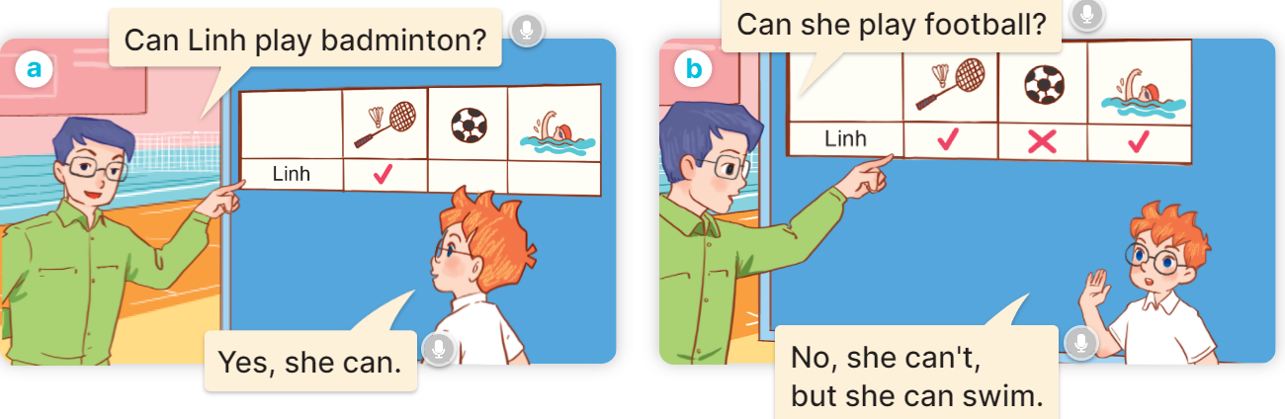  - Play the audio twice (sentence by sentence). Correct their pronunciation where necessary.  - Have Ss to practice the diaguage  - T invites a few pairs to the front of the class to practice.  - T checks pronunciation for ss.  Activity 3. Listen, point and say.  *Aims: Ss will be able to correctly say the phrases and use Can he / she … ? – Yes, he/ she can. / No, he/ she can’t, but he/ she can ……. to talk about abilities or lack of abilities.  *Procedure:  * Model sentences:  - T asks Ss look at picture a and helps Ss know the structure from the dialogue.  - T introduces new structure for Ss.  - T explains, models and gives meaning.  - Have Ss repeat the model sentences.  A: Can he swim?  B: Yes, he can.  A: Can he roller skate?  B: No, he can’t, but he can swim.  3.Practice: (7’)  *Drill pictures  - Have Ss look at the pictures and elicit the activities.  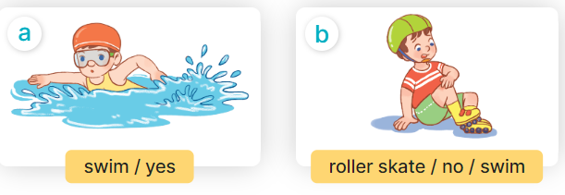  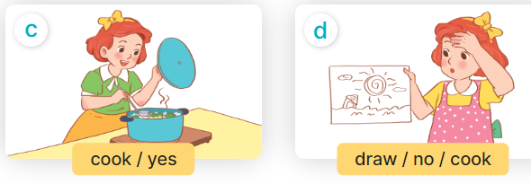  - Run through all the pictures.  - Run through model sentences.  + Run through the questions  + Run through the answers  - Have Ss to practise:  + T asks – Ss answer (change role).  + Ss – Ss (change role).  - Ask Ss to work in pairs.  - T controls and corrects.  - Invite a few pairs to come to the front of the classroom, point at the pictures and say the questions and answers in front of the class.  - T gives feedbacks.  4.Production: (7’)  Activity 4. Let’s talk.  *Aims: Ss will be able to enhance the correct use of Can he / she …. ? – Yes, …. / No, , but ....... to talk about abilities and lack of abilities in a freer context.  *Procedure:  - T asks ss to guess each character and what the children say.  + What can you see in the picture?  +Who are they?  +Where are they?  +What are they doing?  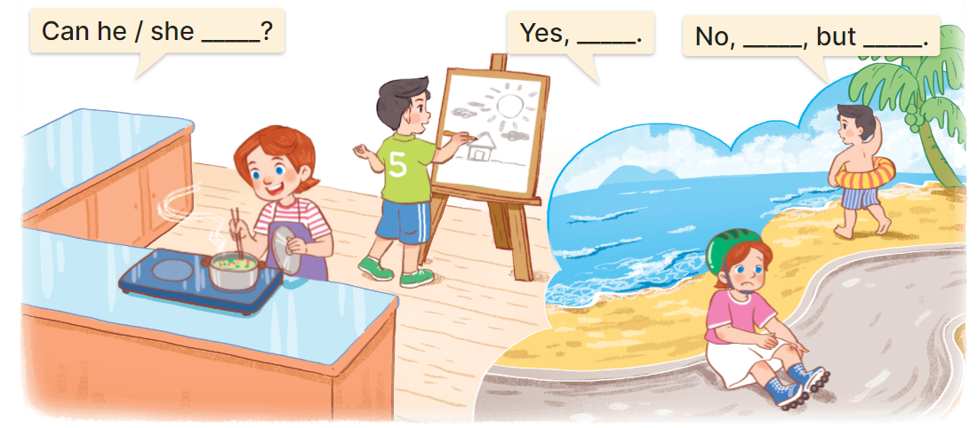  - Put Ss into pairs and encourage them to ask and answer questions using Can he/ she….? I Yes/ No, I….….  - Elicit the missing words in the speech bubbles and write them on the board.  - Get pupils to say the completed sentences.  - Give pupils time to work in pairs and take turns asking and answering about what the friends in the pictures can or can’t do.  - Invite a few pairs to come to the front of the classroom and act out the roles.  *Consolidation  *Aims: Ss will be able consolidate and wrap up the content of the lesson.  *Procedure:  - T asks ss to answer the following questions:  + What have you learnt from the lesson today?  +What are the core values of the lesson? (if the teacher can take from the lesson).  - T review the vocabulary and model sentences.  - T praises some Ss who are hardworking / active/ good…. as well as encourage others to try more.  5. Homework. (2’)  - Learn the vocabulary and model sentences by heart  - Prepare the new lesson: Unit 5, Lesson 2 (4,5,6). | - Ss listen  - Ss play the game  -Ss play the game  - Ss open their books  -Ss listen and answer  - - Ss listen and repeat  + Choral repetition (3 times).  + Individual repetition (3 ss)  - Ss take note  - Ss look, remember and slap  -Look at the pictures and get to know the characters in the pictures.  + In picture a:  Mr Long: Can Linh play badminton? Ben: Yes, she can.  – In picture b:  Mr Long: Can she play football?  Ben: No, she can’t, but she can swim.  -Ss listen and repeat in chorus (twice)  -Ss work in pairs to practice  -Ss practice the diaguage  -Ss listen  -Ss look at the picture and answer.  -Ss listen  -Ss listen and repeat  -Ss repeat to the sentences.  -Ss listen and answer  +Picture a: swim/ yes  +Picture b. roller skate/ no/ swim  +Picture c. cook/ yes  +Picture d. draw/ no/ cook.  - Ss look, listen and repeat  - Ss practice in chorus  - Ss practice in chorus  -Ss work in pairs to practice  -Ss listen  -Ss go to the board and point and say  -Ss listen  -Ss look at the picture and answer  + Lucy is cooking, Nam is drawing, Lucy cannot skate, Nam cannot swim.  -Ss work in pairs  -Ss write the missing words  -Ss say the completed sentences  -Ss check nd answer  -Ss act out in front of the class  -Ss answer the questions  - Ss listen  -Ss listen and clap their hands  -Ss listen and take note

D. ADJUSTMENTS (if necessary):
………………………………………………………………………………………….…..……………………………………………………………………………...………………………………………….…..……………………………………………………………………………….……………………………………………………………………...

Week 8
Period 32
Unit 5: Things we can do
Lesson 2 (4, 5, 6)
A. OBJECTIVES:
By the end of the lesson, Ss will be able to:
1. Knowledge:
- listen to and understand four communicative contexts in which pupils talk about abilities and lack of abilities and tick or cross the pictures.
- complete four gapped exchanges with the help of picture cues.
- sing the song Things they can do with the correct pronunciation, rhythm and melody.
- Vocabulary: Review
- Skills: speaking, listening, reading and writing.
2. Competences:
- Critical Thinking: self-introduce
- Co-operation: ready to help friends in pair work/ group work.
- Self-control and independent learning: perform listening tasks.
3. Attitude/ Qualities:
- Kindness: Help partners to complete learning tasks.
- Honesty: tell the truth about feelings and emotions.
- Diligence: complete learning tasks.
B. TEACHING AIDS:
- Teacher: Teacher’s guide Pages 75,76; audio Tracks 51, 52; website hoclieu.vn, posters, laptop, pictures, textbook, lesson plan, TV or projector.
- Students: Pupil’s book Page 37, notebooks, workbooks, school things.
C. PROCEDURES:
Teacher’s activities | Students’ activities
1.Warm- up: (5’)  Sing a song: Slap the board  *Aims: to create a friendly and active atmosphere in the class to beginning the lesson.  *Procedure:  - Divide the class into two or three teams.  - Teacher puts up a set of pictures or words on a board.  - A pupil from each team comes up to the board with fly swatters.  - They listen as the teacher calls out a word or a sentence and they race to slap the correct picture.  - Whoever is the fastest with the correct slap gets a point for their team.  - Team with the most points is the winner.  - Say “Open your book page 13” and look at “Unit 5, Lesson 2 (4,5,6)”.  2.Practice: (27’)  Activity 1. Listen and tick or cross:  *Aims: Ss will be able to listen to and understand two communicative contexts in which pupils discuss different hobbies.  *Procedure:  - Elicit the activities in the pictures and tick or cross the boxes while listening.  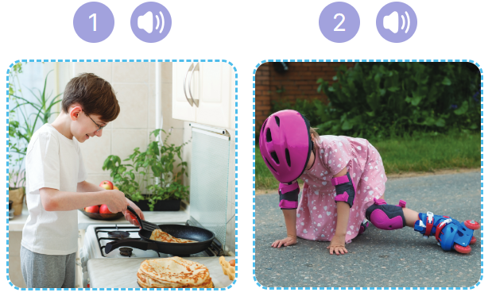  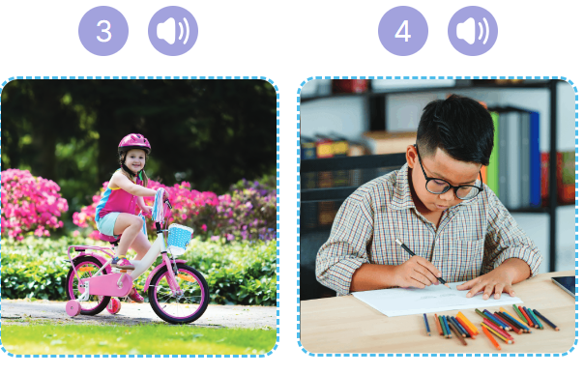  - T ask Ss to guess the answers.  + T writes Ss’guessing on the board.  - Listen to the tape:  + Play the recording  + Play the recording again and get Ss to swap books with their partners.  + Play the recording again to check answers together as a class.  + Write the answers on the board for Ss to correct their answers. Then checks Ss’ guessing.  - Play the recording, sentence by sentence, for the class to listen and repeat in chorus.  Key: 1. Tick 2. Cross 4.Tick 5.Cross  Activity 2. Look, complete and read  *Aims: Ss will be able to complete four target sentences with the help of picture cues.  *Procedure:  - Draw pupils’ attention to the picture and elicit the words to complete the sentence.  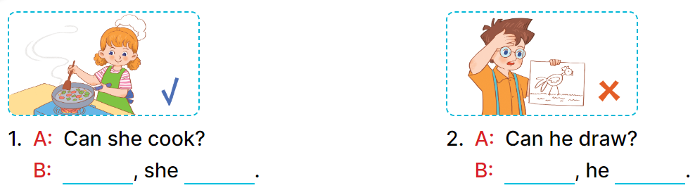  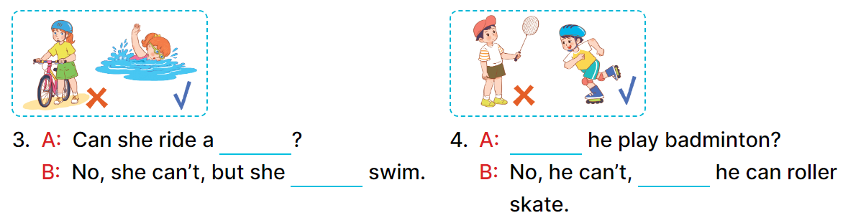  - Have Ss look at the four incomplete sentences and elicits the missing words in the sentences.  - T models with picture 1  + Ask Ss what is missing in the sentence.  + Have Ss look at the picture and complete the gap, then read the completed sentence in chorus.  -Have Ss work in groups and complete the picture 2, 3 and 4.  - Ask a few Ss to stand up and read the completed sentences aloud.  -T gives feedbacks.  Key: 1. Yes; can 2. No; can’t  3. bike; can 4. Can; but  Activity 3. Let’s sing.  *Aims: Ss will be able to sing the song Things they can do with the correct pronunciation, rhythm and melody.  *Procedure:  - Introduce the title and lyrics of the song: “ Things they can do ”  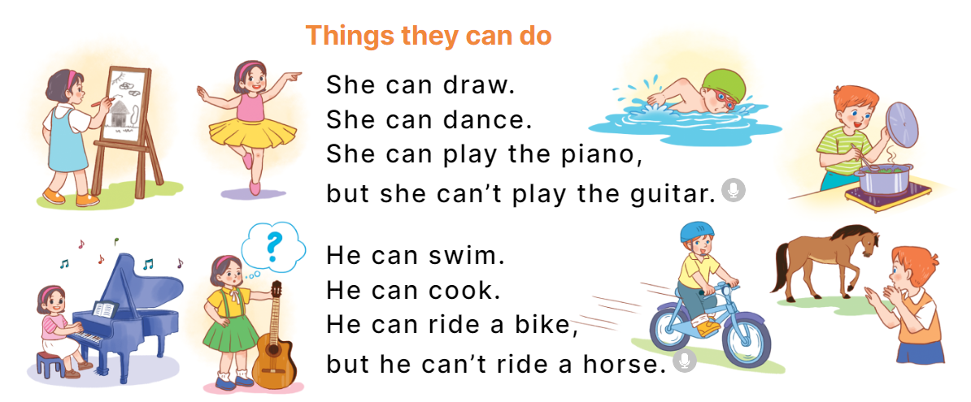  - Play the recording for Ss to listen to the whole song.  + Have them repeat the title and lyrics line by line.  + Tell Ss to point at the pictures while singing.  - Play the recording all the way through for Ss to listen to pronunciation and melody of the song.  - Play the recording line by line for Ss to listen, repeat and point to the pictures  - Play the recording for Ss to sing and do actions.  - Ask Ss to practice singing and doing actions in pairs or groups.  - Invite groups to the front of the classroom to perform the song  -T gives feedback.  *Consolidation  *Aims: Ss will be able consolidate and wrap up the content of the lesson.  *Procedure:  - T asks ss to answer the following questions:  + What have you learnt from the lesson today?  +What are the core values of the lesson? (if the teacher can take from the lesson).  - T praises some Ss who are hardworking / active/ good…. as well as encourage others to try more.  3. Homework. (3’)  - Practice part 5 again.  - Prepare the new lesson: Unit 5, Lesson 3 (1,2,3). | - Ss listen  - Ss play game  - Ss open their books  -Look at the pictures and say:  + Picture 1. a boy cooking  + Picture 2. a girl falling off her roller skates  + Picture 3. a girl riding a bike  + Picture 4. a girl painting  -Ss guess the answers  - Ss listen to the tape and tick/ cross  - Ss listen again, tick/ cross and swap books with their partners.  - Ss check their answers and guessing  -Ss listen and repeat.  -Ss look at the picture and say  -Ss answer: Yes, she can  -Ss look, complete and read the completed sentence in chorus.  -Ss complete the sentence  -Ss read aloud  - Ss listen  -Ss listen to the song  - Ss listen and repeat line by line without the action.  -Ss point to the pictures while singing  -Ss listen to melody of the song  - Ss listen and sing line by line.  - Ss sing and do actions.  + Ss work in groups (two groups) to sing.  -Ss perform in front of the class.  -Ss listen  -Ss answer the questions  - Ss listen  -Ss listen and clap their hands  -Ss listen

D. ADJUSTMENTS (if necessary):
………………………………………………………………………………………….…..……………………………………………………………………………...………………………………………….…..………………………………………………………….

