Week 6

Period 23

Unit 4: My birthday party
Lesson 1 (1, 2, 3)
A. OBJECTIVES:
By the end of the lesson, Ss will be able to:
1. Knowledge:
- understand and correctly repeat the sentences in two communicative contexts focusing on asking and answering questions about birthdays.
- correctly say the words and use When’s your birthday? – It’s in …... to ask and answer questions about someone’s birthday.
- enhance the correct use of When’s your birthday? – It’s in ……... to ask and answer questions about someone’s birthday in a freer context.
- Vocabulary: January, February, March, April, May, June, birthday.
- Skills: speaking and listening
2. Competences:
- Co-operation: ready to help friends in pair work/ group work.
- Sociability: Talk to each other, say good words to others.
3. Attitude/ Qualities:
- Kindness: Help partners to complete learning tasks.
- Honesty: tell the truth about feelings and emotions
B. TEACHING AIDS:
- Teacher: Teacher’s guide Pages 55,56,57 audio Tracks 36,37; website hoclieu.vn, posters, laptop, pictures, textbook, lesson plan, TV or projector.
- Students: Pupil’s book Page 28, notebooks, workbooks, school things.
C. PROCEDURES:
Teacher’s activities | Students’ activities
1.Warm- up: (3’)  Sing: Happy birthday to you  *Aims: to create a friendly and active atmosphere in the class to beginning the lesson  *Procedure:  - Show the song on the screen.  https://www.youtube.com/watch?v=90w2RegGf9w  - Ask pupils to listen, sing and dance the song.  - Say “Open your book page 28” and look at “Unit 4, Lesson 1 (1,2,3)”.  2. Presentation (16’)  Activity 1. Vocabulary.  *Aims: Ss will be able to know the vocabulary in the new lesson.  *Procedure:  -T elicits the new words  + January :tháng 1 (siuation)  + February :tháng 2 (situation)  + March :tháng 3 (translation)  + April :tháng 4 (translation)  + May :tháng 5 (situation)  + June :tháng 6 (translation)  +birthday : ngày sinh, sinh nhật (picture)  - T models (3 times).  - T writes the words on the board.  - Checking: Rub out and remember  Activity 2. 1. Look, listen and repeat:  *Aims: Ss will be able to understand and correctly repeat the sentences in two communicative contexts focusing on asking and answering questions about birthdays  *Procedure:  - Have Ss look at Pictures a and b and identify the characters in the pictures.  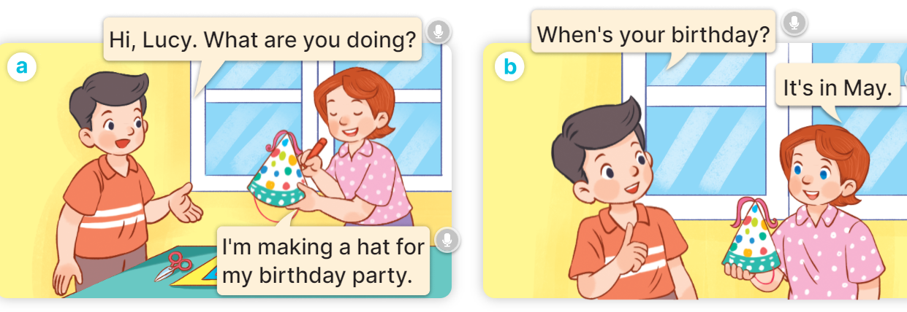  - Play the audio twice (sentence by sentence). Correct their pronunciation where necessary.  - Have Ss to practice the dialogue  - T invites a few pairs to the front of the class to practice.  - T checks pronunciation for ss.  Activity 3 2. Listen, point and say.  *Aims: Ss will be able to correctly say the words and use When’s your birthday? – It’s in …… to ask and answer questions about someone’s birthday.  *Procedure:  * Model sentences:  - T asks Ss look at picture b and helps Ss know the structure from the dialogue.  - T introduces new structure for Ss.  - T explains, models and gives meaning.  -Have Ss repeat the model sentences.  A: When’s your birthday?  B: It’s in May.  3.Practice: (7’)  *Drill pictures  - Have pupils look at the pictures and elicit the names of the months.      - Run through all the pictures.  - Run through model sentences.  - Have Ss to practise:  + T asks the first picture, Ss answer  + Ss asks the second picture, T answers  + Group A asks the third picture, group B answers  + Group B asks the last picture, group A answers.  - Ask Ss to work in pairs.  - T controls and corrects.  - Invite a few pairs to come to the front of the classroom, point at the pictures, and say the questions and answers in front of the class.  - T gives feedbacks.  4.Production: (7’)  Activity 4. Let’s talk.  *Aims: Ss will be able to enhance the correct use of When’s your birthday? – It’s in …….. to ask and answer questions about someone’s birthday in a freer context.  *Procedure:  - Have pupils say the names of the months in the picture.  + When’s your birthday? – It’s in ……..  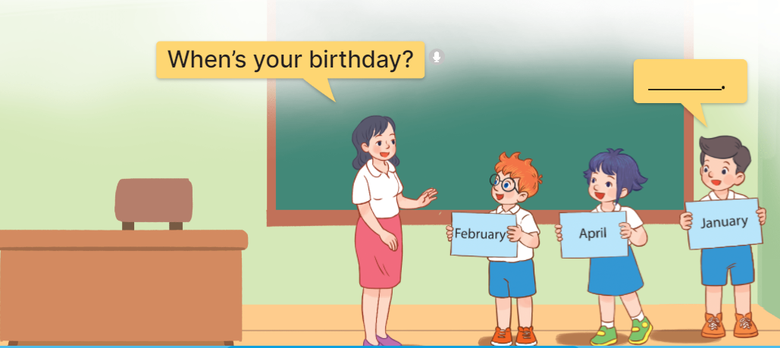  - Elicit the missing words in the speech bubble and write them on the board.  - Have pupils look at the bubbles to understand how the sentence pattern is used. - Have pupils role-play to practise asking the questions and giving their answers in pairs, using picture cues.  - Make sure pupils understand the structure and say them with the right pronunciation and intonation.  - Invite some pupils to practise asking and answering questions in front of the class.  *Consolidation  *Aims: Ss will be able consolidate and wrap up the content of the lesson.  *Procedure:  - T asks ss to answer the following questions:  + What have you learnt from the lesson today?  +What are the core values of the lesson? (if the teacher can take from the lesson).  - T review the vocabulary and model sentences.  - T praises some Ss who are hardworking / active/ good…. as well as encourage others to try more.  5. Homework. (2’)  - Learn the vocabulary and model sentences by heart  - Prepare the new lesson: Unit 4, Lesson 1 (4,5,6). | - Ss sing and dance the song  - Ss open their books  -Ss listen and answer  - - Ss listen and repeat  + Choral repetition (3 times).  + Individual repetition (3 ss)  - Ss take note  - Ss look, remember and match  -Look at the pictures and get to know the characters in the pictures.  + In picture a:  Nam: Hi, Lucy. What are you doing?  Lucy: I’m making a hat for my birthday party.  + In picture b:  Nam: When’s your birthday?  Lucy: It’s in May.  -Ss listen and repeat in chorus (twice)  -Ss work in pairs to practice  -Ss practice the dialogue  -Ss listen  -Ss look at the picture and answer.  -Ss listen  -Ss listen and repeat  -Ss repeat to parts of the body.  - Ss look, listen and answer  +Picture a: a calendar showing January.  + Picture b: a calendar showing February.  + Picture c: a calendar showing March.  + Picture d: a calendar showing April.  -Ss listen and repeat  -Ss practice in chorus  -Ss practice in chorus  -Ss work in pairs to practice  -Ss listen  -Ss point and say the questions  -Ss listen.  -Ss look at the bubbles and picture and answer  + It’s in ……..  -Ss listen and pay attention  - Ss answer  -Ss work in pairs, ask and answer  -SS ask and answerwith the right pronunciation and intonation.  -Ss perform in front of the class.  -Ss answer the questions  - Ss listen  -Ss listen and clap their hands  -Ss listen and take note

D. ADJUSTMENTS (if necessary):
………………………………………………………………………………………….…..……………………………………………………………………………...………………………………………….…..……………………………………………………………………………….……………………………………………………………………...

Week 6

Period 24

Unit 4: My birthday party
Lesson 1 (4, 5, 6)
A. OBJECTIVES:
By the end of the lesson, Ss will be able to:
1. Knowledge:
- listen to and understand four communicative contexts in which pupils ask and answer questions about their birthdays and number the correct pictures.
- complete four target gapped exchanges with the help of picture cues.
- sing the song When's your birthday? with the correct pronunciation, rhythm and melody.
- Vocabulary: Review
- Skills: speaking, listening, reading and writing.
2. Competences:
- Co-operation: ready to help friends in pair work/ group work.
- Self-control and independent learning: perform listening tasks.
3. Attitude/ Qualities:
- Kindness: Help partners to complete learning tasks.
- Honesty: tell the truth about feelings and emotions.
- Diligence: complete learning tasks.
B. TEACHING AIDS:
- Teacher: Teacher’s guide Pages 57,58,59,60; audio Tracks 39, 40; website hoclieu.vn, posters, laptop, pictures, textbook, lesson plan, TV or projector.
- Students: Pupil’s book Page 29, notebooks, workbooks, school things.
C. PROCEDURES:
Teacher’s activities | Students’ activities
1.Warm- up: (5’)  Game: Slap the board  *Aims: to create a friendly and active atmosphere in the class to beginning the lesson.  *Procedure:  - Divide class into 2 groups: Tom and Jerry.  - How to play:  + Each group chooses five Ss to play.  + Class will read aloud.  + Look at the picture, listen and slap the picture you heard.  + Who faster will get 1 mark.  + Which group with higher mark is the winner.  - Say “Open your book page 29” and look at “Unit 4, Lesson 1 (4,5,6)”.  2.Practice: (27’)  Activity 1. Listen and number:  *Aims: Ss will be able to listen to and understand four communicative contexts in which pupils ask and answer questions about their birthdays and number the correct pictures.  *Procedure:  - Elicit the name of the month in each picture.  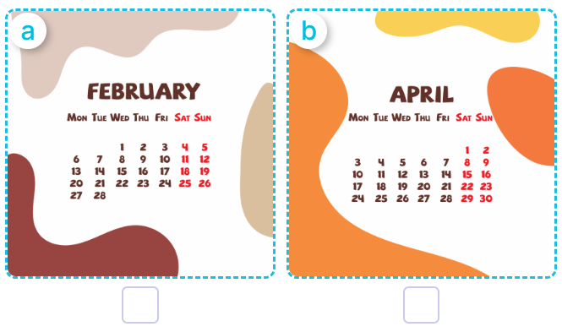  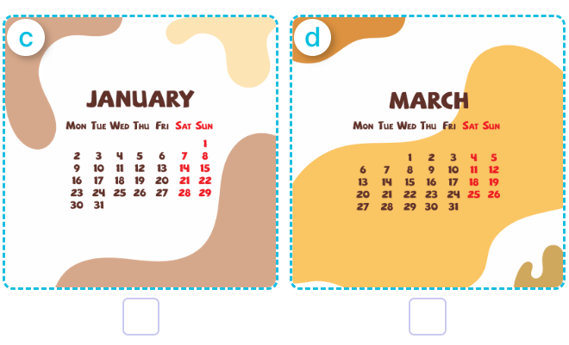  - T ask Ss to guess the answers.  + T writes Ss’guessing on the board.  - Listen to the tape:  + Play the recording  + Play the recording again and get Ss to swap books with their partners.  + Play the recording again to check answers together as a class.  + Write the answers on the board for Ss to correct their answers. Then checks Ss’ guessing.  - Play the recording, sentence by sentence, for the class to listen and repeat in chorus.  Key: 1.b 2.a 3.d 4.c  Activity 2. Look, complete and read.  *Aims: Ss will be able to complete four target gapped exchanges with the help of picture cues.  *Procedure:  - Get Ss to look at the pictures and identify the body parts in the pictures.  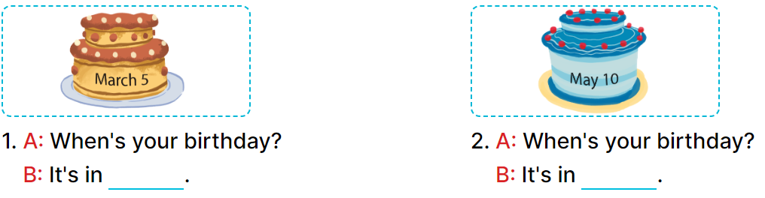  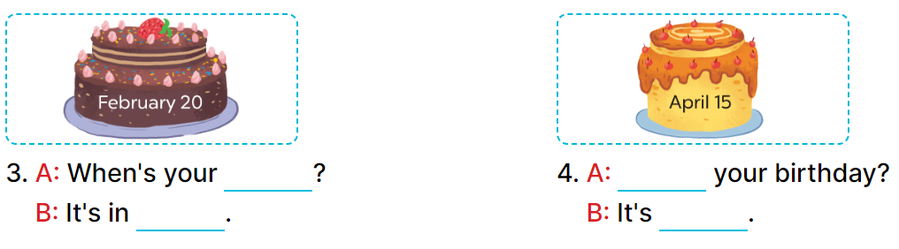  - Have Ss look at the four incomplete dialogues and elicits the missing words in the sentences.  - T models with picture 1  + Ask Ss what is missing in the sentence.  + Have Ss look at the picture and complete the gap, then read the completed sentence in chorus.  -Have Ss work in groups and complete the picture 2, 3 and 4.  - Ask a few Ss to stand up and read the completed sentences aloud.  -T gives feedbacks.  Key: 1. March 2. May  3. birthday; February  4. When’s; in April  Activity 3. Let’s sing.  *Aims: Ss will be able to sing the song When's your birthday? with the correct pronunciation, rhythm and melody.  *Procedure:  - Introduce the title and lyrics of the song: “ When's your birthday? ”  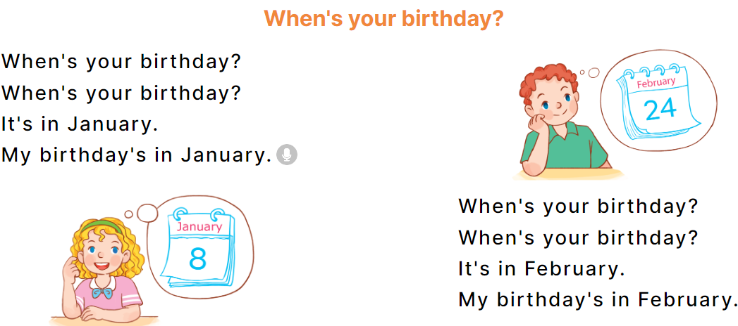  - Play the recording for Ss to listen to the whole song.  + Have them repeat the title and lyrics line by line.  + Tell Ss to point at the parts of their body while singing his or her name.  - Play the recording all the way through for Ss to listen to pronunciation and melody of the song.  - Play the recording line by line for Ss to listen, repeat and point to the part of their body  - Play the recording for Ss to sing and do actions.  - Ask Ss to practice singing and doing actions in pairs or groups.  - Invite groups to the front of the classroom to perform the song  -T gives feedback.  *Consolidation  *Aims: Ss will be able consolidate and wrap up the content of the lesson.  *Procedure:  - T asks ss to answer the following questions:  + What have you learnt from the lesson today?  +What are the core values of the lesson? (if the teacher can take from the lesson).  - T praises some Ss who are hardworking / active/ good…. as well as encourage others to try more.  3. Homework. (3’)  - Practice part 5 again.  - Prepare the new lesson: Unit 4, Lesson 2 (1,2,3). | - Ss listen to the rule  - Ss play game  - Ss listen  - Ss open their books  -Look at the pictures and say:  + Picture a: a calendar showing February.  + Picture b: a calendar showing April.  + Picture c: a calendar showing January  + Picture d: a calendar showing March  -Ss guess the answers  - Ss listen to the tape and number  - Ss listen again, number and swap books with their partners.  -Ss listen again and check.  - Ss check their answers and guessing  -Ss listen and repeat.  -Ss look at the picture and say  -Ss look and answer  -Ss answer: It’s in March…………  -Ss look, complete and read the completed sentence in chorus.  -Ss complete the sentences  -Ss read aloud  - Ss look and listen.  -Ss listen to the song  - Ss listen and repeat line by line without the action.  -Ss point to the parts of their body while singing  -Ss listen to melody of the song  - Ss listen and sing line by line.  - Ss sing and do actions.  + Ss work in groups (two groups) to sing.  -Ss perform in front of the class.  -Ss listen  -Ss answer the questions  -Ss listen and clap their hands  -Ss listen and take note
D. ADJUSTMENTS (if necessary):

………………………………………………………………………………………….…..……………………………………………………………………………...………………………………………….…..……………………………………………………………………………….……………………………………………………………………..

