Week 5 From 7/10/2024 to 11/10/2024
Period 17
Unit 3: My week
Lesson 1 (1, 2, 3)
A. OBJECTIVES:
By the end of the lesson, Ss will be able to:
1. Knowledge:
- understand and correctly repeat the sentences in two communicative contexts (pictures) in which pupils ask and answer questions about the days of the week.
- correctly say the words and use What day is it today? – It’s ………. to ask and answer questions about the days of the week.
- enhance the correct use of What day is it today? – It’s …….. to ask and answer questions about the days of the week in a freer context.
- Vocabulary: Monday, Tuesday, Wednesday, Thursday, Friday, Saturday, Sunday, today.
- Skills: speaking and listening
2. Competences:
- Critical Thinking: self-introduce
- Co-operation: ready to help friends in pair work/ group work.
- Sociability: Talk to each other, say good words to others.
3. Attitude/ Qualities:
- Kindness: Help partners to complete learning tasks.
- Honesty: tell the truth about feelings and emotions
B. TEACHING AIDS:
- Teacher: Teacher’s guide Pages 43, 44, 45, audio Tracks 26, 27, website hoclieu.vn, posters, laptop, pictures, textbook, lesson plan, TV or projector.
- Students: Pupil’s book Page 22, notebooks, workbooks, school things.
C. PROCEDURES:
Teacher’s activities | Students’ activities
1.Warm- up: (3’)  Sing: What day is it today?  *Aims: to create a friendly and active atmosphere in the class to beginning the lesson.  *Procedure:  - Show the song on the screen.  https://www.youtube.com/watch?v=ij0iWJB2uMo  - Ask pupils to listen, sing and dance the song.  - Say “Open your book page 22” and look at “Unit 3, Lesson 1 (1,2,3)”.  2. Presentation (16’)  Activity 1. Vocabulary.  *Aims: Ss will be able to know the vocabulary in the new lesson.  *Procedure:  -T elicits the new words  + Monday : thứ 2 (situation)  + Tuesday : thứ 3 (situation)  + Wednesday :thứ 4 (situation)  + Thursday : thứ 5 (translation)  + Friday : thứ 6 (translation)  + Saturday : thứ 7 (situation)  + Sunday : chủ nhật (situation)  + today : hôm nay (translation)  - T models (3 times).  - T writes the words on the board.  - Checking: Matching  Activity 2. Look, listen and repeat:  *Aims: Ss will be able to understand and correctly repeat the sentences in two communicative contexts (pictures) in which pupils ask and answer questions about the days of the week.  *Procedure:  - Have Ss look at Pictures a and b and identify the characters in the pictures.  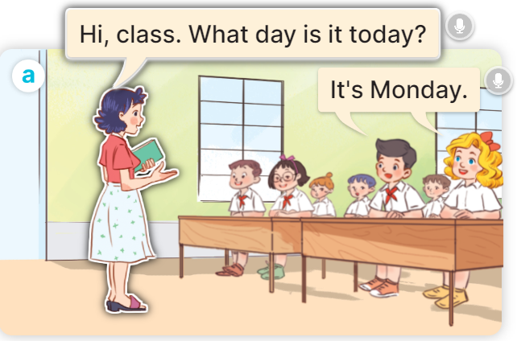  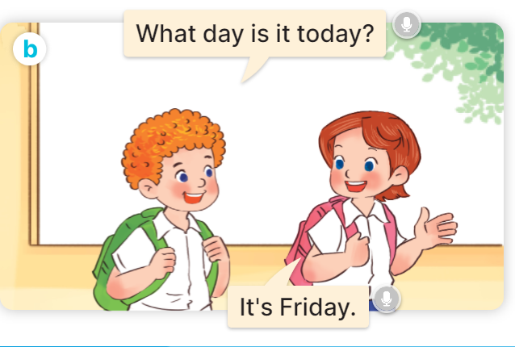  - Play the audio twice (sentence by sentence). Correct their pronunciation where necessary.  - Have Ss to practice the dialogue  - T invites a few pairs to the front of the class to practice.  - T checks pronunciation for ss.  Activity 3 Listen, point and say.  *Aims: Ss will be able to correctly say the words and use What day is it today? – It’s …….. to ask and answer questions about the days of the week.  *Procedure:  * Model sentences:  - T asks Ss look at picture a, b and helps Ss know the structure from the dialogue.  - T introduces new structure for Ss.  - T explains, models and gives meaning.  - Have Ss repeat the model sentences.  A: What day is it today?  B: It’s Monday.  3.Practice: (7’)  *Drill pictures  - Elicit and check comprehension the name of each character.      - Run through all the pictures.  - Run through model sentences.  - Have Ss to practise:  + T says the first picture  + Ss says the second picture  + Group A says the third picture  + Group B say the last picture.  - Ask Ss to work in pairs.  - T controls and corrects.  - Invite a few pairs to come to the front of the classroom, point at the relevant character in each picture, and act out his/her role.  - Encourage Ss to practise speaking English.  - T gives feedbacks.  4.Production: (7’)  Activity 4. Let’s talk.  *Aims: Ss will be able to enhance the correct use of What day is it today? – It’s …….. to ask and answer questions about the days of the week in a freer context.  *Procedure:  - T asks ss to guess each character and what the children say.  + What can you see in the picture?  +Who are they?  +Where are they?  +What are they saying?  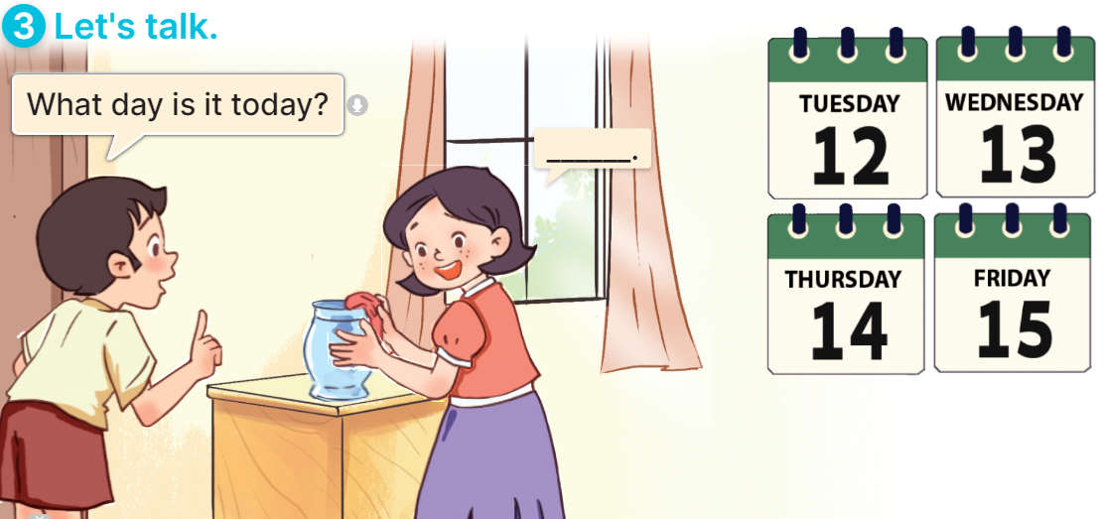  - T fills the gaps and writes the sentences on the board.  - T models  - T asks Ss to greet and introduce someone. (groups of four)  - Invite some groups to perform.  - Give feedbacks  *Consolidation  *Aims: Ss will be able consolidate and wrap up the content of the lesson.  *Procedure:  - T asks ss to answer the following questions:  + What have you learnt from the lesson today?  +What are the core values of the lesson? (if the teacher can take from the lesson).  - T review the vocabulary and model sentences.  - T praises some Ss who are hardworking / active/ good…. as well as encourage others to try more.  5. Homework. (2’)  - Learn the vocabulary and model sentences by heart  - Prepare the new lesson: Unit 3, Lesson 1 (4,5,6). | - Ss sing and dance the song  - Ss open their books  -Ss listen and answer  - - Ss listen and repeat  + Choral repetition (3 times).  + Individual repetition (3 ss)  - Ss take note  - Ss look, remember and match  -Look at the pictures and get to know the characters in the pictures.  + In picture a: Ms Hoa says: Hi, class. What day is it today? And Mr Long says: It’s Monday.  + In picture b: Mai says: That’s Mr Long. And Bill says: Hello, Mr Long.  -Ss listen and repeat in chorus (twice)  -Ss work in pairs to practice  -Ss practice the dialogue  -Ss listen  -Ss look at the picture and answer.  -Ss listen  -Ss listen and repeat  -Ss repeat to the introduce someone.  - Ss look, listen and answer  +Picture a: Monday  + Picture b: Tuesday  + Picture c: Wednesday  + Picture d: Thursday  -Ss listen and repeat  -Ss practice in chorus  -Ss practice  -Ss work in pairs to practice  -Ss point and say  -Ss listen.  -Ss listen  -Ss look at the picture and answer  + a boy asks a girl about the days of the week: Tuesday, Wednesday, Thursday, Friday (illustrated by calendars).  -Ss note  - Ss say the completed sentences.  -Ss pay attention  -Ss work in groups  -Ss perform in front of the class.  -Ss answer the questions  - Ss listen  -Ss listen and clap their hands  -Ss listen and take note

D. ADJUSTMENTS (if necessary):
………………………………………………………………………………………….…..……………………………………………………………………………...………………………………………….…..……………………………………………………………………………….……………………………………………………………………...

Week 5 From 7/10/2024 to 11/10/2024
Period 18

Unit 3: My week
Lesson 1 (4,5,6)
A. OBJECTIVES:
By the end of the lesson, Ss will be able to:
1. Knowledge:
- listen to and understand two communicative contexts about the days of the week and tick the correct pictures.
- complete four gapped exchanges with the help of picture cues.
- revise target words about the days of the week by playing the game Slap the board.
- Vocabulary: Review
- Skills: speaking, listening, reading and writing.
2. Competences:
- Critical Thinking: self-introduce
- Co-operation: ready to help friends in pair work/ group work.
- Self-control and independent learning: perform listening tasks.
3. Attitude/ Qualities:
- Kindness: Help partners to complete learning tasks.
- Honesty: tell the truth about feelings and emotions.
- Communication and collaboration: work in pairs and groups to complete the learning tasks
B. TEACHING AIDS:
- Teacher: Teacher’s guide Pages 45,46,47; audio Tracks 29; website hoclieu.vn, posters, laptop, pictures, textbook, lesson plan, TV or projector.
- Students: Pupil’s book Page 23, notebooks, workbooks, school things.
C. PROCEDURES:
Teacher’s activities | Students’ activities
1.Warm- up: (5’)  Game: Lucky number  *Aims: to create a friendly and active atmosphere in the class to beginning the lesson.  *Procedure:  - Divide the class into 2 teams (boys and girls).  - Each team takes turns to choose a number.  - They need to ask and answer with the picture corresponding to that number to get points.  - The group with more points at the end of the game will be the winner.  - Praise the winner, encourage the other team.  - Say “Open your book page 23” and look at “Unit 3, Lesson 1 (4,5,6)”.  2.Practice: (27’)  Activity 1. Listen and tick:  *Aims: Ss will be able to listen to and understand two communicative contexts about the days of the week and tick the correct pictures.  *Procedure:  - Elicit the days of the week.  - Point at the pictures respectively to explain the context.  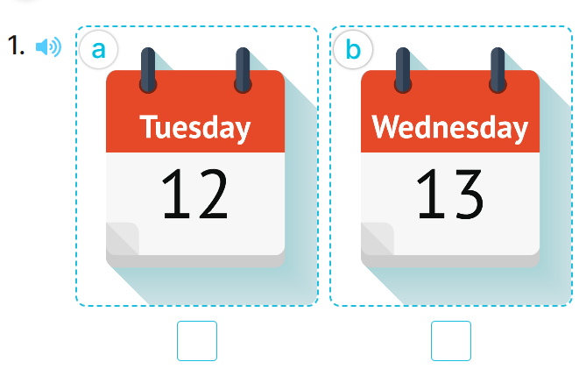  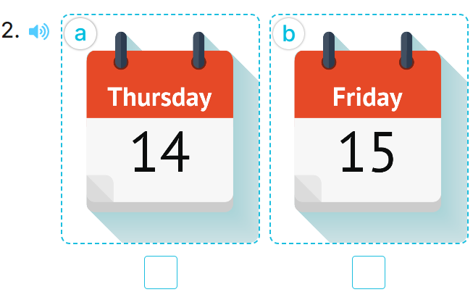  - T ask Ss to guess the answers.  + T writes Ss’guessing on the board.  - Listen to the tape:  + Play the recording  + Play the recording again and get Ss to swap books with their partners.  + Play the recording again to check answers together as a class.  + Write the answers on the board for Ss to correct their answers. Then checks Ss’ guessing.  - Play the recording, sentence by sentence, for the class to listen and repeat in chorus.  Key: 1.b 2.a  Activity 2. Look, complete and read.  *Aims: Ss will be able to complete four gapped exchanges with the help of picture cues.  *Procedure:  - Have pupils look at the pictures and identify the days of the week in the pictures. 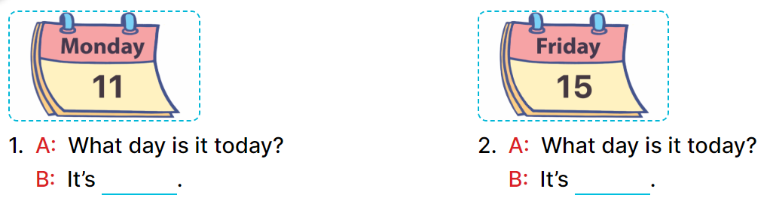  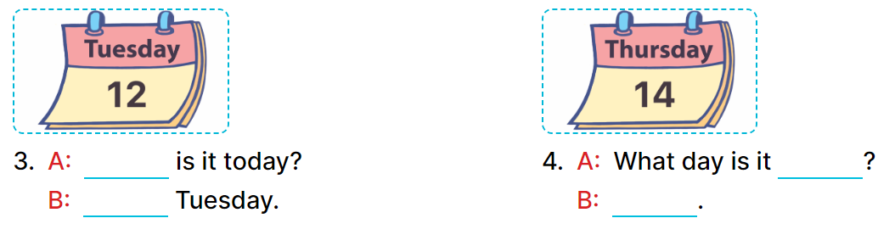  - Have Ss look at the two incomplete dialogue and elicits the missing words in the sentences.  - T models with picture 1  + Ask Ss what is missing in the sentence.  + Have Ss look at the picture and complete the gap, then read the completed sentence in chorus.  -Have Ss work in groups and complete the picture 2.  - Ask a few Ss to stand up and read the completed sentences aloud.  -T gives feedbacks.  Key:  - Monday 2. Friday  - 3. What day; It’s  - 4. today; It’s Thursday  Activity 3. Let’s play: Slap the board  *Aims: Ss will be able to revise target words about the days of the week by playing the game Slap the board. *Procedure:  - Tell pupils that they are going to listen to and slap the correct words as quickly as possible.  - Have them look at the days of the week on the board to recall the days of the week.  - Call two pupils to the front. Get them to stand at a certain distance from the board.  - Say a day of the week using It’s …….with one of the words on the board, for example, It’s Monday.  - The pupil who is the quickest to slap the right word (Monday) gets one point.  - The pupil who slaps the most words is the winner.  - Invite a few pairs to the front of the class to play the game.  - Praise pupils if they perform well.  *Consolidation  *Aims: Ss will be able consolidate and wrap up the content of the lesson.  *Procedure:  - T asks ss to answer the following questions:  + What have you learnt from the lesson today?  +What are the core values of the lesson? (if the teacher can take from the lesson).  - T praises some Ss who are hardworking / active/ good…. as well as encourage others to try more.  3. Homework. (3’)  - Practice part 5 again.  - Prepare the new lesson: Unit 3, Lesson 2 (1,2,3). | - Ss listen to the rule  - Ss play game  Ex: What day is it today?  It’s Tuesday.  -Ss listen  - Ss open their books  -Look at the pictures and say:  + Picture 1a: Tuesday  + Picture 1b: Wednesday  + Picture 2a: Thursday  + Picture 2b: Friday  -Ss guess the answers  - Ss listen to the tape and tick  - Ss listen again, tick and swap books with their partners.  -Ss listen again and check  - Ss check their answers and guessing  -Ss listen and repeat.  -Ss look at the picture and say:  -Ss look and answer  -Ss answer: Monday  -Ss look, complete and read the completed sentence in chorus.  -Ss work in groups and complete the sentences  -Ss read aloud  -Ss listen  - Ss look and listen.  - Ss listen  - Ss pay attention  -Ss play the game  -Ss listen and play games  -Ss listen  -Ss answer the questions  -Ss listen and clap their hands  -Ss listen and take note

D. ADJUSTMENTS (if necessary):
………………………………………………………………………………………….…..……………………………………………………………………………...………………………………………….…..……………………………………………………………………………….……………………………………………………………………...

Week 5 From 7/10/2024 to 11/10/2024
Period 19
Unit 3: My week
Lesson 2 (1, 2, 3)
A. OBJECTIVES:
By the end of the lesson, Ss will be able to:
1. Knowledge:
- understand and correctly repeat the sentences in two communicative contexts focusing on asking and answering questions about what someone does on certain days of the week.
- correctly say the phrases and use What do you do on ……? – I ……... to ask and answer questions about what someone does on certain days of the week.
- enhance the correct use of What do you do on ……? – ………. to ask and answer questions about what someone does on certain days of the week in a freer context.
- Vocabulary: study at school, do housework, listen to music, stay at home
- Skills: speaking and listening
2. Competences:
- Co-operation: ready to help friends in pair work/ group work.
- Sociability: Talk to each other, say good words to others.
3. Attitude/ Qualities:
- Kindness: Help partners to complete learning tasks.
- Honesty: tell the truth about feelings and emotions
B. TEACHING AIDS:
- Teacher: Teacher’s guide Pages 47,48,49; audio Tracks 29,30, website hoclieu.vn, posters, laptop, pictures, textbook, lesson plan, TV or projector.
- Students: Pupil’s book Page 24, notebooks, workbooks, school things.
C. PROCEDURES:
Teacher’s activities | Students’ activities
1.Warm- up: (3’)  Game: Pass the ball  *Aims: to create a friendly and active atmosphere in the class to beginning the lesson.  *Procedure:  - T gives Ss a ball.  - T asks Ss to listen to music and transfer a ball around the class.  - When the music stops, Ss who keep a ball have to look at the picture and answer the question using: What day is it today? and It’s……..  - T gives feedback.  - Say “Open your book page 24” and look at “Unit 3, Lesson 2 (1,2,3)”.  2. Presentation (16’)  Activity 1. Vocabulary.  *Aims: Ss will be able to know the vocabulary in front of starting the new lesson.  *Procedure:  -T elicits the new words  + study at school : học ở trường (situation)  + do housework : làm việc nhà (situation)  + listen to music : nghe nhạc (mime)  + stay at home : ở nhà (translation)  - T models (3 times).  - T writes the words on the board.  - Checking: What and where  Activity 2. Look, listen and repeat:  *Aims: Ss will be able to understand and correctly repeat the sentences in two communicative contexts focusing on asking and answering questions about what someone does on certain days of the week. *Procedure:  - Have Ss look at Pictures a and b and identify the characters in the pictures.  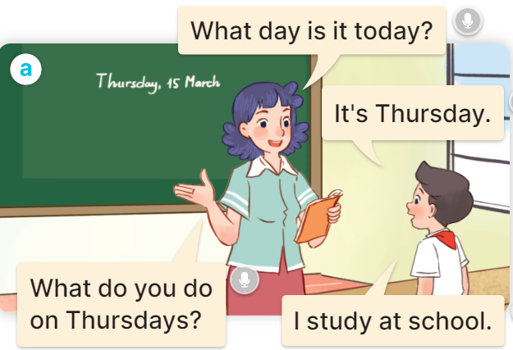  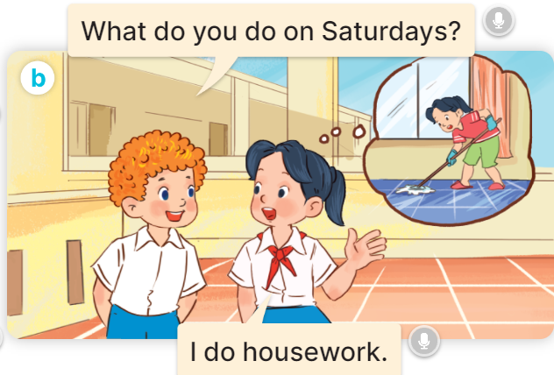  - Play the audio twice (sentence by sentence). Correct their pronunciation where necessary.  - Have Ss to practice the diaguage  - T invites a few pairs to the front of the class to practice.  - T checks pronunciation for ss.  Activity 3. Listen, point and say.  *Aims: Ss will be able to correctly say the phrases and use What do you do on …..? – I …….. to ask and answer questions about what someone does on certain days of the week  *Procedure:  * Model sentences:  - T asks Ss look at picture a, b and helps Ss know the structure from the dialogue.  - T introduces new structure for Ss.  - T explains, models and gives meaning.  - Have Ss repeat the model sentences.  A: What do you do on Mondays?  B: I study at school.  3.Practice: (7’)  *Drill pictures  - Have pupils look at the pictures and elicit the activities and the days of the week.    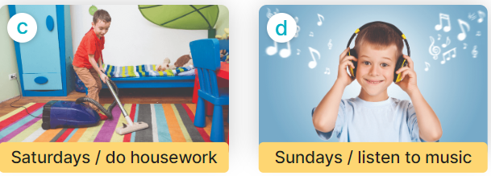  - Run through all the pictures.  - Run through model sentences.  + Run through the questions  + Run through the answers  - Have Ss to practise:  + T asks Ss answer (change role).  + Ss – Ss (change role).  - Ask Ss to work in pairs.  - T controls and corrects.  - Invite a few pairs to come to the front of the classroom, point at the relevant character in each picture, and act out his/her role.  - Invite Ss to go to the board and role play. Encourage Ss to practise speaking English.  - T gives feedbacks.  4.Production: (7’)  Activity 4. Let’s talk.  *Aims: Ss will be able to enhance the correct use of What do you do on …….? – ……. to ask and answer questions about what someone does on certain days of the week in a freer context.  *Procedure:  - Ask questions to help them identify the context.  + What can you see in the picture?  +Who are they?  +Where are they?  +What are they saying?  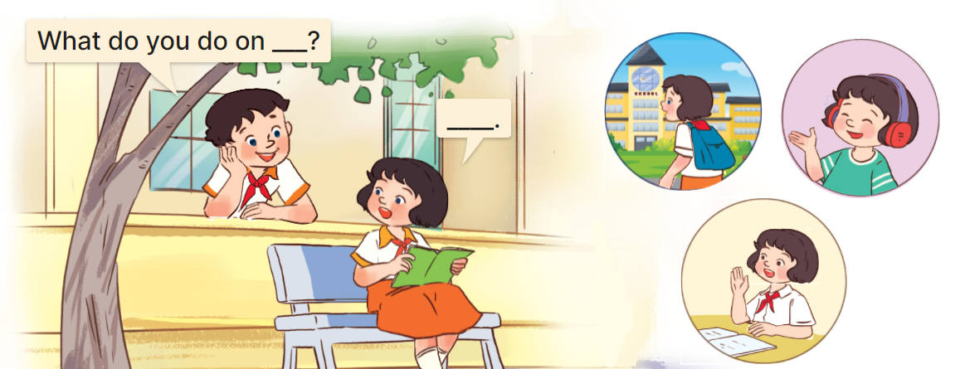  - T fills the gaps and writes the sentences on the board.  - T models  - T asks Ss use of What do you do on….? to ask, and answer (work in pairs)  - Invite some groups to perform.  - Give feedbacks  *Consolidation  *Aims: Ss will be able consolidate and wrap up the content of the lesson.  *Procedure:  - T asks ss to answer the following questions:  + What have you learnt from the lesson today?  +What are the core values of the lesson? (if the teacher can take from the lesson).  - T review the vocabulary and model sentences.  - T praises some Ss who are hardworking / active/ good…. as well as encourage others to try more.  5. Homework. (2’)  - Learn the vocabulary and model sentences by heart  - Prepare the new lesson: Unit 3, Lesson 2 (4,5,6). | - Ss listen  - Ss play the game  - Ss open their books  -Ss listen and answer  - - Ss listen and repeat  + Choral repetition (3 times).  + Individual repetition (3 ss)  - Ss take note  - Ss look, remember and slap  -Look at the pictures and get to know the characters in the pictures.  + In picture a:  Ms Hoa: What day is it today?  Nam: It’s Thursday.  Ms Hoa: What do you do on Thursdays?  Nam: I study at school.  – In picture b:  Bill: What do you do on Saturdays?  Mai: I do housework.  -Ss listen and repeat in chorus (twice)  -Ss work in pairs to practice  -Ss practice the diaguage  -Ss listen  -Ss look at the picture and answer.  -Ss listen  -Ss listen and repeat  -Ss repeat to the introduce someone  -Ss listen and answer  - Ss look, listen and repeat  - Ss practice in chorus  Ex: Mondays/ study at school  A: What do you do on Mondays?  B: I study at school.  -Ss work in pairs to practice  -Ss listen  -Ss point and say  -Ss go to the board and role play.  -Ss listen  -Ss look at the picture and answer  + A boy asks a girl about what she does on Tuesdays, Fridays and Sundays (illustrated by the calendars and her activities)  -Ss note  - Ss say the completed sentences.  -Ss work in pairs  -Ss perform in front of the class.  -Ss listen  -Ss answer the questions  - Ss listen  -Ss listen and clap their hands  -Ss listen and take note

D. ADJUSTMENTS (if necessary):
………………………………………………………………………………………….…..……………………………………………………………………………...………………………………………….…..……………………………………………………………………………….……………………………………………………………………...

Week 5 From 7/10/2024 to 11/10/2024
Period 20

Unit 3: My week
Lesson 2 (4, 5, 6)
A. OBJECTIVES:
By the end of the lesson, Ss will be able to:
1. Knowledge:
- - listen to and understand four communicative contexts about days of the week and what someone does on certain days of the week and number the correct pictures.
- complete four gapped exchanges with the help of picture cues.
- sing the song My week with the correct pronunciation, rhythm and melody.
- Vocabulary: Review
- Skills: speaking, listening, reading and writing.
2. Competences:
- Co-operation: ready to help friends in pair work/ group work.
- Self-control and independent learning: perform listening tasks.
3. Attitude/ Qualities:
- Kindness: Help partners to complete learning tasks.
- Honesty: tell the truth about feelings and emotions.
- Diligence: complete learning tasks.
B. TEACHING AIDS:
- Teacher: Teacher’s guide Pages 49, 50,51; audio Tracks 31, 32; website hoclieu.vn, posters, laptop, pictures, textbook, lesson plan, TV or projector.
- Students: Pupil’s book Page 25, notebooks, workbooks, school things.
C. PROCEDURES:
Teacher’s activities | Students’ activities
1.Warm- up: (5’)  Play a game: Guess the pictures  *Aims: to create a friendly and active atmosphere in the class to beginning the lesson.  *Procedure:  - The first Ss has to take the last four or three letters of that word and form a new word.  - The second Ss does the same, and the chain continues until a Ss is unable to form a word.  - The Ss who fails to form a word or misspells it is out of the game.  -T give feedback  - Say “Open your book page 25” and look at “Unit 3, Lesson 2 (4,5,6)”.  2.Practice: (27’)  Activity 1. Listen and number:  *Aims: Ss will be able to listen to and understand four communicative contexts about days of the week and what someone does on certain days of the week and number the correct pictures.  *Procedure:  - Elicit the activities and the days of the week.  - Point at the pictures respectively to explain the context.  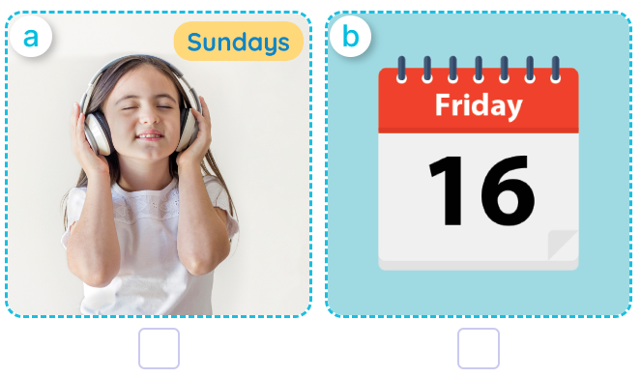  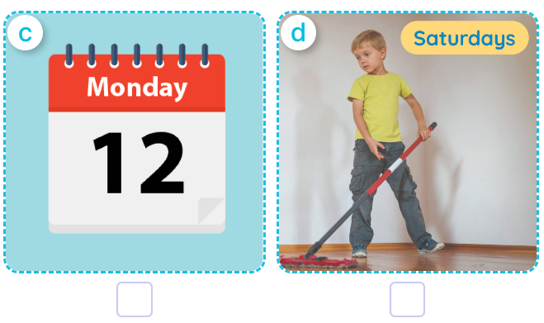  - T ask Ss to guess the answers.  + T writes Ss’guessing on the board.  - Listen to the tape:  + Play the recording  + Play the recording again and get Ss to swap books with their partners.  + Play the recording again to check answers together as a class.  + Write the answers on the board for Ss to correct their answers. Then checks Ss’ guessing.  - Play the recording, sentence by sentence, for the class to listen and repeat in chorus.  Key: 1. c 2. d 3. b 4. a  Activity 2. Look, complete and read  *Aims: Ss will be able to complete four gapped exchanges with the help of picture cues.  *Procedure:  - Have pupils look at the pictures and identify the days of the week and the activities in the pictures.  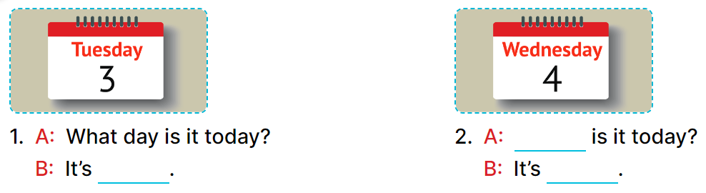  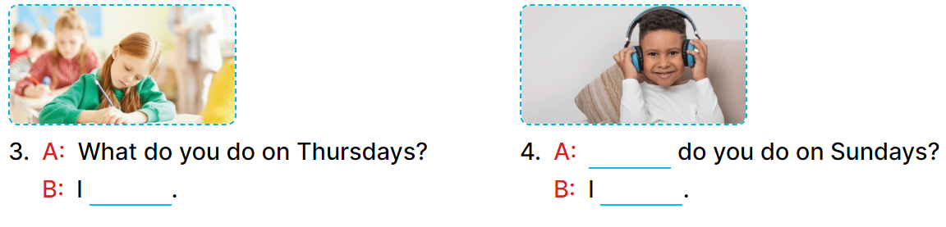  - Have Ss look at the four incomplete dialogue and elicits the missing words in the sentences.  - T models with picture 1  + Ask Ss what is missing in the sentence.  + Have Ss look at the picture and complete the gap, then read the completed sentence in chorus.  -Have Ss work in groups and complete the picture 2, 3 and 4.  - Ask a few Ss to stand up and read the completed sentences aloud.  -T gives feedbacks.  Key: 1. Tuesday  2. What day; Wednesday  3. study at school  4. What; listen to music  Activity 3. Let’s sing.  *Aims: Ss will be able sing the song What day is it today? with the correct pronunciation, rhythm and melody.  *Procedure:  - Draw pupils’ attention to the title and lyrics of the song.  - Encourage pupils to point at the characters’ activities to reinforce their understanding.  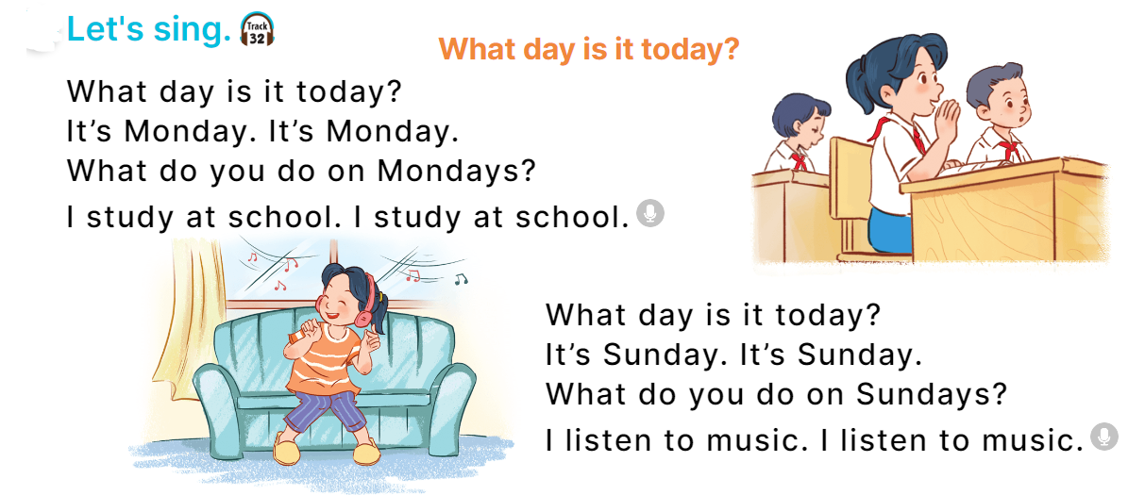  - Play the recording all the way through for pupils to listen to the whole song.  - Play the recording line by line for pupils to listen and repeat.  - Play the recording all the way through for pupils to sing along.  - Play the recording again for pupils to sing and clap along with the recording.  - Pupils can sing the song What day is it today? with the correct pronunciation, rhythm and melody.  *Consolidation  *Aims: Ss will be able consolidate and wrap up the content of the lesson.  *Procedure:  - T asks ss to answer the following questions:  + What have you learnt from the lesson today?  +What are the core values of the lesson? (if the teacher can take from the lesson).  - T praises some Ss who are hardworking / active/ good…. as well as encourage others to try more.  3. Homework. (3’)  - Practice part 5 again.  - Prepare the new lesson: Unit 3, Lesson 3 (1,2,3). | - Sing and dance the song in chorus.  - Ss open their books  -Look at the pictures and say:  a. a girl listening to music on Sundays  b. a calendar: Friday  c. a calendar: Monday  d. a boy doing housework on Saturdays  -Ss guess the answers  - Ss listen to the tape and write number  - Ss listen again, write number and swap books with their partners.  - Ss check their answers and guessing  -Ss listen and repeat.  -Ss look and answer  -Ss answer: It’s Tuesday.  -Ss look, complete and read the completed sentence in chorus.  -Ss work in groups and complete the sentence  -Ss read aloud  - Ss listen  -Ss listen to the song  -Ss listen and repeat line by line  -Ss listen and sing along  -Ss sing and clap along  -Ss sing with the correct pronunciation, rhythm and melody.  -Ss answer the questions  - Ss listen  -Ss listen and clap their hands  -Ss listen

D. ADJUSTMENTS (if necessary):
………………………………………………………………………………………….…..……………………………………………………………………………...………………………………………….…..………………………………………………………….

