Week 18
Period 69
Review 2
Parts 3, 4, 5
By the end of the lesson, Ss will be able to:
- correctly use the following sentence patterns:
PROCEDURES:
Teacher’s activities | Students’ activities
*Aims: to review the vocabulary and structure about greet and respond to greetings.  - Divide class into 2 groups.  -Ask 5 Ss in each group stand in a straight line.  - T says a word or phrase to the first pupil in this line.  - Then, the first pupil whispers what she/ he hear to the second person in line; the second one whispers what he/ she hears to the third one and so on until the last pupil in group hears the word or phrase.  - The last pupil says the word or phrase out loud.  - The faster group has correct word or phrase is the winner.  - Say “Open your book page 75” and look at Review 2.  Activity 1. Read and match  *Aims: Ss will be able to read and match pairs of target sentence patterns  *Procedure:  - Tell Ss about this activity. Point at sentence 1, elicit the answer and models.  - Give Ss work in pairs to do the sentence 2,3,4,5.  - Tell Ss to swap their books with their partners, then check answers together as a class.  - Write the correct answers on the board for Ss to correct their answers.  - Invite some pairs to stand up and read the matched exchanges aloud.  Key:  1. e 2. d 3. b 4. c 5. a  Activity 2. Look, complete and read.  *Aims: Ss will be able to understand and complete two incomplete sentence patterns and two exchanges.  *Procedure:  - Elicit the missing words and the conversation.  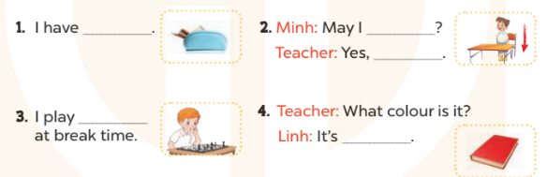  - Tell Ss about this activity. Point at number 1, elicit the answer and models.  - Give Ss work in pairs to do the task  - Tell Ss to swap their books with their partners, then check answers together as a class.  - Write the correct answers on the board for Ss to correct their answers.  - Invite some pairs to stand up and read the matched exchanges aloud.  Key:  1. a pencil case  2. stand up, you can  3. chess  4. red  Homework.  - Prepare Fun time 2. | - Ss listen  -Ss play game  - Ss open their books  -Ss look at the sentence 1 and say  -Ss work in pairs and match  -Ss swap their books and match  -Ss check  -Ss read aloud  -Ss listen and answer  -Ss look at the dialogue and say number 1  -Ss work in pairs and complete  -Ss swap their books and match  -Ss check  -Ss read aloud  -Ss listen and take note
D. ADJUSTMENTS (if necessary):
………………………………………………………………………………………….…..……………………………………………………………………………...…………

Week 18
Period 70

Fun time 2
By the end of the lesson, Ss will be able to:
- take part in three fun activities relating to their language knowledge and competences.
PROCEDURES:
Teacher’s activities | Students’ activities
*Aims: to create a friendly and active atmosphere in the class to beginning the lesson.  Activity 1. Find and circle  *Aims: Ss will be able to revise learnt vocabulary by doing the word search.  *Procedure:  - Have Ss look at the pictures and ask +What’s this?  + What can you see in the pictures?  + What colour is it?  - Write the words or stick the flash cards of the words, one by one, on the board.  - Point at each word on the board and have Ss say the word as a class.  - Point at the picture of the school, and circle it in the word search as an example.  - Tell Ss to find the rest of the words in the word search.  - Have Ss check and correct their answers in pairs  - Have Ss work in pairs, one points at the pictures and the other points at the circled words in the word search and say them aloud.  Key:  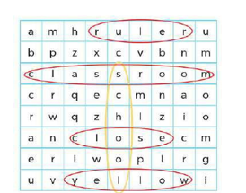  Activity 2. Quiz time  *Aims: Ss will be able to revise vocabulary and sentence patterns related to asking and answering questions that help to identify school things and their colours.  *Procedure:  - Elicit the words and stick the flash cards on the board one by one as Ss say the corresponding words.  - Point at each flash card and have Ss say the word as a class.  - Point at a flash card and elicit the answers to the questions  + Do you have …….?  +What colour is it?  + What colour are they?  - Hold up a textbook, point at a picture of a school thing and ask these questions again.  - Show the class how to complete the task: Point at a picture of a school thing and ask the questions in pairs.  - Have Ss work in pair to as and answer about their school things  - Invite a few pairs to the front of the class to interact with each other.  - Prepare the first test. | - Ss listen  - Ss sing a song  -Ss look at the picture and answer  - - Ss note  - Ss say the word  - Ss point and circle  -Ss find the words  -Ss check their answer  -Ss say aloud  -Ss listen  -Ss listen and say the word  -Ss point and say  -Ss point, ask and answer  -Ss listen  -Ss work in pairs  -Ss present  -Ss listen and take note

D. ADJUSTMENTS (if necessary):
………………………………………………………………………………………….…..……………………………………………………………………………...………………………………………….…..……………………………………………………………………………….……………………………………………………………………...

