Week 19
Period 75

Unit 11: My family
Lesson 2 (1, 2, 3)
By the end of the lesson, Ss will be able to:
- correctly pronounce the sounds of the letters o and ure in isolation, in the words old and sure and in the sentences How old is your brother? and Are you sure?
-use the numbers from 11 – 20 related to the topic “My family”
-use How old is he / she? – He’s / She’s………….. to ask and answer questions about the age of a family member
PROCEDURES:

Teacher’s activities | Students’ activities
Game: Pass the ball  *Aims: to create a friendly and active atmosphere in the class to beginning the lesson.  *Procedure:  - T gives Ss a ball.  - T asks Ss to listen to music and transfer a ball around the class.  - When the music stops, Ss who keep a ball have to practice with partner using: Who’s this/ that? and It’s my……..  - T gives feedback.  - Say “Open your book page 8” and look at “Unit 11, Lesson 2 (1,2,3)”.  Activity 1. Vocabulary.  *Aims: Ss will be able to know the vocabulary in front of starting the new lesson.  *Procedure:  -T elicits the new words  + eleven : số 11 (picture)  + twelve : số 12 (picture)  + thirteen : số 13 (picture)  + fourteen : số 14 (picture)  + fifteen : số 15 (picture)  + sixteen : số 16 (picture)  + seventeen: số 17 (picture)  + eighteen : số 18 (picture)  + nineteen : số 19 (picture)  + twenty : số 20 (picture)  - T models (3 times).  - T writes the words on the board.  - Checking: Rub out and remember  Activity 2. Listen, point and repeat:  *Aims: Ss will be able to understand and correctly repeat the sentences in two communicative contexts (pictures) to to ask and answer questions about the age of a family member.  *Procedure:  - Have Ss look at Pictures a and b and identify the characters in the pictures.  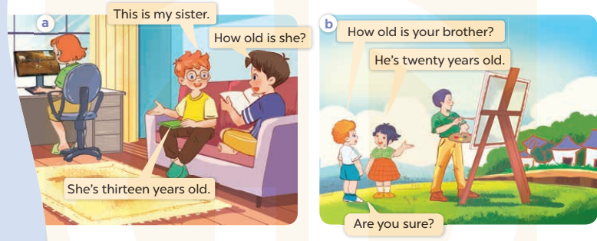  - Play the audio twice (sentence by sentence). Correct their pronunciation where necessary.  - Have Ss to practice the diaguage  - T invites a few pairs to the front of the class to practice.  - T checks pronunciation for ss.  - Learn the number by heart  - Prepare the new lesson: Unit 11, Lesson 2 (4,5,6). | - Ss listen and keep the ball  - Ss listen to music and play the game  - Ss open their books  -Ss listen and answer  - - Ss listen and repeat  + Choral repetition (3 times).  + Individual repetition (3 ss)  - Ss take note  - Ss look, remember and write  -Look at the pictures and get to know the characters in the pictures.  + In picture a: Ben says This is my sister And Minh asks : How old is she? , Ben answers She’s thirteen years old.  – In picture b: Bill asks How old is your brther?. And Linh answers He is twenty years old. Bill says Are you sure?  -Ss listen and repeat in chorus (twice)  -Ss work in pairs to practice  -Ss practice the diaguage  -Ss listen  -Ss listen and take note

D. ADJUSTMENTS (if necessary):
………………………………………………………………………………………….…..……………………………………………………………………………...………………………………………….…..……………………………………………………………………………….……………………………………………………………………...

Week 19
Period 76

Unit 11: My family
Lesson 2 (4, 5, 6)
By the end of the lesson, Ss will be able to:
- listen to and demonstrate understanding of simple communicative contexts in relation to the topic “My family”
- read and write about family members and their ages
PROCEDURES:
Teacher’s activities | Students’ activities
Sing a song: “how are you”  *Aims: to create a friendly and active atmosphere in the class to beginning the lesson.  *Procedure:  - Show the song on the screen.  https://www.youtube.com/watch?v=O13gITUS5t4  - Ask pupils to listen, sing and dance the song.  - Say “Open your book page 9” and look at “Unit 11, Lesson 2 (4,5,6)”.  Activity 1. Listen and number:  *Aims: Ss will be able to listen to and understand four communicative contexts in which pupils ask their teachers for permission  *Procedure:  - Elicit the names and ages of the characters in the pictures.      - T ask Ss to guess the answers.  + T writes Ss’guessing on the board.  - Listen to the tape:  + Play the recording  + Play the recording again and get Ss to swap books with their partners.  + Play the recording again to check answers together as a class.  + Write the answers on the board for Ss to correct their answers. Then checks Ss’ guessing.  - Play the recording, sentence by sentence, for the class to listen and repeat in chorus.  Key: 1.a 2. d 3. b 4. c  Activity 2. Look, complete and read.  *Aims: Ss will be able to complete four gapped dialogues with the help of picture cues.  *Procedure:  - Have Ss look at the pictures and ask them pay attention to the cakes with candles or numbers  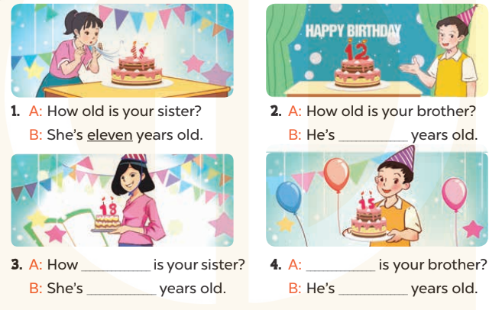  - T models with sentence 1.  + Have Ss look at the sentence.  + Ask them what is missing in the answer (eleven).  + Have Ss complete the gap.  + Have Ss read the completed sentence in chorus.  -Have Ss work in pairs and complete the sentences 2, 3 and 4.  - Invite pairs of pupils to stand up and read aloud the sentences.  -T gives feedbacks.  Key: 1. eleven 2. twelve  3.old; eighteen  4. How old; fifteen  - Prepare the new lesson: Unit 11, Lesson 3 (1,2,3). | - Sing and dance the song in chorus.  - Ss open their books  -Look at the pictures and say:  + Picture a: a 13-year-old girl  + Picture b: an 18-year-old girl  + Picture c: a 14-year-old boy  + Picture d: a 20-year-old man.  -Ss guess the answers  - Ss listen to the tape and write number  - Ss listen again, write number and swap books with their partners.  - Ss check their answers and guessing  -Ss listen and repeat.  -Ss look at the pictures and say  -Ss listen and answer  -Ss read and complete  -Ss work in pairs  -Ss read  -SS listen  -Ss listen and take note

D. ADJUSTMENTS (if necessary):
………………………………………………………………………………………….…..……………………………………………………………………………...………………………………………….…..……………………………………………………………………………….……………………………………………………………………...

