Week 15
Period 59

Unit 9: Colours
Lesson 2 (4, 5, 6)
By the end of the lesson, Ss will be able to:
- listen to and demonstrate understanding of simple exchanges related to the topic “Colours”
- read and write about colours of school things.
PROCEDURES:
Teacher’s activities | Students’ activities
Activity 1. Listen and number:  *Aims: Ss will be able to listen to and understand four communicative contexts in which the characters ask and answer questions about the colours of school things and number the correct pictures.  *Procedure:  - Elicit the names and clours of the school thing in each picture.  + What is this?  + What colour is it?  + What are these?  + What colour are they?  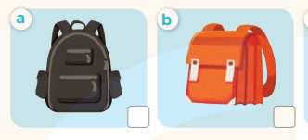  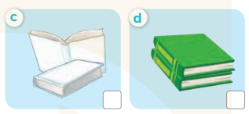  - T ask Ss to guess the answers.  + T writes Ss’guessing on the board.  - Listen to the tape:  + Play the recording  + Play the recording again and get Ss to swap books with their partners.  + Play the recording again to check answers together as a class.  + Write the answers on the board for Ss to correct their answers. Then checks Ss’ guessing.  - Play the recording, sentence by sentence, for the class to listen and repeat in chorus.  Key: 1. b 2. d 3. c 4. a  Activity 2. Look, complete and read  *Aims: Ss will be able to complete the four gapped dialogues with the help of the picture cues  *Procedure:  - Get Ss to look at the pictures and identify the names and colours of the school things.  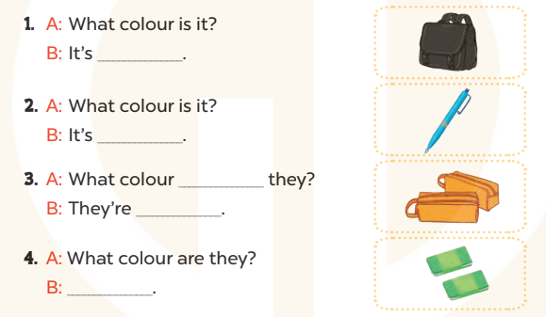  - Have Ss look at the four dialogues and the pictures. Elicit and model with number 1  + Get Ss to read number 1 in chorus. + Ask them what A and B are talking about.  + Write the word notebook on the board.  + Tell Ss to identify the picture of a notebook (black).  + Then write number 1 with black  -Have Ss work in pairs and match the sentences 2, 3, 4.  - Ask a few Ss to stand up and read the sentences aloud.  -T gives feedbacks.  Key:  1. black 2. blue  3. are; orange 4. They’re green. | -Look at the pictures and say:  + Picture a: a black school bag  + Picture b: an orange school bag  + Picture c: two white books  + Picture d: two green books  -Ss guess the answers  - Ss listen to the tape and write  - Ss listen again, write and swap books with their partners.  - Ss check their answers and guessing  -Ss listen and repeat.  -Ss look at the picture and say  -Ss look and answer  -Ss read  -Ss answer  -Ss write  -Ss listen and match  -Ss work in pairs and complete  -Ss read aloud  -Ss listen and answer
D. ADJUSTMENTS (if necessary):
Week 15
Period 60

Unit 9: Colours
Lesson 3 (1, 2, 3)
By the end of the lesson, Ss will be able to:
- correctly repeat the sounds of the letter bl and letter br in isolation, in the words blue and brown, and in the sentences My school bag is blue. and The pencil cases are brown. with correct pronunciation and intonation.
- listen to two sentences and circle the correct options to complete the gaps in two gapped sentences.
- say the chant with the correct rhythm and pronunciation.
PROCEDURES:
Teacher’s activities | Students’ activities
Activity 1. Listen and repeat:  *Aims: Ss will be able to correctly repeat the sounds of the letter bl and letter br in isolation, in the words blue and brown, and in the sentences My school bag is blue. and The pencil cases are brown. with correct pronunciation and intonation.  *Procedure:  - T gives instruction to the letter bl and br, blue and brown , and in the sentences My school bag is blue. and The pencil cases are brown.  - Play the recording for the letter bl, br.  - Encourage Ss to point at the letter/ word/ sentence while listening.  - Play the recording again and encourage Ss to listen and repeat. - Do this several times until Ss feel confident.  - T calls some Ss to practice.  - T gives feedbacks.  Activity 2. Listen and circle.  *Aims: Ss will be able to identify the target words blue and brown while listening.  *Procedure:  - Elicit the sentences and the gap-fill options.  - T ask Ss to guess the answers.  + T writes Ss’guessing on the board.  - Listen to the tape:  + Play the recording  + Play the recording again and get Ss to swap books with their partners.  + Play the recording again to check answers together as a class.  + Write the answers on the board for Ss to correct their answers. Then checks Ss’ guessing.  - Play the recording, sentence by sentence, for the class to listen and repeat in chorus.  - Invite one or two Ss to stand up and read the completed sentences.  Key: 1.b 2.b | - Ss recognize the differences about color of letter  - - Ss listen  - Ss listen and point  - Ss listen again and repeat  -Ss listen again and repeat  -Ss practice  -Ss listen  -Ss listen and say:  + Number 1: My school bag is .…….  + Number 2: The pencils are  -Ss guess the answers  - Ss listen to the tape and circle  - Ss listen again, circle and swap books with their partners.  - Ss check their answers and guessing  -Ss listen and repeat.  -Ss read the sentences

D. ADJUSTMENTS (if necessary):

