Week 16
Period 61

Unit 9: Colours
Lesson 3 (4, 5, 6)
By the end of the lesson, Ss will be able to:
- read a short text and tick the colours of some school things.
- use the target language in a real context by writing a short paragraph about the colours of some of their school things.
- revise the target vocabulary items they have learnt in a real context.
- do a project on how to draw, colour and say the colours of school things.
PROCEDURES:
Teacher’s activities | Students’ activities
Activity 1. Read and tick:  *Aims: Ss will be able to read and understand a short text and tick the colours of some school things.  *Procedure:  - Explain how to complete the task: read the text and tick the correct colours of the school things in the table.  - Ask Ss to read the list of the school things in the first column of the table.  - Ask Ss look at the colours on the right side of the table.  - Ask Ss read the text and tick the correct colours.  - Let Ss swap and check answers.  - Check the answers  - Ask some Ss to read the text aloud.  Key:  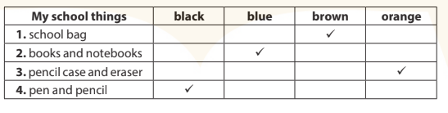 | -Ss read and answer  -Ss listen and read  -Ss listen  -Ss read and tick  -Ss swap their answers  -Ss check their answer  -Ss read aloud
D. ADJUSTMENTS (if necessary):
………………………………………………………………………………………….…..……………………………………………………………………………...………
Week 16
Period 62

Unit 10: Break time activities
Lesson 1 (1, 2, 3)
By the end of the lesson, Ss will be able to:
- understand and correctly repeat the sentences in two communicative contexts about school break time activities.
- correctly say the words and use I …………..at break time. to identify school break time activities.
- enhance the correct use of I ………… at break time. to identify school break time activities.
PROCEDURES:
Teacher’s activities | Students’ activities
Activity 1. Vocabulary.  *Aims: Ss will be able to know the vocabulary in front of starting the new lesson.  *Procedure:  -T elicits the new words  + chess : cờ (visual)  + volleyball : bóng chuyền (picture)  + basketball :bóng rổ (picture)  + badminton : cầu lông (visual)  + play: chơi (translation)  + break time: giờ giải lao (situation)  - T models (3 times).  - T writes the words on the board.  - Checking: Rub out and remember  Activity 2. Look, listen and repeat:  *Aims: Ss will be able to understand and correctly repeat the sentences in two communicative contexts about school break time activities.  *Procedure:  - Have Ss look at Pictures a and b and identify the characters (Ben Minh and Lucy) in the pictures.  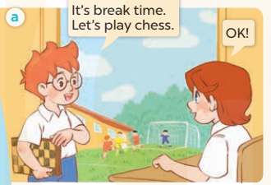  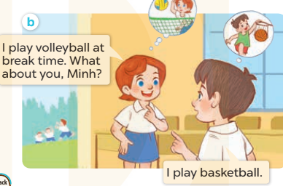  - Play the audio twice (sentence by sentence). Correct their pronunciation where necessary.  - Have Ss to practice the dialogue  - T invites a few pairs to the front of the class to practice.  - T checks pronunciation for ss. | -Ss listen and answer  - - Ss listen and repeat  + Choral repetition (3 times).  + Individual repetition (3 ss)  - Ss take note  - Ss look, remember and write  -Look at the pictures and say  + In picture a: Ben says: It’s break time. Let’s play chess. Lucy says: OK!  + In picture b: Lucy says: I play volleyball at break time. What about you, Minh? Minh  answers: I play basketball.  -Ss listen and repeat in chorus (twice)  -Ss work in pairs to practice  -Ss practice the dialogue  -Ss listen
D. ADJUSTMENTS (if necessary):

Week 16
Period 63

Unit 10: Break time activities
Lesson 1 (4, 5, 6)
By the end of the lesson, Ss will be able to:
- listen to and understand two communicative contexts in which pupils talk about what they do at break time.
- complete four target sentence patterns with the help of the picture cues.
- sing the song “It’s break time” with the correct pronunciation and melody.
PROCEDURES:
Teacher’s activities | Students’ activities
Activity 1. Listen and tick:  *Aims: Ss will be able to listen to and understand two communicative contexts in which pupils talk about what they do at break time.  *Procedure:  - Elicit the name of the activities in each picture.  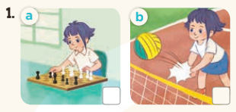  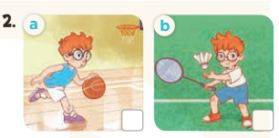  - T ask Ss to guess the answers.  + T writes Ss’guessing on the board.  - Listen to the tape:  + Play the recording  + Play the recording again and get Ss to swap books with their partners.  + Play the recording again to check answers together as a class.  + Write the answers on the board for Ss to correct their answers. Then checks Ss’ guessing.  - Play the recording, sentence by sentence, for the class to listen and repeat in chorus.  Key: 1. b 2. a  Activity 2. Look, complete and read  *Aims: Ss will be able to complete four target sentence patterns with the help of the picture cues.  *Procedure:  - Have Ss look at the picture cues and identify the activity of the character.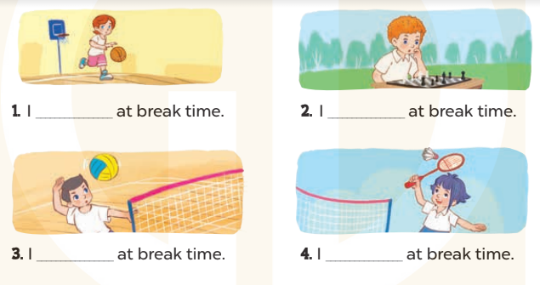  - Have Ss look at the four incomplete sentences. Elicit and model with picture 1  + Ask Ss to read the sentence 1 in chorus.  + Ask Ss what word is missing in the gap (play volleyball). Then have them complete the sentence (I play volleyball at break time).  -Have Ss work in pairs and complete the sentences 2, 3, 4.  - Ask a few Ss to stand up and read the sentences aloud.  -T gives feedbacks.  Key:  1.play basketball  2. play chess  3. play volleyball  4. Play badminton | -Look at the pictures and say:  + Picture 1a: Linh is playing chess.  + Picture1 b: Linh is playing volleyball.  + Picture 2a: Ben is playing basketball.  + Picture 2b: Ben is playing badminton.  -Ss guess the answers  - Ss listen to the tape and tick  - Ss listen again, tick and swap books with their partners.  - Ss check their answers and guessing  -Ss listen and repeat.  -Ss look at the picture and say  -Ss look and answer  -Ss read  -Ss say and write  -Ss work in pairs and complete  -Ss read aloud
D. ADJUSTMENTS (if necessary):
………………………………………………………………………………………….…..……………………………………………………………………………...………………………………………….…..……………………………………………………………………………….……………………………………………………………………...Week 16
Period 64

Unit 10: Break time activities
Lesson 2 (1, 2, 3)
By the end of the lesson, Ss will be able to:
- use the words football, table tennis, chat, word puzzle related to the topic school break time activities
- use What do you do at break time? – I……… to ask and answer questions about school break time activites.
PROCEDURES:
Teacher’s activities | Students’ activities
Game: Act and Guess  *Aims: to create a friendly and active atmosphere in the class to beginning the lesson.  *Procedure:  - T divides class into 2 Teams (Boys and Girls)  - 1 pupil of each team comes to the board and does actions for their team to guess the names of break time activities and sticks the right pictures.  -The first Team to stick 4 correct pictures with right order is the winner.  - Say “Open your book page 70” and look at “Unit 10, Lesson 2 (1, 2, 3)”.  Activity 1. Vocabulary.  *Aims: Ss will be able to know the vocabulary in front of starting the new lesson.  *Procedure:  -T elicits the new words  + football : bóng đá (visual)  + word puzzle : trò chơi ô chữ  (visual)  + chat :trò chuyện (translation)  + table tennis : bóng bàn (visual)  - T models (3 times).  - T writes the words on the board.  - Checking: Rub out and remember  Activity 2. Look, listen and repeat:  *Aims: Ss will be able to understand and correctly repeat the sentences in two communicative contexts (pictures) to talk about school brek time activities.  *Procedure:  - Have Ss look at Pictures a and b and identify the characters (Bill and Mai) in the pictures.  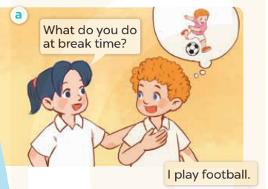  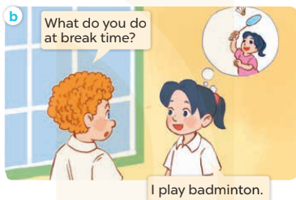  - Play the audio twice (sentence by sentence). Correct their pronunciation where necessary.  - Have Ss to practice the dialogue  - T invites a few pairs to the front of the class to practice.  - T checks pronunciation for ss.  - Learn the vocabulary and model sentences by heart  - Prepare the new lesson: Unit 10, Lesson 2 (4,5,6). | - Ss listen  -Ss play game  -Ss open their books  -Ss listen and answer  - - Ss listen and repeat  + Choral repetition (3 times).  + Individual repetition (3 ss)  - Ss take note  - Ss look, remember and write  -Look at the pictures and say  + In picture a: Mai asks Bill if What do you do at break time? Bill says that I play football.  + In picture b: Bill asks Mai: What do you do at break time?  Mai answers: I play badminton.  -Ss listen and repeat in chorus (twice)  -Ss work in pairs to practice  -Ss practice the dialogue  -Ss listen  -Ss listen and take note
D. ADJUSTMENTS (if necessary):
………………………………………………………………………………………….…..……………………………………………………………………………...………………………………………….…..……………………………………………………………………………….……………………………………………………………………...

