Week 14
Period 55

Unit 8: My school things
Lesson 3 (4, 5, 6)
By the end of the lesson, Ss will be able to:
- read and complete a gapped paragraph with the words provided.
- read, understand and complete the writing frame with Ss’ information.
- collect three school things from home and bring them to the classroom to present to their classmates
PROCEDURES:
Teacher’s activities | Students’ activities
Activity 1. Read and complete:  *Aims: Ss will be able to read and complete a gapped paragraph with the words provided.  *Procedure:  - Elicit and introduce the paragraph to complete  - Elicit the missing word for the first gap (have)  - Then tell Ss to pay attention to the article a / an to select appropriate nouns in the box for the next two gaps  - Give Ss time to do the rest individually or in pairs.  - Tell Ss to swap their answers with a partner.  - Check answers as a class. Write the correct answers on the board for Ss to correct their answers.  - Have Ss read the text aloud.  Key: 1. have 2. pen 3. eraser 4. my  Activity 2. Let’s write  *Aims: Ss will be able to read, understand and complete the writing frame with pupils’ information  *Procedure:  - Write the writing frame on the board.  - Have Ss read the sentences in chorus.  - When you reach the first gap, point to it and tell Ss to complete it with their name.  - Then read the next line and tell them to complete each gap with the school things they have.  - Give Ss time to do the task.  - Invite a few Ss to stand up and read their writing aloud.  Key: Pupils’ answer | - Ss look at the pictures and answer  -Ss read and complete the first sentence  -Ss listen and answer  -Ss do the task  -Ss swap their answers  -Ss check their answer  -Ss read aloud  -Ss look and listen  -Ss read  -Ss write  -Ss do the task  My name is…….Look at my school things. I have……..  and……….  -Ss listen and repeat
D. ADJUSTMENTS (if necessary):
………………………………………………………………………………………….…..……………………………………………………………………………...…………
Week 14
Period 56

Unit 9: Colours
Lesson 1 (1, 2, 3)
By the end of the lesson, Ss will be able to:
- use the words blue, brown, red, yellow related to the topic “colours”
- use What colour is it? – It’s ……… to ask and answer questions about colours of school things
PROCEDURES:
Teacher’s activities | Students’ activities
Activity 1. Vocabulary.  *Aims: Ss will be able to know the vocabulary in front of starting the new lesson.  *Procedure:  -T elicits the new words  + blue : màu xanh da trời  (visual)  + brown : màu nâu (visual)  + red :màu đỏ (visual)  + yellow : màu vàng (visual)  + colour: màu sắc (translation)  - T models (3 times).  - T writes the words on the board.  - Checking: Rub out and remember  Activity 2. Look, listen and repeat:  *Aims: Ss will be able to understand and correctly repeat the sentences in two communicative contexts (pictures) to talk about colours.  *Procedure:  - Have Ss look at Pictures a and b and identify the characters (Minh and Mary) in the pictures.  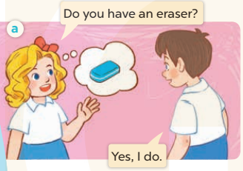  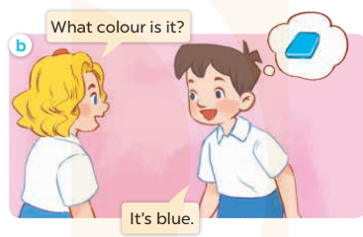  - Play the audio twice (sentence by sentence). Correct their pronunciation where necessary.  - Have Ss to practice the dialogue  - T invites a few pairs to the front of the class to practice.  - T checks pronunciation for ss. | -Ss listen and answer  - - Ss listen and repeat  + Choral repetition (3 times).  + Individual repetition (3 ss)  - Ss take note  - Ss look, remember and write  -Look at the pictures and say  + In picture a: Mary asks Minh: Do you have an eraser?  Minh replies: Yes, I do.  + In picture b: Mary asks Minh: What colour is it?  Minh replies: It’s blue.  -Ss listen and repeat in chorus (twice)  -Ss work in pairs to practice  -Ss practice the dialogue  -Ss listen
D. ADJUSTMENTS (if necessary):

