Week 11
Period 41

Unit 6: Our school
Lesson 2 (4, 5, 6)
By the end of the lesson, Ss will be able to:
- listen to and understand simple exchanges in relation to the topic “Our school”
- read some sentences and match them with the correct pictures.
- practise the target sentence pattern by playing the game Guess the place.
PROCEDURES:
Teacher’s activities | Students’ activities
Activity 1. Listen and number:  *Aims: Ss will be able to listen and understand four communicative contexts in which pupils make suggestions to go to different places at school  *Procedure:  - Elicit the word for the place in each picture  - Point at the pictures respectively to explain the context.      - T ask Ss to guess the answers.  + T writes Ss’guessing on the board.  - Listen to the tape:  + Play the recording  + Play the recording again and get Ss to swap books with their partners.  + Play the recording again to check answers together as a class.  + Write the answers on the board for Ss to correct their answers. Then checks Ss’ guessing.  - Play the recording, sentence by sentence, for the class to listen and repeat in chorus.  Key: 1. c 2. b 3. d 4. a  Activity 2. Read and match  *Aims: Ss will be able to read some sentences and match them with the correct pictures.  *Procedure:  - Get Ss to look at the pictures and identify the places in the pictures.  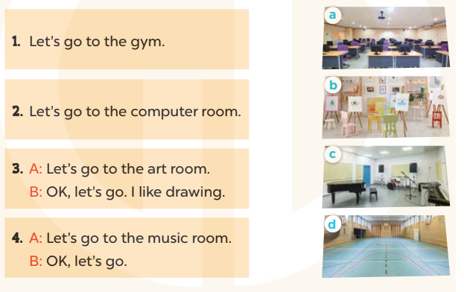  - Have Ss look at the four dialogues and the pictures. Elicit and model with picture 1  + Ask Ss to read the sentence 1 in chorus.  + Ask Ss to match sentence 1 with the correct picture  -Have Ss work in pairs and complete the sentences 2, 3, 4.  - Ask a few Ss to stand up and read the sentences aloud.  -T gives feedbacks.  Key:  1. d 2. a 3. b 4. c | -Look at the pictures and say:  + Picture a: a music room + Picture b: an art room  + Picture c: a gym  + Picture d: a computer room  -Ss guess the answers  - Ss listen to the tape and write  - Ss listen again, write and swap books with their partners.  - Ss check their answers and guessing  -Ss listen and repeat.  -Ss look at the picture and say  -Ss look and answer  -Ss read  -Ss say and match  -Ss work in pairs and macth  -Ss read aloud
D. ADJUSTMENTS (if necessary):
………………………………………………………………………………………….…..……………………………………………………………………………...………………………………………….…..……………………………………………………………………………….……………………………………………………………………...
Week 11
Period 42

Unit 6: Our school
Lesson 3 (1, 2, 3)
By the end of the lesson, Ss will be able to:
- correctly pronounce the sounds of the letters pl and cl in isolation, in the words playground and classroom, and in the sentences Let's go to the playground. and Is that your classroom
- listen and circle the correct words.
PROCEDURES:
Teacher’s activities | Students’ activities
Activity 1. Listen and repeat:  *Aims: Ss will be able to correctly pronounce the sounds of the letters pl and cl in isolation, in the words playground and classroom, and in the sentences Let's go to the playground. and Is that your classroom?  *Procedure:  - T gives instruction to the letter pl and cl, playground and classroom, and in the sentences Let's go to the playground. and Is that your classroom?  - Play the recording for the letter cl, pl.  - Encourage Ss to point at the letter/ word/ sentence while listening.  - Play the recording again and encourage Ss to listen and repeat.  - Do this several times until Ss feel confident.  - T calls some Ss to practice.  - T gives feedbacks.  Activity 2. Listen and circle.  *Aims: Ss will be able to identify the target words playground and classroom while listening.  *Procedure:  - Elicit the sentences and the gap-fill options.  - T ask Ss to guess the answers.  + T writes Ss’guessing on the board.  - Listen to the tape:  + Play the recording  + Play the recording again and get Ss to swap books with their partners.  + Play the recording again to check answers together as a class.  + Write the answers on the board for Ss to correct their answers. Then checks Ss’ guessing.  - Play the recording, sentence by sentence, for the class to listen and repeat in chorus.  - Invite one or two Ss to stand up and read the completed sentences.  Key: 1.b 2.c | - Ss recognize the differences about color of letter  - - Ss listen  - Ss listen and point  - Ss listen again and repeat  -Ss listen again and repeat  -Ss practice  -Ss listen  -Ss listen and say:  + Number 1: Let’s go to the …....  + Number 2: Is that our ……?  -Ss guess the answers  - Ss listen to the tape and circle  - Ss listen again, circle and swap books with their partners.  - Ss check their answers and guessing  -Ss listen and repeat.  -Ss read the sentences  - Ss look and listen.

D. ADJUSTMENTS (if necessary):
………………………………………………………………………………………….…..……………………………………………………………………………...………………………………………….…..……………………………………………………………………………….……………………………………………………………………...
Week 11
Period 43
Teaching date: November 15th, 2023

Unit 6: Our school
Lesson 3 (4, 5, 6)
By the end of the lesson, Ss will be able to:
- read and write about a school;
- make a poster to introduce their school to a new pupil.
PROCEDURES:
Teacher’s activities | Students’ activities
Activity 1. Read and complete:  *Aims: Ss will be able to read and choose the words to complete the text.  *Procedure:  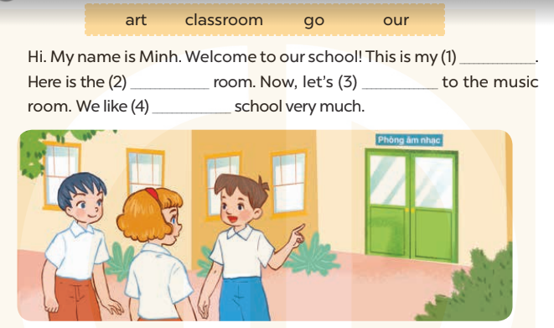  - Elicit and introduce the context.  + Minh is introducing his school to his friends.  - Have Ss read aloud the words to fill in.  - Model the first blank with Ss to make sure that they know how to do the task.  - Give Ss enough time to complete the text.  - Check the answers as a class.  - Have Ss read the text aloud.  Key: 1. classroom 2. art  3. go 4. our | - Ss look at the pictures and answer  -Ss read the words  -Ss fill in the gap  -Ss complete the text  -Ss check their answer  -Ss read aloud  -Ss listen and answer
D. ADJUSTMENTS (if necessary):
………………………………………………………………………………………….…..……………………………………………………………………………...…………
Week 11
Period 44
Teaching date: November 16th, 2023

Unit 7: Classroom instructions
Lesson 1 (1, 2, 3)
By the end of the lesson, Ss will be able to:
-use the words open, close, stand up, sit down and please in relation to the topic “Classroom instructions”
-use …………. please! to give instructions;
C. PROCEDURES:
Teacher’s activities | Students’ activities
Activity 1. Vocabulary.  *Aims: Ss will be able to know the vocabulary in front of starting the new lesson.  *Procedure:  -T elicits the new words  + open : mở (mime)  + close : đóng (mime)  + stand up :đứng lên (mime)  + sit down : ngồi xuống (mime)  + please : xin mời (translation)  - T models (3 times).  - T writes the words on the board.  - Checking: Rub out and remember  Activity 2. Look, listen and repeat:  *Aims: Ss will be able to understand and correctly repeat the sentences in two communicative contexts (pictures) focusing on classroom instructions.  *Procedure:  - Have Ss look at Pictures a and b and identify names of the speakers in the pictures.  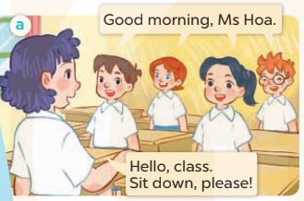  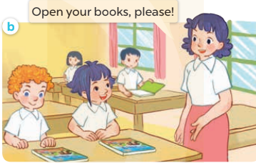  - Play the audio twice (sentence by sentence). Correct their pronunciation where necessary.  - Have Ss to practice the dialogue  - T invites a few pairs to the front of the class to practice.  - T checks pronunciation for ss. | -Ss listen and answer  - - Ss listen and repeat  + Choral repetition (3 times).  + Individual repetition (3 ss)  - Ss take note  - Ss look, remember and write  -Look at the pictures and say  + In picture a: Class says: Good morning, Ms Hoa. Lucy answers: Hello, class. Sit down, please!  + In picture b: Ms Hoa says: Open your books, please!  -Ss listen and repeat in chorus (twice)  -Ss work in pairs to practice  -Ss practice the dialogue  -Ss listen  -Ss look at the picture and answer.  -Ss listen  -Ss listen and repeat  -Ss repeat to the place
D. ADJUSTMENTS (if necessary):
………………………………………………………………………………………….…..……………………………………………………………………………...………………………………………….…..……………………………………………………………………………….……………………………………………………………………...

