Week 14
Period 53

Unit 8: My school things
Lesson 2 (4, 5, 6)
By the end of the lesson, Ss will be able to:
- listen to and understand four communicative contexts in which pupils ask and answer questions about having a school thing.
- read and match four simple exchanges with the correct pictures
- review vocabulary words for school things and use them in the sentence patterns Do you have ………...? and Yes, I do. / No, I don’t. by playing the matching game or Pelmanism.
PROCEDURES:
Teacher’s activities | Students’ activities
Activity 1. Listen and number:  *Aims: Ss will be able to listen to and understand four communicative contexts in which pupils ask and answer questions about having a school thing.  *Procedure:  - Elicit the words for the school thing in each picture.  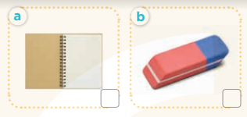  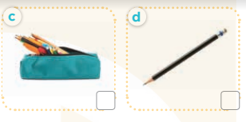  - T ask Ss to guess the answers.  + T writes Ss’guessing on the board.  - Listen to the tape:  + Play the recording  + Play the recording again and get Ss to swap books with their partners.  + Play the recording again to check answers together as a class.  + Write the answers on the board for Ss to correct their answers. Then checks Ss’ guessing.  - Play the recording, sentence by sentence, for the class to listen and repeat in chorus.  Key: 1. c 2. d 3. a 4. b  Activity 2. Read and match  *Aims: Ss will be able to read and match four simple exchanges with the correct pictures.  *Procedure:  - Get Ss to look at the pictures and identify the school things.  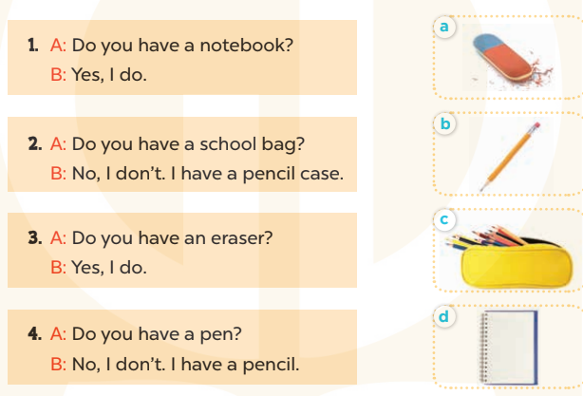  - Have Ss look at the four dialogues and the pictures. Elicit and model with number 1  + Get Ss to read number 1 in chorus. + Ask them what A and B are talking about.  + Write the word notebook on the board.  + Tell Ss to identify the picture of a notebook (Picture d).  + Then match number 1 with Picture d.  -Have Ss work in pairs and match the sentences 2, 3, 4.  - Ask a few Ss to stand up and read the sentences aloud.  -T gives feedbacks.  Key:  1. d 2. c 3. a 4. b | -Look at the pictures and say:  + Picture a: a notebook  + Picture b: an esaser  + Picture c: a pencil case  + Picture d: a pencil.  -Ss guess the answers  - Ss listen to the tape and write  - Ss listen again, write and swap books with their partners.  - Ss check their answers and guessing  -Ss listen and repeat.  -Ss look at the picture and say  -Ss look and answer  -Ss read  -Ss answer  -Ss write  -Ss listen and match  -Ss work in pairs and complete  -Ss read aloud
D. ADJUSTMENTS (if necessary):
………………………………………………………………………………………….…..……………………………………………………………………………...………………………………………….…..……………………………………………………………………………….……………………………………………………………………...Week 14
Period 54

Unit 8: My school things
Lesson 3 (1, 2, 3)
By the end of the lesson, Ss will be able to:
- correctly repeat the sounds of the letter cluster oo and letter a in isolation, in the words book and eraser, and in the sentences I have a book. and Do you have an eraser? with correct pronunciation and intonation.
- identify the target words book and eraser while listening.
- say the chant with the correct rhythm and pronunciation.
PROCEDURES:
Teacher’s activities | Students’ activities
Activity 1. Listen and repeat:  *Aims: Ss will be able to correctly repeat the sounds of the letter cluster oo and letter a in isolation, in the words book and eraser, and in the sentences I have a book. and Do you have an eraser? with correct pronunciation and intonation.  *Procedure:  - T gives instruction to the letter oo and a, book and erase, and in the sentences I have a book. and Do you have an eraser?  - Play the recording for the letter oo, a.  - Encourage Ss to point at the letter/ word/ sentence while listening.  - Play the recording again and encourage Ss to listen and repeat.  - Do this several times until Ss feel confident.  - T calls some Ss to practice.  - T gives feedbacks.  Activity 2. Listen and circle.  *Aims: Ss will be able to identify the target words book and eraser while listening.  *Procedure:  - Elicit the sentences and the gap-fill options.  - T ask Ss to guess the answers.  + T writes Ss’guessing on the board.  - Listen to the tape:  + Play the recording  + Play the recording again and get Ss to swap books with their partners.  + Play the recording again to check answers together as a class.  + Write the answers on the board for Ss to correct their answers. Then checks Ss’ guessing.  - Play the recording, sentence by sentence, for the class to listen and repeat in chorus.  - Invite one or two Ss to stand up and read the completed sentences.  Key: 1.b 2.c | - Ss recognize the differences about color of letter  - - Ss listen  - Ss listen and point  - Ss listen again and repeat  -Ss listen again and repeat  -Ss practice  -Ss listen  -Ss listen and say:  + Number 1: I have .…….  + Number 2: Do you have …?  -Ss guess the answers  - Ss listen to the tape and circle  - Ss listen again, circle and swap books with their partners.  - Ss check their answers and guessing  -Ss listen and repeat.  -Ss read the sentences  - Ss look and listen.

D. ADJUSTMENTS (if necessary):
………………………………………………………………………………………….…..……………………………………………………………………………...………………………………………….…..……………………………………………………………………………….……………………………………………………………………...
Week 14
Period 55

Unit 8: My school things
Lesson 3 (4, 5, 6)
By the end of the lesson, Ss will be able to:
- read and complete a gapped paragraph with the words provided.
- read, understand and complete the writing frame with Ss’ information.
- collect three school things from home and bring them to the classroom to present to their classmates
PROCEDURES:
Teacher’s activities | Students’ activities
Activity 1. Read and complete:  *Aims: Ss will be able to read and complete a gapped paragraph with the words provided.  *Procedure:  - Elicit and introduce the paragraph to complete  - Elicit the missing word for the first gap (have)  - Then tell Ss to pay attention to the article a / an to select appropriate nouns in the box for the next two gaps  - Give Ss time to do the rest individually or in pairs.  - Tell Ss to swap their answers with a partner.  - Check answers as a class. Write the correct answers on the board for Ss to correct their answers.  - Have Ss read the text aloud.  Key: 1. have 2. pen 3. eraser 4. my  Activity 2. Let’s write  *Aims: Ss will be able to read, understand and complete the writing frame with pupils’ information  *Procedure:  - Write the writing frame on the board.  - Have Ss read the sentences in chorus.  - When you reach the first gap, point to it and tell Ss to complete it with their name.  - Then read the next line and tell them to complete each gap with the school things they have.  - Give Ss time to do the task.  - Invite a few Ss to stand up and read their writing aloud.  Key: Pupils’ answer | - Ss look at the pictures and answer  -Ss read and complete the first sentence  -Ss listen and answer  -Ss do the task  -Ss swap their answers  -Ss check their answer  -Ss read aloud  -Ss look and listen  -Ss read  -Ss write  -Ss do the task  My name is…….Look at my school things. I have……..  and……….  -Ss listen and repeat
D. ADJUSTMENTS (if necessary):
………………………………………………………………………………………….…..……………………………………………………………………………...…………
Week 14
Period 56

Unit 9: Colours
Lesson 1 (1, 2, 3)
By the end of the lesson, Ss will be able to:
- use the words blue, brown, red, yellow related to the topic “colours”
- use What colour is it? – It’s ……… to ask and answer questions about colours of school things
PROCEDURES:
Teacher’s activities | Students’ activities
Activity 1. Vocabulary.  *Aims: Ss will be able to know the vocabulary in front of starting the new lesson.  *Procedure:  -T elicits the new words  + blue : màu xanh da trời  (visual)  + brown : màu nâu (visual)  + red :màu đỏ (visual)  + yellow : màu vàng (visual)  + colour: màu sắc (translation)  - T models (3 times).  - T writes the words on the board.  - Checking: Rub out and remember  Activity 2. Look, listen and repeat:  *Aims: Ss will be able to understand and correctly repeat the sentences in two communicative contexts (pictures) to talk about colours.  *Procedure:  - Have Ss look at Pictures a and b and identify the characters (Minh and Mary) in the pictures.  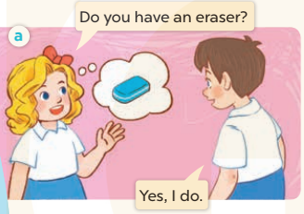  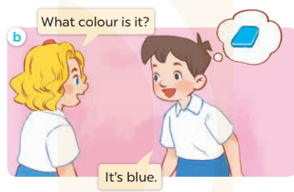  - Play the audio twice (sentence by sentence). Correct their pronunciation where necessary.  - Have Ss to practice the dialogue  - T invites a few pairs to the front of the class to practice.  - T checks pronunciation for ss. | -Ss listen and answer  - - Ss listen and repeat  + Choral repetition (3 times).  + Individual repetition (3 ss)  - Ss take note  - Ss look, remember and write  -Look at the pictures and say  + In picture a: Mary asks Minh: Do you have an eraser?  Minh replies: Yes, I do.  + In picture b: Mary asks Minh: What colour is it?  Minh replies: It’s blue.  -Ss listen and repeat in chorus (twice)  -Ss work in pairs to practice  -Ss practice the dialogue  -Ss listen
D. ADJUSTMENTS (if necessary):

